TABLE OF CONTENTS
DOCUMENT CONTROL 3
Executive Summary 4
1. Introduction 6
1.1 Develop Operational Demonstration Plant 6
1.2 Develop Standard Operating Procedures 7
2. Overall Process Flow 9
2.1 Process Flow Development 9
3. Standard Operating Procedures 13
3.1 Battery Breaking and Stream Separation 13
3.2 Lead Paste (Ex Battery) Preparation & Waste Stream Removal 16
3.3 Lead Paste De-Sulphurization Process 18
3.4 Milling & Particle Sizing Processes 21
3.5 De-Watering Processes 24
3.6 Dissolution of Lead Compounds in Acetic Acid 27
3.7 Transfer of Slurry Based on Lead Acetate to Filter Press 30
3.8 Filter Process Operation to Liberate Lead Acetate Solution 31
3.9 Handling of the Residue Filter Cake 34
3.10 Addition of Citric Acid to Lead Acetate Solution 36
3.11 Filter Press Operation to Collect Tri Lead Citrate 39
3.12 Transferring Tri-Lead Citrate to Dryer 42
3.13 Operation of the Dryer 44
3.14 Handling of Dried Tri-Lead Citrate 47
13.5 Transport of Tri-Lead Citrate to Calciner 49
13.6 Operation of the Calciner 50
3.17 Handling of Final Calcined Product 54
3.18 Storage of Final Calcined Product 56
4. Additional Operating Procedures 59
4.1 Control of Lead Guidelines 59
4.2 Blood Lead Management Procedures 59
4.3 LAB Awareness Guidelines/Procedure 60
5. Conclusions 61
Appendix 1 – Control of Lead Guidelines 62
Appendix 2 – LAB Awareness Procedure 70
Appendix 3 – Blood Lead Management Procedure 84

Introduction

This report is a full Technical Report on the design and operation of the HALO Battery Recycling Plant in the UK.

1.1 Develop Operational Demonstration Plant
Development of Demonstration Plant with production throughput of 10,000 tonnes LABs/year, capable of operating continuously (24/7) with effective controls to ensure safe, efficient use and quality production.
This report will cover the development of the standard operating procedures including ethics issues, health and safety for both in-line visual checks and an electronic process flow for operation via a tablet computer. The standard operating procedures also covered will include are not limited to identification of hazards and risk controls; lead exposure monitoring procedures for emergency operating conditions.
Halo Battery Recycling have developed standard corporate operating procedures covering the requirements/guidance for employees on aspects such as health & safety, emergency operating conditions, environmental monitoring, operation control etc, for each stage of the process from the battery breaking and separation stage through the final stage of storage of the final product.
Careful consideration has been given to each of the procedures developed to ensure that each is in-line with the current regulatory requirements and legislation for battery processing. In addition, Halo Battery Recycling have also developed standard procedures for LAB awareness, blood lead management and control of lead guidelines which are expected to be adhered to by all employees.

1.2 Develop Standard Operating Procedures
The objective was to develop standard operating procedures (SOPs) including ethics issues, health and safety for both in-line visual checks and an electronic process flow for operation via a tablet computer. These include but are not limited to: identification of hazards and risk controls; lead exposure monitoring; procedures for emergency operating conditions.
To achieve the objective during the early stages of the project we have developed the standard operating procedures covering the following aspects of the overall process:
- Battery Breaking and Stream Separation
- Lead Paste (Ex Battery) Preparation
- Lead Paste De-sulphurization Process
- Milling and Particle Sizing Process
- Dewatering (including settlement of solids prior to dewatering)
- Dissolution of Lead compounds in Acetic Acid
- Transfer of Slurry based on Lead Acetate to Filter Press
- Filter Press Operation to liberate Lead Acetate
- Handling of Filter Cake/Solids Prior to Removal of Residues
- Addition of Citric Acid to Lead Acetate Solution
- Filter Press Operation to collect Tri Lead Citrate
- Transport of Solid Tri Lead Citrate to Dryer
- Dryer Operation
- Handling of Dried Solids
- Transfer of Calciner
- Calciner Operation
- Handling of Final Product
- Storage of Final Product
- Disposal of Sodium Sulphate Solution
- Disposal of Unwanted Solid Residues
- Recycling of Acetic Acid Solution
Environmental Permitting requires HALO to understand
- Ethics Issues
- Identification of Hazards
- Identification of Risk Controls
- Lead Exposure Monitoring
- Emergency Operating Conditions

2. Overall Process Flow

2.1 Process Flow Development
In order to generate the Standard Operating Procedures as required by the operators of the plant, the process needs to be defined in terms of safety, risk and monitoring. As a continuous process this requires following a detailed design procedure to seamlessly integrate each step and such design must incorporate all the previously discussed control issues.
Firstly, the complete process flow must be defined. This process flow can be described generally via an overview Process Flow Diagram (PFD) and in depth with more detailed Process Flow Diagrams.
The overall PFD and the detailed PFDs for each operation of the plant are shown at relevant points within the document. It must be noted that all process flow has been, and is, subject to revision following critique and all aspects are subject to continuous improvement.
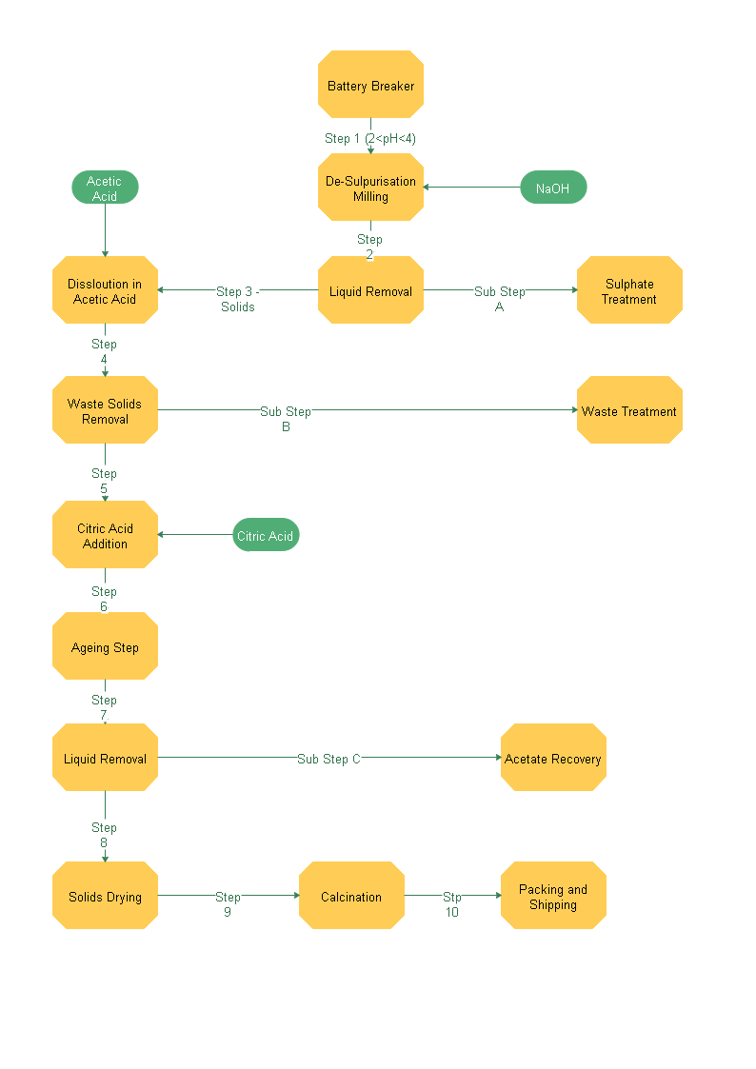

It is then possible to design the overall plant layout which shows the physical position of each of the process steps in relation to each other, and thus determines the required footprint of the processing plant.
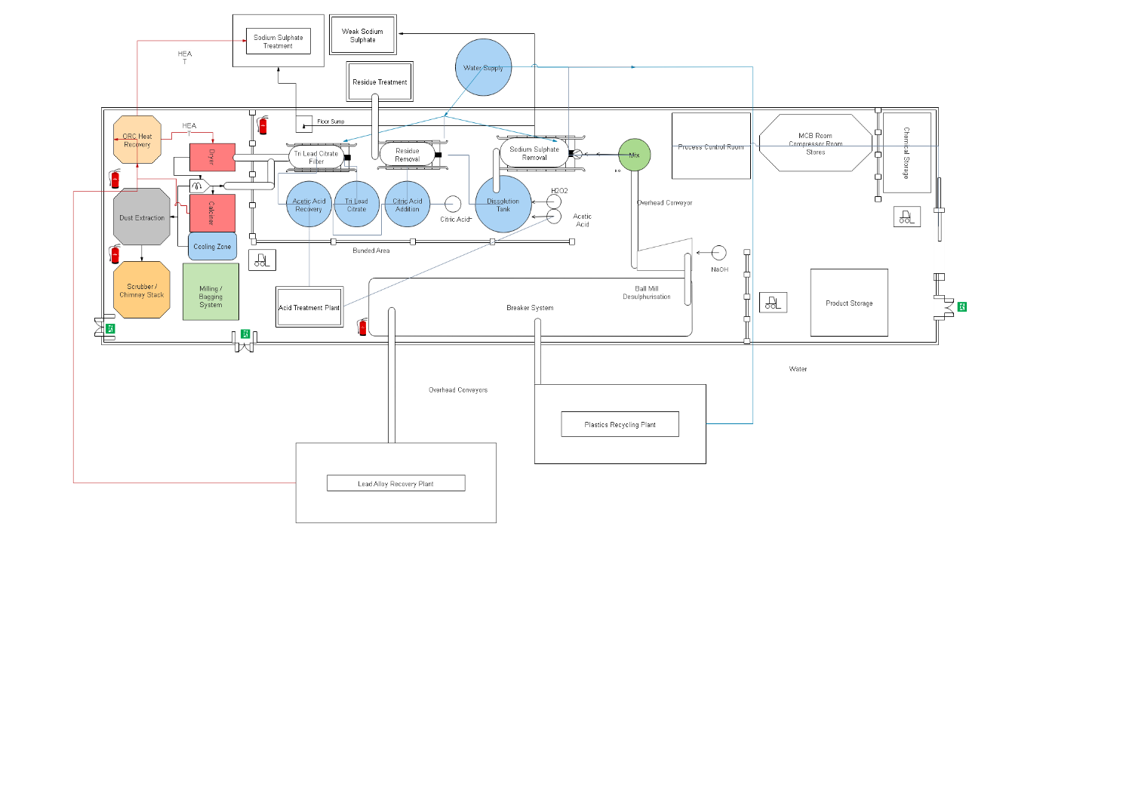
The process flow diagrams are then used to generate the Piping and Instrumentation Diagram (P&ID) which is the basis for the plant mechanical and electrical installation.
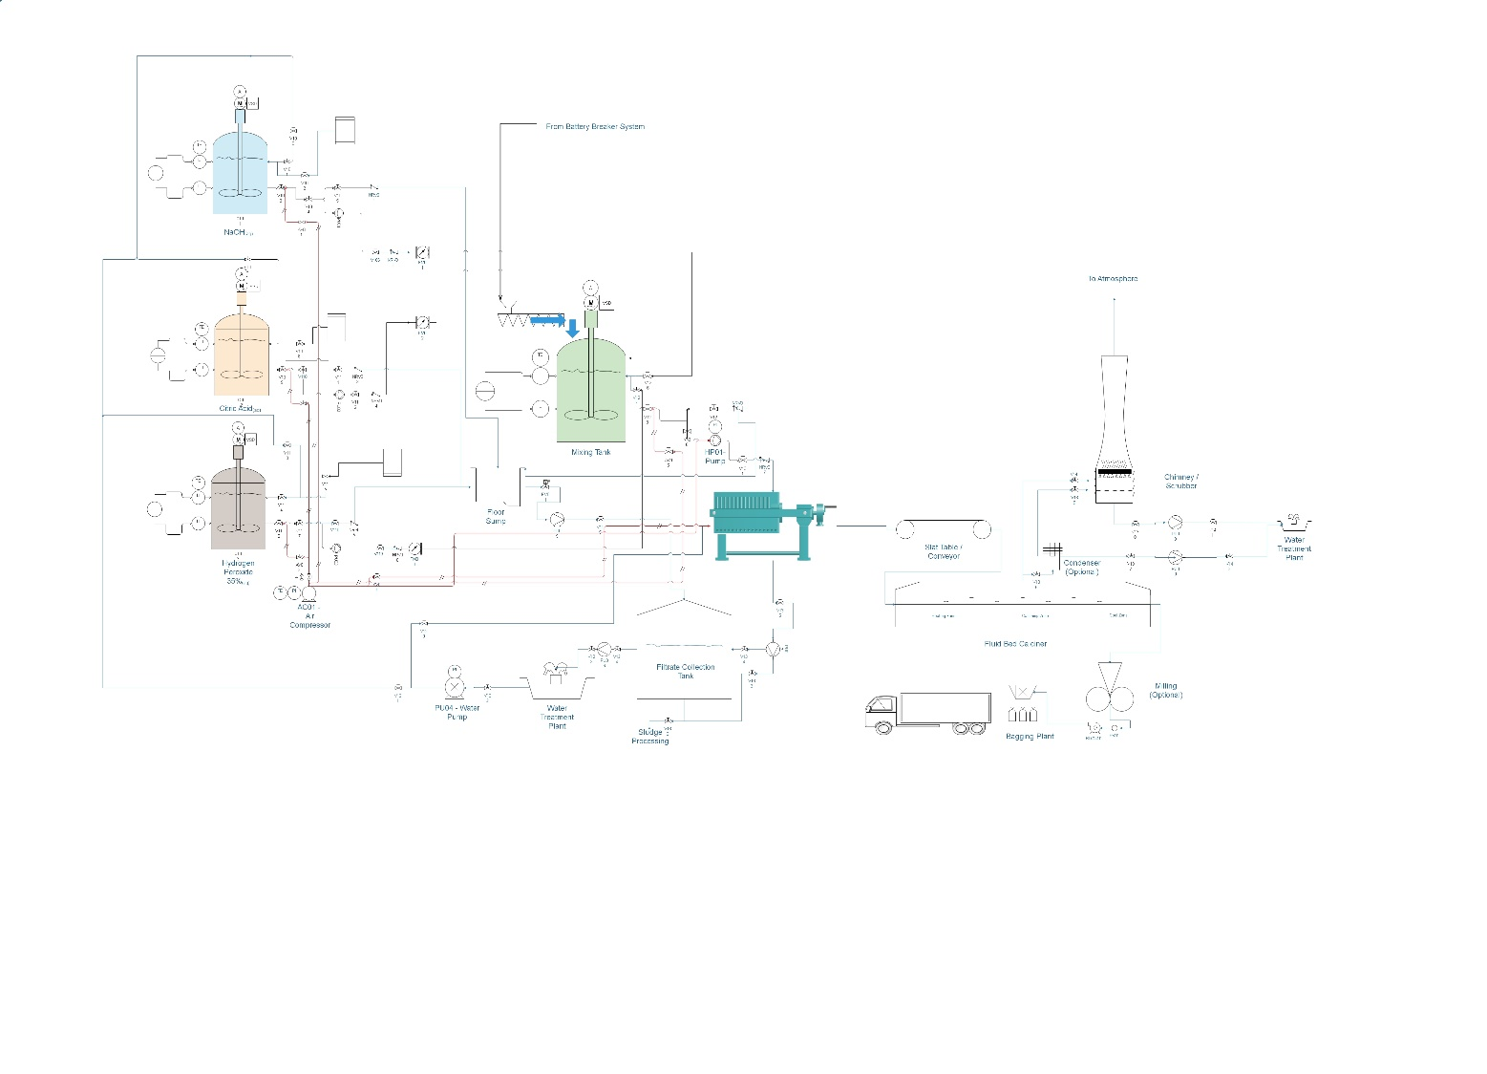
Once the full layout, process flow diagrams and P&ID have been produced, it is possible to carry out the hazard investigation which then leads to the Standard Operating Procedures, starting with the Battery Breaking and Separation stage and then following logically through.

3. Standard Operating Procedures

3.1 Battery Breaking and Stream Separation
The standard operating procedures for the battery breaking and separation stage of the NUOVOPb process include procedures covering the following aspects:
Materials Processed/Storage
- The material to be processed will only consist of drained or non-spillable (dry) gel-filled Lead acid batteries, which have been vented of any residual hydrogen gas.
- Material waiting for processing is stored in (sealed) plastic HDPE storage containers.
Environmental/Operational Control Systems
- Batteries to be processed may potentially contain low levels volumes of hydrogen gas and for safety purposes the battery must be free of hydrogen gas prior to processing for which sealed batteries will have vent caps lifted/removed at least half an hour prior to processing in a well-ventilated area of the building.
- To negate this risk a Hydrogen Gas Meter may be installed at the battery venting area to monitor for hydrogen, in addition to employing local ventilation systems and bag capture in the warehouse building for lead dusts.
- All conveyors and mechanical equipment will be regularly checked for the effects of Acid attack and all fugitive emissions of Sulphuric Acid via drips and spills will be dealt with by skilled, trained operators.
Emergency Operating Conditions
- Only trained and experienced operators are permitted around the breaking process.
- The shredder system will not be used if the integral interlocks and extraction system are not proven to prior to operations commencing
- Should the extraction system on the shredder fail then operations on the shredder will cease immediately
- The dust extraction plant will be maintained or repaired (if required), with any dust residues around the process area being dry cleaned prior to any breaking operations restarting.
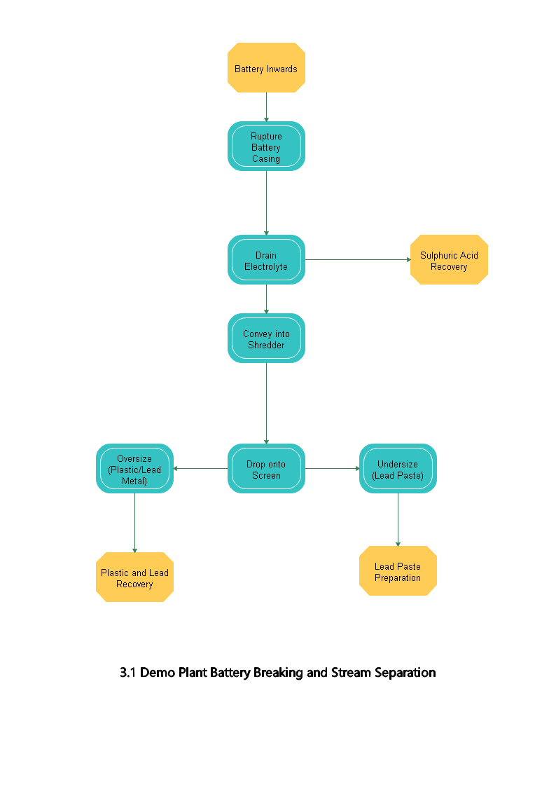
Environmental Monitoring
- The operation of the shredder generates a single product stream which has the potential for accidental release into the plant. To negate this risk, any accidental releases in this process are contained within in a bunding system for the process.
- Any accidental spillages are treated in accordance with our Environmental Permit.
Health & Safety
The battery breaking, and separation process is covered by the Halo Battery Recycling Health and Safety Policy, which includes:
- Risk Assessments
- STOP Assessments
- PPE
- Occupational Health Requirements including HSWA, MHSWA, PUWER, LOLER
The full detailed standard operating procedures including the responsibility for each aspect of the battery breaking and separation process are enclosed within the appendices of this report.

3.2 Lead Paste (Ex Battery) Preparation & Waste Stream Removal
The standard operating procedures for the preparation of the lead paste for NUOVOPb include procedures covering the following aspects:
Material Processed/Storage
- The material processed will only be a suitable lead paste from a known source of batteries.
- The material to be processed is to be stored in plastics HDPE stillages
Emergency Operating Procedures
- Only trained and experience operators are permitted on the Granulator
- System not to be used if Granulator interlocks not proven prior to operations commencing
- On shut down the process stations must be electrically isolate from unauthorised use
- If the system fails, then operations will be suspended immediately
Environmental/Operational Control Systems
- Regular housekeeping and interlock checks on the granulator system are carried out.
- Local Ventilation Systems are in place in the warehouse building for operators and to capture dusts and residues emitted from the process.
Environmental Monitoring
- The lead paste preparation process has the potential for accidental release into the plant via the operation of the milling and screen system. To negate this risk any accidental release of heavy particles is contained within in a bunding system for the process.
- Any accidental spillages are treated in accordance with our Environmental Permit.

Health & Safety
The lead preparation process is covered by the Halo Battery Recycling Health and Safety Policy which includes:
- Risk Assessments
- STOP Assessments
- PPE
- Occupational Health Requirements including HSWA, MHSWA, PUWER, LOLER
The full detailed standard operating procedures including details of the responsibility for each aspect of the lead paste preparation process are enclosed within the appendices of this report.

3.3 Lead Paste De-Sulphurization Process
The standard operating procedures for the lead paste de-sulphurization for NUOVOPb include procedures covering the following aspects:
Materials Processed/Storage
- The material to be processed during the lead paste de-sulphurization will only be a slurry consisting of insoluble lead-based materials in a slightly acidic solution.
- Material to be processed is stored in plastic containers.
Environmental/Operational Control Systems
- Regular housekeeping and interlock safety checks on de-sulphurization system are carried out.
- Local exhaust ventilation is placed within the warehouse building for operators and for capture of dusts/residues emitted from the process.
Emergency Operating Conditions
- Only trained and experienced operators are permitted to carry out the de-sulphurization process
- The system is not to be used if the interlocks not proven prior to operations commencing
- Should the system be shutdown then the process stations must be electrically isolated from unauthorised use
- If the system fails, then operations will be suspended immediately
Environmental Monitoring
- The operation of the lead paste de-sulphurization system has the potential for accidental release into the plant. Any accidental releases in the process are contained in a bunding system for this process.
- Any accidental spillages are treated in accordance with our Environmental Permit.
Health & Safety
The lead paste de-sulphurization process is covered by the Halo Battery Recycling Health and Safety Policy which includes:
- Risk Assessments
- STOP Assessments
- PPE
- Occupational Health Requirements including HSWA, MHSWA, PUWER, LOLER
The full detailed standard operating procedures including the responsibility for each aspect of the lead paste de-sulphurization process are enclosed within the appendices of this report.
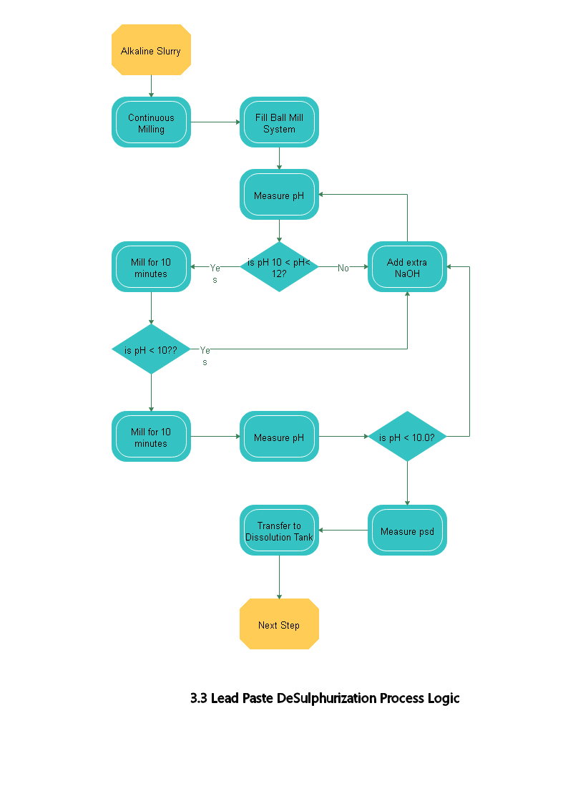

3.4 Milling & Particle Sizing Processes
The standard operating procedures for the mixing process for NUOVOPb include procedures covering the following aspects:
Materials Processed/Storage
- The material which will be processed will only be a fully processed feed slurry consisting of lead salts and lead solids in a slightly acidic solution, the composition of which will be continually monitored.
- Material which is awaiting processing is stored in the stainless-steel de-sulphurization tanks
Environmental/Operational Control Systems
- Milling is done on a continuous, closed-loop system, where the particle size of the final product is controlled by an overflow system and a classifier.
- The acidity/alkalinity of the milled slurry is controlled using a 50% Sodium Hydroxide solution which has its own set of environmental control procedures (refer to MSDS for 50% Sodium Hydroxide Solution)
- Regular housekeeping and interlock checks are carried out on the mechanical bearings, agitation and pumping systems.
- Local exhaust ventilation is placed within the warehouse building for operators and for capture of dusts/residues emitted from the mechanical process.
Emergency Operating Conditions
- Only trained and experienced operators are permitted to carry out the mixing process.
- The system is not to be used if interlocks are not proven prior to the operations commencing
- Should the system be shutdown then the process stations must be electrically isolated from unauthorised use
- If the system fails, then operations will be suspended immediately
Environmental Monitoring
- The operation of the mixing system and the subsequent slurry has the potential for accidental release into the plant. Any accidental releases in the process are contained in a bunding system for this process. Any accidental spillages are treated in accordance with our Environmental Permit.
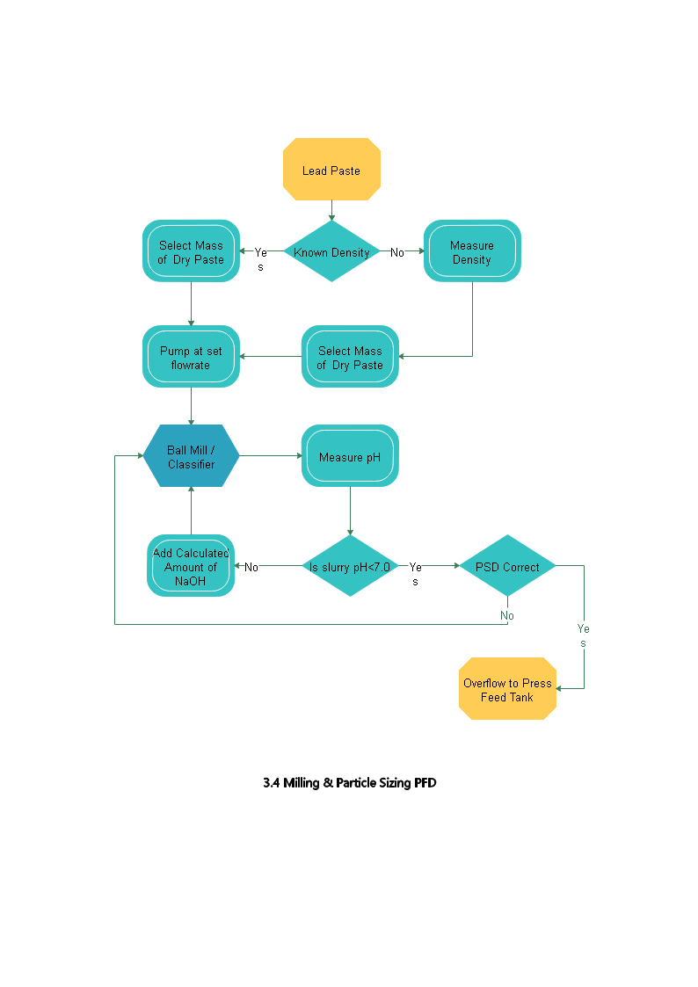
Health & Safety
The mixing process is covered by the Halo Battery Recycling Health and Safety Policy which includes:
- Risk Assessments
- STOP Assessments
- PPE
- Occupational Health Requirements including HSWA, MHSWA, PUWER, LOLER
The full detailed standard operating procedures including the responsibility for each aspect of the mixing process are enclosed within the appendices of this report.

3.5 De-Watering Processes
The standard operating procedures for the De-Watering Process for NUOVOPb include procedures covering the following aspects:
Materials Processed/Storage
- Material processed will only be a fully processed feed slurry consisting of Lead Oxides and Residues in an alkali solution of Sodium Hydroxide and Sodium Sulphate.
Environmental/Operating Control Systems
- Regular housekeeping and interlock checks on the de-watering systems are carried out.
- Local exhaust ventilation is located within the process building for operators and for the capture of dusts and residues emitted from the mechanical processing of the batteries.
Emergency Operating Conditions
- Only trained and experienced operators are permitted to carry out the de-watering process.
- The system is not to be used if interlocks are not proven prior to the operations commencing
- Should the system be shutdown then the process stations must be electrically isolated from unauthorised use
- If the system fails, then operations will be suspended immediately
Environmental Monitoring
- The operation of the filter press generates two separate product streams, one solid and one liquid, each of which has the potential for accidental release into the plant. To negate this risk any potential accidental released are contained within a bunding system for this process.
- Any accidental spillages are treated in accordance with our Environmental Permit.
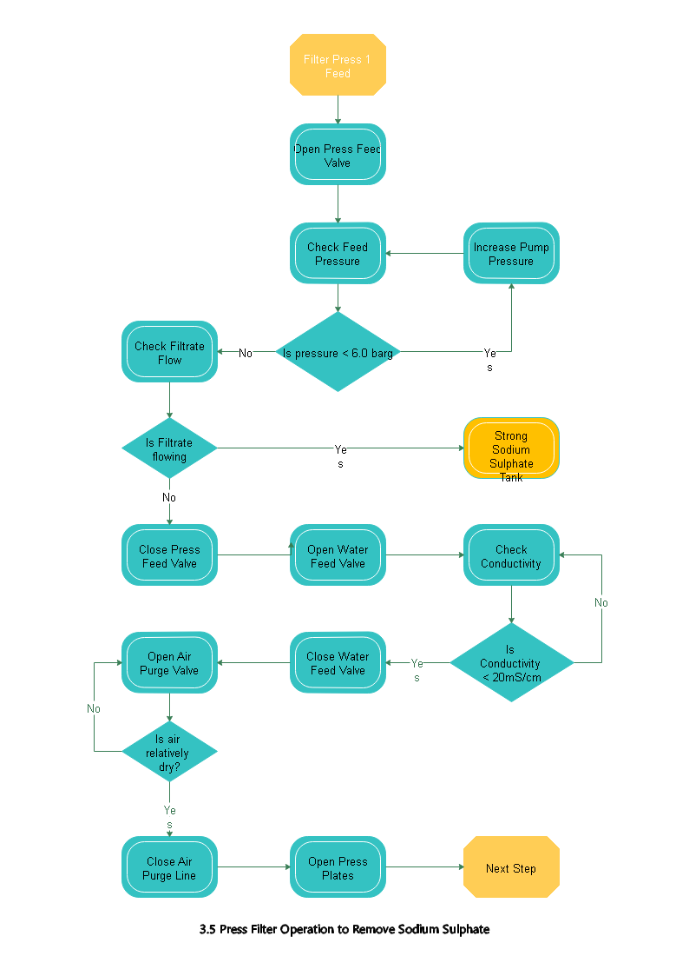
Health & Safety
The de-watering process is covered by the Halo Battery Recycling Health and Safety Policy which includes:
- Risk Assessments
- STOP Assessments
- PPE
- Occupational Health Requirements including HSWA, MHSWA, PUWER, LOLER
The full detailed standard operating procedures including the responsibility for each aspect of the de-watering process are enclosed within the appendices of this report.

3.6 Dissolution of Lead Compounds in Acetic Acid

The standard operating procedures for the Dissolution Process for NUOVOPb include procedures covering the following aspects:
Materials Processed/Storage
- Material processed will only be a fully processed feed slurry consisting of Lead Oxides in water to which Acetic Acid of known strength will be added.
- All slurries will be contained in Stainless Steel tanks and pressure tested pipework.
Environmental/Operating Control Systems
- A solution of Acetic Acid will be added to an alkali slurry so will generate heat, thermal analysis will be carried out on a regular basis to monitor the system
- Regular housekeeping and interlock checks on the de-watering systems are carried out.
- Local exhaust ventilation is located within the process building for operators and for the capture of dusts and residues emitted from the mechanical processing of the batteries.
Emergency Operating Conditions
- Only trained and experienced operators are permitted to carry out the de-watering process.
- The system is not to be used if interlocks are not proven prior to the operations commencing
- Should the system be shutdown then the process stations must be electrically isolated from unauthorised use
- If the system fails, then operations will be suspended immediately
Environmental Monitoring
- The operation of the filter press generates two separate product streams, one solid and one liquid, each of which has the potential for accidental release into the plant. To negate this risk any potential accidental released are contained within a bunding system for this process.
- Any accidental spillages are treated in accordance with our Environmental Permit.
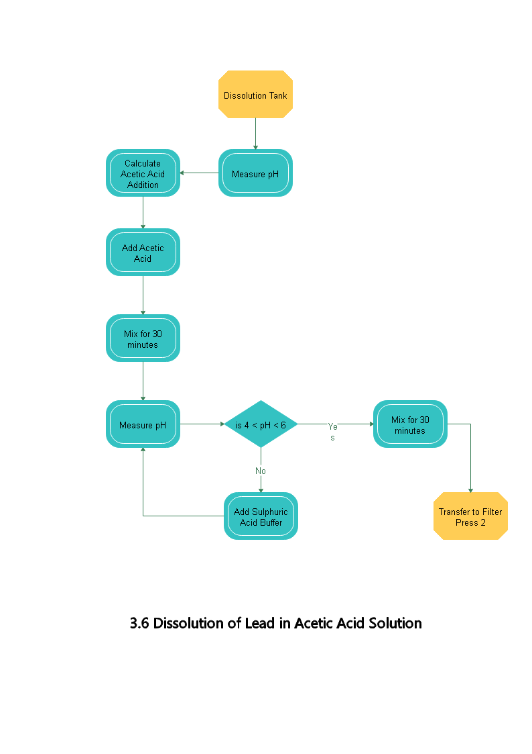

Health & Safety
The de-watering process is covered by the Halo Battery Recycling Health and Safety Policy which includes:
- Risk Assessments
- STOP Assessments
- PPE
- Occupational Health Requirements including HSWA, MHSWA, PUWER, LOLER
The full detailed standard operating procedures including the responsibility for each aspect of the de-watering process are enclosed within the appendices of this report.

3.7 Transfer of Slurry Based on Lead Acetate to Filter Press

The standard operating procedures for the Dissolution Process for NUOVOPb include procedures covering the following aspects:
Materials Processed/Storage
- Material processed will only be a fully processed slurry containing residues in an acid Lead Acetate solution of known strength.
- All slurries will be contained in Stainless Steel tanks and pressure tested pipework.
- Acid resistant pumps capable of 6bar pressure will be used to transfer the slurry.
Environmental/Operating Control Systems
- Regular housekeeping and interlock checks on the de-watering systems are carried out.
- Local exhaust ventilation is located within the process building for operators and for the capture of dusts and residues emitted from the mechanical processing of the batteries.
Emergency Operating Conditions
- Only trained and experienced operators are permitted to carry out the de-watering process.
- The system is not to be used if interlocks are not proven prior to the operations commencing
- Should the system be shutdown then the process stations must be electrically isolated from unauthorised use
- If the system fails, then operations will be suspended immediately
Environmental Monitoring
- The operation of the filter press generates two separate product streams, one solid and one liquid, each of which has the potential for accidental release into the plant. To negate this risk any potential accidental released are contained within a bunding system for this process.
- Any accidental spillages are treated in accordance with our Environmental Permit.

3.8 Filter Process Operation to Liberate Lead Acetate Solution
The standard operating procedures for the filter process operation for NUOVOPb include procedures covering the following aspects:
Material Processed/Storage
- The material to be processed will either be a full processed feed slurry consisting of residues in a solution of Lead Acetate.
- Material awaiting processing is stored in stainless-steel mixing tanks
Environmental/Operational Control Systems
- Regular housekeeping and interlock checks on system are carried out
- Filter cloths should be washed in situ to prolong useful filtering performance
- Damaged cloths, valves and plates should be changed immediately due to the high pressures in the system.
- Local exhaust ventilation is placed within the warehouse building for operators and for capture of dusts/residues emitted from the mechanical processing of the batteries
Emergency Operating Conditions
- Only trained and experienced operators are permitted on the filtering process.
- The system is not to be used if interlocks are not proven prior to the operations commencing
- Should the system be shutdown then the process stations must be pneumatically and electrically isolated from unauthorised use
- If the system fails, then operations will be suspended immediately
Environmental Monitoring
- The operation of the filter press generates two separate product streams, one solid and one liquid each of which has the potential for accidental release into the plant. Any accidental releases in this process are contained in a bunding system for this process.
- Any accidental spillages are treated in accordance with our Environmental Permit.
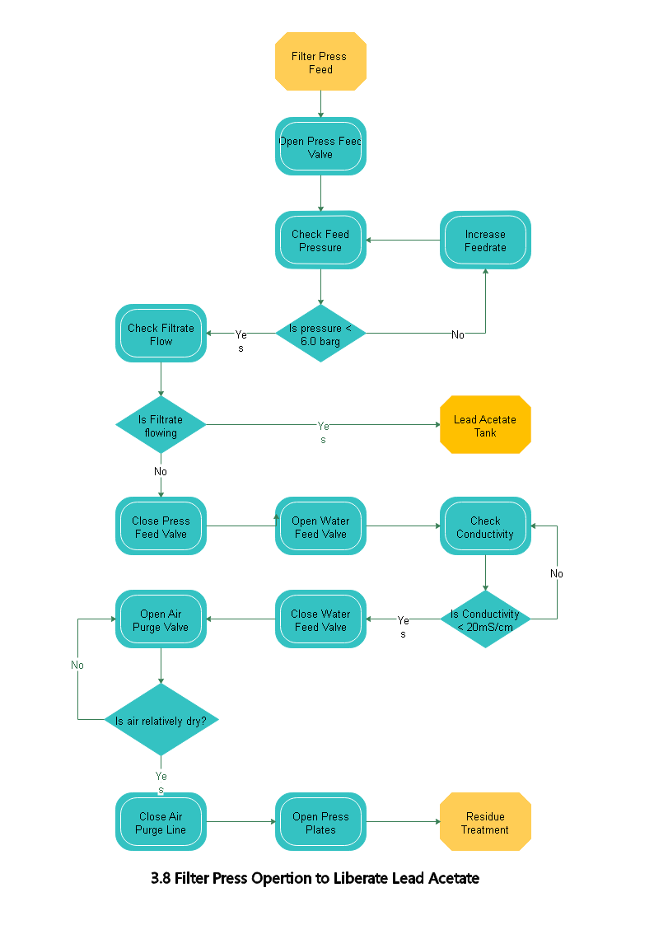
Health & Safety
The operation of the filter press is covered by the Halo Battery Recycling Health and Safety Policy which includes:
- Risk Assessments
- STOP Assessments
- PPE
- Occupational Health Requirements including HSWA, MHSWA, PUWER, LOLER
The full detailed standard operating procedures including the responsibility for each aspect of operation of the filter press are enclosed within the appendices of this report.

3.9 Handling of the Residue Filter Cake
The standard operating procedures for the handling of the filter cake for NUOVOPb include procedures covering the following aspects:
Material Processed/Storage
- The material processed will only be cake consisting of residue in a dilute Lead Acetate solution which has been washed with clean water.
Environmental/Operational Control Systems
- Regular housekeeping and interlock checks on system are carried out
- Local exhaust ventilation is placed within the warehouse building for operators and for capture of dusts/residues emitted from the mechanical processing of the batteries
Emergency Operating Conditions
- Only trained and experienced operators are permitted on the filtering process.
- The system is not to be used if interlocks are not proven prior to the operations commencing
- Should the system be shutdown then the process stations must be pneumatically and electrically isolated from unauthorised use
- If the system fails, then operations will be suspended immediately
Environmental Monitoring
- The transportation of the cake from the Filter Press generates potential for accidental release into the plant. Any accidental releases in this process are contained in a bunding system for this process.
- Any accidental spillages are treated in accordance with our Environmental Permit.
Health & Safety
The handling of the filter cake is covered by the Halo Battery Recycling Health and Safety Policy which includes:
- Risk Assessments
- STOP Assessments
- PPE
- Occupational Health Requirements including HSWA, MHSWA, PUWER, LOLER
The full detailed standard operating procedures including the responsibility for each aspect of the handling of the filter cake are enclosed within the appendices of this report.

3.10 Addition of Citric Acid to Lead Acetate Solution

The standard operating procedures for the handling of the filter cake for NUOVOPb include procedures covering the following aspects:
Material Processed/Storage
- The material processed will only be solutions of dilute Lead Acetate and concentrated Citric Acid.
Environmental/Operational Control Systems
- Regular housekeeping and interlock checks on system are carried out
- Local exhaust ventilation is placed within the warehouse building for operators and for capture of dusts/residues emitted from the mechanical processing of the batteries
Emergency Operating Conditions
- Only trained and experienced operators are permitted on the filtering process.
- The system is not to be used if interlocks are not proven prior to the operations commencing
- Should the system be shutdown then the process stations must be pneumatically and electrically isolated from unauthorised use
- If the system fails, then operations will be suspended immediately
Environmental Monitoring
- The transportation of the cake from the Filter Press generates potential for accidental release into the plant. Any accidental releases in this process are contained in a bunding system for this process.
- Any accidental spillages are treated in accordance with our Environmental Permit.
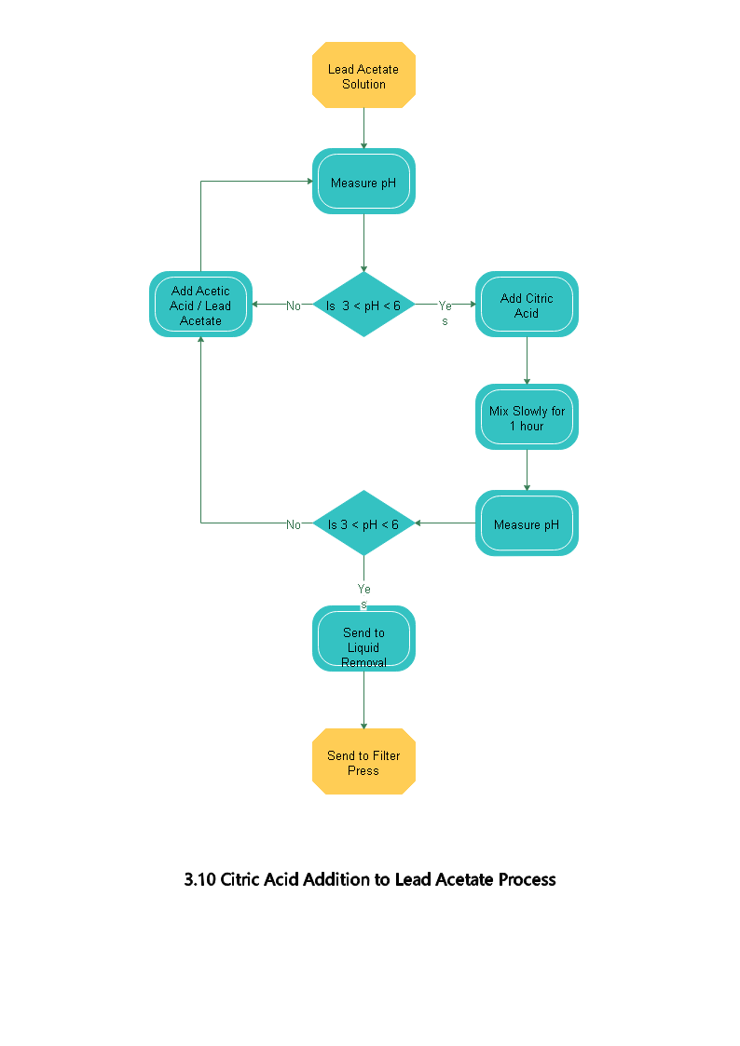
Health & Safety
The handling of the filter cake is covered by the Halo Battery Recycling Health and Safety Policy which includes:
- Risk Assessments
- STOP Assessments
- PPE
- Occupational Health Requirements including HSWA, MHSWA, PUWER, LOLER
The full detailed standard operating procedures including the responsibility for each aspect of the handling of the filter cake are enclosed within the appendices of this report.

3.11 Filter Press Operation to Collect Tri Lead Citrate
The standard operating procedures for the washing of lead citrate for NUOVOPb include procedures covering the following aspects:
Material Processed/Storage
- Material processed will only be a fully processed feed slurry consisting of Tri Lead Citrate in a solution of dilute Acetic Acid.
- Material awaiting processing in stored in stainless steel mixing tanks
Environmental/Operating Control Systems
- Regular housekeeping and interlock checks on the system are carried out
- All filter press feed/discharge pipework and filter press plates are washed between single operations and the water sent for treatment.
- All pipework and process equipment is pressure tested on a regular basis
- Local exhaust ventilation is placed within the warehouse building for operators and for capture of dusts/residues emitted from the mechanical process.
Emergency Operating Conditions
- Only trained and experienced operators are permitted to carry out the washing process.
- The system is not to be used if interlocks are not proven prior to the operations commencing
- Should the system be shutdown then the process stations must be electrically isolated from unauthorised use
- If the system fails, then operations will be suspended immediately
Environmental Monitoring
- The operation of the multi-stage washing process generates two separate product streams, one slurry with suspended solids and one liquid, each of which has the potential for accidental release into the plant. To negate this risk any potential accidental released are contained within a bunding system for this process.
- Any accidental spillages are treated in accordance with our Environmental Permit.
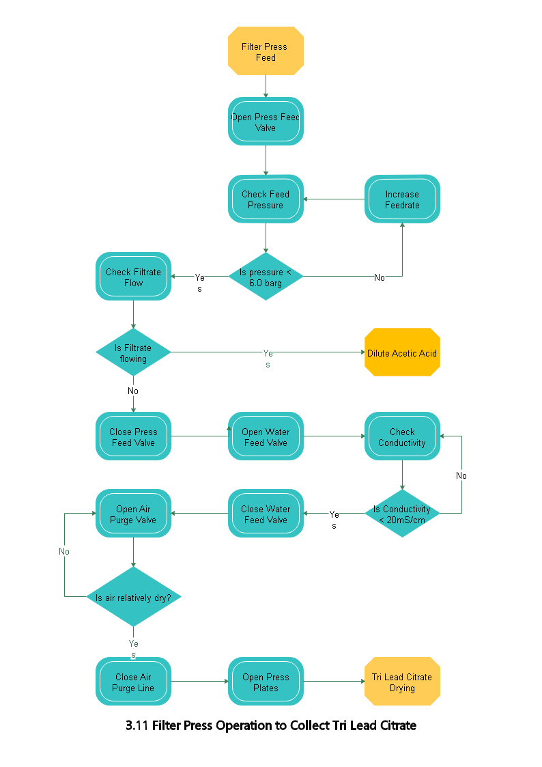
Health & Safety
The washing of lead citrate process is covered by the Halo Battery Recycling Health and Safety Policy which includes:
- Risk Assessments
- STOP Assessments
- PPE
- Occupational Health Requirements including HSWA, MHSWA, PUWER, LOLER
The full detailed standard operating procedures including the responsibility for each aspect of the lead citrate washing process are enclosed within the appendices of this report.

3.12 Transferring Tri-Lead Citrate to Dryer
The standard operating procedures for the transferring of the tri-lead citrate for NUOVOPb include procedures covering the following aspects:
Material Processed/Storage
- Material processed will only be a fully processed, dewatered cake consisting of Tri Lead Citrate in a very dilute solution of Acetic Acid.
- Material awaiting processing is transferred using slow conveyor systems
Environmental/Operational Control Systems
- Regular housekeeping and interlock checks on system are carried out
- Local exhaust ventilation is placed within the warehouse building for operators and for capture of dusts/residues emitted from the mechanical processing of the batteries
Emergency Operating Conditions
- Only trained and experienced operators are permitted on the transfer process.
- The system is not to be used if interlocks are not proven prior to the operations commencing
- Should the system be shutdown then the process equipment must be pneumatically and electrically isolated from unauthorised use
- If the system fails, then operations will be suspended immediately
Environmental Monitoring
- The operation of the transfer pump requires a single process stream which has the potential for accidental release into the plant. Any accidental releases in this process are contained in a bunding system for this process.
- Any accidental spillages are treated in accordance with our Environmental Permit.
Health & Safety
The transfer of the lead citrate process is covered by the Halo Battery Recycling Health and Safety Policy which includes:
- Risk Assessments
- STOP Assessments
- PPE
- Occupational Health Requirements including HSWA, MHSWA, PUWER, LOLER
The full detailed standard operating procedures including the responsibility for each aspect of the transfer of lead citrate process are enclosed within the appendices of this report.

3.13 Operation of the Dryer
The standard operating procedures for the operation of the dryer for NUOVOPb include procedures covering the following aspects:
Materials Processed/Storage
- The material to be processed will only be a fully processed feed cake consisting of Lead Citrate with a moisture content less than 15%, the solution being a minimal percentage of Acetic Acid.
- Material awaiting processing in stored in suitable stillages
Environmental/Operational Control Systems
- Regular housekeeping and interlock checks on system are carried out
- Local exhaust ventilation is placed within the warehouse building for operators and for capture of dusts/residues emitted from the mechanical processing of the batteries
Emergency Operating Conditions
- Only trained and experienced operators are permitted on the filtering process.
- The system is not to be used if interlocks are not proven prior to the operations commencing
- Should the system be shutdown then the process stations must be electrically isolated from unauthorised use
- If the system fails, then operations will be suspended immediately
Environmental Monitoring
- The transportation of the cake from the Filter Press generates potential for accidental release into the plant. Any accidental releases in this process are contained in a bunding system for this process.
Waste Management
- Any accidental spillages are treated in accordance with our Environmental Permit.
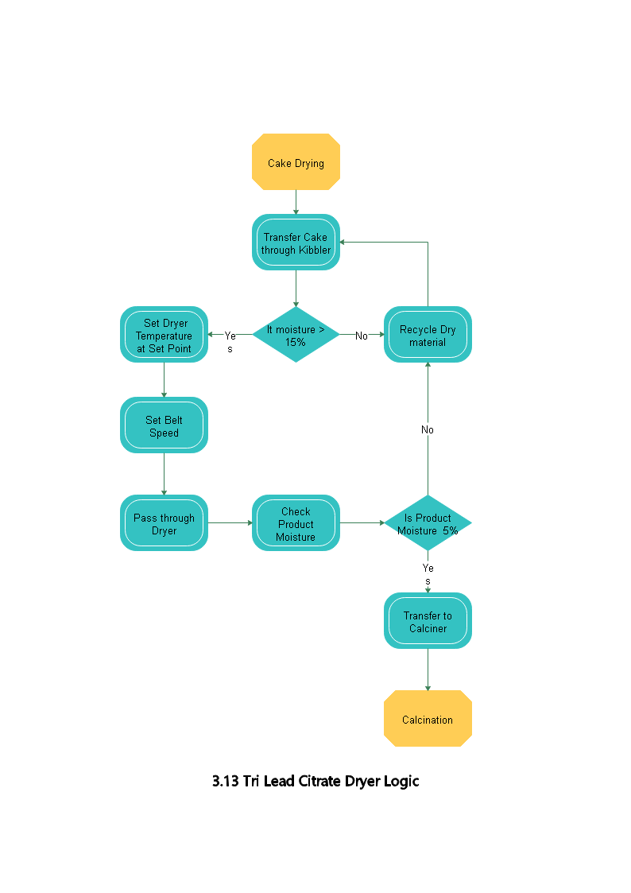
Health & Safety
The operation of the dryer is covered by the Halo Battery Recycling Health and Safety Policy which includes:
- Risk Assessments
- STOP Assessments
- PPE
- Occupational Health Requirements including HSWA, MHSWA, PUWER, LOLER
The full detailed standard operating procedures including the responsibility for each aspect of the operation of the dryer are enclosed within the appendices of this report.

3.14 Handling of Dried Tri-Lead Citrate
The standard operating procedures for the handling of the dried tri-lead citrate for NUOVOPb include procedures covering the following aspects:
Material Processed/Storage
- The material to be processed will only be a fully processed dried product consisting of Tri-Lead Citrate with a moisture content of less than 5%
Operating Procedure
- Material is manually handled from the cooling section of the dryer into intermediate storage
Environmental/Operational Control Systems
- Regular housekeeping and interlock checks on system are carried out
- Local exhaust ventilation is placed within the warehouse building for operators and for capture of dusts/residues emitted from the mechanical processing of the batteries
Emergency Operating Conditions
- Only trained and experienced operators are permitted to handle the dried tri-lead citrate
- The system is not to be used if interlocks are not proven prior to the operations commencing
- Should the system be shutdown then the process stations must be electrically isolated from unauthorised use
- If the system fails, then operations will be suspended immediately
Environmental Monitoring
- The transportation of the cake from the Dryer generates potential for accidental release into the plant. Any accidental releases in this process are contained in a bunding system for this process.
- Any accidental release of dust or gases need to be contained by local extraction systems
- Any accidental spillages are treated in accordance with our Environmental Permit.
Health & Safety
The handling of the dried tri-lead citrate is covered by the Halo Battery Recycling Health and Safety Policy which includes:
- Risk Assessments
- STOP Assessments
- PPE
- Occupational Health Requirements including HSWA, MHSWA, PUWER, LOLER
The full detailed standard operating procedures including the responsibility for each aspect of the handling of the dried tri-lead citrate are enclosed within the appendices of this report.

13.5 Transport of Tri-Lead Citrate to Calciner

The standard operating procedures for the transportation of the tri-lead citrate to the calciner NUOVOPb include procedures covering the following aspects of the process:
Materials Processed/Storage
- Material to be processed will only be a fully processed dried feed consisting primarily of Tri-Lead Citrate with a maximum moisture content of 5%
- Material awaiting processing is stored in appropriate stillages
Operating Procedure
- Material is manually handled into the feed aperture of the calcining unit
- The calcining unit is maintained at +350$°$C in a carbon dioxide-controlled atmosphere.
Environmental/Operational Control Systems
- Regular housekeeping and interlock checks on system are carried out
- Local exhaust ventilation is placed within the warehouse building for operators and for capture of dusts/residues emitted from the mechanical processing of the batteries
Emergency Operating Conditions
- Only trained and experienced operators are permitted to operate the calcining process
- The system is not to be used if interlocks are not proven prior to the operations commencing
- Should the system be shutdown then the process stations must be electrically isolated from unauthorised use
- If the system fails, then operations will be suspended immediately
Environmental Monitoring/Waste Management
- The transportation of the cake to the calciner and the operation of the calciner generates the potential for accidental release into the plant. Any accidental releases in this process are contained in a bunding system for this process.
- Any dust generation is removed using a local extraction system
- Any accidental spillages are treated in accordance with our Environmental Permit.
Health & Safety
The transportation of the tri-lead citrate to the calciner is covered by the Halo Battery Recycling Health and Safety Policy which includes:
- Risk Assessments
- STOP Assessments
- PPE
- Occupational Health Requirements including HSWA, MHSWA, PUWER, LOLER
The full detailed standard operating procedures including the responsibility for each aspect of the transportation of the tri-lead citrate to the calciner are enclosed within the appendices of this report.

13.6 Operation of the Calciner
The standard operating procedures for the operation of the calciner for NUOVOPb include procedures covering the following aspects of the process:
Materials Processed/Storage
- The material processed will only be a fully processed dried feed consisting primarily of Tri-Lead Citrate with a maximum of moisture content of 5%.
- Material awaiting processing is stored in appropriate stillages
Operating Procedure
- The material is manually handled into the feed aperture of the calcining unit
- The calcining unit is maintained at +350°C in a carbon dioxide controlled atmosphere.
Environmental/Operational Control Systems
- Regular housekeeping and interlock checks on system are carried out
- Local exhaust ventilation is placed within the warehouse building for operators and for capture of dusts/residues emitted from the mechanical processing of the batteries
Emergency Operating Conditions
- Only trained and experienced operators are permitted to operate the calcining process
- The system is not to be used if interlocks are not proven prior to the operations commencing
- Should the system be shutdown then the process stations must be electrically isolated from unauthorised use
- If the system fails, then operations will be suspended immediately
Environmental Monitoring/Waste Management
- The operation of the calciner generates the potential for accidental release into the plant. Any accidental releases in this process are contained in a bunding system for this process.
- Any dust generation is removed using a local extraction system
- Any accidental spillages are treated in accordance with our Environmental Permit.
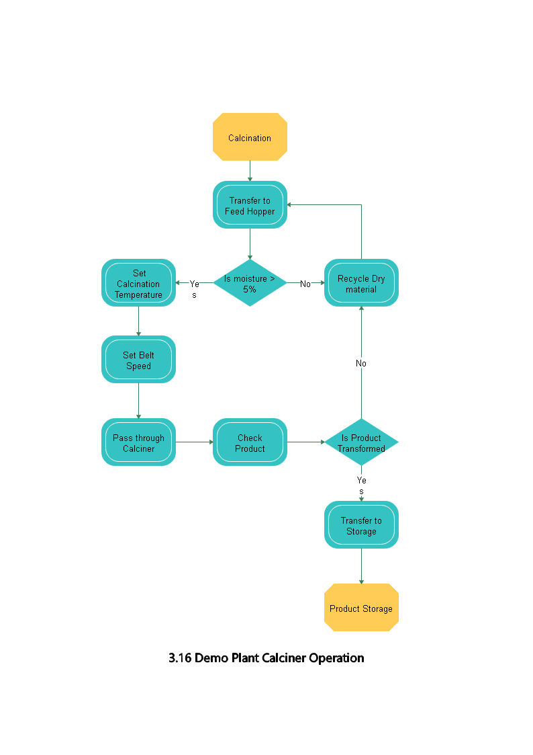
Health & Safety
The operation of the calciner is covered by the Halo Battery Recycling Health and Safety Policy which includes:
- Risk Assessments
- STOP Assessments
- PPE
- Occupational Health Requirements including HSWA, MHSWA, PUWER, LOLER
The full detailed standard operating procedures including the responsibility for each aspect of the operation of the calciner are enclosed within the appendices of this report.

3.17 Handling of Final Calcined Product
The standard operating procedures for the handling of the final calcined product for NUOVOPb include procedures covering the following aspects of the process:
Materials Processed/Storage
- The material stored in the final calcined product will only be a fully tested material consisting of primarily Lead Oxide.
- The material is stored in appropriate packaging on shelves which have been weight tested
Operating Procedure
- The material must be handled with following Hazard Warnings: Signal Word (DANGER) & with the relevant hazard warning as listed within the full standard operating procedures for the handling of the final calcined product.
Environmental/Operational Control Systems
- Regular housekeeping and checks on storage racks are carried out.
- Local exhaust ventilation is placed within the warehouse building for operators and for capture of dusts/residues emitted from the mechanical processing of the batteries
Emergency Operating Conditions
- Only trained and experienced operators are permitted to handle the final calcine product
Environmental Monitoring/Waste Management
- The storage of the final calcined product generates the potential for accidental release into the environment. Any accidental releases in the storage area must be treated immediately are per the environmental permit.
- All spillages to be treated as per the Environmental Permit
- Disposal of non-conforming product if required, is by sale to specialist re-treatment facilities. Lead-based material will be sold as per existing smelter contracts and all other materials would be sold as per existing waste contracts with companies such as Veolia or Biffa.
Health & Safety
The handling of the final calcined product is covered by the Halo Battery Recycling Health and Safety Policy which includes:
- Risk Assessments
- STOP Assessments
- PPE
- Occupational Health Requirements including HSWA, MHSWA, PUWER, LOLER
The full detailed standard operating procedures including the responsibility for each aspect of handling of the final calcined product are enclosed within the appendices of this report.

3.18 Storage of Final Calcined Product
The standard operating procedures for the storage of the final calcined product for NUOVOPb include procedures covering the following aspects of the process:
Materials Processed/Storage
- The material stored in the final calcined product area will only be a fully tested material consisting of primarily Lead Oxide.
- Material is stored in appropriate packaging on shelves which have been weight tested.
Environmental/Operational Control Systems
- Regular housekeeping and checks on storage racks are carried out.
- Local exhaust ventilation is placed within the warehouse building for operators and for capture of dusts/residues emitted from the mechanical processing of the batteries
Environmental Monitoring/Waste Management
The storage of the final calcined product generates potential for accidental release into the environment. Any accidental releases in the storage area must be treated immediately as per the environmental permit.
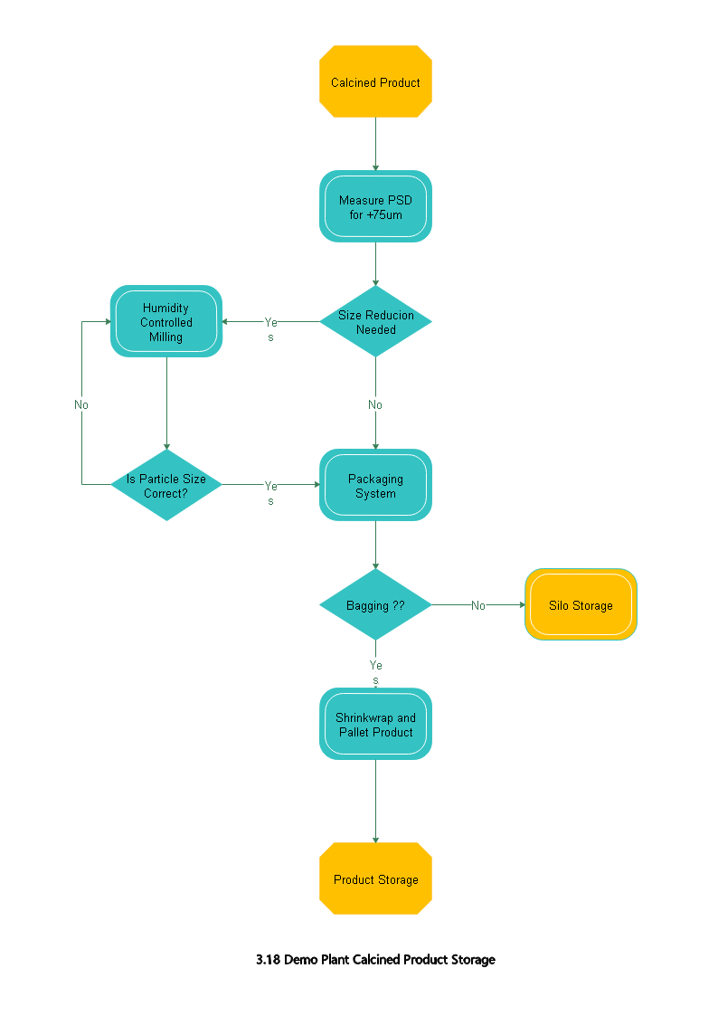
Health & Safety
The storage of the final calcined product is covered by the Halo Battery Recycling Health and Safety Policy which includes:
- Risk Assessments
- STOP Assessments
- PPE
- Occupational Health Requirements including HSWA, MHSWA, PUWER, LOLER
The full detailed standard operating procedures including the responsibility for each aspect of the storage of the final calcined product are enclosed within the appendices of this report.

3.19 Disposal of Sodium Sulphate Solution

3.20 Disposal of Unwanted Solid Residues

3.21 Recycling of Acetic Acid Solution

4. Additional Operating Procedures
In addition to the standard operating procedures for each of the processes that will be carried out during NUOVOPb, following a detailed COSHH Assessment carried out Halo Battery Recycling created corporate operating procedures required for Lead Acid Battery Businesses.
The creation of the following procedures ensures that Halo Battery Recycling complies with national legislation for Health & Safety:

4.1 Control of Lead Guidelines
The procedures detail the following actions/guidelines which are to be adhered to by employees to ensure their health is protected, should areas become contaminated:
- The location where protective clothing is to be put on/removed
- Where/when employees should wash to remove lead contamination
- Cleaning procedures for areas such as the canteen
A review and signature of acceptance of the control of lead guidelines, is required by Halo Battery Recycling from every employee.
The full document is enclosed within the appendices of this report.

4.2 Blood Lead Management Procedures

In addition to the creation of the control of lead guidelines, Halo Battery Recycling have also created procedures for employees covering the limitation of lead within their blood levels as detailed below:
- Halo Battery Recycling will sample prospective employees lead blood levels. Employees who have an unacceptably high blood lead level will not be employed.
- All new employees will be given sufficient information, instruction and training by their line manager in relation to the handling of lead
- Periodic medical assessments are carried out on employees by a contracted medical advisor. Should the results of the medical assessments indicate that an employee’s blood level assessments are higher than permitted, the employee will be offered counselling.
- Should the medical assessments indicate that an employee’s blood level assessments dangerously higher than permitted, then the employee will be suspended from overtime or from work completely
The full document is enclosed within the appendices of this report.

4.3 LAB Awareness Guidelines/Procedure
Halo Battery Recycling have created guidelines to ensure that all employees are aware of the potential dangers that working with lead acid batteries can pose. Employees will be made aware of the following aspects:
- Handling of LABs is not hazardous provided that the appropriate facilities are available.
- Handling of LABs is not hazardous provided that the operatives have been thoroughly instructed and are adequately supervised and take reasonable care.
In addition to the above aspects it is expected and is the responsibility of an employee to pass on relevant information for the handling of LABs to other employees or third parties (i.e contractors) working directly on the batteries or in areas where the batteries are stored.
The full document is enclosed within the appendices of this report.

5. Conclusions
To complete this deliverable Halo Battery Recycling have reviewed and developed the standard corporate operating procedures for each of the stages form the overall NUOVOPb process from the initial stage of battery breaking and stream separation through to the final stages of the handling and storage of the final product. Each of these procedures cover the health & safety aspects for the specific procedure in addition to detailing further relevant aspects such as environmental and operational control, emergency operating conditions, process and material details, plant design and equipment and waste management.
In addition to the development of the standard procedures for each stage of the NUOVOPb process, Halo Battery Recycling have also developed further standard corporate procedures covering the control of lead guidelines, blood lead management procedures.
Halo Battery Recycling intend to continuously update the developed procedures both as the project progresses and in line with any changes that may occur within the regulatory landscape of battery processing, thereby ensuring that Halo Battery Recycling continue to be fully compliant with the legislation in this sector.
Following the work which has been completed within this report, D1.2 is considered to have been completed.

Appendix 1 – Control of Lead Guidelines

Welfare/Canteen Rules and Guidance

General Rules
- All operational staff are required to shower at the end of the working day
- Access from car park entrance is only permitted when wearing normal clothing, i.e. clean clothing and footwear
- Use of access door into/from warehouse from the canteen lobby area is only ever permitted in an emergency
- No dirty footwear/soiled clothes are permitted in the Canteen area, Clean change area or Shower/wash room areas, i.e. only permitted in dirty area
- Overshoe covers must be worn over work shoes if no clean footwear available in any area other than the dirty change area
- No used masks, soiled Hi-Vis or used gloves shall go beyond the dirty change area
- Ensure overshoes are thrown into bins after use along with any other PPE that is not to be re-used
- Ensure all rubbish is deposited to Bins immediately
- Clean away your own cutlery and crockery and wipe down surfaces after use on canteen tables or kitchen surfaces

Start of Day procedure
- Enter welfare/canteen via Car park entrance
- Disable alarm if set using your alarm fob
- Proceed to Clean change area and adorn clean work clothes
- Walk through shower/washroom area to dirty change
- At dirty change area put on workshoes and/or additional over garments (i.e. coats, Hi-Vis etc…)
- Proceed to vehicles or Site for work to commence only leaving via the dirty entrance

Breaks / Comfort breaks procedure
- Enter welfare facility via dirty change area
- Remove work boots/shoes and put on clean footwear or wear overshoe protectors over workboots
- Remove soiled clothing
- Walk through to washroom area
- Clean face and hands
- Use toilets or canteen as necessary
- Proceed back through clean change area and/or washroom area and return to dirty area
- Put soiled clothing back on and remove overshoes (if worn) and deposit in bin
- Put workshoes back on if in clean footwear
- Return to work via the dirty change area

End of Day procedure
- Enter welfare facility via dirty change area
- Remove work boots/shoes and put on clean footwear or walk through to shower/wash room in bare feet
- Remove all soiled clothing
- Walk through to clean area and/or shower area (depending as to whether you have to collect towels or toiletries from clean area)
- Shower and clean yourself thoroughly (including wash/rinse of hair)
- Dry yourself down and proceed to clean change area
- Adorn all necessary clean clothing and footwear
- Leave site through exit door directly onto car park

Cleaning Regime

- Visitors area to be mopped / damp wiped. DAILY
- Canteen Floor to mopped TWICE DAILY
- Canteen Surfaces/ Tables / Chairs TWICE DAILY
- Medical Room Clean (& run taps) Lock afterwards WEEKLY
- Male & Female Clean Change Area, to include lockers front and top,removal of mats, all floor space mopped. Benches wiped down DAILY
- Male & Female Dirty Change Area, to include lockers front and top, l removal of mats, all floor space mopped. Benches wiped down DAILY
- Male & Female Shower / Toilets, to include all surfaces, mirrors, edging plates, etc... / removal of mats, all floor space mopped. DAILY
- All towels to be changed & soap dispenser top up DAILY
- Weighbridge Office, floor mopped DAILY
- Weighbridge office surfaces, damp / wet wiped DAILY (added November, 2015)
- General Offices (2 Floors) including stairway, includes desks, surfaces, floors (Vacuumed or mopped) toilets kitchens. Replacement towels, toilet paper and saops DAILY
- Removal of debris and replacing bin liners DAILY
- Hard to reach areas and intense cleaning (TBA). AS REQUIRED

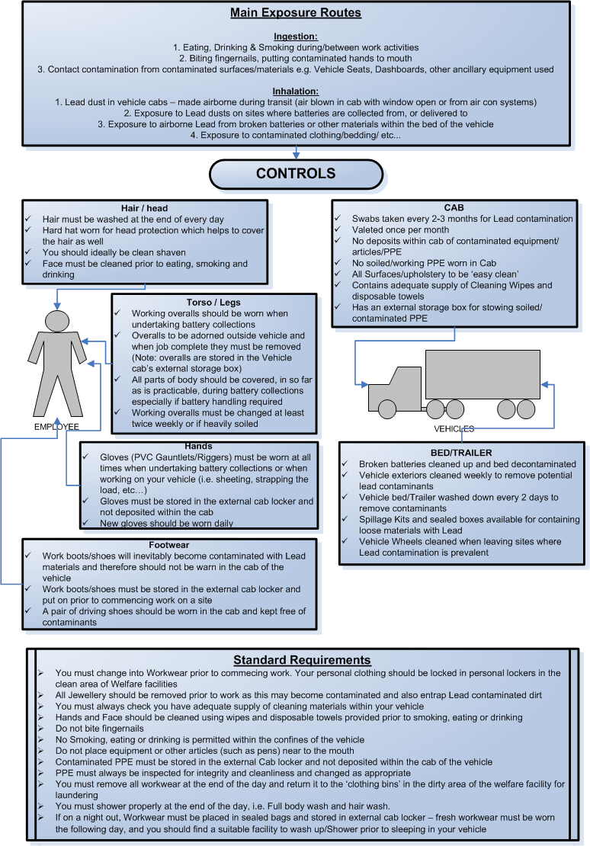
Vehicle Cleanliness

General Provisions
- Drivers will clean vehicle Cab Daily using a damp/wet (disposable) cloth and a surfactant/degreaser spray solution to dampen surfaces prior to cleaning
- Areas wiped daily are:
  - Dashboard
  - Steering wheel
  - Gear stick and centre console
  - Door interiors and handles
  - Storage wells
- Footwells of Vehicle Cabs shall be cleaned daily or as minimum requirement every other day using hand-held or portable vacuum with HEPA filters. After dry cleaning using vacuum cleaner the footwell should be wiped clean using disposable cloth and wet spray system
- Footwell mats are removed every 2 days and cleaned using Jet wash, and/or sponge with soap/water
- Cab bed covers shall be removed and disposed after use, and replaced after use
- Cab curtains and upholstery should be vacuumed every 2 days along with the footwell, ensuring that vacuum nozzles are cleaned prior to cleaning any upholstery (to remove any soiling contamination from other cleaning activities)
- Vehicle Goods area (vehicle bed) shall be cleaned down at least once per week using Jet wash/hose and brush system – P3 dust masks must be worn when cleaning vehicle bed
- Washable fabrics such as curtains within the Cab shall be cleaned every month with Corporate Workwear

All cleaning materials are disposable and must be disposed of in sealed plastic bags after use

Contract Valeting Requirements

- External surfaces of Vehicle are cleaned every week using a Truck-wash solution and Jet wash (Cab, curtains, wheels and rear doors)
- Internal Valeting is carried out quarterly for all vehicle types
- Internal Valeting is carried out every month for ‘High risk’ vehicles of Lead and other Lead bearing products (i.e. Dross, Lead products, etc…)

- Internal Valeting takes approximately half a day and includes the following:
  - Removal of all Sundry items and equipment from Cab (by Driver)
  - Wet cleaning of all upholstered seating and bedding areas
  - Wet cleaning of other materials in cab including curtains, etc…
  - Wet cleaning of all internal surfaces including visors, sun roof area, roof of cab, consoles, footwells and rubber mats, dashboard, Storage wells, Glove box, Door interiors and Windows
  - Thorough cleaning of surfaces under Beds, Seats and other inaccessible areas are also to be undertaken by Valeter
  - Testing of all Sundry items/equipment removed prior to being put back into the Cab (by Driver and QHSE appointed Supervisor)
  - Management & Driver inspection of Valeting post-Valet service (includes Lead swabs)

Important Notice for all Vehicle Valeting/maintenance of hygiene

- All vehicle interiors are designed to have wipeable and non absorbent surfaces except for Bedding and Seating which are upholstered (but have disposable or washable covers)
- Any degradation to plastics, rubber coatings or surfaces or other protective covers (i.e. mats, plastic covers, handles, etc…) should be reported and replaced or repaired immediately
- There should be no rough or absorbent surfaces within the Vehicle

Driver Directive for Control of Lead at Work

Please be advised of the following procedure for handling Lead acid Batteries, to include ALL drivers

- PPE should be worn at all times to include – Safety Shoes, Gloves, Coveralls, Dust masks, Hi-viz vest, safety goggles when on sites.

- All PPE must be inspected to ensure they are fit for use, Dust masks – Clean, Coverall – not ripped or dirty, Gloves - clean and not ripped. Replacements can be issued by Transport department.

- All PPE should (where applicable) should be stored in the vehicle side lockers. This is essential for Enersys runs, as these vehicles are equipped for such.

- No dirty footwear in cab - You should have a pair of clean footwear for driving and change into safety footwear to complete the task.

- No dirty overalls in cab - when undertaking work with Lead, you should wear coveralls (either disposable or reusable) and remove soiled clothing prior to getting back in cab. Disposable soiled coveralls to be disposed of and reusable ones to be kept in stowage area (external locker) outside of cab.

- Gloves should be worn at all times when doing any work outside the Cab

- Smoking should only be in designated areas on any site. This is not legally permitted within the cab, offenders may result in gross misconduct action being taken.

- Good personal hygiene is important to prevent inhaling/ingesting lead – thoroughly clean hands and face before eating. Eating and drinking should ideally also be managed away from the vehicle.

- You will ensure that your vehicle bed is cleaned down at least once a week – Site Operations can support this task. It is compulsory for Enersys work.

- Vehicle shall be regularly cleaned with a handheld or domestic HEPA filter Vacuum, and dust masks worn when vacuuming dust from cab or vehicle bed (sweeping should not be permitted due to risk of making Lead contaminated dusts airborne) – wet/damp cloths to be used when cleaning the cab, to ensure dust suppression when cleaning the cab.

- Tools and equipment such as rachet straps should be checked and cleaned when soiled, alternatively disposed of and replaced.

Any issues from any of the above must be raised with the relevant department as soon as practicably possible.

I sign to confirm acceptance and agree to implement these guidelines when doing the work on behalf of Halo Battery Recycling Limited and during their employment of services.

Print Name.............................................. Date................................................

Signature.............................................

Appendix 2 – LAB Awareness Procedure

Introduction
The handling and use of lead-acid batteries is not hazardous provided that appropriate facilities are available and operatives, having been instructed, are adequately supervised and take reasonable care.

The purpose of this document is;

    - To indicate the potential hazards that may arise.
    - To outline the precautions to be taken to minimise such hazards.
- To indicate the action to be taken in the event of an accident or emergency situation.

This information should be read in conjunction with the appropriate British Standard Code of Practice for the Safe Operation of Lead-acid Stationary Cells and Batteries.
In addition any further appropriate information from the manufacturing or supplier of the batteries should also be consulted.

This Health & Safety information has been drawn up in accordance with section 6 of the Health & Safety at Work Act 1974, as amended by the Consumer Protection Act 1987.

We remind you that it is your responsibility under section 2 (2) (b) and (c) of the Act to pass on this information to anyone who may work either on the batteries or in any area where they may be stored, be they your own personnel or any other third party.

The information has been considered sufficient to meet all reasonable requirements and should be comprehensive enough to enable you to fulfil your obligations regarding ‘assessments’ etc.. as required by the Control of Substances Hazardous to Health (amendment) regulations 2005.

Should you require further information on any Health & Safety matter please do not hesitate to contact us, and we will advise you accordingly.

Similarly please feel free to copy this information and distribute as you feel necessary.

Principal Contact: Steve Andrew

Position: CTO
Telephone:
Facsimile:
Email: steve@recyclusgroup.com

INDEX

- CHEMICAL COMPOSITION

- SULPHURIC ACID
Nature of the hazard
Occupational Exposure standards
Physical properties
Reactivity Data
Handling Precautions
First Aid/Treatment
Spillage
Disposal

- ELECTRICAL ENERGY
Nature of the hazard
Precautions
First Aid Action/Treatment

- GASEOUS EMISSIONS
Nature of the hazard
Precautions
First Aid Action/Treatment

- WEIGHT

- DAMAGED CELLS & BATTERIES

- DISPOSAL

- FIRE
Procedure

- GENERAL

- TRANSPORT INFORMATION

- BATTERY-ACID SAFETY DATA

1.0 Chemical Composition

Primary hazardous chemical: Sulphuric acid electrolyte.

Remaining composition: Lead and Lead Oxides inside the cell.
Either polypropylene, styrene acrylonitrile or acrylonitrile butadiene polystyrene cases.

2.0 Sulphuric Acid

Batteries contain sulphuric acid (dry charge or dry formed batteries prior to filling with acid excluded) which may leak for a number of reasons (spilled from the battery due to defects/degradation to the battery casing/spilled during handling if battery seals/lids are removed) and may be given off as droplets or as a fine mist during boost and float charging.

2.1 Nature of the Hazard

Battery acid is a poisonous, corrosive liquid, which will cause severe burns and irritation to the skin, eyes and could burn clothing.

2.2 Occupational Exposure Standard

Long term exposure limit (8-hour WEL) for sulphuric acid in air is 1 mg/m³

2.3 Physical Properties

Nature: Mineral acid
Appearance: Colourless, odourless liquid.
Solubility in water: Readily miscible.

2.4 Reactivity Data

Stability: Stable

Incompatibility (Materials and conditions to avoid)

Attacks most common metals liberating the flammable gas Hydrogen.

Will react with varying degrees of violence with many substances, e.g. Can cause acetonitrile to undergo a violent reaction. Can react vigorously, violently or explosively with organic nitro compounds, and with potassium permanganate, metal chlorides, carbides, cyanides, halogenates, perchlorates and alkali metals.

Avoid contact with bases (alkali).

2.5 Precautions in handling & use

    - Always handle batteries with care and keep upright.
    - Do not overfill batteries.
    - Always charge in a well ventilated area.
    - Always keep well away from children.
    - Always wear eye protection, protective clothing and rubber gloves when handling sulphuric acid or industrial batteries, to protect from splashes and contact with acid.

Recommended British Standard for protective equipment

i) Eye protection in the form of goggles or visors must comply with Specification B.S. 2092
ii) Protective clothing must comply with specification B.S. 6408 and consist of waterproof clothing made from coated fibres complying with specification B.S.3546.
iii) Industrial gloves must comply with specification B.S. 1651
Rubber gloves in accordance with specification B.S. 1651, appendix C.
iv) Boots and rubber footwear must comply with Specification B.S. 5145.
v) Hard hats must comply with specification B.S. 5240.

2.6 First Aid action/treatment

Skin Contact - Remove contaminated clothing immediately and drench the affected area thoroughly with copious amounts of clean water. Unless contact has been slight and particularly if soreness and irritation persist, seek medical attention.

Eye Contact - Speed of action is vital. Immediately irrigate with clean, cold water or eye solution for at least 10-15 minutes. If pain persists continue for a further period. Obtain immediate medical attention.

Ingestion - DO NOT induce vomiting, but make the patient drink copious amounts of plain water or milk. Obtain immediate medical attention.

2.7 Spillages

Precaution: Wear appropriate protective clothing when dealing with any spillages of acid.

Small spillage: If local conditions permit, either swill away with copious amounts of water or first spread soda ash or hydrated lime liberally over the spillage then mop up cautiously with plenty of water and run to waste storage/waste drainage, diluting greatly with water.

Large Spillage: Spillage should be ringed with neutralising agent (Hydrated lime/soda ash) and gradually soaked up with further neutralising agent, sand or earth. Liquids and solids should be transferred to salvage containers and any residues treated as small spillages.

2.8 Disposal

Suitable acid resistant labelled containers should be used for storage of the electrolyte, neutralised liquids or solids prior to disposal. Disposal must be in accordance with the appropriate statutory environmental legislation.

3.0 Electrical Energy

Electrical Energy can be supplied from both the batteries and the charging equipment in the form of direct current. Batteries are electrically alive at all times, even when discharged and cannot be isolated in the conventional sense. Isolation is only effective by insulating the terminal points on batteries.

3.1 Nature of the Hazard

Burns may occur from the heating effect on metal tools and conductive objects in contact with live battery terminals and conductors. In addition sparks and molten metal may be ejected and combustible materials ignited under short circuit or gross overload conditions.
It is also possible to receive severe electric shocks when the system is in excess of 100 volts, i.e. 50 cells or more connected in series.
When on charge Lead-acid batteries can generate hydrogen gas which is highly flammable and therefore charging of batteries must always be carried out in an exceptionally well ventilated area.

3.2 Precautions

    - Never handle batteries with wet hands or without hand protection.
    - Only use insulated tools when working on batteries.
    - Before working on a battery remove all metallic personal adornments from the hands and wrists, e.g. Rings and watches.
    - Before working on an individual cell or battery system, the battery must be completely isolated from the charger by removing battery fuses or removing terminations or links.
    - Do not place tools or conductive objects on top of batteries.
    - Before using a battery charger, consult the manufacturers’ literature.
    - Always switch off the charger before connecting or disconnecting a battery.
    - Remove terminal wires from batteries and/or ensure terminal wires are insulated as there is a risk of spontaneous combustion should terminal wires come into contact with each other.

3.3 First Aid action/Treatment

Burns - First wash the affected area with copious amounts of cold water then apply a dry sterile dressing and seek medical advice.

Electric shock - Immediate action is essential in cases of severe electric shock as the nerves controlling breathing and heart action may be affected.
If life is in danger DO NOT delay treatment by calling a Doctor, give immediate treatment yourself. When assistance is available or the casualty recovers, a Doctor or ambulance should be called.

    - Make sure it is safe to approach. If the casualty is not clear of the main conductor, break the contact by isolating the system. This is done by switching off the charger at the plug or wrenching the cable free, or by switching off the battery by removing the fuses or links. If this is not possible, or there is doubt that the system is electrically isolated, stand on dry insulating material and try to push or pull the casualty clear of the conductor, using similar insulating material as a lever. DO NOT touch the casualty with bare hands.
    - If necessary when the casualty is clear of the conductor, give artificial resuscitation.

4.0 Emission of Gases

Hydrogen and Oxygen may be emitted during boost/float charging and may be present at other times, particularly if a battery is moved or shaken.

4.1 Nature of the Hazard

An explosive atmosphere is created if the concentration of hydrogen in air exceeds 4% by volume. No explosion can occur without an ignition source.
It is recommended that the average hydrogen concentration within the battery room should not exceed 1% except in the immediate vicinity of the cell tops.

4.2 Precautions

    - Charge in a well ventilated area.
    - Avoid sources of ignition close to the batteries, in particular; NO SMOKING; NO NAKED FLAME
    - Avoid materials which are susceptible to discharge or static electricity.
    - Switch off current before making or breaking electrical connections.
    - Avoid sparks caused by accidental short circuits.

4.3 First Aid action/treatment

Explosion - Seek necessary medical attention and remember that sulphuric acid may have been ejected.

5.0 Weight

Industrial batteries are generally heavy, awkward units to handle and correct manual handling techniques and appropriate manpower/equipment should always be used.

6.0 Damaged Cells and Batteries

- Battery plates consist of lead and its compounds, but can only be exposed if a cell is broken open. The possibility of lead exposure under normal circumstances is negligible.
- As lead and its compounds are toxic by ingestion and inhalation of their dust, caution should be used in dealing with the unlikely event of a broken cell containing dry lead plates.
- Appropriate protective clothing should be worn when handling a damaged cell.
- To prevent ingestion of lead, strict personal hygiene practices should be observed.
- To prevent inhalation of dust, plate materials should be kept damp or in water or in a sealed, appropriately labelled container.
- Damaged cells should be stored, prior to disposal, in a labelled and acid resistant container.

7.0 Disposal

- Batteries, battery cases, electrolyte, lead and lead compounds must not be burned as they either are, or contain, materials which give off toxic fumes.
- Disposal should be in accordance with statutory Environmental and Safety & Health legislation.

8.0 Fire

Since batteries contain combustible materials, the local fire authority should be informed wherever a battery of high voltage is situated, i.e. 100 volts or 50 cells or more.

8.1 Fire fighting procedure

Treat with caution as batteries contain materials which evolve toxic fumes and combustible gases.

Deal with as an electrical fire using CO₂, BCF or dry powder extinguishers.

- General

If any repair or other work on batteries is contemplated, that may result in exposure to lead and its compounds, the appropriate safety documentation should be consulted.

10.0 Transport Information

United Nations:

UN No. 2794 (Batteries, wet, filled with acid, electric storage) or 2800 (Batteries, non spillable, electric sorage)
Classification: 8
Packaging: Group III

Basic Requirements:

- Batteries shall be stacked and adequately secured in tiers.
- Each tier shall be separated by a layer of non-conductive material AND each battery should be isolated to prevent short-circuits.
- Battery terminals shall not in any case support the weight of superimposed elements.
- Terminal Wires must be removed or protected with non-conductive materials to prevent accidental contact between wires and subsequent spontaneous fire due to short circuits
- Batteries shall be fastened with inert cushioning materials.
- Glass batteries should be packaged in single tiers per package.
- Battery packages shall be labelled as required by regulation 8 of the CDGCPL2 regulations

Prescriptive Methods for Packaging; As employed by G&P Batteries
- Due to the size of these batteries it is generally practicable to arrange the batteries in tiers within a package and to separate the tiers of batteries with insulated materials.

Example of how these batteries may be packaged is illustrated below:
Batteries may be packaged on pallets or in crates and then shrink-wrapped or secured with outer packaging – then labelled
Preferably, Batteries will be secured within an integral and sealed battery bank –then labelled
UN 2794
Batteries, wet, filled with acid
UN 2794
Batteries, wet, filled with acid
Cardboard packing
Container
Batteries placed upright
Batteries packed within packages shall be secured with an insulating material to fasten the batteries and additionally shall be placed between tiers of batteries
NB; Insulated packing material is only required if container is made of conductive materials OR batteries require packing to prevent movement during transit

Specific Considerations for Pb-acid batteries:

- Collection and transportation of spent Pb-acid batteries should be carried out under cover, in leak proof containers and in a manner to prevent compaction, mutilation, or any other physical abuse that would destroy their physical integrity.
- They should not be exposed to fires or high temperatures.
- Caution: Cells and batteries, which are not fully discharged may leak, vent or explode when subjected to short circuit or other forms of electrical abuse.

International Conventions:

Air: ICAO / IATA Regulations
Sea: IMDG Code
Land: ADR Agreement (Road)
RID Regulations (Rail)

EMERGENCY ACTIONS

Fire

Use Carbon dioxide or dry powder. Cool any containers exposed to fire by spraying them with water.

Spillage

Neutralise as soon as possible with soda ash (or lime), if local regulations permit, flush away to drain with copious amounts of water.

Otherwise absorb the spillage onto an inert material e.g. Sand, earth, or vermiculite. Neutralise the mixture with soda ash (or lime) and arrange for disposal by a registered waste carrier.
Caution: Neutralising large volume of acid with lime/soda ash will cause generation of carbon dioxide which may deplete oxygen levels in a confined area.

First Aid

Inhalation - remove from exposure.
Ensure there is a plentiful supply of fresh air.

Eyes - Irrigate with copious amounts of water or eye wash solution.

Skin - Drench affected area with water and, if necessary, remove contaminated clothing. Do not neutralise acid whilst in contact with skin.

Ingestion - Drink copious amounts of
Water followed by some milk of magnesia. DO NOT induce vomiting.

Follow Emergency action/obtain medical attention as soon as possible
Substance Name: BATTERY ACID

SYNONYM

Sulphuric acid solution (20 - 40 %)

CLASSIFICATION

Corrosive

OCCUPATIONAL EXPOSURE
STANDARD

1 mg m⁻³

UN No.

2794

PHYSICAL DESCRIPTION

Colourless liquid

HEALTH HAZARD

Contact with the body results in
the rapid destruction of soft
tissue, causing severe burns.
Repeated contact with dilute solutions
may cause dermatitis.

HANDLING PRECAUTIONS

Eyes: Goggles or face visor

Hands: Suitable acid resistant gloves

Body: Suitable acid resistant apron
and rubber boots

Appendix 3 – Blood Lead Management Procedure

- Scope

        - To comply with the requirements of the Halo Battery Recycling Health and Safety Management System, the following policy and procedures shall apply to Blood Lead.
        - The selection, maintenance and use of Personal Protective Equipment (PPE), including Respiratory Protective Equipment (RPE), shall be in accordance with the Personal Protective Equipment System (Health and Safety Procedure Number 005).
        - Although Blood Lead is recognised as the primary indicator of exposure, other factors may also need to be taken into account, in accordance with the Approved Code of Practice for the Control of Lead at Work Regulations 2002 (CLAW ACOP).
        - Test and maintenance of Local Exhaust Ventilation (LEV), central to the successful control of lead at work, are covered specifically in the Local Exhaust Ventilation Test and Maintenance System (Health and Safety Procedure Number 010).
        - Personal hygiene, and standards for washing, showering, changing and refreshment facilities are covered in the Health, Safety and Welfare (General) Standards.
        - The Control of Lead at Work Regulations 2002, and the Approved Code of Practice, applies.

- Responsibilities

3. It is the responsibility of the QHSE Adviser:
- To issue and maintain the Blood Lead Policy. Any changes will be agreed in advance with the Company Medical Adviser and Management.
- To set overall targets and to help Managers, on request, to set departmental targets.
- To help and advise Line Management and Technical Specialists with practical steps to control lead at source, maintain and improve control systems, ensure good housekeeping, effective personal hygiene and proper use of P.P.E. / R.P.E.

4. It is the responsibility of Midland Occuptaional Health Services (Contracted):
- To report on blood lead performance monthly, and otherwise as required, to management and Site Safety Committee.
- To issue regular updates (weekly if any change) of the Halo Battery Recycling Standard Overtime Suspension List, employee and contractor blood lead results, in accordance with the criteria set out in this procedure.
- To undertake such duties as are delegated by the Company Medical Adviser, in accordance with the CLAW ACOP.
- Blood lead monitoring is undertaken in accordance with this Blood Lead Policy.
- The programme is conducted in accordance with the requirements of the Employment Medical Advisory Service (EMAS) and the Approved Code of Practice for CLAW, including the requirements for medical surveillance, and the keeping and submission of records thereof.
- Analysis is undertaken by a competent laboratory (Trace Laboratories), and that the quality assurance of that laboratory is to a consistently high standard.
- Management are kept informed of blood lead performance.
- All employees are advised of their own blood lead results, and counselled as necessary, on lead work, personal hygiene and use of protective equipment.
5. It is the responsibility of every Manager and Supervisor to ensure that:
- Blood lead targets are set for, communicated to, and achieved by, their team.
- All employees reporting to them are advised of hazards and precautions, follow good personal hygiene and work practices, and are counselled as necessary.
- All process controls, LEV, housekeeping, personal hygiene, PPE and RPE are used and maintained to standard within their area of responsibility, and any substandard acts or conditions are corrected by prompt remedial action.
- It is the responsibility of each Halo Battery Recycling representative who wishes to bring a contractor on site to assess risks, ensure that the contractor employees are adequately briefed on control of lead at work, precautions, personal hygiene and protection, that they duly attend for blood sampling and are advised and counselled as necessary. The Contact must also ensure that the Occupational Health subcontractor (MOHS) is advised of each contractor employee who will be on site, and that arrangements are made for sampling, both initially and on an ongoing basis.
- It is the responsibility of every employee to make full and proper use of LEV, process controls, housekeeping, personal hygiene, PPE and RPE provided, and thus minimise the lead exposure of themselves and others who may be affected by what they do.
- It is the responsibility of every female employee who becomes pregnant to advise the reporting Director at the earliest opportunity, in accordance with the Management of Health and Safety at Work Regulations 1999. The company shall advise the Company Medical Adviser at the earliest opportunity. The pregnant employee shall be removed immediately from any work where exposure to lead is liable to be significant.

6. References and/or associated documents

- QHSE Management System, Health and Safety Manual.

- Personal Protective Equipment System (Health and Safety Procedure Number 011).

- Medical Surveillance (Health and Safety Procedure Number 012).

- LEV Test and Maintenance System (Health and Safety Procedure Number 010).

- Health, Safety and Welfare (General) Standards (Health and Safety Procedure 015).

- Halo Battery Recycling Pre - Employment Questionnaire Form.

- Halo Battery Recycling Employee Handbook

- Halo Battery Recycling Employee Blood Lead Consent Form.

- Halo Battery Recycling Contractor Blood Lead Consent Form.

- Halo Battery Recycling Occupational Health Contract.

- Halo Battery Recycling Blood Lead Report by Employee.

- Halo Battery Recycling Blood Lead Samples by Employee (Graph).

- Halo Battery Recycling Blood Lead Counselling Form.

- Control of Lead at Work Regulations 2002 (CLAW), and Approved Code of Practice (ACOP).

- Form FOD MS 98: Initial Medical Assessment.

- Form FOD MS 99: Surveillance record for person exposed to lead.

- Form FOD MS 102: Notification to employer of biological test results and record of medical surveillance.

- Form FOD MS 103: Certification of unfitness / fitness.

- Form EMSU BLOODLEAD 1 - Control of Lead at Work Regulations 2002: Annual return of persons under medical surveillance.

- HSE Leaflet "Lead and You".

- Management of Health and Safety at Work Regulations 1999.

- The Reporting of Injuries, Diseases and Dangerous Occurrences Regulations 1995.

- Form F2508A: Report of a case of disease.

- Objectives and Targets

  - The primary objective is to keep the lead exposure of every employee so low that there is no significant risk of adverse health effects, and below any level at which suspension from lead work on medical grounds might be considered.

  - Targets and action levels for blood lead go beyond the statutory requirements of CLAW, in order to allow a further margin of protection to employees and contractors.

  - "Exposed" workforce average blood lead year end targets (micrograms per dl).

- Procedures

  - All prospective employees will be sampled as part of their pre-employment medical irrespective of job. Any prospective employee with an unacceptably high blood lead will not be employed.

  - All new starters will be given sufficient information, instruction and training by their line manager, supported by medical and health and safety staff, to ensure adequate knowledge of the CLAW ACOP and the company's Blood Lead Policy. They shall be given a copy of the HSE leaflet "Lead and You".

  - The Contract Medical Adviser will give each new starter an initial medical examination in accordance with the CLAW ACOP, complete form FOD MS 98 (or suitable equivalent), and obtain written consent for the disclosure of biological test results to the company.

  - The Contract Medical Adviser will carry out periodic medical assessments in accordance with the CLAW ACOP, complete or update form FOD MS 99 (or suitable equivalent), and notify the company as per form FOD MS 102 (or suitable equivalent).

  - All new starters in direct lead working will be sampled monthly for the first six months.

  - All new starters not in direct lead working but exposed to operations on site associated with lead, will be sampled once every three months for the first six months.

  - All employees in direct lead working will be sampled at least once every three months.

  - All employees exposed to lead on a daily basis will be sampled at least once every six months.

  - All employees not in direct lead working will be sampled at least once a year, increased to every 3 months if blood lead is over 28 (male) or 14 (female). Where such employees are given work that might increase their exposure, an assessment will be made, and frequency of sampling increased if necessary.

  - Where employees have a blood lead over 28 (male) or 14 (female), or show a rising trend, supervisors should consider appropriate actions, which may include counselling, especially in the case of new starters.

  - All employees in direct lead working will be seen by the Contract Medical Adviser at least once per year, and more often if there are matters causing concern.

  - All employees with a blood lead over 30 (male) or 17 (female) will be subject to closer surveillance, and will normally be debarred from overtime. They will be counselled by their supervisor, using the Halo Battery Recycling Standard Blood Lead Counselling Form, copies of which shall be sent to their Head of Department, Reporting Director, Medical Company and CEO. They will be sampled monthly. Overtime working will normally be allowed to resume after two consecutive results of 30 (male) or 17 (female) or less. Discretion is available to the Company Medical Adviser to delay return in cases where recidivism is occurring. Monthly sampling will continue during this period. Departmental Heads may refer such employees to Company Medical Adviser as required.

  - If an employee with a blood lead over 30 (male) or 17 (female) is required or requests to do overtime, then it must be approved by the Operations Director and exposure to lead should be limited.

  - Where any employee has a blood lead level over 35 (male) or 19 (female), the employee's Head of Department shall undertake a review, which shall consider the effectiveness of measures already taken, as well as the following:

Check that recommended and established work practices are being followed.

Check on the effectiveness of all control measures, including where appropriate that engineering controls are working correctly to specification and do not need any repair.

Where appropriate, any RPE is being properly used in accordance with instructions.

Consider the need to increase the level of RPE required, including the mandatory use of a disposal mask beneath an airstream helmet. The employee is following strict hygiene procedures.
Consultation with the doctor to agree any additional protective or preventative measures to be taken for any selected individuals or groups of employees.
If recent air monitoring results are not available, consider whether there is a need to measure lead in air.

  - Where an employee has been suspended from overtime for a period in excess of 6 months the prescribed level of RPE should be increased. This should be agreed at the monthly counselling session.

  - When an employee is on the suspension list for 6 months a formal contract should be drawn up with an agreed action plan which includes either the compulsory wearing of a double mask or the compulsory wearing of RPE with a minimum protection factor of 20. Any exceptions to this must be with the agreement of the Safety Advisor or Operations Director.

  - RPE should be made compulsory prior to entering the works area and until their contaminated work clothing is removed. (It may be necessary to agree an exception list where protective clothing needs to be changed in the workplace where it is difficult to do this whilst retaining their RPE).

  - Monthly blood lead counselling will continue and a log kept detailing the date and attendees. The completed counselling form should be issued to the relevant dept. head / team leader as appropriate.

  - A list of all employees on the suspension list for > 6 months will be displayed on the Information Centres with the name of the supervisor.
  - A log sheet is to be drawn up for that employee where any non-compliance against the contract can be recorded. The log sheet should be retained by the relevant dept. head and any non-compliance reported to them. This should be reviewed at each subsequent blood lead counselling session and disciplinary action considered in the event of repeated non-compliance with the agreed action plan.
  - The QHSE Dept. will retain the information received from the counselling sessions and are responsible for sending remainders when counselling sessions are overdue. If other options need to be considered, these should be with the agreement of the QHSE Advisor or Operations Director. The QHSE Advisor will be available for attendance at counselling sessions and should be invited to attend at least every third session if an employee has been on the overtime suspension list in excessive of 6 months.

  - All employees with a blood lead over 45 (male) or 23 (female) will be withdrawn from direct lead working until at least two consecutive results are 44 (male) or 22 (female) or less. Monthly sampling will continue during this period.

  - All employees with a confirmed (urgent repeat test) blood lead over 59 (male) or 29 (female) will be suspended from work on medical grounds in accordance with the CLAW ACOP. They will be called in for sampling on a monthly basis. The statutory suspension will be advised to EMAS, by means of form FOD MS 103, as well as to the Personnel Manager, by the Contract Medical Adviser.

  - The blood lead action levels, the frequency of sampling and the actions taken may be varied at the discretion of the Operations Director.

  - Medical surveillance results of identifiable individuals must be treated as confidential. Individual results may be reported to Heads of Department, who will use them for Health and Safety Management purposes, with due regard to the principle of confidentiality. Summary reports for shifts and similar groups may be published.

  - All contractor employees who will be in direct lead working, or who may be significantly exposed to lead should be sampled, so far as is reasonably practicable, before they start work, or as soon as can be arranged when they start work.

  - As a guide, contractors on jobs with high exposure potential, e.g. demolition, furnace wrecking and relining, should be further sampled every two weeks, those with medium exposure risk should be sampled monthly, and those with lower exposure risk every 3 to 12 months. For some low risk jobs, for example servicing a photocopier, the assessment may show that the risk from lead is negligible, so sampling will not be required.

  - Where contractor employees are new starters, or show a rapidly rising trend, further counselling, study of work methods and more frequent sampling will be required.

  - Any contractor employee with a blood lead of 40 (male) or 21 (female) or over will be debarred from working in process areas until their blood lead is reduced to 32 (male) or 17 (female) or less. The Contact will ensure that the contractor employer is advised in writing that this is a precautionary measure to avoid any potential risk of suspension under CLAW.

  - The contact should give consideration to the use of any contractor employee with a blood lead of 35 (male) or 19 (female) or over and where possible they should not utilise that contractor to carry out work in an area with a high exposure potential, or for more than 40 hours / week. In the event of a contractor employee having a blood lead of over 40 (male) or 21 (female) working on site but outside the process areas, a risk assessment must be carried out to ensure that any potential exposure is acceptable and that the contractor employee is not exposed to any additional risk .

  - Any contractor employee with a confirmed (urgent repeat test) blood lead over 59 (male) or 29 (female) will be suspended from lead work on medical grounds in accordance with the CLAW ACOP. They will be offered repeat sampling on a monthly basis. The statutory suspension will be advised to EMAS by the Contract Medical Adviser. The Contact will ensure that the contractor employer is advised in writing, in liaison with the Contract Medical Adviser and the Operations Director, of the statutory suspension, and that it applies to all work with lead, including any work that might be carried out elsewhere.

  - When any employee or contractor is diagnosed with "lead poisoning" this must be reported to HSE, using form F2508A, in accordance with the Reporting of Injuries, Diseases and Dangerous Occurrences Regulations 1995. It is also a prescribed disease. The affected person has a right to claim benefit from the Department of Social Security (DSS). Completed forms should be supported by a letter from the Contract Medical Adviser.

  - At 31 March each year, the Contract Medical Adviser will make an annual return to EMAS, using form EMSU BLOODLEAD 1, in accordance with the CLAW ACOP.

  - Copies of all medical records will be maintained for a minimum of 40 years from the date of the last entry therein.

AURELIUS ENVIRONMENTAL
BLOOD LEAD CONSENT

NAME(PRINT):
…………………………………………………………………………………………………

I hereby agree to the QHSE Department of Halo Battery Recycling disclosing and discussing my blood test results with the Management in accordance with the “Control of Lead at Work Regulations”.

SIGNED: ……………………………………………….

DATE: ………………………………

CONTRACTOR’S SAFETY RULES ACCEPTANCE

I have been issued with and agree to abide by Halo Battery Recycling’s ‘Contractor’s Safety Rules’ whilst working on site.

NAME (PRINT) ……………………………………………………………………………….

SIGNATURE ………………………………………………………………………………….

CONTRACTOR COMPANY (PRINT)………………………………………………………..

DATE: ……………………………………………………

HALO BATTERY RECYCLING CONTACT NAME:

……………………………………………………………………….

RETURN THIS PORTION TO THE QHSE DEPARTMENT

NAME(PRINT):……………………………………………………………………………

COMPANY (PRINT):………………………………………………………………………

HALO BATTERY RECYCLING CONTACT NAME (PRINT):

…………………………………………………………………………..

I hereby agree to the QHSE Department of Halo Battery Recycling disclosing and discussing my blood test results with the Management in accordance with the “Control of Lead at Work Regulations”.

ESTIMATE OF TIME TO BE SPENT ON SITE – TICK ONE BOX

LESS THAN 1 DAY LESS THAN 1 WEEK

- DAY ONLY MORE THAN 1 WEEK

SIGNED: ……………………………………………….

DATE: …………………………….

