Ref | Description | Date | Created | Reviewed
V1 | First Issue | December 2021 | DR | SA
V2 | Reviewed and updated to reflect requirements of Appropriate Measures for WEEE, Metal Shredding & Chemical Waste | March 2023 | DR
Bespoke Permit Application
Best available techniqueS
Diane Rainsford
2023

Contents
Scope 4
Responsibility 4
Applicable Standards 4
Waste Acceptance 5
Pre-Acceptance Procedure 5
Records 7
Acceptance Procedure 7
Load Arrival 9
Load Inspection 9
Sampling and Rejection of Waste 9
Drum Labelling 10
Records 10
Waste Storage 11
Batteries 11
Offloading 11
Records 11
Turnover 11
Transfer from bulk storage 11
Non-Hazardous Waste 12
Treatment 12
General 12
Process Description 12
Step 1 13
Step 2 13
Step 3 13
Step 4 14
Step 5 14
Mass Balances 14
Water Balance 15
Management 16
Management System 16
Technical Competence 16
Staff structure and relevant responsibilities 16
Group Level Structure 17
Training Matrix 20
Versatility Matrix 20
Operations and Maintenance 22
Plant Management 22
Legislative Changes 22
Waste Classification 23
Emergency Preparedness and Response 23
Aspects and Impacts Monitoring 26
Raw materials 27
Raw materials selection 27
Waste Minimisation Audit 29
Water use 29
Waste handling 30
Waste recovery or disposal 30
Filter cake 30
Contaminated containers 30
Energy 30
Energy Management Plan 30
Accidents 30
Identification of Hazards 30
Assessment of the risks. 31
Identification of the techniques necessary to reduce the risks. 31
Noise 32
Boundary Noise Survey 32
Noise and Vibration Management Plan 32
Monitoring 32
Emissions monitoring 32
Closure 32
Site Closure Plan 33

Scope
The scope of this document is waste operations performed at the Halo Battery Recycling Facility located at St Georges Works, Bradleys Lane, Tipton.

Introduction
Halo Battery Recycling Ltd (HBR) is part of the Recyclus Group which also own the organisation Libatt Recycling Ltd (Libatt). An integrated management system has been implemented across all 3 organisations and the two sites managed by LBR and LiBatt with each installation being audited and named on the ISO Certificates by UKAS accredited Certification Body AUVA. Certificates for ISO 9001 Quality Management, ISO 14001 Environmental Management and ISO 45001 Occupational Health and Safety Management have been submitted in support of this application.
It is important to note that both HBR and LiBatt share a combined management but there are separate operational documents.
This document has been written o describe how the organisation have approached the best available techniques at the installation which is referenced in the above scope relates to is Georges Works, Bradleys Lane, Tipton
Activities to be undertaken at the site will consist of acceptance, storage and recycling lead acid batteries including automotive, industrial, and portable batteries from various sources into their material components and materials for onwards refining.
All waste streams associated with the treatment of lead acid batteries are sold for further processing are disposed of according to their type.

Responsibility
It is the responsibility of the senior management team of the Recyclus Group and the Site Management of Halo Battery Recycling Ltd to ensure that the standards outlined below, and the management system and controls detailed in this document are implemented and maintained.

Applicable Standards
This document relates to documented standards which are applicable to the operation and the management of the business and the facility which include:
- Sector Guidance IPPC S5.06
- Treating Waste in Metal Shredders Appropriate Measures for Permitted Facilities
- Appropriate Measures for the transfer and treatment of WEEE
- Chemical Waste: Appropriate Measures for Permitted Facilities
- ISO 9001 Quality Management systems
- ISO 14001 Environmental Management Systems
- ISO 45001 Occupational Health and Safety Management Systems

Waste Acceptance

Pre-Acceptance Procedure
In order to prevent the acceptance of unsuitable wastes which may lead to adverse reactions or uncontrolled emissions, a pre-acceptance procedure has been implemented within the management system. This procedure ensures the suitability of the waste for the proposed treatment route. The steps in the following process flow are carried out before any decision is made to accept a waste. Document reference: B3-T3-2.1-A Process Flow Diagrams

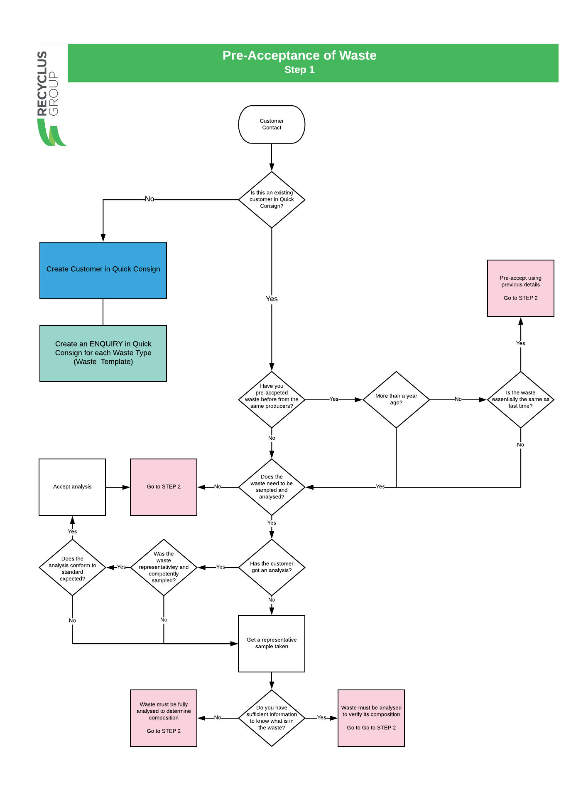

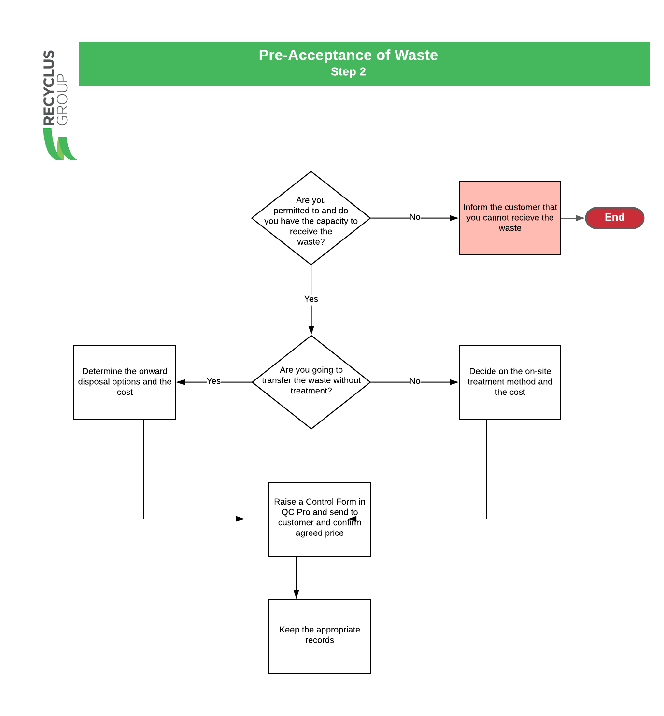

Records
All records required for the movement of the waste from the producer to the facility are maintained in the company’s waste tracking system – Quick Consign (QC). Document Reference: B3-T3-2.1-C Waste Document System

Acceptance Procedure
The company have implemented a documented system to ensure that all waste arriving on site has been pre-accepted to ensure that there is capacity on site at the time of receipt.
Document Reference: B3-T3-2.1-B Materials Receipt & Dispatches

A procedure for the acceptance & pre-treatment of waste has been documented [see below or refer to Document Reference: B3-T3-2.1-A Process Flow Diagrams ] This procedure ensures the following

- Load inspection and control of vehicles
- checking paperwork arriving with the load
- unloading to allow inspection and sampling
- visual load inspection
- Labelling of dolavs, drums and pallets etc.
- assess consistency with pre-acceptance information and proposed treatment method
- rejection criteria
- record keeping in relation to producer details, analysis results and treatment methods
Period review of acceptance records and the process are completed as part of the internal audit programme.
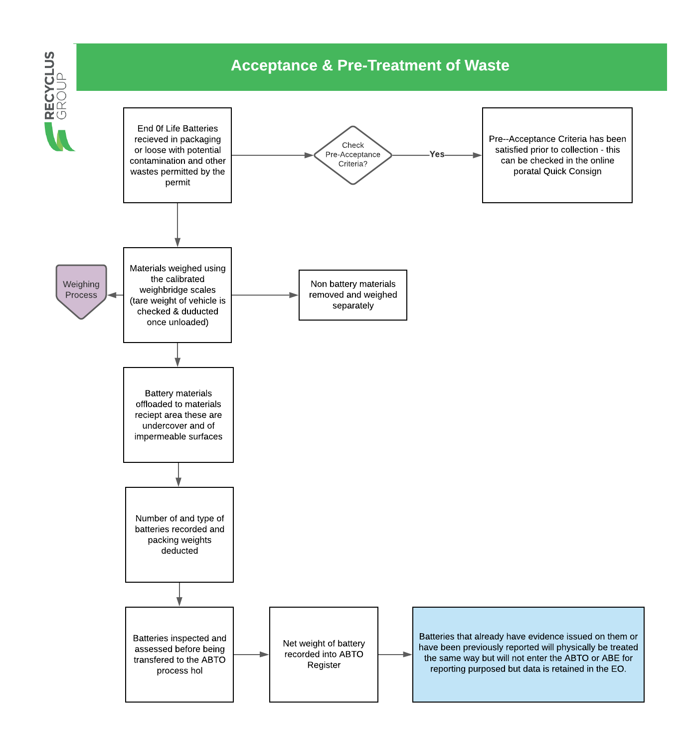

Load Arrival
The Acceptance Procedure [above] ensures that the following points are addressed:
- weighed,
- not be accepted into site unless sufficient storage capacity exists and site is adequately manned to receive waste
- documents checked and approved, and any discrepancies resolved before the waste is accepted
- any labelling that does not relate to the contents of the drum removed before acceptance on site.

Load Inspection
Before a load is accepted it is visually inspected immediately on arrival at the site following initial conformity checks before the load is removed from the vehicle.
In addition to weighbridge weights of the vehicle every container is checked to confirm quantities against accompanying paperwork. All containers are inspected to ensure they are clearly labelled and have well-fitting lids. Any damaged, corroded, or unlabelled drums or containers are put into a quarantine area and dealt with appropriately.
Following inspection, the waste is unloaded into a dedicated sampling/reception area and the waste tracking system unique reference number is attached to the consignment.

Sampling and Rejection of Waste
The process for the sampling and rejection of waste is detailed in the procedure above.
HBR will ensure that where the waste being collected is not a known battery waste
- a technically competent company representative has visited the waste holder/producer of the materials to be accepted at the installation as part of our contract undertaking with the client. This visit will facilitate the raising of, and verification of the pre-acceptance control form from the client and give HBR the opportunity to work with the waste producer or holder to prepare the waste for its acceptance in the correct manner, so that subsequent receipt by HBR is cordially agreed between the parties.
- An assessment of the waste will be taken at the waste producer’s or holder’s site (normally if the waste is a recognizable whole article, e.g., a whole battery or a computer then physical inspection is adequate as the information concerning the waste is the same information as the product information in its market use).

Wastes will not be accepted at the installation without a clear method or defined treatment and recycling/disposal route and associated cost(s).
HBR use Quick Consign which is a waste tracking system that begins at the pre-acceptance stage, and every enquiry and or order is issued with a unique reference number. Wastes then subsequently accepted will have a unique reference number per waste consignment Pre-acceptance agreements prior to this system being implemented have been saved to the applicable Customer Record in Quick Consign and future Pre-Acceptance Agreements are created directly in Quick Consign these are referred to as Control Forms within the system.
The sampling and inspection plan for waste batteries accepted at the installation shall follow the norms in best practice adopted within the UK at all other battery recycling facilities and shall be aligned with the requirements to satisfy the Waste battery and accumulator regulations.
Typically, such a sampling and inspection program is routine sampling and inspection, and subsequent sorting to categorise the batteries in Automotive, Industrial and Portable battery category and then sort them into chemistry by those containing Lead, Cadmium, and other types of battery.

As batteries are whole articles in their waste form, they can be sampled and inspected by their branding and labelling.

Drum Labelling
All containers being stored on the site including Drums and Dolavs are labelled as follows:
- the location of each drum
- the duration of storage
- the chemical identity of the drums contents
- the hazard classification for each drum
Labels are populated through the Waste Tracking System

Records
All records required for the movement of the waste from the producer to the facility are maintained in the company’s waste tracking system – Quick Consign (QC). Document Reference: B3-T3-2.1-C Waste Document System
The waste tracking system holds all the information generated during pre-acceptance, acceptance, storage, treatment and/or removal off-site. Records are maintained daily and reflect deliveries, on-site treatment, and despatches. The tracking system keeps a record of the waste inventory and includes:
- date of arrival on-site
- producers' details
- all previous holders
- a unique reference numbers
- pre acceptance and acceptance analysis results
- package type and size
- intended treatment/disposal route
- record accurately the nature and quantity of wastes held on site, including all hazards and identification of primary hazards
- where the waste is physically located in relation to a site plan
- where the waste is in the designated disposal route
- identification of staff who have taken any decisions re acceptance or rejection of waste streams and decided upon recovery / disposal options

All records relating to pre-acceptance are maintained in the Quick Consign system and are readily available at the installation for cross-reference and verification at the waste acceptance stage.
Records are held for a minimum of two years after the waste has been treated or removed off-site.
Records are available online so are easily accessible especially in the event of an emergency.
The system adopted is capable of reporting on the following:
- total quantity of waste present on-site at any one time, in appropriate units, for example, drums, dolavs etc.
- breakdown of waste quantities being stored pending on-site treatment, classified by treatment route
- breakdown of waste quantities on-site for storage only, that is, awaiting onward transfer
- breakdown of waste quantities by hazard classification
- indication of where the waste is located on site relative to a site plan.
- comparison of the quantity on site against total permitted.
- comparison of time the waste has been on-site against permitted limit

The system is secure, and back-ups are maintained by the systems administrator.

Waste Storage

Batteries

Offloading
All consignments once they have been off-loaded are placed in a holding area. Once inspected if the consignment is not planned to go through the Battery Breaker process that day or it is for onward shipment it will be moved to a designated storage area with impervious surface with self-contained drainage, to prevent any spillage entering the storage systems or escaping off-site.

Records
All consignments once they have been off-loaded are placed in a holding area. Once inspected if the consignment is not planned to go through the Battery Breaker process that day or it is for onward shipment it will be moved to a designated storage area with impervious surface with self-contained drainage, to prevent any spillage entering the storage systems or escaping off-site.
Once material is stored the Waste Management System will be updated with a location of the consignment which has been placed in storage.

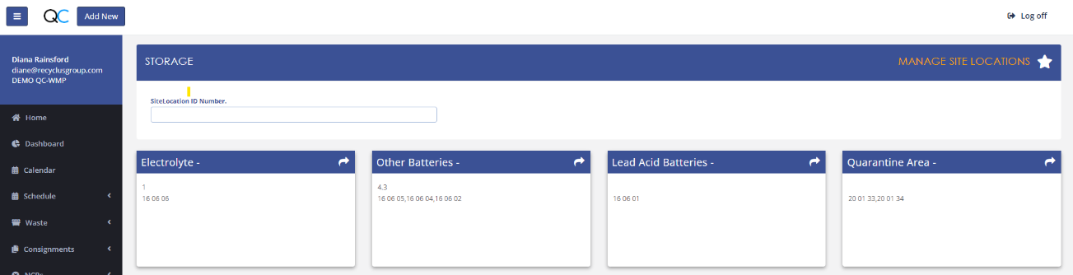

Turnover
If the loads have been placed in the reception area it will not normally be left in this area for longer than 24 hours in normal working times. If there is a holiday or there is a plant breakdown this should not be greater than 5 days.

Transfer from bulk storage
The site has 3 x 20,000 Litre bulk storage containers which are connected to the battery processing plant. These tanks will either contain a mixture of waste processing water and sulphuric acid or sodium Sulphate dependant on if the plant has been run with the De-Sulphurisation Process or not.
This waste will be collected by an approved hazardous waste bulk waste contractor and transferred directly from the tanks into the collecting bulk tanker. The hoses connecting from the storage tanks from the collecting tanker the storage tanks will remain in the processing facility during the pump out procedure which is fully bunded.

Records of these collections are maintained in accordance with the Hazardous Waste Regulations. Suitability of the waste contractor is assessed via the Integrated Management System processes for the management of waste.

Non-Hazardous Waste
The installation generates other non-hazardous wastes which are separated into mixed recycling, metal, and wood waste streams. These wastes are stored in skips and are regularly collected by the waste contractors who are approved by the company and managed in accordance with the process for the management of waste within the Integrated Management System.

Treatment

General
HBR maintain documented information which demonstrate the flow of the Treatment Process. Document Reference: B3-T3-2.1-A Process Flow Diagrams. In addition to this as part of our documented management system HBR maintain a documented description of the Treatment Process in document reference B2-2e_DR – 11.2021 Treatment Summary and a description of the management system in document reference B2-3d_DR-11.2021 Description of Management System.

Diagrams of the plant including the location of tanks and treatment plant design have been documented.
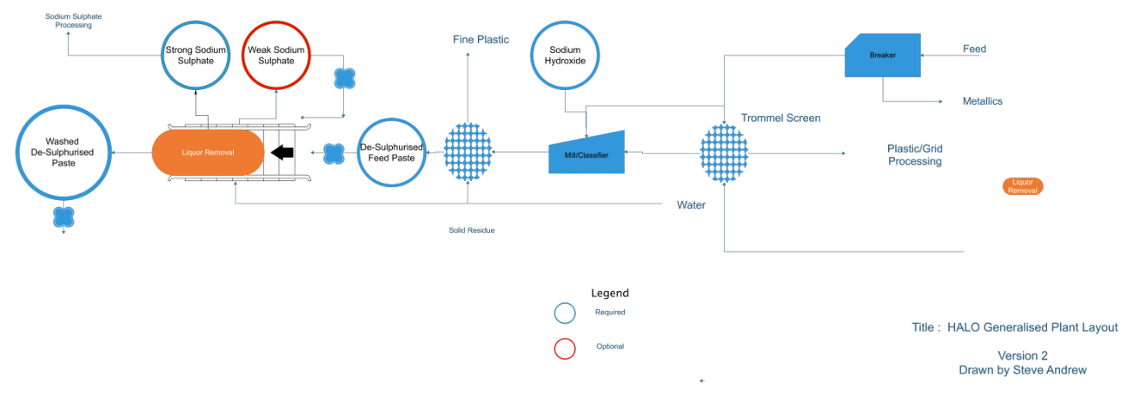

Process Description
The proposed treatment of all feed materials (Lead Acid Batteries) is the same for all feed inputs.
All batteries will be destroyed to liberate all the internal components and each of these components will be treated for the purposes of creating either a product for sale as a feed material for an ongoing process (most of the materials) or cleaned of hazardous contamination for disposal.

The batteries, when destroyed, create 5 separate streams which are as follows:
- Metallic Lead and Lead Alloys
- Lead Oxide Paste
- Battery Acid/Sodium Sulphate
- Plastic Casings
- PVC Internal Dividers

The proposed operation separates all the streams based on either particle size or particle density, and once separated they are either cleaned or chemically treated to remove any hazardous contamination.

Step 1
The machinery used is referred to as the Battery Breaker which initially separates the metallic fractions from the lead oxide paste and plastic fractions using particle density by way of differences in settling rate.
The metallic fraction is removed via an inclined screw conveyor which allows the liquid to drain back into the breaker. Once the metallic fraction is removed it can be washed using circulating process water to remove traces of battery acid.

Step 2
The lead oxide paste is much finer than the rest of the fractions and using its high density (specific gravity) it creates a stable slurry which acts as a more accurate separation media for the lightest fractions. The particles of Lead Oxide are initially suspended in the Battery Acid liberated during the breaking process.
The lead oxide paste settles out in the breaker and is ‘dragged’ out into a discharge screw. This paste is actually and acidic slurry of lead oxide and lead sulphate. The lead sulphate content of the slurry is a function of the age and state of the feed batteries but by running continuously the content remains relatively constant since the batteries are effectively homogenised.
To reduce the production of Sulphur Dioxide gases at the smelter facility, the lead sulphate can be converted to lead oxide using Sodium Hydroxide. This is referred to as desulphurisation.

Step 3
The lead oxide paste is discharged from the battery breaker via a horizontal screw conveyor to maintain a level of liquid content. This heavy slurry is the homogenised and comminuted in a Rod Mill or a Ball Mill.
The slurry is continuously fed into the mill with a controlled dose of Sodium Hydroxide solution (50%) to firstly neutralise the entrained battery acid
2NaOH (aq) + H2SO4. = Na2SO4 + 2H2O
and then secondly to raise the pH to a suitable basic level, typically above ph 12.5 and below pH 13.5.
This level of pH converts the Lead Sulphate into a solution of Sodium Sulphate, which is the only liquid product.
PbSO4 + 2NaOH =. PbO + Na2SO4 + H2O
The mill is used in conjunction with a classifier circuit to ensure no energy is wasted in excessive size reduction and to provide an addition monitoring point for the pH within the circuit.
Once the particles of lead oxide and lead sulphate are of a small enough size, they exit the milling circuit into a conditioning tank. As the Sodium Hydroxide is used in the conversion of the Lead Sulphate, the resultant slurry becomes pH neutral or very slightly acidic (pH 6.5 - 7.0)
This resultant lead oxide slurry in Sodium Sulphate solution is sent to a filter press to remove the liquid from the solid lead oxide.
The filter press has an inset washing system which ensures the maximum extraction of sodium sulphate. As the wash water becomes less contaminated with Sodium Sulphate, the conductivity of the liquid reduces towards background water levels.
Monitoring the conductivity of the wash water stream and ensuring it drops below 20uS/cm will result in a clean, non-hazardous lead oxide paste.
Therefore, the resultant products are:
- A neutral Lead Oxide filter cake at an average moisture content of 8 - 10% which can be handled easily on conventional conveyor systems.
- An aqueous solution of Sodium Sulphate, which can be used as a feed stock for the industrial production of Gypsum (Calcium Sulphate)

Step 4
Using the trommel screen which is integral with the breaker, the plastic fractions and the PVC dividers ‘float’ across the dense slurry and into the screen. These larger particles of plastic migrate up the inside of the trommel whilst any entrained slurry paste through the holes back into the lead oxide slurry tank.
The relatively dry plastics then fall into a separate water bath which reduces the amount of adherent acid on the plastics and effectively washes the plastic.
The Polyurethane based plastics continue to float across the tank and are pushed into an inclined screw conveyor which removes the plastic from the tank and allows the majority of the wash water to drain back into the wash bath.
The plastic is collected in Dolav boxes for removal to further processing by plastic recycling companies.

Step 5
The PVC dividers from inside the batteries will sink in the water bath (but not in the dense slurry) and this allows a separation to take place in the water bath. The PVC dividers are extracted from the water bath by a different inclined screw conveyor, which again allows drainage to take place.

These dividers are only a small fraction of the feed in terms of weight and are collected in Dolav boxes for disposal. This is currently the only material which is not further recycled.

Mass Balances
The throughput of the battery breaker is limited by the capacity of the Filter Press which is used to generate the Lead Oxide press cake.
The overall throughput of the system is limited to 5 tonnes per hour of solid lead oxide, and the lead oxide paste typically compromises 40% of the original battery feed. Therefore, the initial feed rate is in the order of 12 tonnes per hour of whole batteries.
The average breakdown of products from the breaker is as follows:

Product | Volume
Feed Batteries | 100%
Metallic Fraction | 40%
Lead Oxide Fraction | 40%
Battery Acid | 12%
Plastic Fraction | 7.5%
PVC Dividers | 0.5%

This means that it is possible to estimate the initial chemical requirements for the process, which can then be optimised using the pH control within the milling circuit.

Initial Chemical Requirements | pH Control
Feed | 12tph
Metallics | 5 tph
Initial Lead Oxide | 4.5tph
Initial Lead Sulphate | 0.5 tph
Battery Acid | 1.44 tph
Plastics | 0.9 tph
PVC Dividers | 0.06 tph

For acid neutralisation, the majority (99%) of the battery acid is assumed to transfer wholly to the lead oxide slurry.
Therefore, the starting point for acid in the milling circuit is 1.43 tph on average.
This means that the amount of sulphuric acid present is dependent on the feed rate and the average amount of Sulphuric Acid in solution. Typically, the battery acid in the batteries is 20% by weight after significant battery usage.
This would mean that the average amount of Sulphuric Acid available for neutralisation would be 0.3tonnes per hour
According to stoichiometry, it takes 2 moles of Sodium Hydroxide to neutralise 1 mole of Sulphuric Acid, or in terms of weight 0.3 tonnes of Sulphuric Acid would require 0.12 tonnes of Sodium Hydroxide to neutralise the acid.
In order to raise the pH of the slurry to pH 13 would require 10kg of NaOH per 1000 litres of water.
Therefore, on average the amount of liquid added to the circuit is 1.2 tonnes via the battery acid and up to 0.8 tonnes via the spray bars in the battery breaker, which is approximately 2000 litres, and therefore requires 20kg of NaOH to raise the ph to a value of 13.
The amount of Sodium Hydroxide to convert the Lead Sulphate present in the feed would be also evaluated stoichiometrically. It requires 2 moles of Sodium Hydroxide to convert 1 mole of Lead Sulphate, or in terms of weight, 0.5tph of Lead Sulphate requires 0.14tph of Sodium Hydroxide.
This means the total amount of Sodium Hydroxide required per hour should be in the region of 0.28tph (0.12 + 0.02 + 0.14).
This is the starting addition rate which is constantly modified as the pH varies inside the circuit. The circuit requires pre-filling with paste slurry and therefore also needs pre-filling with the requisite amount of Sodium Hydroxide to ensure the continuous monitoring has a stable starting point to work from.

Water Balance
The proposed operation is designed to use minimal water during operation, instead utilising the water in the battery acid and the chemical reagent to do the majority of the work. The only additions to the circuit are via the spray bars in the hammer mill feed chute and the top-up for the process water tank if the washing system on the filter press does not reach low conductivity in a pre-determined amount of process time.
Typically, the wash bars will provide around 500 litres an hour to the circuit. This has the effect of reducing aerosol acid created during the breaking process and flushing the side walls of the hammer mill feed chute.
There is also an automatic top-up system on the process water tank which is fed via a small 20mm feed pipe. The tank has a ballcock system which, when activated, allows a small amount of water into the tank.

- The amount of water added to the circuit via the batteries is on average 1200 litres per hour
- The amount of water added to the circuit via the spray bars is 500 litres per hour
- The amount of water added to the circuit via the Sodium Hydroxide solution is 280 litres per hour

- The amount of water exiting the circuit via the Sodium Sulphate solution is 1400 litres per hour
- The amount of water exiting the circuit via the cake is 500 litres per hour
- The amount of water exiting the circuit via entrainment with the other products is 80 litres per hour

The overall use of water has been minimised to ensure optimum reaction time and minimal water usage.

Management

Management System
Halo Battery Recycling (HBR) have implemented an integrate Health, Safety, Environmental and Quality Management system which has been designed to meet the requirements of ISO 9001, ISO 14001, ISO 45001 and fulfil the BAT requirement for this application.
Detailed relevant procedures for the Management System for the installation have been submitted in document reference: B2-3d_DR-11.2021 Description of Management System.
It is the intention that this management system will be audited by UKAS accredited Certification Body, AUVA to achieve ISO 14001:2015.

Technical Competence
In accordance with the requirements of the BREF the site will be controlled by a technically competent person who holds a WAMITAB certificate. A copy of the certificate has been submitted in document reference: Leigh Davies Competence Certificate

Staff structure and relevant responsibilities
The organisation has identified the structure required for the organisation once it is fully operational. This has been documented in the Organisation Chart

Group Level Structure
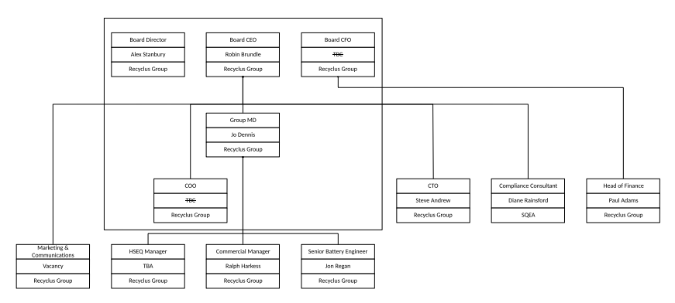
To support the structure as set out above the management system has documented roles and responsibilities for all job roles. These are documented in the integrated management system. This system is currently being developed see example of Site Manager below:
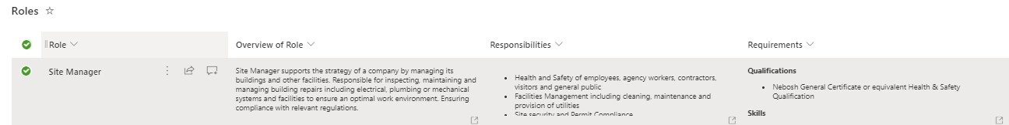
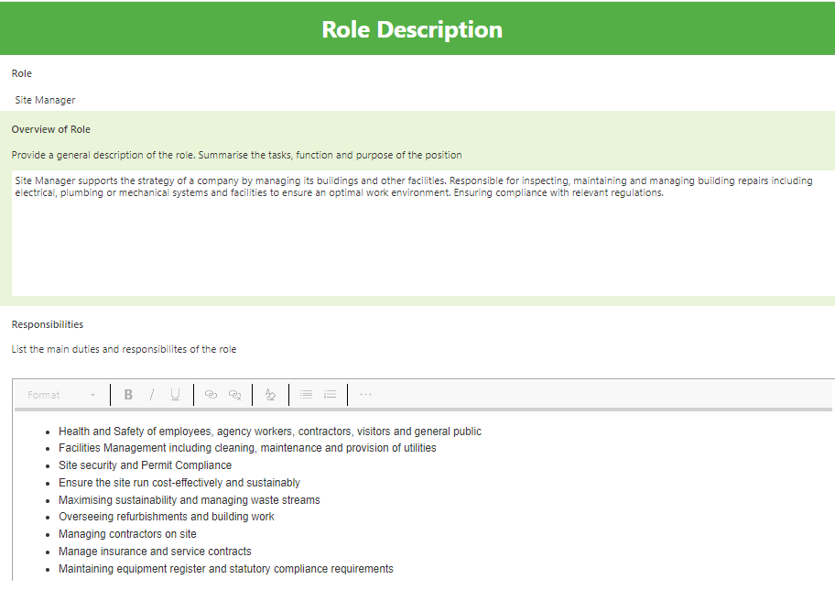
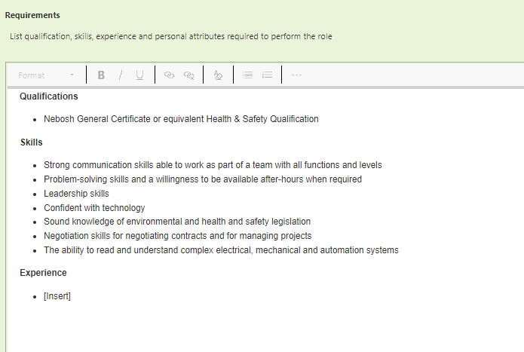
The following flowchart is the process that will be followed once this system is fully operational
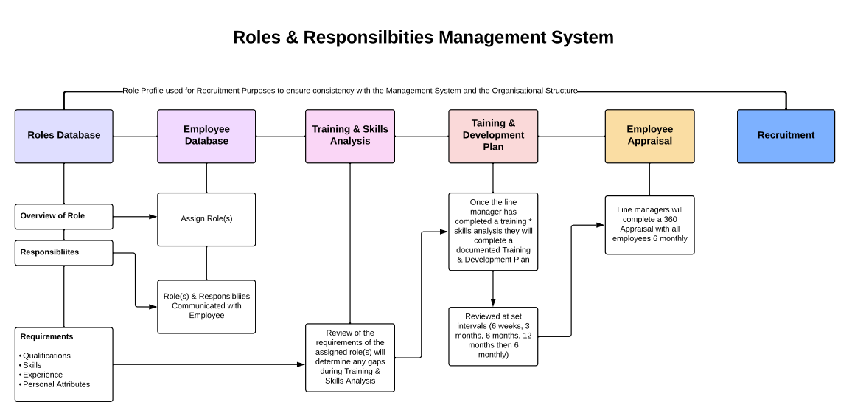
Staff recruitment, training, awareness and competence
As demonstrated in the flow chart above the documented Roles Database will be used for building the Role Profile.
In addition to the system above the organisation have implemented electronic Training and Versatility Matrices.

Training Matrix
This electronic system records all training which has been completed, documents the expiry date if applicable and sends a notification to the Compliance Team of future training requirements. Copies of certificates are attached to the records.
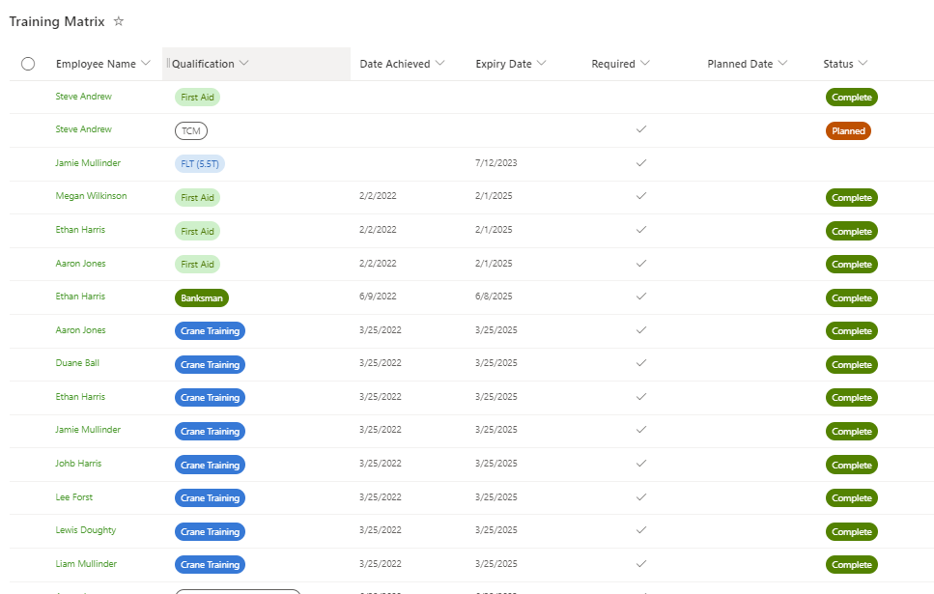
During the Training & Skills Analysis, see flowchart above, the Line Manager will identify training which will be included in the documented training plan and added to the Training Matrix, once completed the training matrix will be updated with the date achieved, expiry date and copy of the certificate etc.

Versatility Matrix
Whereas the Training Matrix records training events such as Statutory Training, the Versatility Matrix is skills and competency based. From the Roles Database above, the tasks of each role are identified and as part of the Training & Skills Analysis where applicable each employee’s competency will be assessed and scored as follows:
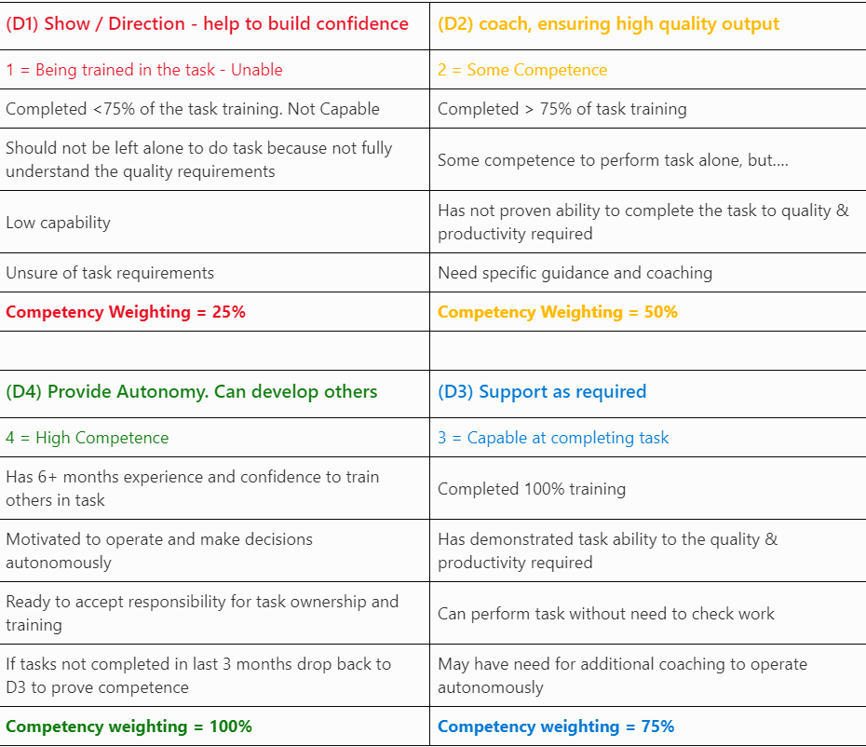
As with above as the Organisation are currently non-operational this is system is in the process of development.
communication (for example, of performance measures and targets)
employee involvement

Document Control
The integrated management system has been implemented using an online system which provides accurate document control. To protect both the environment and exposure of hazardous substances to employees the organisation has endeavoured to implement a ‘paperless’ management system. This system automatically manages version control of documents and allows previous versions to be viewed and if necessary restored.

Effective Process Control
The organisation has implemented a Process Register (see below) as part of the integrated management system through which each Process has been identified including the following:
- SOP/Procedure
- Inputs / Outputs
- Criteria
- Method
- Resources
- Risks
- EHS Risk Assessment
- Measure of Performance
- Responsible Person
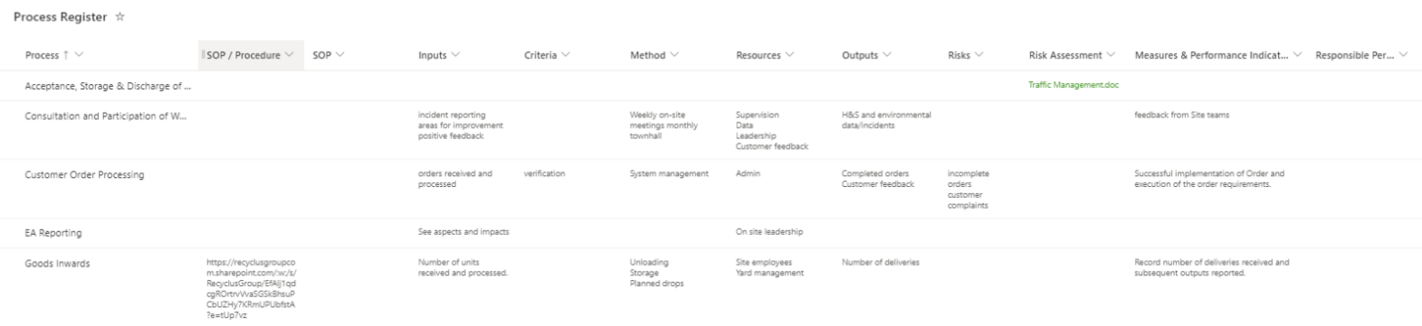

Operations and Maintenance
Within the Management System HBR have implemented a series of documented procedure to control operations that may have an adverse impact on the environment; these include:

Plant Management
The organisation have developed an electronic equipment register which will be used to plan and manage all statutory inspection and routine maintenance requirements.

Preventative Maintenance Programme covering all plant, whose failure could lead to impact on the environment, including regular inspection of major ‘non-productive’ items such as tanks, pipework, bunds and filters etc. A register of plant and equipment has been documented and submitted in document reference: B3-T3-2.3-1 Installation Inventory and Inspection
The Management of Change (including legislative changes and waste classification changes)
The organisation has a documented Risk and Opportunities Register through which change is identified and managed considering legal, environmental, safety and business needs of the organisation.
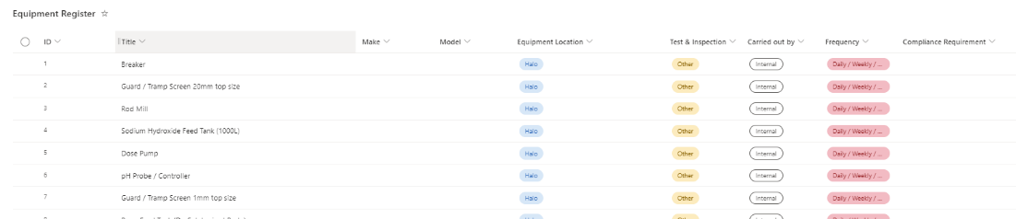

Legislative Changes
As part of the management system a system for identifying Legal and Other Requirements has been implemented. This system identifies the Legal and Other Requirements to which the organisation is obligated. The compliance team are subscribed to notifications of changes to legal requirements and will review and update records as required.
There is a programme of evaluation of the organisations legal and other obligations, and these are documented in the same system the level of compliance is monitored and tracked as part of the management review process.
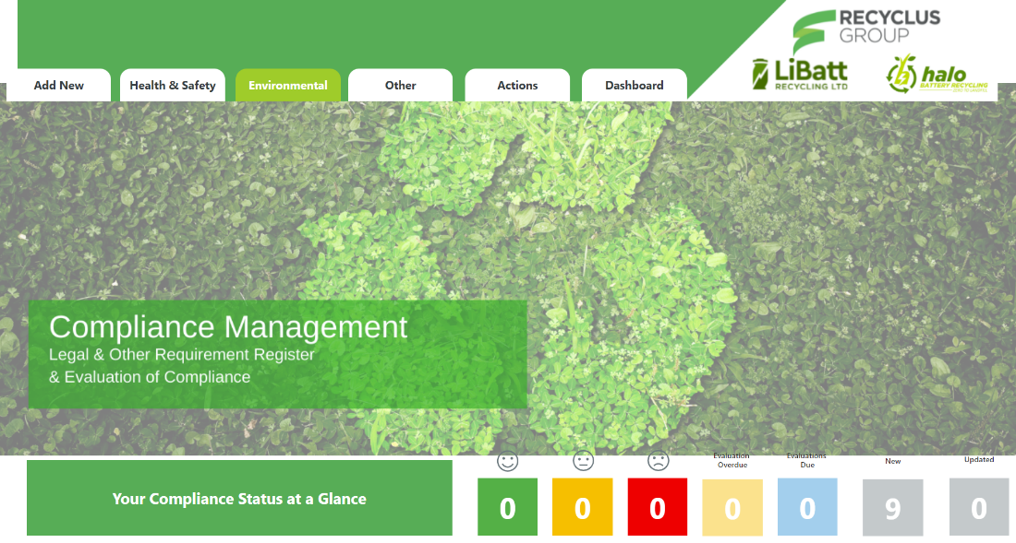
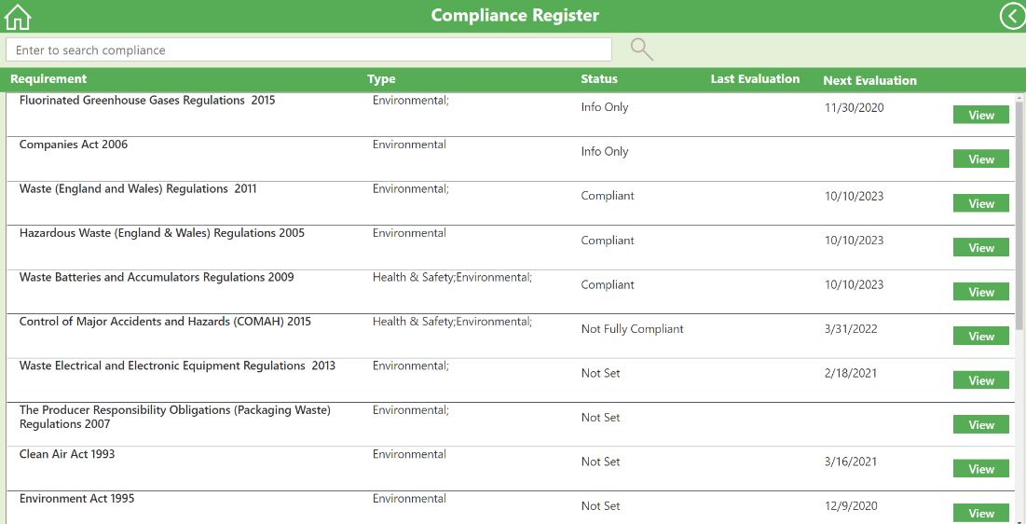
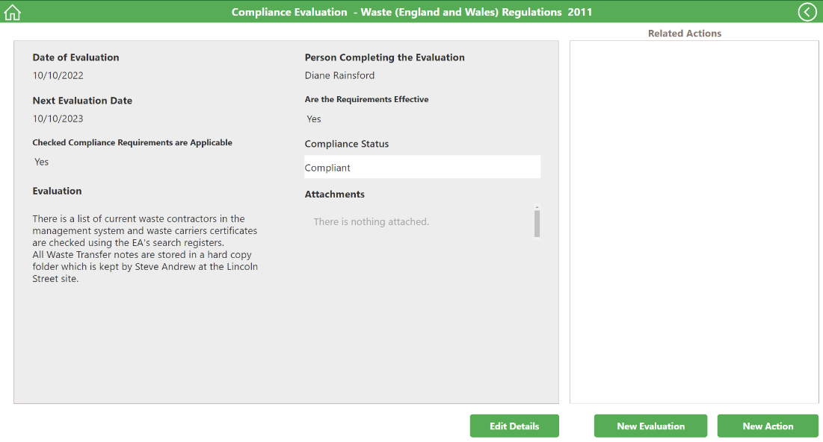

Waste Classification
The organisation refers to Technical Guidance WM3 for guidance on waste classification

Emergency Preparedness and Response
The facility has a documented Emergency Preparedness and Response Plan

Monitoring & Measurement
As part of the integrated management system there are several ways in which the organisation monitors and measures environmental performance. These include but are not limited to:
- Environmental Risk Assessment
- Aspects and Impacts Register and evaluation
- Legal & Other Requirements Register and evaluation of Compliance
- Good Catch Reporting, inspection and audit
- Objectives and Targets
- Management Review

Any issues identified through the above processes will be recorded in the systems Action Register which is the process for managing non-conformance and corrective actions.
The following screen shots demonstrate the register and the process of identifying the issue, documenting the immediate action, identifying the root cause, determining the Corrective Action then completing a verification of the corrective action. The electronic system has been developed to walk the user through the process without the need for a documented procedure.

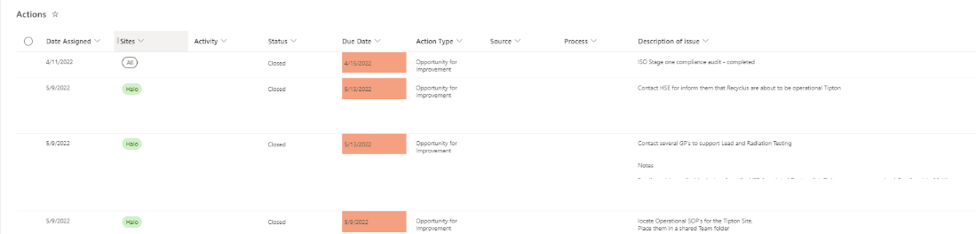
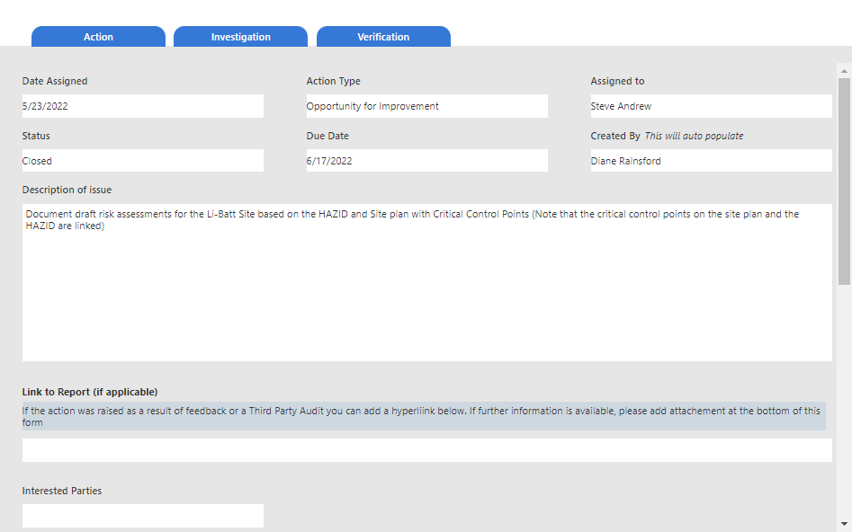
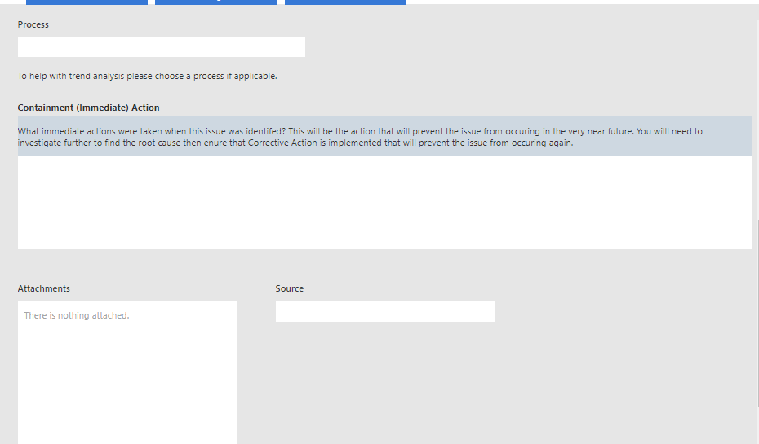
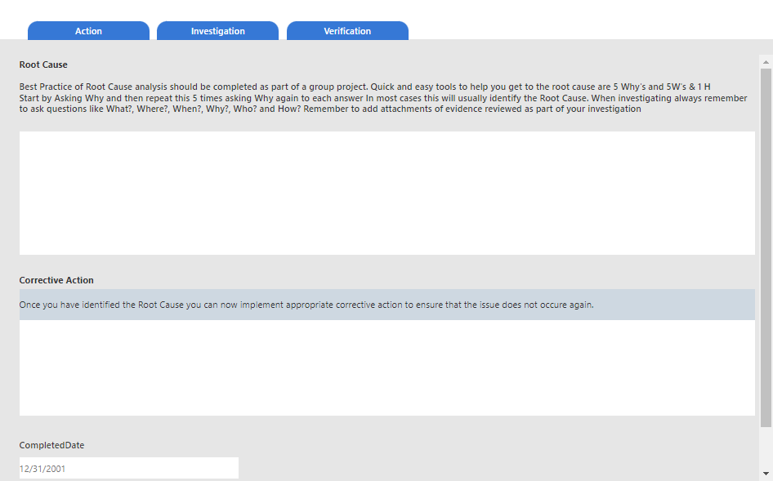
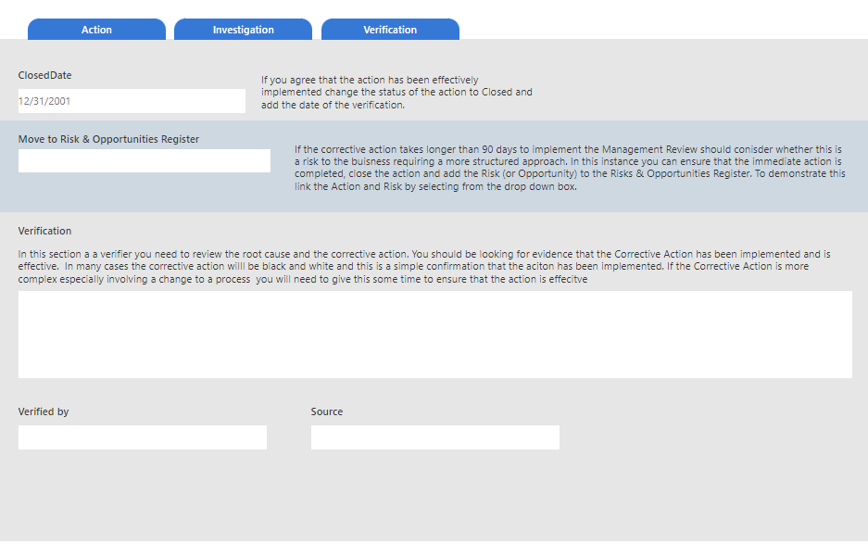
Through this system as seen above any environmental or health and safety incidents or near misses will be recorded and investigated with appropriate corrective action identified and implemented. The electronic nature of the system allows the organisation to monitor progress of corrective actions and to measure items recorded easily identifying trends allowing the organisation to respond quickly.

Internal and Third-Party Auditing
As previously documented the management system has been designed to meet the requirements of ISO 9001, ISO 14001 and ISO 45001 and is audited by Certification Body AUVA who are UKAS certified.
The Compliance Team also have an internal audit schedule which ensures that all processes are audited depending on risk as but at least once per year.

Management Review
In accordance with the requirements of the ISO standards to which the management system has been developed the Senior Management Team complete a Management Review at least once annually. Due to the changing needs of the organisation during the implementation of new processes etc., the Management Team have agreed to complete these management reviews quarterly.
As part of this review the Senior Management Team will review the development of cleaner technologies and their applicability to site operations.
The outcome of the management review will be to determine that management system is suitable, adequate and effective.

Aspects and Impacts Monitoring
Procedure for the identification, assessment and management of significant environmental aspects and impacts has been documented in accordance with the requirements of ISO 14001 [B3-T3-2.3-2 Aspects and Impacts]
As part of the management system the organisation has implemented a register of Environmental Aspects and Impacts. This register is maintained electronically and considers all aspects including Normal and where applicable Abnormal and Emergency conditions. In addition, the register identifies where a particular aspect relates to a Compliance Obligation in which case this is linked from the Legal Register.
Environmental Aspects are reviewed at least once annually this review being included in the Management Review process but more frequently in the event of an incident, near miss, interested party feedback or audit finding, change in legislation etc.

Plant Design
When designing new plant, the lifecycle of our plant is taken into consideration with the assessment of the environmental impacts from the plant’s operating life and eventual decommissioning.

Climate Change
Through the process of environmental aspect review the organisation consider risks a changing climate pose to our operations. Appropriate plans will be in place to assess and manage future risks.

Sectoral Benchmarking
As part of the Environmental Aspect and Management review processes the organisation when the sites are operational will compare our sites performance against relevant sector guidance and standards.

Raw materials

Raw materials selection
HBR maintain a list of raw materials and their properties and will have procedures for the regular review of new developments in raw materials and for the implementation of any suitable ones with an improved environmental profile and complete any longer-term studies needed into less polluting options and should make any material substitutions identified.
Through the electronic COSHH Register which forms part of the Integrated Management System HBR maintain a list of Raw Materials which are considered to be hazardous. Each entry for hazardous raw materials will be reviewed as part of the waste minimisation audit and a justification for use will be provided where a less hazardous material cannot be substituted. Each recorded will be updated.
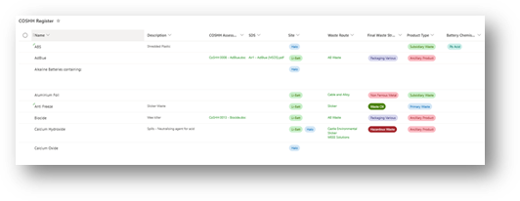
Other items maintained in this register are categorised as Ancillary Products. These are the raw materials we purchase for uses such as fuel, processing, maintenance and spill media etc.
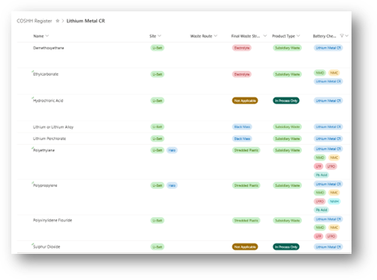
These products can be controlled by the organisation and as part of our Monitoring and Review processes each item will be periodically reviewed. Below is an example of a review of Calcium Hydroxide which is an Ancillary Product used as a spill medium for the clean-up acid.
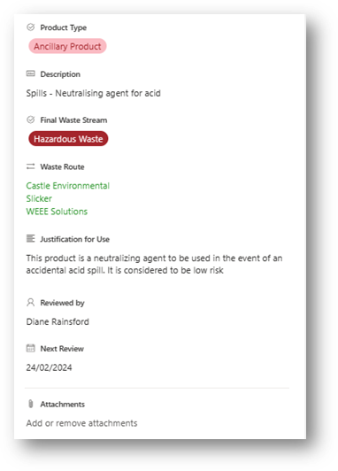

Waste Minimisation Audit
Waste minimisation audit (including minimising the use of raw materials) will form part of the annual internal audit schedule to ensure a systematic approach to the reduction of waste at source, by understanding and changing processes and activities to prevent and reduce waste.

Water use
Except for domestic water which is used in specifically in daily showering by Operators due to the exposure of lead and battery acid water used in the process is recycled. HBR complete a Water Efficiency Audit at least once every 4 years.
Through our programme of Objectives and Targets to ensure we maximise the reuse of water within our process and freshwater consumption is measured and recorded on a regular basis.
Water used in the battery recycling process is re-used but there is an uptake from the battery acid collection. Water consumption is measured at the point of entry into the process daily consumption is recorded and monitored against key performance measures.
Every effort is taken to minimise the risk of contamination of surface waters or groundwater by fugitive releases of liquids or solids. The facility has been fully bunded and the floor sealed with a polyurethane coating preventing any accidental release reaching surface water or groundwater.

Waste handling

Waste recovery or disposal
HBR have implemented measures to avoid or reduce any impact of waste on the environment.

Waste production will be avoided wherever possible and any waste that is produced is recovered, unless it is technically or economically impractical to do so.

Filter cake
Filter cake and sludges removed from the process have high contents of Lead (Pb) and are sent with the other recycled Lead products for onwards recycling.

Contaminated containers
All containers, drums and IBC’s used are designed, manufactured and marked to enable reconditioning / refurbishment, and as such they will be cleaned and reconditioned to enable re-use where technically and economically possible.
Containers that cannot be re-used where there is no reconditioning market, and which have been cleaned will be released into the secondary materials market.

Energy
HBR do not have a CCA or DPA in place within the Emissions Trading Scheme. However, as part our our Objectives and Targets monitoring programme energy consumption is recorded and monitored monthly against key performance measures including the recording of CO2 savings as a result of our energy saving measures.

Energy Management Plan
HBR have implemented an Energy Management Plan which is written in accordance with the requirements of the WEEE and Chemical Appropriate Measures for Permitted Facilities. Energy Management Plan

Accidents
The installation is not subject to COMAH.

Identification of Hazards
As part of our documented management system and operational controls hazards both of an environmental and health and safety nature have been identified, assessed for risk and the risk hierarchy has been implemented. These include as follows:
- Arrangements for the storage, segregation and separation of differing waste types
- Procedures for the internal transfer of waste materials
- Transfer of substances (e.g., filling and emptying of vessels)
- Overfilling of vessels
- Emissions from plant or equipment
- Failure of containment
- Failure to contain firewater
- Wrong connections made in drains or other systems
- Incompatible substances allowed to come into contact
- Unexpected reactions or runaway reactions
- Failure of main services
- Operator error
- Vandalism
These hazards have been assessed through our environmental Aspects and Impacts process and are recorded in the Aspects and Impacts register of our Management System. The assessment has considered the potential impacts, the nature of the activities which could result in the impact being realised, the status of the activity and whether it is normal, abnormal, or emergency etc., and controls have been put in place to eliminate, minimise, or mitigate.

Assessment of the risks.
Once hazards have been identified, the process of assessing the risks addresses six basic questions:

- How likely is the event to occur (source/frequency)?
- What substances are released and how much of each (risk evaluation of the event)?
- Where do the released substances end up (emission prediction-what are the pathways and receptors)?
- What are the consequences (consequence assessment–what are the effects on the receptors)?
- What are the overall risks (determination of overall risk and its significance to the environment)?
- What can prevent or reduce the risk (risk management–measures to prevent accidents and/ or reduce their environmental consequences)?

The detail and type of assessment will depend on the characteristics at this installation, and its location and is based on these main factors being considered:
- The scale and nature of the accident hazard presented by the installation and the activities
- The risks to areas of population and the environment (receptors)
- The nature of the installation and complexity of the activities and the relative difficulty in determining and justifying the adequacy of the risk-control techniques

Identification of the techniques necessary to reduce the risks.

The installation has the following systems and/or protocols in place:

- Site plans showing the precise location of wastes having specific hazard characteristics (eg corrosive) with clear identification of the perimeters of the various designated storage areas and their maximum storage capacity.
- Procedures for checking and handling raw materials and wastes to ensure compatibility with other substances with which they may accidentally come into contact.
- Storage arrangements for raw materials, products and wastes will be designed and operated to minimise risks to the environment.
- Automatic process controls backed-up by manual supervision to minimize the frequency of emergency situations and to maintain control during emergency situations.
- Physical protection will be in place where appropriate (e.g. Barriers to prevent damage to equipment from the movement of vehicles).
- Appropriate secondary containment (e.g. bunds, building containment).
- Security systems to prevent unauthorized access will be provided.
- System for the logging and recording of all accidents, incidents, and near misses, abnormal events, changes to procedures and significant findings of maintenance inspections.
- Processes for responding to and learning from accidents, incidents, near misses, etc…
- Roles and responsibilities of personnel involved in accident/incident management will be formally specified along with clear guidance on how each accident scenario might best be managed.

Spillage prevention controls are in place during the transfer of substances to prevent spill incidents.

Noise
The installation has implemented basic good practice measures for the control of noise including the maintenance of plant and machinery. A noise assessment at the permitter of the installation has been undertaken to ensure that the field rating level (L_{AR,TR}) does not exceed 50 dB by day. The plant does not operate at night.

Boundary Noise Survey
The organisation have previously completed a Boundary noise survey of the existing process and intend to repeat this survey once the permit variation is approved and the process is operational.

Noise and Vibration Management Plan
HBR have a documented Noise and Vibration Management Plan

Monitoring

Emissions monitoring
HBR have a documented Dust and Emissions Management Plan
Monitoring is completed in accordance with the Site Permit which includes as follows:

Air Monitoring
This will be completed by a competent 3rd party supplier in accordance with the requirements of the permit. The plant is located within the Sandwell AQMA and therefore has a predetermined set of limits to adhere to. The emissions management policy and control criteria are determined in the Halo Dust and Emissions Management Plan.
The installation has a requirement for LEV installation on the hammer mill discharge conveyor and the process also uses a 500 kVA generator to provide additional power, therefore the type of air monitoring required is MCERTS equipment operated by a competent person from a certified compliance company.

Closure
Operations during the life of our Permit will not lead to any deterioration of the site. Should any instances arise which have, or might have, impacted on the state of the site, then HBR will record them along with any further investigation or ameliorating work carried out. This will ensure that we have a coherent record of the state of the site throughout the period of the IPPC Permit.

Any changes to this record will be submitted to the Regulator.

HBR will always take care at the design stage to minimise risks during decommissioning. For existing installations, where potential problems are identified, a programme of improvements would typically be put in place to a timescale agreed with the Regulator.

Our designs and planning will ensure that:
- Underground tanks and pipework are avoided.
- Provision for the draining and clean-out of vessels and pipework prior to dismantling
- Insulation provided can be readily dismantled without dust or hazard.
- Materials used are recyclable.

Site Closure Plan
A site closure plan will be implemented and maintained to demonstrate that, in its current state, the installation/installation can be decommissioned to avoid any pollution risk and return the site of operation to a satisfactory state. The plan will be kept updated as material changes occur.

Our closure plan will include:
- The removal or the flushing out of pipelines and vessels and complete emptying of any potentially harmful contents
- The removal of asbestos or other potentially harmful materials unless agreed that it is reasonable to leave such liabilities to future owners.
- Methods of dismantling buildings and other structures
- Testing of the soil to ascertain the degree of any pollution caused by the activities and the need for any remediation to return the site to a satisfactory state as defined by the initial site report.

For existing activities, HBR will complete any detailed studies, and submit the site closure plan as an improvement condition to a timescale to be agreed with the Regulator.

