SITE CONDITION REPORT TEMPLATE

For full details, see H5 SCR guide for applicants v2.0 4 August 2008

COMPLETE SECTIONS 1-3 AND SUBMIT WITH APPLICATION

DURING THE LIFE OF THE PERMIT: MAINTAIN SECTIONS 4-7

AT SURRENDER: ADD NEW DOC REFERENCE IN 1.0; COMPLETE SECTIONS 8-10; & SUBMIT WITH YOUR SURRENDER APPLICATION.

1.0 SITE DETAILS

Name of the applicant | Morris Recycling Limited
Activity address | Unit 34 Coneygree Road, Coneygre Industrial Estate,  Tipton, DY4 8XP
National grid reference | SO 95764 90998

Document reference and dates for Site Condition Report at permit application and surrender | Permit Application  Appendix 12 – Site Condition Report

Document references for site plans (including location and boundaries) | The site plans provided with the environmental permit application were:
Drawing No. | Site Plan Name | Appendix No. with application
01 | Site Location Plan | 3
02 | Permit Boundary Plan | 4
03 | Site Infrastructure Plan | 5
04 | Site Storage Plan | 6
05 | Site Drainage Plan | 7
06 | Fire Protection Plan | 8
07 | Water Pooling Plan | 9
08 | Receptor Plan | 10
569353-1 | Severn Trent Wastewater Map | 11

Note:
In Part A of the application form you must give us details of the site’s location and provide us with a site plan. We need a detailed site plan (or plans) showing:

- Site location, the area covered by the site condition report, and the location and nature of the activities and/or waste facilities on the site.
- Locations of receptors, sources of emissions/releases, and monitoring points.
- Site drainage.
- Site surfacing.

If this information is not shown on the site plan required by Part A of the application form then you should submit the additional plan or plans with this site condition report.

2.0 Condition of the land at permit issue

Environmental setting including:  - geology  - hydrogeology  - surface waters | Site is located on an industrial area. The area is a low groundwater vulnerability area (see below), is outside of a groundwater source protection zone and is not a drinking water protected area or safeguard zone (surface water or groundwater).

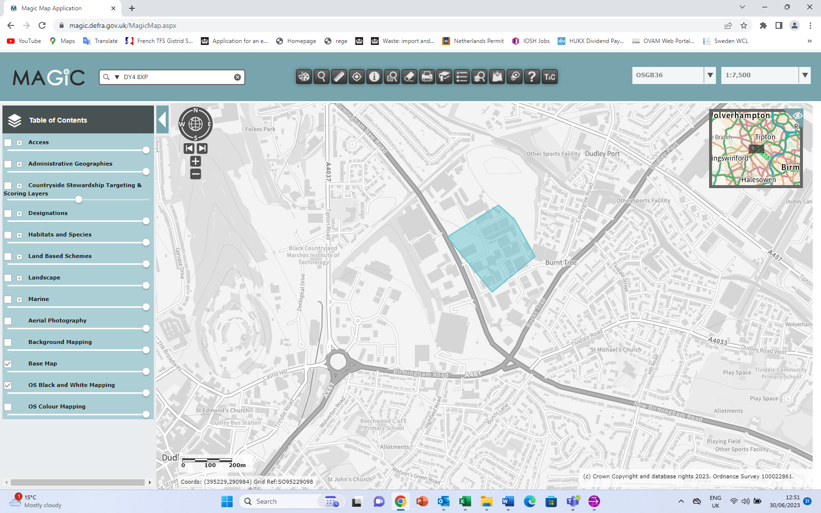

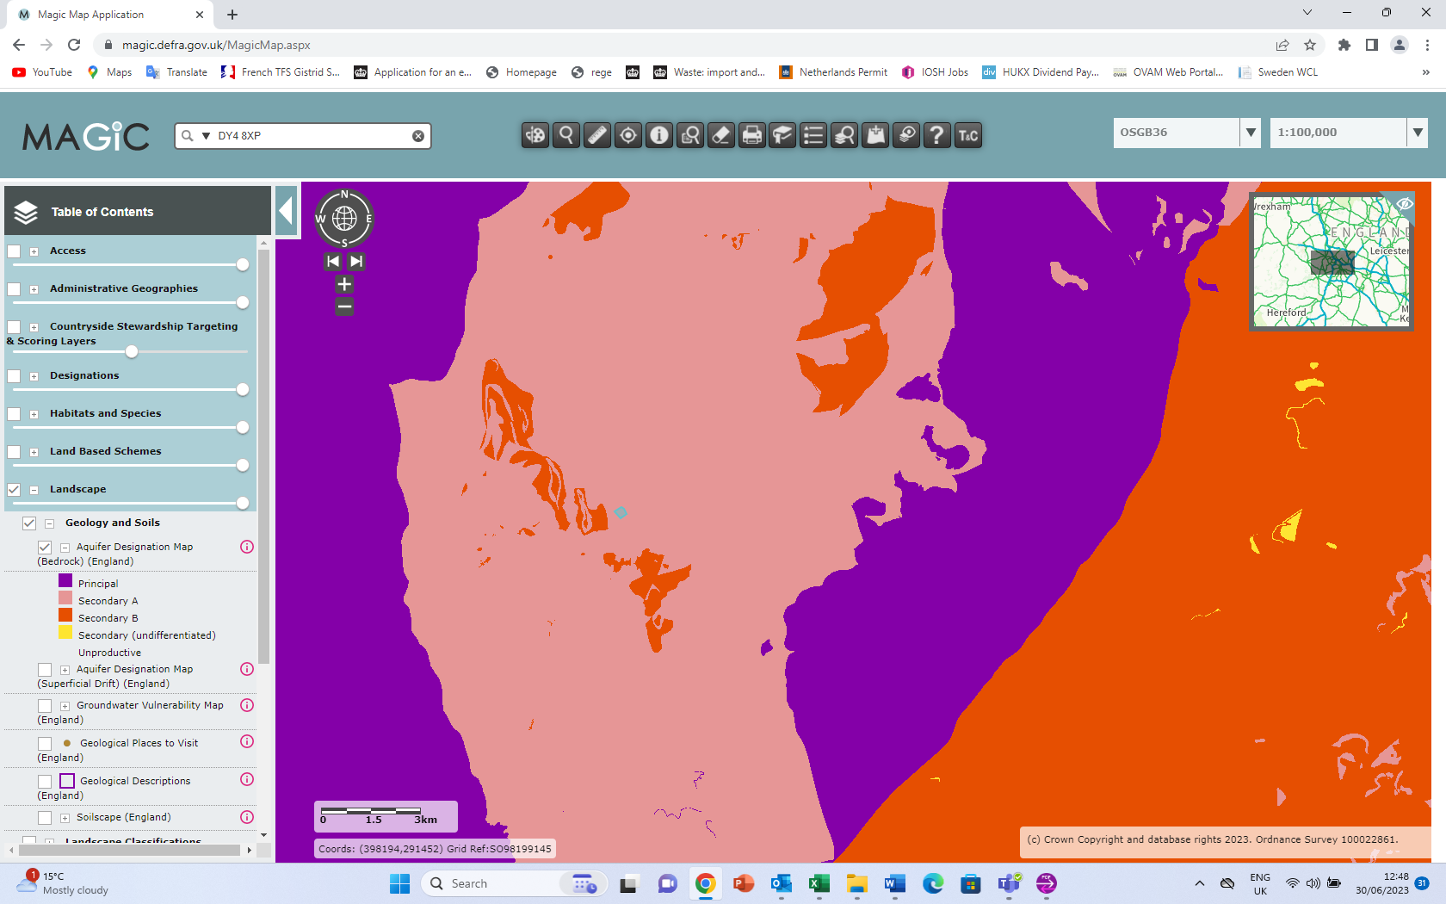

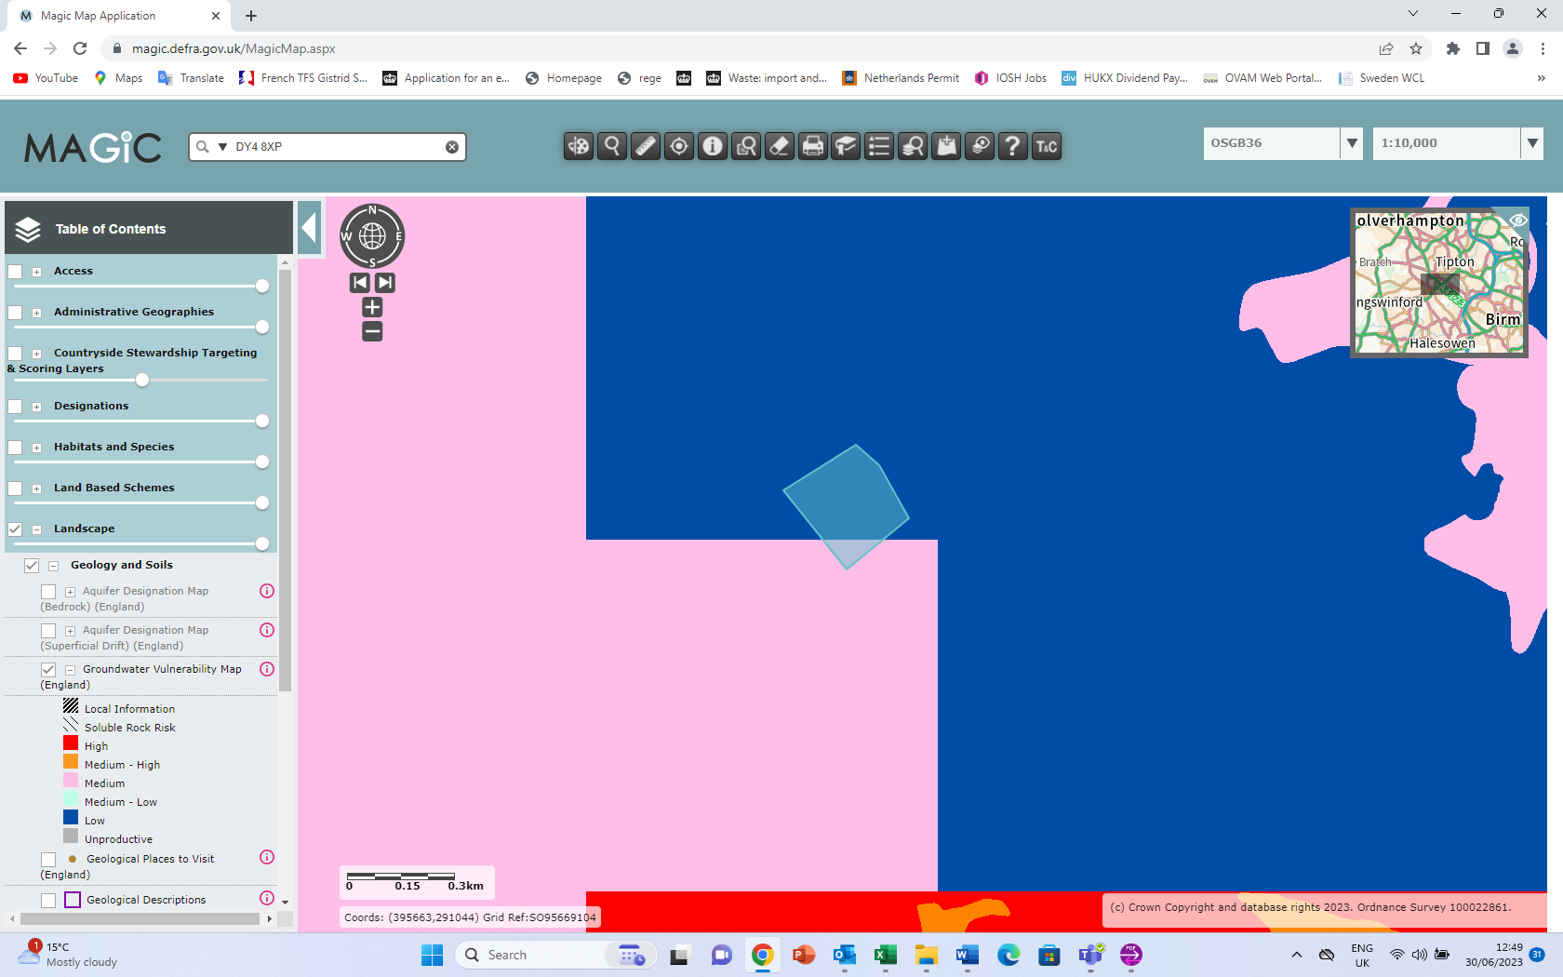

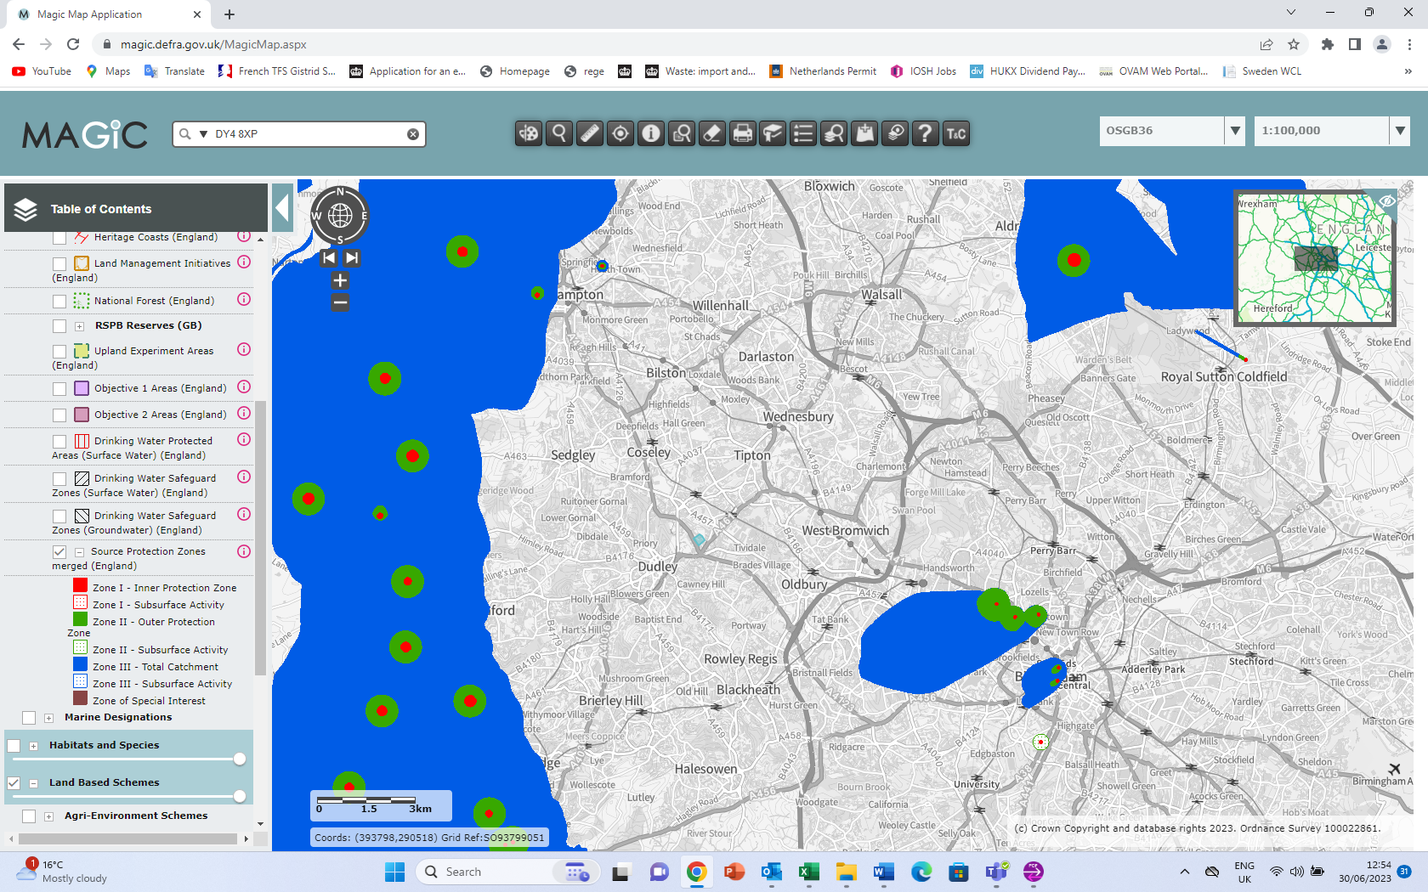
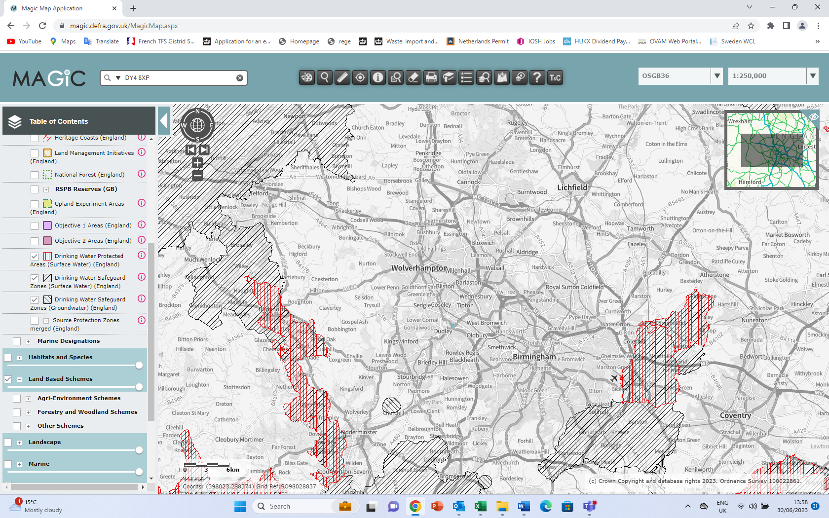

Pollution history including:  - pollution incidents that may have affected land  - historical land-uses and associated contaminants  - any visual/olfactory evidence of existing contamination  - evidence of damage to pollution prevention measures |  | No historical pollution is known to Morris Recycling Limited.  The site is located on an area of historical industrial use (see below).
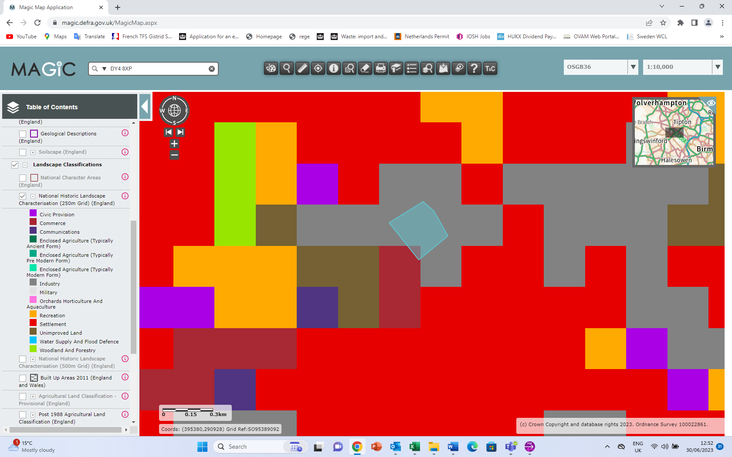

Evidence of historic contamination, for example, historical site investigation, assessment, remediation and verification reports (where available) |  | No evidence of historical contamination evident. No site investigation completed.
Baseline soil and groundwater reference data |  | No baseline soil or groundwater samples taken
Supporting information | - Source information identifying environmental setting and pollution incidents  - Historical Ordnance Survey plans  - Site reconnaissance  - Historical investigation / assessment / remediation / verification reports  - Baseline soil and groundwater reference data

3.0 Permitted activities

Permitted activities | Physical treatment of non-hazardous plastic waste i.e uPVC window frames, PVC profiles and PVC waste.
Non-permitted activities undertaken | None
Document references for:  - plan showing activity layout; and  - environmental risk assessment. | Site plans listed in section 1 above  Appendix 15 – environmental risk assessment

Note:

In Part B of the application form you must tell us about the activities that you will undertake at the site. You must also give us an environmental risk assessment. This risk assessment must be based on our guidance (Environmental Risk Assessment - EPR H1) or use an equivalent approach.

It is essential that you identify in your environmental risk assessment all the substances used and produced that could pollute the soil or groundwater if there were an accident, or if measures to protect land fail.

These include substances that would be classified as ‘dangerous’ under the Control of Major Accident Hazards (COMAH) regulations and also raw materials, fuels, intermediates, products, wastes and effluents.

If your submitted environmental risk assessment does not adequately address the risks to soil and groundwater we may need to request further information from you or even refuse your permit application.

4.0 Changes to the activity

Have there been any changes to the activity boundary? |  | If yes, provide a plan showing the changes to the activity boundary.
Have there been any changes to the permitted activities? |  | If yes, provide a description of the changes to the permitted activities
Have any ‘dangerous substances’ not identified in the Application Site Condition Report been used or produced as a result of the permitted activities? |  | If yes, list of them
Checklist of supporting information | - Plan showing any changes to the boundary (where relevant)  - Description of the changes to the permitted activities (where relevant)  - List of ‘dangerous substances’ used/produced by the permitted activities that were not identified in the Application Site Condition Report (where relevant)

5.0 Measures taken to protect land

Use records that you collected during the life of the permit to summarise whether pollution prevention measures worked. If you can’t, you need to collect land and/or groundwater data to assess whether the land has deteriorated.

Checklist of supporting information | - Inspection records and summary of findings of inspections for all pollution prevention measures  - Records of maintenance, repair and replacement of pollution prevention measures

6.0 Pollution incidents that may have had an impact on land, and their remediation

Summarise any pollution incidents that may have damaged the land. Describe how you investigated and remedied each one. If you can’t, you need to collect land and /or groundwater reference data to assess whether the land has deteriorated while you’ve been there.

Checklist of supporting information | - Records of pollution incidents that may have impacted on land  - Records of their investigation and remediation

7.0 Soil gas and water quality monitoring (where undertaken)

Provide details of any soil gas and/or water monitoring you did. Include a summary of the findings. Say whether it shows that the land deteriorated as a result of the permitted activities. If it did, outline how you investigated and remedied this.

Checklist of supporting information | - Description of soil gas and/or water monitoring undertaken  - Monitoring results (including graphs)

8.0 Decommissioning and removal of pollution risk

Describe how the site was decommissioned. Demonstrate that all sources of pollution risk have been removed. Describe whether the decommissioning had any impact on the land. Outline how you investigated and remedied this.

Checklist of supporting information | - Site closure plan  - List of potential sources of pollution risk  - Investigation and remediation reports (where relevant)

9.0 Reference data and remediation (where relevant)

Say whether you had to collect land and/or groundwater data. Or say that you didn’t need to because the information from sections 3, 4, 5 and 6 of the Surrender Site Condition Report shows that the land has not deteriorated.

If you did collect land and/or groundwater reference data, summarise what this entailed, and what your data found. Say whether the data shows that the condition of the land has deteriorated, or whether the land at the site is in a “satisfactory state”. If it isn’t, summarise what you did to remedy this. Confirm that the land is now in a “satisfactory state” at surrender.

Checklist of supporting information | - Land and/or groundwater data collected at application (if collected)  - Land and/or groundwater data collected at surrender (where needed)  - Assessment of satisfactory state  - Remediation and verification reports (where undertaken)

10.0 Statement of site condition

Using the information from sections 3 to 7, give a statement about the condition of the land at the site. This should confirm that:

- the permitted activities have stopped
- decommissioning is complete, and the pollution risk has been removed
- the land is in a satisfactory condition.

