Proposal for the storage of additional waste activated carbon.
Situation
Reason: Our current storage provider no longer has space for the waste activated carbon we propose to store. We are currently unable to process the material as it is “too high” in sulphur to successfully go through our current process. We have a new plant/process that will come on line in approximately 9 months that will however be able to treat this material and return it as “reactivated carbon” with acceptably low levels of sulphur. We are currently requesting a temporary increase to 1000 tonnes.
Mitigation
Storage: the material will be stored on level ground as indicated on the map below.
Proposed storage site
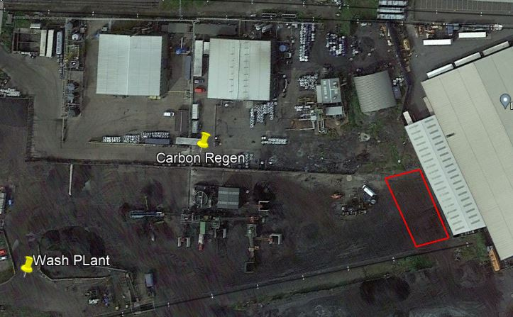

The bags will be stocked in lanes, double stacked.
Weather protection: It is proposed that each bag will be enclosed on a purpose made bag that will prevent the increase of water and therefore surface water run-off to the site drains.
Fire Prevention: The material that will be stored is not of a type that is known to self heat, however, it will also be visually inspected on a shift by shift basis. The bag covers will be zipped to allow access.
Temperature checks will be carried out using an extended temperature probe that can be inserted into the centre of the bags on a daily basis
Dust Management: as with the weather protection, the bags will enclosed with weather proof bags that will prevent any dust from escaping to the atmosphere.
Maintenance/Inspection: Inspections will include visual on a shift basis to ensure the bags are still in good order and a selection of bags will be temperature checked daily to ensure self heating is not taking place, these checks will be recorded on for AC-Temp-Inspect. If the shift inspection show that any of the bags have become compromised the material will be removed from the storage area, inspected and where appropriate rebagged and recovered before being returned to the storage area.
Activated Carbon - Temporary Storage Inspection Record
Date | Shift | Visual Inspection | Bag Temperature |  |  |  |  |  |  |  |  |  | Signed
 |  |  | 1 | 2 | 3 | 4 | 5 | 6 | 7 | 8 | 9 | 10
 | Days
 | Nights
 | Days
 | Nights
 | Days
 | Nights
 | Days
 | Nights
 | Days
 | Nights

Rotation of material through the plant: The material that we propose to store will not go through our Amber plant in its current form as the sulphur loads is too great. The proposal will be to store the material until the new Caustic Wash facility is available (some material will be used during the commissioning process).
Future: Once the Caustic Wash plant is commissioned the material will be processed (the Caustic Wash facility is currently part of a permit variation that is sitting with the Environment Agency)
Final Mitigation: If there is a situation where the material become unstorage for any reason ,the material will be send to a processing facility where it will be committed to land fill. This would be a final stage if all other avenues had been exhausted.
Alternative
The alternative to this would be to reject this material and for it to be processed to land fill.

