**Application for Substantial Variation**

**Non-Technical Summary**

## Report Context

The substantial variation application is being submitted for the following Environmental Protection Regulation permit: SP3936HE V003. This is due to the planned construction of a waste water treatment plant in order to reduce key water quality parameter levels before discharging to the Humber Estuary to meet upcoming legislation of which will be outlined below. This non-technical summary accompanies all other supporting documents that are required for a substantial variation application.

## Background to the Project

The EU Ecolabel Regulation initially prompted discussions on the construction of a waste water treatment plant in 2017, along with the recognition that the Grimsby site is the only one in the Lenzing Group without this facility. However, soon after, the announcement of the BREF Common Waste Water/Waste Gas Treatment and Management System Directive with its stricter effluent parameter limits further emphasized the need for this work stream.

The Ecolabel regulation states a COD level post treatment of effluent to be 20g per kilogram of textile processed, however the upcoming BREF is forcing a further reduction of up of 90% of COD. Meeting this ambitious target was found to be challenging for Lenzing Grimsby due to the non-biodegradability of a portion of our effluent – of which our A100 specialty product line is responsible for. It was found that interim reduction levels of minimum of 65% could be achieved, whilst research of alternative methods to reach the final 90% reduction will be a phase 2 of the project ready for 2026 BREF deadline.

Finally, the Lenzing group wide sustainability target 5 of a 20% reduction in specific COD wastewater emissions based on 2014 baseline figures is being worked towards with this waste water treatment plant in Grimsby a significant step to achieving this.

A wastewater treatment plant is a scheduled activity within the 2016 Environmental Permitting Regulations within Schedule 1 part 2: Section 5.7 A (1) (a) ‘independently operated treatment of waste water not covered by Directive 91/271/EEC and discharged by an installation carrying out any other part A(1) or A(2) activity’. This therefore illustrates the requirement for a substantial variation to the sites existing permit SP3936HE.V003.

## Basic Technology and equipment of the Proposed Facility

Initially, the project will focus on the construction of the biological and phosphate removal stage of the treatment plant of which will be discussed below. It should be noted that in future once innovation and development has been completed a module for removing the non-biological cross linker will be added.

* 1. **Balance tank 1**
  2. D: 20.5m x H:8.6m x V: 2600m3

Main purpose of this balance tank is to collect and feed the biological treatment system with a uniformed flow of wastewater to maintain stable operating conditions. The effluent level in balance tank 1 will be operated at a low level to ensure sufficient capacity is available for additional or sudden flow changes. Mixer aerators will be present to ensure anoxic conditions do not develop and to ensure uniform effluent flow.

* 1. **Balance tank 2**

D: 20.5m x H: 8.6m x V:2600m3

This tank serves a similar purpose to balance tank 1 with the ability to isolate effluent in the event of an abnormal condition to prevent any effects on efficiencies on downstream processes. Effluent can be released from this tank gradually to prevent abnormal process conditions for the biological section.

* 1. **Anoxic tank 1**

D:29.0m x H:8.6m V:5000m3

This is the initial treatment of the effluent to start the breakdown of amines to nitrogen. This process continues through both anoxic tanks and the bioreactor tank.

* 1. **Anoxic tank 2**

D:29.0m x H:8.6m V:5000m3

Along with Anoxic tank 1, tank 2 provides sufficient residence time to allow the reaction to progress to the point it can enter the bioreactor.

* 1. **Bioreactor**

D:29.0m x H:8.6m V:5000m3

Most important and integral part of the LGL WWTP. Aerobic digestion is utilized here to assimilate the undesired contaminants and reduce the volume of sewage sludge. Here, microorganisms assimilate BOD, COD, NH4 organic matter as a food source and produce CO2 and new biomass. This requires oxygen thus air must be continuously circulated through the tank via 3 blowers with acoustic weatherproof enclosures located adjacent to the tank 1. Nitrogen and phosphorus are enzymes to this process.

**3.61 Membrane Bioreactors**

Critical part to the process using membrane ultra film technology to seperate out biomass and solids from the effluent to be passed through to sludge processing, allowing the treated liquor to be released as effluent with low solids and biomass content.

* 1. **DAF sludge (dissolved air flotation)**

To pre-treat a specific process stream (cross linker effluent) in order to remove the phosphate from it. It is brought into the plant seperatley and mixed with a floculating agent (ferric chloride) which then forms solid phosphates to be removed accordingly. Following this, the remaining liquor is fed back into the balance tanks with the rest of the site effluent and treated through the biological route.

The sludge removed from the DAF process is sent to landfill.

* 1. **Waste biomass**

As biomass is constantly generated through the process, a certain portion is removed through sludge presses and sent offsite – potentially for land spreading.

* 1. **Caustic, acid and coagulant tanks:**

Coagulant tank feeds into the pre-DAF mixing system and the bioreactor tank. Acid and caustic both feed into the pre-DAF mixing system.

* 1. **Final discharge transfer pumps**

Following membrane treatment, there is a final effluent holding tank with a 10m3 capacity. This feeds into a final discharge pump system with 2 pumps installed with one for duty and one for standby to transfer clarified effluent to the newly installed connection point within the discharge main to the Humber. The flowmeter transmitter installed at the pump discharge header will be used for monitoring the flow.

* 1. **Sludge treatment**

As discussed above, the DAF sludge will be sent to incineration.

The WWTP will also produce biological sludge from the biomass. As this grows from the process it will periodically need to be removed and disposed of. This is done via sending sludge rich stream into screw presses with the de-watered sludge fed into skips. This will be collected by a licensed waste operator and will be sent to land spreading depending on it having the appropriate characteristics.

## Structure Design and Location

The location of the Lenzing Grimsby site is shown below. It is located in North East Lincolnshire, approximately 5km to the north west of Grimsby town centre and 3km from nearby Stallingborough village. It lies on Energy Park Way adjacent to the Humber Estuary south bank.

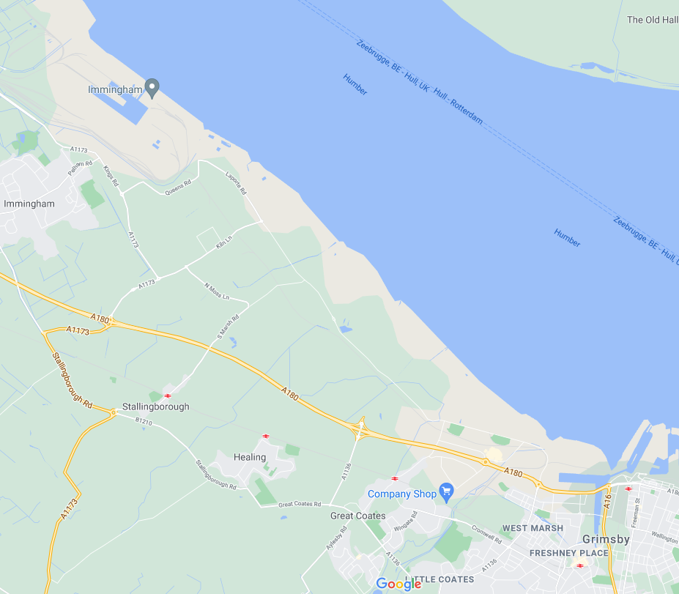

Lenzing Fibers Grimsby

**N**

The waste water treatment plant is planned to be installed to the rear right of the site with the exact location seen shown on the site location plan drawing (rd4417-04-site-location-plan-rev-A). This drawing can be viewed separately within the documents of the substantial variation application.

The waste water treatment plant detailed design can also be seen below or viewed separately within the documents of this application - J6285 – GA001 Rev 3 Site Plan.

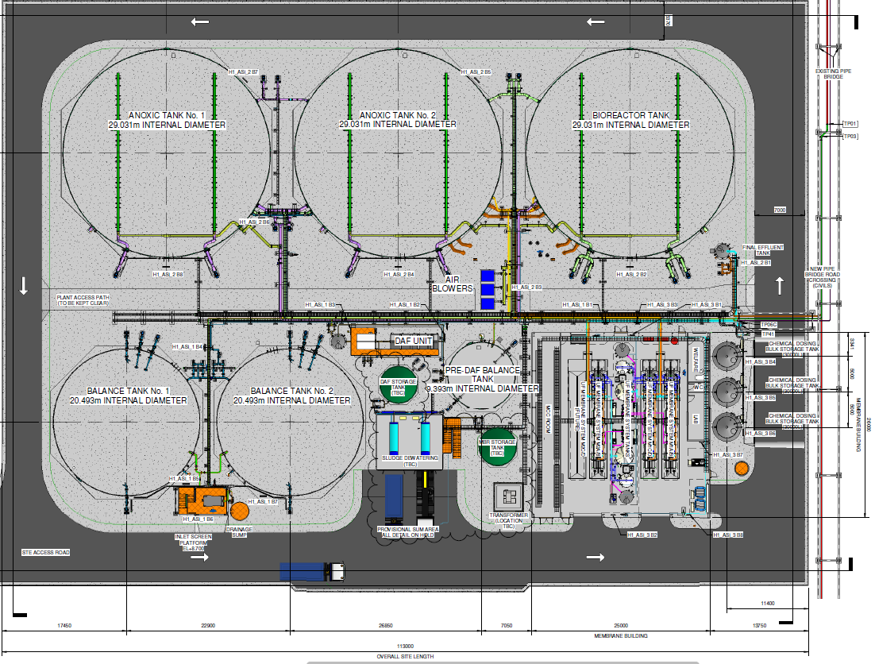

## With reference to the site characteristics, below the surface is characterized by chalk bedrock with superficial deposits of alluvium clay, sand and silt. Boreholes were drilled as part of groundwater survey for this project of which confirmed this strata.

The location falls within flood zone 3 according to the Environment Agency of which indicates a 1 in 100 year risk of site flooding due to riverine causes and 1 in 200 year chance of sea level related flooding assuming no sea defences of which are present along the Humber Estuary bank.

Surface waters nearby consist of the Humber Estuary 0.5km away from the rear border of the site, along with an old firewater pond. Oldfleet drain and Mawbridge drain water courses run along the west and east border respectively draining into the estuary.

## Local receptors can be seen below:

*Residential:*

* Poplar Farm – 1.4km west
* Stallingborough Village – 2.7km south west
* Healing Village – 2.4km south
* Great Cotes – 2.5km south
* Grimsby – 4.8km
* Immingham – 4.5km west

*Commercial and Industry:*

* South Humber Bank Power Station – 0.7km north west
* Kiln Lane Industrial Estate – 2.5km north west
* Solenis – 1km south east Upper COMAH
* Europarc – 1.6km south
* BOC upper COMAH
* Tronox upper COMAH
* Novartis upper COMAH

*Nature and Historical:*

* Humber Estuary SSS1, SPA, SAC, RAMSAR - 0.9km north east

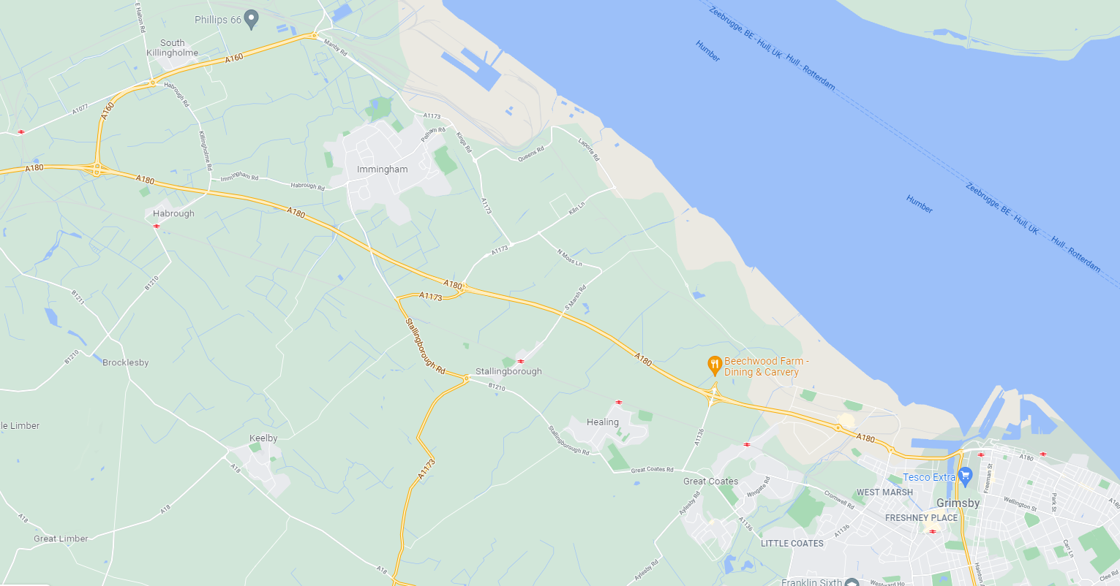

Lenzing Fibers Grimsby Site

Stallingborough village

Healing village

Grimsby Town

Immingham Town

Great Coates village

Humber Estuary

Kiln Lane Industrial Estate

South Humber Bank Power Station

Europarc Industrial Estate

BOC

Tronox Pigments

Solenis

Novartis

**N**

## Environmental Considerations/Wastes

The intent of the plant is to further reduce the effluent impact to the Humber Estuary receptor by reducing COD, phosphate, amines and solids. Through this process, the other main waste streams from the plant has been discussed in section 3, with phosphate non-biological sludge and organic biological sludge.

## Assessment of Best Available Techniques

Following the best available techniques (BATs) within the construction and operation of this treatment plant is important. We have partnered with a reputable treatment design company in order to develop a process that is unique to our effluent produced as there is no existing proven process for our effluent characteristics showing compliance to directly relevant BATs. We have drawn from proven existing in house systems within the group to help in the design of this process. All BAT’s below have been considered throughout the design and incorporated where applicable – as discussed below.

The BATs have been taken from the European BREF documentation with the following noted:

1. *In order to improve the overall environmental performance, BAT is to implement and adhere to an environmental management system that incorporates all of the stated features. The site is accredited to BS ISO.*
   1. 14001 EMS with the new treatment plant to be incorporated to all relevant documents.
2. *In order to facilitate the reduction of emissions to water and air and the reduction of water usage, BAT is to establish and maintain an inventory of waste water streams as part of the EMS that incorporates all of the stated features* 
   1. The site maintains anin house waste water monitoring spreadsheet with the required water quality parameters recorded here weekly. The reduction of water usage is a site wide target with a working group. The new treatment plant will be included within this scope of this working group going forward.
3. *For relevant emissions to water BAT is to monitor key parameters (including continuous monitoring of flow, pH and temperature) at key locations.* 
   1. This is part of existing permit requirements and will be adhered to if part of the new permit variation requirements as legal compliance is a priority on site.
4. *BAT is to monitor emissions to water in accordance with EN standards with at least the minimum frequency given in the BREF. Where EN standards are not present, BAT is to use ISO, national or other international standards that ensure the provision of data of an equivalent scientific quality.*
   1. Monitoring requirements for method and frequency are stated in the site permit and adhered to at all times
5. *BAT is to periodically monitor diffuse VOC emissions to air from relevant sources by using an appropriate combination of the techniques I-III outlined in the BREF* 
   1. No VOCs will be released from this process
6. *BAT is to periodically monitor odour emissions from relevant sources in accordance with EN standards*
   1. Odour is not anticipated to be an issue based on assessments as part of the planning stage, however these will be checked upon start up to confirm
7. *In order to reduce the usage of water and generation of waste water, BAT is to reduce the volume and/or pollutant load of waste water streams, to enhance the reuse of waste water within the production process and to recover and reuse raw materials.*
   1. Reducing pollutant load is the primary target of this project. Water re-use opportunities are being assessed as part of a site wide programme and will be implemented where possible.
8. *In order to prevent the contamination of uncontaminated water and to reduce emissions to water, BAT is to segregate uncontaminated waste water streams to enhance the reuse of wastewater within the production process and to recover and reuse raw materials.* 
   1. This is enhanced further by the project with separated tanks for different purposes within the process.
9. *In order to prevent uncontrolled emissions to water, BAT is to provide an appropriate buffer storage capacity for waste water incurred during other than normal operating conditions based on a risk assessment*
   1. This has been considered and built into the design process with the existing dual effluent pit capacity on site and the new balance tank from this project providing adequate storage capacity for abnormal conditions
10. *In order to reduce emissions to water, BAT is to use an integrated waste water management and treatment strategy that includes an appropriate combination of the techniques shown in the BREF doc.*
    1. This project is using a combination of techniques to meet the BREF
11. *In order to reduce emissions to water, BAT is to pretreat waste water that contains pollutants that cannot be dealt with adequately during final waste water treatment using appropriate techniques.* 
    1. The phosphate removal process using a flocculating agent provides a pre-treatment for this purpose
12. *In order to reduce emissions to water, BAT is to use an appropriate combination of final waste water treatment techniques.* 
    1. The plant design takes this approach for effluent treatment within one plant design

[Best Available Techniques (BAT) Reference Document for Common Waste Water and Waste Gas Treatment/Management Systems in the Chemical Sector - Industrial Emissions Directive 2010/75/EU (Integrated Pollution Prevention and Control) (europa.eu)](https://eippcb.jrc.ec.europa.eu/sites/default/files/2019-11/CWW_Bref_2016_published.pdf)

## Operation and Training

The waste water treatment plant will operate continuously 24 hours 7 days a week – as does the rest of the Lenzing Grimsby production process. As with all Lenzing operational areas of plant, fully trained and skilled operators will be used with written procedures to be followed. In all cases, a well-defined management hierarchy exists for day, shift and engineering maintenance teams.

A site condition report has been completed and submitted within this application for a substantial permit variation. Sections 1-3 have been written with the subsequent sections maintained throughout the permit life and upon surrender.

## Development/Ongoing Work

There is ongoing work on a solution to bridge the gap to meet the final target of 90% reduction by 2026. As previously mentioned, this will result in an additional phase of the project following commissioning of initial works.