**Technical Summary**

The introduction to the plant, its location and non-technical aspects can be read in the non-technical summary provided as part of the C2 application form. This document focuses on describing the process side of the treatment plant.

## Basic Technology and equipment of the Proposed Facility

The mass balance document attached as part of this application can be viewed – ref: 19-023-06-1-001 Mass Balance Rev 5. This shows the process and how each area below link together with inflows and outflows including our expected water quality parameters after treatment to be discharged.

Initially, the project will focus on the construction of the biological and phosphate removal stage of the treatment plant of which will be discussed below. It should be noted that in future once innovation and development has been completed a module for removing the non-biological cross linker will be added.

* 1. **Balance tank 1**
  2. D: 20.5m x H:8.6m x V: 2600m3

Main purpose of this balance tank is to collect and feed the biological treatment system with a uniformed flow of wastewater to maintain stable operating conditions. The effluent level in balance tank 1 will be operated at a low level to ensure sufficient capacity is available for additional or sudden flow changes. Mixer aerators will be present to ensure anoxic conditions do not develop and to ensure uniform effluent flow.

* 1. **Balance tank 2**

D: 20.5m x H: 8.6m x V:2600m3

This tank serves a similar purpose to balance tank 1 with the ability to isolate effluent in the event of an abnormal condition to prevent any effects on efficiencies on downstream processes. Effluent can be released from this tank gradually to prevent abnormal process conditions for the biological section.

* 1. **Anoxic tank 1**

D:29.0m x H:8.6m V:5000m3

This is the initial treatment of the effluent to start the breakdown of amines to nitrogen. This process continues through both anoxic tanks and the bioreactor tank.

* 1. **Anoxic tank 2**

D:29.0m x H:8.6m V:5000m3

Along with Anoxic tank 1, tank 2 provides sufficient residence time to allow the reaction to progress to the point it can enter the bioreactor.

* 1. **Bioreactor**

D:29.0m x H:8.6m V:5000m3

Most important and integral part of the LGL WWTP. Aerobic digestion is utilized here to assimilate the undesired contaminants and reduce the volume of sewage sludge. Here, microorganisms assimilate BOD, COD, NH4 organic matter as a food source and produce CO2 and new biomass. This requires oxygen thus air must be continuously circulated through the tank via 3 blowers with acoustic weatherproof enclosures located adjacent to the tank 1. Nitrogen and phosphorus are enzymes to this process.

* 1. **Membrane Bioreactors**

Critical part to the process using membrane ultra film technology to seperate out biomass and solids from the effluent to be passed through to sludge processing, allowing the treated liquor to be released as effluent with low solids and biomass content.

* 1. **DAF sludge (dissolved air flotation)**

To pre-treat a specific process stream (cross linker effluent) in order to remove the phosphate from it. It is brought into the plant separately and mixed with a flocculating agent (ferric chloride) which then forms solid phosphates to be removed accordingly. Following this, the remaining liquor is fed back into the balance tanks with the rest of the site effluent and treated through the biological route. The sludge removed from the DAF process is at final procedures with our waste carrier, however, mostly incineration at the very beginning until process is balanced and then sent to landfill.

* 1. **Waste biomass**

As biomass is constantly generated through the process, a certain portion is removed through sludge presses and sent offsite – potentially for land spreading as fertilizer.

* 1. **Caustic, acid and coagulant tanks:**

Coagulant tank feeds into the pre-DAF mixing system and the bioreactor tank. Acid and caustic both feed into the pre-DAF mixing system.

* 1. **Final discharge transfer pumps**

Following membrane treatment, there is a final effluent holding tank with a 10m3 capacity. This feeds into a final discharge pump system with 2 pumps installed with one for duty and one for standby to transfer clarified effluent to the newly installed connection point within the discharge main to the Humber. The flowmeter transmitter installed at the pump discharge header will be used for monitoring the flow.

* 1. **Sludge treatment**

As discussed above, the DAF sludge will be sent to incineration at the beginning of the process and then landfill.

The WWTP will also produce biological sludge from biomass. As this grows from the process it will periodically need to be removed and disposed of. This is done via sending sludge rich stream into screw presses with the de-watered sludge fed into skips. This will be collected by a licensed waste operator and will be sent to land spreading depending on it having the appropriate characteristics as potential fertilizer.

## Structure Design and

The waste water treatment plant detailed design can also be seen below or viewed separately within the documents of this application - J6285 – GA001 Rev 3 Site Plan. Along with this, drawings within the application help to explain the design from an elevation, drainage, and specific processes such as membranes and sludge treatment areas.

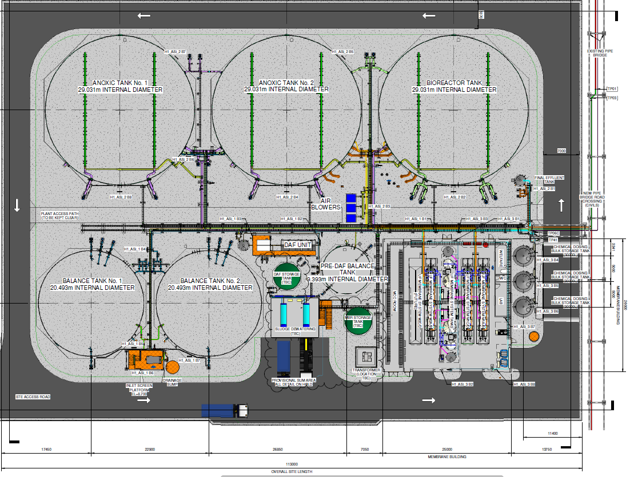

## Assessment of Best Available Techniques

Following the best available techniques (BATs) within the construction and operation of this treatment plant is important. We have partnered with a reputable treatment design company to develop a process that is unique to our effluent produced as there is no existing proven process for our effluent characteristics showing compliance to directly relevant BATs. We have drawn from proven existing in-house systems within the group to help in the design of this process. All BAT’s below have been considered throughout the design and incorporated where applicable – as discussed below.

The BATs have been taken from the European BREF documentation with the following noted:

1. *To improve the overall environmental performance, BAT is to implement and adhere to an environmental management system that incorporates all of the stated features. The site is accredited to BS ISO.*
   1. 14001 EMS with the new treatment plant to be incorporated into all relevant documents.
2. *In order to facilitate the reduction of emissions to water and air and the reduction of water usage, BAT is to establish and maintain an inventory of waste water streams as part of the EMS that incorporates all of the stated features* 
   1. The site maintains anin-house waste water monitoring spreadsheet with the required water quality parameters recorded here weekly. The reduction of water usage is a site wide target with a working group. The new treatment plant will be included within the scope of this working group going forward.
3. *For relevant emissions to water BAT is to monitor key parameters (including continuous monitoring of flow, pH and temperature) at key locations.* 
   1. This is part of the existing permit requirements and will be adhered to if part of the new permit variation requirements as legal compliance is a priority on site.
4. *BAT is to monitor emissions to water in accordance with EN standards with at least the minimum frequency given in the BREF. Where EN standards are not present, BAT is to use ISO, national or other international standards that ensure the provision of data of an equivalent scientific quality.*
   1. Monitoring requirements for method and frequency are stated in the site permit and adhered to at all times
5. *BAT is to periodically monitor diffuse VOC emissions to air from relevant sources by using an appropriate combination of the techniques I-III outlined in the BREF* 
   1. No VOCs will be released from this process
6. *BAT is to periodically monitor odour emissions from relevant sources in accordance with EN standards*
   1. Odour is not anticipated to be an issue based on assessments as part of the planning stage, however these will be checked upon start up to confirm
7. *In order to reduce the usage of water and generation of waste water, BAT is to reduce the volume and/or pollutant load of waste water streams, to enhance the reuse of waste water within the production process and to recover and reuse raw materials.*
   1. Reducing pollutant load is the primary target of this project. Water re-use opportunities are being assessed as part of a site-wide programme and will be implemented where possible.
8. *In order to prevent the contamination of uncontaminated water and to reduce emissions to water, BAT is to segregate uncontaminated waste water streams to enhance the reuse of wastewater within the production process and to recover and reuse raw materials.* 
   1. This is enhanced further by the project with separate tanks for different purposes within the process.
9. *In order to prevent uncontrolled emissions to water, BAT is to provide an appropriate buffer storage capacity for waste water incurred during other than normal operating conditions based on a risk assessment*
   1. This has been considered and built into the design process with the existing dual effluent pit capacity on site and the new balance tank from this project providing adequate storage capacity for abnormal conditions
10. *In order to reduce emissions to water, BAT is to use an integrated waste water management and treatment strategy that includes an appropriate combination of the techniques shown in the BREF doc.*
    1. This project is using a combination of techniques to meet the BREF
11. *In order to reduce emissions to water, BAT is to pretreat waste water that contains pollutants that cannot be dealt with adequately during final waste water treatment using appropriate techniques.* 
    1. The phosphate removal process using a flocculating agent provides a pre-treatment for this purpose
12. *In order to reduce emissions to water, BAT is to use an appropriate combination of final waste water treatment techniques.* 
    1. The plant design takes this approach for effluent treatment within one plant design

[Best Available Techniques (BAT) Reference Document for Common Waste Water and Waste Gas Treatment/Management Systems in the Chemical Sector - Industrial Emissions Directive 2010/75/EU (Integrated Pollution Prevention and Control) (europa.eu)](https://eippcb.jrc.ec.europa.eu/sites/default/files/2019-11/CWW_Bref_2016_published.pdf)