Cawingredients – Source Emission Points (Air)
EPR/UP3937FW
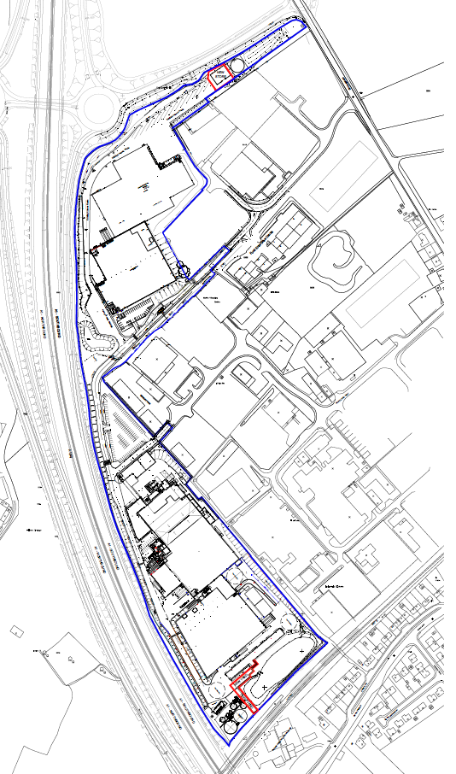
A2 Source 2 – Existing boiler 2
(Oct 2020)

GR SE 2824 8988
A1 Source 1 – Replacement boiler 1
(2025)

GR SE 2816 9003

