Update: 31 March 2023 by James Morley
Intro ( please read in conjunction with Production operation and Site development overview ppt docs for more detailed information)
BM Tech Ltd was established in 2005 and has been developing a solution to recycle PVC for the last decade. Waste containing PVC is sourced from Cooling towers and Water treatment plants. BM Tech estimates an incoming stream of 55,000 tonnes of waste material between 2023 and 2028. In the absence of a recycling solution, this material would go to landfill or an energy from waste plant (incineration). When processed through an Open-loop system as used by BM Tech the net benefit of recycling PVC compared to virgin PVC is a saving of just over 2,800kg CO₂e per tonne*.
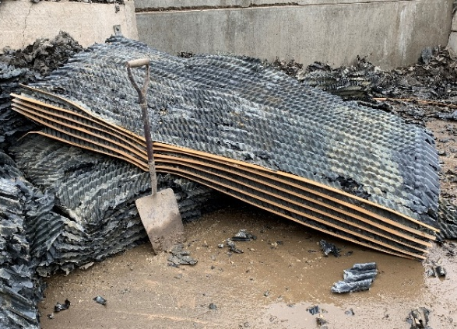 | 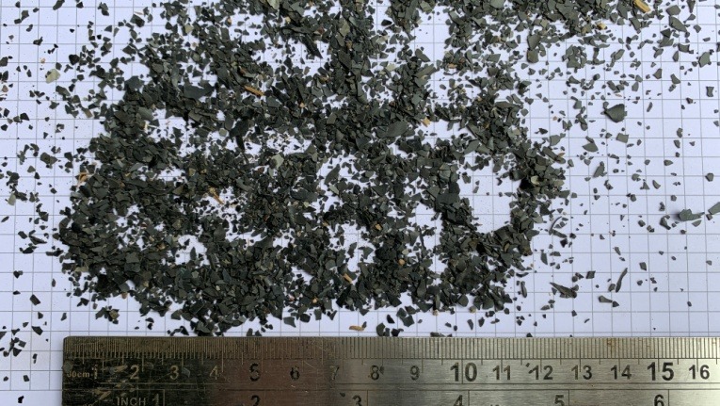
Waste plastic fill media used in cooling towers and trickle filter beds (the shovel helps to understand the scale). | The recycled PVC is in demand by companies manufacturing products such as pipes, gutters and fascias. Material other than PVC such as steel, concrete, wood and soils are separated and recycled as well.

Inputs | Process |  | Outputs
Dirty Plastic (200139, 170302, 170203)  Water (Rainwater harvesting and Mains supply)  Fuel & oils  Flocculants  Equipment  Consumables | Processing for transportation (client site):  Mobile compactor (using dust suppression / wet process) to shred and compact dirty plastic and ensure transportation efficiency (reducing transport CO₂ emissions). |  | Plastic regrind / flake (for manufacturers)  Concrete  Steel  Wood  Soils  Potential for very low levels of Asbestos  General non-hazardous 'litter'  Emissions from equipment and machinery exhausts.  Emissions from employee vehicle exhausts - commute  Emissions from bulk transport vehicles exhausts  Noise - plant and equipment, delivery vehicles and employees  Dust potential - dirty plastic treatment process (wet process)  Storm water  Spent consumables  General wastes - welfare  Potential for Contaminated rags and spill kits - leaks and spills.
Process to Flake stage (Foston Waste Recovery facility):

Tipping and storage awaiting treatment:
Damp plastic tipped in designated area

Pre cleaning:
Dirty plastic processed to remove large foreign objects (concrete, steel and wood)
stone trap / settlement
dewatering screen

Main plant Processing:
Primary Shredder
1st Wash
Dewatering
Quality Control - water check and flocculent additives as required.
2nd Size reduction - (hammer mill)
Float sink Tank
Rinse and dewatering
Drying
Transfer to bulk storage End of Waste status
Quality control - visual check of flake size and contamination and possible return through plastic process.

Notes:
- The process plant is powered by a diesel generator, with additional diesel engines on the Primary shredder and the hammer mill.
- The main process plant is fed by a telehandler
- Dirty plastic delivered to site is wet / damp (for dust suppression reason)
- Precleaning is undertaken outside of operational buildings and is a wet process.
- Main plant plastic processing is undertaken within operational buildings.
- Rainwater is harvested and used to wash the plastic. The dirty water is returned to a water settlement tank
- BMTECH currently have historic piles of part processed plastic which will be processed & sold as regrind product. Going forwards BMTECH do not plan to store dirty plastic material in stock piles. Material will be processed on arrival.
Transfer to PVC Pellets Ltd

Once the product has reached End of Waste status it is sold to PVC Pellets Ltd for further processing as below. PVC Pellets markets and sells the recycled PVC. This section is included simply to finish the process, but is no longer under control of BM Tech Ltd

Bulk storage

Post grading:
Size Screening - Over, medium, fine and under size.
Oversize Size reduction (Hammer mill) to bulk store
Medium , fine and under to holding bin
Quality Control - visual size

Bagging
Bagging area (Regrind / flake)

Dispatch
Bagged product is loaded by forklift truck on to articulated lorry for transport off site
 | R&D works for PVC processing:  Redesign of the compactor to improve efficiency of shredding and compacting material for transport to Foston site  Development of the Precleaning stage | R&D works for future Pelletisation:  Gravity table separation  Pelletiser feed tank  Moisture removal  Additive application  Quality control
* Greenhouse gas reporting: conversion factors 2021 - GOV.UK (www.gov.uk)

