Noise Management Plan
Site details
Site name: Dove Valley Park
Site address: Land North East of Dove Valley Park, Derby
Operator name: Client to Fill??
Permit number: EA to fill??
Who this plan is for
- Who should be made aware of this plan?
Environmental Agency, HSE Superintendent, Site Supervisors, Management Team, Others Designated by the Organisation
- How will they be made aware?
Though normal communication routes, such as presentations, email, post, annual/ monthly management meetings, etc.
Document owner
Document author: Acoustic Consultant Ltd
Version number: V1.0 – 1st Issue
Date: 2022-02-09

List of revisions

Revision number | Revision authorised by | Date submitted to Environment Agency | Revision owner

Contents
Table of Contents
1. Introduction 4
1.1 Site description 4
1.2 Maintenance and review of the NMP 4
1.3 Relevant sector guidance on which this NMP is based 5
2. Receptors 7
2.1. Receptor List 7
3. Noise sources and processes 9
3.1 Noise impact assessment (NIA) conclusion 12
3.2 Noise sources 13
3.3 Overview of noise processes and emissions 15
4. Control measures and process monitoring 18
4.1 Ongoing sound monitoring procedures 18
4.1 Appropriate measures / Best available techniques (BAT) 25
5. Complaints reporting 28

Introduction

1.1 Site description
The site is located at Land North East of Dove Valley Park, Derby. The proposal is for a “Part single, two-storey facility for the extraction, processing, bottling and distribution of water-based products (combined B2 and B8 use), with associated parking and landscaping”.
The nearest noise sensitive residential dwellings are those located to the north on the northern boundary facing Littlemeadow Lane and north west boundary abutting Woodyard Lane. There is also Woodlands farm which is located to the west of the site and next to an existing industrial site.
The main source of noise source currently affecting the site is road traffic in the surrounding road network such as Woodyard Ln, including distant road traffic on A50 (Foston – Hatton – Hilton Bypass) and industrial noise from the existing operations around the site.
It is understood that the site will operate 24 hours, 7 days a week. This includes a mixture of internal/ external plant and HGV movements on both, daytime and night time periods.
It is also understood that the site will be erected in 2 different Phases.

1.2 Maintenance and review of the NMP
- who (job Title) is responsible for the NMP and ensuring people are trained?
The HSE Superintendent or any other designated person with sufficient training/ qualifications should be responsible. The HSE Superintendent / designated person should ensure that staff is trained and the NMP is implemented and followed.
- where is the plan stored?
HSE Superintendent Office / Site Manager’s office
- state when the plan is reviewed
This NMP should be reviewed every 6 months / annually or every time significant changes in operations occur e.g. introduction of new plant, new vehicle routes, etc, including any new operation / mitigation resultant from a complaint
Any new plant/ operation likely to cause noise related issues in future should be assessed by a competent acoustic consultant. The NMP should then be revised if required.
A Risk Assessment to be produced of noise problems from normal and abnormal situations, including worst case scenarios due to, for example, weather, temperature, breakdowns, and accidents. The NMP should be reviewed if required following the risk assessment being produced.
- what training have the staff on site received in order to implement the NMP?
Initial training can be provided by an Acoustic consultant to an HSE Superintendent or another designated site operative.
An initial noise assessment should be carried out by an Acoustic Consultant to verify whether planning limits / BS4142 :2014 rating noise level limits have been archived and noise sources are in line with initial noise model used for the site. Training should then be provided on site to demonstrate how noise monitoring/ measurements should be taken around the site/ at nearest noise sensitive receivers to check whether the noise limits have not been exceeded. Due to the special circumstances of this site and complex noise modelling required for this site, we would recommend the monitoring on site is carried out by an acoustic consultant.
In addition, a desktop noise modelling might also be carried out by an acoustic consultant, using the noise data collected by the HSE/ competent person on site if necessary, e.g where access to the nearest sound sensitive property is not possible, measurements shall be undertaken at an appropriate location and corrected to establish the noise levels at the nearest sound sensitive property. This is also a requirement of the current planning condition 18 (Ref. DMPA/2019/1205).
- any other information you feel is relevant
The residual noise levels at the nearest noise sensitive receivers is understood to be higher than the noise emission level limits imposed by the Planning condition 18, therefore, it might be difficult to determine whether the ambient noise levels measured on site are a result of the site operations of residual sound. Noise levels might need to be undertaken near the noise sources and corrected to establish the noise levels at the nearest sound sensitive receivers if required, to established whether the site’s noise emissions have been achieved.
- who will maintain records of complaints and associated investigations due to noise on site?
HSE Superintendent / Office Manager / Site Manager / Designated competent person by the company / Acoustic Consultant
- who is responsible for carrying out ongoing noise monitoring and acting on the results of this monitoring?
HSE Superintendent (trained) / Competent Person (trained) or Acoustic Consultant.

1.3 Relevant sector guidance on which this NMP is based
- provide titles, sources and publication dates of all guidance referred to when writing this NMP
- British Standard 4142:2014
- British Standard 8233:2014
- Best Available Techniques (BAT) Reference Document for Food, Drink and Milk Industries – 2010/75/EU
- South Derbyshire District Council, Decision Notice Ref. No. DMPA/2019/1205, made valid on 21 October 2019
- Acoustic Consultants Ltd, Noise Impact Assessment Report, 9532 - Dove Valley Park Derby - V1.0 - 1st Issue, dated February 2022
- Noise and vibration management: environmental permits” published on the 23rd of July 2021 (EA)
- ISO 9613-1:1993 – “Acoustics, Attenuation of sound during propagation outdoors — Part 1: Calculation of the absorption of sound by the atmosphere”
- any other information you feel is relevant
We are not aware of any other relevant information at this point, this can however be amended in future if required.

Receptors

2.1. Receptor List

Table 2.1. Receptor list
Receptor reference  (Use to label Fig 2.1) | Land use | Direction from site (north, south, east, west) | Approximate distance to site  boundary (m)
Receptor 1 | Residential | north | 18 metres
Receptor 2 | Residential | north | 31 metres
Receptor 3 | Residential | north | 27 metres
Receptor 4 | Residential | west | 28 metres

Figure 2.1 Map of existing site location and receptors
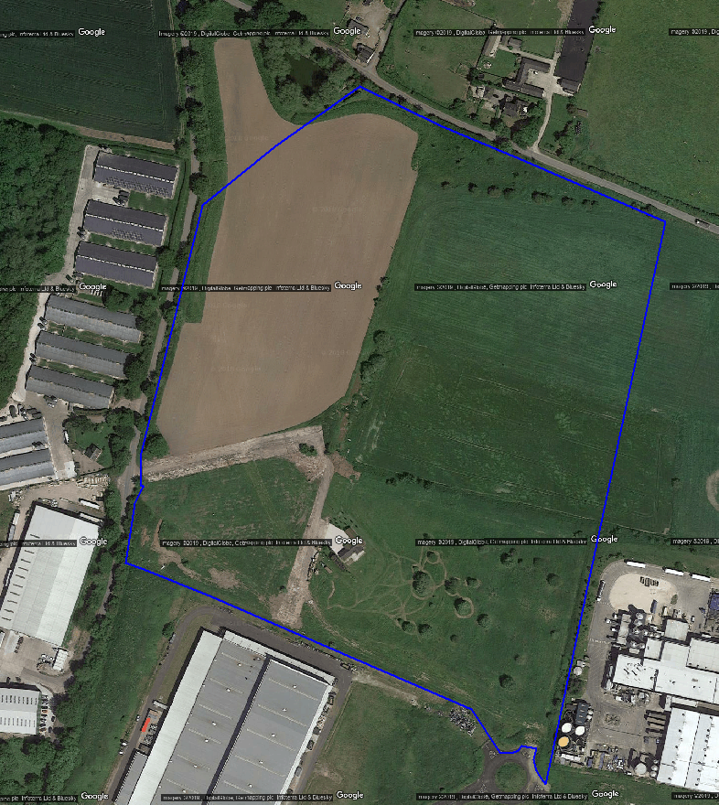
Receiver 4
Receiver 3
Receiver 1
Receiver 2

Noise sources and processes

The proposal is for a “Part single, two-storey facility for the extraction, processing, bottling and distribution of water-based products (combined B2 and B8 use), with associated parking and landscaping”. The site will therefore include a mixture of indoor and external operations.
The main indoor noise sources relate to plant used in the processing, bottling and distribution of water-based products.
External noise sources include external plant such as Chillers and Condenser units located on the northern area of the site, and Air Handling Units (AHU’s) and Extraction Fans (EF’s) on the roof. Special care should be given to the operational levels of the AHU’s and EF’s located on the northern side of the roof, despite the fact that noise modelling suggests these are not likely to have a significant impact upon the northern receivers. There are also other items of plant such as the Sugar Silo on the eastern elevation and smaller condenser units on the western site.
HGV delivery vehicles will also load/ unload goods from/ to site using the loading docks located on the south eastern elevation of the site. Some deliveries might also occur occasionally on the northern site and relate to recycling and gas delivery/ collections. These were found to have some level of impact upon the receivers to the north, however, main vehicle movements on site will occur within the loading dock and to the east of the site, and therefore away from the sensitive receivers. However, the gas deliveries/ recycling collection might need to be monitored to inform on whether they are likely to cause any nuisance upon the sensitive receivers to the north.
Indoor noise levels are based on a similar site in Germany which uses similar processing, bottling and distribution plant. The designated as AVT areas, where the main processing and bottling occurs is considered to be one the noisiest areas and with potential noise impact upon sensitive receivers. Phase 1 and Phase 2 are expected to include at least 4No. AVT areas, each with 2 bottling processing lines, Boiler room and compressor Air rooms both located on the northern elevation are also considered to be key areas where indoor levels are high and with the risk of impacting upon the nearest receivers to the north.
Proposed Condenser units and Chillers located within the plant area on the north side, can also impact upon the receivers to the north and would need to be constantly monitored. Noise emissions from these units were found to have a key role on the noise levels likely to impact upon the nearest receivers to the north. Ventilation plant located on the roof such as AHU’s and EF’s might also have a key role on the overall level impacting upon the receivers, however, these will be fitted with attenuators and orientated away from this receivers and noise predictions suggest have less impact than when compared to Condenser units and Chillers. Nevertheless, regular inspections/ maintenance/ monitoring should occur to ensure noise emissions meet the noise limits at the nearest receivers.
Noise sources currently proposed and used in the noise model predictions are shown in more detail in the ACL’s Noise Impact Assessment Report, 9532 - Dove Valley Park Derby - V1.0 - 1st Issue, dated February 2022.
The key industrial areas to be considered in this NMP with higher risk of impacting upon the nearest receivers according to the noise models and predictions carried out are shown below in Figure 3.3.

Figure 3.3 Map of indicative industrial site location and receptors
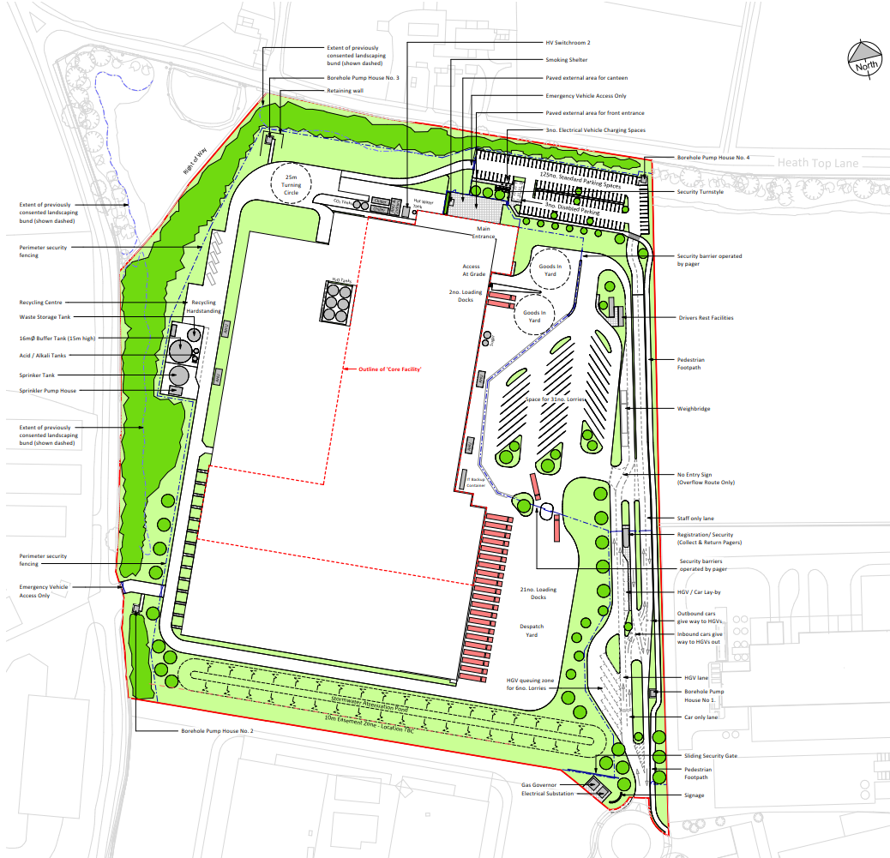
Roof’s AHU / Ventilation Plant
Boiler Rooms/ Compressor Room
AVT Areas (Phase 2)
AVT Areas (Phase 1)
Condensers/ Chillers
Gas/ Recycling Delivery
Sugar Silo / Delivery
Receiver 4

3.1 Noise impact assessment (NIA) conclusion
- state the overall conclusion of the noise impact assessment (low / below adverse / adverse / significant adverse impact) and the location at which this impact occurs.
The BS4142:2014 noise impact assessment carried out in ACL’s report 9532 – Dove Valley Park Derby – B1.0 – 1st Issue was determined to be of a low impact when compared to the background noise levels obtained at the nearest noise sensitive receivers.
In addition, the predicted worst-case noise level emission L_{Aeq, T} at the nearest noise sensitive receivers are also expected to meet the planning condition 18, which are considered by us to be more onerous than when rating levels are assessed against background noise levels in accordance with BS4142:2014. We would consider the current proposals to be acceptable and to have a low impact at all the noise sensitive receivers around the site.
- describe any important contextual points
It was concluded that once context is considered and the noise impact of the proposed site operation is compared to the existing noise climate, plus internal noise levels compared to the relevant adopted guidance of BS8233, then it is clear that the proposed site will be acceptable when assessed to British Standard 4142:2014.
- state which sound sources on site are dominant at nearby receptors
Based on the 3D noise model of the site, the predominant noise sources affecting the northern receivers (worst case) are the northern operations and plant including mainly the Chillers & Condenser units located on the northern area. The operational internal noise levels breaking out from the processing areas (AVT), Boiler Room, Compressor rooms and vehicle movements along the northern yard area also contribute to the overall cumulative level received at the nearest worst affect receivers to the north. In addition, the sugar silo ‘filter’ located on the eastern façade might also have a significant noise impact upon these receivers, depending whether the main noise source areas are located in relation to the ground floor level and whether are a line of sight upon these receivers.

3.2 Noise sources

Table 3.2 Description of noise emitting processes
Noise source | Sound power level (dBA) | Sound pressure level (dBA) | Measurement distance (m) | Operational conditions | Additional comments
HGV Movements Incoming Goods) | 96 | 68 | 10 | 4 deliveries / per hour between (07:00 – 23:30) and 1 delivery per 15 minutes between (23:00 – 07:00 hrs) | Measurement taken on site, at 10 metres, level measured from passing by vehicle
HGV Movements (CO2/N2 H2O Vehicle Supply) | 96 | 68 | 10 | 1 deliveries / per hour between (07:00 – 23:30) and 1 delivery per 15 minutes between (23:00 – 07:00 hrs) | Measurement taken on site, at 10 metres, level measured from passing by vehicle
Silo ‘Filter’ | 89 | 86 | 1 | Assumed continuous 24 hours | Measurement location to be determine on site
Chiller | 82.2 | 53 | 10 |  | Site measurements are expected to be lower than sound power noise levels used in modelling (worst case)
Condenser Units - COND-01 | 78.3 | 70.3 | 1
Condenser Units - COND-04, 05, 07, 08, 09 and 10 | 70 | 62 | 1
AVT (processing Area), indoor Level | - | 87 | Indoor Level | Assumed continuous 24 hours | Indoor sound pressure noise level of AVT Areas (to be obtained near walls, or area representative of level at roof before breaking out; If louvred door is present, then level should also be taken outside the door
Boiler Room | - | 65 |  |  | Indoor sound pressure noise level within the room; If louvred door is present, then level should also be taken outside the door
Compressed Air LP/HP | - | 84
Cooling Central | - | 85
AHU 01 (Casing) – Plant Located on the roof to the north above offices | 63 | 56 | 1 |  | It might be difficult to obtain casing breakout / supply / extract level alone without the effect of other surrounding units, nevertheless, the level at close proximity of the unit should be taken if possible, Supply & Extract levels assume fitted attenuators
AHU 01 (supply/ exhaust) – Plant Located on the roof to the north above offices | 62 / 62 | 54 / 54
AHU 02 (Casing) – Plant Located on the roof to the north above offices | 65 | 57
AHU 02 (supply/ exhaust) – Plant Located on the roof to the north above offices | 63 / 71 | 55 / 63
AHU 03 (Casing) – Plant Located on the roof to the north above offices | 65 | 57
AHU 03 (supply/ exhaust) – Plant Located on the roof to the north above offices | 64 / 68 | 56 / 60
EF-03 / 04 / 05 Casing – Plant Located on the roof above the Cooling Centre | 70 | 62
EF-03 / 04 / 05-ATMOSPHERIC-extract-fan | 76 | 68

3.3 Overview of noise processes and emissions
Provide a description (whether text / diagrams or tables) of the site layout and the processes carried out including the information in the bullet points below as a minimum. Use Figure 3.4 as a guide to show the site infrastructure relevant to any noise emitting processes carried out and the sound emission locations on your site e.g.
- name and type of buildings,
Industrial Building for bottling processing, with HGV loading/ unloading and movements, and external plant
- loading and unloading areas,
Mainly loading/ unloading areas to occur on the south east side of the building and away from sensitive receivers; Some deliveries might also occur occasionally on the northern site and relate to recycling and gas delivery/ collections. These were found to have some level of impact upon the receivers to the north, however, main vehicle movements on site will occur within the loading dock and to the east of the site, and therefore away from the sensitive receivers. However, the gas deliveries/ recycling collection might need to be monitored to inform on whether they are likely to cause any nuisance upon the sensitive receivers to the north.
- routes which mobile plant take on site,
HGV Routes with potential impact upon the northern receivers (worst case) are shown in Figure 3.4 below
- locations of static equipment,
The predominant external static noise sources (plant) are shown in Figure 3.4 below
- storage areas,
Main storage area to be located on the south east and away from sensitive receivers, there is also an incoming goods area on the north eastern side of the building and next to the offices, however, the number of vehicles using this area will be low in comparison with main storage areas on the south east outgoing goods area (loading bay)
- processing areas,
AVT bottling processing areas are shown in Figure 3.4 below
- which activities create the most noise,
These are explained in Section 3 above, and are northern external fixed plant (Condensers/ Chillers), ventilation plant on the roof above offices (northern area), Silo Sugar on the North Eastern elevation, vehicle movements. Operational noise levels such as the ones occurring within the boiler room, compressor room, cooling central along the northern elevation might also contribute significantly to the cumulative level received at the northern receivers.
- fixed plant and layout of equipment,
This is shown in Figure 3.4 below and in more detail in ACL’s Noise Impact Assessment report 9532 - Dove Valley Park Derby - V1.0 - 1st Issue.
- locations of mobile plant,
No mobile plant has been proposed externally, apart from HGV’s accessing/ leaving the site.
- noise emission points,
In the areas identified in Figure 3.4 and more specifically within ACL’s Noise Impact Assessment report 9532 - Dove Valley Park Derby - V1.0 - 1st Issue, including noise model of the site also provided
- any other information you feel is relevant
No additional info to be added at this point, to be added in future if required

Figure 3.4 – Site plan showing locations of noise emitting processes, with routes shown of mobile noise emitting sources, fix Sources (Plant), Indoor Levels Breaking Out
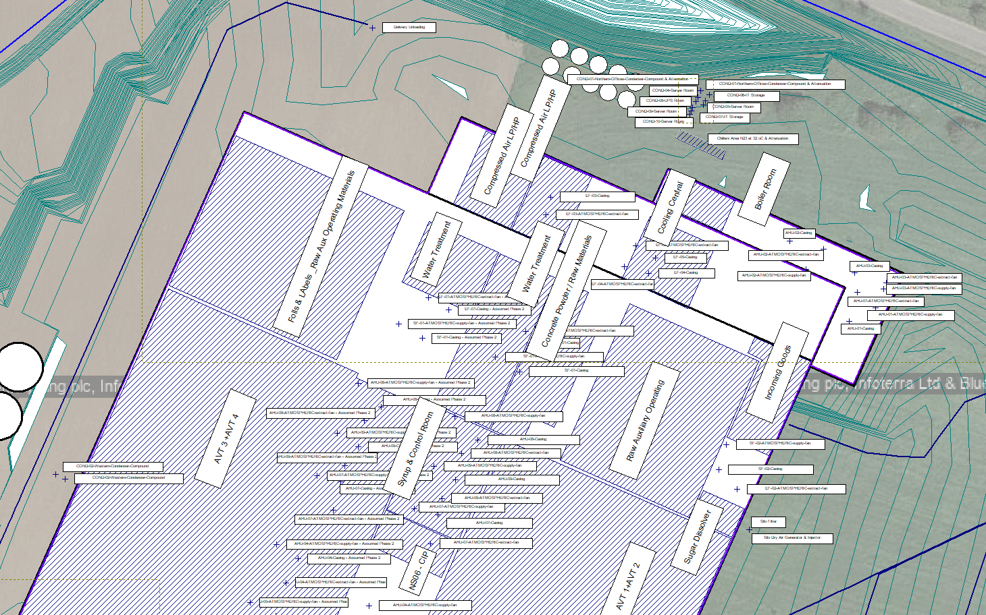
Cooling Central
Boiler Room
Compressor Air
HGV route to/ from Incoming Good Area
HGV route to/ from loading bay
Sugar Silo Filter
Ventilation Plant on Roof
AVT’s Processing Areas
AVT’s Processing Areas
Condenser Units & Chiller

Gas/ Recycling Delivery and circuit

Control measures and process monitoring

4.1 Ongoing sound monitoring procedures

A Noise Monitoring Plan at the noise sensitive receivers should be implemented every 6 months/ 12 months and around the site as specified above. Once installed, items of plant should be assessed to validate noise levels used in the model above or where they are found to be different than the above considered. This should be completed by an acoustic consultant, using Class 2 (minimum) sound level meters. The noise monitoring should be completed under normal conditions, to check compliance with the limits below, which are based on the more stringent noise level emission limits stated in Planning Condition 18. Any subsequent monitoring exercise can be carried out by a trained competent person if required.
By complying with the planning condition 18 specific noise limits, we would also consider that the resultant noise rating levels L_{Ar,T} at the nearest noise sensitive receivers will be acceptable in accordance with BS4142:2014 and the noise impact assessment will result in a low significant impact.

Table 4.1 Noise Limits at Noise Sensitive Receivers
Parameter | Planning Condition 18  Specific Noise Level Limits,  L_{Aeq, T} (dB) | BS4142:2014  Noise Rating Limits,  L_{Ar, T} (dB)
Daytime (07:00 – 23:00 hours) | 44 dB L_{Aeq(1 hour)} | 50 L_{Ar (1 hour)}
Night Time (23:00 – 07:00 hours) | 41 dB L_{Aeq(15mins)} | 46 L_{Ar (15 min)}

However, access to the nearest residential properties might not be granted or it might not be possible to distinguish each individual noise source or cumulative industrial noise level from the site at these locations. Therefore, additional measurements at close proximity from the sources should be taken.
Previously determined ambient noise levels on site along the northern boundary, suggests that the residual noise levels were already above the rating noise limits L_{Ar, T} and Specific Noise Level Limits L_{Aeq, T} imposed by planning condition 18.
For these reasons, noise levels will need to be obtained at different locations around the site, in particular along the northern boundary of the site (worst case), and in close proximity of the predominant noise sources and assess the likely impact at the nearest receivers using the noise modelling.
We would propose carrying out at the following locations, which should allow us to check the validity of our initial model use.

Figure 4.1 – plan showing locations of sound measurement positions used to monitor sound from the site.
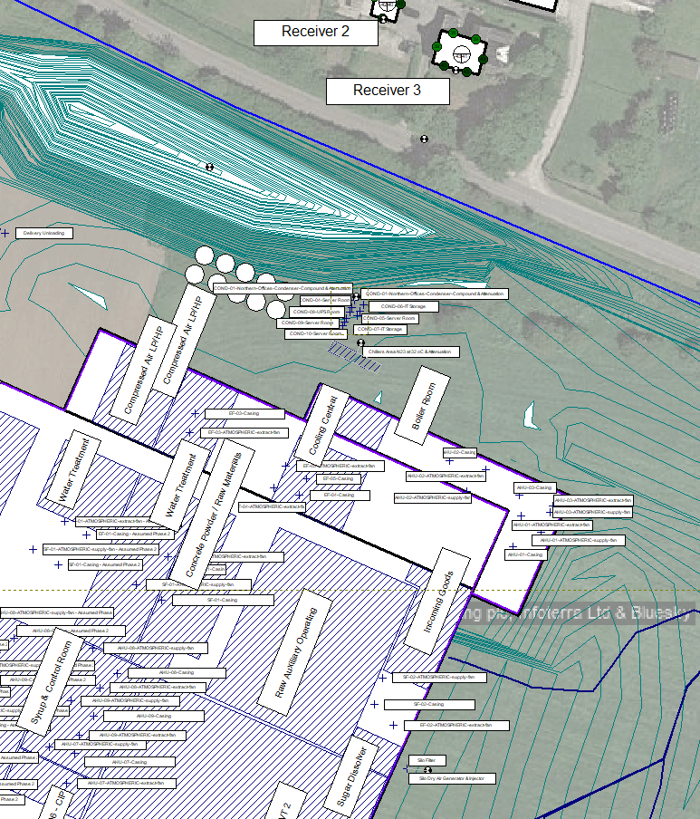
Location H
Location G
Location F
Location F
Location E
Location D
Location C
Location B
Location A

Table 4.1 Description of the sound monitoring procedures
Measurement Location | Frequency of measurement | Minimum measurement duration | Measurement period | Operating conditions on site | Expected specific sound level (2)
A | Every 6 months / 1 year | 24 hours | Continuous, min. 24 hours | Cumulative Noise Impacting Upon residents to the north, at monitoring location representative of monitoring location prior to site being erected. | Below 45 dB L_{Aeq,1hour}
 |  | 24 hours | Continuous, min. 24 hours |  | Below 45 dB L_{Aeq,15min}
B |  | 1 hour | Within operational hours (07:00 – 23:00) | Noise Level at NSR (if access is not granted, alternative location can be used, e.g along the public assess road / boundary of NSR  Measurements to be taken at 1.5 metres above ground | Below 41 dB L_{Aeq,1hour}
 |  | 1 hour | Within operational hours (23:00 – 07:00) |  | Below 41 dB L_{Aeq,15min}
C |  | 1 minute (Condenser Units ON) / 1 minute (Condenser Units / OFF); if plant cannot be switched off, then ON scenario should be measured (not ideal) | Within operational hours (07:00 – 23:00); | Ideally an ON/ OFF exercise should be carried out at this location to determine the levels emitted from Condenser Units. If not possible, only ON measurements should be carried out, of each individual unit at 1 metre distance instead.  Ideally the measurements should be carried out during a periods of low external activity e.g. lower HGV movement  Measurements to be taken at 1.5 metres above ground | Below 68 L_{Aeq,1min}
 |  |  | Within operational hours (23:00 – 07:00); Night Time measurements only if set to operate at lower |  | Below 68 L_{Aeq,1min}
D |  | 1 minute (Chiller Units ON) / 1 minute (Chillers / OFF); if plant cannot be switched off, then ON scenario should be measured (not ideal) | Within operational hours (07:00 – 23:00); Night Time measurements only if set to operate at lower level | Ideally an ON/ OFF exercise should be carried out at this location to determine the levels emitted from the chiller. If not possible, only ON measurements should be carried out at 2.5 metre distance instead.  Ideally the measurements should be carried out during a periods of low external activity e.g. lower HGV movement  Measurements to be taken at 1.5 metres above ground | Below 62 L_{Aeq,1min}
E |  | 1 minute (Silo Filter ON) / 1 minute (Silo Filter / OFF); if plant cannot be switched off, then ON scenario should be measured (not ideal) | Within operational hours (07:00 – 23:00); Night Time measurements only if set to operate at lower level | Ideally an ON/ OFF exercise should be carried out at this location to determine the levels emitted from the chiller. If not possible, only ON measurements should be carried out at 5 metre distance instead from silo; This might need to be revised once silo is initialled and main noise source location located  Ideally the measurements should be carried out during a periods of low external activity e.g. lower HGV movement  Measurements to be taken at 1.5 metres above ground | Below 76 L_{Aeq,1min}
F - AVT  (processing areas indoors) |  | 1-minute Samples (different location within the room) Continuous monitoring within the room representative of noise breaking out/ typical indoor level | Daytime samples within operational hours (07:00 – 23:00); 24-hour monitoring after | Samples of indoor noise levels should be measured around the room in different locations (To be determined on site once operations are established) and near façades. Long term monitoring can then be carried out continuously during 24 hours to establish typical worst-case daytime and night time levels | Below 87 dB L_{Aeq,1 hour} / L_{Aeq,15 min}
G - Compressor Air LP/ HP |  | 1-minute Samples (different location within the room) | Within operational hours (07:00 – 23:00); Night Time measurements only if set to operate at lower level | Samples of indoor noise levels should be measured within the room in different locations | Below 83 dB L_{Aeq,1 hour} / L_{Aeq,15 min}
H - Boiler Room |  | 1-minute Samples (different location within the room) | Within operational hours (07:00 – 23:00); Night Time measurements only if set to operate at lower level | Samples of indoor noise levels should be measured within the room in different locations | Below 65 dB L_{Aeq,1 hour} / L_{Aeq,15 min}
(1) Specific Sound Level estimated based on noise modelling predictions using Cadna:A noise mapping at the monitoring location and which is expected to meet the planning condition noise emission limits / and BS4142:2014 rating noise level limits (low impact) at the NSR’s.
(2) Please note that the exceedance of the specific noise levels / indoor noise levels shown above in the table does not necessarily mean exceedance of the noise limits imposed by the planning condition 18 / BS4142:2014 rating noise levels below background noise; A noise impact assessment might need to be carried out by an acoustic consultant to assess the impact upon the nearest noise sensitive receivers by correcting back the levels measured at close proximity, using the initial noise model, or other means. This should be supported by a noise impact assessment report.
Provide a description (whether text / diagrams or tables) of the procedure which will be implemented if sound levels are measured which are in excess of the expected results in Table 4.1 above.
- who will be responsible for carrying out the investigation?
An initial assessment/ monitoring should be carried out by an acoustic consultant. The NMP should be amended including noise sources and mitigation used in the initial model of the site if required. Once baseline noise levels / plant levels are determined, and it has been confirmed that noise levels at the nearest noise sensitive receivers are in line with noise limits, then monitoring measurements should occur every 6 months / yearly.
The specific noise levels above are based on noise modelling predictions using CadnaA software and worst-case sound pressure / sound power noise source levels. Where recommended noise levels at each monitoring position are exceeded (or revised ones following initial assessment if require), these should be communicated to an acoustic consultant that should investigate the cause of that exceedance and determine whether that exceedance is likely to impact adversely upon the nearest noise sensitive receivers;
Please note that residual noise levels obtained on site before the erection of the development suggest that these were already above the noise emission limits imposed by the planning condition 18 / BS4142:2014 noise limits. It is therefore anticipated that noise levels from the site operations when measured at close proximity of the receivers will not be distinguishable against ambient levels previously measured.

- what immediate steps will be taken in the short term to reduce sound levels?
A noise consultant should be contacted, which should then investigate further if required. If the noise source has been identified and is not operating as initially estimated/ measured in the initial assessment, then this should be mitigated asap.
- what steps will be taken in the long term to reduce sound levels?
Where plant is to be replaced, then quieter plant should be used always where possible. Any new plant/ operation likely to cause noise related issues in future should be assessed by a competent acoustic consultant
- When will equipment be replaced?
The plant should be inspected and should be maintained as instructed by its supplier;

4.1 Appropriate measures / Best available techniques (BAT)

Table 4.2 Actions and procedures which will be in place to achieve appropriate measures / best available techniques (BAT)
Activity which produces noise | Operational Hours | Control measures (Appropriate Measure / BAT) | Contribution to overall impact | Action taken if outside optimum process parameters
Condenser Units / Chillers / Silo Filter | Continuous 24 hours | Check whether plant is running as designed, and whether attenuators have been fitted and as designed (depending on the condenser types used/ measured site levels, these might require additional attenuation as stated in ACL’s NIA report) | High | Cease operation and investigate reasons for elevated sound levels. Mitigation might include replacement of unit by a quiet one, additional attenuation (specialist acoustic enclosures, fitted attenuators, noise barriers)
AVT, processing bottling / Boiler Area / Compressor Air | Continuous 24 hours | Check whether typical indoor noise levels likely to break out are in accordance with initial design modelling,  Check whether there are any weak breaking out points along the façade / roof.  Check whether plant has been maintained and running as initially designed and in accordance with manufacturer instructions | Medium | Cease operation and investigate reasons for elevated sound levels. Mitigation might include replacement of plant parts/ local screens, barriers, plant encasement, etc
HGV movements | Continuous 24 hours | Control vehicle speeds on site, routes as per design, include signs which state no use of horns / reverse alarms at night, assuming Health and Safety allows it. Reduce the amount of times delivery bay doors are open when loading/ unloading goods | Medium | Cease operation and investigate reasons for elevated sound levels.  Determine whether speed used on site is appropriate, routes have been followed as designed, change vehicles movements to periods of the day/ night where residual noise levels are higher;  Determine whether no used of horns/ reverse alarms at night have been followed.
Ventilation Plant/ Roof | Continuous 24 hours | Ventilation grilles/ terminals should be orientated away from northern receivers as shown in the M&E proposals. Daily visual inspection, yearly full mechanical inspections and in accordance with manufacturer  Check whether attenuation fitted are in accordance with initial design  Where parapets are present, check whether there are any significant penetration that could compromise the noise barrier effect | Medium | Check whether ventilation plant is running as designed / attenuators are fitted and provide sufficient attenuation

Complaints reporting
Detail the protocol for each stage of your complaints response:
- Recording
Provide nearby residents with the direct telephone number to the store/security to ensure an open communication line is available if required. All complaints should be recorded by management and investigated

- Investigation
Investigate the cause of complain within 48 hours. If there is a noise risk this to be supported by a noise assessment by a suitably qualified acoustician. The outcome of the investigation to be issued to the complainants.

- notification of EA
Notify the EA if there is noise risk following a noise complaint and investigation outcome

- remedial action
Any remedial action should be assessed by a suitably qualified acoustician and implemented asap
- feedback to complainants and EA
Keep the complaints and EA updated of the outcomes of the investigation, proposed remedial works, timescales.

Ensure that your procedures are in line with your permit and include a review and improvement cycle following complaints.
The noise management plan should be reviewed, following a complaint if required. The review should also consider land use around the facility and any future developments that may increase the impact.

