Go 4 Greener

AEROBIC DIGESTER

**Environmental Permit Variation Application**

**Non-Technical Summary**

CONTENTS

* 1. INTRODUCTION 2
  2. The Site 2
  3. Aerobic Digestion 2

1. OVERVIEW OF PROPOSED DEVELOPMENT 4
2. PERMITTED WASTE OPERATIONS 6
   1. Waste Types and Quantities 6
   2. Waste Storage 6
3. APPLICATION OVERVIEW 8
   1. Application Forms 8
   2. Drawings 8
   3. Environmental Risk Assessment 8
   4. Site Condition Report 8
   5. Operations and Environmental Management Plan 8
4. KEY TECHNICAL STANDARDS 9
5. CONCLUSION 9

DOCUMENT REFERENCES

TABLES

Table 1 List of Wastes Proposed for Acceptance 6

FIGURES

Figure 1 - Aerobic Digestion Process Overview 3

Figure 2 – Process Flow Diagram of Site Treatment and Storage 5

Figure 3 - Advetec Installation at Cribbs Causeway 5

DRAWINGS

Drawing EP1 Site Location Plan

Drawing EP2 Environmental Permit Boundary Drawing EP3 Environmental Site Setting

G4G V6- Site Plan Drawing

# INTRODUCTION

This is an application to vary Go 4 Greener Waste Management’s (G4G) existing environmental permit (EPR/FB3104FY) to include the operation of an Advetec unit for the treatment of residual waste generated at G4G’s Waste Treatment Transfer Station. The application involves an aerobic digestion system, to be operated by G4G and will be located at Go 4 Greener Waste Management, 201 Slack Lane, Derby DE22 3EE (hereafter referred to as ‘the Site’).

This Non-Technical Summary (NTS) provides a summary of what is being applied for, the regulated facility and outlines the key technical standard and control measures that will be implemented at the Site as a result of the risk assessments.

## The Site

The Site is located at 201 Slack Lane, Derby DE22 3EE, centered on National Grid Reference (NGR) SK 33580 36194.

Immediately to the north and east lies residential housing and apartments. Immediately to the south and west lies industrial and commercial properties.

Further information on the Site’s setting can be found in the Environmental Risk Assessment in Section 4 of the application and also in the Fire Protection Plan which details local receptors.

The site is accessed via Slack Lane to the North entrance.

The Site Location and the Environmental Permit Boundary is illustrated in Annex 17, can be found as an attached document with this application.

## Aerobic Digestion

Aerobic digestion is a natural bacterial process in which micro-organisms breakdown organic material in the presence of oxygen. Aerobic bacteria digest and consume the organic material, typically only producing by- products of heat, water vapour, carbon dioxide (CO2) and a post-process floc.

Aerobic digestion has typically been used to treat sewage sludge however the process has been proved to also be an effective method of solid waste treatment, reducing volume, mass and moisture content and enabling simpler handling for the operator. The process is able to accept a range of feedstocks including food waste, green waste, selected industrial waste and food by-products.

A diagrammatic overview of an aerobic digestion process is provided as Figure 1.

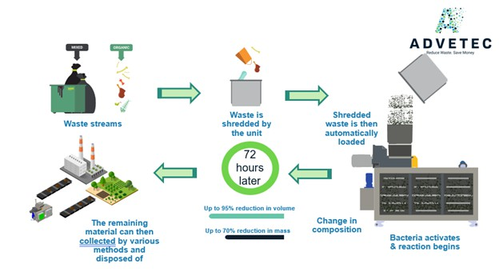

##### Figure 1 - Aerobic Digestion Process Overview

# OVERVIEW OF PROPOSED DEVELOPMENT

The proposed G4G aerobic digester will only accept waste accepted into the transfer station namely offensive washrooms waste.

Advetec have produced a range of aerobic digester systems. It is proposed that Advetec’s XO22 model is installed at G4G’s site.

Initially, G4G proposes to install one XO22 unit at the Site which will accept up to 10 tonnes of waste per day, approximately 2800 tonnes per annum. Following digestion, an approximate mass reduction of 51.9%, resulting in an approximate output of 5 tonnes per day of floc suitable for onwards recovery off-site as Solid Recovered Fuel (SRF).

Depending on the success of the XO22 unit, G4G may install another XO22 unit with the potential to accept a further 10 tonnes of waste per day. The Site would then accept up to 20 tonnes of waste per day across two Advetec units which equates to approximately 5600 tonnes per annum.

This permit variation application seeks to allow the treatment of no more than 20 tonnes of non-hazardous waste per day, equating to 5600 tonnes per annum.

The waste will be loaded into a hopper which connects to a shredder, both of which will be located internally in the building. The RS50 shredder will shred the waste into 80mm2 particle size, the shredded waste is then augered into the digester, where bacteria and bio-stimulants are automatically dosed into the waste. The digester will be located internally.

Trials completed by Advetec using the same process on the offensive washrooms waste concluded that:

* The material has a high moisture content ideal for aerobic digestion and mass reduction
* The material has a high organic content and calorific value ideal for the production of fuel.

Test results from the initial trial showing the gross calorific value and element content of the material produced are shown below:

The XO22 has four chambers, with an internal mass of 22m3 at any given point, through which the waste is moved for digestion. Movement is by a centralized shaft with engineered paddles that rotate according to pre- programmed algorithms. The paddles allow the system to stay aerobic while ensuring residence, and index mass throughout the process.

The only by-products of the aerobic digestion system are water vapour, carbon dioxide, condensate and a post- process residue (floc). The process uses exothermic aerobic respiration; therefore, it generates its own heat which is channelled internally back into the process, using a closed-loop heating system. The process does not use water. Condensate will be vented into the atmosphere.

The entire aerobic digestion process takes approximately 72 hours to complete, after completion the post- process floc will be collected internally within the main building. It will be collected into a holding bay and dry stored until collection / haulage off site.

A basic process flow diagram of this process is provided as Figure 2.

Offensive waste

18-01-04

Waste undergoes aerobic digestion

Post-process floc collected internally within the main building

Post- process floc is dry stored in holding bay until collection/ haulage off site.

##### Figure 2 – Process Flow Diagram of Site Treatment and Storage

The XO22 is accessible via a regulated cloud-based portal. Data points are collected, logged and stored at programmable intervals, including temperature, humidity, rotational speeds, emissions monitoring, power consumption, maintenance schedules. Alert and alarm levels are programmed into the system to notify in the event of system errors or parameters moving out of range. There is also an in-line gas monitoring system which continuously monitors levels of methane (CH4), carbon monoxide (CO), volatile organic compound (VOCs) and sulphur dioxide (SO2), which in the event of detection of any of these parameters, an alarm is raised. To mitigate against any possible odours from the process, an odour abatement system is fitted within the XO22 whereby the by-products of water vapour and carbon dioxide are vented to the atmosphere through a passive drum scrubber.

A picture of an XO3 unit which treats up to 1.5 tonnes of waste per day can be seen in Figure 3 for illustrative purposes only.

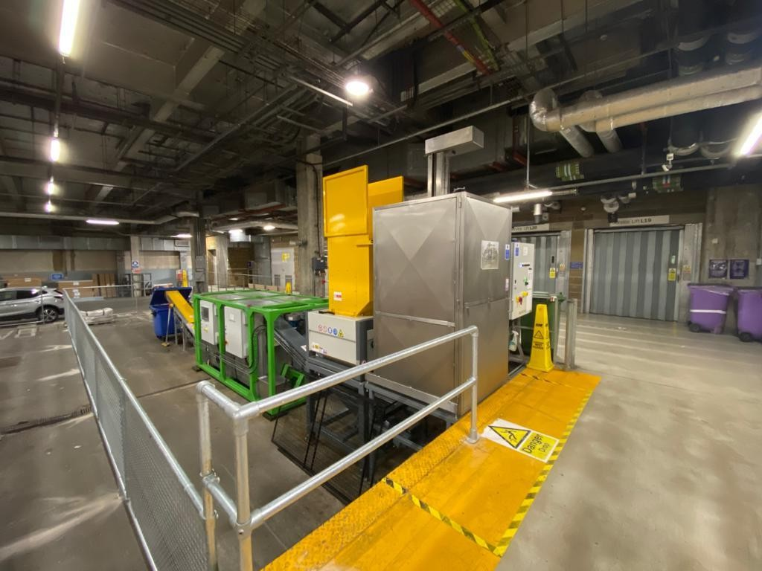

##### Figure 3 - Advetec Installation at Cribbs Causeway

# PERMITTED WASTE OPERATIONS

The activities at the Site will be regulated as a bespoke waste operation as per the Environmental Permitting (England and Wales) Regulations 2016 (as amended).

This permit application seeks to vary G4G’s existing bespoke permit, EPR/FB3104FY to a bespoke permit to include the use of an Advetec aerobic digestor.

Waste management activities as described in the Waste Framework Directive 2008, which are currently undertaken as part of the waste transfer operation on site include:

* D15 - Storage pending any of the operations numbered D1 to D14 (excluding temporary storage, pending collection, on the site where it is produced);
* R13 - Storage of wastes pending any of the operations numbered R1 to R12 (excluding temporary storage, pending collection, on the site where it is produced);
* D14 - Repackaging prior to submission to any of the operations numbered D1 to 13;
* D9 - Physio-chemical treatment not specified elsewhere in Annex IIA which results in final compounds or mixtures which are discarded by means of any of the operations numbered D1 to D8 and D10 to D12;
* R3 - Recycling/reclamation of organic substances which are not used as solvents;
* R4 - Recycling/reclamation of metals and metal compounds; and
* R5 - Recycling/reclamation of other inorganic materials.

The following waste management activities as described in the Waste Framework Directive 2008 will be undertaken at the Site as part of the aerobic digestion process. These include:

* R3 - Recycling or reclamation of organic substances that are not used as solvents;
* R5 - Recycling/reclamation of other inorganic materials; and
* R12 - Exchange of wastes for submission to any of the operations numbered R1 to R 11.

## Waste Types and Quantities

The maximum quantity of waste proposed for treatment by aerobic digestion is up to 26 tonnes per day, 9,490 tonnes per annum. Table 1 lists the wastes which are proposed for treatment by aerobic digestion.

##### Table 1

##### List of Wastes Proposed for Acceptance

|  |  |
| --- | --- |
| List of Waste Code | Description |
| 18 | **WASTES FROM HUMAN OR ANIMAL HEALTH CARE AND/OR RELATED RESEARCH (except kitchen and restaurant wastes not arising from immediate health care)** |
| 18-01-04 | Offensive waste |

## Waste Storage

Waste awaiting processing will be stored within a holding bay at G4G’s Waste Transfer Station in accordance with their currently permitted arrangements on Site.

The post-process floc will be collected internally within the main building. It will be collected into a holding bay and dry stored until collection / haulage off site.

# APPLICATION OVERVIEW

This environmental permit application describes how the Site has been designed and will be operated in accordance with the relevant technical standards. In addition to this Non-Technical Summary, the application comprises the following elements, each of which are described below:

* Section 2 - Application forms (Parts A, B4 and F1);
* Section 3 – Drawings;
* Section 4 - Environmental Risk Assessment;
* Section 5 – Site Condition Report; and
* Section 6 – Operations and Environmental Management Plan.

## Application Forms

Parts A, C2, C4, and F1 of the EA’s application forms have been completed in support of the application and are enclosed as Section 2 of the application.

## Drawings

Section 3 contains drawings for the Site, these include:

* + - Drawing EP1 Site Location Plan;
    - Drawing EP2 Environmental Permit Boundary;
    - Drawing EP3 Environmental Site Setting; and

## Environmental Risk Assessment

The Environmental Risk Assessment has considered odour, fugitive emissions, dust, releases to water, litter, mud, birds, vermin and insects, and potential for accidents and incidents. The assessment concludes that with the implementation of the risk management measures described, potential hazards from the proposed development are not likely to be significant.

The Environmental Risk Assessment is enclosed in Section 4 of this application.

## Site Condition Report

The Site Condition Report details the condition of soil and groundwater at the Site. It contains the information necessary to determine the current state of soil and groundwater conditions at the Site, so that a comparison can be undertaken upon the eventual cessation of activities.

A copy of the Site Condition Report is provided in Section 5 of this application.

## Operations and Environmental Management Plan

The OEMP describes how the Site has been designed and will be operated in accordance with relevant technical standards and guidance. The document includes an overview of the technology, operational processes, emissions monitoring and reporting implemented at the Site.

The OEMP is enclosed in Section 6 of this application.

# KEY TECHNICAL STANDARDS

Key technical standards laid out in the following documents have governed the design and proposed operation of the Site:

* Develop a management system: environmental permits,;
* Control and monitor emissions for your environmental permit,
* Environmental Permitting Regulations - Site Condition Reports Guidance and Templates’ (version 3 April 2013);
* Risk assessments for your environmental permit,
* Biological waste treatment: appropriate measures for permitted facilities,

Due to the small scale of the aerobic digester, the risk to sensitive receptors is considered low. However, the following control measures that are necessary to ensure the Site does not give rise to significant environmental impact have been determined through the risk assessment process and are summarised below:

* Activities are managed in accordance with an environmental management system;
* Performance against the management system is audited at regular intervals;
* Odour management measures will be employed to ensure odour emissions are minimised from the Site;
  + A carbon filter is fitted to the aerobic digestor to abate against odours; and
  + Post-process floc will be collected internally within the main building. It will be collected into a holding bay and dry stored until collection / haulage off site.
* Noise management measures will be employed to minimise emissions of noise including;
  + Machinery is operated so as to minimise noise;
  + Vehicles adhere to a speed limit when accessing the Site.
* Strict waste acceptance procedures, detailed in the OEMP, will be adhered to prevent odour and contamination.
* Daily observational monitoring is undertaken at the Site boundary, for odour, noise and dust emissions.

# CONCLUSION

The overall conclusion from the studies undertaken as part of the application is that there is unlikely to be a significant environmental impact as a result of the proposed operation of the Aerobic Digester.

Go 4 Greener waste management is fully committed to ensuring the highest standards are met and will undertake its activities in a manner consistent with best industrial practices and in accordance with the company’s environmental policy and management system.

It is therefore considered that the permit variation should be issued as detailed above.