Berkswell Quarry
784-B031730

Hydrogeological Risk Assessment, Version 2

Purpose of Issue

Purpose of Issue
H.D. Rickets
February 2024
Document prepared on behalf of Tetra Tech Limited. Registered in England number: 01959704

DOCUMENT CONTROL
Document: | Hydrogeological Risk Assessment
Project: | Berkswell Quarry
Client: | H.D. Rickets
Project Number: | 784-B031730
Revision: | 002 | Prepared by: | Peter Murphy BSc MSc FGS  Principal Hydrogeologist
Date: | 09/02/2024
Status: | Final | Checked by: | Adam James BSc MSc FGS  Associate
Description of Revision: | Version 2 | Approved By: | Conor Lydon MSc, BSc, CEnv, FGS  Director

Table of Contents
1.0 Introduction 1
1.1 Instruction and Background 1
1.2 Proposed Development 2
1.3 Report Objectives and Aims 2
1.4 Scope of works and Methodology 2
1.5 Limitations 3
2.0 Site Setting 4
2.1 Introduction 4
2.2 Site Location 4
2.3 Site History 4
2.4 Topography 5
2.5 Geology 5
2.6 Registered Historic Landfill Sites 7
2.7 Hydrology 8
2.8 Hydrogeology 13
3.0 Conceptual Site Model 26
3.1 Introduction 26
3.2 Source Term Charateristics 26
3.3 Pathways 27
3.4 Receptors 28
3.5 Summary of Conceptual Site Model 29
4.0 Hydrogeological Risk Assessment 32
4.1 Justification for Modelling Approach 32
4.2 Site Subdivision – Source Areas 33
4.3 The Priority Contaminants to be Modelled 33
4.4 Environmental Assessment Levels 33
4.5 Water Balance 33
4.6 Model Scenarios 36
4.7 Scenario 1 -Model Parameterisation 37
4.8 Scenario 1 - Emissions to Groundwater / Receptors 42
4.9 Scenario 2 – Model Parameterisation 48
4.10 Scenario 2 - Emissions to Groundwater / Receptors 50
5.0 REQUISITE SURVEILLANCE 51
5.1 Groundwater Monitoring 51
5.2 Surface Water Monitoring 52
6.0 Conclusions 53
6.1 Compliance with the Environmental Permitting Regulations (England And Wales) 2016 53
6.2 COMPLIANCE WITH REQUIREMENTS OF AN ENVIRONMENTAL PERMIT VARIATION 54
List of Tables
Table 2-1 - Summary of site geology 6
Table 2-2 - Surface Water Quality Summary, Monitoring points SW01 – SW04, 2018 to 2021 11
Table 2-3 - Groundwater quality summary, all available boreholes, 2018 to 2023 24
Table 2-4 - Groundwater Quality Summary , Upgradient Boreholes GW01, GW02 and GW03, 2018 to 2023 25
Table 3-2 Summary of Site Conceptual Site Model - SPR Linkages 30
Table 4-1 - Site Geometry 37
Table 4-2 - Source Term Concentrations 38
Table 4-3 - Aquifer Pathway definition - Superficial 39
Table 4-4 - Aquifer pathway definition - Bedrock 40
Table 4-5 - Selected Retardation and Decay Parameters 41
Table 4-6 - Scenario 1, Source 1, SSSI Stream Receptor 43
Table 4-7 - Scenario 1 Source 1, Shallow 50m Borehole Receptor 44
Table 4-8 - Scenario 1, Source 1, Deep 50m Borehole Receptor 45
Table 4-9 - - Scenario 1, Source 2, SSSI Stream Receptor 46
Table 4-10 - Scenario 1, Source 2, Shallow 50m Borehole Receptor 47
Table 4-11 - Scenario 1, Source 2, Deep 50m Borehole Receptor 48
Table 4-12 - Scenario 1 and Scenario 2 Source Term Concentrations 49
Table 4-13 - Single Exceedance - Nickel, Source 2, Deep 50m Borehole Receptor 50
Table 5-1 - Proposed Groundwater Monitoring Determinants 51
Table 5-2 Proposed Compliance Limits 51
Table 5-3 - Proposed Surface Water Monitoring Determinands and Sampling Frequency 52
Figures and Appendices
Figure 1: Site Location Plan / Permit Boundary
Figure 2A Surface Water Features
Figure 2B: Surface Water Managment
Figure 3: Groundwater Contours
Figure 4: Site Hydrogeological Sections

Appendix A: Report Terms and Conditions
Appendix B: SuRface Water Monitoring Data (Digital Only)
Appendix C: Groundwater Quality Data (Digital Only)
Appendix D: WAC Equivalent Leachability Calculations
Appendix E: RAM Models (Digital Only)

Introduction

Instruction and Background
Tetra Tech Limited (‘Tera Tech’) have been commissioned by H.D. Ricketts Limited (‘the client’) to carry out a quantitative hydrogeological risk assessment (HRA) in to support the variation to the existing Waste Recovery Permit at Berkswell Quarry.
Berkswell Quarry is located approximately 4km from the village of Balsall in the West Midlands and is centred at approximate National Grid Reference (NGR) SP 22909 80758. Hereafter, the entire permit application area is referred to as “the site”.
A HRA is required to demonstrate that the site will be compliant with the Environmental Permitting Regulations 2016 (as amended) including the Inert Waste Guidance (2009). These Regulations require that certain substances (Hazardous Substances) are not discharged to groundwater such that they are not discernible, and that the discharge of other substances (Non-Hazardous Pollutants) is limited to prevent pollution of the water environment.
Berkswell Quarry currently benefits from an Environmental Permit (Ref. EPR/KB3203MT) which allows for the construction of silt lagoons as part of the importation of inert materials. H.D. Ricketts Limited is seeking to vary the current environmental permit to extend the permit boundary and to increase the quantity of inert waste permitted by a further 1,800,000 tonnes (1,000,000m³). This would increase the total site capacity from 1,576,500 to 3,376,500 tonnes and will allow the site to achieve the proposed restoration profiles as depicted on the restoration contours, as appended to the ESSD Report.
Tetra Tech originally produced a HRA for the site in February 2023 to support the permit variation. The Environment Agency (EA) responded in December 2023, requesting amendments to the application to account for the entire new permit boundary and total waste deposits, rather than new application area only. The EA have made the following requests with respect to the HRA in their correspondence dated the 20th December 2023:
“2. The application is for a variation to the existing permit rather than a new application, therefore you need to update all the documentation to reflect the new permit boundary and total waste deposits within it.
(i) Specifically the risk assessments require updating to consider:
a. assessments of cumulative risks from the site as a whole (including the existing permitted area and all the extension area);
b. inclusion of extension area to the northwest as well as the aforesaid additional extension area;
c. variation in groundwater flow across the whole site (including the flow to the west);
d. assessments of risks to spring on north-western boundary (short or long term);
e. assessments of risks (mobilisation of contamination) to adjacent SSSI in long term given that the restoration plan reflects the topography which results in there being shallow valley features towards the SSSI;
f. assessments of risks to ‘drain/spring on southern boundary';
g. risk assessment source term for sulphate v. low;
h. current discrepancies between the numerical model and the total permitted area for recovery; and
i. the southern extension is on a principal aquifer.
(ii) Monitoring regime needs to be reviewed in consideration of points c and i above.
(iii) Gas screening needs to reflect site as a whole and take into account the property (including Park Farm House) within 50m of permit boundary.
(iv) All monitoring data and supporting models to be provided electronically.”
This updated HRA has been prepared to address the above EA comments and supersedes the HRA dated February 2023 in its entirety.

Proposed Development
The proposed development comprises the importation of inert waste to restore the quarry void within the extension area as approved under planning permission 2003/1480. The site will be restored back to agricultural land and broadleaf woodland in accordance with the restoration scheme (Drawing ref. BE 20 / 23 A).
Further information on the proposed development, waste recovery scheme and waste types are discussed in the Tetra Tech Environmental Site Setting and Design (ESSD), dated February 2024.

Report Objectives and Aims
This HRA has been undertaken in line with EA guidance – Landfill operators: environmental permits. What to include in your hydrogeological risk assessment. Environment Agency. January 2020 (updated 17th January 2024).
The principal objective of this assessment is to characterise the hydrological and hydrogeological site setting of the proposed installation, allowing the development of a conceptual site model and numerical modelling to determine the risk that the facility will pose to underlying groundwater environment. The updated HRA aims to address EA comments presented in Section 1.1.

Scope of works and Methodology
The remainder of this report is structured as follows:
- Section 2 – Site Setting;
- Section 3 – Conceptual Hydrogeological Site Model;
- Section 4 – Numerical Modelling & Rogue Load Assessment; and,
- Section 5 – Conclusions.

Limitations
This assessment considers information contained within other Tetra Tech reports, third party reports, regulatory and statutory guidance and other technical reference documents listed and is subject to report limitations and conditions attached in Appendix A.
The recommendations and opinions expressed in this report are based on information obtained as part of the study or provided by others. Information provided from other sources is taken in good faith and Tetra Tech cannot guarantee its accuracy.
The information contained in this report is intended for the use of H.D. Ricketts Limited. Tetra Tech can take no responsibility for the use of this information by any third party or for uses other than that described in this report or detailed within the terms of our engagement.

Site Setting

Introduction
This section provides a summary of the environmental setting at the site. For additional information, the reader is referred to the Environmental Site Setting and Design Report (ESSD), produced by Tetra Tech in February 2024.

Site Location
The site is located approximately 4km from the village of Balsall in the West Midlands and is centred at approximate National Grid Reference (NGR) SP 22909 80758.
H.D Ricketts are seeking to vary the environmental permit boundary to include an area of land to the north west of the site (NGR SP 22420 80934) and the south east of the site (NGR SP 23115 80186) as shown on Figure 1.
Access to the site will is achieved via Cornets End Lane which is located to the north of the site. The immediate surroundings of the proposed extension area largely comprise agricultural land with an area of deciduous woodland (Coronation Spinney) adjacent to the south boundary and woodland located approximately 210m south (Sixteen Acre Wood) of the proposed extension areas. The nearest residential dwelling is Park Farm House, located approximately 120m east of the proposed extension areas.
The route of HS2 is located 275m south-west of the south-western boundary of the site; major construction of the nearby leg of the route began in 2023, visible on the most recent available aerial imagery.
The northern portion of the site currently house the processing area for the quarry, and has already been fully extracted and largely restored with imported inert materials.

Site History
For full details of the site history, please refer to the Environmental Setting and Site Design (ESSD) report. In summary:
    - Planning History
- Sand and gravel extraction at the site has been ongoing since the late 1990s. The original planning permission between Cornets End Lane and Mercote Hall Lane in the northern part of the permit area (planning reference W10999/10) was granted by Solihull Metropolitan Borough Council in 1999.
- In July 2003, a planning application (reference 2003/1480) was submitted Solihull Metropolitan Borough Council to extend mineral extraction activities in an area to the south of Mercote Hall Lane and restore the site back to agriculture and broadleaf woodland as detailed in the restoration scheme.
- In addition to the above, Solihull’s Metropolitan Borough Council’s planning register indicates that an application was submitted in 2001 under reference PL/2001/00320/FULL ‘for the determination of conditions for mineral site under environment act 1995 - review of permission granted under ref. APP/5108/A/79/8037 and 92/0023’ - a letter was issued in October 2016 for a postponement of the review date to 13th September 2022.
    - Permitting Context
- The site was originally regulated under a Paragraph 9 exemption (reference number BD3/003094) to allow the importation of inert waste to infill the quarry void and restore the site to create agricultural land and woodland.
- Following changes to the exemption system under the Environmental Permitting (England and Wales) Regulations in 2010, an environmental permit (reference EPR/BB333RH) was issued to CEMEX UK Materials Limited (CEMEX) in April 2012 for the site to allow the continued restoration activities.
- Due the site’s permitting history, groundwater monitoring infrastructure and sampling data is largely absent from the northern portion of the site, which had been extracted and largely infilled prior to the granting of permit EPR/BB333RH.
- In 2017, an environmental permit application (reference EPR/BB3333RH/V002) was submitted to the EA to extend the permit boundary to include the extension area located to the south of the site and increase the maximum throughput from 316,500 tonnes to 1,576,500 tonnes. The purpose of this application was to help facilitate the restoration of the extended quarry area as approved under planning permission 2003/1480.
- In May 2021, the environmental permit was transferred from CEMEX to H.D Ricketts and the reference number for the environmental permit was changed to EPR/KB3203MT.

Topography
The site is located on the eastern margin of the valley of the River Blyth. Prior to quarrying, the site was gently sloping from east to west at around 97.5mAOD to 90mAOD in the north, and 105mAOD to 91mAOD in the south.
The River Blythe is located towards the west of the site, at a distance of approximately 800m to 1000m from the western boundary of the site. The river is classified as a Site of Special Scientific Interest (SSSI) and a fine morphological example of a lowland river on clay.

Geology
Published geological information for the site and the surrounding area have been determined using the British Geological Survey (BGS) GeoIndex and BGS paper map sheet 168, Birmingham (1992) 1:50,000 geological map series.

Table 2-1 - Summary of site geology
Age | Group | Formation | Lithology
Quaternary | N/A | Alluvium | Clay and silt.
 | N/A | Glaciofluvial Deposits | Sand and gravel.
Triassic | Mercia Mudstone | Sidmouth Mudstone | Mainly mudstone.
 |  | Tarporley Siltstone | Interbedded mudstone, siltstone and sandstone.
 | Sherwood Sandstone | Helsby Sandstone | Sandstone, interbedded with mudstones in upper part.

    - Artificial Ground
Areas of Artificial Ground (Infilled Ground) comprising worked and infilled former gravel workings are shown to be present to the west, north -west and north of the site.
    - Superficial Geology
The majority of the site is covered by deposits of Quaternary Glaciofluvial Deposits, consisting of sand and gravel. These form the principal mineral resource at the site. A small spread of Alluvium is also shown to outcrop within the northern part of the site, where the mineral processing area is currently located. Alluvium and River Terrace Deposits are shown to outcrop to the west and south west of the site, in association with minor watercourses and the River Blyth.
The thickness of the superficial deposits is variable, but mineral proving boreholes indicate that the depth to the base of the superficial deposits in the area averages around 15m.
    - Bedrock Geology
The bedrock geology of the entirety of the site comprises the Mercia Mudstone Group (MMG). The Sidmouth Mudstone Formation of the MMG outcrops on the northern portion of the site, and consists principally of mudstone. The Tarporley Siltstone Formation is lowermost part of the MMG, and outcrops on the southern portion of the site due to faulting. It consists of interbedded mudstone, siltstone and sandstone. The Tarpoley Siltstone Formation will also underlie the Sidmouth Mudstone formation at depth. Beneath the Mercia Mudstone Group, the Helsby Sandstone Formation of the Sherwood Sandstone Group is present, consisting of sandstone interbedded with mudstone in the upper part. The Helsby Sandstone Formation is the uppermost unit of the Sherwood Sandstone Group.
    - Structural Geology
Regionally, the site is located on the eastern side of the Knowle Basin, a graben structure which is infilled with Triassic sediments. Several geological faults are present in the local area:
- A fault passes from the south-western corner of the site, running north-east towards the north-eastern corner of the site. This fault is shown to be downthrown on the north-western side.
- A geological fault is shown to be present in the northern part of the site, running north-south, with downthrow on the western side.
- A geological fault is present 70m to the south-west of the site, running from north-west to south-east, with downthrow shown on the southern side.
- A geological Fault is also present around 600m to the east of the site. This fault is named as the ‘Western Boundary Fault’ of the Knowle Basin, and has a large amount of downthrow of the western side.
The combination of these faults has led to downthrow of the Mercia Mudstone Group in the local area, with the older and stratigraphically ‘lower’ Tarporley Siltstone Formation left outcropping at surface across the southern part of the site.
The Western Boundary Fault, located 600m east of the site, has experienced a significant degree of downthrow. Much older and stratigraphically lower Carboniferous rocks of the Warwickshire Group are shown to outcrop at surface on the eastern side of the fault.
No dip angles are shown on paper BGS mapping for any of the fault blocks associated with the site. Regionally, the general dip is shown to be towards the centre of the Knowle Basin – towards the north-west at shallow rates.
    - BGS Borehole Records
BGS borehole records in within the local area mainly consist of mineral proving bores; the majority of borehole records within the local area are confidential. However, where available borehole records appear to confirm the published geology:
- Record SP28SW336 is located 80m west of the south-western boundary of the site. The borehole was advanced in 1981 to a depth of 10mbgl and proved 9.6m of glacial sand and gravel, with a silt and clay lacustrine interbed. Red brown mudstone of the MMG was proved from 9.6m to 10.0m.
- Record SP28SW335 is located on the sites south-eastern boundary. The borehole was advanced in 1981 to a depth of 8.0mbgl and proved glacial sand and gravel to 2.5mbgl, stoney clay to 7.4mbgl, and red brown mudstone of the MMG to 8.0mbgl.

Registered Historic Landfill Sites
A large historic landfill, Meriden Quarry, is located 20m north of the site’s northern boundary (site ref. 644/205, SL/286, 4600/0512). According to EA data the, accepted waste between 1980 and 1992, and accepted inert, industrial, household, special, and liquid /sludge wastes.
The closest active landfill is Meriden Quarry Landfill Site Area G which is 600m north of the site’s northern boundary. The site takes inert waste.
As previously noted, areas immediately to the west of the site have previously been quarried for sand and gravel and infilled, as marked on BGS mapping.

Hydrology
    - Watercourses
A plan of surface water features is presented as Figure 2A.
The River Blythe is located between 800m and 1km west of the site’s western boundary, and is the main surface water feature draining the area. The River Blythe lies at an elevation of approximately 84 mAOD (based on LiDAR data) and flows to the north.
An unnamed tributary of the River Blythe runs north of the site at a distance of around 350m, flowing in a westerly direction. Based on LiDAR data, this tributary is approximately at an elevation of 88 mAOD.
A ditch is mapped immediately to the west of the processing plant area in the northern part of the site, running north-west and joining the unnamed tributary of the Blyth. This ditch is also located at an elevation of around 88mAOD, is not mapped for it’s entire length on OS mapping, and is seasonally dry. A ditch is also shown south of the processing area, adjacent to woodland, although this ditch has no inlet or outfall mapped.
Multiple streams and ditches are present within Berkswell Marsh SSSI to the south and south-west of the site which lie at slightly higher elevations of 90 – 95 mAOD compared to the other surface water courses in the area.
The most northerly of these is a ditch located adjacent to the southern and south-western boundary of the site. This ditch flows in a south-eastern direction to a ‘T Junction’, where it flows south to join the more southernly stream.
In the winter period or during periods of wet weather, this feature is fed by an emerging spring located in a woodland area approximately 55m to the west of the site. The spring is shown to emerge at approximately 95mAOD (i.e. ground elevation at the point of the spring emergence) and is expected to be reflective of shallow perched groundwater contained within clay rich soils which overlie the sand and gravel Secondary A aquifer.
Groundwater levels recorded in monitoring borehole ‘GW09’ at the sites south-western boundary (i.e. the closest monitoring borehole to the spring) indicates that the water table elevation in this area was approximately 91.6mAOD (in 2013 – pre-extraction) which is a difference of 3.40 metres below the spring. Therefore, the spring is not thought to be fed by or in direct hydraulic connection with the sand and gravel aquifer.
The most southerly stream flows from a pool located ~1km to the south-west near the village of Berskwell. This stream flows north-west, roughly through the centre of the Berkswell Marsh SSSI at a lower elevation of around 90mAOD, beneath the A452 and past two large pools before discharging into the River Blythe.
    - Waterbodies
A number of ponds are present within and to the north and east of Park Farm which are used for quarry processing activities (detailed below).
There are also multiple pools to the west of the A452 adjacent to the River Blythe, around 600 m west of the site. These appear to be flooded former sand and gravel workings and are part of Marsh Lane Nature Reserve.
There are further ponds at Manor Nurseries, to the west of the A452, which are stocked with koi carp. A number of pools are present in the former workings to the north of Cornets End Lane, and small ponds and pools are present on agricultural land to the west of the site.
A spring is shown on OS mapping, located to the west of the A452 but this is over 1 km south-west of the site.
    - Surface Water Management
A schematic of the current site surface water management arrangements is presented as Figure 2B.
The current site water management plan includes a sump which is located in the south of the quarry, within the quarry void where water is pumped from. Some of this water is pumped to the freshwater lagoon in the north which is located close to the processing plant, with the balance being used to compensate flows and levels in Berkswell Marsh SSSI as described below.
Some of the water from the freshwater lagoon is used in the processing plant area (mineral washing, dust suppression and wheel washing). The water used in the processing plant is abstracted under licences 03/28/11/0132/G and 03/28/11/0133/G.
Some water flows from the freshwater lagoon through an overflow to the off-site discharge point. The water is discharged off-site via discharge consent T/11/09245/ to the drain immediately north-west of the processing plant area (which flows to the north-west) at an approximate elevation of 88 mAOD.
Silty water is recirculated from the processing plant area to the silt lagoon where suspended solids are allowed to settle out of suspension. Finally, there is some recirculation of water from the silt lagoon to the east, back to the sump.
    - Surface Water Monitoring
Surface water quality data has been provided between 2018 and 2021. These samples are collected approximately quarterly at four locations as shown in Insert 2-1. Locations SW01 to SW04 are sampled from various points at the ditch and stream within Berkswell Marsh SSSI. Please note that SW01 and SW02 have been dry for much of the review period.
An electronic copy of surface water monitoring data is included within Appendix B.
Summary water quality statistics from these locations are displayed in Table 2-2 and show that overall, the surface water quality of these surface water features is good.
Concentrations have been compared against a Threshold Screening Value (TSV), comprising either the Freshwater Environmental Quality Standard (EQS) or UK Drinking Water Standards (DWS) where an EQS is not available. Preference is given to the EQS, on the basis that:
- Environmental Quality Standards are the most appropriate screening value the primary receptors within the local area are surface water courses and the Berkswell Marsh SSSI.
- No Private Water Supplies or Potable Groundwater Abstractions have been identified within the local area (Sections 2.8.6 and 2.8.7).
- The site is not located within a SPZ (Section 2.8.8).
pH is generally slightly alkaline (average pH 8). The only determinands above the TSV are copper, nickel and zinc. However these exceedances appear to be outliers, with most recorded concentrations for these metals below the laboratory limit of detection.
Insert 2-1 – Surface Water Monitoring locations
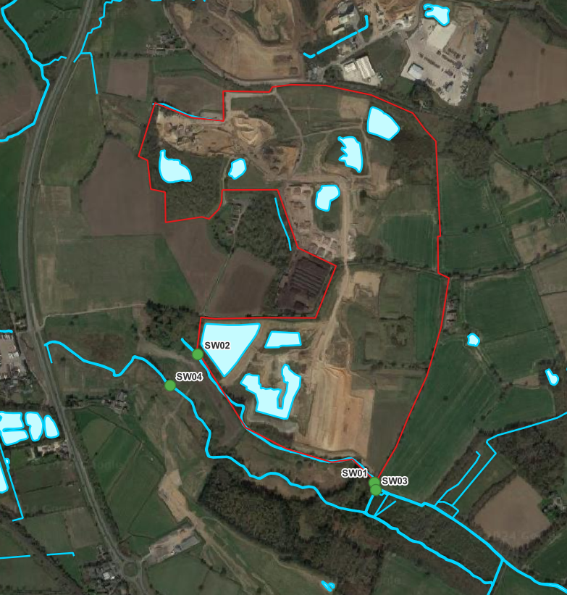

Table 2-2 - Surface Water Quality Summary, Monitoring points SW01 – SW04, 2018 to 2021
Parameter | Units | EQS | DWS | Sample Count | No. of Detecti-ons | min | av | max | TSV | No. of Exceedances
Alkalinity | mg/l | N/A | N/A | 32 | N/A | 102.0 | 165.7 | 233.0 | N/A | N/A
pH | pH Units | N/A | N/A | 49 | N/A | 7.7 | 8.0 | 8.4 | N/A | N/A
TOC | mg/L | N/A | N/A | 32 | N/A | 3.0 | 7.1 | 11.6 | N/A | N/A
Arsenic | mg/l | 0.05 | 0.01 | 14 | 12 | 0.0010 | 0.0016 | 0.0028 | 0.05 | 0
Barium | mg/l |  | 0.7 | 2 | 2 | 0.1000 | 0.1075 | 0.1150 | 0.7 | 0
Cadmium | µg/l | 0.00015 |  | 31 | 0 | - | - | - | 0.00015 | 0
Chromium | mg/l | 0.0047 |  | 0 | 0 | - | - | - | 0.0047 | 0
Copper | mg/l | 0.001 | 2 | 14 | 1 | - | - | 0.012 | 0.001 | 1
Mercury | mg/l | 0.00007 | 0.001 | 2 | 0 | - | - | - | 0.00007 | 0
Molybdenum | mg/l |  | 0.07 | 2 | 0 | - | - | - | 0.07 | 0
Nickel | mg/l | 0.004 | 0.02 | 31 | 5 | 0.0030 | 0.0048 | 0.0110 | 0.004 | 1
Lead | mg/l | 0.0012 | 0.01 | 14 | 0 | - | - | - | 0.004 | 0
Antimony | mg/l | 0.05 | 0.005 | 2 | 0 | - | - | - | 0.05 | 0
Selenium | mg/l |  | 0.01 | 2 | 0 | - | - | - | 0.01 | 0
Zinc | mg/l | 0.014 |  | 14 | 1 | - | - | 0.02 | 0.014 | 1
Chloride | mg/l |  | 250 | 55 | 55 | 16.6 | 31.4 | 49.7 | 250 | 0
Sulphate | mg/l |  | 250 | 51 | 51 | 24.4 | 43.1 | 73.5 | 250 | 0
Phenol | µg/l | 0.0077 |  | 2 | 0 | - | - | - | 0.0077 | 0
Ammoniacal Nitrogen | mg/l | 0.6 |  | 49 | 11 | 0.06 | 0.15 | 0.33 | 0.6 | 0

    - Berkswell Marsh SSSI Compensation
Due to the proximity of Berkswell Marsh SSSI to the site, the Environment Agency (EA) and Natural England (NE) expressed concerns that dewatering of the extension could impact on these protected features.
Based on predictions of the extent of the radius of influence of dewatering, it was concluded that the SSSI and SSSI should remain unaffected by dewatering in the initial phases but with the commencement of the final phase, mitigation measures may be required.
To mitigate this impact, multiple measures have been put in place including:
- A low permeability clay cut-off wall,
- Recharge wells; and
- Discharging directly to the ditch which feeds the watercourse in the SSSI.
A clay barrier was installed in June – July 2019 along the southern face of the quarry, keyed into a new silt lagoon as shown on Figure 2B to reduce the recirculation of water recharging Berkswell Marsh SSSI from Park Farm. The clay seal was extended to the east in 2021, and 2023.
Six recharge wells were installed along the boundary between Park Farm and Berkswell Marsh SSSI to maintain groundwater levels within the SSSI during dewatering by injecting clean dewatering discharge water into the SSSI. These were effective at recharging the SSSI from July to September 2018 and from May 2019 onwards (pumping at a rate of 500 – 1,500 m³/d). The recharge wells have since clogged up and to counteract this, dewatering water is now discharged from the sump to the marsh via the ditch at the south-western site boundary to maintain groundwater levels within Berkswell Marsh SSSI.
A discharge permit application is currently under preparation to support the compensatory flows, but the flows have been agreed in principle with both the EA and NE.

Hydrogeology
    - Aquifer Classifications
The Quaternary superficial deposits (Alluvium and Glaciofluvial Deposits) are all classified as Secondary A aquifers which are permeable layers capable of supporting water supplies at a local rather than strategic scale and can be an important source of base flow to rivers.
The Sidmouth Mudstone Formation of the MMG is classified as a Secondary B aquifer which are predominately lower permeability layers that may be capable of yielding limited volumes of groundwater due to localised features such as fissures, thin permeable horizons and weathering.
The Tarporley Siltstone Formation of the Mercia Mudstone Group is classified as a Principal Aquifer, which are layers of rock or drift deposits that have high intergranular and/or fracture permeability, meaning they usually provide a high level of water storage. They may support water supply and/or river base flow on a strategic scale. The underlying Helsby Sandstone Formation is also classified as a Principal Aquifer.
    - Aquifer Properties
Groundwater within the superficial deposits is stored and transported though intergranular means through the more permeable sand and gravel rich horizons. Superficial aquifers can be vulnerable to surface pollution and drying out in drought.
The physical properties of minor aquifers in England and Wales states the following of the Mercia Mudstone Group:
“While effectively a non-aquifer in many areas, limited quantities of groundwater suitable for domestic or small scale agricultural use are, however, occasionally obtainable from the Mercia Mudstone… in the sequence groundwater is usually obtained from the sandstone horizons present within a predominantly mudstone succession.”
“Despite being generally thin (often less than 1 m thick) and very well cemented, the sandstone and siltstone horizons may contain and transmit limited quantities of groundwater through fractures.”
On the Tarporley Siltstone Formation:
“The basal section of the group [MMG], consisting of mudstones together with siltstones and sandstones (Tarporley or Sneinton Formation) often forms a localised minor aquifer in its own right. Numerous small springs occur along the outcrop of this horizon and shallow wells have provided limited but adequate supplies to a clustering of old villages and farms which have arisen along the outcrop.”
“This basal unit of the group was formerly known as the Keuper Waterstones, reputedly due to their similarity in appearance to watered silk rather than their water bearing properties.”
The physical properties of major aquifers in England and Wales states the following of the Helsby Sandstone:
“The Helsby Sandstone Formation comprises a complex sequence of conglomerates to fine-grained sandstones and mudstones.
…the Helsby Sandstone Formation is generally more cemented, has lower porosities and is slightly less permeable than the rest of the Sherwood Sandstone Group.”
    - Groundwater Levels
Groundwater monitoring data has been supplied by client for the monitoring locations installed around the site and the surrounding area. Wells monitor the various areas and strata as categorised below:
- ‘P’ piezometers, BHF2, BHC2, BHG1, BHF3, BHA2 and BHA3 monitor the SSSI marsh (shallow);
- BH1/01 – BH5/01 monitor the bedrock beneath the SSSI;
- BHA1 – BHG1 and GW04 – GW06 monitor along the SSSI boundary;
- GW01 - GW03, GW08 – GW11, BH06/13 – BH08/13, BH10/13, BH01/20, BH04/20 and BH81 monitor within or adjacent to the quarry;
- BH01/21 – BH06/21, BH08/20 and MF04/16 and MF05/16 monitor adjacent parcels of land.
Note that there is less groundwater monitoring infrastructure in place in the northern portion of the site, as this portion was excavated and infilled under a Paragraph 9 exemption, rather than an environmental permit.
Groundwater hydrographs for each of these categories have been produced and are presented on the following pages.
The highest water levels were generally recorded in those boreholes located in the east of the site, e.g. GW01 and GW02. The lowest levels are recorded in GW08, GW09 and GW10, and the BHXX/21 series, which are located in the west of the site.
Multiple boreholes monitoring the quarry have shown decline due to quarry dewatering activities at Park Farm. Groundwater levels decline between in 2018 to 2022 due to dewatering and below average rainfall. Levels have slightly increased following this due to high rainfall, the operation of the recharge wells and the clay seal mitigation.
Piezometers and boreholes monitoring shallow deposits within the SSSI Marsh generally show a more mixed picture, with some response to seasonal variation, but less of an observable declining trend in levels.
    - Groundwater Flow direction
Groundwater contours for the site were produced for four dates within 2021 for version 1 of this HRA and are presented in Figure 3. Based upon review of groundwater levels in the hydrographs below, there have been no major changes to the overall groundwater flow directions beneath the site since 2021.
Groundwater flow within the superficial sand and gravel aquifer generally mimics the topography, with flow from east to west towards the River Blythe, with components of flow towards the south-west in the south of the site, and to the north-west in the north of the site.
Quarrying activities, including dewatering, have depressed groundwater levels and drawn water into the excavations as shown around the sump.

Insert 2-2 - Groundwater level monitoring positions
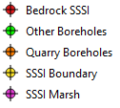
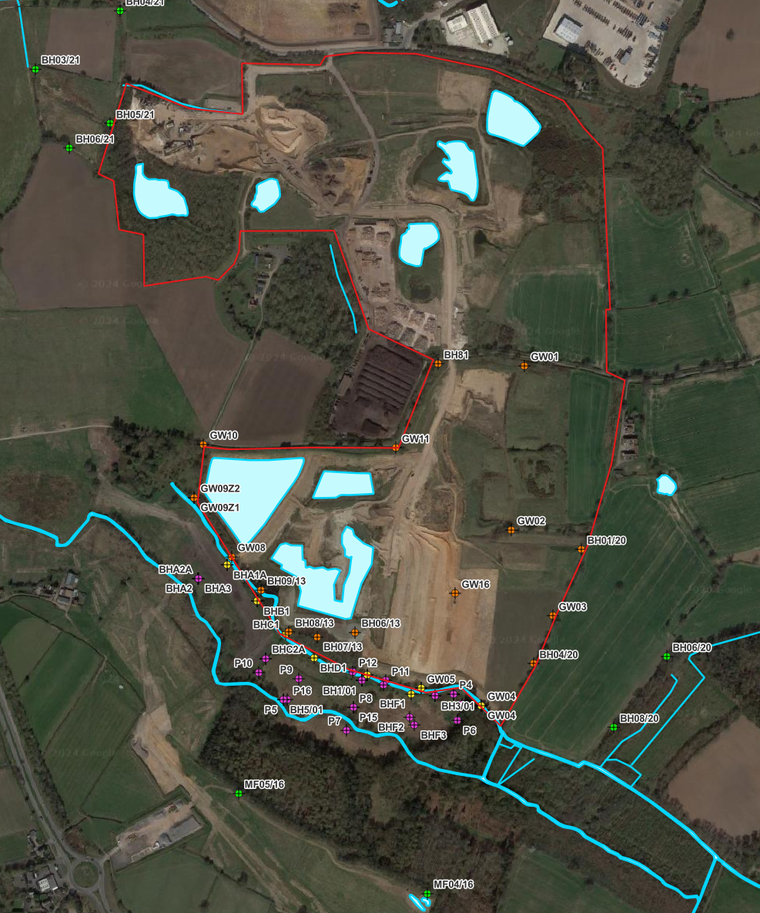

Graph 1 – Groundwater Hydrograph, SSSI bedrock boreholes

Graph 2 – Groundwater Hydrograph, SSSI Marsh boreholes (shallow)

Graph 3 - Groundwater Hydrograph, SSSI/Quarry Boundary Boreholes

Graph 4 - Groundwater Hydrograph, Quarry Boreholes

Graph 5 -Groundwater hydrograph, other boreholes

    - Groundwater Quality
Groundwater monitoring data covering the period 2018 to 2023 has been supplied by CEMEX for the monitoring locations installed around the site and the surrounding area. Boreholes with available groundwater quality data are shown in Insert 2-3.
An electronic copy of groundwater monitoring data is included within Appendix C.
Some contaminants have been analysed for on a monthly basis over this period, such as chloride and sulphate, with other contaminants only tested annually or only once over the period (e.g., phenol. molybdenum).
Summary statistics of selected parameters for all available boreholes are displayed in Table 2-3.
Borehole GW01, GW02 and GW03 are located mostly upgradient of any current quarrying or infilling, and are considered to be representative of background groundwater quality within the local area. Summary statistics for these upgradient boreholes only is presented in Table 2-5.
Concentrations have been compared against a Threshold Screening Value (TSV), comprising either the Freshwater Environmental Quality Standard (EQS) or UK Drinking Water Standards (DWS) where an EQS is not available.
The data shows that overall, the groundwater quality is fairly good at within the site and surrounding area.
Cadmium, copper, mercury, nickel, zinc, sulphate and ammoniacal nitrogen recorded results above their respective TSV. Most of the readings above the UK TSVs are on sporadic occasions across a range of locations with no trends observed, although nickel and sulphate recorded the highest proportion of exceedances.
Nickel concentrations generally appear highest in GW02 and GW03, although no apparent trend is visible within the data. As GW03 is located on the upgradient eastern boundary of the site, this may be reflective of background groundwater quality within the area.
Many of the exceedances for sulphate were recorded in BH5/01, located within the SSSI. This borehole is partially screened within the MMG bedrock, and sulphate rich waters may be the result of the borehole penetrating gypsum bands within this location or stratum.
    - Private Water Supplies
Details of private water supplies within 1 km of Park Farm were requested from Solihull Metropolitan Borough Council. One private water supply within 1 km was provided by Solihull Metropolitan Borough Council. It is located to the south of the A452 but only a postcode was provided (Kenilworth Road, B92 0LW). The source of this supply was not provided but it is considered likely that it abstracts from a well or borehole screened within the sand and gravel deposits based on its inferred location.

    - Licensed Abstractions
The EA provided information on licenced groundwater and surface water abstractions in February 2024. There are 5 licenced abstractions within 1 km of the site. One is a surface water abstraction along the northern tributary of the River Blythe, and the remaining 4 are groundwater abstractions.
Client holds two abstraction licenses at the site. These are both from the same lagoon which is supplied from underground strata (Sand and Gravel). One consists of a lagoon and pump for the purpose of concrete manufacture with an output not exceeding 2.1 l/s. The other is for gravel washing and consists of a lagoon and two pumps with a combined capacity not exceeding 129.3 l/s.
The two other groundwater abstractions are located ~850m to the north-east of the site for general use relating to secondary category and mineral washing at Cornets End Quarry.
    - Source Protection Zones
The site does not lie within a Source Protection Zone (SPZ). The closest (total catchment zone) is located approximately 700 m north-east of the site relating to an abstraction around Eaves Green. This SPZ is likely to be associated with an abstraction within the Warwickshire Group, based on BGS mapping.

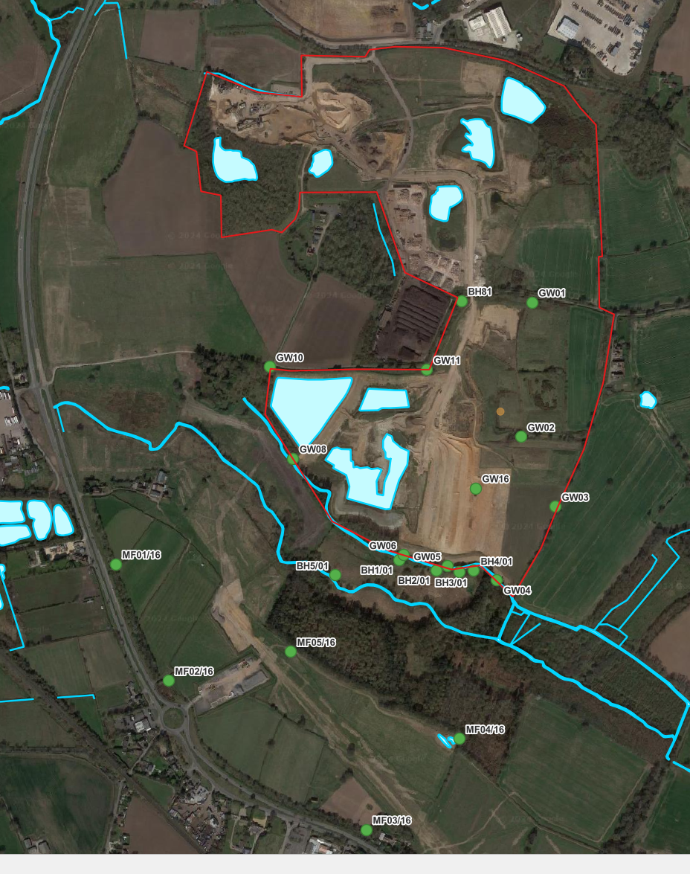
Insert 2-3 - Groundwater quality monitoring locations

Table 2-3 - Groundwater quality summary, all available boreholes, 2018 to 2023
Parameter | Units | EQS | DWS | Sample Count | No. of Detections | Minimum | Average | Maximum | TSV | No. of Exceedances
Arsenic | mg/l | 0.05 | 0.01 | 143 | 95 | 0.00031 | 0.00300 | 0.01700 | 0.05 | 0
Barium | mg/l |  | 0.7 | 18 | 18 | 0.009 | 0.158 | 0.399 | 0.7 | 0
Cadmium | mg/l | 0.00015 |  | 329 | 17 | 0.00003 | 0.000201 | 0.00124 | 0.00015 | 4
Chromium | mg/l | 0.0047 |  | 143 | 1 | - | - | 0.003 | 0.0047 | 0
Copper | mg/l | 0.001 | 2 | 120 | 20 | 0.0090 | 0.0126 | 0.0220 | 0.001 | 15
Mercury | mg/l | 0.00007 | 0.001 | 18 | 3 | 0.00011 | 0.00036 | 0.00063 | 0.00007 | 3
Molybdenum | mg/l |  | 0.07 | 18 | 3 | 0.007 | 0.02033 | 0.036 | 0.07 | 0
Nickel | mg/l | 0.004 | 0.02 | 303 | 123 | 0.003 | 0.00873 | 0.031 | 0.004 | 82
Lead | mg/l | 0.0012 | 0.01 | 143 | 0 | - | - | - | 0.0012 | 0
Antimony | mg/l | 0.05 | 0.005 | 18 | 0 | - | - | - | 0.05 | 0
Selenium | mg/l |  | 0.01 | 18 | 7 | 0.0008 | 0.00163 | 0.0033 | 0.01 | 0
Zinc | mg/l | 0.014 |  | 143 | 7 | 0.02 | 0.06129 | 0.196 | 0.014 | 7
Chloride | mg/l |  | 250 | 490 | 490 | 0 | 26.3 | 100 | 250 | 0
Sulphate | mg/l |  | 250 | 491 | 486 | 4.6 | 117.02 | 1420 | 250 | 35
Phenol | mg/l | 0.0077 |  | 18 | 1 | 0.0027 | 0.0027 | 0.0027 | 0.0077 | 0
Ammoniacal Nitrogen | mg/l | 0.60 |  | 490 | 119 | 0.06 | 0.452 | 14.3 | 0.60 | 15
Table 2-4 - Groundwater Quality Summary , Upgradient Boreholes GW01, GW02 and GW03, 2018 to 2023
Parameter | Units | EQS | DWS | Sample Count | No. of Detecti-ons | Minimum | Average | Maximum | TSV | No. of Exceedances
Arsenic | mg/l | 0.05 | 0.01 | 25 | 13 | 0.00031 | 0.001056 | 0.002100 | 0.050000 | 0
Barium | mg/l |  | 0.7 | 3 | 3 | 0.041 | 0.071 | 0.116 | 0.7 | 0
Cadmium | mg/l | 0.00015 |  | 60 | 4 | 0.00008 | 0.00023 | 0.00060 | 0.00015 | 2
Chromium | mg/l | 0.0047 |  | 25 | 0 | - | - | 0 | 0.0047 | 0
Copper | mg/l | 0.001 | 2 | 21 | 5 | 0.011 | 0.0172 | 0.022 | 0.001 | 5
Mercury | mg/l | 0.00007 | 0.001 | 3 | 2 | 0.00034 | 0.00049 | 0.00063 | 0.00007 | 2
Molybdenum | mg/l |  | 0.07 | 3 | 1 | 0.036 | 0.036 | 0.036 | 0.07 | 0
Nickel | mg/l | 0.004 | 0.02 | 57 | 48 | 0.004 | 0.014 | 0.031 | 0.004 | 47
Lead | mg/l | 0.0012 | 0.01 | 25 | 0 | - | - | - | 0.0012 | 0
Antimony | mg/l | 0.05 | 0.005 | 3 | 0 | - | - | - | 0.05 | 0
Selenium | mg/l |  | 0.01 | 3 | 0 | - | - | - | 0.01 | 0
Zinc | mg/l | 0.014 |  | 25 | 2 | 0.02 | 0.0615 | 0.103 | 0.014 | 2
Chloride | mg/l |  | 250 | 87 | 87 | 10.7 | 18.0 | 25.9 | 250 | 0
Sulphate | mg/l |  | 250 | 87 | 87 | 27.9 | 42.1 | 56.3 | 250 | 0
Phenol | mg/l | 0.0077 |  | 3 | 0 | - | - | - | 0.0077 | 0
Ammoniacal Nitrogen | mg/l |  | 0.60 | 87 | 23 | 0.06 | 0.32 | 2.72 | 0.60 | 3

Conceptual Site Model

Introduction
An understanding of the key physical components of a soil and groundwater system must be accomplished prior to undertaking any risk assessment modelling for controlled waters. To simplify the complexity of observed soil and groundwater conditions and to identify the relevant flow and transport parameters, a conceptual site model has been prepared.
The model accounts for both the physical ground conditions and the key hydrological inputs and outputs to and from the system. The environmental site setting description and data presented in the above sections have been conceptualised into a set of potential source, pathway and receptor (S-P-R) linkages. These are described in this section, for the assessment of risk to controlled waters from the inert restoration materials deposited at the site. The source-pathway-receptor scenario is a useful means to generate a conceptual model, which can be used to identify critical pathways and receptors for use within the controlled waters risk assessment. This section of the report presents the Conceptual Site Model (CSM).
Geological sections across the southern and northern portions of the site are presented in Figures 4A and 4B, respectively.

Source Term Charateristics
    - Waste Types and Volumes
The northern portion of the site currently house the processing area for the quarry, and has already been fully extracted and largely restored with imported inert materials. For the restoration of the northern portion of the site, it was predicted to require 875,000m³ of material. When using a bulk density conversion factor of 1.9 tonnes/m³ this equates to approximately 1,662,500 tonnes.
In order to achieve the restoration profiles provided on the approved restoration scheme within the southern part of the site, approximately 1,000,000m³ of additional material will be required. When using a bulk density conversion factor of 1.9 tonnes/m³ this equates to approximately 1,900,000 tonnes.
The proposed waste types are detailed within the Waste Recovery Plan; the site will only accept specific wastes that are classed as inert in accordance with the Landfill Directive (1999/31/EC) and Council Decision (2003/33/EC) of 19 December 2002 ‘establishing criteria and procedures for the acceptance of waste landfills’.
    - Capping
No engineered sealing liner or engineered capping layer is proposed. The site will be subject to effective rainfall infiltration through restoration soils. It is intended to restore the site to mixed agricultural land and broadleaf woodland.
    - Attenuation Layer
Following restoration, the site will be subject to groundwater throughflow via the residual sand and gravel aquifer at the edge of the site; however, a low permeability clay attenuation layer will be emplaced at the base and sides of the southern extension area, at least one meter thick and with a hydraulic conductivity of less than 1 x 10⁻⁷m/s (or equivalent),as per the Landfill Directive.
A clay side wall liner is already emplaced against the south-western boundary of the site to provide protection from lowering of groundwater levels within the SSSI.
The northern portion of the site was infilled prior to permitting controls. It is known that the basal sections of infilling will comprise silt from sand and gravel washing operations, which are likely to be low in permeability and broadly meet the requirements of an attenuation layer.
However, as a conservative modelling measure, no side or basal attenuation layer has been modelled within the Hydrogeological Risk Assessment.
    - Leachate Contaminants of Concern
Inert waste is defined by the Landfill Directive (article 2(e)) as “waste that does not undergo any significant physical, chemical or biological transformations. Inert wastes do not dissolve burn or otherwise physically or chemically react, biodegrade or adversely affect other matter with which it comes into contact in a way likely to give rise to environmental pollution or harm human health.”
Due to the inert nature of the proposed waste material, it is considered unlikely that water coming into contact with the material at the site will result in the generation of highly concentrated leachate / pollutants. To ensure that this remains the case, the operator can restrict source of waste materials allowed on to the site through the adoption of stringent Waste Acceptance procedures.
The 10:1 eluate results taken from the Inert WAC Limits are considered to represent a good approximation to pore water concentration. This is reasonable given there will likely be minimal agitation of the waste during or post deposition. This view is supported by the Environment Agency (2013) report on waste sampling and testing for disposal to landfill (page 27), which states ‘for most wastes destined for disposal in landfill sites government consider that a single step leaching test at a Liquid to Solis (L:S) ratio of 10:1 l/kg is adequate for establishing and monitoring the cumulative mass leached and general leaching behaviour’.
Equivalent leachability concentrations for the Inert WAC limit values have been calculated using the methodology presented in Appendix D
Tetra Tech have been provided a selection of Waste Information Forms that detail the waste acceptance procedures within the northern portion of the site, and the accompanying information included with these forms indicates that the site mainly accepts naturally occurring subsoils with contaminant concentrations far below inert WAC limits. Deliveries of topsoil (and other biodegradable soils/materials) and made ground are not accepted at the site, in line with the waste classification codes for inert landfills.

Pathways
The generation of leachate and its resultant concentration is controlled by the level of water contact with the restoration material on site. The primary water inputs are expected to be effective rainfall (infiltration), and groundwater flowing through part of and below the restoration material.
The site will be worked for the extraction of Glaciofluvial Deposits (sand and gravel deposits) to a maximum level of 84 metres Above Ordnance Datum (mAOD) which corresponds to the top of the Mercia Mudstone Group (bedrock geology).
The Glaciofluvial Deposits are classified by the EA as a Secondary A Aquifer, which are defined as permeable layers that are capable of supplying water supplies and sustaining baseflow to watercourses on a local scale. The underlying bedrock geology of the site is the Tarporley Siltstone Formation in the south (Principal Aquifer) and the and the Sidmouth Mudstone Formation in the north (Secondary B Aquifer).
Prior to the quarrying of the sand and gravel deposits, groundwater within the superficial Secondary A Aquifer would have received recharge from effective rainfall hitting the ground on site and on land surrounding the site. The general direction of groundwater flow within the sand and gravel deposits is known to be from east to west as shown in Figure 3.
For the southern portion of the site, groundwater flow during the pre- and post-extraction periods is expected to be towards a stream located approximately 150m to the south-west of the site, within the Berkswell Marsh SSSI.
For the northern portion of the site, groundwater flow is to the west or west-north-west, towards the northern tributary of the River Blythe.
During the extraction process groundwater levels are lowered within the site by dewatering from a sump located at the base of the site, within the southern quarry void.. This results in a change of the natural (pre-mineral extraction) groundwater contours, with a cone of depression noted around the southern quarry void. Following the cessation of pumping and recovery of the water table, it is expected that groundwater levels and flow direction with return to near pre-quarrying conditions.

Receptors
Potential receptors are detailed below.
An unnamed tributary of the River Blythe runs north of the site at a distance of around 350m, flowing in a westerly direction. Based on LiDAR data, this tributary is approximately at an elevation of 88 mAOD. This northern tributary is considered to be the closest potentially groundwater fed surface water feature associated with groundwater flow beneath the northern portion of the site.
This northern tributary receives flows from ditches to the west of the site’s mineral processing area, but these ditches are not mapped for their entire length on OS mapping, and are seasonally dry.
Multiple streams and ditches are present within Berkswell Marsh SSSI to the south and south-west of the site which lie at slightly higher elevations of 90 – 95 mAOD compared to the other surface water courses in the area. The most northerly of these is a ditch located adjacent to the southern and south-western boundary of the site. This ditch flows in a south-eastern direction to a ‘T Junction’, where it flows south to join the more southernly stream.
In the winter period or during periods of wet weather, this feature is fed by an emerging spring located in a woodland area approximately 55m to the west of the site. The spring is shown to emerge at approximately 95mAOD (i.e. ground elevation at the point of the spring emergence) and is expected to be reflective of shallow groundwater contained within clay rich soils which overlie the sand and gravel Secondary A aquifer.
Groundwater levels recorded in monitoring borehole ‘GW09’ at the sites south-western boundary (i.e. the closest monitoring borehole to the spring) indicates that the water table elevation in this area was approximately 91.6mAOD (in 2013 – pre-extraction) which is a difference of 3.40 metres below the spring. Therefore, the spring and ditch are not thought to be fed by or in direct hydraulic connection with the sand and gravel aquifer, and is not considered to be a receptor in the conceptual site model.
The more southerly stream flows through the centre of the Berkswell Marsh SSSI at a lower elevation of around 90mAOD, beneath the A452 and past two large pools before discharging into the River Blythe. This steam is located at a lower elevation and is likely to receive baseflow from groundwater within the superficial deposits of Alluvium and Glaciofluvial deposits.
The superficial deposits are classified as a Secondary A Aquifer, and are also considered to be a receptor.
The bedrock geology of the north-western portion of the site comprises the Sidmouth Mudstone Formation (Secondary B Aquifer). In the south-western portion of the site, faulting has led to the subcrop of the Tarporley Siltstone Formation (Principal Aquifer) beneath the superficial deposits.
Layers of Mudstone within the Sidmouth Mudstone, and to a lesser extent within the Tarporley Siltstone, are likely to provide a degree of protection to groundwater within the Mercia Mudstone Group and underlying Sherwood Sandstone Group.
Faulting present within the site also appears to have a large degree of displacement, throwing mudstone down against sandstone. This is likely to have resulted in compartmentalisation of the Tarporley Siltstone aquifer which subcrops at the site. It is reported in literature sources that where mudstones of the MMG are displaced by faulting against sandstones of the Sherwood Sandstone Group, these faults often provide barriers to groundwater flow, rather that preferential pathways. However, as a conservative measure, it has been assumed that the bedrock beneath the site comprises entirely strata equivalent in composition and behaviour to the Tarporley Siltstone Formation, and that the faults do not present a barrier to groundwater flow.

Summary of Conceptual Site Model
A summary of the potential S-P-R linkages is detailed within Table 3-2, below.

Table 3-2 Summary of Site Conceptual Site Model - SPR Linkages
Source | Pathway | Receptor | Notes | Carried Forward Into Numerical Modelling?
Restoration Soils - Northern Portion of Site (Currently Permitted Area) | Leachate Migration Through Superficial Deposits | Watercourse – Northern Tributary of River Blythe | Perennial. Likely to receive baseflow through superficial deposits. | Yes
 |  | Drainage Ditches Northwest of processing area | Mainly dry throughout year. Not considered to be a receptor for groundwater. | No
 |  | River Blyth | Northern tributary located at closer distance. Modelling protective of this tributary will also be protective of River Blythe. | No
 |  | Groundwater within Superficial Secondary A Aquifer | Considered within modelling. | Yes
 | Groundwater migration from superficial deposits to Bedrock Deposits | Bedrock – Mercia Mudstone Group – Tarporley Siltstone (Principal Aquifer) and Sidmouth Mudstone | Considered within modelling. | Yes
 |  | Bedrock - Sherwood Sandstone Group | Modelling protective of MMG will also be protective of SSG. | No
Restoration Soils – Southern Portion of Site (Permit Extension Area) | Leachate Migration Through Superficial Deposits | Watercourse – ditch located close to south western boundary. | Based on elevations, unlikely to be fed from groundwater within Glaciofluvial Deposits. | No
 |  | Spring feeding ditch located on southern boundary | Based on elevations, unlikely to be fed from groundwater within Glaciofluvial Deposits. | No
 |  | Watercourse within centre of Berkswell March SSSI | Based on elevations, likely to receive baseflow through superficial deposits. | Yes
 |  | Groundwater within Superficial Secondary A Aquifer | Considered within modelling. | Yes
 | Groundwater migration from superficial deposits to Bedrock Deposits | Bedrock – Mercia Mudstone Group – Tarporley Siltstone (Principal Aquifer) and Sidmouth Mudstone | Considered within modelling. | Yes
 |  | Bedrock - Sherwood Sandstone Group | Modelling protective of MMG will also be protective of SSG. | No

Hydrogeological Risk Assessment

Justification for Modelling Approach
The hydrogeological risk assessment has been carried out using conservative assumptions regarding the source, pathways and receptors. Site specific data have been used wherever possible to parameterise the risk assessment.
As discussed in Section 3, the quarry void at the site is proposed to be restored using inert material, as per the northern portion of the site. Based on the definition of inert waste, the site should not produce any leachate that could result in any significant discharge of hazardous substances or non-hazardous pollutants throughout the lifecycle of the site.
However, notwithstanding this, a risk assessment is required for an inert landfill where the receiving environment is particularly sensitive, for example where waste is located below the water table or overlies a Principal Aquifer, which is the case at the site.
The risk assessment has been undertaken within the ESI’s Risk Assessment Model (RAM Version 3) commercial software package (ESI, 2008). The RAM software package, together with a number of groundwater risk assessment tools, has previously been benchmarked by ESI for the Environment Agency and found to be compatible with the EA’s approach to the Remedial Target Methodology.
RAM uses a spreadsheet model to solve a water balance for the site, considering as many distinct regions as required. The source of contaminant is then defined in terms of a contaminant inventory and the release of contaminants from the inventory has been quantified in a contaminant mass balance, leading to a declining source term. An advantage of the RAM software is that this contaminant mass balance can address several distinct pathways to receptors.
In the case of Berkswell Quarry, RAM is used to address pathways of potential contaminant migration from the restoration material, laterally through the superficial deposits to adjacent surface water and groundwater bodies; groundwater within the bedrock MMG (Sidmouth Mudstone and Tarporley Siltstone, which is a Principal Aquifer) has also been considered.
The simple risk assessment model constructed is based on a Level 3 risk assessment (Environment Agency, 2006), which accounts for dilution in groundwater and for attenuation, dispersion, decay and retardation. No dilution has been accounted for within the surface water stream receptors, as a conservative measure.
Electronic copy of the models is presented in Appendix E.
    - General Assumptions
There are a number of general assumptions made which simplify the model:
- For the sake of simplicity and clarity the thickness of the inert restoration material is averaged across the site.
- It is assumed that the entire material mass is present at the start of the simulation. Since filling of the northern portion of the site is largely complete, and filling of the southern portion will take several years, the actual source term has and will continue to decline during this time and will subsequently be smaller than that represented in the model by the time filling is complete, which thus represents a conservative approximation of the system.

Site Subdivision – Source Areas
The site has been split into two separate source areas. Whilst these two source areas do not represent distinct “cells”, they do assist in distinguishing the southern area of the site, which is currently undergoing extraction, to the northern area of the site, which is mostly infilled.
Groundwater contour mapping for the site appears to demonstrate a slight groundwater divide in the centre of the site running east west; splitting the site into two sources allows for apportion of the contaminant fluxes, and impact upon receptors.
- Source Area 1 – Southern – Source Area 1 comprises the southern extension area of the site, and currently permitted silt lagoon in the south-western corner of the site.
- Source Area 2 – Northern – Source Area 2 comprises the norther portion of the site, largely infilled, which currently contains the site mineral processing area.

The Priority Contaminants to be Modelled
The priority contaminants which are to be modelled are the determinands presented in Table 2-2 which are based on the Waste Acceptance Criteria (WAC) for inert landfills.
The representative contaminants that are modelled in the assessment are as follows:
- The metals arsenic, chloride, chromium, copper, nickel, cadmium, selenium and zinc; plus Ammoniacal Nitrogen.
- Hazardous inorganic contaminants: lead and mercury; and,
- Hazardous organic contaminant: Phenol.

Environmental Assessment Levels
The setting of Environmental Assessment Levels (EALs) is necessary to ensure the protection of controlled water receptors that exist beyond the site boundary.
The adopted EALs (TSVs) are based upon freshwater Environmental Quality Standards (EQS), or where these are unavailable, the UK Drinking Water Standards (DWS).

Water Balance
The numerical modelling for Berkswell Quarry is based on a steady-state local water balance for the quarried areas that is designed to represent the long term post-closure hydrogeological system at the site following restoration.
Following completion and restoration of the site, dewatering will cease and the water level in the site is therefore expected to rise. Under this situation, the various fluxes into and out of the site will be estimated in the model using a water balance approach, as detailed below.
- Rainfall will fall onto the ground surface, where a proportion will infiltrate the restoration soils and the balance will run off.
- Infiltration to the restoration soils will be subject to evaporation and use by plants (transpiration). These two processes are often jointly referred to as evapotranspiration. During the summer the evapotranspiration demand may be higher than rainfall, whereas during the winter the rainfall may be greater than evapotranspiration. For this reason, in summer all of the rainfall is usually accounted for by evapotranspiration, whilst during the winter months there is excess water which percolates downwards deeper into the soil zone. Within this deeper zone, there may be lateral movement of this water due to local heterogeneity. This lateral flow will ultimately infiltrate through the sides of the restoration soil mass and into the shallow residual superficial deposits at the site perimeter. The remaining water will percolate further down into the inert restoration material.
- The inert restoration material is likely to be less permeable than the surrounding aquifer. As such, it is likely there will be a ‘doming’ of water within the inert restoration material due to recharge to the site surface, and discharge at the sides. Water may cross the boundary of the site through the up and down gradient sides, by passing through the sidewall artificially established geological barrier (AEGB) (or in the case of the northern portion of the site, directly out of the soil mass). Depending on the leachate level, this flux may be either into or out of the site. The direction and quantity of flow will be determined based on the relative head difference between the leachate in the site and groundwater in the surrounding aquifer.
- At the up-hydraulic gradient end of the site, the restoration soils will act as a lower permeability barrier to groundwater flow, and groundwater will preferentially flow around the waste along the path of least hydraulic resistance within the superficial deposits.
- There may also be some vertical flow through at out of the base of the restoration soils mass, as doming of groundwater across the inert fill is likely to lead to a greater head difference, and potential downwards flows into bedrock beneath the site. The volume of flow through the base of the site and the contaminant flux through the base of the site has therefore also been accounted for.
- If the leachate head in the site does not rise to ground level, then all the effective rainfall will be able to infiltrate the inert restoration material and the outflow from the Site must balance the inflow. In this case, there is no runoff from the Site surface.
- Any water running off the site surface is considered to infiltrate the aquifer at the Site perimeter and will act to dilute any contamination that migrates out the sides of the Site. As a conservative measure, this dilution is not taken into account in the HRA.
- If the leachate head in the site rises above ground level run-off will occur. This is not leachate breakout overflowing from the site; rather it is excess recharge (‘rejected recharge’) that is not able to infiltrate the inert restoration material.
- As such this water will be clean; any runoff or rejected recharge that is directed towards the site boundary post restoration will not pose a risk to the Berkswell Marsh SSSI, or other surface water features outside of the site boundary.
- The outflow from the site thus reaches a maximum value controlled by the hydraulic gradient between the site and the surrounding groundwater and the hydraulic conductivity of the inert restoration material and base and sides.
    - Infiltration
The infiltration flux for each phase is calculated from the recharge rate (effective rainfall, ER) multiplied by the surface area of the phase. Recharge is assumed to be 100% of the effective precipitation.
$$Qinf = ER x Area$$
    - Flux Through Sides
For the up and down hydraulic gradient edges of each of the phases, the combined flux out of the two faces is calculated as follows;
$$Qup/down = [(hl – hgwlS / (W/2)) x Kwaste x L x SatThick] x 2$$
Where;
- hl = leachate head in phase
- hgwS= groundwater head outside phase (shallow)
- Kwaste = hydraulic conductivity of waste
- L = Length of site (perpendicular to groundwater flow)
- W = width of site (parallel to groundwater flow)
- SatThick = saturated thickness of remaining Superficial deposits
    - Flux Through Base
The flux through the base of the site through the clay layer which forms the base of the quarry void is calculated according to the following formula:
$$Qbase = (hl – hgwls / twaste) x Kwaste x SiteA$$
Where;
- hl = leachate head in phase
- hgwd = groundwater head in bedrock (deep)
- twaste= thickness of waste
- Kwaste= hydraulic conductivity of waste
- SiteA= Site basal area

Note that if the maximum value of Qside or Qbase is greater than effective rainfall, then the flux out of the site is limited to effective rainfall. If the maximum value is less than effective rainfall, then the flux out of the site is set to the maximum value, the infiltration flux is also set to this maximum value and the difference between the effective rainfall and the infiltration flux is assumed to be runoff.

    - Aquifer Dilution
Dilution by groundwater flowing through the aquifer has been applied to the flux leaving the restoration soils, as it is expected that post restoration, groundwater will continue to flow past the site in both the superficial and bedrock aquifer. This dilution flux is calculated as follows:
$$Qdilute_aquifer = Kaq x Iaq x Mw x Md$$
Where;
- Kaq = Hydraulic conductivity of aquifer
- Iaq = Hydraulic gradient in aquifer
- Mw = Mixing width of aquifer perpendicular to groundwater flow
- Md = Mixing depth of aquifer
    - Recharge Dilution
Dilution due to rainfall recharge to the aquifer, between the source and the receptors is incorporated in the model and is calculated as follows;
$$Qrainfall_recharge = L x D x ER$$
Where;
- L = length of source edge perpendicular to pathway
- D = Distance from source to receptor
- ER = Effective rainfall
Note that recharge dilution is only applied for the superficial aquifer pathway.
    - 4.2.1 Compliance Points
In order to protect the quality of groundwater resources, potential future use and surface water features located beyond, a compliance point of 50m has been set within the assessment. The compliance point comprises a theoretical borehole, screened in either the superficial or bedrock geology downgradient of the site (dependant on pathway.

Model Scenarios
The following assessment (models) scenarios have been carried out using the modelling approach outlined above:
- Scenario 1 – Inert WAC Limits Model: The source term applied in the model are the inert WAC limits. These input concentrations represent a conservative assessment as the majority of imported material is expected to be significantly below these levels; and,
- Scenario 2 – Rogue Load Assessment Model: The Environment Agency have provided suggested maximum values for the source term of ammoniacal nitrogen, chloride, sulphate and nickel, based upon experience within other Deposit for Recovery sites. In Scenario 2, the soil pore water concentrations have been set to the maximum value of the suggested range for these contaminants. For the remainder of CoC, Inert WAC limits are increased by 10% to model the potential for a rogue load to be accidentally incorporated within the waste stream. Rogue loads would be expected to marginally exceed inert WAC thresholds for one or two determinands, resulting in a classification of non-hazardous material.

Scenario 1 -Model Parameterisation
The simulation has been set to predict concentrations up to 10,000 years. This is considered to be sufficiently protective of receptors.
Time slices have been set in the simulation at 1 year, 5 years, 10 years, 50 years, 100 years, 500 years, 1,000 years 5,000 years and 10,000 years.
The model parameterisation is presented in the following tables, with justification provided for each of the parameters based upon the site conceptual model.
Table 4-1 - Site Geometry
Description | Source Area 1 (Southern) | Source Area 2 (Northern) | Data Source
Surface Area | 340 000 m² | 365,000 m² | From surveyed plans, GIS
Basal Area | 340 000 m² | 365,000 m² | Assume equal to surface area
Assumed Thickness of Restoration Soils | 10m | 12m | Based on site sections
Typical saturated thickness in Superficial Deposits | 8m | 6m | Calculated from restoration contours and site sections.
Width perpendicular to groundwater flow | 475 m | 460m | From groundwater contour plans
Void to be filled | 1,000,000m³ | 875,000m³ | H.D. Ricketts Limited
Proportion of leachate that would freely drain from the restoration soils mass | 30% |  | From Beavan, 1996; Robinson 1996.
Hydraulic conductivity of restoration soils | 1x10⁻⁷ m/s |  | Assumed value for inert waste, from 6466R1.
Average elevation of base of restoration soils | 85 mAOD | 87mAOD | Site sections
Maximum leachate head before overtopping occurs | 100 m AOD | 95mAOD | Estimated elevation of post completion ground level at site

Table 4-2 - Source Term Concentrations
CoC | Value (mg/L) | Justification
Arsenic | 0.05 | See section 3.2 and Appendix D – based on inert WAC limits.
Cadmium | 0.004
Chromium | 0.05
Copper | 0.2
Mercury | 0.001
Molybdenum | 0.05
Nickel | 0.04
Lead | 0.05
Antimony | 0.006
Selenium | 0.01
Zinc | 0.4
Chloride | 80
Fluoride | 1
Sulphate | 100
Phenol | 0.1
Ammoniacal Nitrogen | 8 | Most likely value suggested by EA

Table 4-3 - Aquifer Pathway definition - Superficial
Description | Source Area 1 - Value | Source Area 2 - Value | Units | Data Source
Mean Groundwater Head | 91 | 90 | mAOD | Site monitoring data and extrapolated post dewatering rebound
Hydraulic gradient | 0.0160 | 0.0077 | - | See CSMs, GW Contour Plots– expected post rebound gradient
Fraction Organic Carbon | 0.00071 |  | - | Mid of range for gravelly sand (ConSim Help Files)
Porosity | 0.375 |  | - | Mid of range for sand and gravel (ConSim suggested values)
Hydraulic conductivity | 5.00E-4 |  | m/d | Mid of range for gravelly sand (ConSim Help Files)
Tortuosity | 5 |  | - | Mid of range for sands and clays (Marsily, 1986)
Dry bulk density | 1,600 |  | kg/m3 | Mid of range for gravelly sand (ConSim Help Files)

Table 4-4 - Aquifer pathway definition - Bedrock
Description | Source Area 1 - Value | Source Area 2 - Value | Units | Data Source
Mean Groundwater Head | 91 | 90 | mAOD | Assumed same as superficial aquifer
Hydraulic gradient | 0.0160 | 0.0077 | - | Assumed same as superficial aquifer
Fraction Organic Carbon | 0.0034 |  | - | Mid of range of MMG (ConSim Help Files)
Porosity | 0.25 |  | - | WD/00/04 suggests value of 25% for sandstone and siltstone skerries.
Hydraulic conductivity | 2E-7 |  | m/s | WD/00/04 suggests values of 2E-9 to 2E-5 for MMG sandstones and siltstones. Set to geometric mean of 2.00E-07.
Tortuosity | 2 |  | - | Suggested value for fractured siltstones (Marsily, 1986)
Dry bulk density | 2150 |  | kg/m3 | Mid of range of MMG (ConSim Help Files)

Retardation parameters have been selected largely from ConSim suggested values provided within the ConSim help files.
In A review of ammonium attenuation in soil and groundwater, produced by the Environment Agency in 2004, the degradation rate of ammoniacal nitrogen in sands and gravels is given as 365 to 2,160 days (1 year to 5.91 years). The upper end of this range has been selected as a conservative value.
Table 4-5 - Selected Retardation and Decay Parameters
Parameter | Decay (days) | Kd (L/kg) | Justification
Arsenic | No Decay | 25 | ConSim Suggested Values
Cadmium | No Decay | 240 | ConSim Suggested Values
Chromium | No Decay | 67 | ConSim Suggested Values
Copper | No Decay | 295 | ConSim Suggested Values
Mercury | No Decay | 450 | ConSim Suggested Values
Molybdenum | No Decay | 110 | ConSim Suggested Values
Nickel | No Decay | 400 | ConSim Suggested Values
Lead | No Decay | 270 | ConSim Suggested Values
Antimony | No Decay | 400 | ConSim Suggested Values
Selenium | No Decay | 9.5 | ConSim Suggested Values
Zinc | No Decay | 200 | ConSim Suggested Values
Chloride | No Decay | 0 | ConSim Suggested Values
Fluoride | No Decay | 0.8 | ConSim Suggested Values
Sulphate | No Decay | 0 | ConSim Suggested Values
Phenol | 100 | 0.22 | ConSim Suggested Values  Decay – high end of aerobic half life.
Ammoniacal Nitrogen | 2,160 | 1.25 | ConSim Suggested Values for Kd. See note above for decay rate.

    - Infiltration -Total and Effective Rainfall
Total annual average rainfall at the site is around 725mm/year, and evapotranspiration is around 525mm/year, based upon and the Met Office MORECS data, giving a value of effective rainfall of 200mm/year.
This agrees well with NRFA data and datasets provided in the UK Hydrometric Register, which state that for the Blythe catchment at Whitacre, total rainfall is 732mm/year and evapotranspiration is 522mm/year, giving a value of effective rainfall of 210mm/year.

Scenario 1 - Emissions to Groundwater / Receptors
Predicted emissions to groundwater from Scenario 1 are presented in the following tables. Note that Source Area 1 refers to the southern portion of the site, and Source Area 2 to the northern portion.
No exceedances of the EAL are noted at either the 50m superficial BH compliance point, 50m deep BH compliance point, or at any of the watercourse receptors.
The concentrations of the source term being set at the Inert WAC Limit and applied across the site is considered to be very conservative. In reality, the likelihood for the whole waste mass to be present at the upper inert WAC limits is highly unlikely.

Table 4-6 - Scenario 1, Source 1, SSSI Stream Receptor
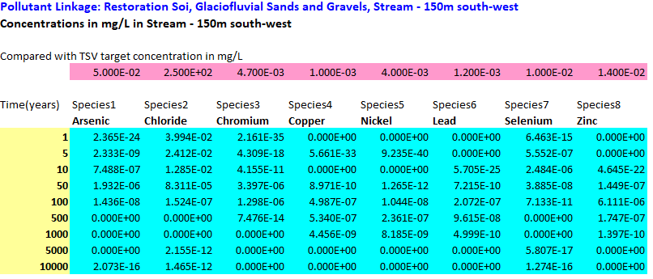
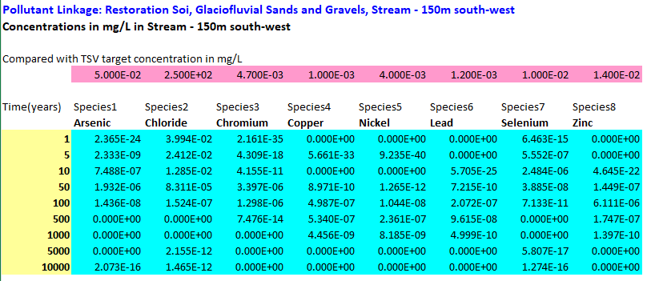

Table 4-7 - Scenario 1 Source 1, Shallow 50m Borehole Receptor
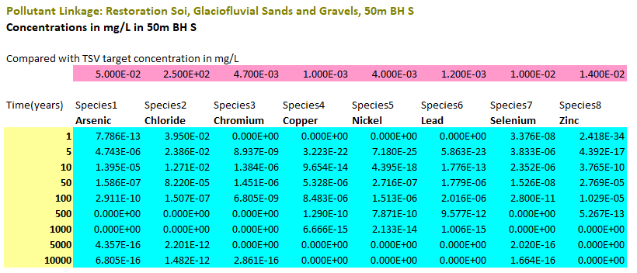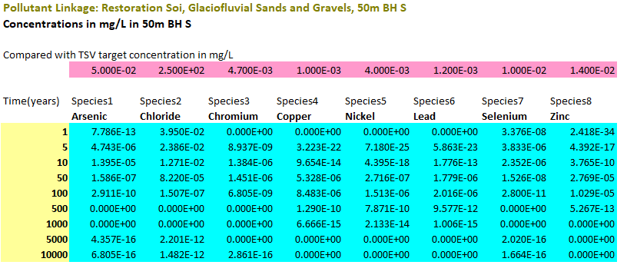

Table 4-8 - Scenario 1, Source 1, Deep 50m Borehole Receptor
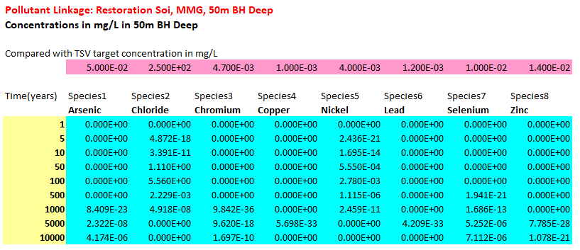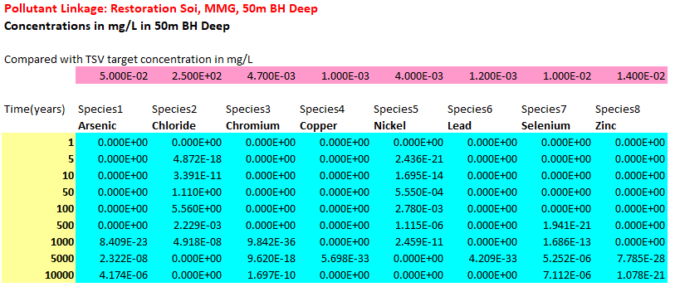

Table 4-9 - - Scenario 1, Source 2, SSSI Stream Receptor
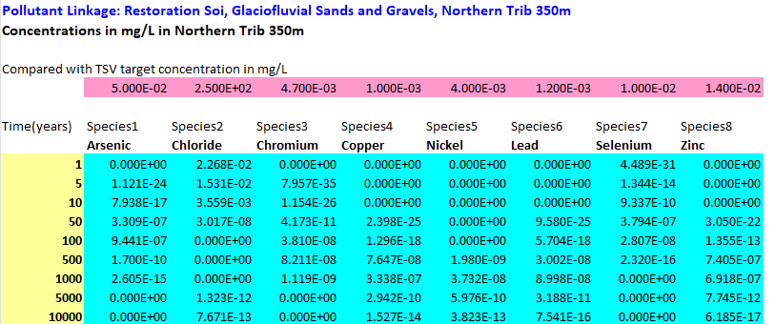
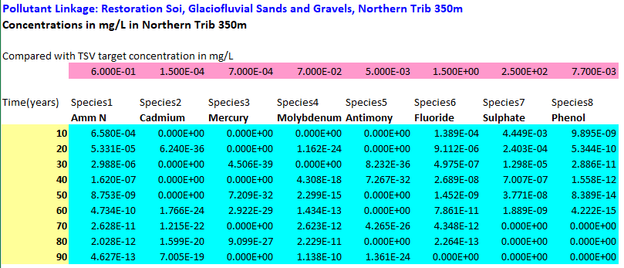
Table 4-10 - Scenario 1, Source 2, Shallow 50m Borehole Receptor
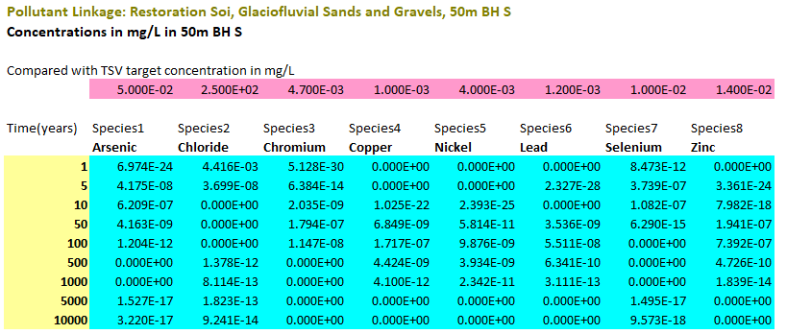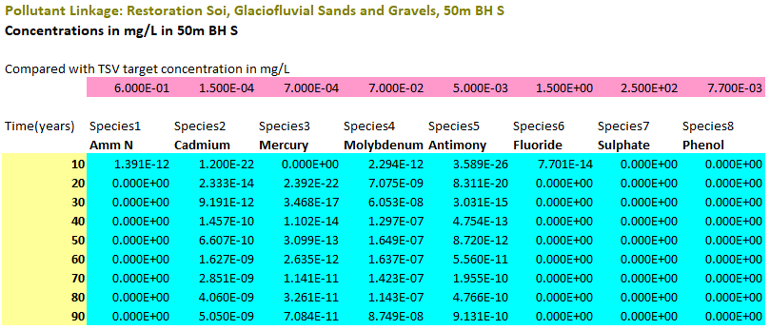
Table 4-11 - Scenario 1, Source 2, Deep 50m Borehole Receptor
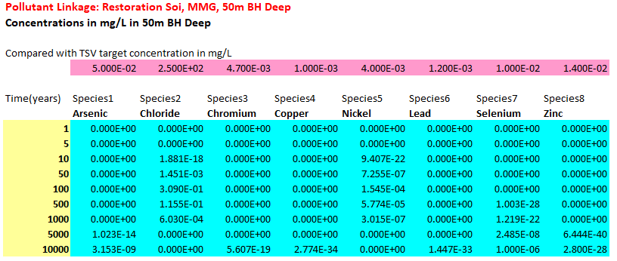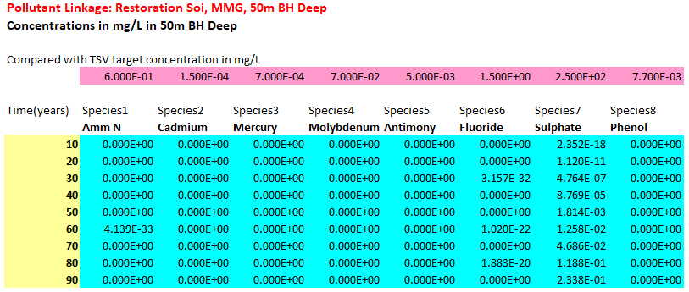

Scenario 2 – Model Parameterisation
Scenario 2 represents the hypothetical that rogue loads are accepted at the site, resulting in source term concentrations which fall outside of the normal WAC limits.
The Environment Agency have provided suggested maximum values for the source term of ammoniacal nitrogen, chloride, sulphate and nickel, based upon experience within other Deposit for Recovery sites. In Scenario 2, the soil pore water concentrations have been set to the maximum value of the suggested range for these contaminants.
For the remainder of CoC, Inert WAC limits are increased by 10% to model the potential for a rogue load to be accidentally incorporated within the waste stream. Rogue loads would be expected to marginally exceed inert WAC thresholds for one or two determinands, resulting in a classification of non-hazardous material.
A comparison of source term concentrations between Scenario 1 and Scenario 2 is presented in Table 4-6; All other parameters within the models remain the same as Scenario 1.
Table 4-12 - Scenario 1 and Scenario 2 Source Term Concentrations
CoC | Scenario1 Value (mg/L) | Scenario 2 Value (mg/L)
Arsenic | 0.05 | 0.055
Cadmium | 0.004 | 0.0044
Chromium | 0.05 | 0.055
Copper | 0.2 | 0.22
Mercury | 0.001 | 0.0011
Molybdenum | 0.05 | 0.055
Nickel | 0.04 | 0.1
Lead | 0.05 | 0.055
Antimony | 0.006 | 0.0066
Selenium | 0.01 | 0.011
Zinc | 0.4 | 0.44
Chloride | 80 | 800
Fluoride | 1 | 1.1
Sulphate | 100 | 1800
Phenol | 0.1 | 0.11
Ammoniacal Nitrogen | 8 | 25

Scenario 2 - Emissions to Groundwater / Receptors
With the increased source term concentrations, only one exceedance was reported within Scenario 2. Nickel was found to exceed the target criteria for the Source Area 1 to deep (bedrock) 50m borehole receptor, at the 100 year timeslice. A predicted concentration of 6.95 x 10⁻³ mg/L was reported, versus a target criteria of 4.00 x 10⁻³ mg/L, as shown in Table 4-12.
Table 4-13 - Single Exceedance - Nickel, Source 2, Deep 50m Borehole Receptor
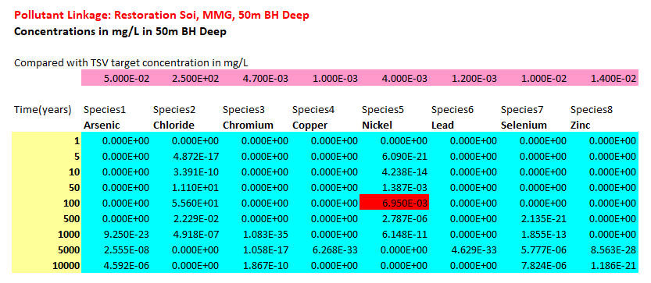
All other contaminants in all other S-P-R linkages were found to pass the target criteria.
This exceedance should be considered in light of the input source term concentration of 0.1/mg/L. This is over double the calculated Inert WAC limit equivalent concentration. Example DfR data provided by the EA indicates that the most likely value for nickel in inert landfill leachates is 0.02mg/L, five times less than the maximum value utilised above, and half of that used within Scenario 1, where no exceedances were recorded.
For a rouge load to be deposited at the site, a series of failures would need to occur in the Waste Acceptance Procedures such that non-permitted wastes bypass the stringent procedures and checks in the site’s management system and are accidentally deposited at the site without being detected. In the extremely unlikely event of a rogue load of material bypassing the stringent checking processes and accidentally being deposited at the site, it is assumed that the visual inspection regime adopted would result in any material that remains in-situ being limited in volume.

REQUISITE SURVEILLANCE
The requisite surveillance for groundwater and surface water that is considered necessary and appropriate for the site is presented in the following sections.

Groundwater Monitoring
A comprehensive monitoring infrastructure is currently in place downgradient of the southern extension, such that no additional monitoring boreholes are required.
The monitoring boreholes GW01, GW02 and GW03 are present on the up-gradient side of Berkswell Quarry within the extension area, and may be removed by quarrying operations. If this is the case, additional monitoring boreholes will need to be installed on the upgradient (eastern) edge of the quarry, such that appropriate monitoring of background groundwater quality can continue to be undertaken.
Table 5-1 - Proposed Groundwater Monitoring Determinants
Monitoring Location | Parameter | Frequency
Upgradient  GW01, GW02, GW03  Replacement boreholes to be installed if removed. | Water Level, Electrical Conductivity, Chloride, Phenol, pH, Nickel, Sulphate, Lead, Ammoniacal Nitrogen | Quarterly
Downgradient  GW04, GW05, GW06, GW08 and GW10 | Water Level, Electrical Conductivity, Chloride, Phenol, pH, Nickel, Sulphate, Lead, Ammoniacal Nitrogen | Quarterly
Upgradient and Downgradient  GW01, GW02 GW03, GW08 and GW10 | Base of monitoring point (mAOD) | Annually
Table 5-2 contains the compliance limits that are proposed for the site, based upon a review of background groundwater quality in the upgradient boreholes GW01, GW02 and GW03 and the assessment EALs.
Table 5-2 Proposed Compliance Limits
Parameter | Units | max | Compliance Limit | Basis For Compliance Limit
Chloride | mg/l | 25.9 | 32.4 | Max Background +25%
Sulphate | mg/l | 56.3 | 70.4 | Max Background +25%
Nickel | mg/l | 0.031 | 0.00775 | Max Background +25%
Lead | mg/l | ND | 0.006 | LOD
Phenol | µg/l | ND | 0.001 | LOD
Ammoniacal Nitrogen | mg/l | 2.72 | 3.4 | Max Background +25%
Representative contaminants of concern have been selected for monitoring: Ammoniacal Nitrogen Sulphate, Chloride, Nickel, Lead and Phenol – three general landfill parameters (including two conservative traces, SO4 and Cl,), two heavy metals, and one organic compound.

Surface Water Monitoring
Surface water quality has been monitored regularly at one location (SW04). Surface water will continue to be monitored at this location in accordance with the schedule detailed in Table 5-3.
Table 5-3 - Proposed Surface Water Monitoring Determinands and Sampling Frequency
Monitoring Location | Parameter | Frequency
SW04 | Ammoniacal Nitrogen, Chloride Suspended Solids, Visual Oil and Grease, pH, Electrical Conductivity, Nickel, Sulphate and Cadmium | Quarterly
No compliance limits are set out for surface water monitoring. Data should be reviewed as part of site annual monitoring reports and comparison made to generic assessment criteria, with exceedances or general trends reported.

Conclusions
This report presents an assessment of the hydrogeological regime at the Berkswell Quarry as the basis of a risk assessment. The assessment uses an accurate model of the relevant flow mechanisms and contaminant transport theory and is based on detailed knowledge of the hydrogeology and hydrology of the area surrounding the proposed restoration site.
A conceptual model of Berkswell Quarry was developed for the original permit application through the interpretation of data in the vicinity of the site to provide descriptions of the geology, hydrogeology and hydrology. The original conceptual model has been reviewed and extended to take account of the proposed extension area, and RAM modelling has been adopted for this most recent HRA.
A number of possible source, pathway, receptor linkages have been identified, and those considered insignificant via risk screening have been excluded.
The risk assessment approach is presented, along with data input parameters. A simple Risk Assessment model was constructed. The model considers the fate of the leachate determinands derived in the source along the transport pathway and the effects of attenuation, decay, retardation, dispersion and dilution.
The modelling has demonstrated that based on the proposed restoration scheme, there should be no significant release of hazardous substances or non-hazardous pollutants throughout the whole lifecycle of the site. Therefore, the installation should not result in any discernible discharge of hazardous substances to groundwater or result in groundwater or surface water pollution by non-hazardous pollutants.

Compliance with the Environmental Permitting Regulations (England And Wales) 2016
Compliance of the Berkswell Quarry with the relevant parts of the Environmental Permitting Regulations 2016 (as amended) is discussed in the following sections.
    - Accidents and their consequences
A rogue load analysis has been undertaken, demonstrating that if the inert waste acceptance criteria thresholds were exceeded, there would be no exceedance of the relevant water quality standards at the downgradient receptors.
    - Acceptance of Simulated Contaminants
It is conceivable that the waste may unintentionally contain substances not acceptable by the restoration site, in spite of strict waste acceptance criteria being adhered to. The HRA shows that, even if small quantities of non-hazardous substances were tipped at the site, all simulated contaminants are predicted to be present at low concentrations at environmental receptors.
Therefore the risk assessment model predicts that non-hazardous substances from the site will not impact on the wider groundwater or surface water environment.
    - Compliance and Trigger Levels
Assessment and compliance of the site will be quantified against the proposed groundwater compliance limits.
Groundwater compliance limits are proposed within Section 5 of this report and are based on observed groundwater quality data for the site, and the outcomes of the assessment.
Surface water monitoring is also undertaken at the site, details of which are also provided within the Environmental Management and Monitoring Plan.
    - Groundwater quality
The risk assessment model shows that the Berkswell Quarry restoration site is unlikely to impact upon the groundwater quality or the quality of the groundwater or surface water receptors.
The maximum concentrations that may result from the site are based on a theoretical source term, set at the Inert WAC limits. Given that the actual source term concentrations in the site are likely to be much lower than simulated here, as strict adherence to the Waste Acceptance Criteria and Procedures will be applied, the actual resultant concentrations are likely to be much lower. It is considered extremely unlikely that a breach of the EP Regulations will occur.
This risk assessment has been completed without considering the impact of capping or lining the site, and has conclusively illustrated that the site does not pose any significant risk to groundwater or surface waters.

COMPLIANCE WITH REQUIREMENTS OF AN ENVIRONMENTAL PERMIT VARIATION
This report constitutes the Hydrogeological Risk Assessment required to support an application to substantially vary an Environmental Permit.

Figure 1: Site Location Plan / Permit Boundary

Figure 2A Surface Water Features

Figure 2B: Surface Water Managment

Figure 3: Groundwater Contours

Figure 4: Site Hydrogeological Sections

Appendix A: Report Terms and Conditions
This report is produced solely for the benefit of H.D. Rickets and no liability is accepted for any reliance placed on it by any other party unless specifically agreed in writing otherwise.
This report refers, within the limitations stated, to the condition of the site at the time of the inspections. No warranty is given as to the possibility of future changes in the condition of the site.
This report is based on a visual site inspection, reference to accessible referenced historical records, information supplied by those parties referenced in the text and preliminary discussions with local and Statutory Authorities. Some of the opinions are based on unconfirmed data and information and are presented as the best that can be obtained without further extensive research. Where ground contamination is suspected but no physical site test results are available to confirm this, the report must be regarded as initial advice only, and further assessment should be undertaken prior to activities related to the site. Where test results undertaken by others have been made available these can only be regarded as a limited sample. The possibility of the presence of contaminants, perhaps in higher concentrations, elsewhere on the site cannot be discounted.
Whilst confident in the findings detailed within this report because there are no exact UK definitions of these matters, being subject to risk analysis, we are unable to give categoric assurances that they will be accepted by Authorities or Funds etc. without question as such bodies often have unpublished, more stringent objectives. This report is prepared for the proposed uses stated in the report and should not be used in a different context without reference to Tetra Tech. In time improved practices or amended legislation may necessitate a re-assessment.
The assessment of ground conditions within this report is based upon the findings of the study undertaken. We have interpreted the ground conditions in between locations on the assumption that conditions do not vary significantly. However, no investigation can inspect each and every part of the site and therefore changes or variances in the physical and chemical site conditions as described in this report cannot be discounted.
The report is limited to those aspects of land contamination specifically reported on and is necessarily restricted and no liability is accepted for any other aspect especially concerning gradual or sudden pollution incidents. The opinions expressed cannot be absolute due to the limitations of time and resources imposed by the agreed brief and the possibility of unrecorded previous use and abuse of the site and adjacent sites. The report concentrates on the site as defined in the report and provides an opinion on surrounding sites. If migrating pollution or contamination (past or present) exists further extensive research will be required before the effects can be better determined.

Appendix B: SuRface Water Monitoring Data (Digital Only)

Appendix C: Groundwater Quality Data (Digital Only)

Appendix D: WAC Equivalent Leachability Calculations
According to BS EN 12457, the leachable contaminant concentrations (mg/kg) are calculated from the
concentration of contaminant in the eluate (mg/L) by the following equation:
A = C [(L/Md) + (MC/100)]
Where:
A = is the leachable contaminant concentration within the soil sample [mg/kg]
C = is the contaminant concentration within the eluate
[mg/L]
L = is the volume of leachate used during the test
[L]
Md = is the dry mass of the soil sample
[kg]
MC = is the moisture content* of the soil sample [%]
* Note: moisture content is 100 * (Mw – Md)/Md, where:
Mw = is the undried mass of soilsample
L = is calculated by the laboratory from the following
equation:
[10 – (MC/100)]
Md
Thus, substituting L into the equation above, it can be seen
that
A = 10C
The equivalent leachabilities were calculated by re-arranging the formula to:
C = A/10
This is then multiplied by 1,000 to allow for the conversion of mg/l to μg/l

Appendix E: RAM Models (Digital Only)

The physical properties of minor aquifers in England and Wales. British Geological Survey Technical Report, WD/00/4. 234pp. Environment Agency R&D Publication 68. (2000)
The physical properties of major aquifers in England and Wales. British Geological Survey Technical Report WD/97/34. 312pp. Environment Agency R&D Publication 8. (1997)
Including site investigation reports, solid and leachability analyses, WAC testing, and Waste Classification Assessments.
9 A review of ammonium attenuation in soil and groundwater, S. R. Buss1, A. W. Herbert, P. Morgan1, S. F. Thornton, and J. W. N. Smith, 2004
Meteorological Office Rainfall and Evaporation Calculation System (MORECS version 2.0), 1961 to 2020.
National River Flow Archive, Standard-period Average Annual Rainfall (SAAR) map for 1961 to 1990.
UK Hydrometric Register, UK Hydrometric Register, Marsh, T. J. and Hannaford, J. (Eds). 2008. Hydrological data UK series. Centre for Ecology & Hydrology. 210 pp.

