Waste Acceptance

Purpose: To ensure that all waste accepted is permitted under the conditions of the Environmental Permit Cornets End Lane Recovery

 |  |  | RESPONSIBLE PERSON | RECORD
 | Environmental Permit and waste codes
1. | The Environmental Permit contains the list of waste types that are permitted to be accepted at the Site for the recovery.  A table containing the codes and descriptions of waste types that are permitted on this Site is included at the end of this procedure, see Table 1 Permitted Waste Types.  This list of waste types shall be consulted if you are unsure whether a load can be accepted, alternatively the Technical and Compliance Team should be consulted.  Please note the Permit will always contain the most up to date list of waste codes acceptable at the Site and should be consulted if in any doubt. |  | All | Table 1 Permitted Waste Types  Environmental Permit
 | Waste Acceptance
2. | Following a customer enquiry, the Technical and Compliance Team will follow the steps in the ‘Pre- Acceptance Flowchart’ to determine if further information is required. |  | Sales/Technical | Pre-Acceptance Flowchart
 | Such information could include; Site investigation reports/laboratory test reports/Assessments/Photos.
3. | A judgement should be made as to the necessity to obtain comprehensive information at this stage. If the source of the waste is not likely to be contaminated, then it may not be necessary to obtain a full site investigation or laboratory testing under COUNCIL DECISION of 19 December 2002 establishing criteria and procedures for the acceptance of waste at landfills pursuant to Article 16 of and Annex II to Directive 1999/31/EC. However, in most cases a site investigation report including UKAS/MCERTS testing will be requested to review. |  | Technical and Compliance Team
4. | Classification of waste is the responsibility of the waste producer, however, NRS may carry out a technical assessment to highlight any potential hotspots from the site investigation/testing received.  - If the Waste is deemed acceptable, the technical team will email the client confirming this and request a Waste Information Form/Season Ticket to be completed and returned prior to bringing in any waste, this information is then checked by the technical team to ensure the waste is correctly described and the EWC is listed on the permit. If it is approved it will then be passed onto the weighbridge whom will create a unique job for that client and site address.  - If the waste is acceptable in the main but there are hotspots which are not suitable, the technical team will request a method statement from the waste producer confirming the waste can be/will be kept separate and not come to our facility, in some cases a site visit may be required. Once the technical team have the necessary information the job may be approved.  - If the waste is not suitable for whatever reason the client will be emailed to confirm this, the technical team will advise the weighbridge, transport and accounts the job cannot be tipped in order to stop any unsuitable waste being tipped. |  | Technical and Compliance Team | Waste Classification Procedure
5. | All associated waste information records and waste transfer notes will be kept on record in a secure location. These records will be maintained for a minimum of two years |  | Technical and Compliance Team
 |  | Acceptance of waste onto the Site
6. |  | A WTN shall be obtained from the driver and the WTN is checked.  A blank WTN may be given to the driver to complete if they do not produce one  In some cases, an annual season ticket may be used. | Site Operative | Waste Transfer Note
7. |  | Loads will be checked to ensure that the load matches the description on the WTN and the EWC code is acceptable under the permit.  Acceptable waste types are detailed in and in Table 1 below. | Site Operative | Table 1: Permitted Waste Types
8. |  | If the load does not match the description on the WTN. The driver may be given the chance to amend the WTN or it may be rejected in accordance with the Waste Rejection Procedure once the Technical Team/Site Manager has been informed. | Site Operative | Waste Rejection Procedure  Table 1: Permitted Waste Types
9. |  | Every load is visually inspected prior to being off loaded.  If there is any doubt about the waste type delivered, then a message is relayed to the Technical Team/Site Manager. | Site Operative | Table 1 Permitted Waste Types
10. |  | After checking the load and the associated paperwork to ensure the job is approved the vehicle is directed where to tip, as we consider the waste hierarchy, loads that can be recycled will be stockpiled ready for treatment and waste that contains too much clay or subsoil shall be directed to the quarry restoration scheme. A Site Operative on the excavator/dozer shall inspect tipped loads from their cab to ensure there is no gross deleterious waste hidden within the load I.E. Plastics, Wood, Metal, Roots etc. If the dozer operator suspects there to be visual or olfactory contamination they shall inspect the load further, if the waste is not suitable the rejection procedure will be followed. | Site Operative
11. |  | If there is a discrepancy with the load or its paperwork, then the Site Manager and Technical Team may be informed if required. If the load has been tipped and is not acceptable under the Environmental Permit, then, if possible, it should be re-loaded onto the vehicle and rejected from Site in accordance with the Waste Rejection Procedure. | Site Operative | Waste Rejection Procedure
12. |  | If it is impossible to load a rejected load back onto the delivering vehicle the load will be put into the quarantine area and the company shall be contacted to collect the waste. Waste will be rejected from the Site in accordance with the Waste Rejection Procedure. | Site Operative | Waste Rejection Procedure
 |  | Compliance Testing
13. |  | Compliance testing may be carried out on waste accepted on to the Site, the load will be tipped in the quarantine area. Samples taken tested at a laboratory to determine the characteristics of the waste and to ensure that the waste is as described on the WTN. | Site Manager/ Technical and Compliance Team
14. |  | For classification compliance testing, an ‘Environmental Suite’ should be requested from the laboratory for the sample of waste. | Technical and Compliance Team
 | 15. | A Technical Assessment may be completed using the testing results received from the laboratory. This Technical Assessment will classify the waste as non-hazardous or hazardous. | Technical Team
 | 16. | If a waste sample is found to be hazardous in nature, then the corresponding waste pile will be quarantined and removed from the Site in accordance with the Waste Rejection Procedure. | Technical Team | Waste Rejection Procedure
 |  | Records
 | 17. | A record is kept of all vehicles delivering waste to and from the Site, along with the type, quantity and source of waste delivered.
 | 18. | Waste Transfer Notes will be appropriately stored for a minimum of two years. |  | Waste Transfer Note
 | 19. | Information from the Waste Transfer Notes will be used to provide the necessary information to complete the Waste Return as required by the Environmental Permit.
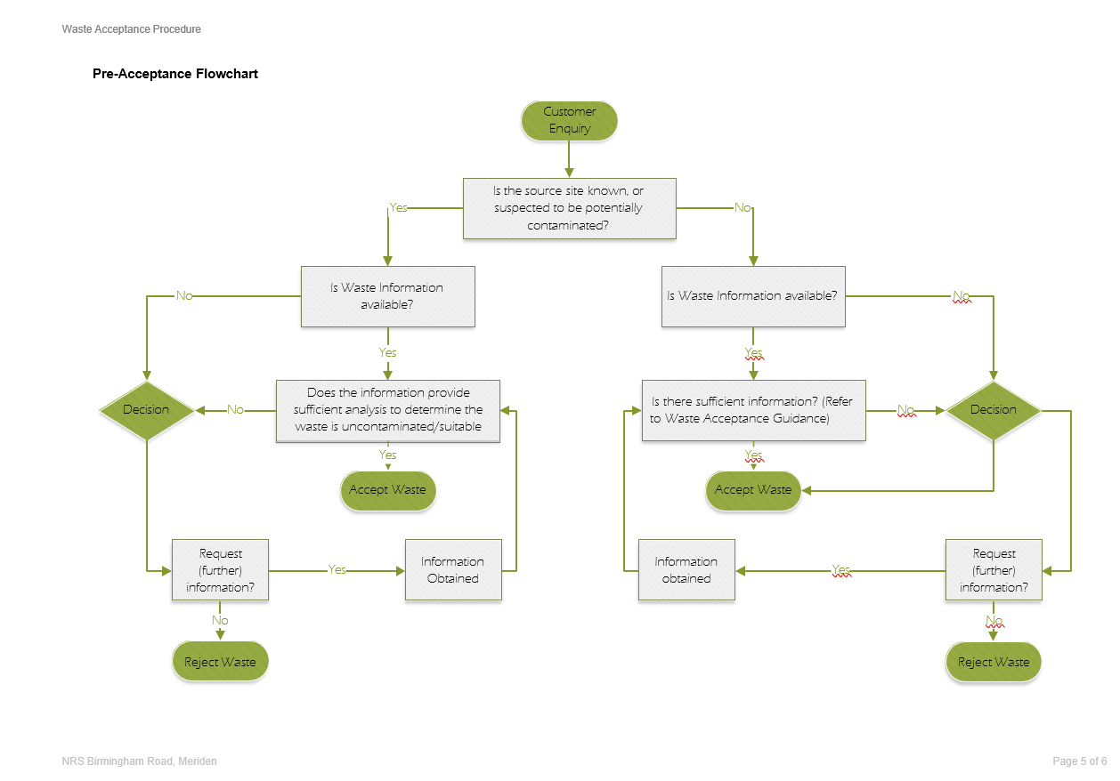

Table 1: Permitted waste types

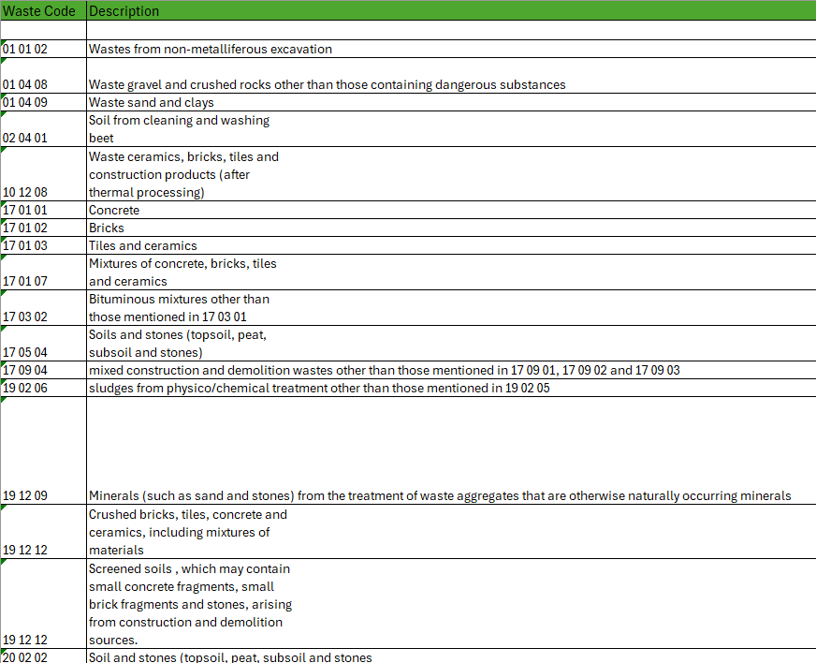

Procedure: Waste Rejection

Purpose: To ensure non-compliant waste is rejected and that associated records of rejected loads are created.

 |  | RESPONSIBLE PERSON | RECORD
 | Reasons for Rejection
1. | A waste may be non-conforming and rejected from the Site for the following reasons:  - Delivery vehicle is unsuitable for Site operations / conditions.  - The waste is not acceptable at the Site under the Environmental Permit.  - There is prohibited waste within the load.  - The load is not accompanied by the correct documentation.  - The waste does not match the description on the accompanying documentation.  - The waste is unsuitable for treatment/disposal.  - The waste contains unsuitable waste.  - The job has not been approved.  The list is not exhaustive, if you are unsure speak to the Site Manager/Technical Team. | Site Operative/Technical and Compliance Team/Site Manager | Waste Transfer Notes
2. | If a waste is identified as being unacceptable at the Weighbridge or at the point of offloading the Site Manager is contacted and a Waste Rejection Form produced and kept onsite. | Site Operative/Technical and Compliance Team/Site Manager | Form No. 1.3a Waste Rejection
3. | The driver of the load is informed of the load’s rejection. The driver will be informed of the reasons for this and requested to leave the Site. | Site Operative/Technical and Compliance Team/Site Manager
4. | If the load is being rejected because the description of the waste on the transfer note is incorrect, the driver may be given the opportunity to correct the mistake so long as the waste is acceptable at the Site.
 |  | Site Manager
5. | If the load is not safe to be sent back onto the road, then the vehicle is requested to stay in the Quarantine Area until appropriate arrangements can be for its removal.
 | Waste rejected after offloading of the vehicle
7. | If appropriate, a rejected load should be reloaded onto the delivery vehicle.
8. | If waste cannot be reloaded onto the delivery vehicle, the waste will be stored in the quarantine area. The customer will be contacted, arrangements to remove the quarantined waste will be made and a copy of the rejection form containing reasons for the rejection will be supplied.
9. | If arrangements for the customer to remove the waste cannot be made, NRS Group of Companies will make these arrangements themselves. Waste material in the quarantine area will be exported off Site by a licensed waste carrier to an appropriately licensed facility. | Site Manager/Technical and Compliance
10. | Waste will be stored for a maximum of seven working days in the quarantine area. | Site Manager/Technical and Compliance
11. | Details of any unauthorised waste and its subsequent removal from Site is recorded and retained on Site.  EWC Code 19 02 06 sludges from physico/chemical treatment other than those mentioned in 19 02 05  The waste accepted under EWC 19 02 06 shall be assessed under WM3, if it proves to be unsuitable it shall be rejected at the pre-acceptance stage. The waste shall be delivered in a suitable physical condition so it can be used as a fill material. If the waste was to be used within a liner it again would have to be fit for purpose and tested in accordance with WM3 and annex II of the landfill directive and the council decision 2003/33/EC. |  | Form No. 1.3a Waste Rejection

Rejection Form
