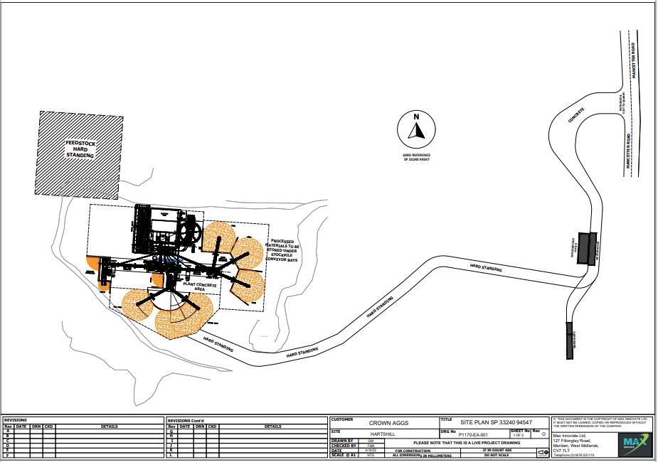
CWML 11 – Proposed site layout - Crown Waste Management Limited - Hartshill Quarry Nuneaton Road, CV10 0RT – 11.05.2022 – SP33240 94547

Proposed waste storage area and bays
