Whitstable Metals Limited
Fire Prevention Plan
February 2022
Version 1.0

Whitstable Metals Limited

Unit 20-21
Joseph Wilson Industrial Estate
Millstrood Rd
Whitstable, CT5 3PS

Document Control Sheet

Version Reference | Date | Reason for Change | Issued by
1.0 | 24/02/22 | Initial Draft | PD
Approved by |  | Adrian Smith

CONTENTS
1 Introduction 4
1.1 Roles and Responsibilities 4
1.2 Purpose 4
1.3 Scope 4
1.4 Liaison with Fire Rescue Service (FRS) 4
1.5 General considerations 4
2 Causes of Fire 5
3 Fire Prevention Plan 6
3.1 Site Plan and Receptors 6
3.2 Material Receipt and Storage 6
3.3 Signage 8
3.4 Training, Awareness and Visitors 8
3.5 Security 8
3.6 Planned Preventative Maintenance 9
3.7 Self Combustion 9
3.8 Hot Works 10
3.9 Mechanical Treatment 10
3.10 Hot Exhausts 10
3.11 Additional Actions 10
4 Fire Detection and Management 12
4.1 Fire Detection 12
4.2 Fire Fighting Strategy 13
4.3 Managing Fire Water 14
4.4 Future Actions 16
5 Annex A: Site Layout 17
6 Annex B: Site Drainage 19
7 Annex C: Fire Fighting Access, Equipment & Water Supply Plan 20
8 Annex D: Key Receptors 21
9 Annex E: Waste Acceptance Procedures 22
10 Annex F: Fire Risk Checks Form for Fire Prevention 23
11 Annex G: Emergency Contacts 24
12 Annex H: EMS Documents 25

- Introduction
  - Roles and Responsibilities
The Site Manager Adrian Smith has responsibility for ensuring these procedures are adhered to. The Site Manager is specifically responsible for:
- Ensuring the adequate training of staff and contractors working on site regarding the content of these procedures;
- Ensuring the adequate provision of resources such as personal protective equipment (PPE);
- Ensuring the provision and maintenance of hand held fire extinguishers and other fire fighting equipment at the site is adequate.
  - Purpose
The primary purpose of this Fire Prevention Plan (FPP) is to guide staff and contractors in the prevention of fire for Whitstable Metals Limited. This FPP also confirms the actions to be taken in the event of fire in order to minimise any impact on the environment and to control the fire where appropriate.
This FPP will be issued to the Fire Brigade in the event of a fire to aid with fire fighting.
  - Scope
This FPP has been prepared in accordance with Environment Agency guidance.
In addition, all fire prevention measures will meet the stringent insurance requirements for the business.
Annex A shows a site layout plan.
  - Liaison with Fire Rescue Service (FRS)
The FRS will be provided a copy of this FPP in advance of commencing operations.
  - General considerations
The Whitstable Metals Limited site is located in Joseph Wilson Industrial Estate, Whitstable CT5 3PS. Approximately 1Km North of the A299 and 2Km SE of Whitstable Town Centre. The site conmprises of a sealed industrial unit with an area of parking and yard to the front of approximately 0.04 Hectares in size and consists of a small enclosed industrial unit. There is only the storage of Catalytic Convertors in a concrete firebay in unit 20 internally. The unit is used for the storage of CAT’s only with no treatment taking place. At the time of writing this FPP, the site currently consists of concrete impermeable surface in the unit.
The surrounding land use is a mix of light industrial, agricultural & commercial business.
Whitstable Metals Limited operate under an existing Environmental Management System [EMS] which identifies the potential sources of pollution from site activities and controls site operations to eradicate emissions or where that is not possible to minimise their effect on human and environmental health.
This Fire Prevention Plan [FPP] forms part of the EMS.
The individual fire emergency procedures for each part of the site form part of the FPP.
The site has sealed drainage and there is no run off to foul or surface water from the waste storage process. See Annex B Site Drainage.
- Causes of Fire
The following have been identified as potential causes of fire and their relevance to this site, when operational, is given in Table 1
Table 1 Causes of Fire and Applicability to the Whitstable site.
Cause of Fire | Applicability to the Whitstable Metals Limited Site
- Arson or vandalism | Yes – see section 3.5 Security
- Self-combustion | No – see 3.7 Self Combustion
- Naked lights | No – none on site
- Plant or equipment failure | No – see 3.6 Planned Preventative Maintenance
- Electrical faults | No – none on site
- Discarded smoking materials | No – on site smoking is prohibited
- Hot works | No – see 3.8 Hot works
- Hot exhausts | No – see 3.10 Hot exhausts
- Industrial heater | No – none on site
- Open burning (adjacent to site) | No – no likely sources of burning adjacent to site
- Damaged or exposed electrical cables | No – no live cables on the site or to be introduced
- Reactions between incompatible materials | Not relevant given the waste types
- Neighbouring site activities | No - potential sources of risk from neighbouring land use
- Sparks from loading buckets | No – No loading buckets.
- Hot loads deposited at the site | No – not a risk given the types of materials and sources of materials.
Mitigation measures in relation to these activities, where under control of Whitstable Metals Limited, are set out in this FPP.
- Fire Prevention Plan
Whitstable Metals Limited recognises that the risk of fire cannot be eliminated. However, the site will be operated in accordance with a robust management system. Operational Procedures are listed in the site’s EMS Manual Section 1.6 ‘Operational Control’.
In addition to Operational Procedures, the following reasonable actions will be taken to minimise the risk of fire, in accordance with Environment Agency guidelines.
  - Site Plan and Receptors
A Site Plan is given in Annex A showing the key features of the site relevant to the Fire Prevention Plan including site access, security, drainage and buildings. Annex C is a Fire Fighting Equipment plan including the location of hose reels and hydrants.
A map showing key receptors within 1 km of the site is in Annex D.
  - Material Receipt and Storage
Waste CAT’s will be collected using the company’s vehicles (van) which will be removed from the customer’s site and returned to Whitstable Metals Limited site. Waste acceptance procedures will be followed as set out in Annex E.

Only the waste types and EWC ( waste code 16 01 21* or 16 01 22) codes named on the environmental permit will be accepted at the site. Wastes entering the site will be inspected and registered at the site. Non-compliant waste materials not allowed on the permit will be turned away from the site. A record will be made in the site diary.

    - Quarantine area
The site plan shows a quarantine area of 2mx2mx2m (8 cubic M) as waste is stored on the premises overnight. This can easily accommodate 50% of the largest firebay 2.4mx2mx2m = 9.6 cubic M. The area is located close to a water supply for quenching burning or smouldering material.
The Fire Quarantine Area is a dedicated emergency or quarantine area with a clear area of 6m around it.
- The unit is used for CAT storage only.
- Only small quantities of CAT’s would ever be put in this firebay i.e. 2t max.
- There is a large area in front of the building should any material need to be moved outside.

    - Waste storage times
CAT’s will be kept on site for less than 3 months. Consideration is given to the likely dry nature of the material and the implications this has for self-combustion. See 3.2.3 (stock rotation and management).
Whitstable Metals Limited has key customers for each material. In addition, contingency customers are in place in case of a need to move material off site when the regular customer is not able to receive it. In this way, the stock will not build up to levels over the permitted limits.

    - Stock rotation and management
Given the limited storage time on site stock rotation is deemed unnecessary, however;
The company will, if necessary, undertake monthly stock checks which will involve moving the waste within each pile. The purpose of the stock check is:
- To turn wastes in order to ensure the waste is not at risk of self-combustion and any potential hotspots are dissipated;
- To ensure the waste volumes do not exceed those specified in the permit.
- To ensure waste is not kept on site for longer than allowed by the permit
Records will be maintained in the site office of the physical monthly stock checks.
The site manager in charge of stock checking will be vigilant for signs of combustion or hotspots. If any are found, these will immediately be quenched with water and reported to the management team. Stock rotation will be by mechanical means as necessary.
Waste will follow the first in/first out principle as detailed in Annex F points 10/11/12 and waste will be rotated in date order to ensure that waste is removed in date order.
    - Waste storage
CAT’s will be kept in the unit on an impermeable surface whilst they are being stored. No other combustible waste will be stored on site overnight.

Firebay - 2.4mx2mx2m = 9.6 Cubic M – max 2t CAT’s at any one time. 1m Freeboard will be observed in the firebay.

  - Signage
Signage will be positioned throughout the facility showing Fire Exits and the position of extinguishers and other relevant fire fighting equipment.
All waste storage areas will be clearly marked to ensure waste throughput timescales are adhered to.
Whitstable Metals Limited will reinforce fire prevention messages using signs with key messages for staff.
  - Training, Awareness and Visitors
All staff and contractors working on-site will be aware and understand the contents of this FPP and the site Fire Response Plan. Through site inductions and on-going staff awareness and training, Whitstable Metals Limited will ensure that all relevant staff and contractors will:
- Understand what they must do during a fire.
- Know where the fire prevention plan is kept
- Participate in regular exercises to test how well this FPP plan works and to confirm staff understand what to do.
For visitors to the site:
- They will be escorted at all times and signed in.
- They will understand the No Smoking policy for the site.
- When signing in, information on the fire exits and muster point will be provided.
Training records are maintained as required by the site EMS.
Staff will be required to undergo regular fire training as part of the WAMITAB competency requirements. In addition, regular drills (annually) will be undertaken where desktop scenarios are played out and staff will be required to become familiar with this FPP as part of their ongoing competence. Mr Adrian Smith will be responsible for implementing this plan and detailing annual tests and drills.

  - Security
The following security features will reduce fire risks from vandalism and deliberate arson through preventing access to the site by unauthorised people:
- Doors are closed and locked outside of office hours to block access further.
- Regular checks of the Perimeter fencing and gates to the premises. The unit is secured by a wall on all 4 boundaries.
- Only one entrance/ exit point to the site to/ from the public highway is in place, which is secured by means of lockable doors to be locked shut at any time the site is left unattended.
- CCTV/motion detectors which can be viewed remotely by the management team covering the whole of the permitted area and yard areas.
- A CCTV system with 24 motion detection and heat detection is employed for nigh time security. This sends alerts to all staff of Whitstable Metals Limited and would notify the owner if a fire were to break out during out of hours.
- There are no security staff on-site overnight but the security camera system in the yard and entrance provides 24hr coverage and sends alerts to the operator once motion is detected.

  - Planned Preventative Maintenance
The site has a Planned Preventative Maintenance Programme to ensure all machinery and components continue to remain effective. There are no mobile plant on site and no other lifting equipment other than 1 FLT.
There is a programme of routine planned maintenance is for each item of plant and machinery to manufacturers specifications, as well as the processing equipment in order to prevent breakdown and faults which may pose a fire risk.
Limited Electrical equipment including CCTV, lights & depollution rig will be used at the site.
A PAT certificate will be provided to demonstrate that this equipment has been checked by a qualified electrician. A PPM schedule and maintenance contract will be in place to ensure that electrical equipment & plant is fit for purpose and to minimise the risk of ignition sources.
All faults needing corrective action will be reported to the Site Manager to be implemented.
For contingency, Whitstable Metals Limited recognises that if needed to ensure a continued material throughput, machinery will be hired from specialists if a significant plant breakdown occurs. This is to ensure continued effective operations and prevent excessive storage of materials which are likely to give rise to the exceeding of permitted waste quantities.
Appendix K shows the maintenance schedule

  - Self Combustion
Given the stock rotation throughput times and material type, there is a limited potential for self-combustion. EA Guidance states that the risk increases when wastes are stored over 3 months and that combustible materials must not be stored for more than 6 months. No waste is stored on the premises for more than 3 months.
Daily checks are made on the site as part of the Fire Risk Daily Checks Form (Annex F) and this includes checking for signs of self-combustion and housekeeping issues which may impact on fire risk.
The risk of combustion is low, as the materials which will be managed on site are not anticipated to be contaminated with oil, however they will be dry. As a result, a regime of turning the waste materials monthly during a stock take will be in place only if required. For details see 3.2.3 Stock Rotation and Management.
The company has considered the risk of self-combustion and consider that given the storage times, management procedures in place and materials stored, the waste is unlikely to generate hot spots. However, during operation, if the site records show that hotspots do occur on site regularly, the Site Management will consider further measures such as temperature probes.

  - Hot Works
Hot works will not be undertaken at the site..
No other combustible gases, chemicals, aerosols or fuels are kept on site

  - Mechanical Treatment
Mechanical treatment means the use of mobile plant. The plant used on site will be as follows:

- 1x FLT.

  - Hot Exhausts
During operations, site operatives will be vigilant for signs of ignition from operational hot exhausts.
At the end of the working day, vehicles will be parked away from combustible materials as indicated on the site plan. A Daily Site fire watch & Check at the end of the shift will be undertaken by the site manager or his nominee to check that there is no risk of ignition from exhausts. The fire watch will be conducted at the beginning of the shift (9am) – lunchtime (1pm) and end of the shift (5pm). See Fire Risk Daily Checks Form Annex F.

  - Additional Actions
Further actions to mitigate fire risk on site include:
- Overnight parking of vehicles away from processing and storage areas.
- The access route into the site is always kept clear and will therefore provide access for emergency vehicles.
- Site walkovers taken each day will identify any accumulations of combustible dust, litter or material which may pose a fire risk in the areas used by vehicles.
- Debris off site will be checked and removed at shift start and finish.
- Good housekeeping will be maintained at all times to ensure dust and wastes are prevented from accumulating on site.
- Operational vehicles will be fitted with fire extinguishers
- Any fuel/oil spills from plant or vehicles will be cleaned up immediately with absorbent material and disposed of correctly
- Sources of ignition including non-energy efficient (heat emitting) light bulbs, lit cigarettes, naked flames and storage heaters will not be allowed on site.

- All other sources of ignition will be kept at least 6m from flammable & combustible waste
- Cleaning – The site will be cleaned daily at the end of the operational shift in order to prevent build-up of dust, fluff and combustible waste. This will be focused on areas where dust may build up e.g. computer screens flat surfaces, mobile plant etc. Surfaces will be dusted, wiped and/or jet washed if appropriate.
- Regular inspections of vehicles and the main roads are made to ensure that no annoyance to other road users and neighbours is apparent.
- Activity location benefits from good sound attenuation provided by the internal industrial location & rural setting.
Ensure operations are only conducted within working hours and where practical noise is minimised by using the minimal movements of vehicles and materials onto and from site
- Fire Detection and Management
  - Fire Detection & Suppression
Whitstable Metals Limited will
- Provide portable extinguishers both CO2 and Foam types x 2 of each stored in the unit. Fire blankets are also stored in the unit if required. All staff will be trained in their use. Mr Adrian Smith will be responsible for directing their deployment.
- carry out regular inspections, including at the start and end of every working day
All staff are aware of this FPP and the risk of fire on site and are trained to remain vigilant.
Security staff are trained in actions in case of fire detection.
The camera systems detailed below will be installed prior to permit issue. One overlooking the yard area and one looking down inside the unit. These cameras will detect heat and send alerts to staff out of hours. Staff can respond to alerts within 1 hour.

https://www.axis.com/en-gb/products/axis-q29-series

Whitstable Metals Limited will fit automatic fire suppression system in the covered buildings proportionate to the waste type and volume prior to permit issue.
Fire Suppression:
The Site Fire Fighting Equipment Plan (Annex C & A2) shows the following items for fire suppression:
1 x hydrants with at least 2000l/min flow 185m from the site entrance. Within the office, hand held fire extinguishers are also provided along with fire blankets for battery stores. See picture below and annex

    - Water Supplies
Table 2 shows the available water on site which can be delivered from the tank above. See Annex C for water supply site plan.

Table 2: Volume of Water Available
Hydrant Delivery (l/min) | 2000
Total Delivery (l/m) | 2000

Water supplies for fire fighting can come from the fire hydrant close to the site, in addition to one or more FRS water supply trucks if the FRS deems it necessary.
The largest stockpile likely to require water for fire fighting is considered to be the CAT’s firebay. The largest pile - a maximum of 9.6m^{3.}

  - Fire Fighting Strategy
In the event of a fire being suspected or detected, the following steps will be taken:
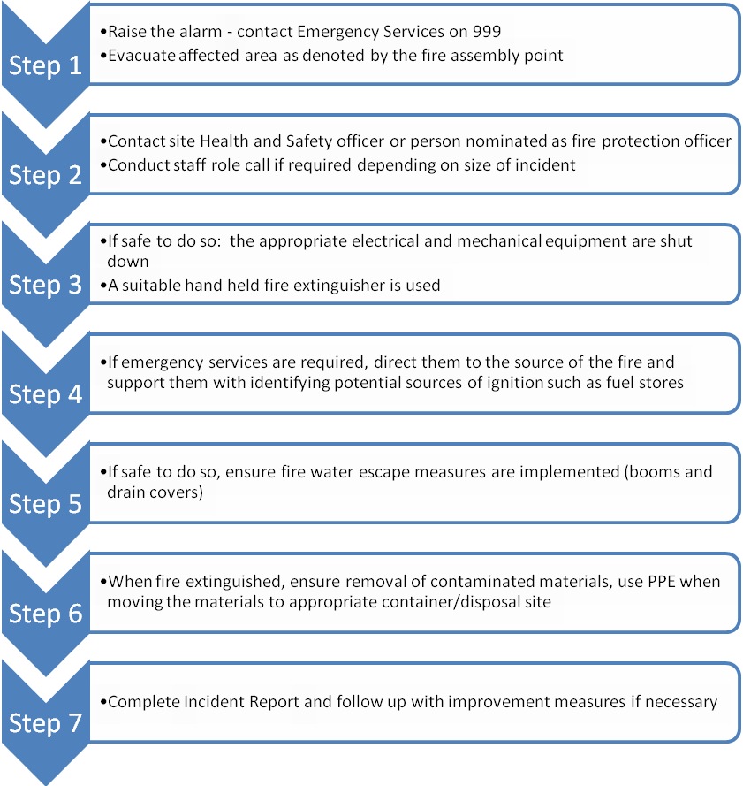
The Site Manager, will liaise with the Emergency Services on their arrival. The Site Manager will clearly identify him/herself to the Emergency Services on their arrival on site and update the FRS on the situation ensuring they are made aware of the location any compressed gases or flammable liquids on site.
Prior to arrival of the FRS on-site there are several measures that Whitstable Metals Limited can take to help fight fire, assuming there is no risk to life.
- Hand held fire extinguishers & fire blankets can be deployed in order to contain fires where possible see 4.1
- Access to the hydrant on site located in the road may be used by Whitstable Metals Limited staff if required – see annex A2 – 185m from the unit.
- Fire blankets/sheets can be used to smother smaller isolated sources of fire. See 4.1
- In the event of a fire or observed self-combustion, burning waste, if safe to do so, will be moved to the Fire Quarantine Area or alternative designated site. No more incoming waste will be allowed to enter the premises and will be diverted or stopped until it is safe to resume delivery.
- The Fire Quarantine Area is signposted.
- Neighbours and local businesses downwind will be notified of any potential fire incident by the site operator by telephone as soon as possible from the local contact list. This will be completed by telephone and will be completed as soon as it is safe to do so. Local receptors will be notified in order of proximity to the site and prevailing wind direction. Local receptors will be kept updated as to the progress of fire-fighting as new information comes to light and fully debriefed at the end of the event.
- Once the fire has been dealt with, post fire de-contamination arrangements will be agreed with the local EA officer
- The site is an impermeable surface and will be scraped clean
- Drains and runs will be gulped out and cleaned by tankers with whom Whitstable Metals Limited have a contract.
- Waste will be removed from site if necessary
- If necessary, soil and groundwater monitoring will be undertaken as agreed with the EA
- Once the local EA officer has agreed that the site is ready to become operational again then operations will recommence.

  - Managing Fire Water
Table 3 shows the potential volume of fire water which may need to be managed on site should the largest waste pile (CAT’s) require quenching.

Table 3: Volume of Water Required
l/min/1m³ of waste * | 6.6
Largest Combustible Pile (m³) | 9.6
Water Required (l/min) | 63.36
Total Requirement for 3 hours (l) | 11,400
*Based on EA guidance: 2000l of water minute is required for a 300m³ stockpile for three hours

Table 4 shows the volume of fire water which can be contained within the site. The operation benefits from being inside a covered area and sealed drainage system inside the unit which will contain firewater. There is no discharge to surface water. A kerb will be deployed across the entrance to retain water to a height of 10cm as per Annex C if required.

Table 4: Volume of Firewater Contained within Site
Average Site Length (m) | 18
Average Site Width (m) | 7
Water Depth (m)* | 0.1
Site Volume (m³) | 12.6
Site Volume (l) | 12600
*minimum height of curb or boom

These tables show that the site would be able to contain the volume of water needed in a worst-case scenario. Therefore, the key receptors in Annex D which could be affected by firewater will be protected.. The site entrance will be protected by kerbing of 10cm to prevent egress of firewater out of the entrance. Staff are trained in deployment of the booms and are aware of the importance of isolating the site in the event of firewater being used on-site.

  - Future Actions
This plan is based on current planned operations. Whitstable Metals Limited understand that it is important that this Fire Prevention Plan is maintained up to date and relevant to the business. Therefore, it will be updated accordingly, in collaboration with the Environment Agency as required, should business operations change in the future.

- Annex A: Site Layout

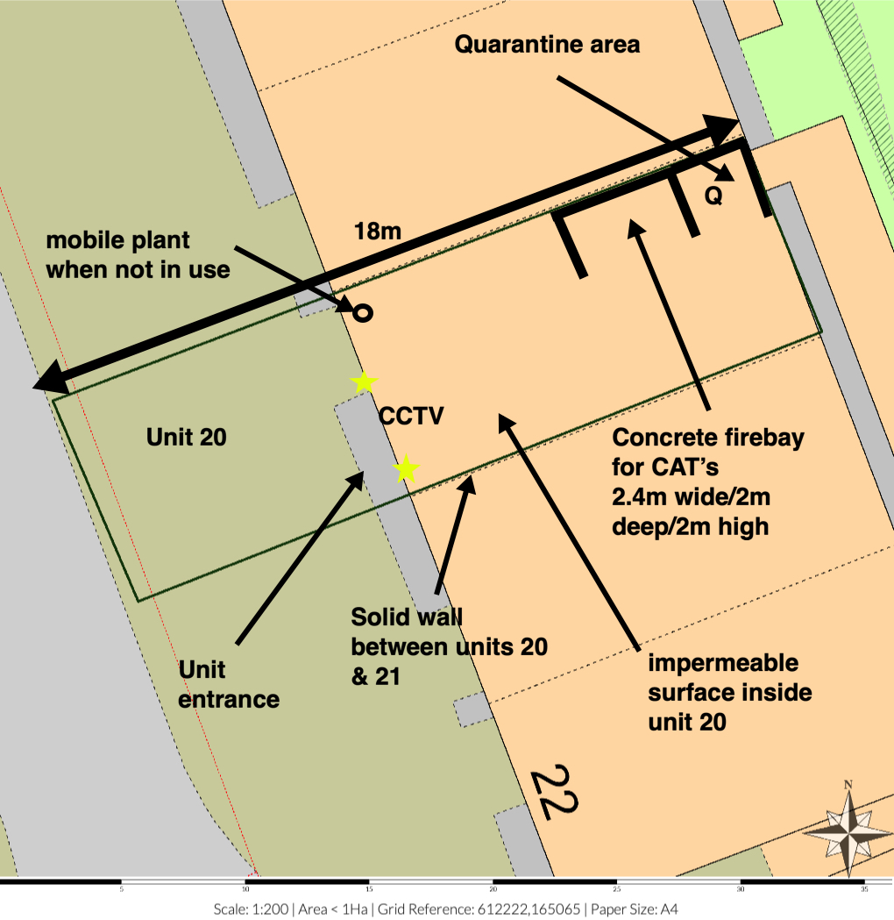
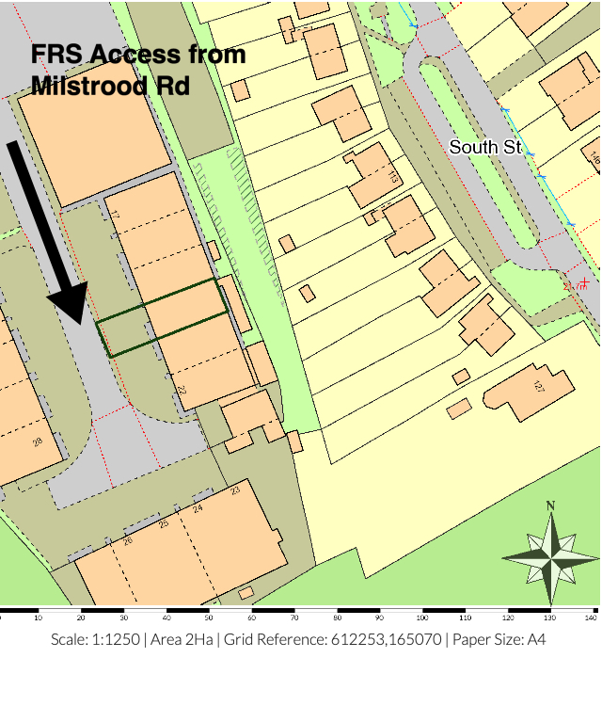A2- Site Access
- Annex B: Site Drainage

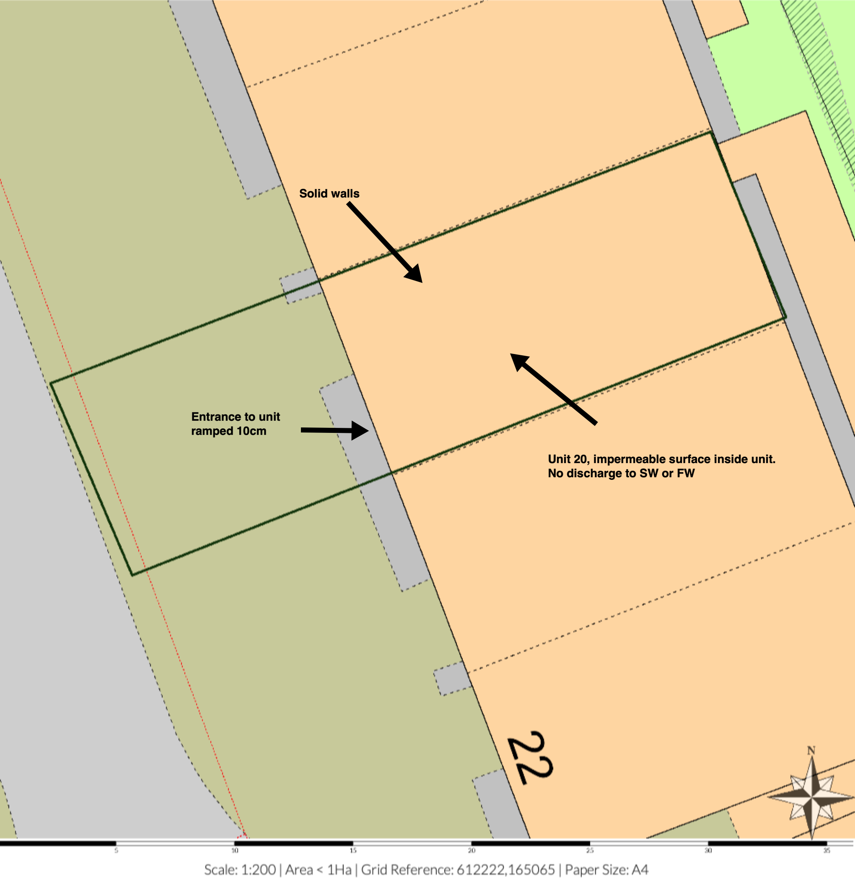
- Annex C: Fire Fighting Access, Equipment & Water Supply Plan
Car parking area

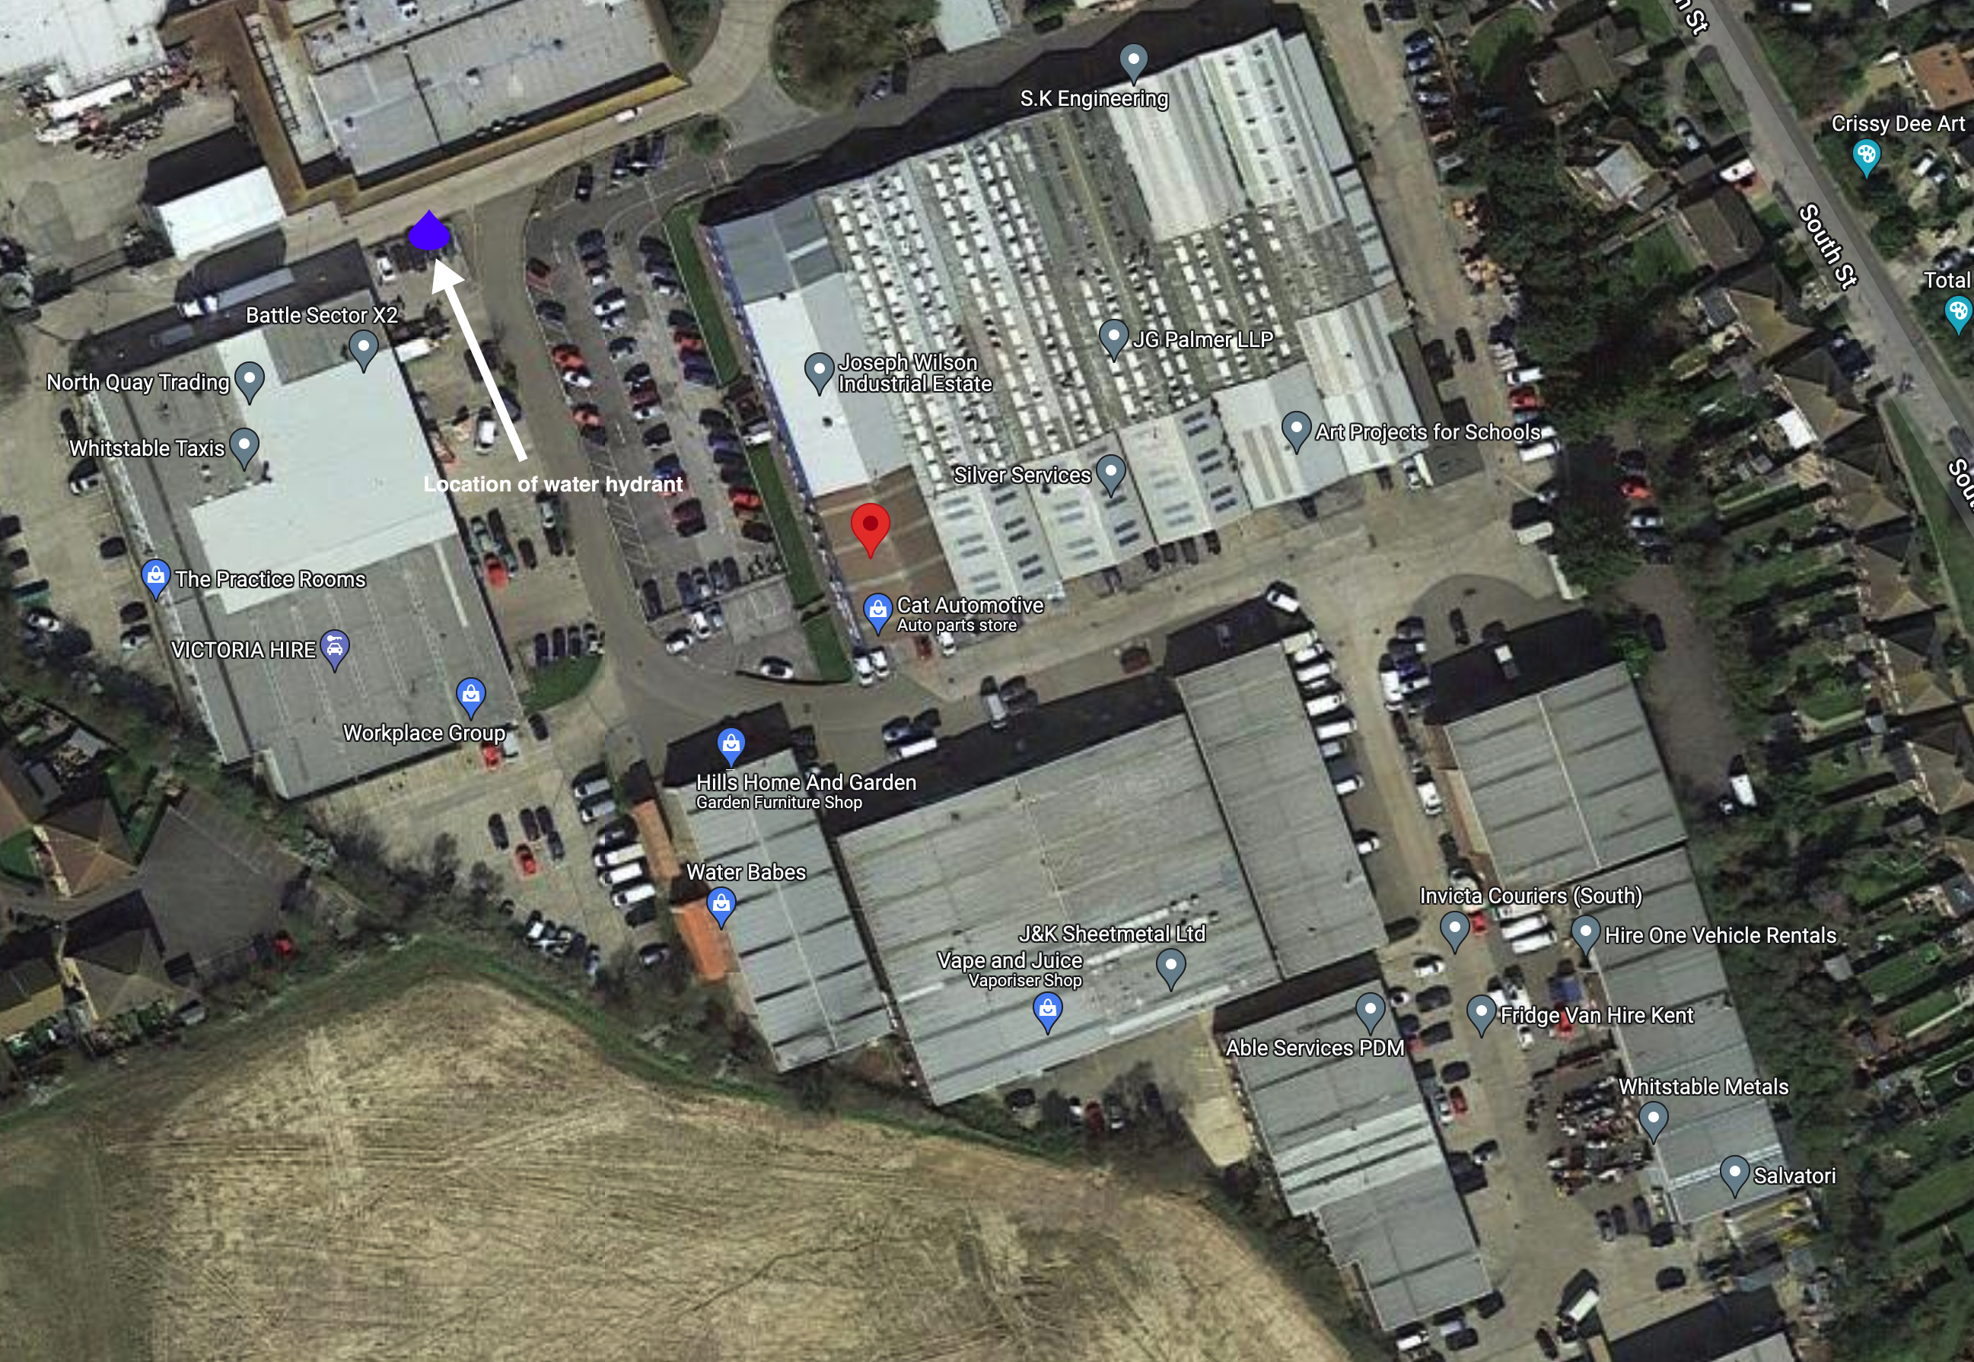C1

- Annex D: Key Receptors
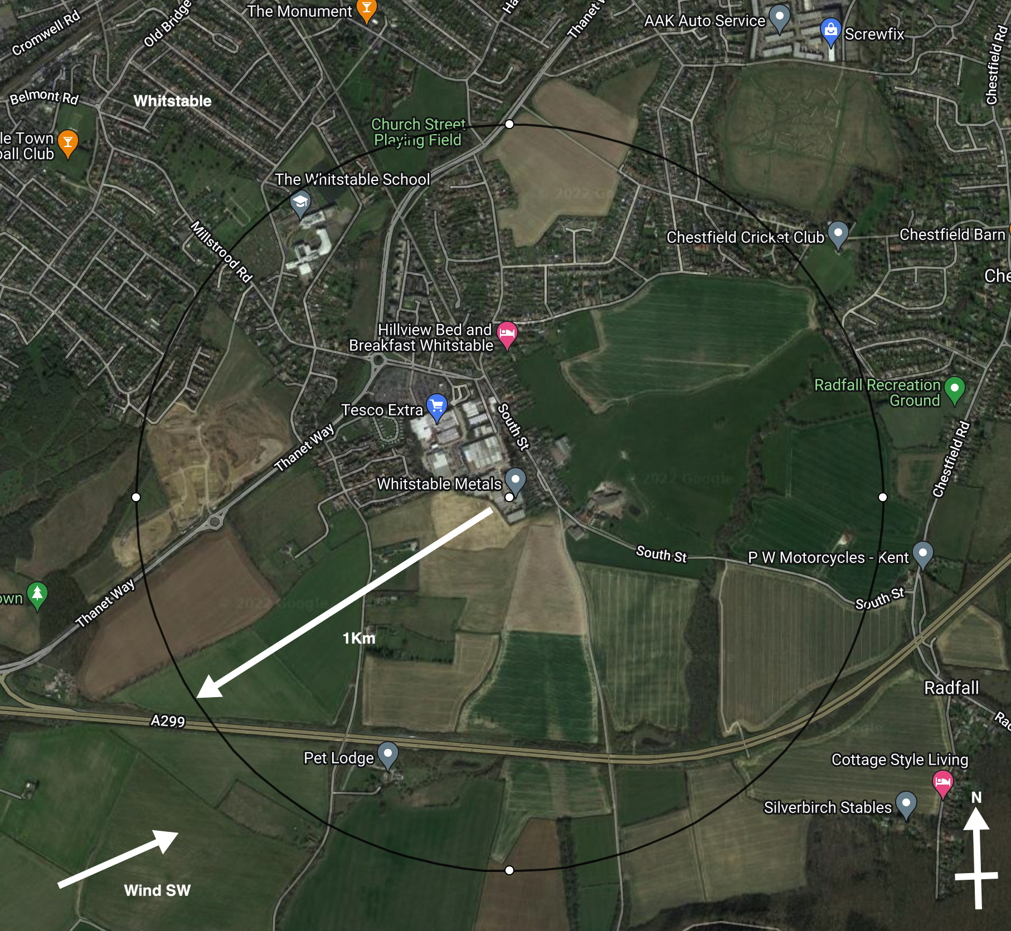 | Key Receptors  The receptors shown are within 1km of the site (black circle). Sensitive human receptors include areas containing residential properties & light industry all round the site.  The site is in on a small semi-rural industrial estate which is bordered on all sides by agricultural land and residential properties There are very few residential premises nearby apart from to the NW. There are no designated local wildlife site or SSSI’s within 1Km. There is no key infrastructure nearby.  The nearest Fire Response Service is in 11 Borstal Hill, Whitstable CT5 4NA some 1.5Km West  Wind Direction  According to the UK Met Office, the prevailing wind direction in the area is South-Westerly. This means the prevailing winds blow over the site to the north east, which is away from the bulk of the residential areas.

- Annex E: Waste Acceptance Procedures
In order to identify non-compliant wastes including any hot loads, the following Waste Acceptance Procedure is implemented by Whitstable Metals Limited.
Waste Acceptance
The procedure that shall be adopted at site is detailed below
1. Waste arrives on site.
2. Documentation is checked at the office at the entrance to the site. See annex A2.
3. All vehicles will have their contents examined during unloading and this shall be crosschecked with the documentation presented.
4. Staff will check that the type of waste is acceptable in terms of the waste permit.
5. If the waste is unacceptable the waste shall be isolated and arrangements put in place for the contractor to remove the waste from site or for the waste to be segregated in the quarantine area until such times that it can be removed.
6. If the person who is checking in the load is suspicious of its contents the driver shall be directed to the waste inspection area near the reception office, where the load shall be sampled and inspected to ensure that it corresponds to the accompanying documentation. In any event compliance testing will be carried out at regular intervals.
7. Assuming the on-site verification at the office is satisfactory, the load is checked in and directed to the yard as appropriate. Here, the waste will be checked again to verify that the description is correct before unloading is allowed.
N
- Annex F: Fire Risk Checks Form for Fire Prevention
The following regular check has been completed:

Checks to be made
- Security – all security fencing and security equipment is intact (daily)
- Signs of Self Combustion – no smoke visible /potential hot spots identified (daily)
- Storage areas – housekeeping is suitable (daily)
- Storage areas – pile sizes within permitted limits (daily)
- Exhausts – exhausts are cool and located away from combustible materials(daily)
- Fire fighting water – all hose reels and hydrants are accessible(daily)
- Fire extinguishers – all fire extinguishers are in the correct place and intact(daily)
- Fire Quarantine area – clear from waste and signage intact(daily)
- Mobile plant parked remotely, secured and key out when site closed(daily)
- Waste turned when? – recorded on waste inventory in site office(monthly)
- Waste in (t) – recorded on waste inventory weekly in site office. Waste removed in date order
- Waste out (t) – recorded on waste inventory weekly in site office. Waste removed in date order.

Date | Morning check (initials) | Evening Check (Initials) | Issues to Report to Site Manager

- Annex G: Emergency Contacts

Name & Address |  | Telephone Number
Environment Agency | General Enquiries:  Incident Hotline Reporting: | 03708 506 506  0800 80 70 60
Electricity Supplier & mains switch location
Gas supplier & shut off valve location
Water supplier & shut off valve location
Local Authority Emergency Services
Insurance Company and policy number
Nearest Hospital
Emergency Spillage Response company

- Annex H: EMS Documents
Drainage & Bund Checks
- A current site drainage plan will be drawn up and displayed in the office areas for information. The standard colour coding of blue for surface water drainage that discharge to the environment and red for sealed or foul drainage systems will be employed.
- The integrity of impermeable surfaces, gulleys and storage areas will be visually inspected by the operator on a monthly basis. To achieve this, it will be necessary to sweep/ wash clean the impermeable surface that form licensed area and clear any debris that has collected in drain gulleys to the front of the building. Where any defects are found, remedial steps will be taken promptly to maintain the integrity of the structure. If, however the integrity of the structure is breached a temporary repair will be made by the end of the working day and a full repair will be made within 10 days.

Area | When Checked | Date | Comments
Fire bay | weekly | 20/12/21 | Clean
Hardstanding | 6 monthly

Site Vehicle and Machinery Maintenance.

- All site vehicles and machinery will be fitted with working exhaust silencing equipment.
- Staff will not continue to operate any piece of machinery or equipment that appears to be visibly or audibly failing.
- All vehicles and machinery operated within the site will undergo regular planned preventive maintenance/ servicing and inspections, at the frequency deemed appropriate by manufacturer or required by legislation. As a minimum, this will be a statutory annual inspection of lifting (LOLER) and work (PUWER) equipment. Maintenance/ Servicing and inspection records will be kept on site for reference.
- Where the necessary maintenance and repair skill do not exist within the company, a contract for these services will be in place, so that the repair of site vehicles and machinery will be undertaken promptly.
- If mobile plant maintenance/ repair will involve the removal/ loss of potentially polluting fluids from the vehicle, if possible, the vehicle should be moved to impermeable concrete area and worked on there, where any spills will land on an impermeable surface. All fluid leaks or drained oils will be collected in a container and removed.
- Where mobile plant must be repaired in the location that it breaks down, if this is on hard standing, drip trays and absorbent mats will be put in place under the vehicle before work begins, to capture any spills of potentially polluting substances and prevent contamination to the earth below.
Plant and Vehicles will be inspected and recorded below;

Equipment | When checked | Date | Comments | signed
FLT | 6 monthly
Dealing with Spills

Scope: To detail how spills during normal and abnormal operations are dealt with to minimize impact on the environment
Responsibility: Site owner
Background: Spillage of oils and chemicals can have an impact on the soil and groundwater beneath the site.
The site carries quantities of absorbent granules and absorbent booms to mop up small quantities of hydrocarbon and other liquids if spilt. If used these are stored in a hazardous waste container until removed from the site by specialist contractor within a reasonable period of time.

- During normal operations, all staff have been made aware of the requirement to minimise fuel and liquid spills on site
- All staff have had appropriate training on how to deal with a fuel spill in the event of an incident occurring
- Absorbent is used to clean up the spill at source. If it is a larger spill and it is safe to do so then the source of the spill is curtailed if possible.
- The location of spill kits and absorbent material is identified on the site plan
- Where possible all spills are directed to the sealed drainage system for containment
- A store of general absorbent material will be kept on site in an easily accessible central location known to all site staff.
- Where leakage from any storage container (No known storage on-site) on site is found, actions to remedy the leak will be taken. Any such leakage and remedial action will be recorded in the site diary.
In addition:
- The source of the leak or spill will be investigated, located and stopped.
- If any significant leaks or spills of substances occur, which have the potential to harm the environment or pose a risk to human health; the materials detailed under the section 'site provisions' will be utilized and disposed of appropriately.
- Any pooling leak or spill of a potentially polluting liquid will be soaked up with appropriate absorbent material, such as saw dust, sand or granules. The absorbent material will be cleared from the ground when it has soaked up all free polluting liquid.
- In the event of a significant and/ or on-going leak or spill of a potentially polluting liquid, clay damit mats or suction covers will be applied to drain grills to seal them to prevent (further) liquid from entering the drainage system.
- If any leaks or spills of substances occur, which have the potential to harm the environment or pose a risk to human health escape the site boundary, the management will inform the Environment Agency immediately. Any remedial action specified by the Environment Agency will be under taken, a record of which will be made in the site diary.

Waste Acceptance, Storage and Inspection
To deal with the acceptance, storage & inspection of waste on-site.
Introduction
The company will introduce a system of storage on-site to minimise the potential for cross contamination and potential run off from wastes whilst stored on site.

Waste Types
Only the waste types and EWC codes named on the environmental permit will be accepted at the site. Wastes entering the site will be inspected and registered at the site. Non-compliant waste materials not allowed on the permit will be turned away from the site. A record will be made in the site diary.

Working Hours

Normal working hours will be 0800-1800 Monday - Saturday

Sunday – closed

Responsibility

The Manager (Adrian Smith) is responsible for identifying and highlighting non-conforming waste. The Environmental Manager is responsible for inspecting, documenting and safe removal of any non-conforming waste.

Waste Storage
Areas will be nominated on-site for waste storage - firebay. These will be labelled and identified on the site plan. The site plan will be updated on a regular basis provide a record of what type of waste and quantity is stored where.

Waste Acceptance
The procedure that shall be adopted at site is detailed below
1. Waste arrives on site.
2. Documentation is checked at the office.
3. All vehicles will have their contents examined during unloading and this shall be crosschecked with the documentation presented.
4. Staff will check that the type of waste is acceptable in terms of the waste licence.
5. If the waste is unacceptable the waste shall be isolated and arrangements put in place for the contractor to remove the waste from site.
6. If the person who is checking in the load is suspicious of its contents the driver shall be directed to the waste inspection area close to the reception office, where the load shall be sampled and inspected to ensure that it corresponds to the accompanying documentation. In any event compliance testing will be carried out at regular intervals if required
7. Assuming the on-site verification at the office is satisfactory, the load is checked in and directed to the yard as appropriate. Here, the waste will be checked again to verify that the description is correct.

Waste Area Inspection
As part of the EMS waste areas are inspected routinely, deviations from normal operation conditions, result are logged and acted upon in the site log.

Records
Whitstable Metals Limited shall keep records of all waste loads rejected including;
- Date
- Name of Carrier
- Source of Waste
- Vehicle Registration
- Description of Waste
- EWC code
- Quantity of Waste
- Name of person carrying out inspection
Destination of Load prior to rejection

Fire Prevention Plans, Version 3 January 2021
http://www.metoffice.gov.uk/climate/uk/regional-climates/

