Stephen Griffiths
EnviroAwards
Able Waste Services Limited
Fire Prevention Plan
Fire Prevention Plan

Contents Page

- Fire Prevention Objectives ……………………………………………………………………………………………
- Who This Guidance Applies to ……………………………………………………………………………………..
- Who This Guidance Does not Apply to …………………………………………………………………………
- Types of Combustible Waste ……………………………………………………………………………………….
- Using the Fire Prevention Plan …………………………………………………………………………………….
- Fire Prevention Plan Contents …………………………………………………………………………………….
- Activities On Site ………………………………………………………………………………………………………..
- Site Plans and Maps ……………………………………………………………………………………………………
- Manage Common Causes of Fire …………………………………………………………………………………
- Prevent Self-Combustion …………………………………………………………………………………………….
- Manage Waste Piles ……………………………………………………………………………………………………
- Where Maximum Pile Sizes do not Apply ……………………………………………………………………
- Prevent Fire Spreading ……………………………………………………………………………………………….
- Quarantine Area …………………………………………………………………………………………………………
- Detecting Fires ……………………………………………………………………………………………………………
- Suppressing Fires ………………………………………………………………………………………………………..
- Firefighting Techniques ……………………………………………………………………………………………….
- Water Supplies ……………………………………………………………………………………………………………
- Managing Fire Water …………………………………………………………………………………………………..
- During and After an Incident ……………………………………………………………………………………….

Appendix 1 – Site Infrastructure Plan
Appendix 2 – Sensitive Receptor Plan
Appendix 3 – Location Plan
Appendix 4 – Waste Table

- Fire Prevention Objectives

Sites that store combustible wastes are at risk from fires on sites. These events can pose an environmental risk to receptors off site, both from the smoke plume from the fire and from the firewater runoff created by any firefighting activities. Sites storing combustible materials such as paper, plastics, cardboard and scrap metal are required to have in place a fire prevention plan that follows the standards prescribed in the Environment Agency’s (EA) guidance documents – updated 11th January 2021

This fire prevention plan has been designed to meet the following three objectives:

- Minimise the likelihood of a fire happening.
- Aim for a fire to be extinguished within 4 hours; and
- Minimise the spread of fire within the site and to neighbouring sites.

This is a working document and will be reviewed and updated, in consultation with the Environment Agency (EA) on at least an annual basis, or immediately after an incident or a change to operations.

- Who This Guidance Applies to

The EA’s Fire Prevention guidance applies to this site as the operator stores combustible waste; the combustible wastes include non-hazardous waste and waste metals as detailed within this document.

- Who This Guidance Does not Apply to

The Environment Agency guidance document does not apply to materials or waste that are; flammable; combustible liquids or gasses; hazardous; or dangerous substances stored under the Control of Major Accident Hazards Regulations. The guidance states that these materials should still be considered within the fire prevention plan because of their potential to increase the impact of fire on site. Therefore, the following materials are considered within this plan:

Type | Storage Location | Storage Features
DERV | See site plan (appendix 1) | 5000L LLDPE Bunded Diesel Tank. Tank is double skinned and capable of containing at least 110% of the volume of the tank
Gas Canisters | See site plan (appendix 1) | Gas Canister Cage

- Types of Combustible Waste

The types of combustible waste stored on site are limited to:

- Wood
- Paper/Cardboard
- Mixed Construction Waste
- Iron/Steel
- Non-Ferrous
- Inert, Hardcore/Soil

The location and dimensions of the combustible waste stockpiles are presented within the waste table (Appendix 3)

- Using the Fire Prevention Plan

This fire prevention plan forms part of the Operator’s Environmental Management System. This fire prevention plan is a standalone document – it contains all relevant information, site plans and information to be used in a time of emergency. A copy of the fire prevention plan is stored within the site office. It is stored in a clearly marked Red Folder, the site file is marked ‘FIRE PREVENTION PLAN AND EMERGENCY ACTIONS’.

All site staff will be able to access the site file at all times, including during an incident. All staff and contractors working on site will be instructed on the content of the fire prevention plan and what to do prevent a fire occurring, including what to do during a fire if one Occurs.

All staff will receive training on the fire prevention plan. The Company will undertake regular exercises to test how well the plan works and they will make sure that the staff understands how to respond.

Table (1) below outlines the schedules that will be carried out on site:

All new site staff and contractors (and existing site staff and contractors when the plan is introduced on site) | To be trained on the fire prevention plan and emergency actions during site induction
Existing site staff and contractors | To be trained on the fire prevention plan and emergency actions during the first week of the FPP being approved, and every 6 months (on the nearest practicable date to the 1st of the month)
Site Managers to carry out a fire drill and test the fire prevention plan and emergency actions | Every 6 months (or the nearest practicable date to the 1st of the month)
Site TCM and Site Manager | Annual review each year, or earlier if in a response to an incident or change in operational procedures

There is always at least one Fire Marshal present on site during operational hours. The procedures for fires discovered on site are provided both in Able waste’s Fire Prevention Plan (FPP), Environmental Management System (EMS) and on-site notice boards.

- Fire Prevention Plan Contents

This Fire Prevention Plan ensure that Able Waste will do all that is reasonable to prevent fires on site. The plan forms part of the broader written management system and includes an assessment of the sites fire risk and the measures in place to prevent, detect, suppress, mitigate and contain fires. The Fire plan will be intrinsically linked to the sites operations and will provide the most robust set of actions required to protect from all reasonably foreseeable fire risks.

- Site Activities

The activities that can be carried out at the site as defined under Annex II of the Waste Framework Directive can be summarised as follows:

- D15: Storage pending any of the operations numbered D1 to D14 (excluding temporary storage, pending collection, on the site where it is produced)
- R13: Storage of wastes pending any of the operations numbered R1 to R12 (excluding temporary storage, pending collection, on the site where it is produced)
- D9: Physico-chemical treatment not specified elsewhere in Annex IIA which results in final compounds or mixtures which are discarded by means of any of the operations numbered D1 to D8 and D10 to D12
- R3: Recycling/reclamation of organic substances which are not used as solvents
- R4: Recycling/reclamation of metals and metal compounds
- R5: Recycling/reclamation of other inorganic materials

Activities on site currently consist of the receipt, unloading, sorting, storage, of mixed construction and domestic waste. The predominant waste types are:
17-09-04; Mixed Construction Waste
20-03-07; Bulky Waste

Once tipped the material is pre-sorted using a 360-material handler to remove the larger fractions, the remaining material is put through our picking station to remove target materials into single waste streams – Wood, Paper/Cardboard, Iron/Steel, Non-Ferrous, Inert, Hardcore/Soil

Once processed the target materials are classified inline with WM3 Technical guidance and transferred from site for further processing.

- Site Plans and Maps

The site is located within the Imperial Way Industrial Estate, just of the A23 – Purley Way Croydon

The National Grid Reference (NGR) for the site is TQ 31007 63679 and the site location is illustrated on the location plan (appendix 3). The site layout is shown on the site plan (appendix 1)

The site is in a mixed-use industrial area. The closest receptors are businesses that lie within the industrial estate surrounding the site. The closest residential receptors lie 318 meters to the west of the site – Mollison Drive Estate. The site backs directly onto a recreational area consisting of playing fields - Roundshaw playing field & Croydon baseball club. Purley Way Playing fields lies 266 meters to the east of the site.

The surrounding land-use and receptors are identified on Appendix 2 (Sensitive Receptor Plan).

Searches on MAGIC confirmed that there are none of the following within 1km of the site’s boundary:

- Areas of Outstanding Natural Beauty (AONB);
- Special Areas of Conservation (SAC);
- RAMSAR sites;
- Special Protection Areas (SPA);
- Sites of Special Scientific Interest (SSSI);
- National and Local Nature Reserves;
- National Trust Properties;
- Woodland Trust Sites; and
- National Forest.

Identified Sensitive Receptors

See Sensitive Receptor Plan (Appendix 2)

Windrose

A windrose providing the frequency of wind speed and direction from the Biggin hill Airport Meteorological Station for the period of 2018 is presented below. The windrose shows that the most prominent wind direction is from the Southwest to the Northeast. Winds from the north, east and south are relatively infrequent. Smoke contains a multitude of combustion products including irritants and asphyxiants which are toxic. These toxic pollutants can impact anyone within 1km of the site and in certain circumstances will have an impact on public health at greater distances than 1km. Smoke will have a significant effect on human health, as detailed within the research studies. The fire and smoke would affect the immediate businesses, local houses and the wider industrial and residential areas.

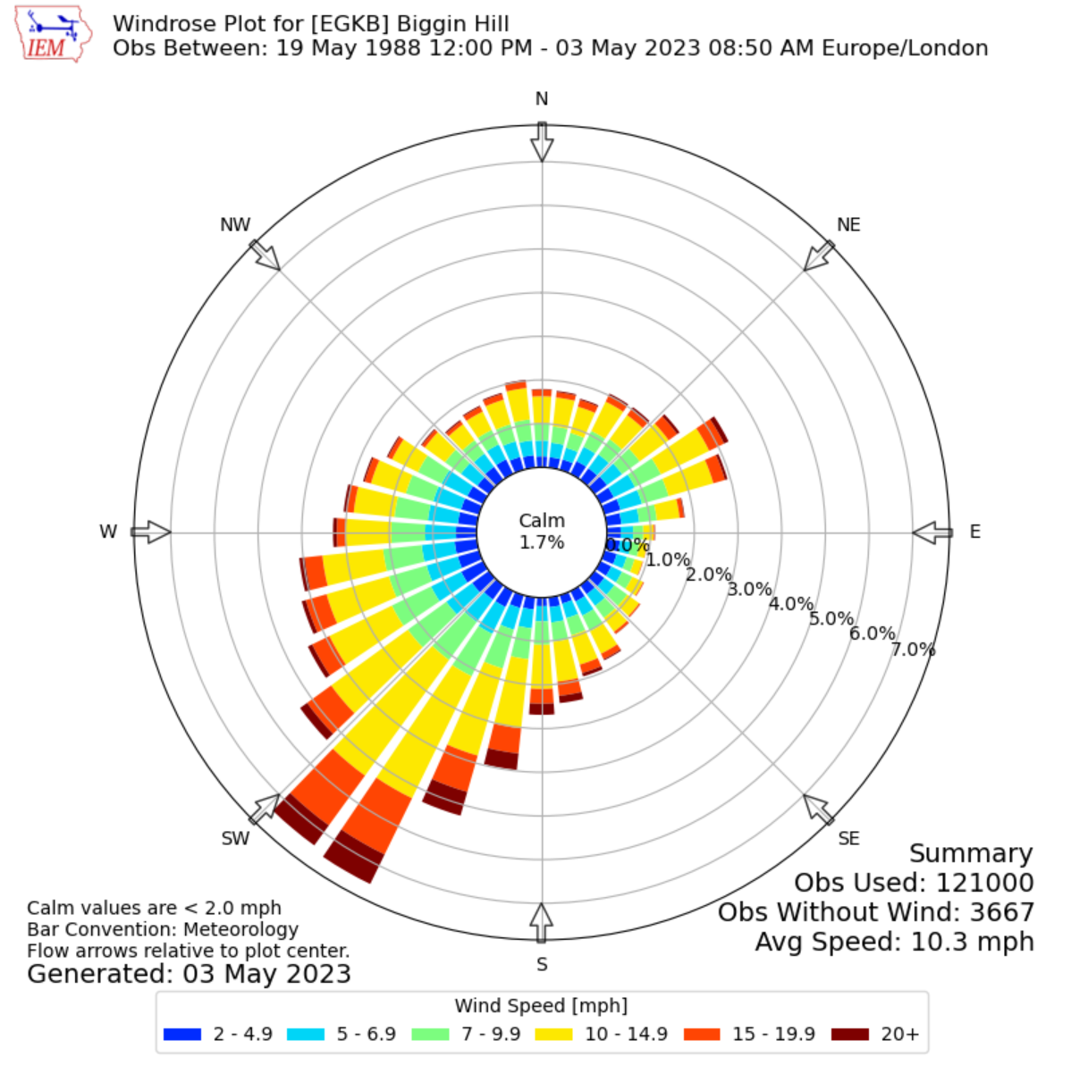

Site Infrastructure Plan
The Environment Agency Guidance states that the site plan must show the following information:

The location and layout of the site buildings, location of fire assembly area, fire extinguishers, fire hose, smoke detectors and PPE storage area. Any areas where hazardous materials are stored on site (location of gas cylinders, process areas, chemicals, piles of combustible materials, oil and fuel tanks) See Appendix 1.

Main access routes for fire engines and any alternative access, access points around the site perimeter to assist firefighting, hydrants and water supplies. See Appendix 1.

Areas of natural and unmade ground (Appendix 1) shows areas of unmade and impermeable areas.

The location of fixed plant or where mobile plant is stored when not in use. Appendix 1

Drainage runs, pollution control features such as drain closure valves and fire water containment systems. Appendix 1 shows Site drainage system, firewater and containment bunding

Storage areas with pile dimensions and fire walls (where applicable) – includes wastes stored in a building or containers. Including a Quarantine area. Appendix 1 shows site layout, including combustible waste storage and quarantine area.

Emergency Services:

- Wallington Fire rescue Service, 19 Belmont Rd, Wallington SM6 8TE, 2.2 miles from the site, 8 minutes travel time.
- Croydon Police Station, 71 Park Ln, Croydon CR9 1BP , 2.3 miles from the site, 9 minutes travel time.
- War memorial Hospital, War Memorial Hospital, 856 Brighton Rd, Purley CR8 2YL, 1.7 miles from the site, 6 minutes travel time.

- Manage Common Causes of Fire

Arson
The site benefits from a continuous presence of staff during operational hours, currently between 6am to 6pm Monday to Friday. Saturdays 6am – 17.00pm In addition, there is a night time security guard posted during 6pm to 12am Monday to Friday, The on site residents are present outside of operation hours as a added layer of security.

Security features on site includes:

- 2m high perimeter fencing surrounding the site;
- The process building is completely lockable.
- 2m high perimeter fencing surrounding the quarry face (along the bridle way);
- Access gate controlled by Able Waste staff;
- CCTV system; and
- Presence of a security guard or a resident member of staff outside of operational hours.
- Combustible waste is stored within the buildings and protected from arson attacks, or contained within a bay or container.
- The site has installed thermal imaging cameras

All visitors and contractors are required to sign in and are escorted by a member of staff. CCTV is accessible to site operatives throughout the working day, and remotely viewable on mobile devices at all times. If a breach in security is detected site operatives/the security guard would contact the Site Manager or their deputy and the emergency services as appropriate, both inside and outside of operational hours.

All security measures on site are inspected at the commencement of every working day by site operatives to ensure their continued integrity. Any defects or damages which compromise the integrity of the enclosure will be made secure by temporary repair by the end of the working day. Permanent repairs will be made within a maximum of 5 days.

In the event of a breach of security at the site, the cause is investigated, and appropriate mitigation measures implemented, such as repositioning of CCTV cameras, repair of security infrastructure, and/or additional deterrents. This is recorded in the site diary. Records maintained include inspections and maintenance of perimeter fencing and gates, doors and locks, breaches of security, investigations and actions taken.

Mobile Plant and Equipment
Mobile plant and equipment consists of:

- X2 Material Handlers;
- X1 Loading Shovel; and
- x1 360 Excavator

Mobile Plant and equipment is checked daily before use and regularly maintained as part of Health & Safety Procedures and within manufacturer guidelines. Maintenance is recorded in daily and weekly (depending on the maintenance requirements) and recorded on the plant maintenance sheets. Any faults or problems noted during the daily checks are reported either directly to the manager, or in his absence, the site supervisor so that the problem or fault can be rectified. Again, actions will be recorded using the sites defect sheet. Fire extinguishers are strategically located around the site to ensure that fires can be dealt with swiftly.

Mobile plant will be cleaned down daily to remove dust build up, fluff and any other potentially combustible materials.

Mobile plant that is not being used is kept a minimum distance of 6 meters away from combustible materials. Mobile plant will be fully isolated at the end of every working day. Employee/visitor/contractor vehicles are parked in the designated car park which is located at the front of the site well away from storage and processing areas

Fixed Plant
Fixed Plant consists of:

- X1 Picking Station

The picking station is checked daily before use and regularly maintained as part of Health & Safety Procedures and within manufacturer guidelines. Maintenance is recorded in daily and weekly (depending on the maintenance requirements) and recorded on the plant maintenance sheets. Any faults or problems noted during the daily checks are reported either directly to the Plant Manager, or in his absence, the Site Manager so that the problem or fault can be rectified. Again, actions will be recorded using the sites defect sheet. Fire extinguishers are strategically located around the fixed plant to ensure that fires can be dealt with swiftly.

Fixed plant that is not being used (E.g. at the end of the working day) will be overrun (shafts, conveyors etc) to ensure all combustible wastes are fully discharged out from the plant. This will take approximately 6 – 10 minutes (depending on debris build up). Combustible waste will be kept a minimum distance of 6 metres away from all static plant (unless it is being used to process waste). There will be a site clean up at the end of each working day to remove any combustible material (fluff, dust, accumulations) from rollers, bearings and motors. Static Plant will be fully isolated at the end of every working day.

Ian (Plant Manager) is responsible for all aspects of plant maintenance for safety, preventative maintenance, and fire and pollution prevention.

Electrical faults including damaged or exposed electrical cable
All buildings have been wired by a qualified/certified electrician and daily checks are carried out on all portable hand tools and electricals. Fixed electrical are protected from the operations activities but will undergo a full inspection every 2 years. In addition, an electrician will carry out annual checks on all electrical equipment as part of the PAT testing regime. This will also be recorded on the Maintenance Logs.

If cables are Identified as damaged, procedures are in place for reporting damage to cables to ensure isolation to these areas. The TCM will be responsible for making these checks and instigating repair works.

Discarded smoking materials
A no smoking policy is enforced on site with clear signage prohibiting it. The designated smoking area is a safe distance away from combustible wastes to prevent accidental ignition. Smoking materials, lighters and matches will not be taken in to the storage tents, or treatment buildings.

Hot Works
Hot works is not an intended activity for the site, however, If for anything hot works was undertaken (E.g. using cutting equipment for engineering works on the fixed plant) then this activity will carried out in a controlled setting due to it giving rise to sparks and through generation of heat. A permit to work system has been implemented to factor in the risks involved with ignition and heat sources. A fire watch will take place after the hot works is complete. A hand held thermal imaging camera will be used to detect any residual heat. Once the heat has dissipated, the components will be placed into storage. The permit to work system will dictate what firefighting equipment will be needed. Waste and other combustible materials will be placed a minimum of 15 metres away from any hot works. Heat/spark screens will be erected around the hot works area.

Industrial Heaters
No industrial heaters will be utilised on site.

Hot Exhausts
Vehicles are turned off when not in use and stored outside, at least 6m away from combustible waste storage areas. Consideration is given to the high-risk time for hot exhausts (one hour after switching off when dust can settle on hot surfaces). Vehicles and plant are switched off at least 30 minutes before the end of the day, for them to cool down prior to site staff leaving site. They are also cleaned daily to remove any dusty materials. A fire watch is conducted via visual assessment a minimum of twice every working day to detect signs of fire caused by dust settling on hot vehicle exhausts or engine parts. A visual assessment is also conducted at the end of the working day.

The hot exhaust fire checks will be carried out at the following times:

Fire watch visual inspection on plant and exhaust parts (and using heat detection camera on stockpiles) | Date | Time | Actions Taken | Signature
Fire Watch 1 |  | 12:00
Fire Watch 2 |  | 16.30

Sunlight
Due to the possibility of heating of waste by the sun, no combustible wastes will be stored loose outside in direct sunlight. Treatment activities will only take place within the 4-sided building to prevent access, rain ingress, direct sunlight and to prevent windblown wastes escaping. Temperature checks are taken 3 times daily.

Ignition Sources
Potential ignition sources include hot exhausts and engine parts and discarded smoking materials (all described above). All ignition sources will be kept a minimum of 6m away from the storage of combustible and flammable wastes. A risk assessment will be made on all sources of ignition to ensure that they are required on site or if other items of equipment can be utilised instead (reduce requirement for items which carry inherent risks).

Leaks and spillages of oils and fuels
All fuels and lubricating oils/fluids are appropriated stored. The DERV tank is surrounded by a leakage containment bund capable of containing at least 110% of the volume of the tank. Bunds are impermeable and resistant to stored materials. Inspection of any spillages or leaks from containment will be completed at least once per shift by a site operative. The results of all daily and weekly monitoring will be recorded in the site diary, as well as any remedial actions. In the event of any potentially polluting leak or spillage occurring on site following actions will be taken:

- Minor spillages will be cleaned up immediately, using sand or proprietary absorbent. The resultant materials will be placed into containers and will then be removed from site and disposed of at a suitably permitted facility. The incident will be logged in the site diary.
- In the event of a major spillage, which is causing or is likely to cause polluting emissions to the environment, immediate action will be taken to contain the spillage and prevent liquid from flowing outside the EP boundary. The spillage will be cleared immediately and placed in containers for offsite disposal, and the EA will be informed.

All equipment and plant is inspected on a daily basis for leaks.

Build up of loose Combustible Waste, Dusts, and Fluff
The site will be inspected regularly for the build-up of loose combustible waste, dust and fibres. This material will be removed from site on a regular basis, and immediately if near a source of ignition or heat. The frequencies are outlined below:

Inspection to assess the build up of loose wastes, dusts and fluff | Date | Time | Actions Taken | Signature
Loose waste inspection 1 |  | 12:00
Loose waste inspection 2 |  | 16.30

The risk of the build-up of combustible waste, dust and fluff is low due to the following measures implemented on site.

- All incoming waste is off loaded directly into the storage areas to minimise unnecessary handling and transport distance therefore minimising the potential for wind-borne dust;
- All plant and equipment is subject to a programme of planned preventative maintenance which follows the inspection and maintenance schedule recommended by the manufacturer. This includes corrosion prevention where applicable;
- All waste treatment takes place in buildings, minimising the potential for dust emission;
- Storage areas benefit from daily inspections
- Site access roads and external operational areas are maintained and swept regularly to reduce dust generation; and
- Daily visual inspection of the site and site boundary is carried out by site personnel.
- Daily site shut down procedure which includes the over running of conveyors, rollers, and shafts to ensure all materials are discharged and a full clean down proceeds.

Reactions Between Wastes

The environmental permit limit’s the incoming waste to specified non-hazardous wastes.
The site does not accept chemicals, lithium batteries (but does accept lead acid), etc. therefore the risk of a reaction between
the wastes is negligible. Care will be taken to ensure that any non-conforming wastes found
within loads are stored in an appropriate manner; for example, avoiding the storage of
incompatible wastes such as oxidisers and flammable together. The quarantined wastes will
be checked daily as a precaution.

Lead acid batteries will be stored up right within a battery box with the terminals tapped.

Deposit of Hot loads
Hot loads, or suspected hot loads identified will be placed into the designated quarantine
area on detection. The waste will be extinguished, or safely isolated to allow the heat to
naturally dissipate. Any volatile material/waste will be transferred of-site as is practical to do so.

Storage of Fuel, Oils and Maintenance Fluids
Procedures are put in place to ensure safe storage of fuels and fluids associated with maintenance. Guidance will be taken from the HSE and the fire and rescue service.

Hazardous materials such as maintenance fluids will be stored within a bunded spill tray situated in the maintenance building (plan 2) - to reduce the associated risks. Fluids will be stored in appropriate containers and will be located within bunds. They will be located away from likely sources of ignition, away from the perimeter of the site, away from processing areas and out of the direct line of traffic. Maintenance Flammables and oxidizing wastes will not be stored together.

DERV will be Stored in two locations shown on the site plan, (5000 litres and 2500 litres) both stored within a secondary containers, to comply with the relevant oil storage regulations. Situated to the outside of the building. the storage is covered by CCTV. (Plan 1). A fire within this zone will be deemed an emergency and the emergency services will be called within the first instance, and the site evacuated.

- Prevent Self-Combustion

The most effective way to reduce the impact from fire on site is to prevent them from occurring in the first place. Managing storage times, pile volumes and height, and the temperature of the wastes can prevent the self-combustion of wastes.

The locations, sizes and composition of the stockpiles are presented within Appendix 4 (Waste Table) and Appendix 1 (site plan)

Self-combustion of waste on site is not considered to be a significant risk due to the short storage times (under normal operational conditions) and because waste is segregated into dedicated storage areas. All waste types are stored in dedicated storage bays.

- No loads are removed without an onsite operative in supervision;
- A visual fire watch is performed as the loads are received and unloaded; and
- Quarantine areas are kept available. Should the wastes be found not to conform during the initial visual inspection, then the details will be recorded, and the vehicle turned away. If wastes have already been discharged and are deemed not to conform or otherwise not be permitted, then the waste will be:
- Removed to a designated quarantine area and marked with a yellow sign; and
- The site manager will notify the customer of the non-conforming material within 24 hours of receipt and arrangements will be made to return the material at the customer’s expense
- Nighttime security watchman will use handheld thermal imaging camera to monitor the stockpiles throughout the shift

Storage Times

All storage times are detailed in Appendix 4 (Waste Table)

Waste Storage

Daily stock rotation of incoming commercial, industrial & household waste Incoming wastes are delivered and tipped inside of the weatherproof building. Waste will then be immediately sorted into its single waste streams for recycling or recovery. Once the waste has been sorted, it will be transferred into designated waste bays and/or 40 yard skips ready for dispatch. The skips and bays will be emptied/collected from site in order of when they were loaded in order to maintain stock rotation, The skips will be stored 6 meters away from one another to maintain a fire break. If waste needs to remain inside the building for temporary storage, Stock rotation is of paramount importance:
- The incoming waste is naturally placed at the front of the stockpile;
- The front of the stockpile is moved forward with a 360 during the course of the day to ensure that the waste moves forward on a systematic basis.
- Waste that is stored at the back of the pile can be reached with the 360 due to the extended dipper and boom of the machine. This waste will be loaded first into the relevant containers/skips.
- This system ensures that old waste is removed first every time.

Storage of Waste - Contingency Procedures to ensure that waste is not stored over one month – specific wastes storage time indicated in Table 1.
Able Waste Ltd can demonstrate that the stored processed waste is removed from site on a regular basis. The Operator is a has multiple contracts and outlets in place to prevent waste being stored on site for an excessive period. If a situation evolved where a current outlet stopped trading, the Operator would either transfer their waste to another waste management company – many of whom have a historic working relationship with the Operator.
Once sorted into the designated recyclable waste streams any combustible materials will be kept on site for no more than one month (maximum). Some materials may self-combust, this means that as they degrade through oxidation they can generate heat, this heat can build to a point where the stack of material can catch fire on its own. These materials include:

- Green material, compost, wood and wood products, paper and paper products, general waste including residual wastes;
- Smaller size or graded materials either stored or mixed;
- Material that has not had potential hazards removed before stacking e.g. exposed rust (which can generate heat); and
- Treated materials that are not cold before storage (treatment processes can generate heat).

The Operator will put the following operational procedures, to ensure that the waste is on
site for no longer than one month.

- Rejected wastes will be recorded and will be stored within the quarantine area, a record will be kept within the site office;
- Authorised wastes will be processed on site and stored within an appropriate area of site;
- Stock will be rotated to ensure that waste is added to the stockpile in a logical manner;
- A daily inspection will be undertaken by the TCM. if there is any doubt to the condition of the material, the material will be removed from site as priority;
- The Operator will ensure the oldest stock will be removed from site before the new stock (although stock that is a potential risk will be removed as priority as outlined above), this is to reduce the risk associated with storing combustible materials; and
- A weekly review of the storage times and the stockpiles will be made by the Authorised Person to ensure that all stock is removed within one month It also must be considered that the Operators Fire Prevention Plan is a live document and will be updated throughout the life of the site, and that the updates will detail any increase or decrease of importation quantities and will incorporate the most recent EA’s Fire Prevention Plan updates. Any proposals to amend the FPP and associated management system will first be submitted to the Environment Agency for approval.

Monitoring and control temperature

The site is continually manned during operational hours and site operatives remain vigilant at all times and look out for signs of fire. Staff are trained in how to identify fires and fire hazards on site. During operational hours, the temperature of all waste storage is checked at 3-hour intervals by site operatives, using a handheld infra-red thermal imaging gun to detect any temperature increase. If a temperature of above 60°C is detected, the actions described in the table below will be carried out. The night watchman will take temperature readings from 6pm – 12am.

Temperature (°C) | Actions needed
0 - 60 | No Actions Required
60 - 80 | Report to management and continue monitoring on an hourly basis
85+ | Immediately remove waste from the stockpile to the quarantine area and report to management.

All material storage areas are visually inspected by site operatives throughout the day and all findings are logged in the site diary as a minimum. Should signs of self-combustion be identified such as steaming/smoulder/smoking, the pile will be removed to the quarantine area using suitable mobile plant. checks of the affected stockpile will be increased to hourly for the remainder of the day to ensure no further hotspot development occurs. All wastes received on site are identified by a unique batch number. The entire batch will be targeted for monitoring.

- Manage Waste Piles

Waste piles must be managed carefully to help to prevent the risk of self-combustion and limit the scale of a fire if one breaks out. Wastes are not shredded and therefor processed materials are kept within their largest form. it is imperative that these stockpiles are managed to reduce the associated risks.

Maximum pile size
All stacks, piles and stores of sorted wastes, will be stored in a manner that allows emergency vehicular access to the whole site at all times and will meet the standards for maximum height, width, length, volume, area and separation for fire breaks in accordance
with the relevant guidance (January 2021)

Appendix 4 (Waste Table) provides information on the amounts of combustible waste stored on site, as well as the storage arrangement, height, volume, and particle size.

All combustible stockpiles are below 4 metres in height (max amount allowed on guidance). On the site, the surface of the site is composed entirely of concrete – there is no uneven ground beneath the waste.
If the stockpile is composed of a mixture of combustible wastes, the size of the stockpile will be dependent upon the dominant waste type.
The stockpiles do not exceed 20m in any direction (max length or width allowed on guidance).
The TCM will carry out daily checks to assess the size of the stockpile and the separation distances, to ensure that the dimensions outlined within Plan (2) are adhered to. When the stockpile reaches 75% capacity measures will be implemented to slow the input of material into site and increase outputs until stocks can be reduced.
The Operator will not accept incoming wastes beyond the capacity of the pile size; this will
ensure that the volume of waste accepted on site can be managed in a controlled and safe
manner.

- Where Maximum Pile Sizes do not Apply

All wastes stored on site must comply with the maximum pile sizes as per the Environment Agency Guidelines

- Prevent Fire Spreading

On site, all combustible wastes will be stored under cover/inside the building. Combustible wastes will be stored within 40yd bins apart from the waste acceptance area of which will store a pile of 25m3 pile of mixed waste. The waste will not be over night the acceptance area and will be kept 6m’s from any other combustible wastes and ignition sources. The container areas and waste acceptance bay can be seen on the site plan.

- Quarantine Area

The quarantine area will be used to place burning wastes (if appropriate) to extinguish them. It may also be used to hold unburnt wastes if the burning waste is in another area of site and cannot be relocated to the quarantine area

The quarantine areas are located within the permit boundary, as shown on Plan (1) this area is engineered to be impermeable. The quarantine area is capable of holding 50% of the volume of the largest stockpile on site.

Dependent on the size and location of a fire, the mobile plant on site is capable of quickly clearing an area around the burning waste to provide a flexible quarantine area. The specified quarantine area will be kept clear at all times (unless being used in the event of a fire) If the quarantine area will remain accessible at all times.

In the event of a fire, the following procedure will be put in place:

- During a fire event, the Authorised Person or his Appointed Deputy will inspect the quarantine
- Mobile plant will be utilised to move temporarily quarantined material.
- Burning materials or hot waste will be transferred via mobile plant to the quarantine
- The quarantine area has a 6 metre circumference from the site boundary, building and wastes

In the event of non-compliant waste being identified it will be immediately moved to the quarantine area and marked with a yellow quarantine sign. The site manager will notify the customer of the non-conforming material within 24 hours of receipt, and arrangements will be made to return the material to the customer at the customer’s expense. Appropriate PPE would be worn by site operatives.

- It allows for the prompt and direct removal of smouldering, burning or fire damaged wastes from the waste storage and to allow access by the Fire & Rescue Service (FRS); and
- Proximity to flammable liquids – the quarantine area is situated at least 6m from any potentially flammable liquids on site such as the diesel tank.

- Detecting Fires

The site benefits from a fire detection system (thermal imaging cameras). The offices and residential dwellings are fitted with smoke detectors and call points linked to the fire alarm, throughout the buildings. If the detection system is activated, the alarm will sound, and site operatives will call the FRS during operational hours. Outside of operational hours security or the on-site member of staff would call the FRS followed by the nominated site contact. The nominated site contacts would be the on-duty Fire Marshal.

The site is continuously monitored by site operatives throughout the working day to ensure the early detection of fires in waste storage areas. All areas where waste is stored are visually inspected throughout the day by site operatives, and outside of operational hours by the security guard or the member of staff resident on site. The watchman has two positions to work from that give him optimal vision to observe combustible materials stored on site. The site is fully equipped with CCTV thermal imaging cameras. If a fire is identified on the CCTV, site operatives will call the FRS during operational hours, and outside of operational hours security or the resident member of staff would call the FRS followed by the nominated site contact as above. Site boundary checks are completed weekly to ensure site security is maintained and the risk of arson is reduced.

As outlined throughout the document, the following procedures will be put in place to detect fires:

- The site will be inspected visually throughout the day and at the end of the day for hot waste
- The site will be inspected with a hand – held Thermal Imaging Camera throughout the day and at the end of the day for hot waste
- The Thermal CCTV (cameras/monitors) can be remotely viewed via computer or mobile phone (internet offsite monitoring). The system sends notifications to staffs mobile phones and can be programmed in a variety of ways for effective offsite, out of hours monitoring. As there are multiple cameras on site, all areas are covered.
- Fire detection sensors are fitted to the office.
- Site security are in place out of hours

- Suppressing Fires

In the event of fire, The operator will track the 360 to a safe and strategic area and evacuate.
The site has mains fed water supply to tackle fires on site, a hydrant is located 12 meters from the main entrance.
Combustible wastes are stored within 40-yard containers. Each container can be accessed from both long sides, so any fire inside can be put out. In the event of a fire the operator would be able to move containers as soon as is reasonably practicable to prevent the fire spreading.
No combustible waste will be stored inside of the building outside of operational hours. The site has various fire extinguishers located strategically across site.

- Firefighting Techniques

All site staff will be trained to understand the principle that no one should put themselves at risk to fight a fire. Upon the detection of a fire, if it is safe to do so, site staff should attempt to extinguish the fire.
Upon the detection of a fire, if it is safe to do so, site staff should attempt to extinguish the fire deploying water and fire extinguishers. If this is not possible or unsuccessful the fire service should be called immediately.
This should be followed up with a call to the environment agency’s incident reporting service on 0800 80 70 60.
Available water supply (fire hoses – 1 x 45m can extend to all areas of site) the hoses are near the mains water feed at the front of the building. At present the supply has a flow rate of 25 litres/min.
If the staff cannot extinguish the fire, the Fire rescue service will be called. They will have the use of a fire Hydrant located 12 meters from the sites entrance, the minimum flow rate for this is 2000 L per minute.

Small Fire
A small fire or area of smouldering waste will be dealt with as follows:

- A fire or area of smouldering waste will not be dealt with in-situ, mobile plant will be utilised to pull the affected waste into the open and away from any further waste that could become a light on contact; and
- Depending on the size/nature of the fire the waste will either be: Extinguished immediately utilising the fire extinguishers; or Moved to the quarantine area and extinguished.
- Depending on the size, location and nature of the fire the burning waste will be pulled into the quarantine area following the procedures detailed within this fire prevention plan.
- Out of operational hours – the night watchman is trained to operate the loading shovel, if needed he can smother the fire with fines to extinguish or control the fire.

Once a small fire is dealt with the remaining area will be visually inspected immediately by site operatives for any signs that a fire/smouldering waste remains. The same procedure, detailed in this section, will be implemented should this be the case.

Uncontainable Small Fire or Large Fire
The following procedure is in place on site that will be followed in the event of a small fire becoming uncontainable or in the event of a major fire onsite;

- The Site Manager and FRS will be contacted immediately. The EA will be notified at the first opportune moment.
- Following arrival of the FRS, all site staff will take instructions from the FRS which may include any of the following:
- If possible, waste that is unburnt will be doused with a fire extinguisher to prevent the fire from spreading further;
- If possible, unburned material will be separated from the fire using heavy plant;
- The burning area will be isolated, and attempts will be made to extinguish the fire utilising the onsite fire extinguishers if safe to do so; and
- The site and buildings will be evacuated.

- Water Supplies

From EA guidance – the worst-case scenario would be the largest waste pile catching fire and a water supply of a least 2,000 litres a minute for a minimum of 3 hours is required for a 300 m3 pile of combustible material if no other actions are taken E.G. fire breaks. the site will maintain adequate fire breaks between wastes.
Based on the EA guidance for water requirements we would require 30.150 litres of water for our largest stockpile of combustible waste – 25M3, this would need to be delivered at a rate of 168 litres per minute.
The site is serviced by a water hydrant, this is located 12 meters from the site entrance, the minimum flow rate for this is 2000 L per minute.
The site also has mains running water, the flow rate has been measured at 25 litres per minute. The site surface is engineered in line with Building Regulations Document H. The gradient allows liquids to flow towards the front of the site.

- Managing Fire Water

We have a procedure to block the outlets to the surface water system (drain plugs will be stored on site for this) The site has a 100mm kerb that runs the entire perimeter of the site. Plugging the drain will allow us to tank the site. The firewater containment area is 25M X 15M X 100mm allowing us to contain more than 75.000 litres of contaminated fire water if needed.
After a fire event, any contaminated firewater stored above ground will be tested and either removed from site via a gulley tanker (to an authorised facility with the requisite paperwork) or with the agreement of the water board to be allowed to discharge through the site’s drainage system

- During and After an Incident

The Operator would cease operations until the Environment Agency / Fire Service advised that the site could be reopened. The Operator has outlets in place to divert wastes as required.

The Operator will inform those who may be affected by fire, such as nearby residents and businesses, via word of mouth. During fire event training sessions, specific site staff will be given specific areas to visit during a fire event – the site staff will be asked to inform those affected that there is a fire event on site, and will give useful information such as to close windows and doors if possible and to avoid the area until the fire is under control. The site staff will also pass on any specific instructions from the FRS.

The Operator will ensure that if the waste has become hazardous in nature as a result of the fire, the waste will be tested and assessed prior to removal from site, and that consignment notes will be issued in transit to the receiving site. The receiving site will be fully permitted and aware of the potential hazards associated with the wastes.

Any contaminated firewater stored above ground will be tested and either removed from site via a gulley tanker (to an authorised facility with the requisite paperwork) or with the agreement of the water board to be allowed to discharge through the site’s drainage system.

This FPP is considered to be a ‘working’ document that is reviewed and updated annually internally or as required should any of the following occur:

- A fire or near miss of a fire on site;
- A change or review of legislation;
- A change in the environment surrounding the site;
- A change to operations on site; or
- If the site is instructed to do so by the EA.

It is the responsibility of the Site Manager or nominated person to maintain this FPP and to ensure it is adhered to in the event of a fire on site.

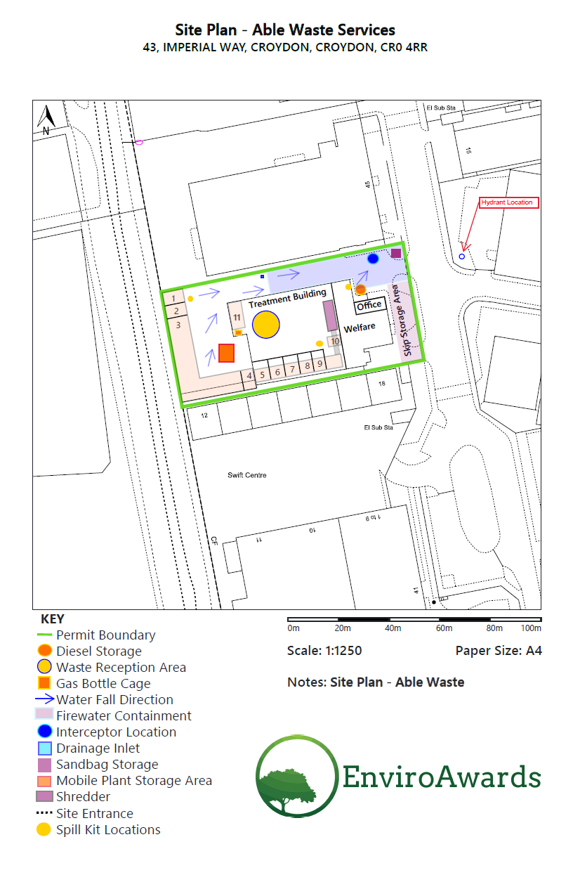
Appendix 1 –

Appendix 2 –
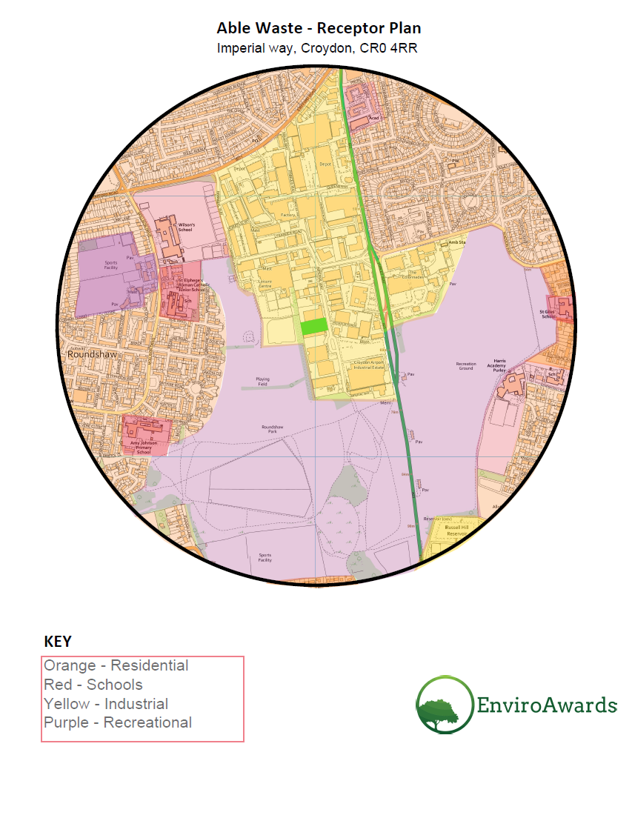

Appendix 3 –

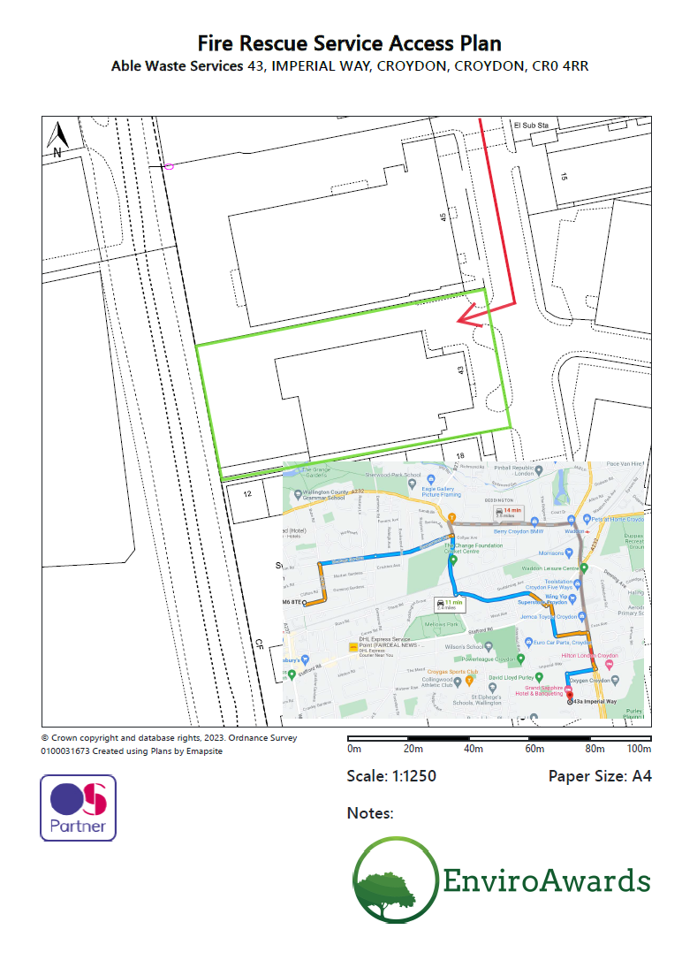
Appendix 4 –

Material | Max Volume | Size Of Pile or Container | Where Stored on Site | Max Time on Site | Combustible  Y/N
Soil | 25m3 | Pile | 3 | 7 Days | No
General Mixed  Waste | 25m3 | Pile | 8  7 | 5 Days | Yes
Hardcore | 25m3 | Pile | 3 | 7 Days | No
Wood | 25m3 | 40 Yard | 1  6 | 5 Days | Yes
Card | 25m3 | 40 Yard | 4 | 5 Days | Yes
Metal | 25m3 | 40 yard | 5  11 | 5 Days | Yes
Fines  0-10 mm | 25m3 | Pile | 10 | 3 days | Yes
Fines  10-40 mm | 25m3 | Pile | 9 | 3 days | Yes
Plasterboard | 25m3 | 40 yard | 2 | 5 days | Yes

Appendix 5 -

Appendix 6 –

Appendix 7 –

Appendix 8 –

Appendix 9 –

Appendix 10 –

Appendix 11 –

Appendix 12 –

