Noise Management Plan
Site details
Site name: Stour Business Park
Site address: Stour Business Park, Little Wratting, near Haverhill, CB9 7TD
Operator name: Essex Waste Limited
Permit number:
Who this plan is for
All operational staff and contractors, as part of their induction, are made aware of their roles and responsibilities. It is the responsibility of all staff to be aware of noise on site and report any potential noise issues to The Site’s TCM or Site Manager at the earliest opportunity. Environment Agency officers are also made aware of this plan on arrival to The Site.
Document owner
Document author: AM (MPG)
Version number: 1

List of revisions

Revision number | Revision authorised by | Date submitted to Environment Agency | Revision owner
1 | MS |  | MPG

Contents
Table of Contents
1. Introduction 3
1.1 Site description 3
1.2 Maintenance and review of the NMP 3
1.3 Relevant sector guidance on which this NMP is based 4
2. Receptors 5
2.1. Receptor List 5
3. Noise sources and processes 8
3.1 Noise impact assessment (NIA) conclusion 8
3.2 Noise sources 8
3.3 Overview of noise processes and emissions 9
4. Control measures and process monitoring 12
4.1 Appropriate measures / Best available techniques (BAT) 12
4.2 Onsite monitoring procedures 13
4.3 Monitoring off site sound levels 13
5. Complaints reporting 17

Introduction

1.1 Site description

This Noise Management Plan (NMP) has been produced for Essex Waste Limited for their site situated at Stour Business Park, Little Wratting, near Haverhill, CB9 7TD (‘The Site’). The grid reference for the site is TL 69779 47520. The local authorities for The Site are Suffolk County Council, and West Suffolk District Council. This plan supports an application for a bespoke permit for the treatment of waste to produce soil, soil substitutes and aggregates, primarily within a recycling building. The Site will accept no more than 250,000 tonnes per annum.
The bespoke permit mirrors the waste codes permitted in SR 2022 No.1, excluding any combustible waste.
The Site is surrounded by a combination of industrial, residential and rural receptors. However, the NIA recognises only the residential receptors to be at risk of adverse noise impacts. The noise levels throughout the day will vary, depending on planned deliveries, collections and operational requirements etc. In accordance with The Site’s EMS, processing of waste only takes place between the following hours:
- 08:00 – 18:00; Monday to Friday
- 08:00 – 13:00; Saturday

1.2 Maintenance and review of the NMP
It is the responsibility of the TCM and Site Manager to oversee the operations on site and to be sufficiently trained and familiar with the requirements of the Environmental Permit and management systems at The Site. The TCM and Site Manager will have the responsibility of ensuring all staff are trained appropriately and that appropriate control measures are in place to reduce the potential for noise impact.
This plan is stored on Site at all times and regular meetings will be held to discuss ongoing and planned operations that have the potential to generate elevated noise emissions. The NMP will be kept in the site office in a clearly marked file. An electronic copy will also be retained in case of emergency. All staff are notified of its location either during induction or annual refresher training.
The NMP and associated control measures will be reviewed on an annual basis and / or following a complaint or elevated noise issue, or as a result of changes to operational activities. The NMP must also be reviewed where is it suspected that it is no longer effective at meeting the primary objectives or upon request from the EA. Any revisions to the NMP must be approved by the EA and implemented accordingly.
Any complaints or elevated noise issues will be recorded in both the site diary and on the Complaints Report Form. Any noise monitoring that may be required as part of an investigation will be carried out by a suitable qualified consultant. The TCM / Site Manager will inform the Environment Agency, where necessary, throughout the process following an elevated noise issue complaint.

1.3 Relevant sector guidance on which this NMP is based
Noise and vibrations management: environmental permits. Updated 31 January 2022

Receptors

2.1. Receptor List

Table 2.1. Receptor list
Receptor reference  (A, B, C etc. Use to label Fig 2.1) | Land use e.g. house, school, hospital, commercial | Direction from site (north, south, east, west) | Approximate distance to site  boundary (m)
A (primary receptor) | Residential | Northwest | 100
B (primary receptor) | Residential | Southwest | 160
Road | Transport | North | 0
Road | Transport | West | 0
(beige) Industrial Area | Industrial | East | 0
(beige) Industrial Area | Industrial | North | 20
(beige) Industrial Area | Industrial | West | 40
(green) Deciduous Woodland | Ecological | Northeast | 40
(blue) Floodplain Grazing Marsh | Ecological | Northeast | 160
(green) Deciduous Woodland | Ecological | Northeast | 160
(dot line) Public footpath | PRoW | East | 300
(grey) Residential Area | Residential | North | 490
(blue) Floodplain Grazing Marsh | Ecological | North | 500
(grey) Residential Area | Residential | South | 520
(blue oval) Religious Building | Religious Building | Northwest | 620
(dot line) Public footpath | PRoW | Northwest | 620
(grey) Residential Area | Residential | Northwest | 670
(grey) Residential Area | Residential | South | 700
(beige) Industrial Area | Industrial | North | 710
(orange square) Playground | Public Playground | South | 730
(green) Deciduous Woodland | Ecological | South | 740
(purple) Good Quality Semi Improved Grassland | Ecological | Southeast | 770
(blue oval) Religious Building | Religious Building | Southeast | 780
(red) Traditional Orchid Priority Habitat | Ecological | Southeast | 920
(pink circle) School | School | Southeast | 940
Figure 2.1 Map of site location and receptors

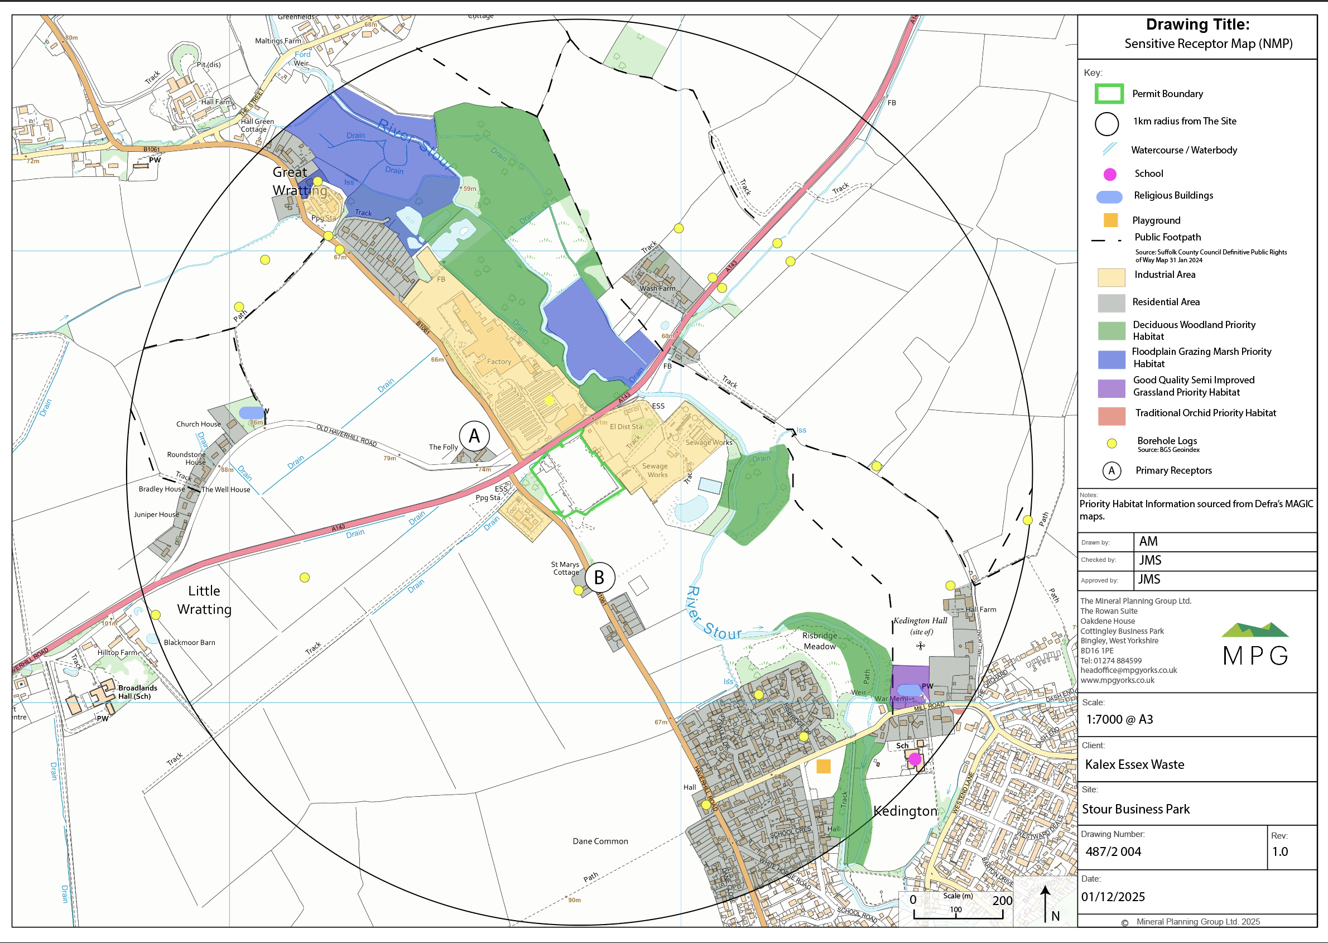

Whist the above table recognises all receptors within a 1km radius of The Site, the two primary receptors as recognised within the NIA, are listed at the top of the table and are identified separately in Figure 2.1.

Noise sources and processes

3.1 Noise impact assessment (NIA) conclusion
The NIA concludes that the operations at The Site have the potential for adverse impacts, assuming a worst-case assessment, without mitigation.
The crushers and concrete plant are the primary noise source recorded at the receptors. Mitigation measures, inclusive of roller shutter doors with rubber seals, and a 4m barrier on the southern edge of the concrete plant, have therefore been recommended to ensure that there are no adverse impacts at the receptors. The roller shutter doors will be kept closed at all times, except for access. The barrier is recommended to have an absorbative northern elevation to ensure no significant noise reflection to the north. As such, a bund/fence combination would be ideal. With the barrier in place, there is a +4 dB exceedance of the background sound level at the northwestern receptor. However, considering the specific sound levels and context, this level of exceedance is not considered adverse.
For Haverhill Road, a +9 dB exceedance is predicted. However, absolute levels of noise, 46 dB, are considered low with internal noise levels of approximately 33 dB with open windows. Noise levels in garden areas are 45 dB which results in a rating level 5 dB in exceedance which would be considered a low impact. As such, no adverse impact is predicted with mitigation measures in place.

3.2 Noise sources

Table 3.2 Description of noise emitting processes
Noise source | Sound power level (dB) | Sound pressure level (dB) | Measurement distance (m) | Operational conditions | Additional comments
Jackhammer attached to 360 | 101.3 | 85.3 | 5 | 10-minute measurement period. Assumed to be on for 15 minutes in a 1-hour period.
Excavator moving material with skip lorry being emptied | 89.1 | 71.6 | 6 | 13-minute measurement period. Assumed to be on for 15 minutes in a 1-hour period.
Crusher with excavator feeding material | 108.9 | 83.1 | 11 | 12-minute measurement period. Assumed to be on for 30 minutes in a 1-hour period.
Box screener loaded by front loader | 102.3 | 83.5 | 4 | 12-minute measurement period. Assumed to be on for 45 minutes in a 1-hour period.
Concrete machine | 104.0 | 75.0 | 13 | 14-minute measurement period. Assumed to be on for 45 minutes in a 1-hour period.
Front Loader pass-by | 106.9 | 77.3 | 12 | 3-minute measurement period. Assumed 10 movements in a 1-hour period.

3.3 Overview of noise processes and emissions
The Sources of noise at The Site are limited to the following activities:
- Transportation of material to and from The Site
- Loading and unloading of materials
- Treatment of materials and the associated plant equipment
- On site vehicle movements
The pathway for noise will be through air. The prevailing wind direction is south and south-westerly, and therefore receptors to the northeast are at greater risk without mitigation measures.

All mobile plant equipment will be located within the recycling building, where the waste will be processed. The recycling building features roller shutter doors which will be closed at all times, except for access. The doors would only be opened for as long as is necessary for vehicles to enter / leave. All waste arriving at The Site will be immediately weighed on the weighbridge and transported to the appropriate area. All plant equipment is mobile and can be reconfigured based on needs at The Site. Materials will be stored in external storage bays.

Figure 3.3 – Site plan showing locations of noise emitting processes
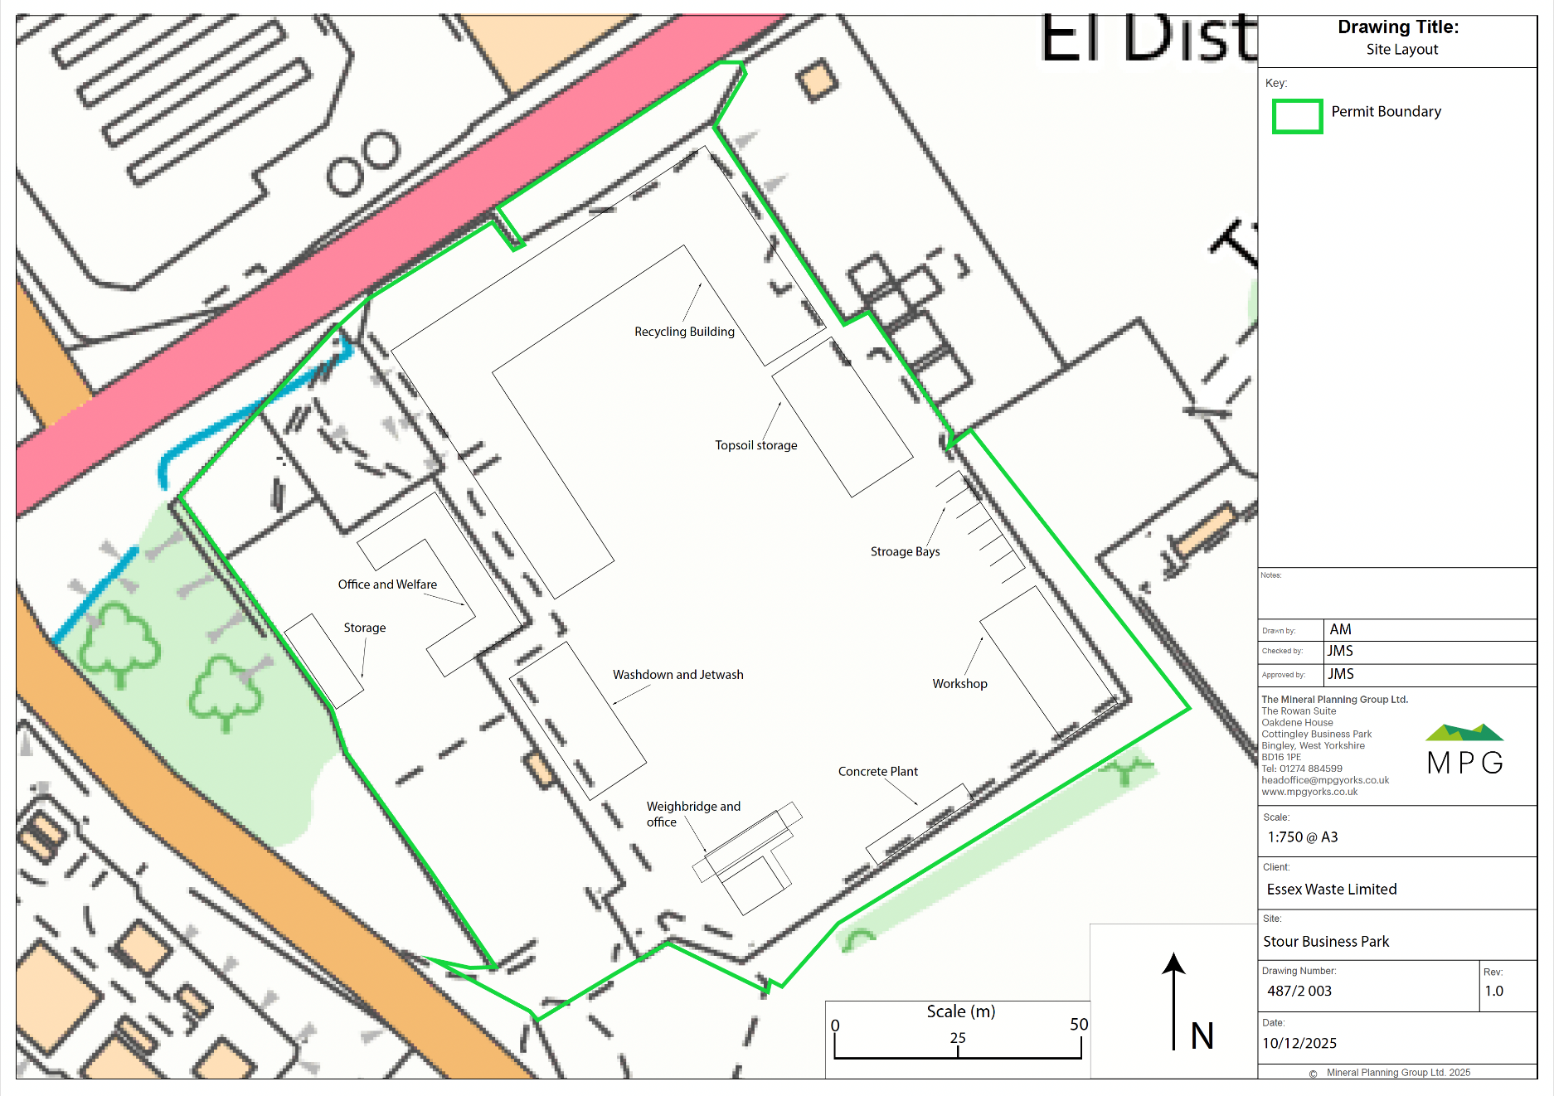

Control measures and process monitoring

4.1 Appropriate measures / Best available techniques (BAT)

Table 4.1 Actions and procedures which will be in place to achieve appropriate measures / best available techniques (BAT)
Activity which produces noise | Operational Hours / days | Control measures (Appropriate Measure / BAT) | Contribution to overall impact | Action taken if outside optimum process parameters
Crusher processing material | 08:00 – 18:00; Mon to Friday,  08:00 – 13:00; Saturday | Location on site – within the recycling building  Daily visual inspection, yearly full mechanical inspections, trained staff using equipment. Regular site walks by Site Manager / TCM checking on procedures. | High | Cease operation and investigate reasons for elevated sound levels.
Concrete plant | 08:00 – 18:00; Mon to Friday,  08:00 – 13:00; Saturday | Location on site – within the recycling building  Daily visual inspection, yearly full mechanical inspections, trained staff using equipment. Regular site walks by Site Manager / TCM checking on procedures. | High | Cease operation and investigate reasons for elevated sound levels.
On-site vehicle movements | 08:00 – 18:00; Mon to Friday,  08:00 – 13:00; Saturday | Location on site – external  Vehicles adhere to a 5mph speed limit. All engines switched off when not in use. Vehicles horns are used only as a health and safety measures. Deliveries are spread out across any working day. Surfaces are maintained adequately. | Low | Cease operation and investigate reasons for elevated sound levels.
Loading / unloading of materials | 08:00 – 18:00; Mon to Friday,  08:00 – 13:00; Saturday | Location on site – external  Loading of plant and equipment on level ground. Drop heights kept to a minimum. | Low | Cease operation and investigate reasons for elevated sound levels.

4.2 Onsite monitoring procedures

Table 4.2 Description of onsite processes which will ensure impacts do not increase on site.
Description of procedure | Procedure | When will this be carried out? | Corrective action
Replacing old / faulty equipment | Procurement of new equipment | When equipment requires replacing | Replace equipment that have sound levels which are equivalent or lower sound levels compared to existing equipment
Checking noise barriers | Visual inspection of barriers to ensure no gaps or holes | Monthly | Repair the barriers if holes or gaps are found.
Roller shutter doors | Roller shutter doors to be closed except for access | All the time, except for access | Close doors if they are open, ensure they remain closed unless for access.
Installation of barrier | 4m high barrier located on southern edge of concrete plant | Permanently | Repair the barrier if holes or gaps are found
Installation of 5mph speed limit | All vehicles to adhere to a 5mph speed limit | Permanently | Ensure all vehicles adhere to the speed limit.

4.3 Monitoring off site sound levels
N/A - Ongoing monitoring at The Site is not deemed necessary at this stage.

Should The Site receive any complaints or should there be any elevated noise emissions, a suitably qualified consultant may undertake noise monitoring as part of an investigation. Figure 4.1 shows the location of monitoring carried out for the NIA. NMP1 would be the likely monitoring location of any future noise monitoring investigations, as required.

The TCM / Site Manager will inform the Environment Agency, where necessary, throughout the process following an elevated noise issue or complaint.

Figure 4.1 – plan showing locations of sound level measurement positions used to monitor sound from the site.

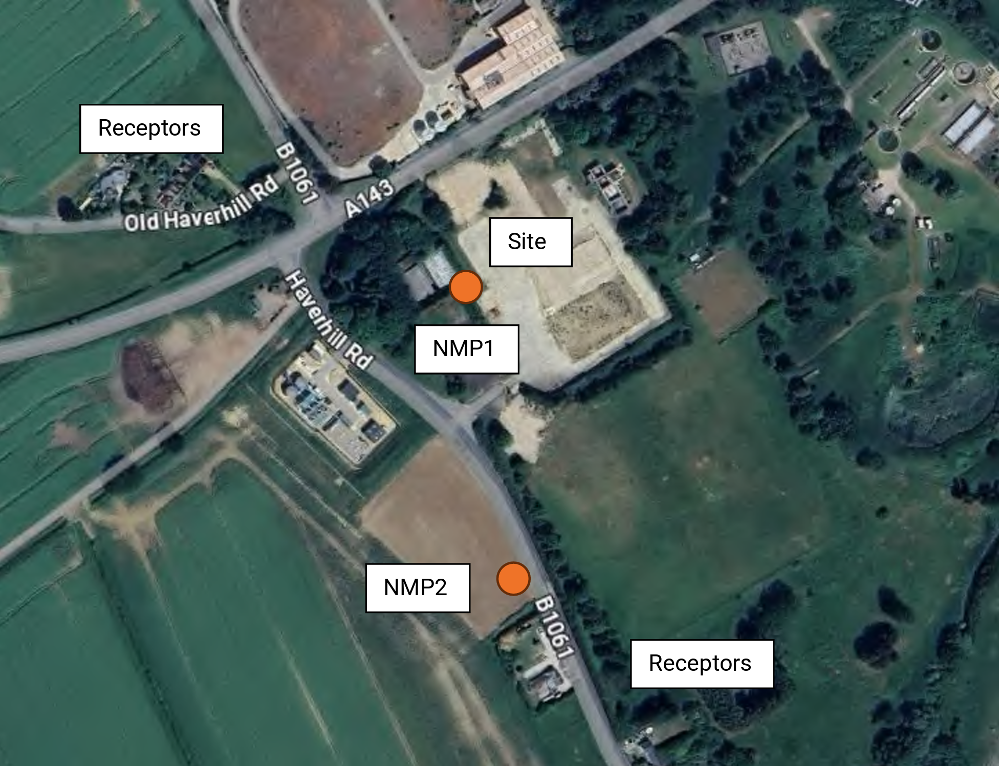

Table 4.3 Description of the sound monitoring procedures in cases of elevated noise emissions and / or complaints.
Measurement Location | Frequency of measurement | Minimum measurement duration | Measurement period | Operating conditions on site | Expected specific sound level
NMP1 | As needed, post elevated noise issue or complaint | 1 hour | Within operational hours | Concrete Plant and crusher operational | Below 48 dB L_{Aeq,1hour}
NMP2 | As needed, post elevated noise issue or complaint | 1 hour | Within operational hours | N/A | Below 48 dB L_{Aeq,1hour}

Ongoing noise monitoring at The Site is not proposed. However, should sound levels be measure in excess, the TCM / Site Manager will immediately assess the situation, and a decision will be made as to whether The Site should reduce hours or suspend operations until the elevated noise is controlled. The measures required would be on a case-by-case basis.
Any noise issues identified will be reported to the TCM / Site Manager at the earliest opportunity and an investigation into the source of the elevated noise will be carried out at the earliest opportunity. The outcome of the noise investigation and any proposed actions will be reported in the site diary and actioned immediately.
Any noise monitoring that may be required as part of an investigation will be carried out by a suitable qualified consultant. The TCM / Site Manager will inform the Environment Agency, where necessary, throughout the process following an elevated noise issue or complaint.

Complaints reporting

Any complaints follow the complaint procedure in the EMS and are recorded in both the site diary and on the Complaints Report Form. The Site manager is responsible for ensuring the forms are fully completed, signed and dated. An investigation into the complaint will be actioned within 72 hours of receipt.

The following details will be recorded:
- Complainants contact details (name, address, phone number, email) – where available
- Nature of complaint
- Date and time of complaint
- Description of the noise issue
- Duration
- Frequency (has it happened before? How often?)
- What prompted the complaint
- Activities at time of complaint (including any unusual off-site activities)
- Summary of findings
All complaints will be investigated to identify the root cause. Details of the corrective and preventative action taken to resolve the issue and prevent re-occurrence will be recorded. The complainant is contacted (where requested) with the outcome of the investigation and the action to prevent further incidents.

The EMS and specific Management Plans within it will be reviewed following receipt of any complaint.

Any noise monitoring that may be required as part of an investigation will be carried out by a suitably qualified consultant. The TCM / Site Manager will inform the Environment Agency, where necessary, throughout the process following an elevated noise issue complaint.

Any complaints or elevated noise issues will be recorded in both The Site diary and the complaint form. The complaint process and form will be reviewed annually.

