
Title | Odour Assessment Report
Site | CAMBRIDGE WRC
Purpose of report | Industrial Emission Directive (IED) permit applications

Project Personnel and Contacts
ROLE |  | NAME | LOCATION
Client |  | Philip Seamons | Cambridge WRC, Cowley Road, Cambridge, Cambridgeshire, CB4 0AP
Author |  | Omid Shafibeik  (Senior Modeller) | Thorpe Wood House,  Peterborough, PE3 6WT
Checked by  Version Control |  | Kate Rider  (Strategic Waste Planner) | Lancaster House,  Huntingdon, PE29 6XU
VERSION | DATE | BY AMENDMENT REASON

CONTENTS
- Executive summary
- Introductions
  - Existing Wastewater Treatment Processes
  - Odour Assessment Modelling
  - Odour Survey and Emissions Data
- Atmospheric Modelling method
  - Modelling method
  - Meteorological data
  - AERMOD
    - Control Options
    - Sources and emissions input
    - Receptors Network
- Dispersion Modelling Results
- Conclusions
- Recommendations

1 Executive summary
Odour models are required as part of the Industrial Emission Directive (IED) permit applications for all of Anglian Water’s (AW) Sludge Treatment Centres (STC).
Cambridge Water Recycling Centre (WRC) already has two waste operation permits which covers the Combined Heat and Power (CHP) plant and the STC. These operate under Environmental Permitting Regulations (EPR) but due to the requirements of the Industrial Emissions Directive (IED), the site requires a permit variation under IED.
Anglian Water Services (AWS) are applying for a Bespoke Installation Permit for the STC waste activity, as a joint Environment Agency (EA) and Department for Environment, Food and Rural Affairs (DEFRA) decision has been made that Anaerobic Digestion (AD) treatment facilities at Water Recycling Centre (WRCs) and STCs should be fall under the Industrial Emissions Directive. AW needs to demonstrate that the STCs have minimal impact at the permit boundary and comply to H4/the BAT conclusions.
An odour impact assessment using AERMOD (9.9.0) was undertaken to determine the odour exposure levels across the areas surrounding the STC.
The modelling methods used are based on assessment techniques that are presented within guidance published by the EA, DEFRA, and the Institute of Air Quality Management (IAQM).
An odour concentration of 1.5 Odour Units Per Cubic Metre (OU/m3) has been taken as the benchmark level at which nuisance and potential loss of amenity would be anticipated. This assessment criterion for the protection of public nuisance/amenity is in line the EA H4 Planning Guidance, including septic effluent and sludge in amongst a range of substances categorised as most offensive and for which a low detection threshold should be taken into consideration.
The odour emission rates used for the modelling study were mainly based on the previous olfactometric surveys from similar WRCs.
Certified processed meteorological data (2018-2020) from Cambridge meteorological station, representative of Cambridge WRC was obtained from Atmospheric Dispersion Modelling Ltd (ADM Ltd) for the modelling study.
The atmospheric dispersion model AERMOD was used to predict the dispersion of odour from the STC, utilising meteorological data and the odour sources details. A model run was completed with each year of meteorological data to determine the odour impacts from Cambridge STC on the surrounding area.
The modelling result showed that the odour from the STC is largely contained within the site boundary, however, there are small pockets on NW, SE, and SW where the 1.5 OUE/m3 isopleth slightly extend outside the WRC where there are medium sensitivity receptors like places of work, commercial/retail premises, and playing / recreation fields.
Bearing in mind that this site will be decommissioned in a few years and will be relocated to a location approximately two kilometres to the east, along with the lack of odour complaints in recent years, it is recommended to ensure that covers remain on the sludge tanks and continue the works operation as it stands.

2 Introduction
Cambridge water Recycling Centre (WRC) is located at northern edge of main conurbation of Cambridge immediately south of A14 motorway. The WRC centre point (X= 547481 E, Y= 261615 N) is shown in the location map given in figure 1 below.

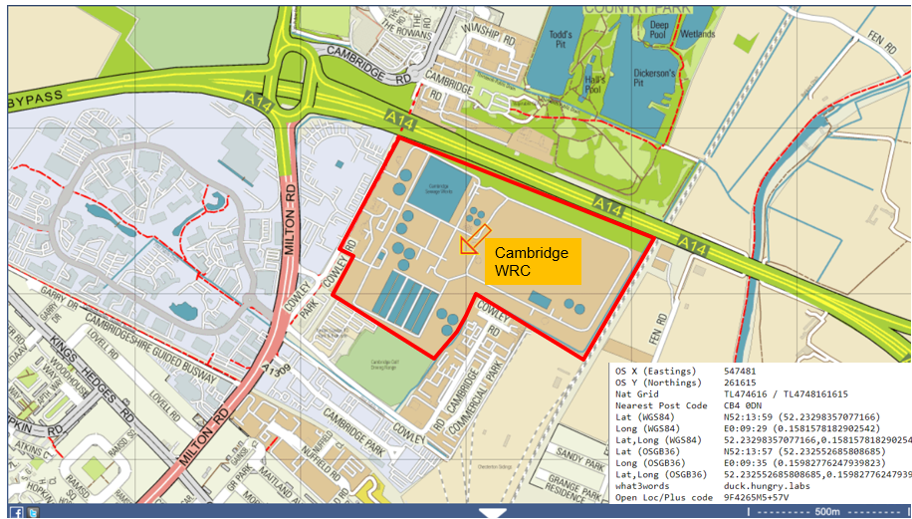
Figure 1: Cambridge WRC-Coordinates

The site address is as follows:
Cambridge WRC (Site short code = CAMBST)
Cambridge WRC, Cowley Road, Cambridge, Cambridgeshire, CB4 0AP
Grid reference: TL4748161615

The WRC and the area occupied by the STC for EA permitting are given in figure 2.

Figure 2: Cambridge WRC location map and STC, EA permitting area.

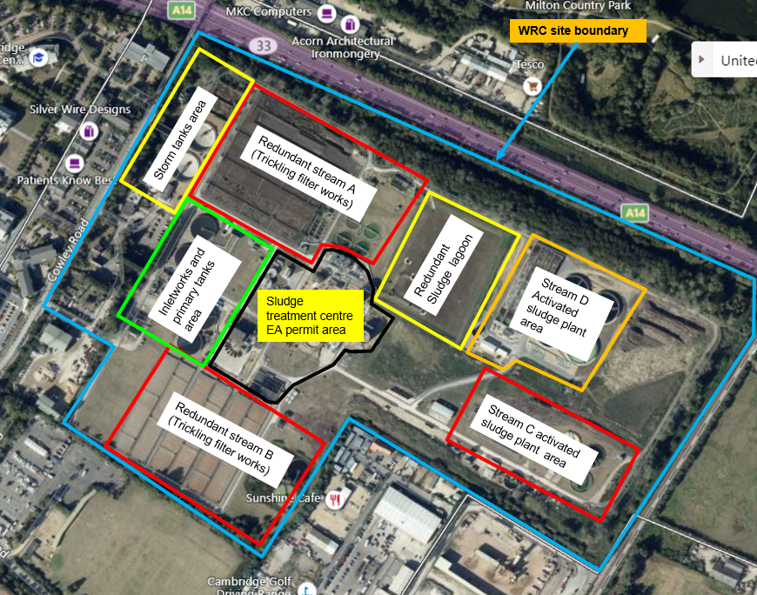
2.1 The Existing Wastewater Treatment Processes
Storm lagoon

Cambridge WRC and STC is located approximately 3.5km north of Cambridge city centre. The address for the Site is Cowley Road, Cambridge, Cambridgeshire, CB4 0AP (NGR TL 47440 61636). The WRC is operated under the Urban Wastewater Treatment Regulations (UWwTR) and has a standalone Discharge Activity Environmental Permit, this will remain an independent permitted activity. The STC is a non-hazardous waste activity which is currently permitted under a SR2008No19_250Kte standard rules permit (EPR/LP3196ER), the Combined Heat and Power (CHP) activities are permitted under separate Environmental Permit (EPR/WP3535HT). The waste activity comprises of imports, physio-chemical and anaerobic digestion treatment, and the storage of waste, all for recovery purposes. The STC treats waste derived from the wastewater treatment process indigenously produced on-site and imported liquid sludge, and will continue this operation under a new bespoke IED installation permit. No hazardous waste is imported or treated at Cambridge STC.
AWS are applying to vary the existing standard rules permit and to consolidate the CHP environmental permit to a single Bespoke Installation Permit to include the AD activities and ensure the STC is in line with the IED and the Environmental Permitting Regulations 2016, as amended.

The primary permitted installation activity will be the AD treatment activity. The AD activity will treat indigenously produced sludges, as well as imported liquid sludge. Permitted Directly Associated Activities (DAAs) will be the import of waste from other sites; the physio-chemical treatment of imported and indigenously produced sludges; the storage of indigenous and imported sludges, and the sludge cake from the AD facility; the storage of biogas derived from the AD treatment of waste and the combustion of biogas in the on-site CHP engines. In the event the CHP engines cannot run in an emergency or due to operational issues, biogas will be combusted via an on-site flare stack and back-up boiler system.

The IED permit will include:
- Primary sludge import tank 1 No. (140m3)
- Pre thickening/Import tank SAS 1 No. (462m3)
- Screening
- Pre thickening tank primary 1 No. (580m3)
- D Works SAS tank (250m3)
- Gravity belt thickeners
- Pre-treatment tank (buffer tank) (800m3)
- Monsal enhanced enzymic hydrolysis tanks (EEH) 6 No. tanks (each 230m3). 5 are in operation
- Anaerobic digesters 3 No. (each 2700m3)
- Post digestion tanks 2 No. (each 1596m3)
- Centrifuges 2 No.
- Boilers 3 No. (1MWth each)
- CHP engines 3 No.
  - 2 No. existing CHP (1.4MWth, and 0.9MWth)
  - 1 No. new CHP (1.5MWth) to be added as part of this permit application
- Biogas burner (flare stack) 1 No.
- Cake storage – 5 No. ro-ro skips (80 tonnes)
- Gas holder 1 No. (2250m3)
- Odour Control Units
The following are outputs from the process:
- Sludge cake (dewatered post digestion sludge) – stored in skips before being shipped for use as a soil conditioner;
- Biogas – stored in an existing gas holder, and is then either:
  - Burnt in CHPs for use on site, the two existing CHP engines also export to the grid;
  - Flared in the waste biogas burner.

2.2 Odour assessment and modelling
Investigative modelling study was carried out to assess odour impacts from Cambridge WRC on the surrounding area.

2.3 Odour Survey and emissions data
AWS developed an odour dispersion model for Cambridge WRC in 2012. Over the years the model has been updated to include the latest developments and operating regime of the treatment plant.
The odour emission rates used for the reactors are mainly based on actual olfactometric samples taken and analysed by specialised odour contractors in an accredited odour laboratory. Some samples were collected by H&M Environmental Ltd, and some were collected by Silsoe Odours. All samples were analysed in Silsoe Odours olfactometry laboratory. Some odour emission rates are from Water Research Council (WRc) library emission rate.
Olfactometry is a sensory measurements that employs the human nose as the odour detector and hence relate to the effect of odours as experienced by humans. The most common sensory measurement is threshold olfactometry which measures the odour concentration in terms of dilution required to reduce an odorous compound until its threshold concentration.
The purpose of this emissions data is to support conclusions to be drawn on prevailing odour risk and to provide source data for the odour dispersion modelling.

3 Atmospheric Dispersion Modelling
Atmospheric dispersion modelling is the mathematical simulation of how air pollutants disperse in ambient atmosphere. It is solved by computer programmes that use mathematical equations and algorithms which simulate the pollutants dispersion. The dispersion models are used to estimate or to predict the downwind concentration of air pollutants emitted from sources such as wastewater treatment plants, industrial plants, and vehicular traffic.
Atmospheric dispersion modelling is a well-documented and recognised technique to predict the dispersion of malodours. Modelling was undertaken using the AERMOD computer programme (release version 9.9.0).
AERMOD is recognised by the Environment Agency, UK Met Office, and the US Environmental Protection Agency. AERMOD uses meteorological data, terrain data and emission data as input to predict the dispersion of odours.

3.1 Modelling Method
Six steps were followed in the modelling of odour dispersed from Cambridge STC.
- Certified pre-processed meteorological data was purchased from an independent source (Atmospheric Dispersion Modelling) for the WRC.
- Terrain data was processed for use in the model.
- Source emission data used were based on actual WRCs olfactometric samples taken and analysed in specialised laboratory over the past years.
- The processed Met data, process units, sources emission data were all inputted into the AERMOD model.
- The AERMOD model was compiled and ran.
- Results from AERMOD are processed by the graphical post-processor. This gives a graphical representation of the odour dispersal on a map of the affected area. These are presented in Section 4 of this report.

3.2 Meteorological Data
Meteorology is fundamental for the dispersion of pollutants because it is the primary factor determining the diluting effect of the atmosphere. It is extremely important that the correct meteorological data is used for the modelling study.
Certified meteorological data (2018-2020) from Cambridge meteorological station representative of Cambridge WRC was purchased from ADM Ltd for the modelling study. ADM Ltd are an independent, accredited source that provide a range of services to industry, developers, consultancies, and government organisations. These services cover the full spectrum of air quality and odour, project management and provision of dispersion modelling software together with terrain and meteorological data.
The certificate of met data from ADM Ltd is provided in Appendix A.
AERMOD requires the input of data that include hourly averaged values for wind speed and direction, cloud cover, ambient temperature, solar radiation, the amount of atmospheric turbulence, the height of mixing layer and other parameters.
Longitude and latitude of both Cambridge WRC and of the meteorological station are given in Table 1.
Table 1: Longitude and latitude of WRC and Meteorological Station.
Location | Latitude | Longitude
Cambridge WRC | 52.234 | 0.156E
Cambridge Met Station | 52.200 | 0.180E

Wind roses from Cambridge station for years 2018-2020 are presented in figures 3 to 5.

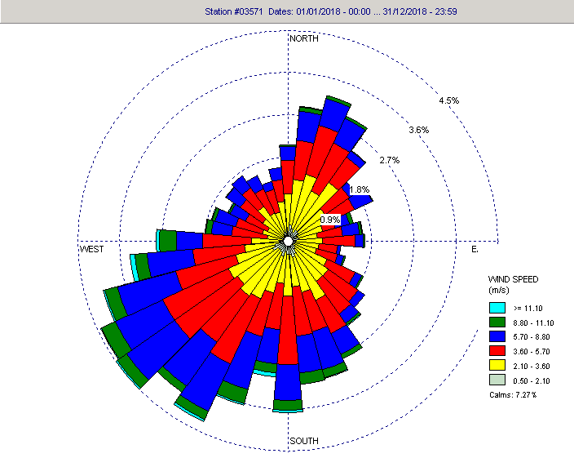
Figure 3: 2018 wind rose for Cambridge Meteorological Station

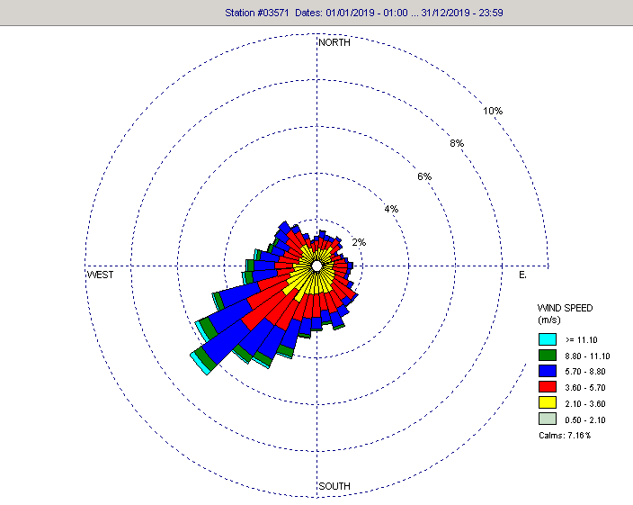
Figure 4: 2019 wind rose for Cambridge Meteorological Station
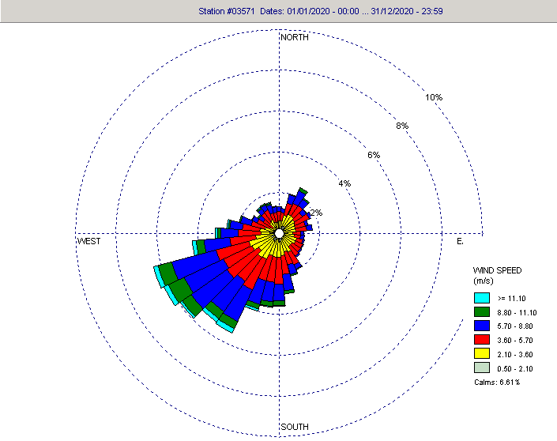

Figure 5: 2020 wind rose for Cambridge Meteorological Station
The wind roses indicate the frequency of occurrence of wind from different directions for the number of wind speed ranges.
These wind roses indicate that the prevailing wind direction is blowing from a south westerly direction directing the odours towards a north easterly direction for majority of the time.
During calm days with no wind and low temperatures dispersion is very poor and odours tend to concentrate close to the source.

3.3 AERMOD
This section details the control options; source inputs and receptor networks used in the models.
Gaussian plume air dispersion model: AERMOD version 9.9.0 was used for the modelling work. The AERMOD atmospheric dispersion modelling system is a steady-state plume model that incorporates air dispersion based on planetary boundary layer turbulence structure and scaling concept, including treatment of both surface and elevated sources, and both simple and complex terrain.

3.3.1 Control Options
The key parameters for the control options of the model are detailed in Table 2 below. The values for dispersion options and averaging time are standard defaults. The rural coefficient is applicable to this location.

Table 2: Control Option Parameters
SETTING | VALUE
Dispersion Options | Regulatory Default
Dispersion Coefficient | Rural
Pollutant Averaging time | 1 hr
Flagpole Receptors | zero

3.3.2 Sources and Emissions Input
The location of Cambridge WRC and STC permit area is given in Figure 6. The STC includes details for covered tanks, and reactors, building and odour sources.

Figure 7 gives details of the STC buildings, covered tanks, and odour sources in STC.

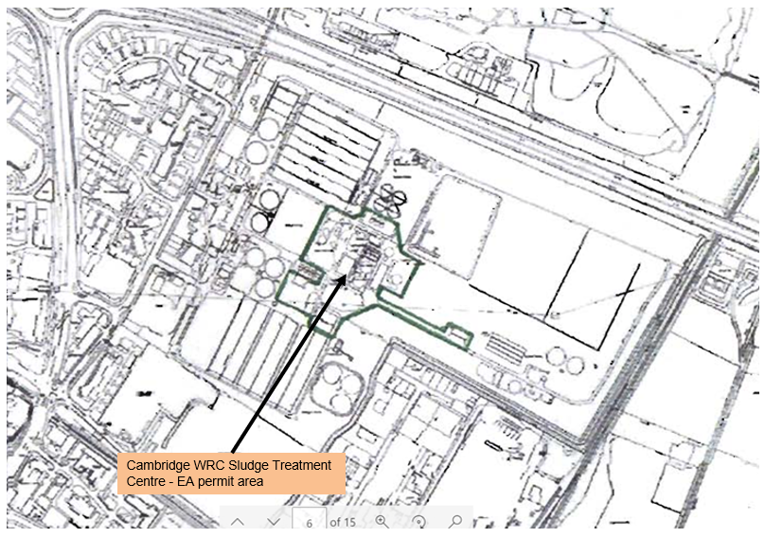
Figure 6: Cambridge EA permit area boundary

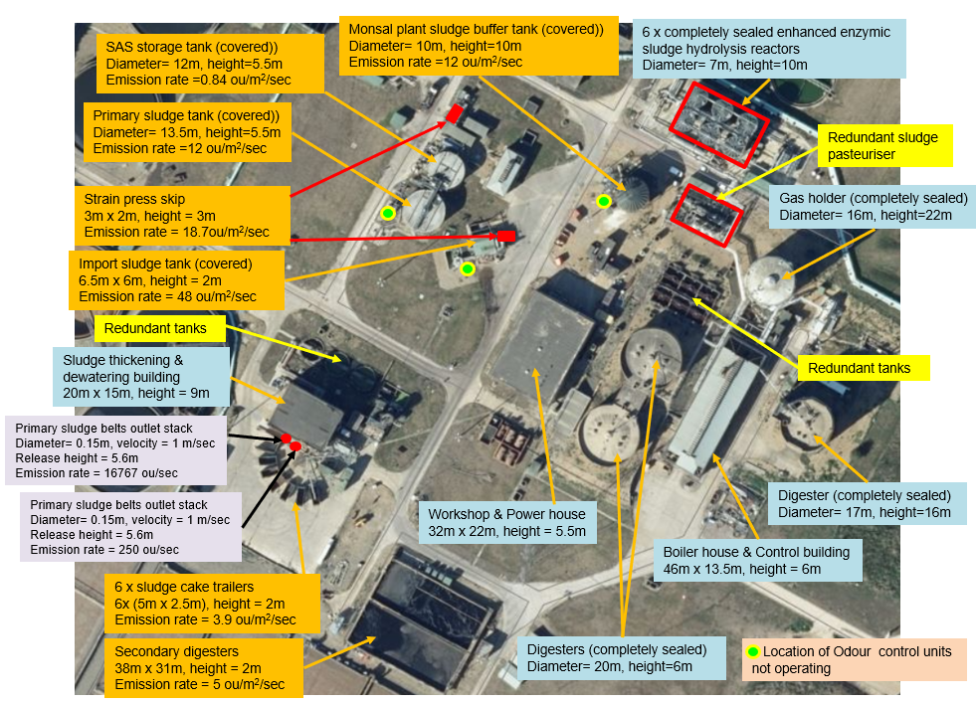
Figure 7: Cambridge STC – Details of the buildings, covered tanks, odour sources and odour control units.

Many of the tanks and reactors are completely sealed and therefore, are not odour sources. They have been included in the odour model to incorporate the effects of building downwash.
Building downwash occurs as the wind flows over and around buildings and impacts the dispersion of pollution from nearby stacks.
The emission rate for the strain presses’ skip is from olfactometric samples collected by H&M Environmental and analysed by Silsoe Odours from other WRCs.
The advanced treated sludge cake emission rate is from olfactometric samples collected by H&M Environmental and analysed by Silsoe Odours from Cotton valley WRC and Whitlingham WRC.
The post digestion tank emission rates are from olfactometric samples collected and analysed by Silsoe Odours from Cotton valley WRC.
None of the Odour Control Units (OCU) were operating when surveyed on 09/11/2021. Therefore, at present, for all the sludge tanks (import sludge, primary sludge, SAS storage and Monsal sludge buffer tank) odour reduction is solely achieved by their covers.
The emission rate for import sludge tank was calculated from water Research Council (WRc) standard library emission rate for high odour sludge (160 ou/m2/sec) with 70% reduction for cover (160 x 0.3 = 48 ou/m2/sec).
The emission rates for primary sludge and Monsal plant sludge buffer tanks were calculated from WRc standard library emission rate for typical odour primary sludge (40 ou/m2/sec) with 70% reduction for enclosure (40 x 0.3 = 12 ou/m2/sec).
The emission rate for SAS tank was calculated from WRc standard library emission rate for high odour SAS (2.7 ou/m2/sec) with 70% reduction for cover (2.7 x 0.3 = 0.84 ou/m2/sec).

3.3.3 Receptor Network
A uniform polar grid with 25 rings at 50m spacing with 45 radials at 8-degree intervals, extending to 1500m from the centre of STC (X=573744 E, Y=190766 N), was placed over the map of the area as a receptors network providing 1125 receptors in and around the STC.
The odour contour maps were generated by orienting the map on the STC centre with a zoom radius of 500m.

4.0 Dispersion Modelling Results
The model was run using the three meteorological years (2018-2020) to test the variability of the odour concentration results among the different years.
The 98th percentile of hourly mean odour concentrations has been calculated. Contour lines for odour concentrations of 1.5, 3, 5, and 10 OUE/m3 have been included for all the scenarios. The significance of these odour concentrations is explained below:
- 1 OUE/m3 is the level of odour detection under laboratory conditions.
- 3 OUE/m3 is the level of odour detection in open environment. Complaints are unlikely to occur and exposure below this level are unlikely to constitute significant pollution.
- 5 OUE/m3 is when odour becomes detectable & recognisable. Complaints may occur and depending on the sensitivity of the locality and nature of the odour.
- 10 OUE/m3 is when odour becomes distinct and intrusive. Complaints are highly likely and odour exposure at these levels represents an actionable nuisance.
The odour contour maps for three model runs are shown in figures 8 to 10.
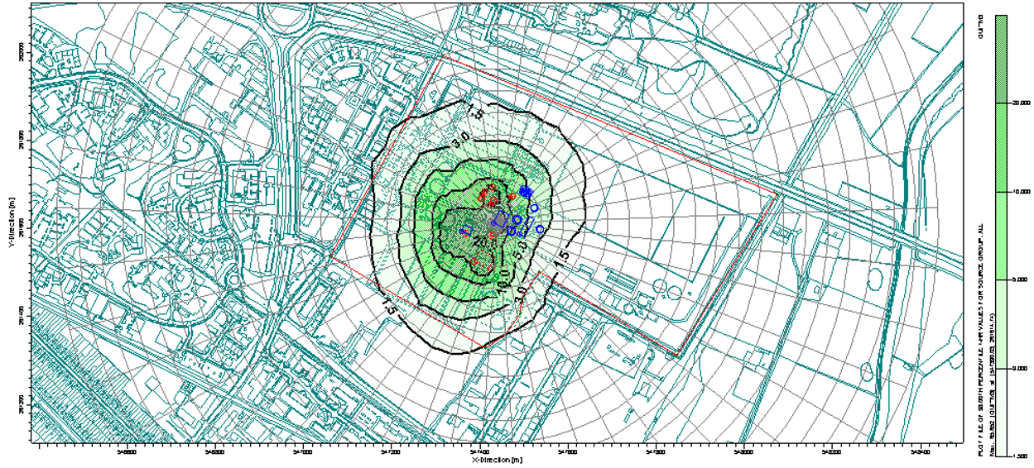
Figure 8: Cambridge WRC 98%ile hourly means odour contour map (year 2018).
Zoom radius 500m.

The 98th percentile of hourly mean odour concentrations calculated using 2018 meteorological data show that the 1.5 OUE/m3 contour line extends 319m in north westerly direction and encompasses an area of 215987m2 approximately. The 1.5 OUE/m3 contour line is mainly contained within the site boundary but slightly extends outside the boundary line in NW, SW and SE sides.
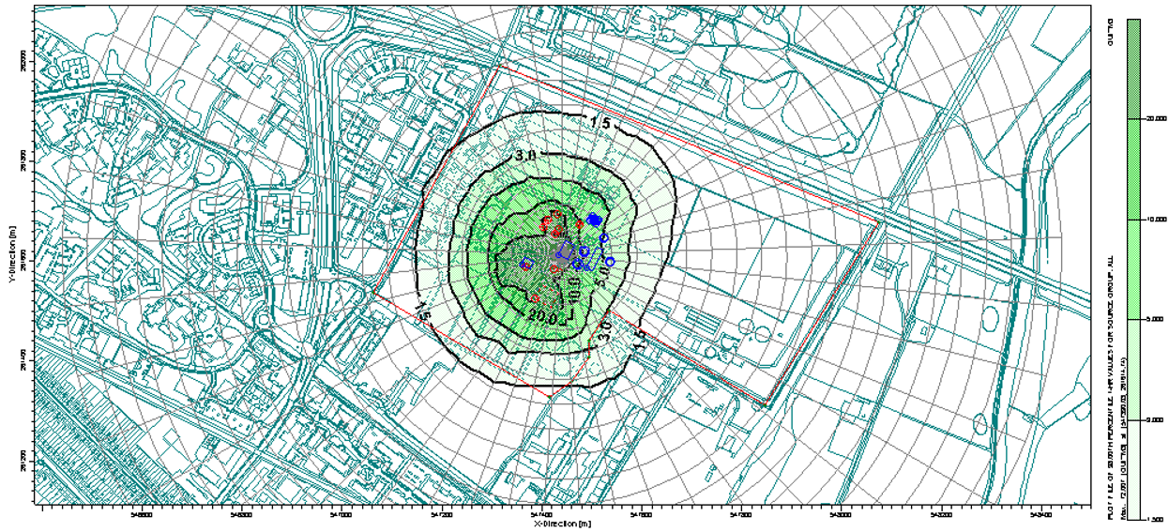
Figure 9: Cambridge STC 98%ile hourly means odour contour map (year 2019).
Zoom radius 500m.

The 98th percentile of hourly mean odour concentrations calculated using 2019 meteorological data show that the 1.5 OUE/m3 contour line extends 306m in north westerly direction and encompasses an area of 230885m2 approximately. The dispersion of odours is very similar to 2018 meteorological year but much smaller areas outside the site boundary are affected by the 1.5 OUE/m3 contour line.
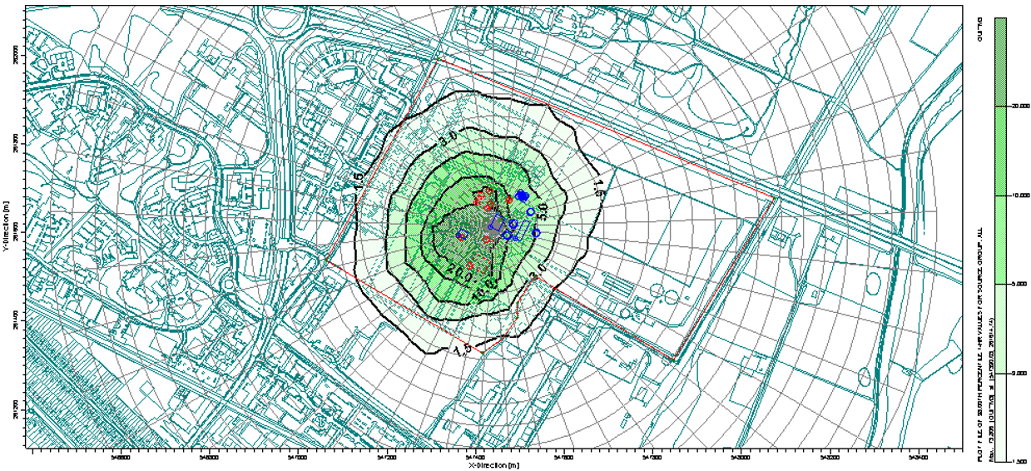
Figure 10: Cambridge STC 98%ile hourly means odour contour map (year 2020).
Zoom radius 500m.

The 98th percentile of hourly mean odour concentrations calculated using 2020 meteorological data show that the 1.5 OUE/m3 contour line extends 333m in a south westerly direction and encompasses an area of 247057m2 approximately.
The model run with 2020 meteorological data gave the worst-case scenario as the area encompassed under the 1.5 OU/m3 was 14% and 7% larger than modelled year with meteorological data for 2018 and 2019, respectively.
The modelling result showed that the odour from the STC is largely contained within the site boundary, however, there are small pockets on NW, SE and SW where the 1.5 OUE/m3 contour isopleth slightly extend outside the WRC where there are medium sensitivity receptors like places of work, commercial/retail premises and playing / recreation fields.

5.0 Conclusions
This modelling study evaluates the risk of amenity loss to areas around Cambridge STC.

An odour concentration of 1.5 OU/m3 has been taken as the benchmark level at which nuisance and potential loss of amenity would be anticipated. This assessment criterion for the protection of public nuisance/amenity is in line the Environment Agency (EA) H4 Planning Guidance, including septic effluent and sludge in amongst a range of substances categorised as most offensive and for which a low detection threshold should be taken into consideration.
The modelling result showed that the odour from the STC is largely contained within the site boundary, but a few medium sensitivity receptors would be affected on NW, SE, and SW where the 1.5 OUE/m3 contour isopleth slightly extend outside the WRC.
Examples of medium sensitivity receptors may include places of work, commercial/retail premises, and playing / recreation fields. According to IAQM, for planning, these types of developments are permitted up to the 5 OUE/m3. Land users are expected to enjoy reasonable level of amenity but wouldn’t reasonably expect the same level of amenity as their homes. Also, people wouldn’t reasonably be expected to be present there continuously or regularly for extended periods as part of normal pattern of use of land.

6.0 Recommendations
Bearing in mind that this site will be decommissioned in a few years and will be relocated to a spot approximately two kilometres to the east, along with the lack of odour complaints in recent years, it is recommended to ensure that covers remain on the sludge tanks and continue the works operation as it stands.

Possible mitigation measures could include;
- Review resource levels to improve management of sheeting of raw cake where appropriate.
- Carry out a complete refurbishment of all of the OCUs on site where needed.
- Strict enforcement that trucks transporting raw cake are to be sheeted. This should be re-enforced throughout the site team and RES operations managers.
- Continue liaison meetings with AW and key stakeholders in the local area to discuss issues and proactive solutions.
- AW has identified a need to review and implement a more transparent and robust complaints monitoring and actions process. This is to increase the site’s visibility of complaints. AW are proactively starting a review of the current process so action and an improved system can be put in place.
- Limiting activities under certain weather conditions e.g., when wind direction is towards sensitive receptors. Cambridge has a weather station and monitor wind direction on site.
- It would be beneficial to continue with frequent boundary monitoring with Jerome & monitoring of the odour control equipment. This is detailed in the OMP.

Appendix A – Certificate of Met Data from Atmospheric Dispersion Modelling


