TEMPORARY Waste Storage plan

site: MBT Waterbeach

Environmental permit number: EPR / AP3339XG

Approval Status

|  |  |  |  |
| --- | --- | --- | --- |
|  | Name | Position | Date |
| Prepared By: | Alex Fishlock | Operations Manager | 26-07-2023 |
| Authorised By: | Jon Jones | Responsible Director |  |

Revision History

This plan shall be reviewed at a minimum of 12 monthly intervals and updated as appropriate. The reviews, including no changes, are noted in the following table.

|  |  |  |  |  |
| --- | --- | --- | --- | --- |
| Version | Status | Sections Changed | Approved By | Date |
| 1.0 | 28-02-2022 | Initial publish | Kevin Benstead |  |
| 2.0 | Uploaded | Temporary changes due to BAT C works | Kevin Benstead | 28-03-2022 |
| 3.0 | Draft | Included loading plan and updated details | Kevin Benstead | 26-07-2023 |

Contents

|  |  |
| --- | --- |
| section | page |
| Introduction | 2 |
| Site Location and Description | 2 |
| Waste Streams | 4 |
| Waste Storage and Retention | 5 |
| Certificate of Technical Competence | 6 |
| Document Liaison and Review | 6 |
| Appendix A: Site Plan (Waste Storage Areas) | 7 |

1. Introduction

Thalia is committed to responsible waste management including separation, storage, transportation and disposal in order to maximise value of waste streams through effective recycling and recovery, reducing waste to landfill.

We will:

* Apply the waste hierarchy referred to in Article 4 of the Waste Framework
* Ensure any waste generated by our activities is treated in accordance with the waste hierarchy referred to in Article 4 or the Waste Framework Directive; and
* Ensure where waste disposal is necessary, this is undertaken in a manner which minimised its impact on the environment.

2. Site Location and Description

2.1 Description of Site and Surroundings

Site location:

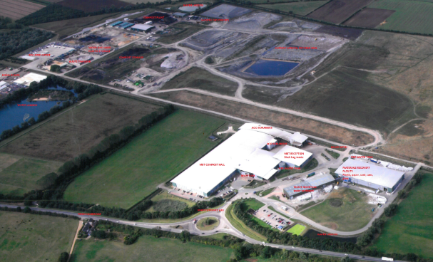

Location map of site - red circle denotes location of waste transfer station.

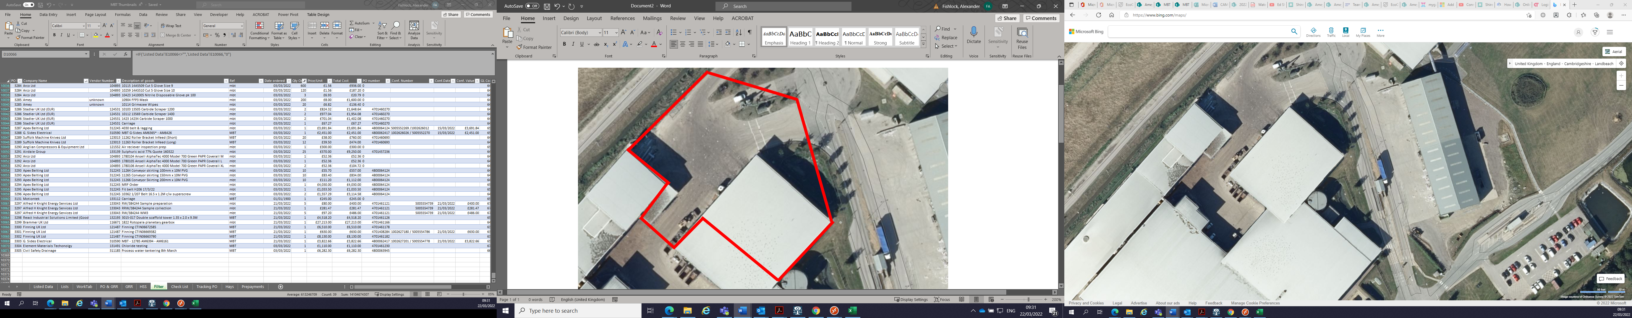

Site Licence Details

Permit number – EPR / AP3339XG / V002

Legal Entity – Thalia WB ODC Limited

2.2 Overview of Site Operations

Function

The temporary transfer station receives residual household waste and similar commercial / industrial waste.

Site management arrangements

MBT Operations Manager – Alex Fishlock

Competence and Compliance Manager – Kevin Benstead

Facilities Manager – Ian Anderson

Account Director – Jon Jones

|  |  |
| --- | --- |
| CAMB-WAT-ConEme-PL-029 | [Contingency](http://ameydocuments.ameygroup.int/Openfile.aspx?FileRef=AMEY-HSEQ-IAP-PL-01&Source=Browse%20Folder) and Emergency Plan |
| [CAMB-MBT-ISP-PL-009](http://ameyportal.ameygroup.int/sites/wasteims/Amey%20Waste%20Treatment%20IMS/CAMB-MBT-ISP-PL-009.pdf) - | [Integrated Site Plan](http://ameydocuments.ameygroup.int/Openfile.aspx?FileRef=AMEY-HSEQ-ISP-PL-01.docx&Source=Browse%20Folder) |

Site Activities

Refer to Environmental Permit Schedule 1

Table 1 - Table of Specified Waste Management Operations

|  |  |  |
| --- | --- | --- |
| Activity | Description of specified activity | Limits of specified activity |
| Temporary Transfer Station | Transfer of waste |  |

Waste Reception

Refer to Environment Agency Temporary Permit on Waste Treatment Local IMS – Thalia Waste Treatment IMS. When a load is considered unacceptable pictures are taken along with the registration of the vehicle and time, this is sent to the Contracts Manager who informs the council. The reject load is sent off site within 24 hours. A detailed waste acceptance procedure is contained within the Odour Management Plan (CAMB-MBT-OdoMan-PL-008)

|  |  |
| --- | --- |
| CAMB-MBT-UNAWASCRI-GD-007 | [Unacceptable](http://ameydocuments.ameygroup.int/Openfile.aspx?FileRef=AMEY-ENVT-WASTEACCEPTANCE-MSP-01&Source=Browse%20Folder) Waste Criteria |

Incoming waste – the transfer shed receives predominantly source segregated household residual waste - “black bag waste.” The waste is collected on a fortnightly basis and is expected to have a medium odour potential.

The expected daily feed material of “black bag waste” is up to 401 tonnes per day.

The reception hall is where the refuse collection vehicles (RCVs) deliver the mixed waste to site are unloaded. The building has two pedestrian doors and four powered roller shutter doors fast acting that operate in accordance with an interfaced sensor that detects a vehicles presence at the point of access and closes behind the vehicle, the same motion takes place when the vehicle exit the building. The delivered waste is deposited onto the floor of the reception hall and then moved using a wheeled loading shovel and materials handling grab to the rear of the shed towards the concrete retaining walls in a clockwise direction towards door 4 for the material handler/shovel for loading onto a landfill dump truck for final destination disposal to the Waterbeach landfill.

The volume of waste stored in the reception hall is kept to a minimum as this assists in minimising odour and flies. Ensuring potentially odorous fresh waste storage and retention within the reception hall is kept to a minimum is an important control measure in minimising potentially odorous emissions arising from this fresh waste. Site personnel direct delivery vehicles to appropriate deposit positions, to ensure older waste is loaded onto dumpers in preference to fresh waste. The wheeled loading shovel mixes the waste as it pushes the waste toward the grab.

The main stockpiling areas are against the rear wall of the reception hall and adjacent to the dumper loading area. Odour abatement equipment comprises of an ‘Atomister’ system consisting of a series of nozzles located across the ceiling approximately five metres from the doors. The system is designed to spray diluted de-odourising and dust suppressing chemical, e.g., Classic ODA 304 over the waste.

In summary the waste material is delivered to the reception hall, it is visually inspected by Thalia operatives. Material that does not comply with the requirements of the MBT permit or the waste PFI contract is deemed to be unsuitable and is classed as ‘MBT unacceptable waste.’ The shovel and grab driver are trained to recognise MBT unacceptable waste, examples of which include mattresses, televisions and large garden furniture. See CAMB-MBT-UnaWasCri-GD-007.

Waste Storage / Transfer

Only waste listed in the site EA permit may be accepted. For a generic list of wastes that cannot be accepted at any of these facilities refer to Waste Treatment Local IMS – Thalia Waste Treatment IMS CAMB-MBT-UnaWasCri-GD-007. Waste is delivered to the reception hall by refuse collection vehicles and roll on roll off vehicles, where it is deposited on the impermeable concrete waste reception area. Each deposited load is subjected to the waste acceptance procedure and if the load is accepted then it is loaded into the landfill dumpers then onto the landfill weighbridge prior to disposal in the landfill.

|  |  |
| --- | --- |
| EPR / AP3339XG / V002 | [Environmental](http://ameydocuments.ameygroup.int/Openfile.aspx?FileRef=AMEY-ENVT-WASTEMANAGEMENT-MSP-01&Source=Browse%20Folder) Permit |

See below table for expected minimum and maximum volumes of waste types expected to be delivered as well as products and expected storage times on site.

|  |  |  |  |  |  |
| --- | --- | --- | --- | --- | --- |
| **Material** | **Inventory** | | **Storage Time** | **Odour Profile** | **Method of Odour Management** |
| Normal | Maximum |
| Waste | | | | | |
| Black bag waste 20.03.01 | 250  tonnes/day | 401  tonnes/day | Minimise storage time.  Transfer the waste as soon as possible | Has a medium odour profile | Contained within reception hall with deodorisers |
| MBT Unacceptable Waste | 0.5 tonnes/day | 2 tonnes/day | Max 24 hours on site | Has a low odour profile | Skip emptied regularly |

Waste Transfer Operations – Loading in Waste reception hall

A detailed fire plan is in place and operated to (CAMB-MBT-Fir-PL-014) should there be a fire in the stored waste.



**3. Waste Streams**

The waste streams managed at the facility are as follows:

Wastes that can be accepted are:

Waste whose collection and disposal is not subject to special requirements in order to prevent infection.

Wastes whose collection and disposal is not subject to special requirements in order to prevent infection (for example dressings, plaster cases, linen, disposal clothing, diapers) 18.01.04

Paper and cardboard (EWC Code 20 01 01)

Glass 20.01.02

Biodegradable kitchen and canteen waste (EWC Code 20 01 08)

Clothes (EWC Code 20 01 10)

Textiles (EWC Code 20 01 11)

Wood other than that mentioned in 20 01 37 (EWC Code 20 01 38)

Plastics (EWC Code 20 01 39)

Metals (EWC Code 20 01 40)

Biodegradable waste (EWC Code 20 02 01)

Soil and stones (EWC Code 20 02 02)

Other non-biodegradable waste (EWC Code 20 02 03)

Mixed municipal waste (EWC Code 20 03 01)

Waste from markets (EWC Code 20 03 02)

Street-cleaning residues (EWC Code 20 03 03)

**3.1 Permitted Waste**

Table 2 - Permitted Wastes

|  |  |
| --- | --- |
| facility type: | Reception shed |
| **USE:** | Reception of waste. Storage and transfer of material. |
| **DESCRIPTION:** | Detailed in the table below is a list of the acceptable waste materials to which the site permit applies. |

|  |  |  |
| --- | --- | --- |
| Waste Categories | Acceptable Waste Classifications | Maximum Capacity of Operation – on site or per month |
| Feed | Municipal Waste | 250-401 tonnes per day |
| MBT Unacceptable Wastes | n/a | 50 tonnes/day |

**3.2 Waste Stream Assessment**

Refer to

|  |  |
| --- | --- |
| THALIA-ENVT-WASTESTREAM-PR-01 | [Waste Stream Assessment Procedure](http://ameydocuments.ameygroup.int/Openfile.aspx?FileRef=AMEY-ENVT-WASTESTREAM-PR-01&Source=Browse%20Folder) |

**4. Waste Storage and Retention**

The storage and retention time arrangements for the waste streams on site are as follows:

|  |  |  |
| --- | --- | --- |
| Waste Stream | Storage | Retention time |
| Feed | Contained within MBT Reception building with fast acting roller shutter doors and odour suppression system. | Reception building is designed to allow for oldest material to be rotated and processed first. |
| MBT Unacceptable Wastes | 24 hours | 24 hours |

5. Certificate of Technical Competence

The facility will be managed by a person of technical competence (as certified by the Waste Management Industry Training and Advisory Board).

At present, several members of staff have achieved WAMITAB COTC level 4 (Certificate details in Appendix F – Environmental Qualifications, Training, and Competence). Whenever the site is open to receive or dispatch waste, or disposal operations, it will be supported by at least one member of staff who is suitably trained and fully conversant with the requirements of the license and this working plan regarding:

* Waste acceptance and control procedures
* Operational controls and environmental monitoring
* Maintenance
* Record-keeping
* Emergency action plans
* Notifications to the agency.

6. Liaison and Document Review

6.1 Review requirement and timescale:

This waste storage plan will be formally reviewed on an annual basis as a minimum to ensure that the controls described are effective and reflect best available techniques. In addition, the waste storage plan will be reviewed following any relevant changes in site operations or procedures that are likely to have implications from a waste storage perspective.

Any required changes to the conditions set out within this document shall be formally agreed with the Environment Agency prior to implementation.

Appendix A: Site Plan (Waste Storage Areas)



MBT reception hall

MBT Unacceptable waste