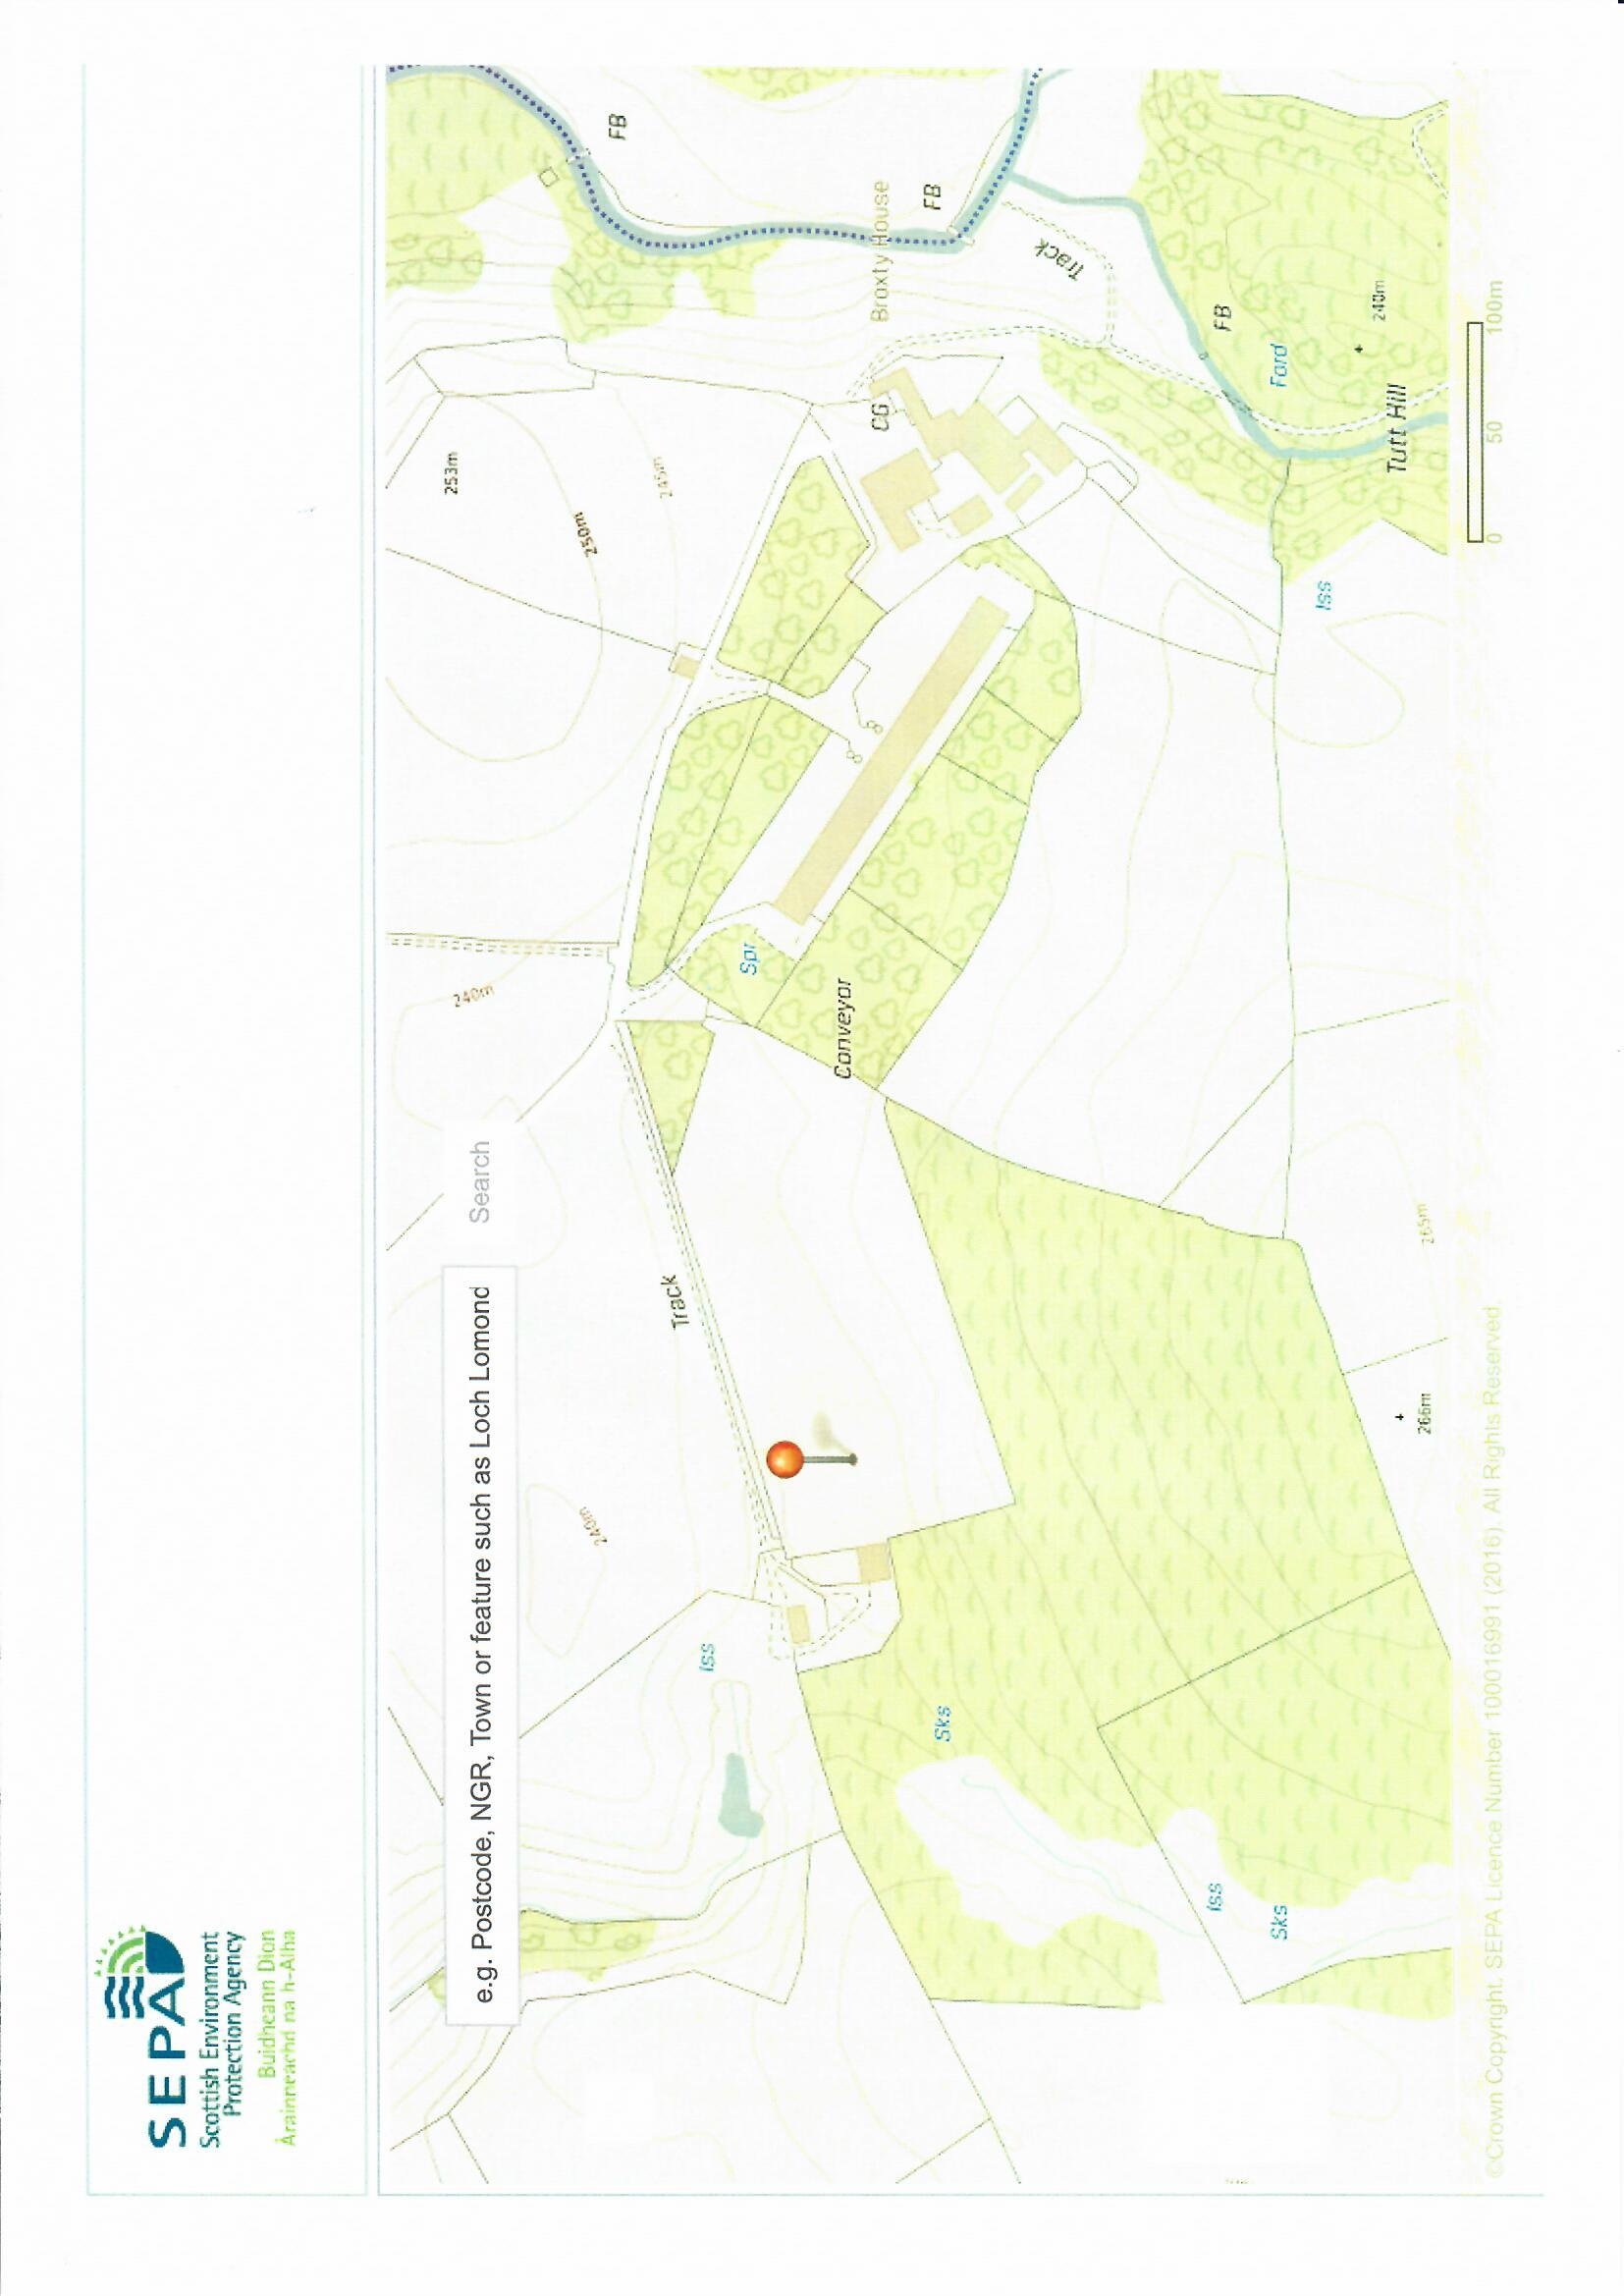

BF Appendix 15(i). Woodland Planting – Site drawing

Broxty Farm , Kaber, Kirkby Stephen.

swale

swale

Prevailing wind direction (westerly)

Proposed Range with plantation

Coldkeld Beck

Broxty farmstead

New site for additional woodland

Proposed Tree buffer strip

To intercept / metabolise N species & particulates

Existing Range plantation

R. Belah