BF Appendix 8. Site Map 1:25,000 scale O.S. map
Courtesy of Ordnance Survey OL 19
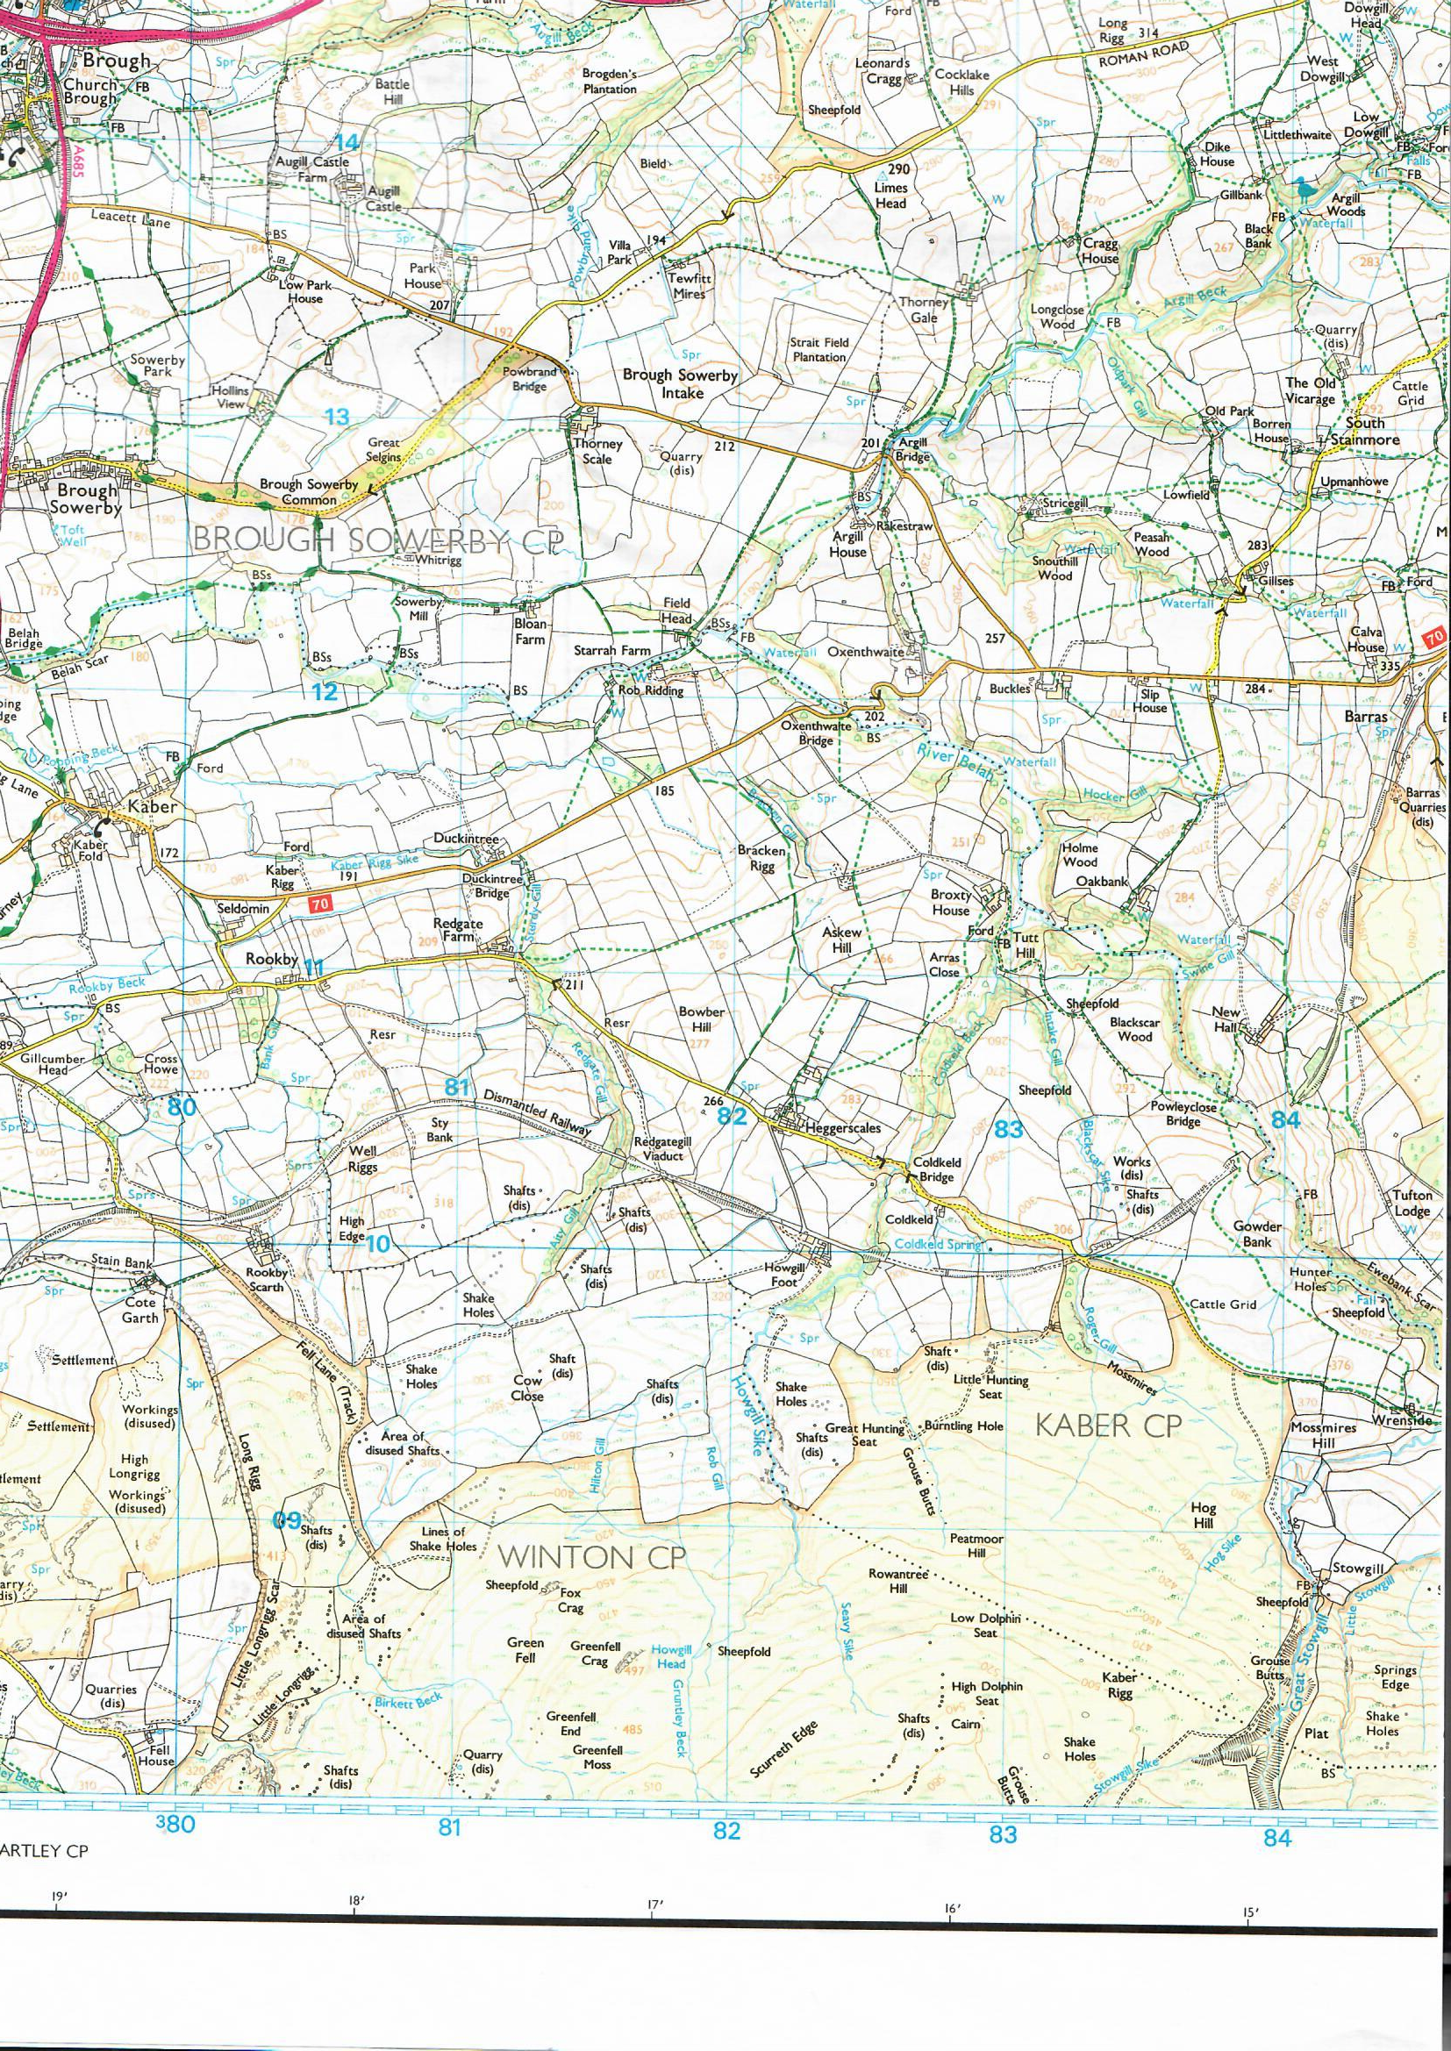
Broxty Farm
NY 829 113
Proposed poultry unit
Existing poultry unit

