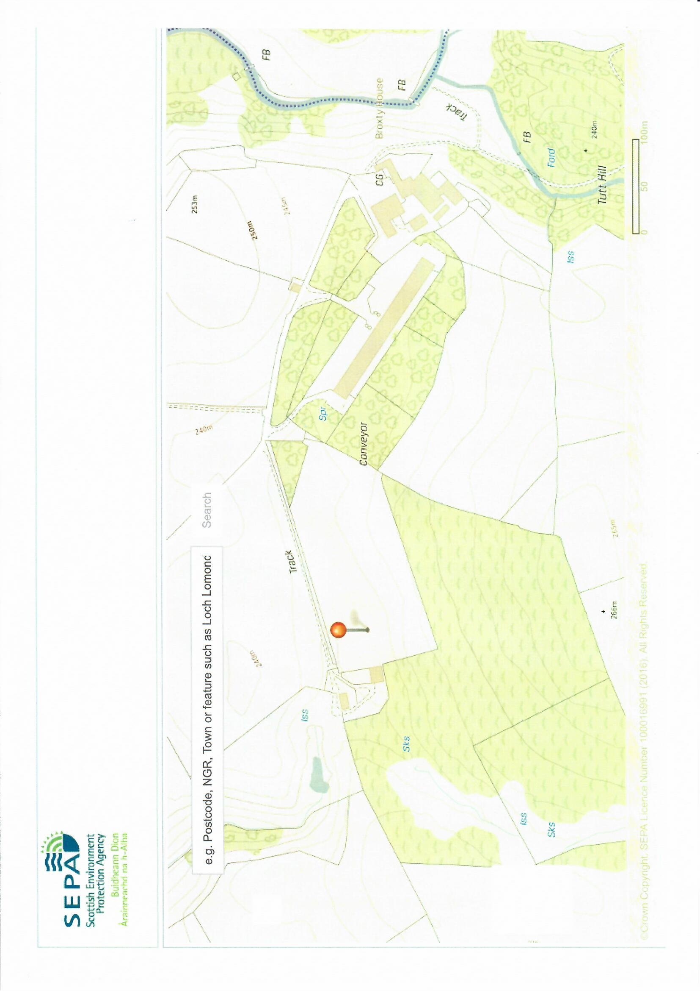

Concrete aprons at gable ends

R. Belah

New swale

Existing swale

Proposed Tree buffer strip

To intercept / metabolise N species & particulates

Bracken Gill

Prevailing wind direction (westerly)

Roof High velocity vents for house 1

*235m from R. Belah*

Gable end vents for house 2.

*310m from R. Belah*

BF 2.2 (ii) Broxty Farm , Site Plan No. 2 Stephen.

Site Plan

Higher ground

Proposed Gable end exhausts

*560m from R. Belah*

Original poultry house.

Proposed Range with plantation

Coldkeld Beck

Broxty farmstead

Site for additional woodland

Existing Range plantation