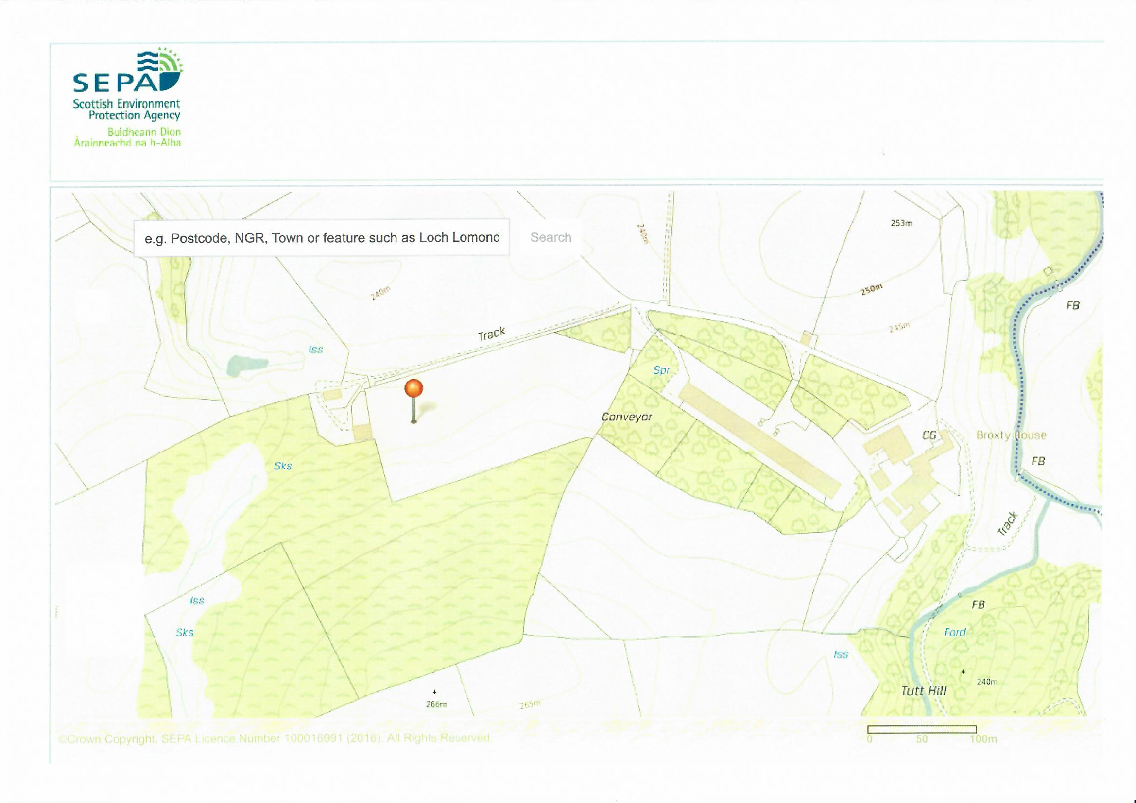

BF 2.2(i) Site Plan Broxty Free Range Egg site

Showing PPC boundary

(Map courtesy of SEPA web site.)

Bracken Gill

Broxty farm house

housetead

House 2b Proposed

House 2a Proposed

House 1b Existing

House 1a Existing

Boundary of Broxty farmstead

Access Road

Boundary of Permitted site.