Application for Environmental Permit EPB3.5 (Version 4)
Buckles Farm, Kaber, Kirkby Stephen. Cumbria
Pre Application Ref.EPR/GP3001LP/A001
BF 20. Fire Prevention Plan

Addressing the risk of fire and responding to such events is a feature of site management already covered through requirements of other agencies, Insurance schedules, market sectors and others. The expansion of the site that requires a PPC permit therefore represents an additional regulation on an existing feature.
The following plan follows the Structure of the EA guidance Note (Gov. UK) revised 11 Jan 2021.
Fire Prevention Objectives.
- Minimise the likelihood of a fire happening.
- Aim for a fire to be extinguished within 4 hours
- Minimise the spread of fire within the site and to neighbouring sites.

Reflecting on these PPC objectives, cognisance is taken of the (very) remote location of Broxty Farm compared with PPC sites generally and in other sectors which the guidance covers.
Further, it is recognised that the guidelines relate to the storage of waste. The site does not generate nor store waste. The guidelines however are used where there is reasonable correlation between the ‘nature’ of waste and materials found on this intensive agriculture (poultry) site.

Types and quantities of combustible material located on site.

Type | Quantity at any one time | Waste / raw material | Location
Wood shavings | 15 bales (20 Kg / bale)=300Kg stored to provide “top up” | Raw Material | Central Services area
Wood shavings / manure (ie ‘litter’) | 750 Kg applied to each house at start of campaign,1500 Kg / building | Raw material. Bedding eventually becomes manure. | Floor of each of 4 No. houses (2 buildings) Recycled through domestic recycling arrangements.
Plastics containers | 10 Kg | waste | Central Services area  Recycled through domestic recycling arrangements.
Plastic wrap | 10 Kg. | waste | Central Services area  Not presently recyclable
cardboard | 20 Kg | waste | Central Services area Recycled through domestic recycling arrangements.
Biocides* | 20.0 l | Raw Material | Central Services area dedicated storage
Pesticides* | 2.0 l | Raw Material | Central Services area dedicated storage
*Not combustible but relevant to fire management

Fire Prevention Plan.

Minimise the likelihood of a fire happening.
Aim for a fire to be extinguished within 4 hours
Minimise the spread of fire within the site and to neighbouring sites.

- Possible causes
  - Ignition of stored sawdust

- Reducing the risk
  - The site is run continuously with a period of ‘clean down every 55 to 65 weeks. During this period the clean down procedure will be consistent year on year.
  - Activities conducted on site where a fire is considered to be a manageable risk.
    - Overheating of fans (proximal to dust)
    - Overheating of bearings on feed distributers, belts, rollers and associated motors.
    - Computer systems (Central Services)
    - Electrical facilities in mess room(Central Services)
    - Electrical components, rollers, belts, motors in egg packing and delivery (Central Services and poultry units)
    - Lighting,
    - Power washers
  - An emergency action plan already exists including fire response through the BIC Assurance Scheme which is an internal audit for securing the ‘Lion’ brand mark. This includes abasic electrical check annually and a NFU 3 yearly check on all electrical; hardware. – NFU certificate.

Fire Prevention

Fire risk | Preventative action
Wood shavings(top up) | Stored adjacent to Central services doorway Minimal amount stored for immediate use only, water supply in CS, adjacent to egg packing station with constant staff presence.
Wood shavings (litter) | Spread thinly and only at start of new campaign. Heat sensors throughout houses for flock welfare recorded on computer and attached to alarm system both internally and to management.
Plastic containers | Minimal. Removed as generated through domestic recycling schedule
Plastic wrap | Minimal. Removed as generated through weekly domestic waste collection
Cardboard | Minimal. Removed as generated through domestic recycling schedule
Conveyor belts | Cleaned 3x weekly. No build- up of manure, rollers and belts on routine maintenance schedule.
Motors | On annual electrical check by qualified electrician (certificated)
Rubber manure belts | Only used for short period 3x/ week and supervised through that task.
Electrical Circuits. Power points, lights, computer | On annual electrical check by qualified electrician (certificated). All lights LEDS preventing localised heat hotspots. Lights switched off every night to generate welfare ‘night time’.
Fan overload (heating) | Breaker in control panel sensing too high an electrical load which cuts fans out.

Above relates to normal egg producing phase of operations.
During clean down all litter removed from houses and significant water usage to wash down and sterilise internal surfaces.(very low risk period).Houses dried before recommissioning.

Activities on site
The single activity is to house egg laying birds providing them with feed, water, nest boxes and perches, all established in a central metal structure. There is access throughout the day for birds to leave the house and range outside via ‘pop holes’ which are located along both sides of the house which can be operated manually from the central services area. All computer controlled with over-ride.
There is no wood in any of the construction and insulation is non-flamable.
Roof fans maintain an internal temperature of approx. 20ºC and heat sensors in the air space throughout the house constantly convey temperatures to the central computer which in turn manages air extraction fans to maintain that temperature. Wide variance of temperature is alarmed to staff during working hours and to management outside of that time.
Belts / rollers to remove eggs are frequent (every day) manure belts run for a short period 3x/ week and move slowly (low friction).
There is no waste management on site

Site Plan (below)
- Main route for fire engine access shown on map. Nearest fire station is Kirkby Stephen . (4 miles , approx. 8 minutes)
- Access to perimeter not relevant. Only houses are risk Both units accessible by road
- No Hydrants on site. Water supply is from borehole. Water pumped by 2” alkathene pipeline for all uses.
- No unmade ground. Range and scratch areas accessible around all buildings. Wooded areas are approx. 15m= beyond that.
- Houses have under-drained stone based areas outside each house on both sides. (scratch area. These drain to swales used for treatment of lightly contaminated surface water but in the event of fire , fire water up to 80m3 could be retained in these by simply blocking off final drain outlet to watercourse. Fire water would be removed before damage to swale would be a critical issue.
- There are no spill kits on houses site as there is no oil storage. This facility does exist at the standby generator distanced some 100m + from houses.
- Groundwater protected by impervious layers within the local geology and drainage will preferentially drain to swales.
- Sensitive receptors
  - Farm house within 200m , 1 neighbouring residence approx. 1 km away
  - R. Belah SSSI runs to east of site approx. 250m to 300m away.

Manage Common Causes of Fire.
Arson
An unlikely event. High fence around site, single main gate locked outside of normal working hours. Buildings also locked and pop-holes shut outside of working hours. Building superstructure and cladding all metal. CCTV installed and entry alarmed to management.
Plant and Equipment
- Maintenance schedule and daily surveillance on all static plant / infrastructure, including fans and motors.
- Mobile plant (washers) only brought in for end of campaign house cleanse.
- Fire extinguishers (electrical) at each doorway. Serviced annually by ‘Beacon Fire’.

Electrical integrity
- All site fully certificated
- Annual inspection
- Low risk (LED) lighting
- Audible alarms checked regularly
No Smoking Policy
- In place inside any building
Industrial heaters
- Heat application limited to air / air heat exchangers, all working at ambient temperatures. Similarly there are no ‘hot’ exhausts. No ignition sources.
Loose combustible material. Dust.
- Accumulation limited to areas around extraction fans. Indication of this potential through fan efficiency but also cleaned thoroughly on each flock change-over. Visual evidence of dust build up seen and actioned in daily operational programme
Reactions between waste
- Limited to biodegradation of manure on belts which is removed every 2-3 days.
- No long term manure stored on site so no risk of self- combustion.
- Trailers of manure removed when full. (less than 1 week and removed to adjacent farms for fertiliser application.
Monitor and control temperature
- Monitors throughout both houses linked to computer which then controls air exhaust fans to cool / retain heat to optimal level.
- Alarms in place to alert management well below fire risk temperatures. Ie 22 to 25⁰C.
Prevent Fire Spreading
- No stockpiling of flammable material apart from small quantity of sawdust / wood shavings (bagged) in Central Services for use in short term.
- No infrastructure or operational practices are recognised for reducing the risk of spread. Staff have strategically placed fire extinguishers and are familiar with their use and location during induction training but this provides response only to small localised events where this is judged an option. Staff have an instructed priority for self- protection and therefore evacuation.
Firewalls and bays
- Not applicable for this site and conducted business
Quarantine Area
- Not applicable for this site and conducted business
Detecting Fires
- Heat detectors installed throughout buildings and data fed to central computer for adjustment of fans or, in case of normal temperature range being exceeded, alarm internally and duty manager if temperature reaches 24⁰C.
Suppressing Fires
- Limited to strategically located (and serviced) fire extinguishers at doorways. Routine servicing certificated.
- Front loader vehicle used to extract litter on depletion available on site. This ‘may’ be an appropriate means of extracting material such as litter, depending on personal risk. Access required through main gable end doors.
- Water is available to site but limited to delivery of 2” mains from pumped borehole.
Water Supply
- No bulk supply of water is readily available. Nearest source is R. Belah which is below the site level by 30m+ and access is difficult and risky for staff fire brigade (approx. 300m away from nearest house, 1km away from furthest poultry house access
- No mains water supply on site, all water from private borehole.Yield is approx.. 0.45m³/ min

Management of Fire water
- All drainage from around houses drains directly into scratch areas which are under-drained and directed to swales for water attenuation and treatment of light contamination. These features will serve to provide that security against pollution of watercourses by fire water. Each swale system has a final pipe outlet which can be blocked, (in safety) as part of the response to a fire event within 2-3 minutes. This would retail all fire water up to a volume of 70m³ for houses 1a & b and 108m³ for houses 2a & b.
All drainage ultimately drains to Bracken Gill.
Ground water is protected by impervious strata; clay and mudstone. (see BF Appendix 10) Existing operations since 2013 have demonstrated no impact on ground water.
- In addition the houses both have a sealed storage tank of approx. 20m³
- No public sewers in this rural area.
Assessing Risk to Groundwater from Fire water
- There is no significant hard standing on the site apart from main access road apron and concrete plinths at each end of houses.
- All drainage will be captured by field drainage system underneath scratch area. For proposed sites, 2a and 2b, these will be additionally underlined with a damp proof membrane to maximise capture.
- MAGIC map describes aquafer designation (bedrock) as secondary ‘A’
- The groundwater vulnerability map shows the site to ‘Medium’. However borehole information on strata demonstrates protection of resource and water analysis confirms integrity. Pump is at approx.. 215m AOD, nearest and highest building 235m AOD but surface topography drains surface water to the west.
- Site is not in a Nitrate Vulnerable Zone or a groundwater SPZ.
- Farm borehole is beyond the 100m from nearest point of House 1a.
- Swales which could offer some downwards drainage are on 230m contour are at a distance of 330m and 480m from borehole. However active emptying immediately after the event would minimise this aspect.
Staff Awareness and training
- Staff informed of fire procedures and location of extinguishers, water supply etc as part of induction / ‘shaddowing’ training.
- Location of extinguishers and fire doors on plan in staff facilities.
- Location of drain stops for swales known to staff.
During and After fire
- Actions will depend on scale of damage. No materials are likely to be brought onto site until the whole unit is re-commissioned.
- Most infrastructure is metal and would be recyclable.
- Only insulation would likely to be a significant material requiring removal as waste.
- Fire water would be removed at first opportunity with advice from The Environment Agency on optimal route and location for disposal.

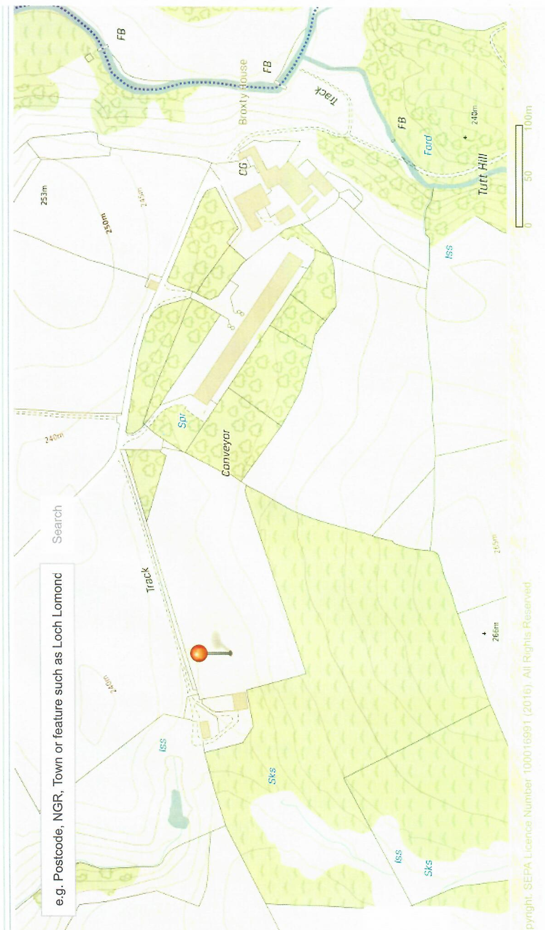
Fire water retention Point (drain stops in swales)
100m
Original poultry house. 1a and 1b
Roof High velocity vents for house 1a
Fire engine access
Drainage from houses
Emergency exits
Potential site for additional woodland
borehole
Standby generator& fuel storage
Appendix 1. to BF 19 Fire Prevention Plan Site Map Broxty Farm.
Superimposed units not to scale
Fire water supply (2”) from borehole
Existing Range plantation
N
Site Boundary
swale
swale
Prevailing wind direction (westerly)
Coldkeld Beck
Broxty farmstead
Gable end exhaust vents
for houses 1a, 2a and 2b 2.

Proposed Tree buffer strip
To intercept / metabolise N species & particulates
R. Belah

