Application for Environmental Permit EPB3.5 (Version 4)
Buckles Farm, Kaber, Kirkby Stephen. Cumbria
Pre Application Ref.EPR/GP3001LP/A001
BF Appendix 22 Flood Risk management

Flood risk mapping is provided by the drawing below, derived from the ‘Magic’ database. The detail however is poorly conveyed from the print- out. It suggests that part of the permitted site around the farm house is class as ‘high priority’ and the majority of the site, including all of the land where the present and proposed poultry houses are and all of the range area is within the ‘medium priority’ sector.
The EA web site(Gov. UK) for post code CA17 4ER indicates that for the full range of storm events from low to high velocity and flooding, there is little to no risk of either the buildings or the range from flooding. This would be expected as the ‘ephemeral’ ditch is absolutely at the head of this small catchment.
All of the site is within the Priority Catchment in relation to the ‘Catchment Sensitive Farming’ classification. This latter point is of significance in relation to the proposed changes in land use and likely longer term surface water quality.
Sub Catchment
The whole of the site is within a small catchment where little surface water is derived from off-site and drains onto it. Consequently, all field drainage and surface flows are collected and move via existing field drains to a central land tile and ditch, finally out-falling as the source of Bracken Gill.
Uniquely, the eastern boundary is an escarpment down to the R Belah which is in a ghyll at this stage of its course to the River Eden. No surface water from the permitted site runs in this direction and the underlying boulder clay across the site suggests that most flow is superficial and therefore directed to Bracken Gill.
Sub Catchment structure
At present the existing site exhibits 4 no. flow regimes:-
- Flashy flow from roofed areas
- Delayed flows for rainfall falling on scratch areas which pass through to swales for further attenuation.
- Normal drained fields and
- Areas formerly field but now planted up with trees / shrubs as part of the free range woodland cover. (Flows significantly attenuated.)

The proposed extension site is entirely covered by field drains presently and therefore operates as point 3 above.

Proposed changes
The extended site will have a single building with the approx. the same roof area as the existing unit. This will drain to a new swale system which will both attenuate flow hydrographs and recharge ground water with uncontaminated rainwater.
The scratch areas will be under-protected by a DPD (damp proof membrane) ensuring all drainage goes by way of the swale, intercepts first flush to retain trace organics; protecting the river network quality and releasing only extreme storms after flow attenuation cf. site 1.
Both the existing site and all of the new site will be extensively planted up with trees / bushes to deliver:-
- Extension of area providing flow attenuation,
- Reduction in cross surface run-off during storm events,
- Capture of trace organics by absorption and metabolism into new biomass,
- Reduction of applied fertiliser cf former practice as grazed pasture.
- No increase in peak run –off from new roof through passing through swale designed with ‘first flush’ hydraulics and full buffering of flow ability.
- The new range is presently traditional field but will move to approx. 30% cover by shrubs / bushes.

Secondary benefits
There are a number of secondary benefits which though not associated with improved water management / flood prevention on that piece of land, do have a net benefit to the wider environment under EA and NE jurisdiction.
- Increase in woodland habitat
- Increase in general woodland cover. (climate change contribution)
- Increase in essential cover for moorland birds presently under support in ‘less favoured area. (Farm stewardship){young birds noticed to use existing tree covered range for protection.}
- Recognised value of 360⁰ tree cover in breaking lateral wind movement and retaining on site residual ammonia releases from farm by deposition on site.
- Absorptive capacity of ammonia by trees increased (Farmtreestoair) Air/ soil / water.
- Absorptive capacity of particulates by trees.
- Further protection of sensitive receptor (R. Belah)
Conclusion: Net impact of proposed development
- Likelihood of greater attenuation of rainfall reducing peak hydrograph run-off.
- Less erosive energy derived from site.
- Improved water quality.

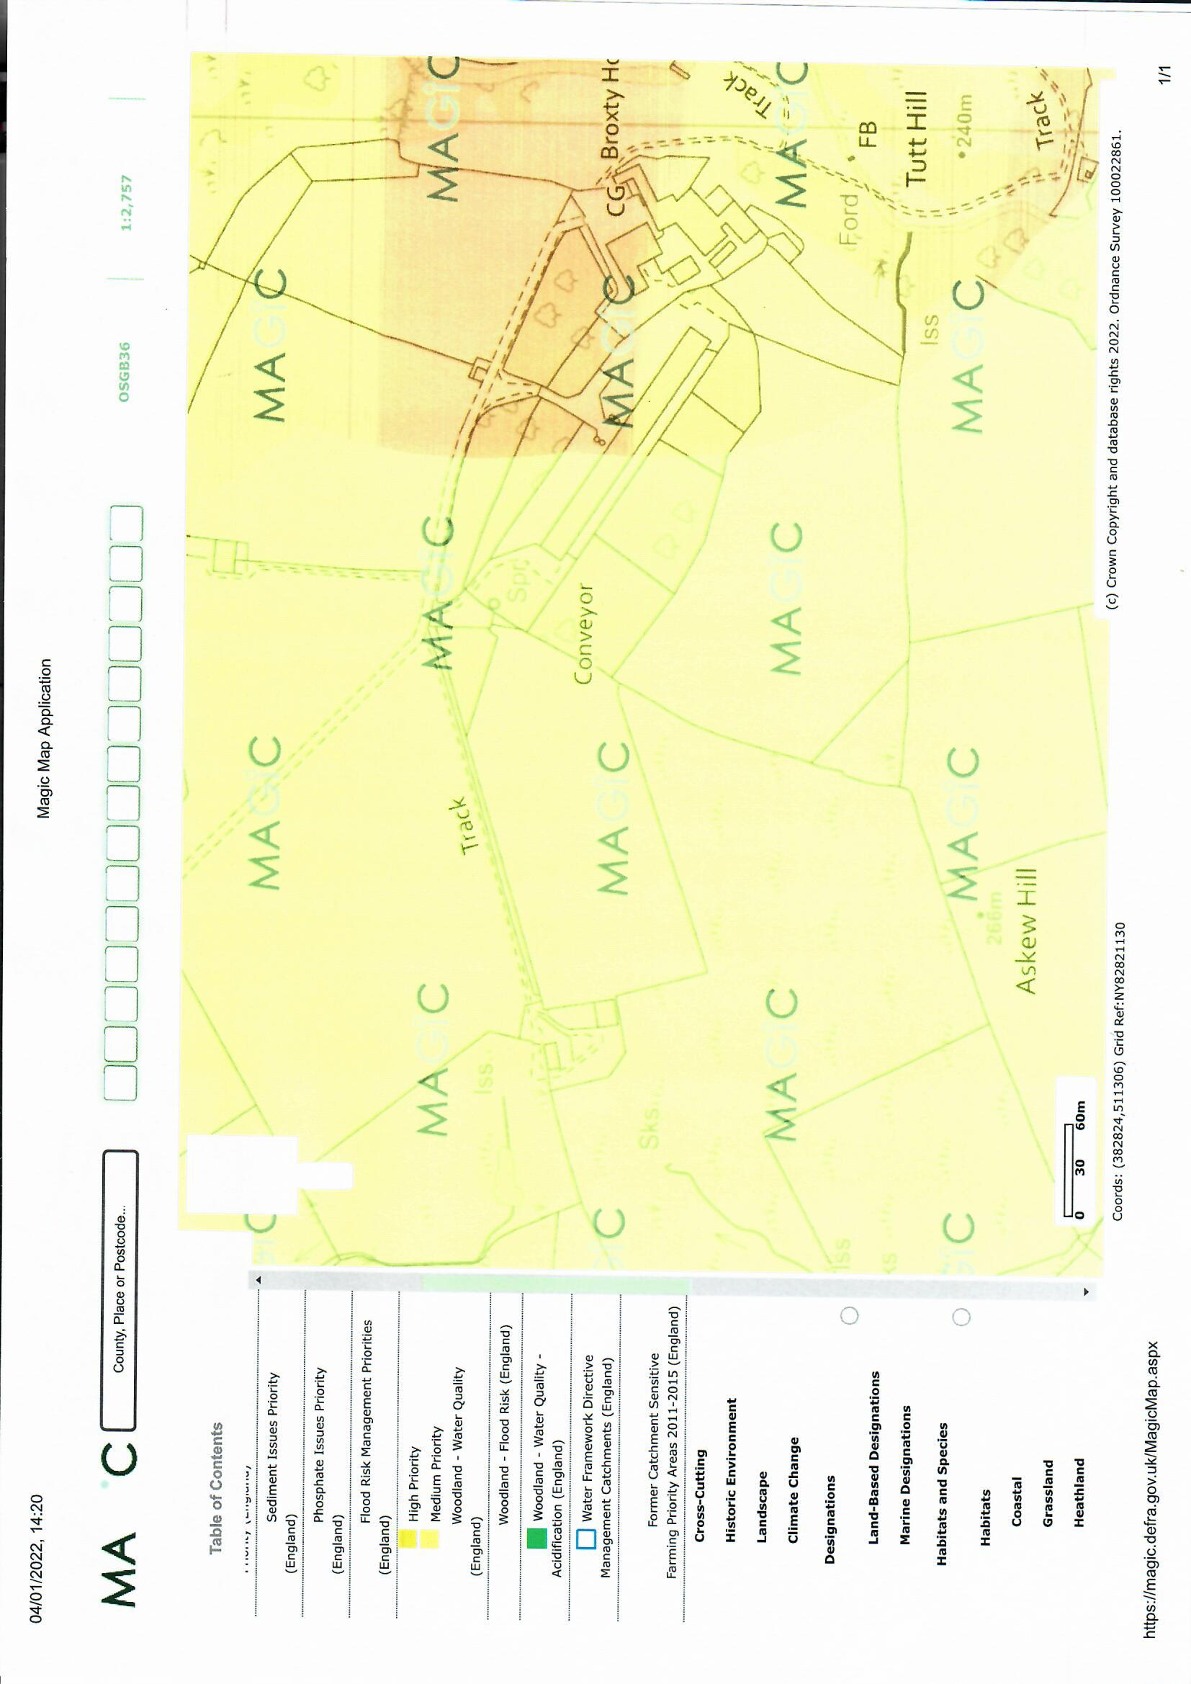
Direction of surface drainage including land tiles
Existing main drainage ditch (ephemeral)
Surface water drainage direction
Discharge points from swales
Open watercourse
R. Belah
Bracken Gill

