Application for Environmental Permit EPB3.5 (Version 4)
Buckles Farm, Kaber, Kirkby Stephen. Cumbria
Pre Application Ref.EPR/GP3001LP/A001
BF Appendix 16
Location of farms where milk businesses have closed within last 5- 10 years.

Over the past 5-10 years the structure of farming in this section of the R. Eden valley has changed significantly with virtually all local farms terminating their milk business. Most have replaced the sector with sheep although a few retain suckler cows on a smaller scale.
The attached map shows those farms ‘local’ to Broxty farm that have terminated their milk business .
The significance of these changes are two fold.
1. Reduction in threat to surface water quality (organic and nitrate pollution) and emission of ammonia to air.
2. increase in import of inorganic fertliser (NPK) for grass growth (hay and silage)

1. Emissions to air
Historically farms would have produced either manure (dry) or slurry which would have been predominent in this area.
An approximation based on ‘general awareness’ has been made on the number of cattle held on those farms historically and is in the order of 770 over the known 14 farms highlighted. (This is aprecautionary number and no consultatio has taken place.)
DEFRA figures¹ suggest that Ammonia emissions for cattle are approx.105Kg N/ Yr which equates to 127Kg of ammonia.
Annual emissions ten years ago would therefore be in the order of 97,790 Kg
This reduction in cattle in the immediate area also suggests that rather than there be a need for adding farms on, to generate a local higher emission, the figure in reality, is significantly less.
Based on the same paper¹ a 64,000 bird flock with no ammonia reduction features would emit approx 0.58 Kg Total Nitrogen / bird/ yr (37,120 Kg) and a figure of 14.5% of the TAN is nominally converted to ammonia. Ie 5,382 Kg.
In reality with modern infrastructure and practices, the emission of ammonia is likely to be in the order of 50% reduction on this or 2,691Kg/yr.
In turn this equates to an expanded Broxty farm emitting 2.7% of former emission levels when milk cattle were the predominent farm stock.
The above equations are simlified and only compare direct and quoted values. However they represent the major components and serve to allow relative comparison.
2. Import of NPK
Without auditting the fields associated with those farms, it is assumed that the aim is still to retain productivity and therefore the amount of inorganic NPK will have increased commensurately since the closure of the milk side of the businesses.
In potential marketting of poultry manure from Broxty Farm to 3rd party farms in the future, the following points are made in support; recognising that field analysis would determine appropriateness for each case:-
- Haulage is minimal – Less than 2 miles (less fuel consumed)
- Manure contains micronutrients / elements not in general NPK fertiliser
- Excess lime (stone) not metabolised by birds precludes further application of lime to fields,
- Application of manure maintains/ restores field C levels.
- Recycling of finite world resource of P

Overview

The transition away from dairy farming over the past few years will have significantly reduced the ammonia release to air from slurry and FYM from this sector. The Broxty Farm contribution to the local aerial environment, even with the doubling of size would only be 2.7% of the previous emissions.
There are significant benefits of the local farmers having access to this manure both financially and in soil protection .
The increased dryness, which prevents ammonia generation, by definition, also increases N availability in the applied manure.

1.The Inventory of Ammonia Emissions from UK Agriculture 2017 : DEFRA Contract SCF 0107
Dated: Feb 2019. T.H. Misselbrook, S.L. Gilespy (P.18 Annex 1:Table A1 column 5)
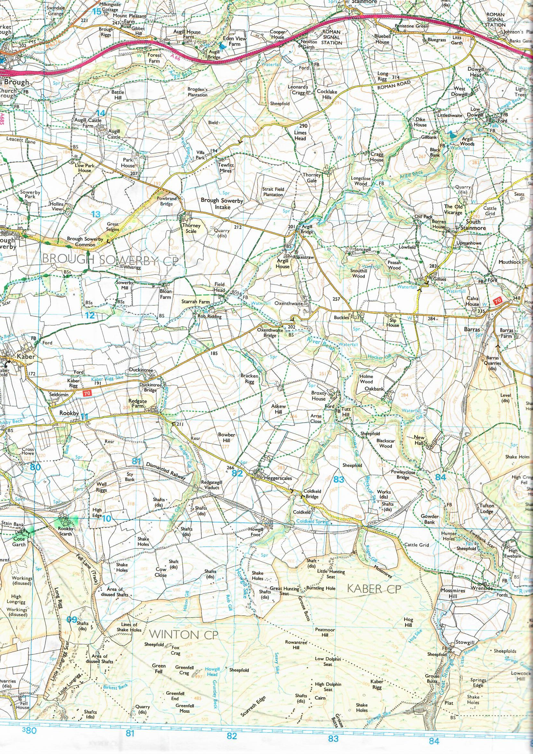
BF Appendix 16
Proximity of farms to Broxty where milk businesses have closed within last 10 years.
2 Km radius
2 Mile radius

