Application for Environmental Permit EPB3.5 (Version 4)
Buckles Farm, Kaber, Kirkby Stephen. Cumbria
Pre Application Ref.EPR/GP3001LP/A001
BF Appendix 9 Geology

Solid Geology
The solid geology for the area covering Broxty Farm is relatively complicated with multiple faulting in the vicinity. Most of the strata towards the surface are of sedimentary materials. The (verbatim) description from the BGS map series and associated with the site is quoted below.
“1:50 000 scale bedrock geology description: Stainmore Formation - Mudstone, Sandstone And Limestone. Sedimentary Bedrock formed approximately 319 to 329 million years ago in the Carboniferous Period. Local environment previously dominated by swamps, estuaries and deltas.
Setting: swamps, estuaries and deltas. These sedimentary rocks are fluvial, palustrine and shallow-marine in origin. They are detrital, forming deposits reflecting the channels, floodplains and deltas of a river in a coastal setting (with periodic inundation from the sea).”

Drift Geology
Like much of east Cumbria the drift geology is predominantly driven by material deposited at the retreat of the ice from the previous ice ages. BGS quote the description as:-

”1:50 000 scale superficial deposits description: Till, Devensian - Diamicton. Superficial Deposits formed up to 2 million years ago in the Quaternary Period. Local environment previously dominated by ice age conditions (U).
Setting: ice age conditions (U). These sedimentary deposits are glacigenic in origin. They are detrital, created by the action of ice and meltwater, they can form a wide range of deposits and geomorphologies associated with glacial and inter-glacial periods during the Quaternary.”

What is not readily available is the cross section which gives the local depth of each; drift and solid geology. However the drift geology map provides detail of that material but no information in the nearby river valleys, probable because this material has been eroded away and the river itself lies on the local bedrock.
Looking at the information from the site borehole does provide some measure although this will of course differ significantly with short linear distances.
At the site of the borehole, It appears that the drift material extends down to 6 m but the mudstone an shale below that may also have a low permeability. This feature is probably consistent with the surface features on land which has been unimproved which tends to become waterlogged in winter time and is also consistent with the soil descriptions in this area.
These data suggest there is, on balance, low permeability and therefore low probability of any run off from the farm adversely affection ground waters. The frequency of surface water streams would also suggest that most incident rainfall runs off rather than pass downwards to an aquafer that is the main feed to the river system. All of the proposed PPC site appears to have its own surface watershed, draining to the west and into Bracken Beck rather than the R. Belah which is closer to the east and much deeper. This observation is probably driven by the impermeable drift geology.
The site may well be protected by this drift geology.

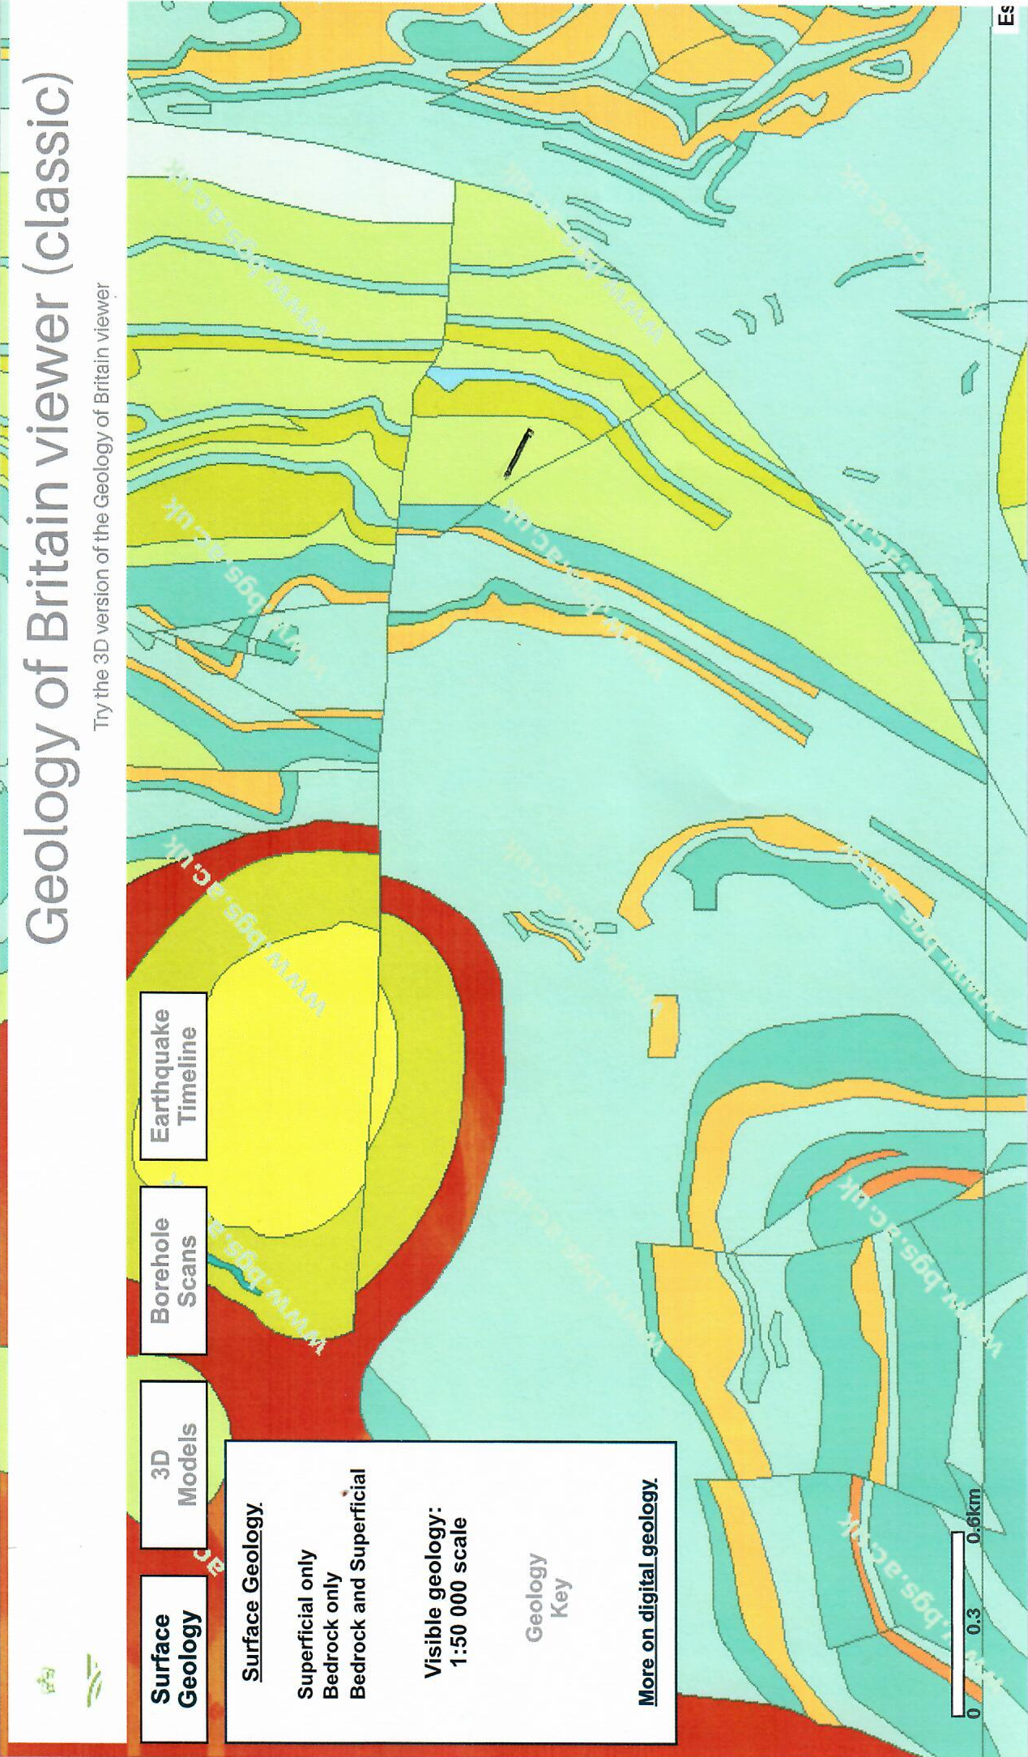
Solid (bedrock) Geology
Broxty Farm
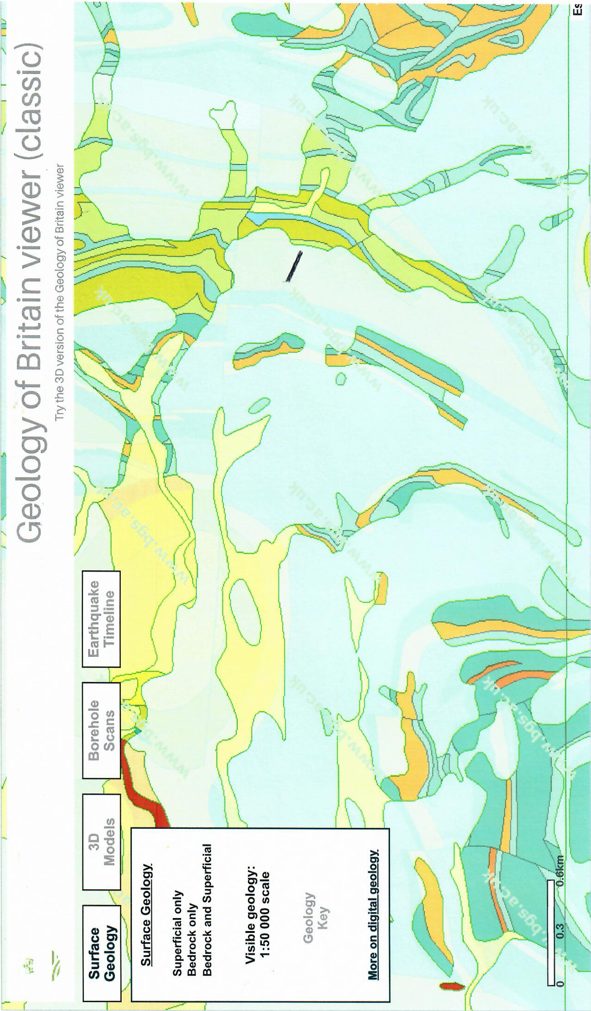
Drift (superficial) Geology
Broxty Farm

