Fan Operations Broxty Farm
Ventilation at Broxty Farm is consistent with most FR egg units operating an aviary system.
Both House 1a (which uses high velocity roof fans) and houses 1b, (plus the proposed houses 2a and 2b) are/ will be ventilated by duty and auxiliary fans.
For those with gable end fans, 1b has 1 fixed duty fan and 1 variable speed fan whereas both proposed houses will have 2 variable speed fans. Consequently there is some variation in operation between the 4 houses but all have a common basic function:-
Most of the time, the duty fan will provide the computer controlled ventilation and only in summer on occasional days and predominantly during daylight hours, will the fixed auxiliary fans come into operation (part of July / August nominally.)
For free range egg farms which have lateral pop-holes to allow access to the range, there is a constant air exchange at ground level, above and beyond fan control during the daylight hours. Consequently throughout most of the year, there is an over-riding need to conserve heat rather than a priority need to remove CO₂, NH₃ and provide ‘fresh air’.
Most units of this type have ventilation control by sensors within the house directing fan operation through the central computer. There is not a fixed period when duty fans are on as this is highly variable. This is because the wide and constantly changing external environment requires control to establish a constant internal environment; nominally meeting 21⁰C.
Farmer experience is therefore more relevant to the specifics for any one site. At Broxty Farm even the range of temperatures throughout the year are well below that optimal temperature and during winter months ventilation needs to only match CO₂ / NH₃ removal. Excess ventilation would result in heat loss.
Details of fan operation are not available at this site as there is no record of operation or even dedicated electricity usage. Therefore an approximation is made using the observations of the management over the past 9 years of operation. The average climatic details have been established for Appleby–in–Westmorland, some 18Km to the NW at 140m AOD compared with the site at 240m AOD, slightly higher up the Pennine range and therefore slightly colder. The tables for Appleby therefore may overestimate the temperature ranges seen on site.

 | January | February | March | April | May | June | July | August | September | October | November | December
Avg. Temperature °C (°F) | 2.5 °C  (36.5) °F | 2.6 °C  (36.6) °F | 3.9 °C  (39.1) °F | 6.4 °C  (43.5) °F | 9.4 °C  (49) °F | 12.2 °C  (54) °F | 14 °C  (57.1) °F | 13.5 °C  (56.3) °F | 11.6 °C  (52.9) °F | 8.6 °C  (47.6) °F | 5.2 °C  (41.4) °F | 3 °C  (37.4) °F
Min. Temperature °C (°F) | 0.4 °C  (32.8) °F | 0.1 °C  (32.2) °F | 0.9 °C  (33.6) °F | 2.7 °C  (36.9) °F | 5.7 °C  (42.3) °F | 8.6 °C  (47.5) °F | 10.5 °C  (50.9) °F | 10.4 °C  (50.7) °F | 8.6 °C  (47.5) °F | 6.1 °C  (43) °F | 3 °C  (37.4) °F | 0.7 °C  (33.3) °F
Max. Temperature °C (°F) | 4.5 °C  (40.1) °F | 5 °C  (41) °F | 6.8 °C  (44.3) °F | 9.8 °C  (49.7) °F | 12.8 °C  (55) °F | 15.2 °C  (59.4) °F | 17 °C  (62.6) °F | 16.3 °C  (61.4) °F | 14.4 °C  (57.9) °F | 11 °C  (51.9) °F | 7.2 °C  (45) °F | 5 °C  (41.1) °F
Precipitation / Rainfall mm (in) | 126  (5) | 104  (4.1) | 90  (3.5) | 83  (3.3) | 87  (3.4) | 97  (3.8) | 103  (4.1) | 107  (4.2) | 90  (3.5) | 107  (4.2) | 110  (4.3) | 129  (5.1)
Humidity(%) | 92% | 88% | 85% | 81% | 80% | 81% | 82% | 84% | 86% | 89% | 91% | 91%
Rainy days (d) | 13 | 11 | 11 | 11 | 11 | 12 | 13 | 13 | 11 | 11 | 12 | 12
avg. Sun hours (hours) | 2.1 | 3.0 | 3.6 | 5.2 | 6.5 | 6.0 | 5.9 | 5.0 | 4.1 | 3.2 | 2.5 | 2.2

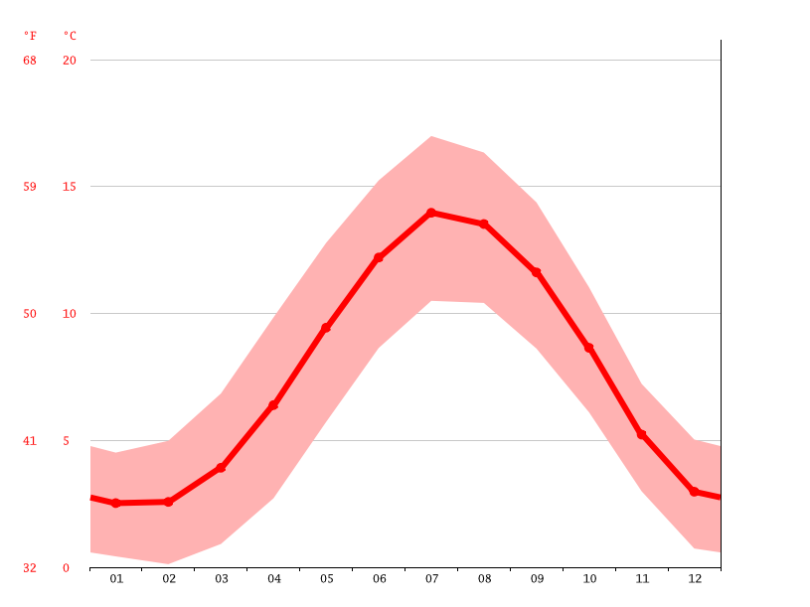
It can be seen that between October and April the average temperature is below 10ºC compared with the ideal house operational temperature of approx. 21⁰C.
On no month is the average temperature above 14⁰C. Consequently there is always a significant temperature variation between the outside environment and inside the houses.
Much of the heat in the existing buildings is generated by the birds and during the winter months heat conservation is critical. Recent installation of heat exchangers partially addresses this issue.
Fan use for most of the year is therefore to ensure fresh air exchange rather than provide a cooling function and the latter is only required when the differential between inside and outside is reduced and there is a net need to expel warm air from the houses.
During the winter months (6- 8 months of the year) All houses (present and future) will be served only by the fixed/ variable speed duty fans, and auxiliary fans limited to daytime occasions in July / August.
Management observations have therefore been used to match the analysis above with ‘site observations’ albeit these are unqualified. However, operational observations have been sought at 3 No other farms and operations concur with those at Broxty Farm.
- Auxilliary fans do not play a significant role in air movement and associated ammonia emission at any time of the year.
- Duty,(smaller) fan are assumed to run at ‘average speed’ recognising they will in reality range between ‘tick-over’ and full speed. Ie. 23,130m3/Hr. / 2 = 11,565m3 / Hr.
6
10

Run Hours / Day
24
20
16
12
Average
8
4

Winter
Summer

- Running hours observations range from :-
- 1 hr in 4 during Winter months (Jan to April and Oct to Dec) (6hrs / D) for 7 months
- 2 hrs in 4 during Spring / Autumn (May-June, Sept.) (12 Hrs/ D) for 3 months
- 4 hrs in 4 during summer (July August) (24 hrs/ D) for 2 months
This gives an average of 10.5 hrs. fan operation / day over the full year, operating at 1 duty fan running at half speed 11,565m³/ hr. (1 No. gable end fan / house)

Free range egg farms will operate very differently to broiler units because of the daytime bird access to the outside and the negative cooling that occurs through that. This is the prime reason why the assumption of 24 hrs a day fan operation is inappropriate for this site, at this location.

