Smart Systems Ltd, Effluent laboratory results.
Baseline as environmental permit.
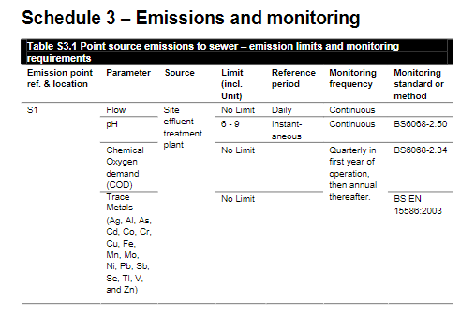
Figure 1 Exert from Smarts Current Permit for point source emission to sewer
Whilst pH is continuously monitored on site, Smart’s send effluent samples to be tested at Somerset Scientific Services once a quarter. The laboratory is accredited to UKAS testing, although pH test do not fall under UKAS Accreditation Schedule.

Wereban lane is not a direct emission/ effluent point for Smart’s however it is used to indicate pH change from Smarts emissions point from another companies’ emission point further downstream.

Figure 2 pH of samples recieved from Smart Systems Ltd. by Somerset Scientific Laboratories 2022

Laboratory monitoring of suspended solids, COD, and trace metals present within the water was conducted on 21.04.2022 for effluent plant 1 & 2, as to align with monitoring needs of the permit. The permit has not set limitations on suspended solids, COD or trace metals.

Table 1 Effluent Plant 1 & 2 samples 21.04.2022
Analysis Description | Effluent Plant 1  Results | Effluent Plant 2  Results | Unit
Suspended Solids | 37 | 29 | Mg/L
COD | 122 | 363 | Mg/L
Silver | <0.01 | <0.01 | Mg/L
Antimony | 0.004 | 0.003 | Mg/L
Aluminium | 22.8 | 13.3 | Mg/L
Arsenic | <0.5 | <0.5 | Mg/L
Boron | <0.2 | <0.2 | Mg/L
Beryllium | <0.002 | <0.002 | Mg/L
Cadmium | 0.005 | 0.005 | Mg/L
Chromium | <0.1 | <0.1 | Mg/L
Colbolt | 0.007 | 0.033 | Mg/L
Copper | <0.1 | <0.1 | Mg/L
Iron | 3.49 | 3.26 | Mg/L
Manganese | 0.25 | 0.46 | Mg/L
Molybdenum | <0.1 | <0.1 | Mg/L
Nickel | <0.1 | <0.1 | Mg/L
Lead | 3.9 | 3.2 | Mg/L
Selenium | <0.02 | <0.02 | Mg/L
Thallium | <0.1 | <0.1 | Mg/L
Vanadium | <0.002 | 0.003 | Mg/L
Zinc | <0.1 | <0.1 | Mg/L
Oil | <20 | <20 | Mg/L

