Smart Systems Ltd
Desktop Survey

Arnolds Way
Yatton
North Somerset
BS49 4QN
FLAGGED ISSUES:
There are five SSSI’s within 5km. There is a water course that connects Smarts with the River Yeo and thus the Severn Estuary. Smart has a commitment to preventing pollution and organises toolbox talks and training to mitigate spill of pollution.
The site sits on top of Secondary B aquifer there are two risks associated with this a) pollution of to the aquifer and b) groundwater usage. In terms of climate change vulnerability, the main pressure on the site area by 2060 will be overheating and humidity. This may have an effect on how much water is needed but also how much can be consumed. Availability of water from water abstraction may reduce by 2030 to help conserve our aquifers against salinity.
The site is in a high priority area for Flood Risk Management. Smarts must have a comprehensive flood management protocol to mitigate flooding and pollution via surface water runoff.
The site is within low priority area for Woodland Priority Habitat and Improvement areas. Woodland management must be considered if altering the landscape within or around the site.
The Lapwing is a Priority Species within the site area. There are multiple Special Action Plans for Lapwing, Redshank and Grey Partridge within proximity of the site. Care must be given to these birds in or around the site. Smart’s
The Keeping Rivers Cool Initiative runs throughout England and is used as a cross cutting method to improve river health and boost biodiversity around rivers. An awareness of this initiative is needed by Smarts, but there are no legally binding requirements attached to it.

Contents
Smart Systems Ltd 1
Acronym List 4
1. Countryside Stewardship 4
1.1 Biodiversity 4
1.2 Water 10
1.3 Cross Cutting 13
1.3.1 Keeping Rivers Cool 13
1.3.2 Community Forest 13
1.4 Historic Environment 15
1.5 Landscape 17
1.6 Tree Preservation Orders 19
1.7 Climate Change Vulnerability 20
2. Designations 24
3. Habitats and Species 26
3.1 Habitats 26
3.1.1 Coastal 26
3.1.2 Grassland 27
3.1.3 Heathland 27
3.1.4 Marine 28
3.1.5 Woodland 28
3.2 Species 29
3.2.1 European Protected Species 29
3.2.2 Bird Species 29
3.2.2 Mammal Species 31
3.2.3 Amphibian Species 32
3.2.4 Plant Species 32
4. Land Based Schemes 34
4.1 Agri-Environment Schemes 34
4.2 Forestry and Woodland Schemes 35
4.3 Other Schemes 36
5. Landscape 37
6. Water Abstraction 39
7. Pollution 43
7.1 Water 43
7.2 Air Quality 43
8. Human Occupancy 44
8.1 Schools 44
8.2 Hospitals 44
8.3 Playgrounds and Parks 46
9. Infrastructure 47
9.1 Highways 47
9.2 Footpaths 48
9.3 Cycleways 48
9.4 Utilities 49
Appendix 51

Acronym List

CS- - Countryside Stewardship
SSSI – Sites of Specific Scientific Interest
SAC- Special Areas of Conservation
SPA- Special Protection Areas
TPO - Tree Preservation Orders
GW - Groundwater
SW – Surface Water
LNR – Local Nature Reserve

1. Countryside Stewardship

1.1 Biodiversity

The site is within 5km of the highly protected Severn Estuary encapsulates a multitude of designations; Ramsar sites, Sites of Specific Scientific Interest, Special Areas of Conservation and Special Protection Areas.
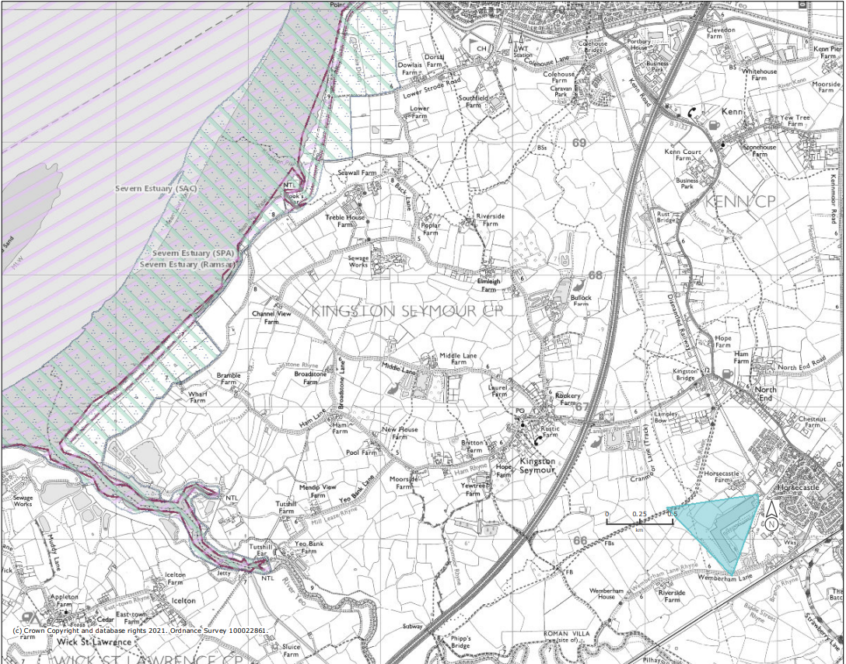
Figure 1. (Magic Maps data set, accessed 08.06.2021) Blue areas encompasses the SMART Yatton site, showing the relation of the site to the Severn Estuary. SAC designations are identified by purple hatched areas; SPA are highlighted by blue dotted areas and Ramsar sites are identified by green hatched areas.

The Yatton site is located within 3km of three SSSI’s with two other SSSI’s within 5km.
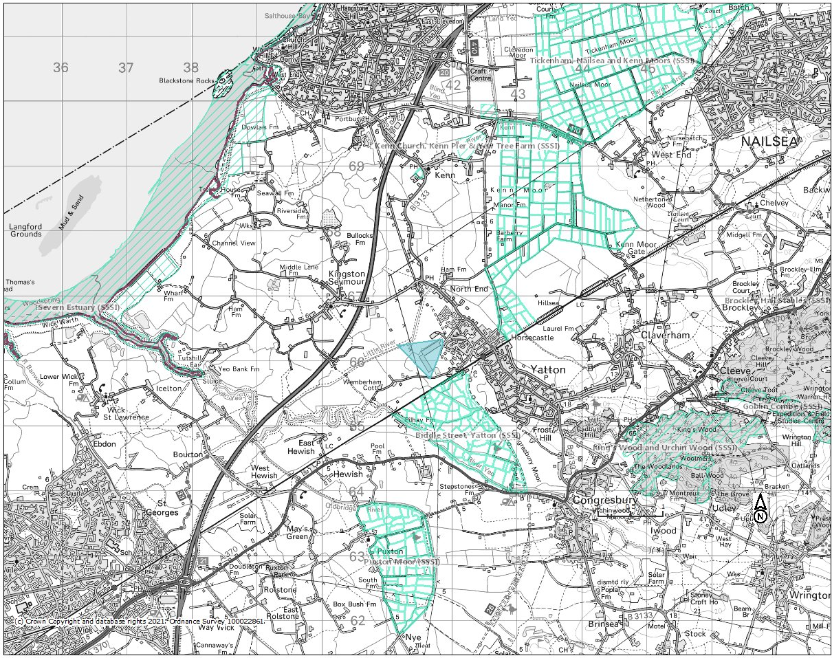
Figure 2. (Magic Maps data set, accessed 08.06.2021) SSSI sites are highlighted by green lined areas, site is encompassed by blue area.

SSSI | Distance from Site | Potential Pollution Streams
Biddle Street Yatton | ~1.5km
Tickenham, Nailsea and Kenn Moors | ~3km
Puxton Moor | ~3.2km
Kenn Church, Kenn Pier and Yew Tree Farm | ~3.3km
Kings Wood and Urchin Wood | ~4.4km
Severn Estuary | ~4.6km | Little River
Table 1. (Magic Maps data set) SSSI within 5km of the site
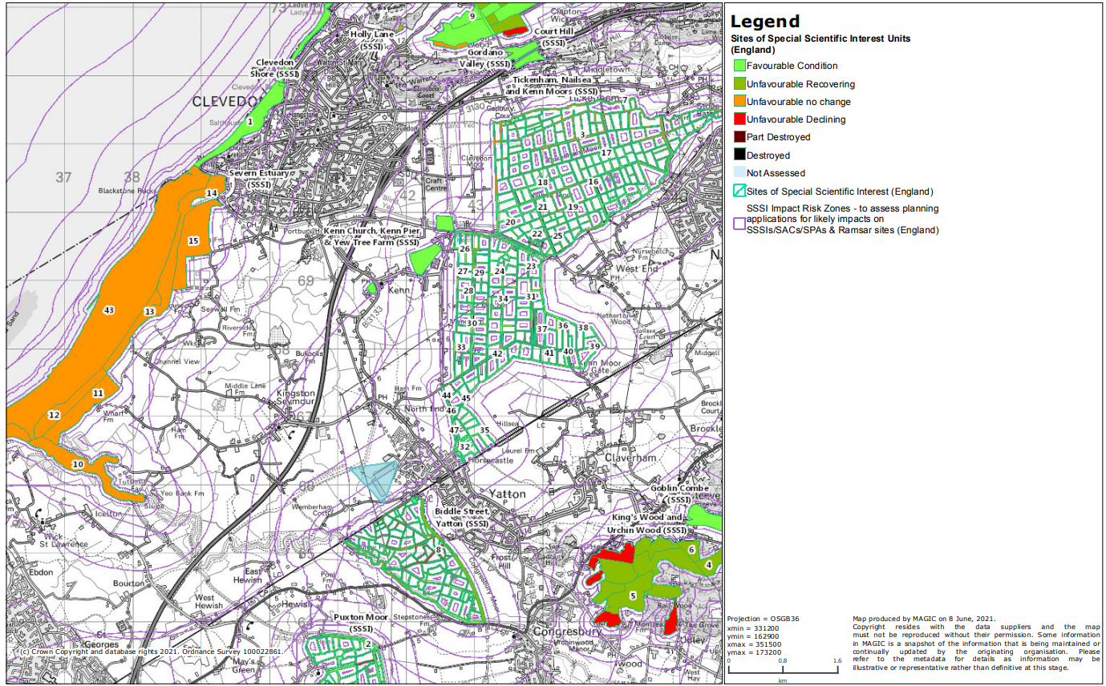
Figure 3. (Magic Maps data set, accessed 08.06.2021) Condition of SSSI and Impact zones surrounding them

Biddle Street Yatton SSSI and King’s Wood and Urchin Wood SSSI have proportions of the sites that are in unfavourable declining conditions. Meaning these areas may be more sensitive to a pollution event if one occurred. The site is within some of the immediate impact zones of the Biddle Street SSSI. The impact of Smart’s upon the Biddle Street SSSI was stressed within a 2012 Environmental Impact Assessment.
The site is located within lower priority areas for Woodland Priority Habitat/ Woodland Improvement Areas. Despite being within a low priority area, future development programmes should continue to consider effects on woodland habitat and provide suitable woodland protection strategies.
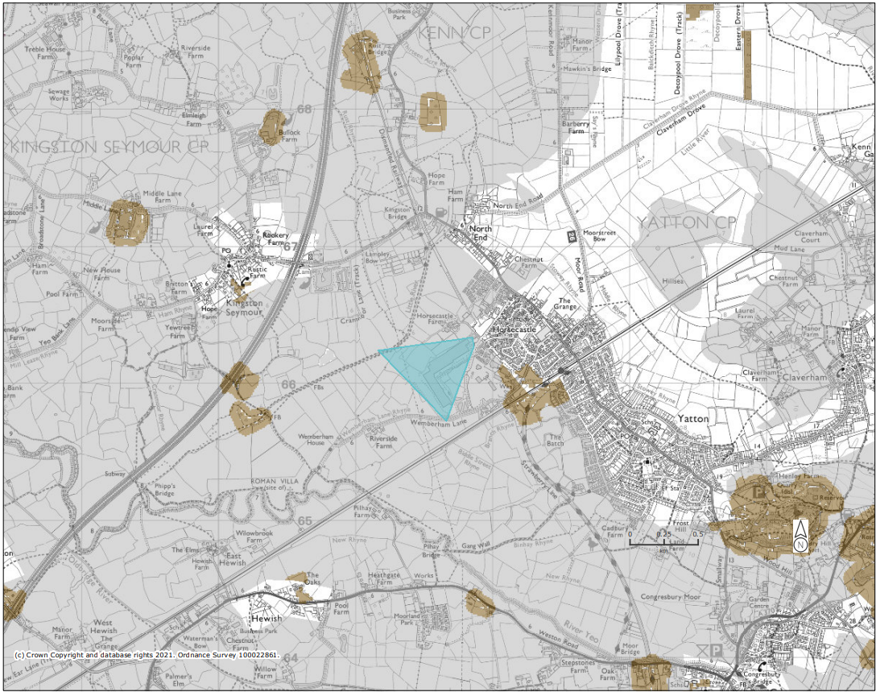
Figure 4. (Magic Maps data set, accessed 08.06.2021) Woodland Priority Habitat Network (England) & Woodland Improvement (England) where brown areas are high spatial priority and grey areas are low.

The site is within Farm Wildlife Package Areas, this is designed to help boost biodiversity in highly agricultural/ monoculture areas. Maintaining hedgerow around the site’s perimeter boosts biodiversity, provides wildlife corridors and can be effective in capturing carbon.
The site aims to maintain existing hedgerows and planting additional native/local species were names as a boundary treatment (Tree survey, 2012). The visual impact of the site is protected from general view by hedges. The biodiversity ecology assessment .

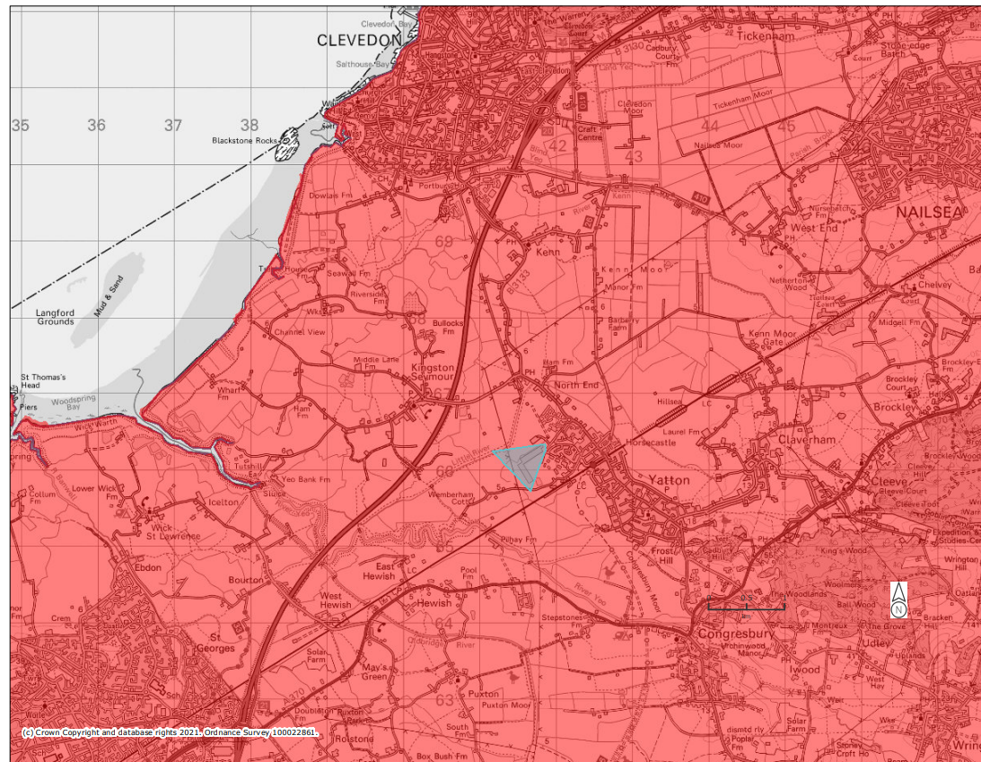
Figure 5. (Magic Maps data set, accessed 08.06.2021) Farm Wildlife Package Areas as highlighted in red.

The Lapwing is a priority species whose populations encompass land within 5km of the site. The site is not within such areas that it needs to maintain habitat for lapwings however an awareness of the species should be preserved.
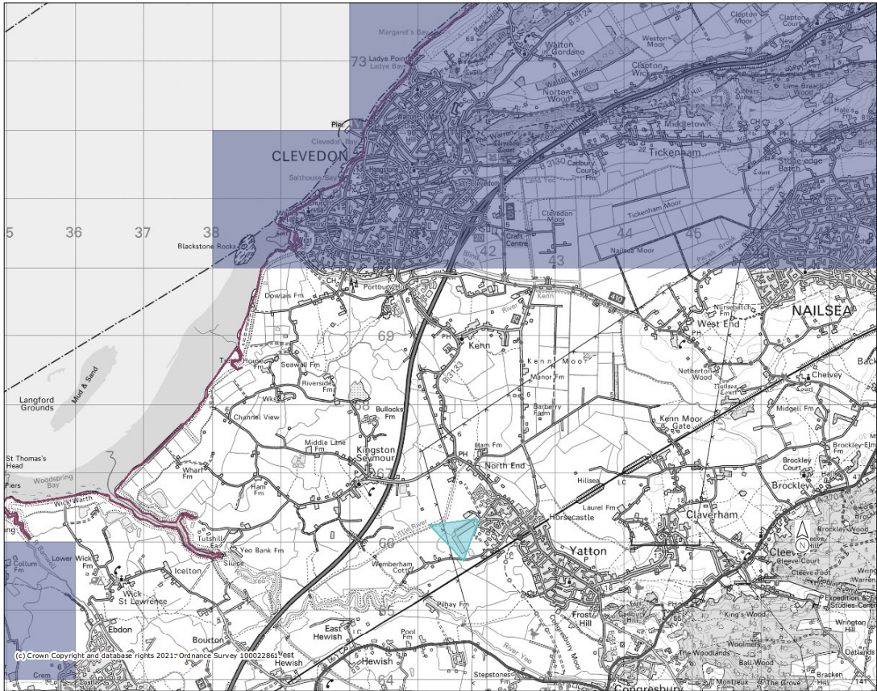
Figure 6. (Magic Maps data set, accessed 08.06.2021) Priority Species for Countryside Stewardship targeting

1.2 Water

Smart systems is located within medium priority areas for countryside stewardship of water quality.
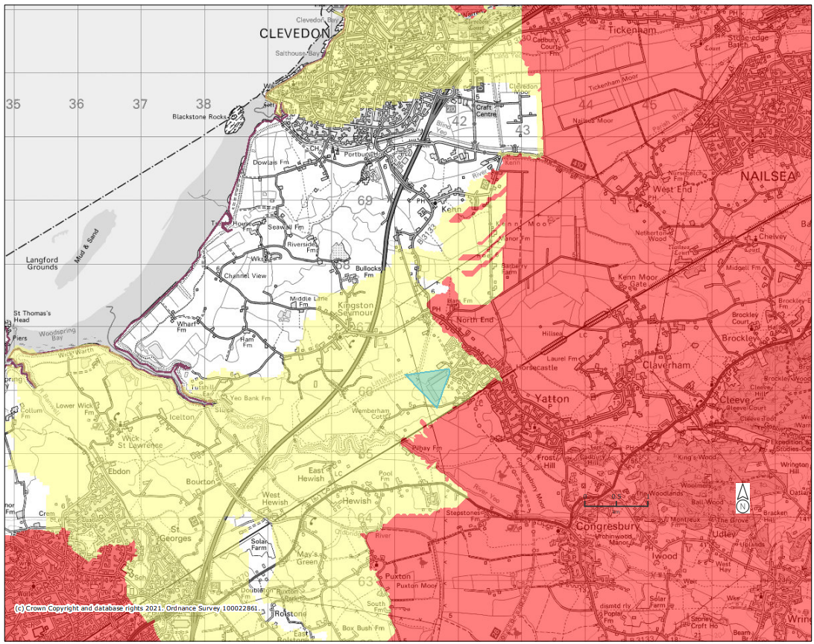
Figure 7. (Magic Maps data set, accessed 08.06.2021) Countryside Stewardship Water Quality Priority Areas (England) where red areas are high priority and yellow areas are medium priority.

The site is within CS medium priority areas for Surface water nitrate issues, sediment issues and phosphate issues.
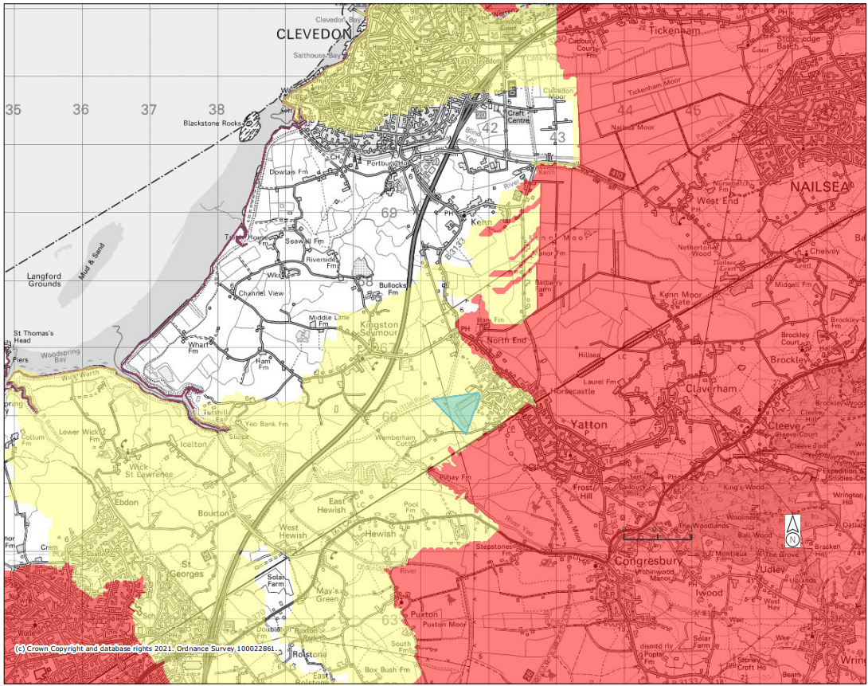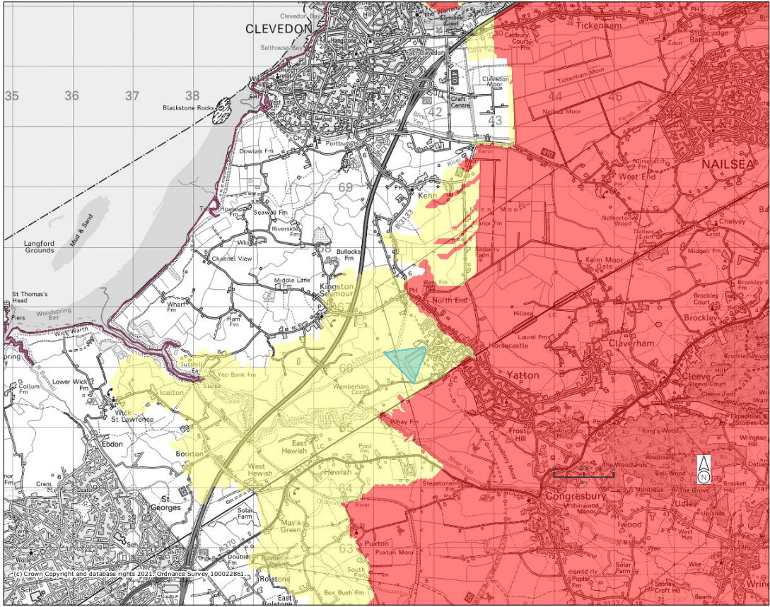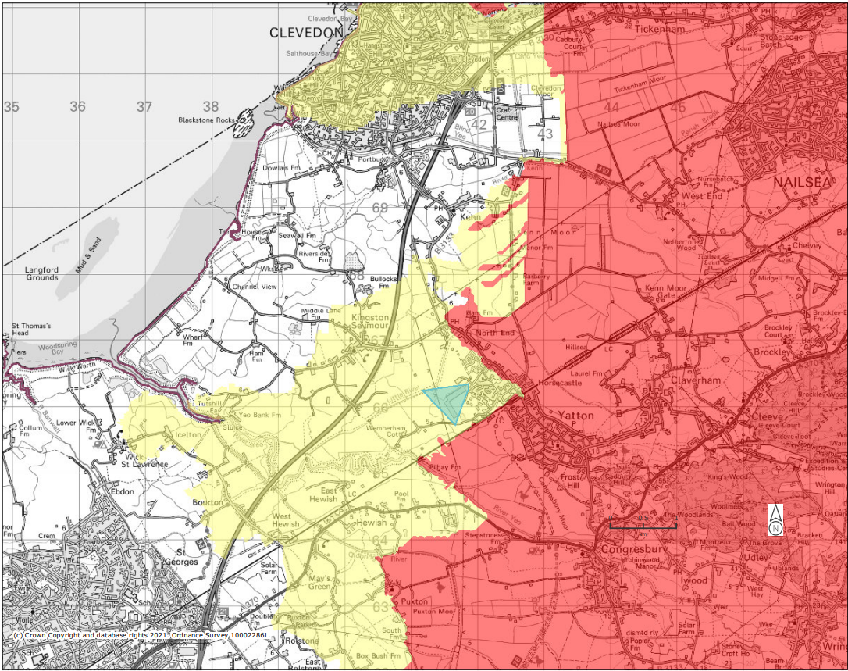
Figure 8. (Magic Maps data set, accessed 08.06.2021) 8.a Surface Water Nitrate Issues 8.b Sediment Issues 8.c Phosphate issues. Where red areas are high priority and yellow areas are medium priority.

There are no surface water or groundwater issues with pesticides within the area of the site. The site is not within priority areas for faecal indicator organism issues.
The site is within high priority areas for flood risk management therefore appropriate management systems are expected to be in place. In the Environment Agency Flood Map SMART’s located within flood zones 2 & 3.
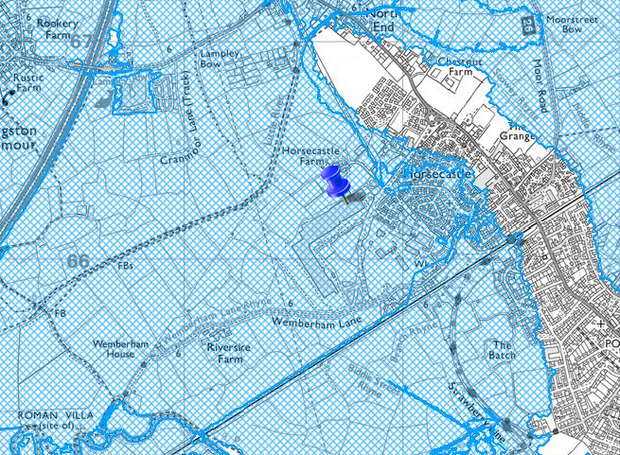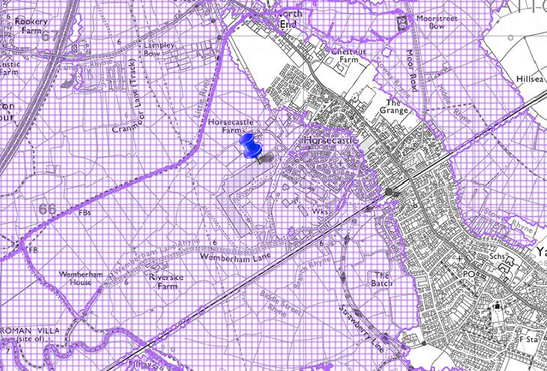
Figure 9 (Aurora, accessed 29.06.2021) 9a. Environment Agency Flood Zone 2 highlighted by blue hatched areas. 9b. Environment Agency Flood Zone 3 highlighted by purple hatched areas.

The site has sufficient flood mitigation strategies to mitigate worst case scenario flooding. Smart uses a service yard that has slight falls towards a recessed drainage channel,the use of a balancing pond, the external Rhyne drainage system and internal drainage system to mitigate against flooding.
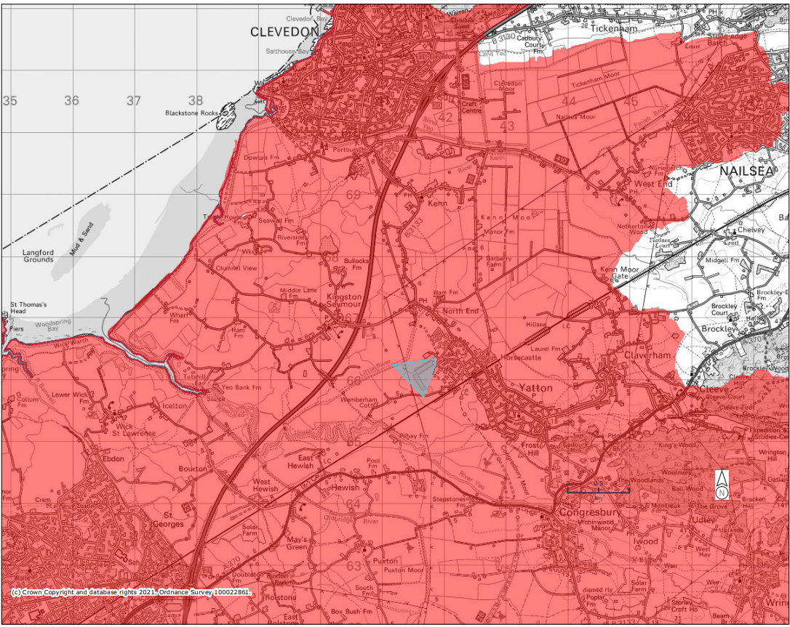
Figure 10. (Magic Maps data set, accessed 08.06.2021) Flood Risk Management Priorities (England) where red areas are high priority and yellow areas are medium priority.

The site is also within lower spatial priority areas for woodland water quality.
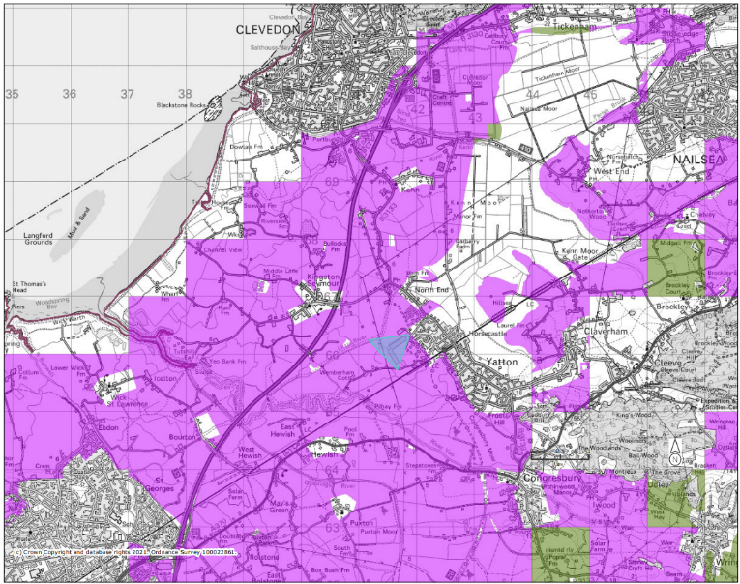
Figure 11. (Magic Maps data set, accessed 08.06.2021) Woodland Water Quality (England) where green areas are high spatial priority and purple areas are lower spatial priority.

1.3 Cross Cutting

Cross cutting is a term given to an action/ project that may improve more than one social, economic, or environmental issue.

1.3.1 Keeping Rivers Cool

Keeping Rivers Cool is an initiative that aims to maintain a healthy temperature for rivers in order to sustain ecosystems and human water resources. Trees are planted on riverbanks to provide shade onto the river whilst helping to mitigate against river bank erosion.
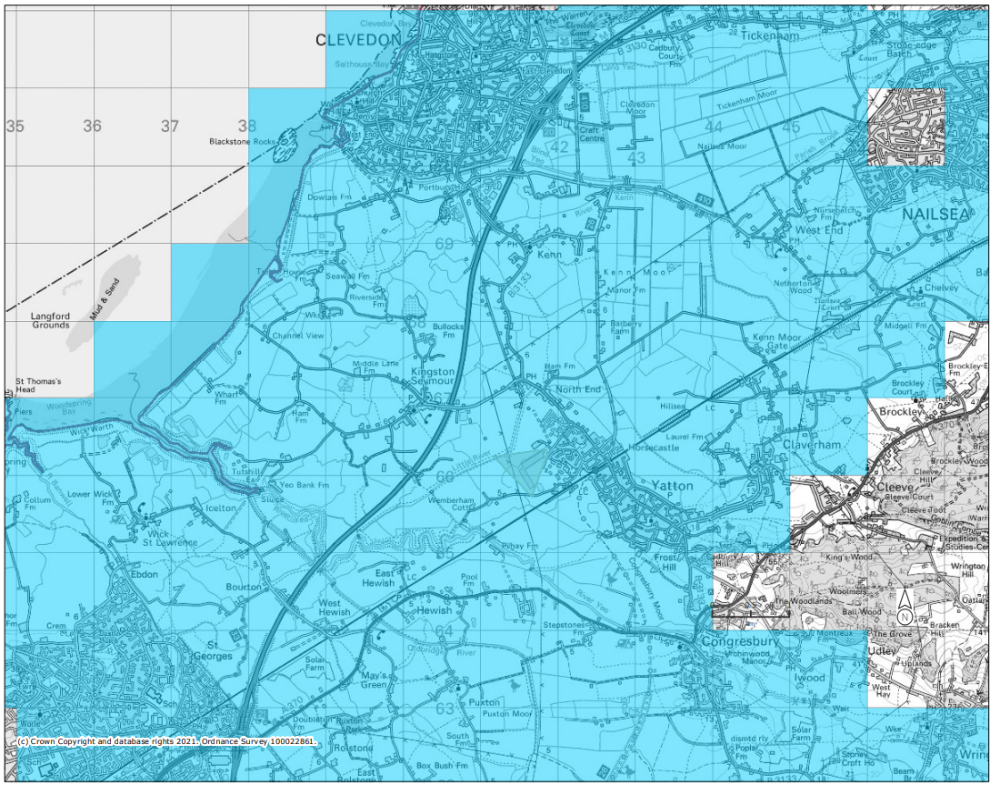
Figure 12. (Magic Maps data set, accessed 08.06.2021) Keeping Rivers Cool (England) where blue areas show the extent of the project.

1.3.2 Community Forest

Community Forest projects aim to provide urbanised areas with more forest/trees and thus boost biodiversity within such areas.
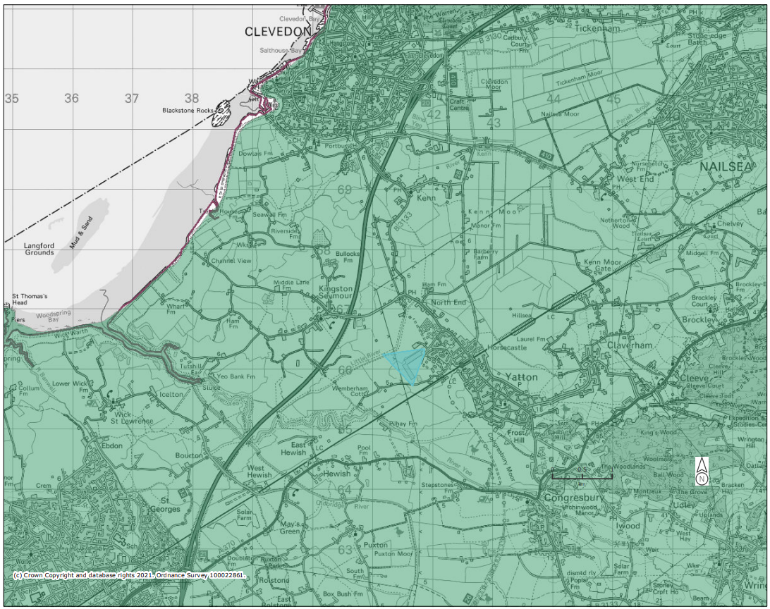
Figure 13. (Magic Maps data set, accessed 08.06.2021) Community Forests (England) where green areas show the extent of the project.

1.4 Historic Environment

There are multiple scheduled monuments within 5km of the site, however there are no registered battlefields, parks, or gardens.
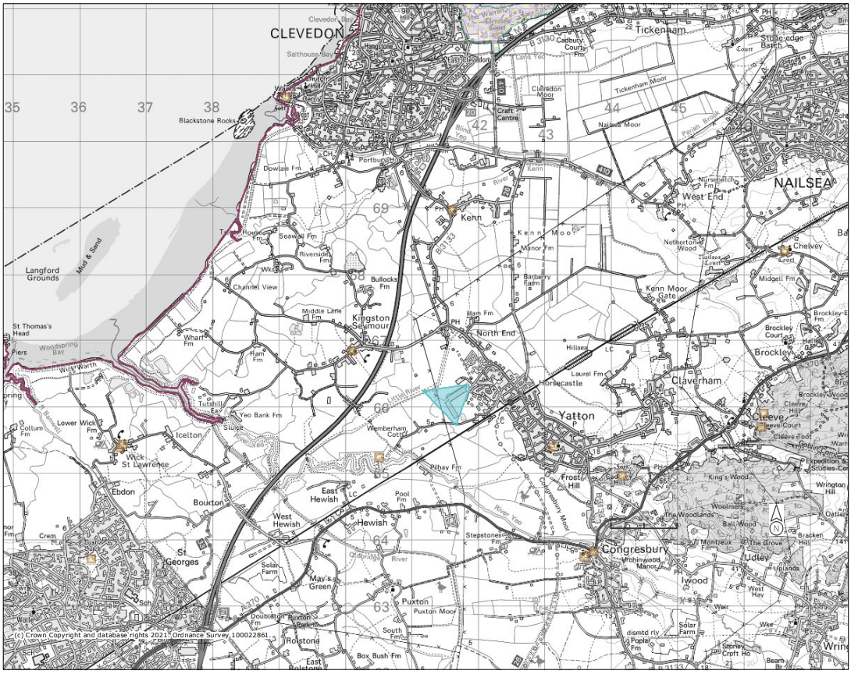
Figure 14. (Magic Maps data set, accessed 08.06.2021) Scheduled Monuments (England) where yellow boxes are points of monuments.

Table 2. (Magic Maps data set) Scheduled Monuments within 5km of the site.
Scheduled Monuments | Reference Number | Distance from Site
Minor Romano- British villa | 1011262 | ~1.5km
Churchyard cross | 1015509 | ~1.6km
Univallate hillfort | 1011258 | ~2.8km
Churchyard cross | 1015515 | ~2.9km
Churchyard cross | 1015506 | ~3.1km
Congresbury Village cross | 1015505 | ~3.1km
Univallate hillfort | 1011263 | ~4.7km
Univallate hillfort and settlement | 1011264 | ~4.7km

The majority of listed buildings surrounding the environment are grade II.
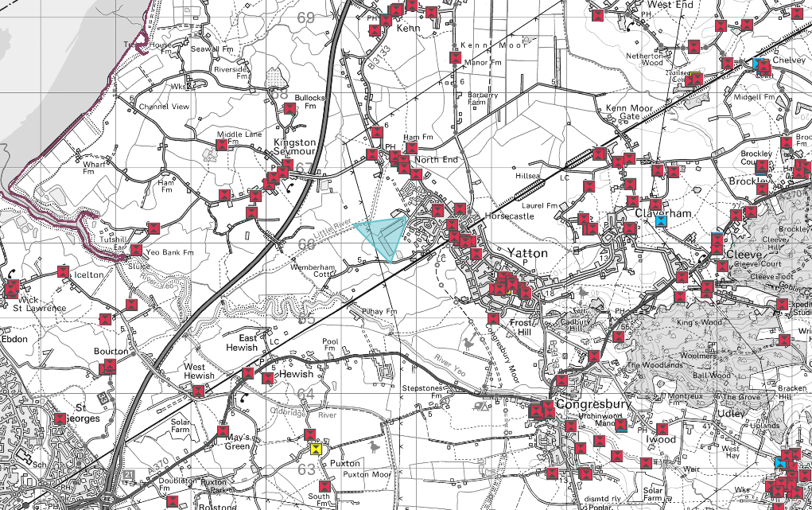
Figure 15. (Magic Maps data set, accessed 08.06.2021) Listed buildings (England) where yellow points are grade I listed buildings, red points are grade II listed and blue boxes are grade III listed buildings.

1.5 Landscape

The site is within a distinct National Character Area in relations to landscape features within the areas.
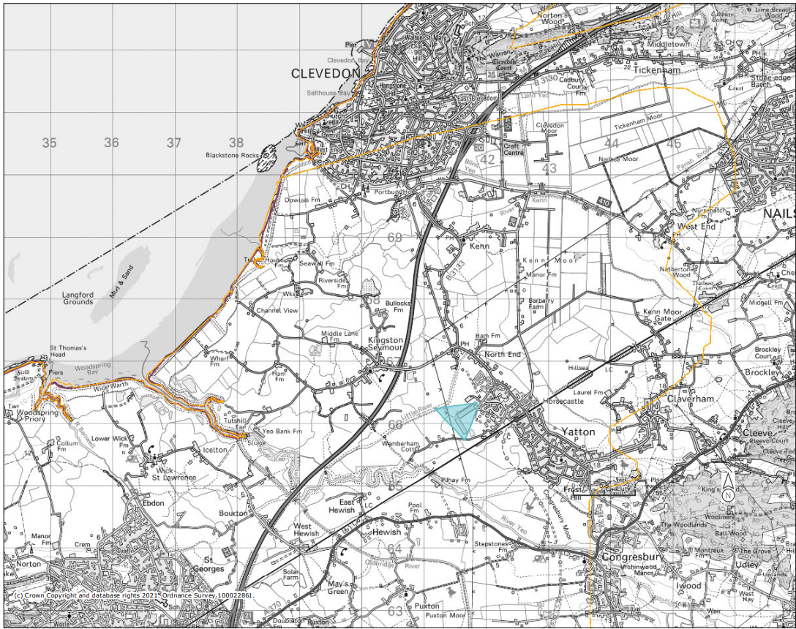
Figure 16. (Magic Maps data set, accessed 08.06.2021) National Character Area Level Landscape Features (England) where yellow lines show landscape features.

The site is within 5km of multiple priority areas for Traditional Orchids, one orchid is connected to the site by Little River.
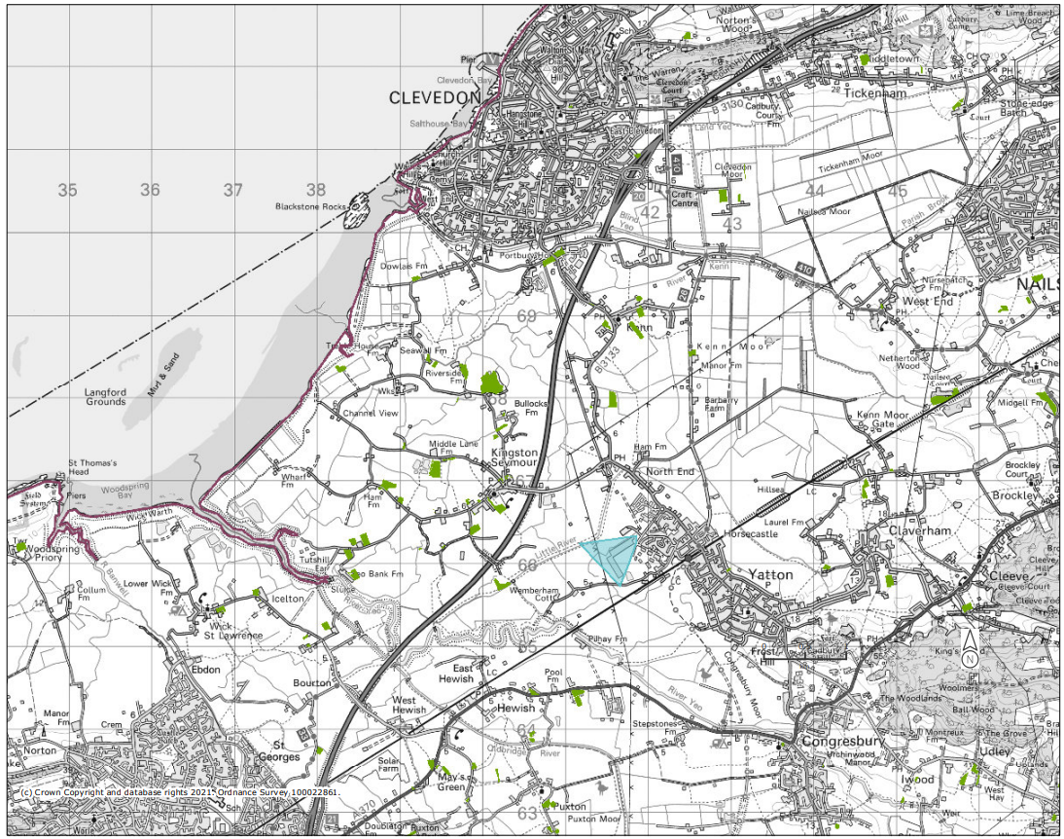
Figure 17. (Magic Maps data set, accessed 08.06.2021) Priority Habitat Inventory- Traditional Orchards (England) highlighted by the green areas on map.

1.6 Tree Preservation Orders

There are no TPOs within the area of the site.
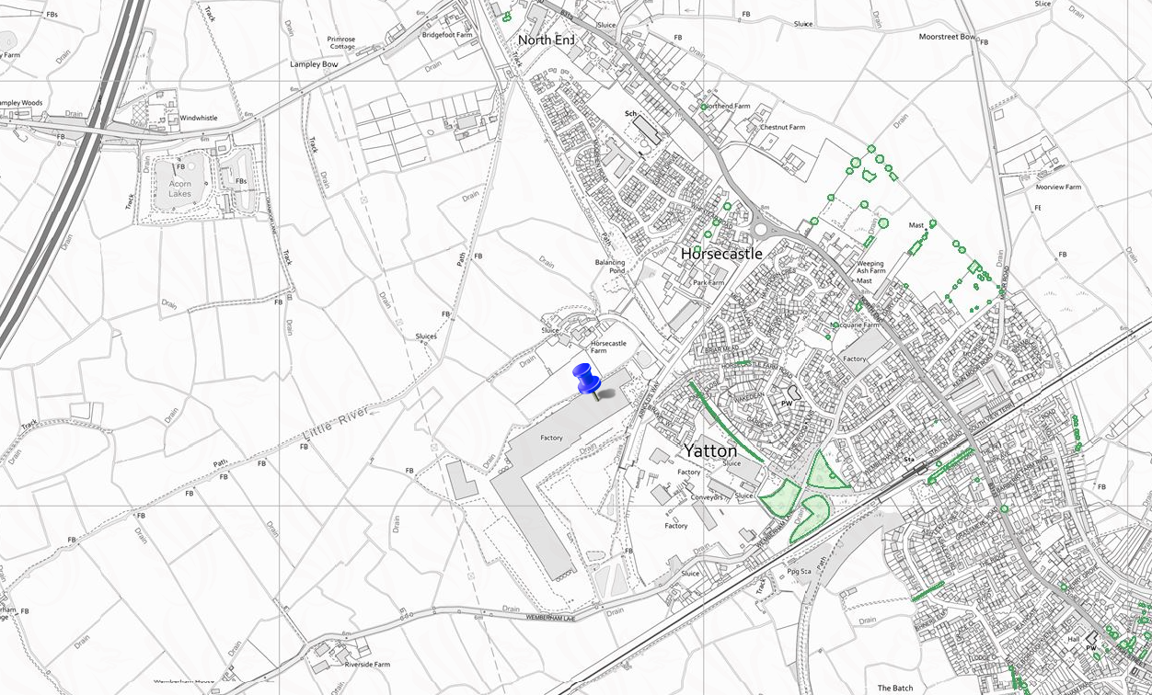
Figure 18. (Aurora data set, accessed 09.06.2021) Tree Preservation Orders within the area as highlighted by green areas.

1.7 Climate Change Vulnerability

The site is located within a medium climate change vulnerability buffer.
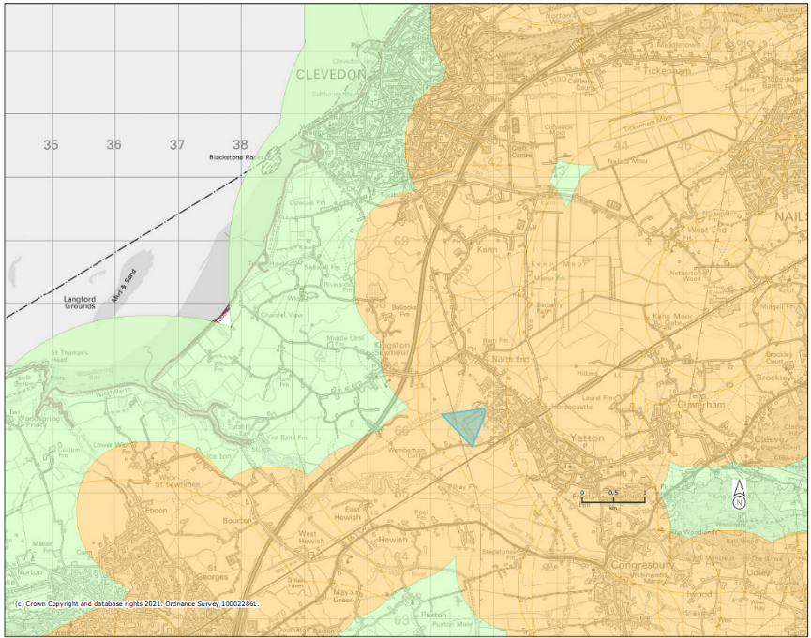
Figure 19. (Magic Maps data set, accessed 08.06.2021) Climate Change Vulnerability Buffer (England) where green areas are low and orange areas are medium vulnerability.

Refugia areas are designated places which will likely be immune to climate change, either due to sea level rise or warming effect. The site is within refugia areas and is just outside of areas that are sensitive to ammonia pollution.
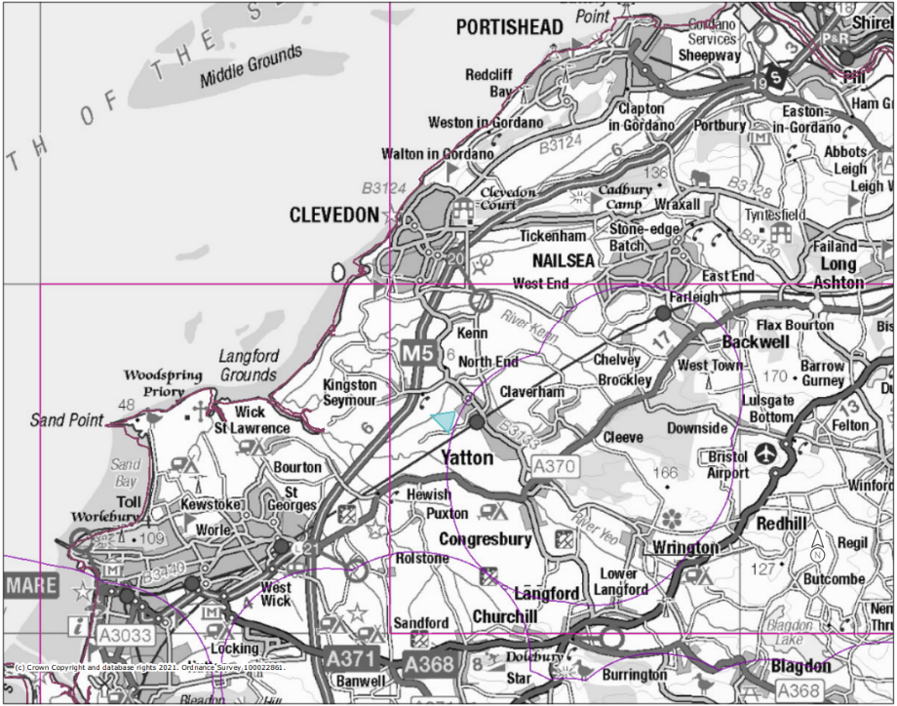
Figure 20. (Magic Maps data set, accessed 08.06.2021) Refugia areas are depicted within pink cuboids. Areas Sensitive to Ammonia Pollution are depicted within purple spheres.

Table 3. (ArcGIS, National Trust & 3KEEVS data set) Changes in exposure to climate related risks on site, from 2020 to 2060.

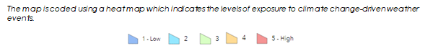
Overheating and Humidity | 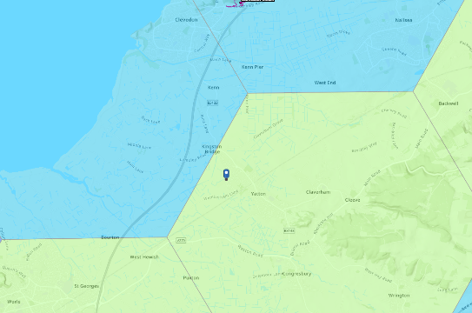 | 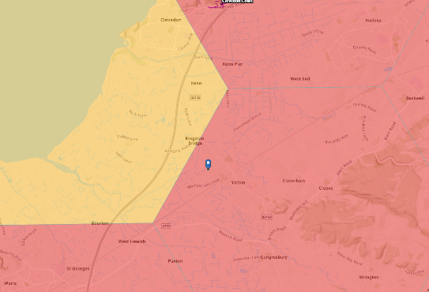
Storm Damage | 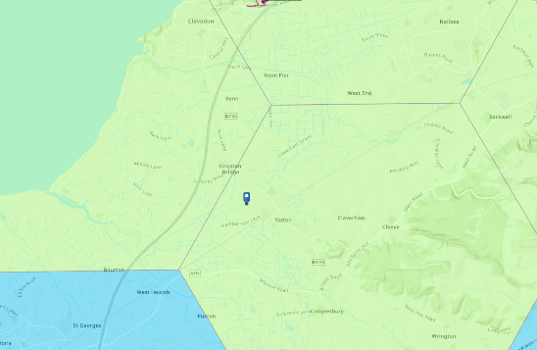 | 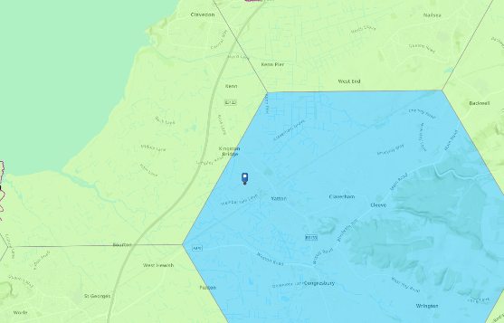
Slope Failure | 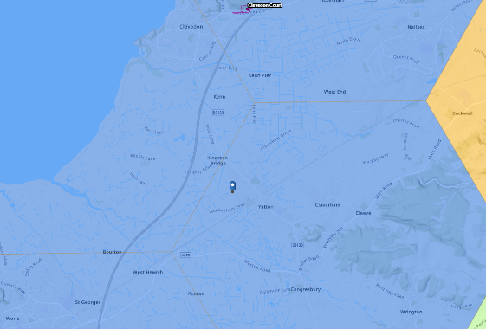 | 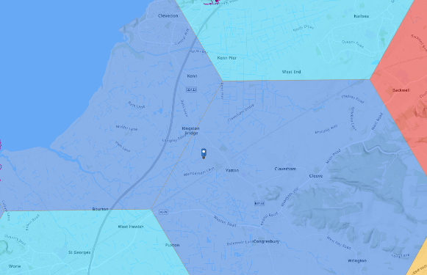
Soil Heave | 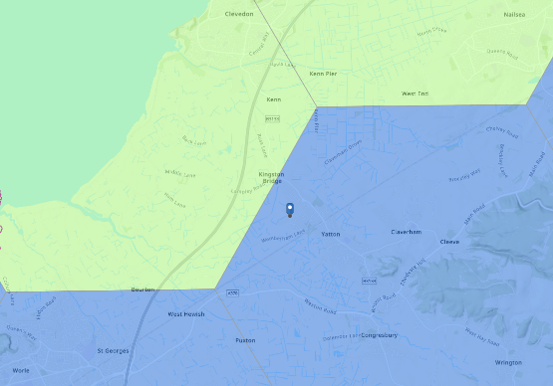 | 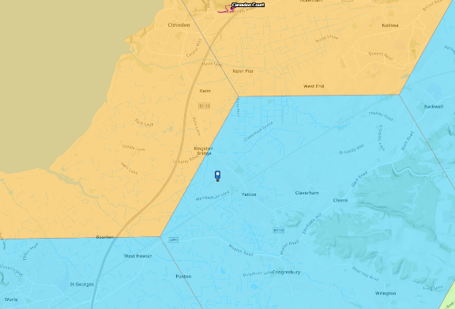

The site area does not show dramatic changes in Soil Heave, Soil Failure or Storm Damage. The most noticeable effect on the site area by 2060 will be overheating and humidity, from medium to high levels of exposure. This may have an effect on how much water can be consumed, availability of water from water abstraction may reduce by 2030.

2. Designations

There are multiple Local Nature Reserves within 5km of the site, Cheddar Valley Railway Walk is the closest to the site. The site runs downstream of the LNR however it may be of importance to know how they operate or what species they are focused on conserving in order to avoid conflict. Furthermore, there is an LNR in action on Severn Estuary which is wear surface water run off will be directed to from the site.
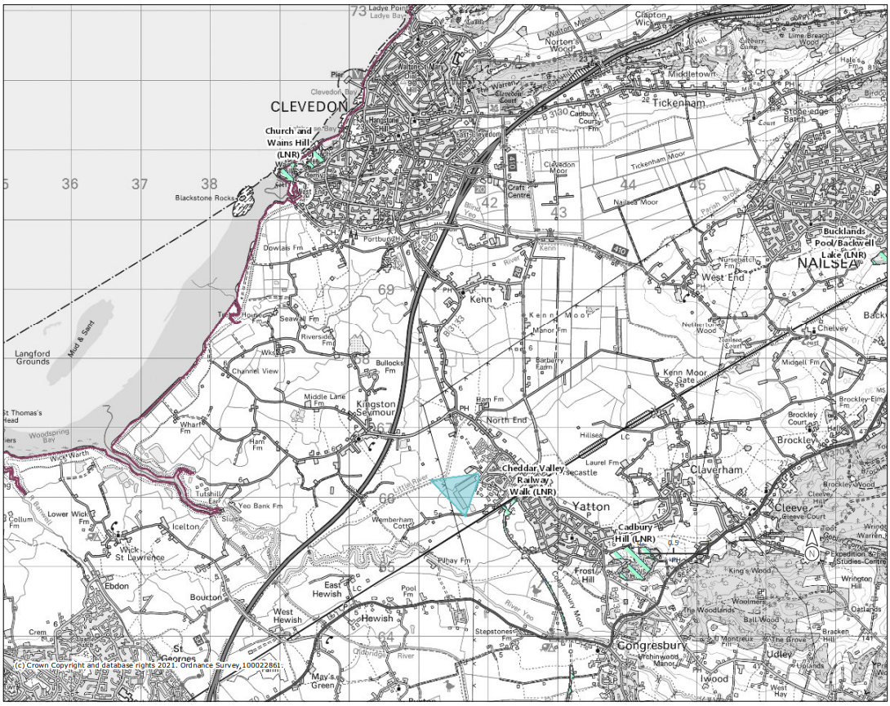
Figure 21. (Magic Maps data set, accessed 08.06.2021) Local Nature Reserves (England) highlighted in turquoise hatched areas.

The site is located within 5km of the North Somerset & Mendip Bats SAP, as bats are a protected species this may have planning implications. *See Mammal Species
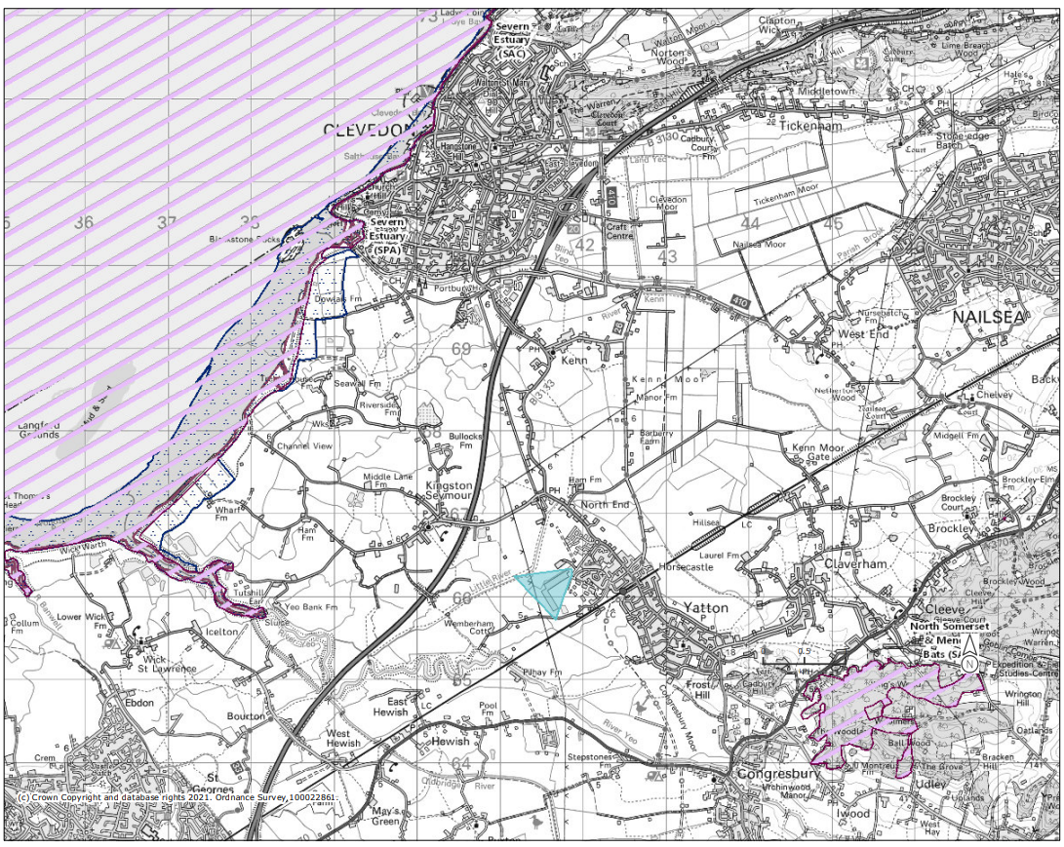
Figure 22. (Magic Maps data set, accessed 08.06.2021) Special Areas of Conservation (England) highlighted in purple hatched areas.

3. Habitats and Species

3.1 Habitats

The site area is characterised by coastal and floodplain grazing habitats but may influence priority coastal, woodland, or marine habitats.

3.1.1 Coastal
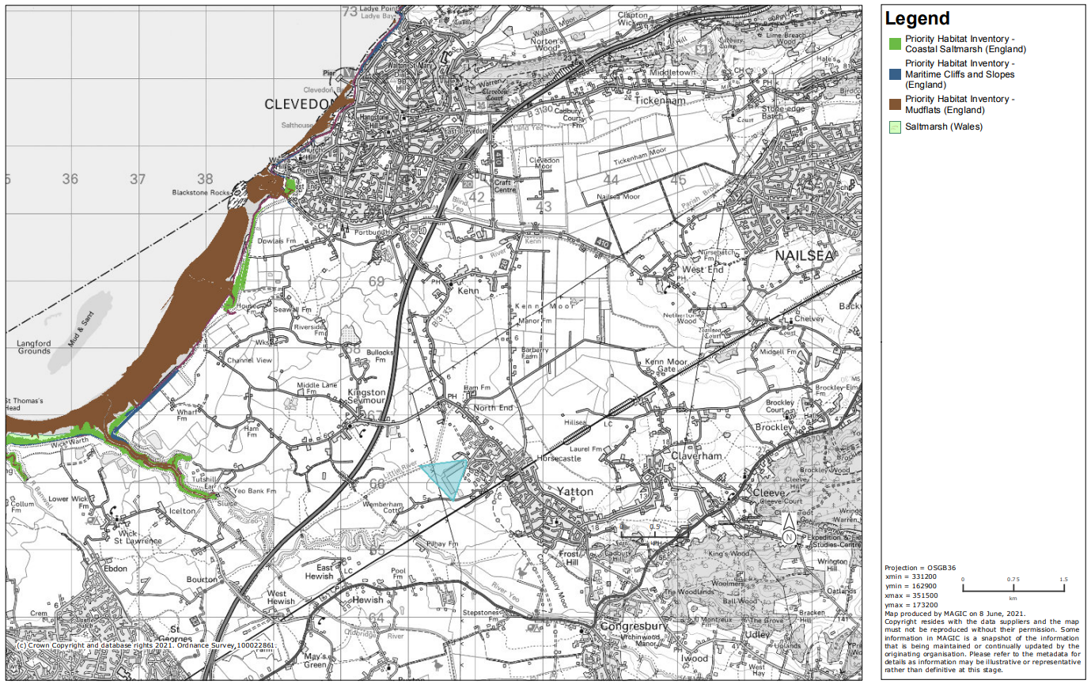
Figure 23. (Magic Maps data set, accessed 08.06.2021) Priority Habitat Inventory- Coastal habitats (England)

3.1.2 Grassland
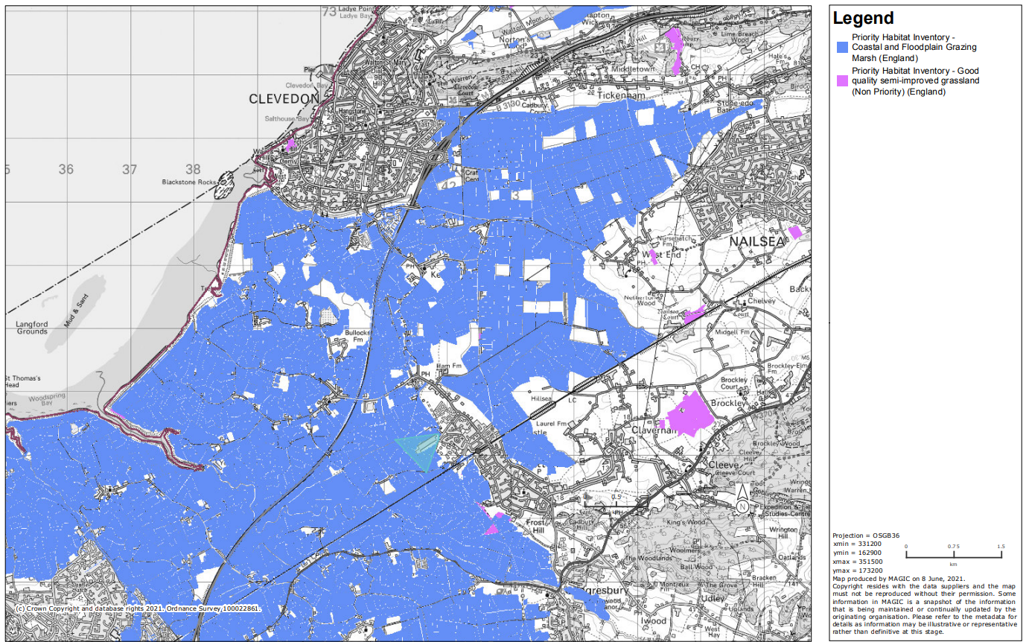
Figure 24. (Magic Maps data set, accessed 08.06.2021) Priority Habitat Inventory- Grassland habitats (England)

3.1.3 Heathland

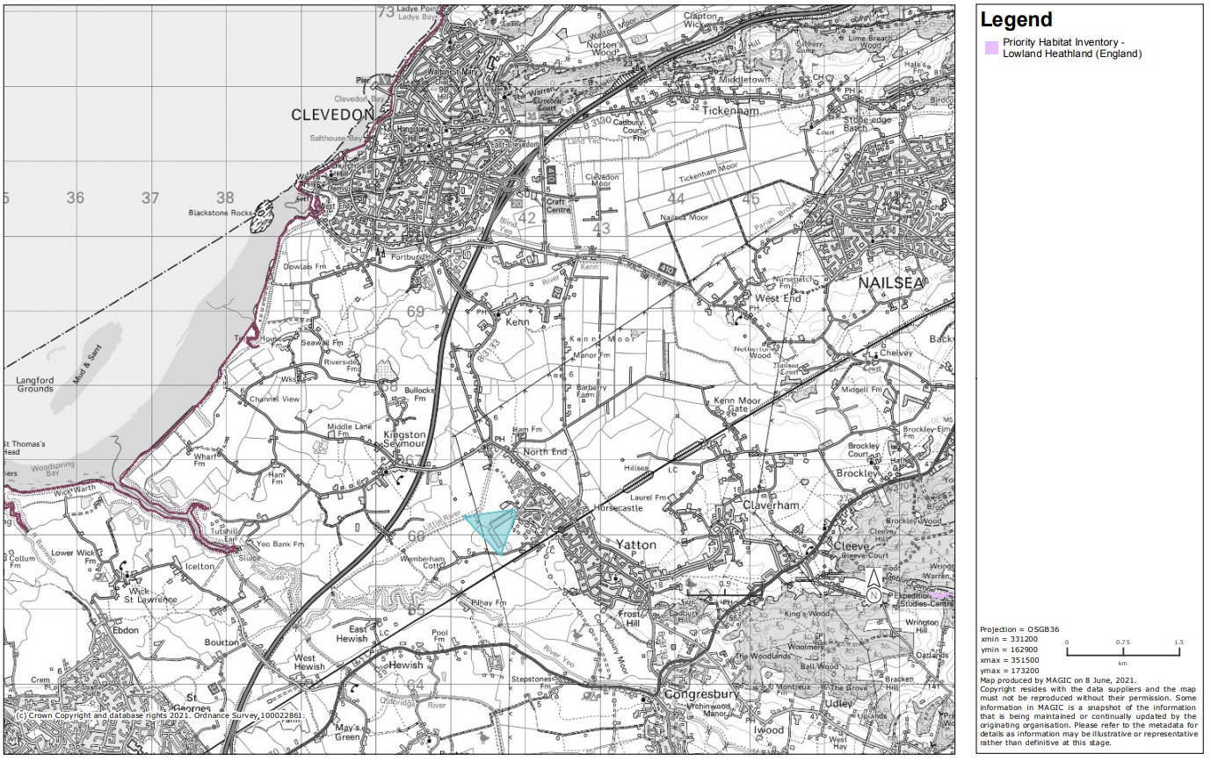
Figure 25. (Magic Maps data set, accessed 08.06.2021) Priority Habitat Inventory- Heathland habitats (England)

3.1.4 Marine

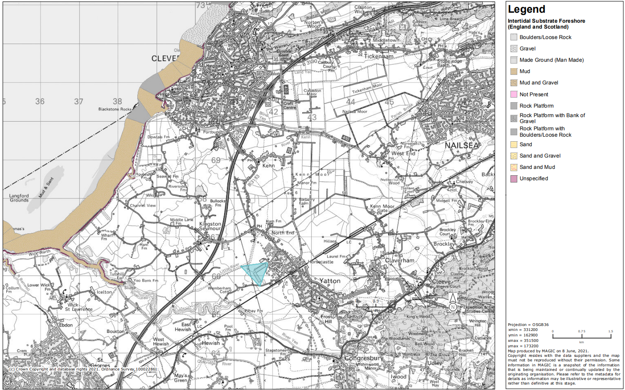
Figure 26. (Magic Maps data set, accessed 08.06.2021) Priority Habitat Inventory- Marine habitats (England)

3.1.5 Woodland
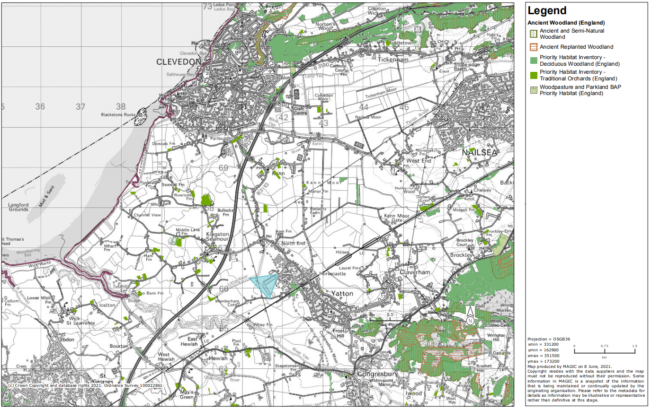
Figure 27. (Magic Maps data set, accessed 08.06.2021) Priority Habitat Inventory- Woodland habitats (England)

3.2 Species

There are no estimated conflicts between the area of the site and protected species.

3.2.1 European Protected Species

Most species applications within the area are granted in relation to bats, with one being cetacean application being granted.
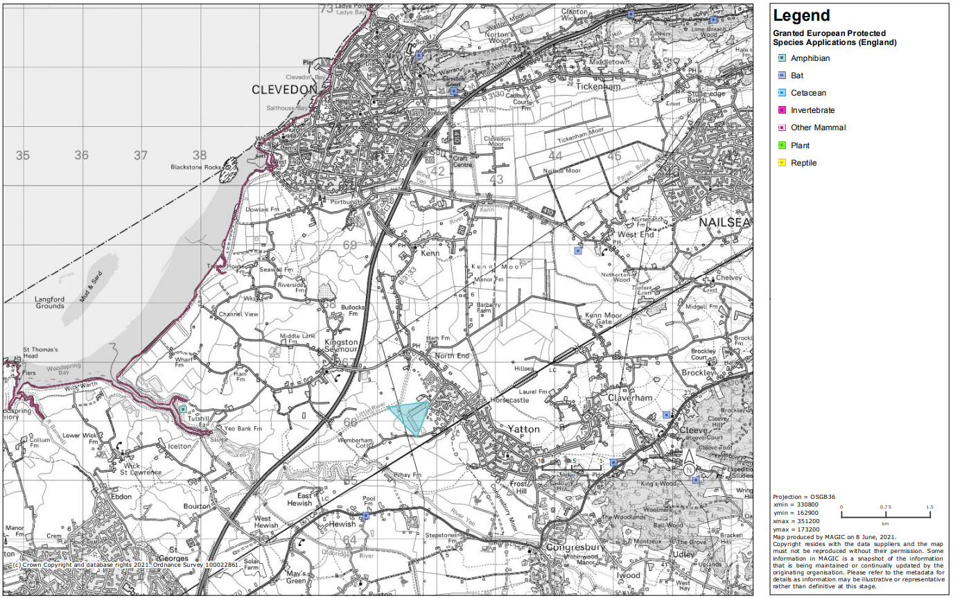
Figure 28. (Magic Maps data set, accessed 08.06.2021) Granted European Protected Applications (England)

3.2.2 Bird Species

The site is not within any countryside stewardship habitat restrictions in protection of any wild bird, although it is within 5km of CS priority habitat for the redshank and lapwing.
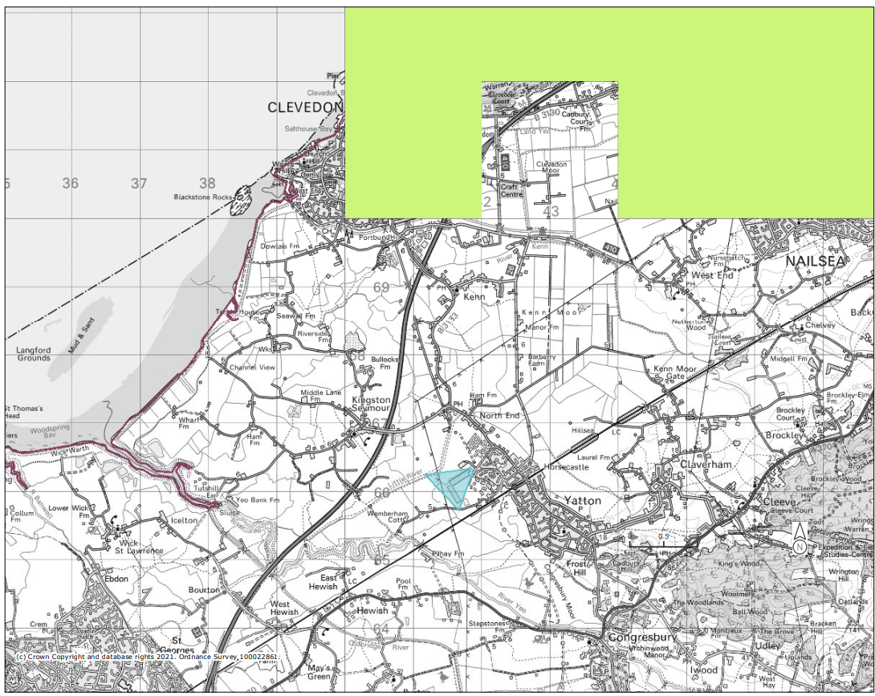
Figure 29. (Magic Maps data set, accessed 08.06.2021) CS Priority Habitat- Redshank (England) highlighted by lime areas.

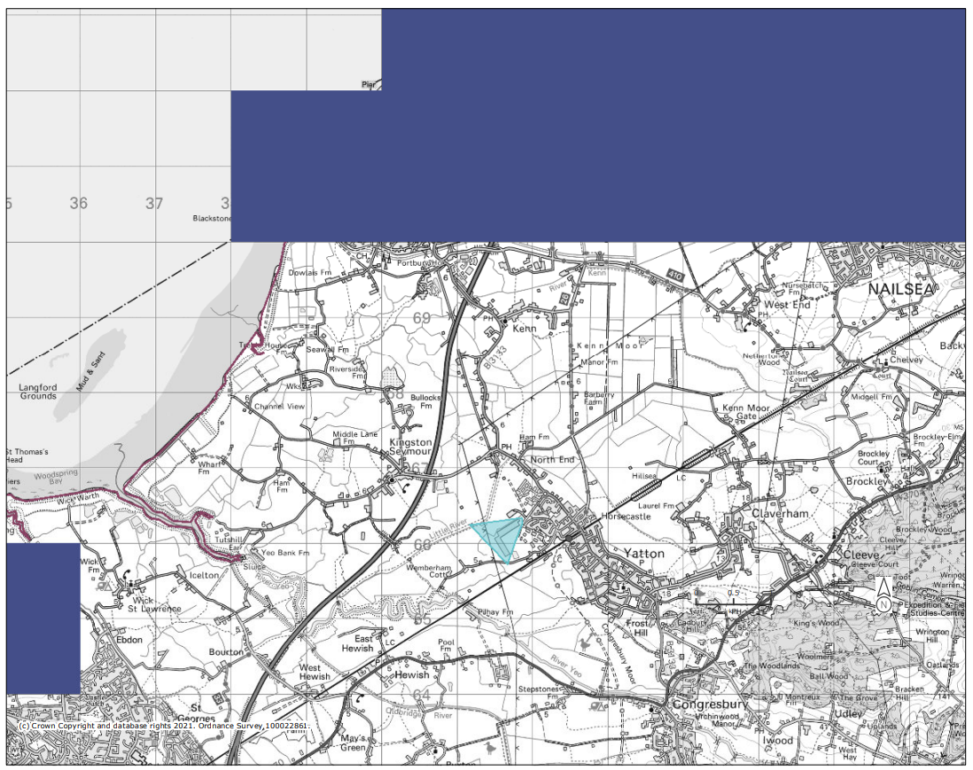
Figure 30. (Magic Maps data set, accessed 08.06.2021) CS Priority Habitat- Lapwing(England) highlighted by dark blue areas.

All wild bird species and their nests and young are legally protected. The site has populations of Lapwings and Grey Partridges around or close to the site.
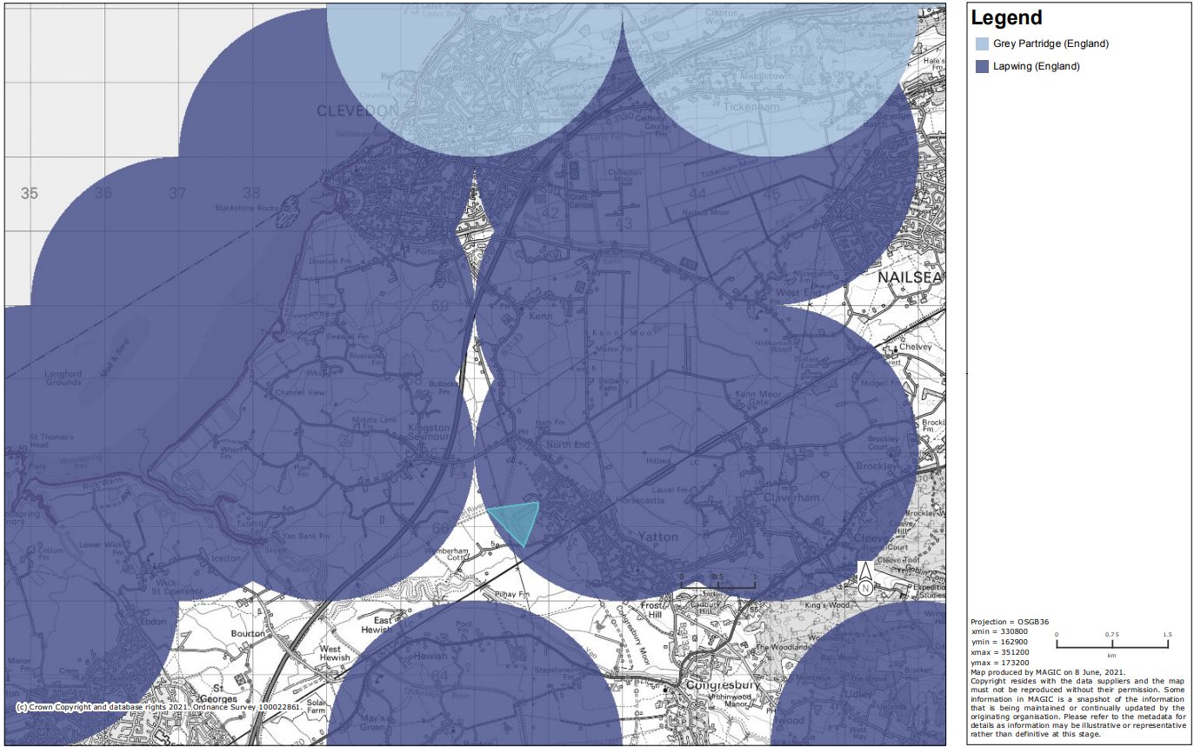
Figure 31. (Magic Maps data set, accessed 08.06.2021) Grey Partridge (England) are highlighted by light blue spheres, areas Lapwings (England) inhabit are shown using blue spheres.

3.2.2 Mammal Species

The site is within “ZONE C for North Somerset and Mendip Bats SAC area consultation zones for Horseshoe bats” meaning the site is of low priority for bat habitat conservation. However, the site should seek advice from an ecological consultant to access whether development could have a major/minor effect on horseshoe bats.
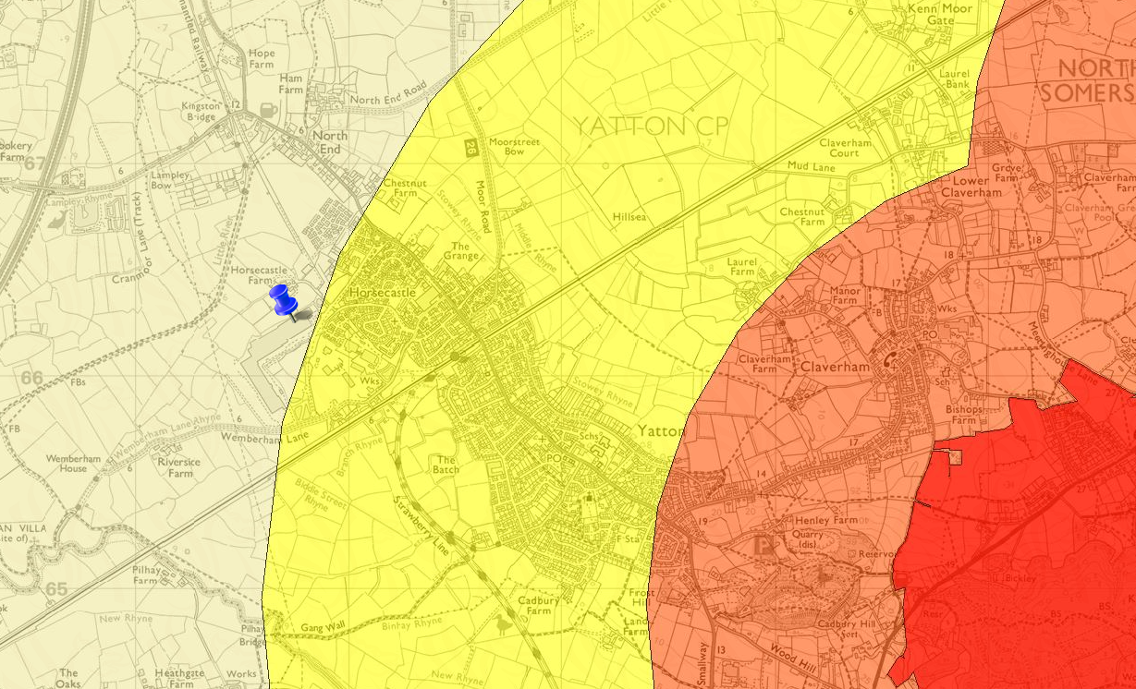
Figure 32. (Aurora data set, accessed 08.06.2021) North Somerset and Mendip Bats consultation Zones. Red areas depict bat SAC sites boundaries. Orange areas show Zone A, yellow Zone B and cream areas are zone C.

3.2.3 Amphibian Species

Ponds that are within an immediate radius of the site show no signs of Great Crested Newt Presence. However, some populations have been recorded within 5km of the site.
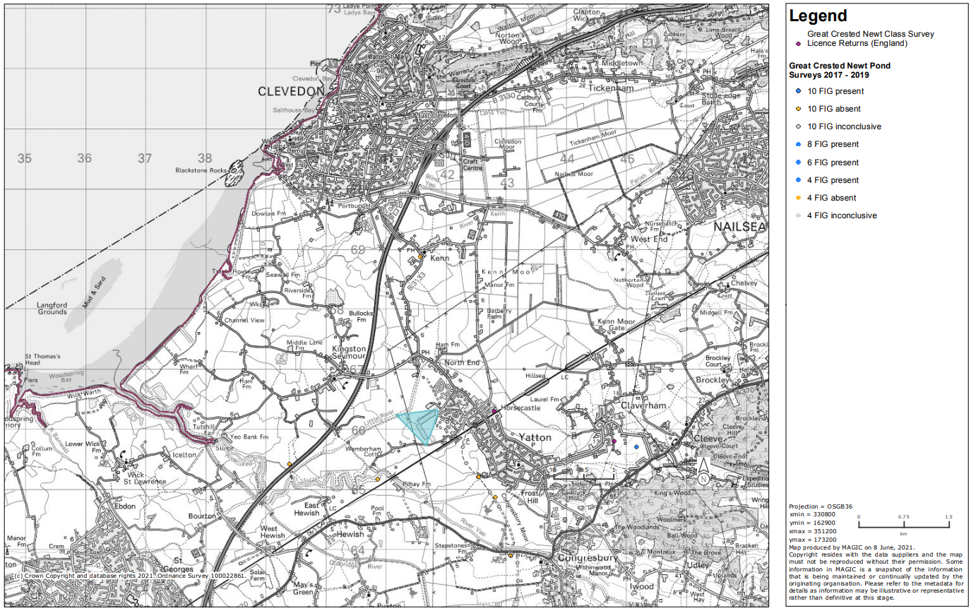
Figure 33. (Magic Maps data set, accessed 08.06.2021) Great Crested Newt Pond surveys 2017-19

3.2.4 Plant Species
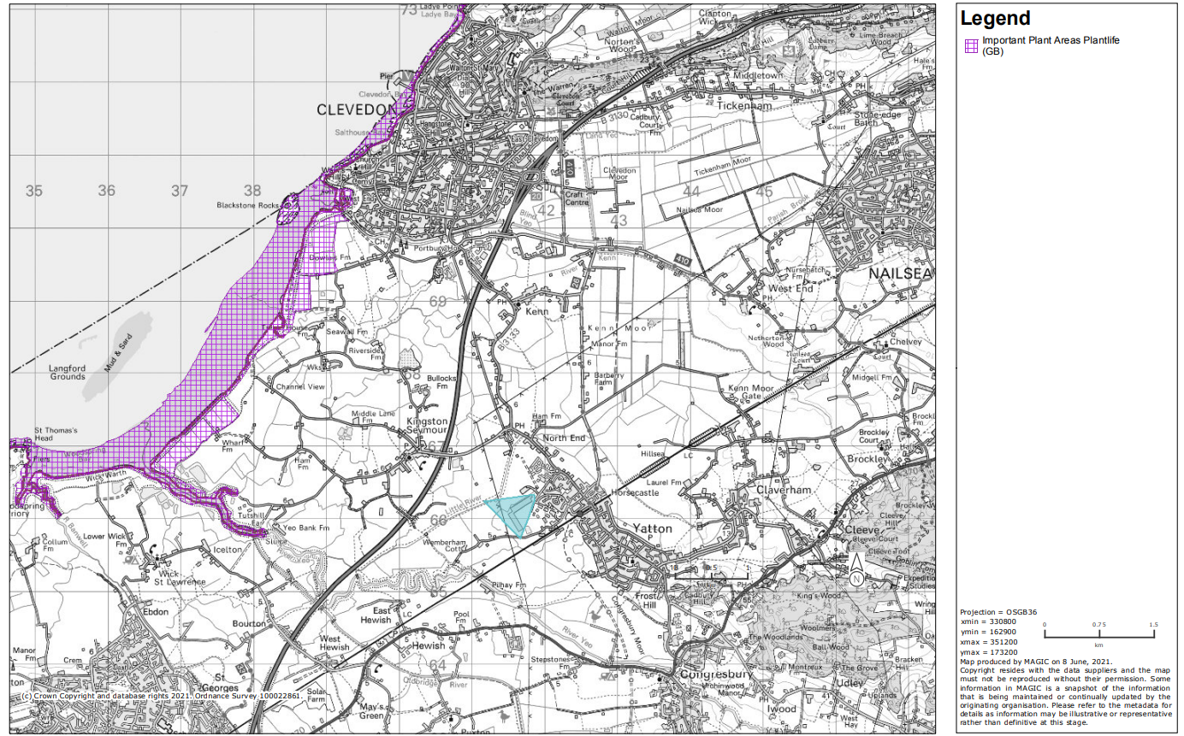
Figure 34. (Magic Maps data set, accessed 08.06.2021) Important Plant Areas (GB)

The Severn Estuary is labelled as an Important Plant Area, such protections heighten the ramifications of a potential pollution incident.

4. Land Based Schemes

4.1 Agri-Environment Schemes
The site is not within countryside stewardship agreement management areas, however some of the land surrounding it is within CS middle tier management areas. The site is adjacent to areas of entry level environmental agreements with higher level stewardship. The South West region is within higher level stewardship themes.
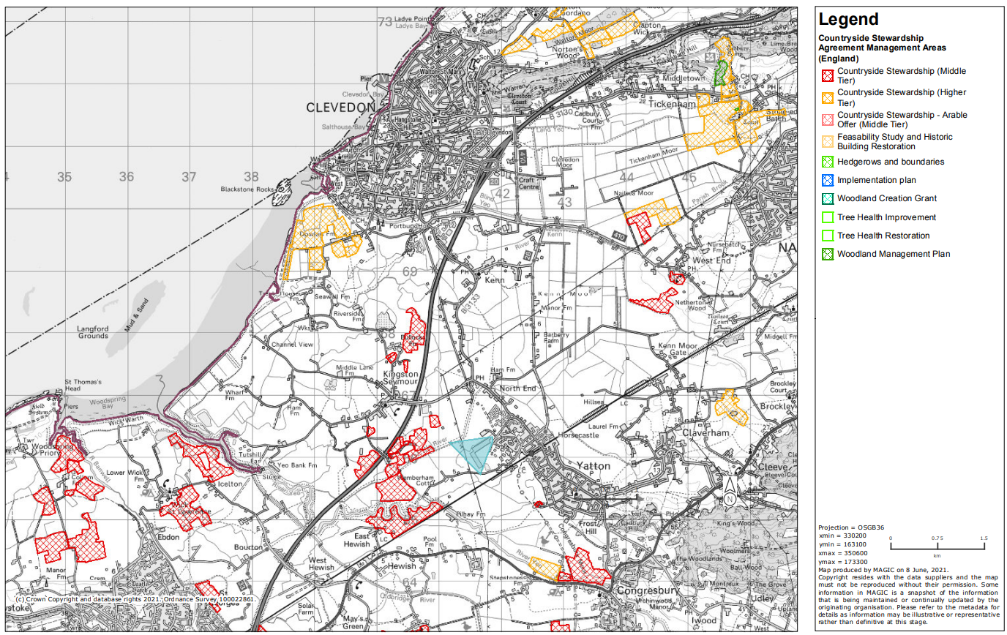
Figure 35. (Magic Maps data set, accessed 08.06.2021) Countryside Stewardship Agreements Management Areas (England)

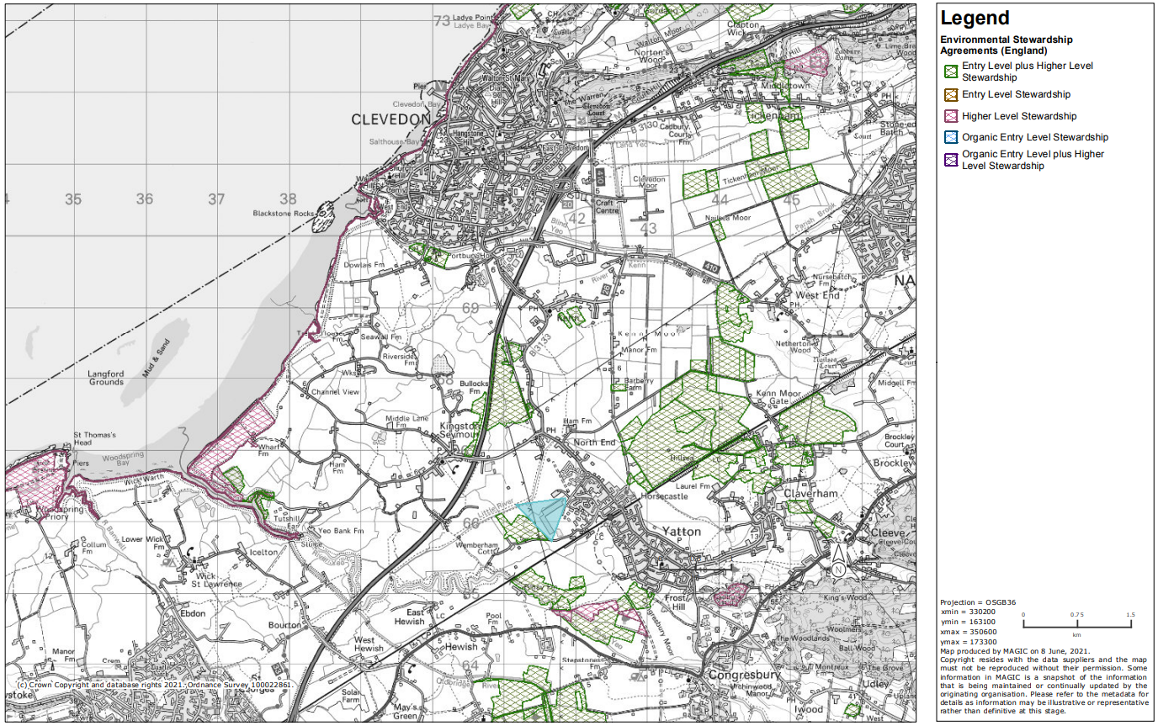
Figure 36. (Magic Maps data set, accessed 08.06.2021) Environmental Stewardship Agreements (England)

4.2 Forestry and Woodland Schemes

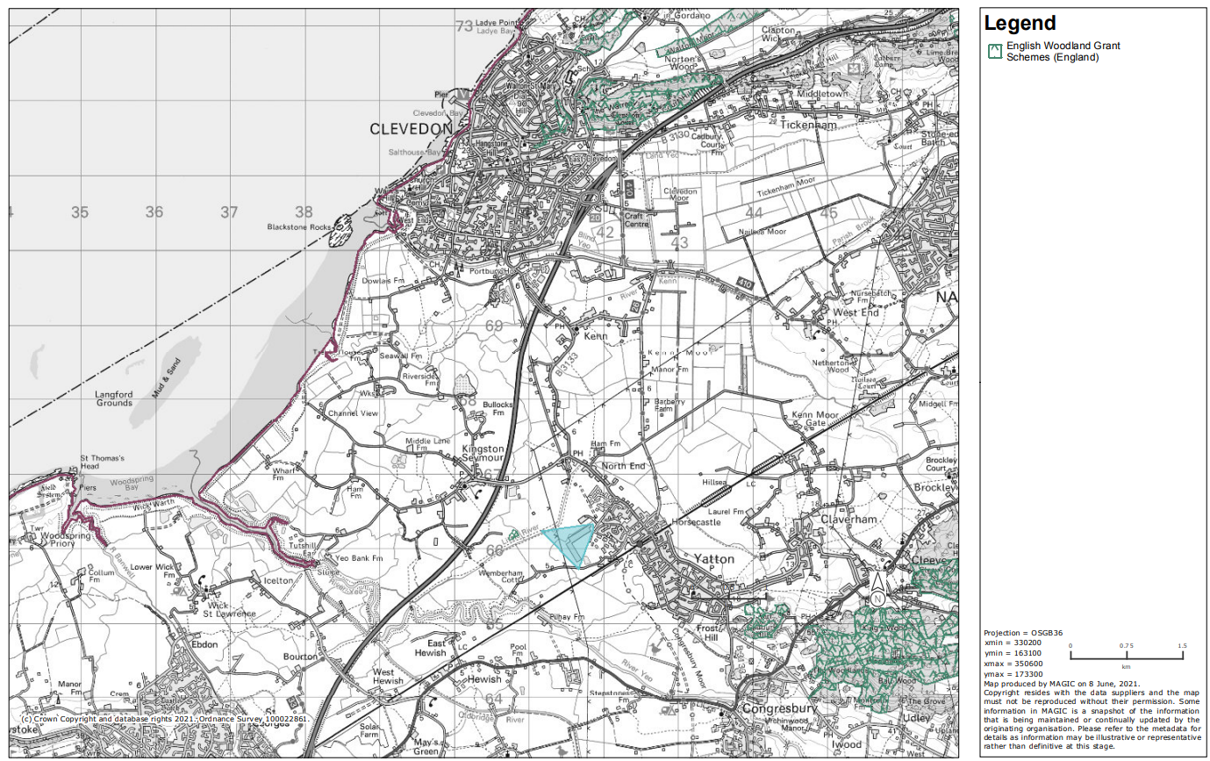
Figure 37. (Magic Maps data set, accessed 08.06.2021) Environmental Stewardship Agreements (England)

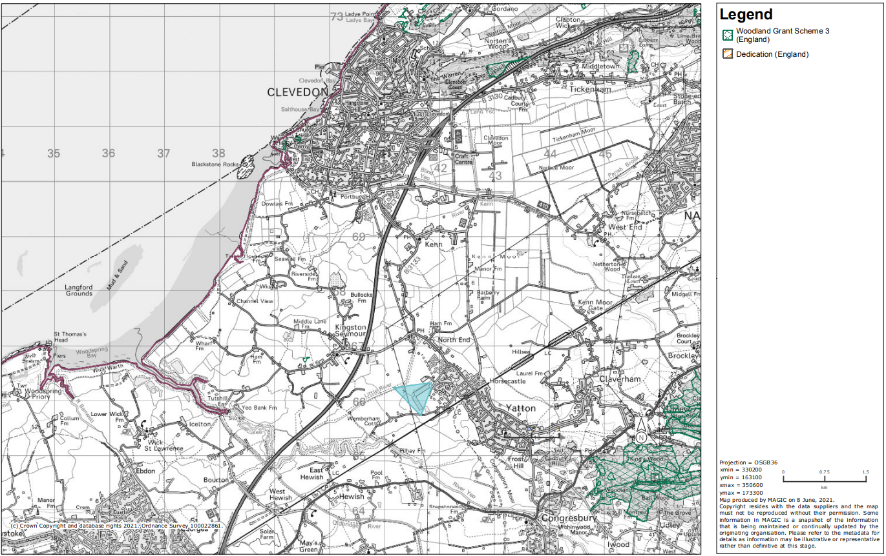
Figure 38. (Magic Maps data set, accessed 08.06.2021) Woodland Schemes designations

4.3 Other Schemes
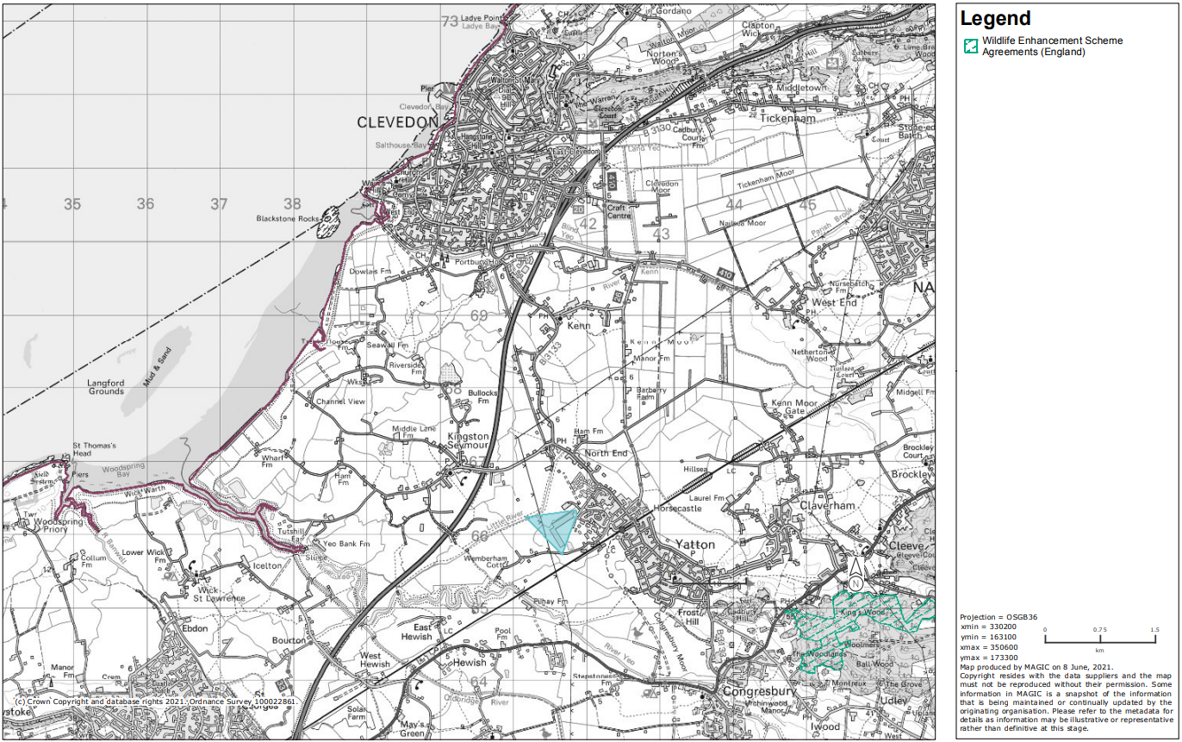
Figure 39. (Magic Maps data set, accessed 08.06.2021) Wildlife Enhancement Scheme (England)

5. Landscape

The site is located within a Secondary B aquifer, ground water within the area is of medium-low vulnerability.
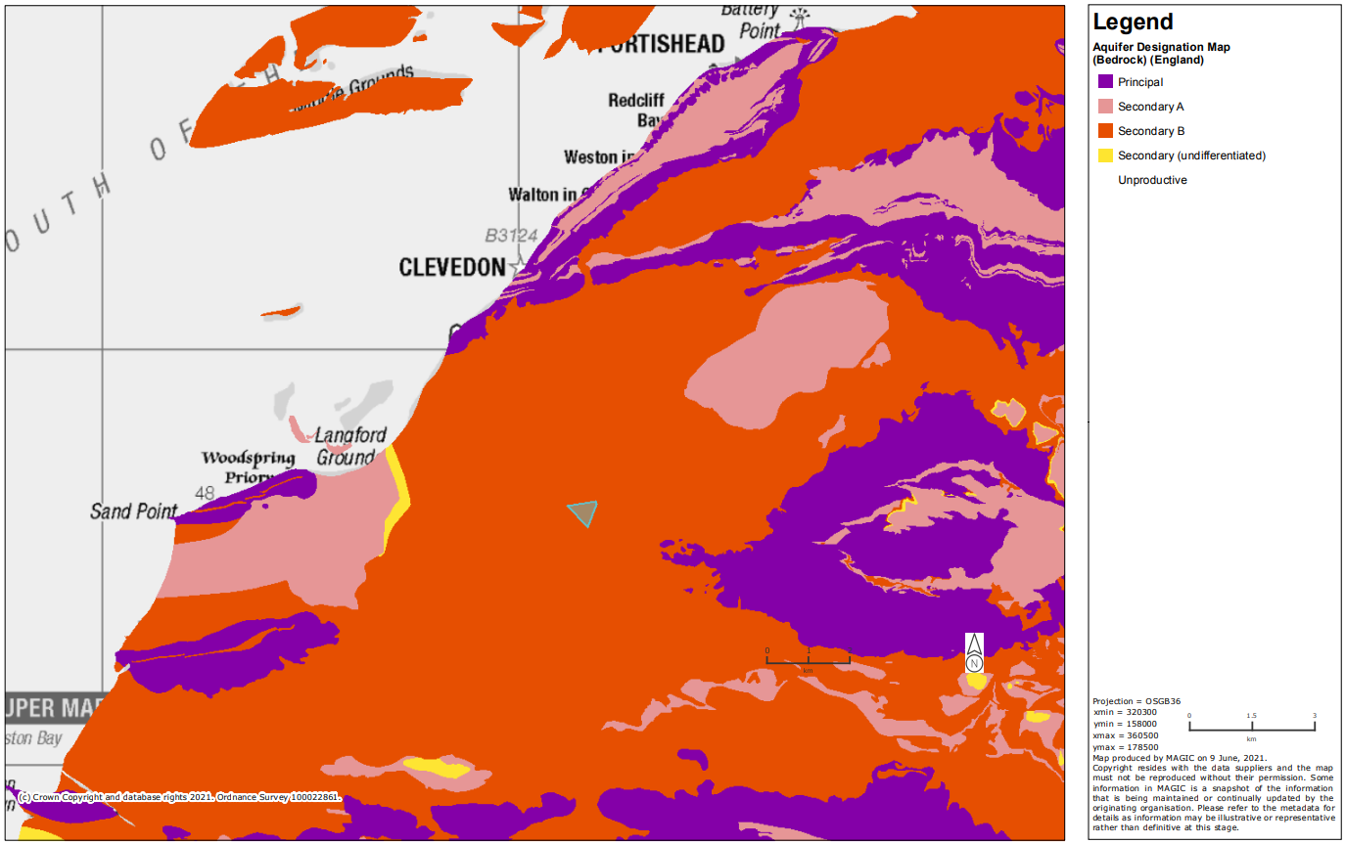
Figure 40. (Magic Maps data set, accessed 08.06.2021) Aquifer Designation Map (Bedrock) (England)

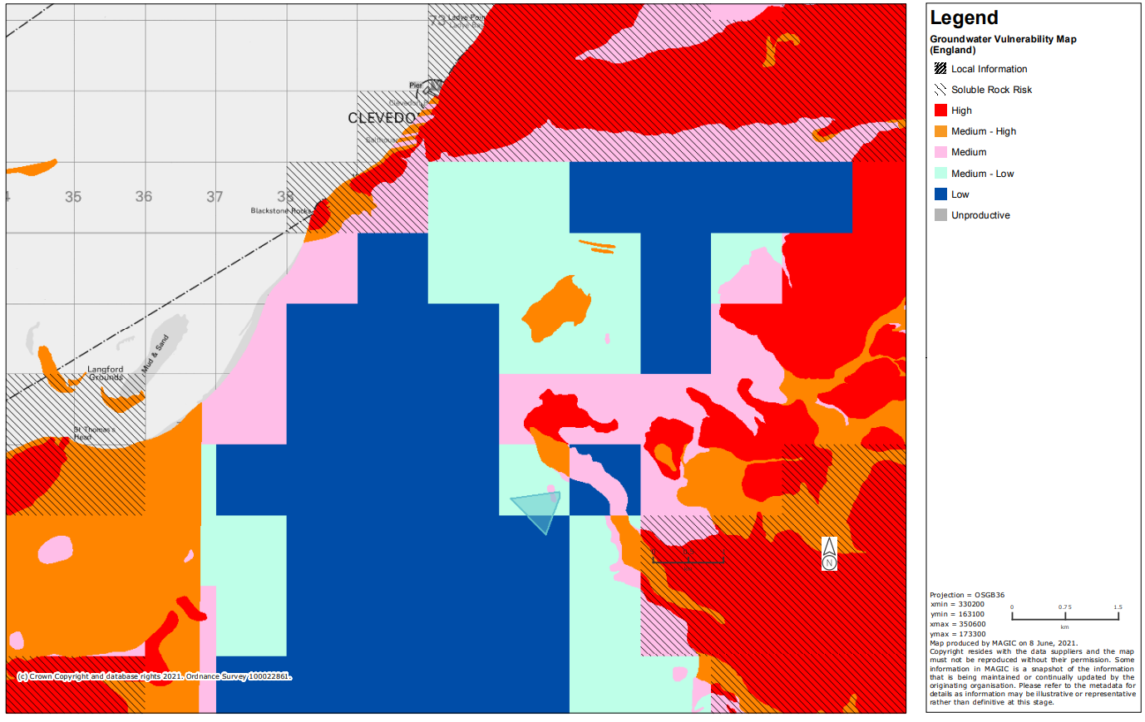
Figure 41. (Magic Maps data set, accessed 08.06.2021) Groundwater Vulnerability Map (England)
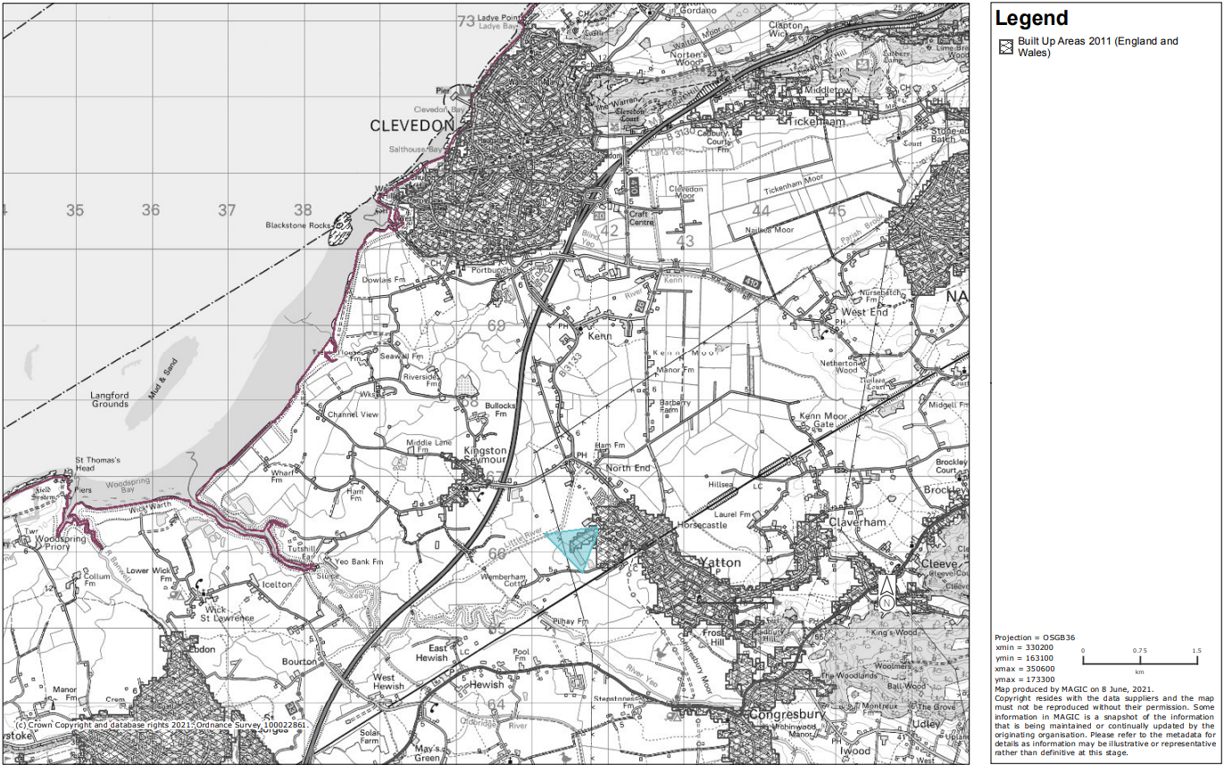
Figure 42. (Magic Maps data set, accessed 08.06.2021) Built up Areas 2011 (England)

6. Water

6.1 Water Abstraction

The site is around 5km away from two public groundwater abstraction facilities.
Water Abstraction Licenses | Source Type | Distance from Site | Maximum Annual Quantity *
Bristol Water PLC | GW | ~5.4km | 1,200,000
Bristol Water PLC | GW | ~5.6km | 5,000,000

Table 3. (Magic Maps data set) Accessible Water Abstraction licences close to the site,

6.2 Surface Water Run off/ Waste Water.

The surface water runoff is directed through internal drainage systems into the Wemberham Lane Rhyne in the somerset drainage systems. North Somerset internal Drainage Board controls water flow into Congresbury Yeo.
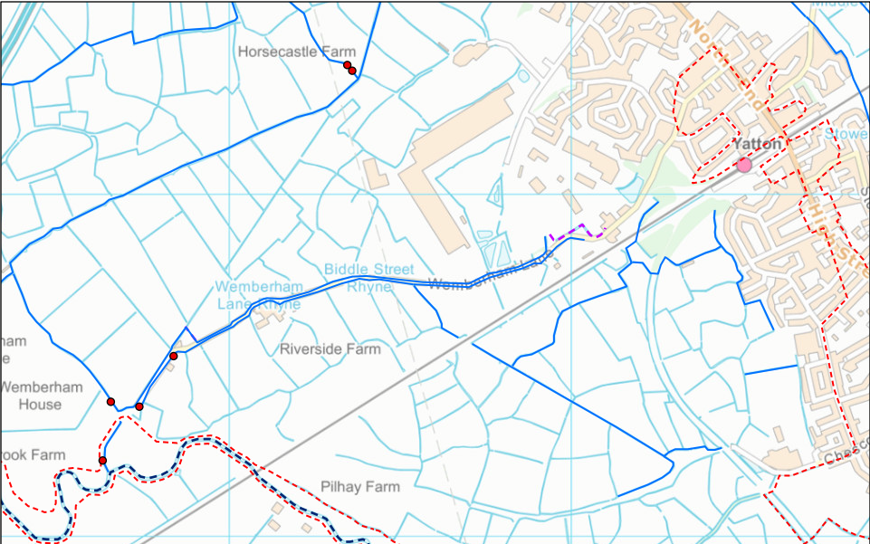
Figure 43. (Magic Maps data set, accessed 08.06.2021) North Somerset drainage boards (England) where blue line are IDB rhynes, purple hatched lines are culverted rhynes, dark blue hatch lines are o
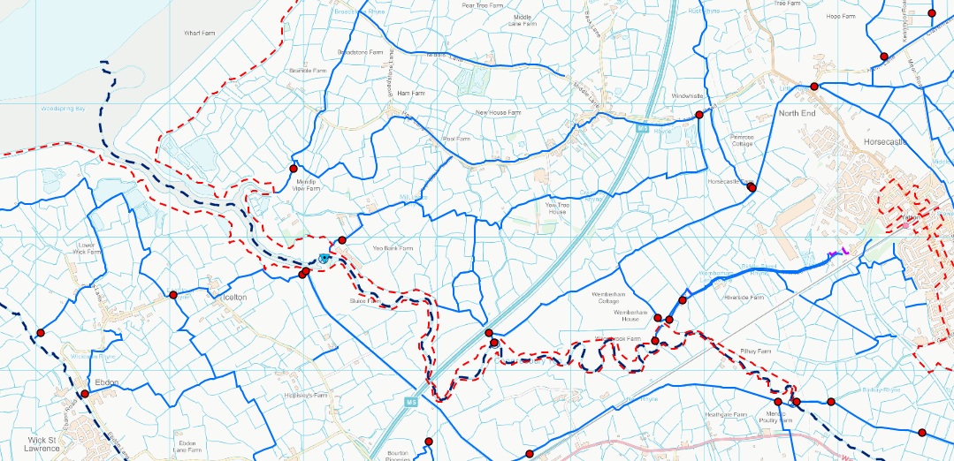
Figure 44. Congresbury Yeo is shown to form parts of the Severn estuary

Trade effluent or surface water that enters into the rhines surrounding the site have been shown to be monitored regularly (twice a day) and will not emit pH over 10, reducing to 9 soon. River Catchment data for the Yeo is shown below, the site is already failing on chemical/hazardous water classification and due to the associated protections around the Severn estuary effluent should continue to be monitored.
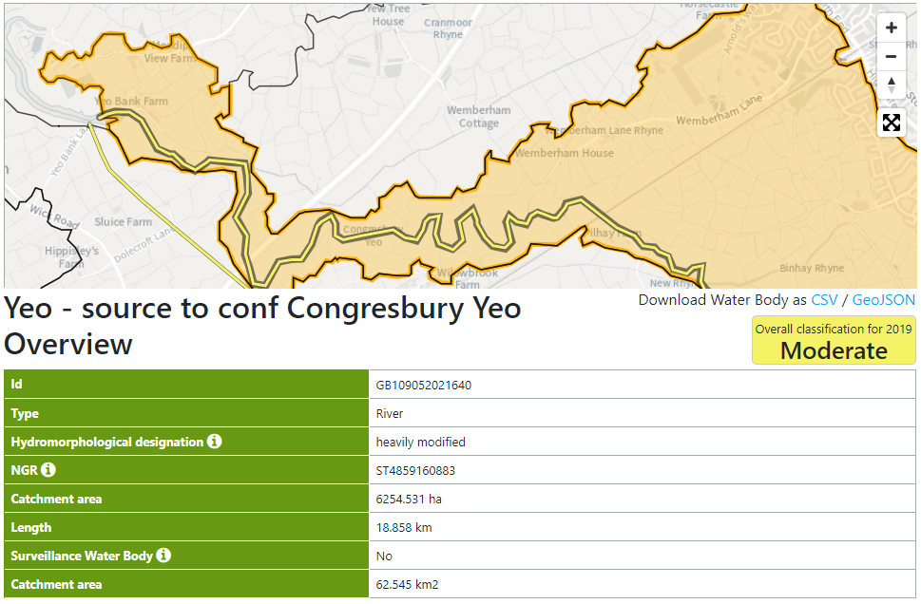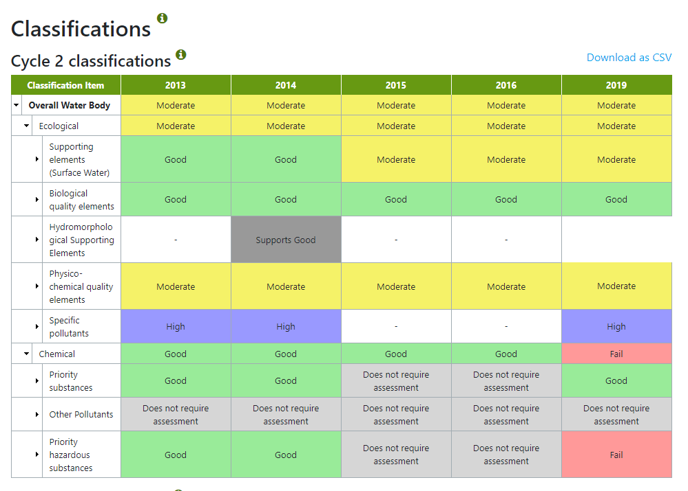
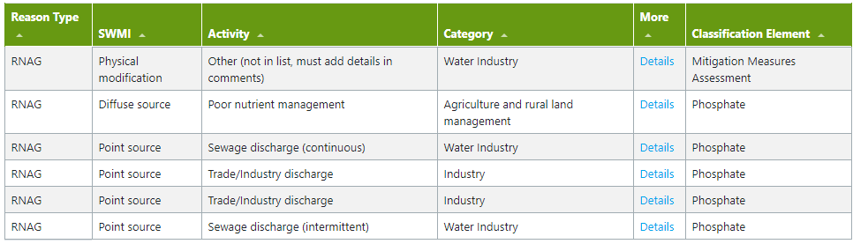
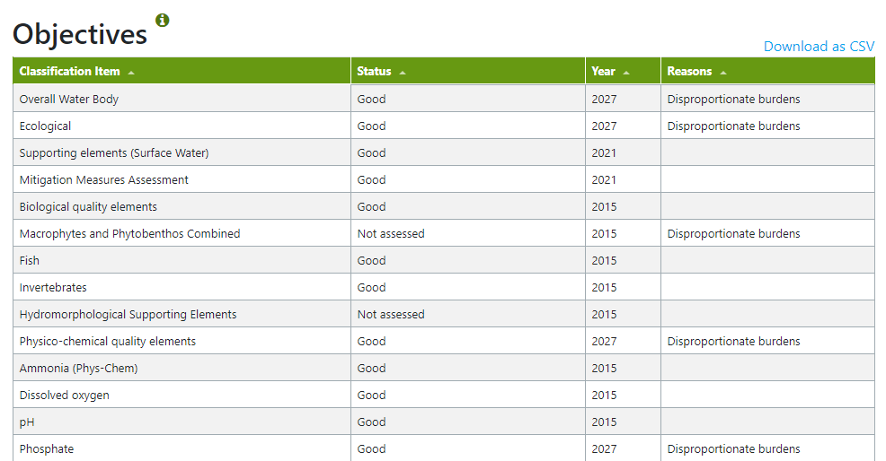
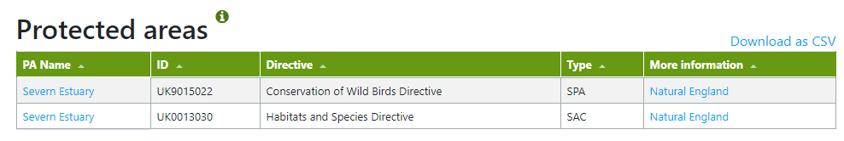

7. Pollution

7.1 Water

The river associated with the site has been shown to be most effected by pollution from the industry sector.
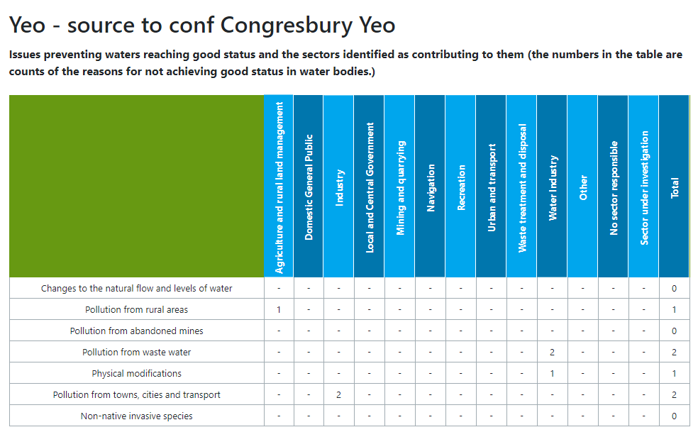

7.2 Air Quality

The site is not within a designated AQMA, the closest management areas are in Bristol, Bath and along the A37.
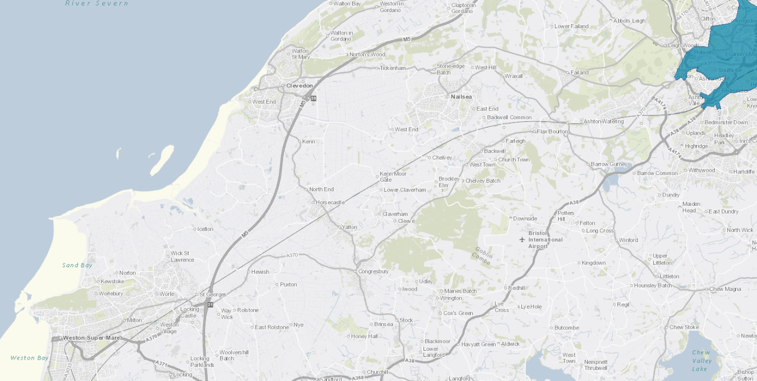

7.3 Litter Pollution

There has been no reported litter incidents around Smarts site on the “planet patrol” website, 06.12.2022.
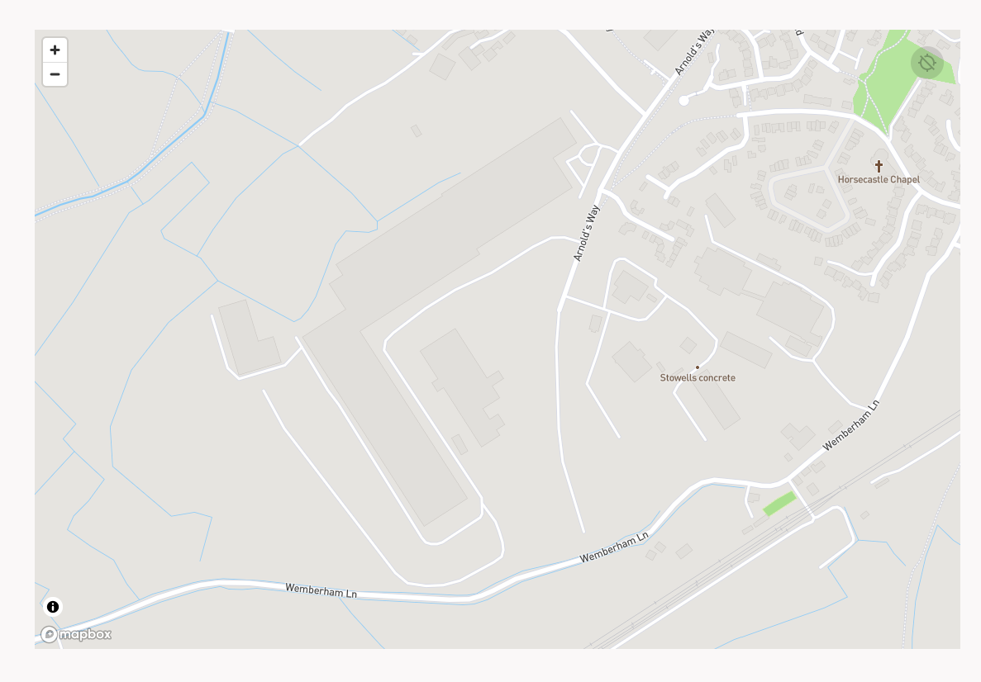
Litter Map | Pollution Map | Planet Patrol

7.4 Radon Exposure Risk

Radon is a decay product of uranium, it has carcinogenic properties and so there is an associated health risk with sites surrounding high radon exposure. The site is not within an area that is likely to be vulnerable to radon exposure.
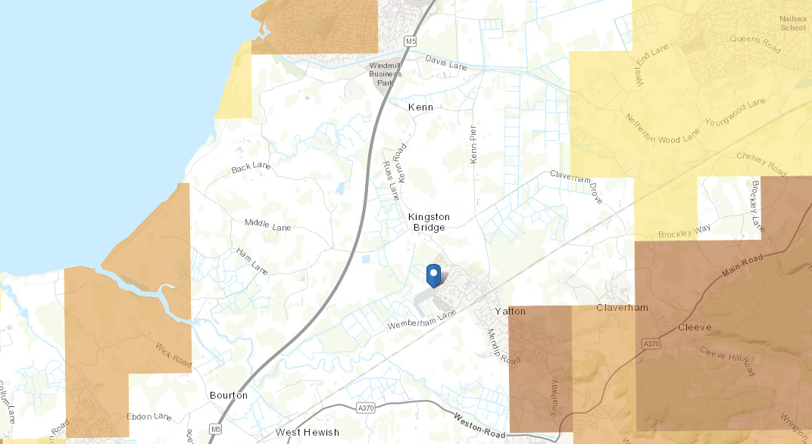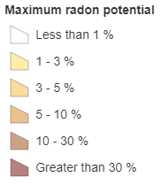

8. Human Occupancy

8.1 Schools

There are multiple schools located within 5km of the site.
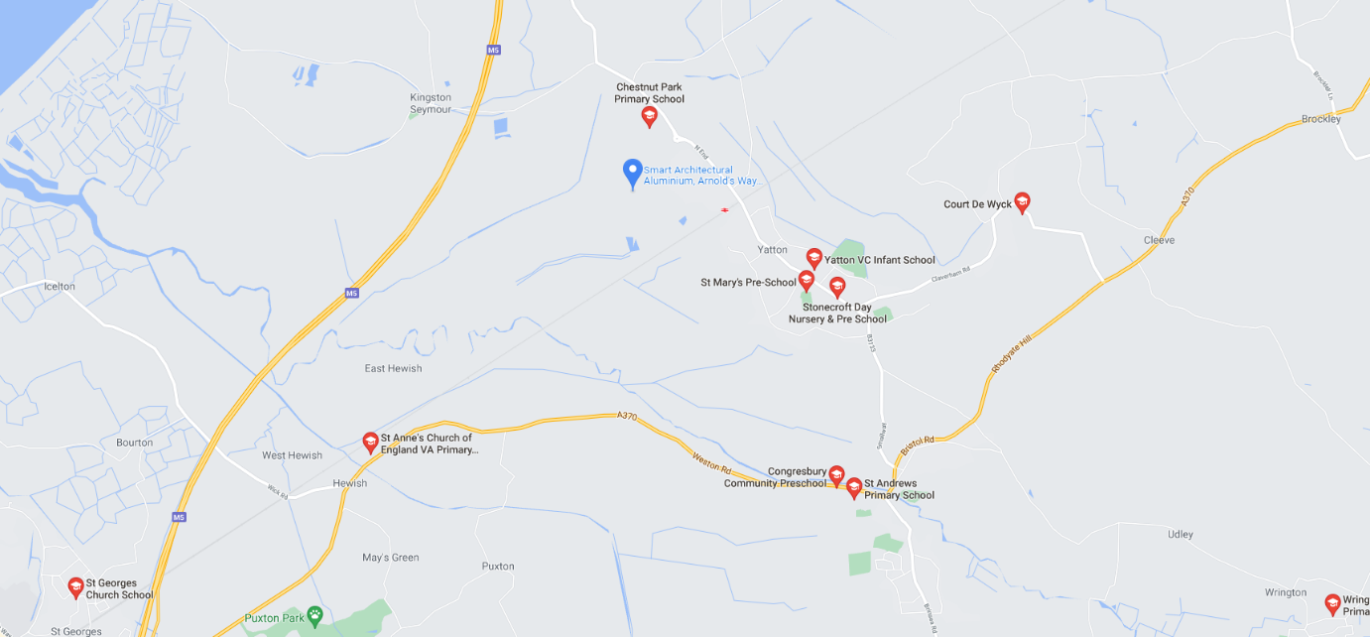

8.2 Hospitals

The nearest hospital, Clevedon, is just over 5km from the site.
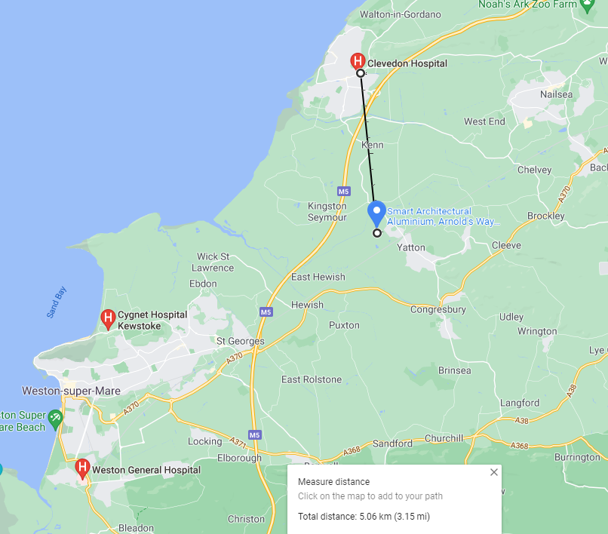

8.3 Playgrounds and Parks
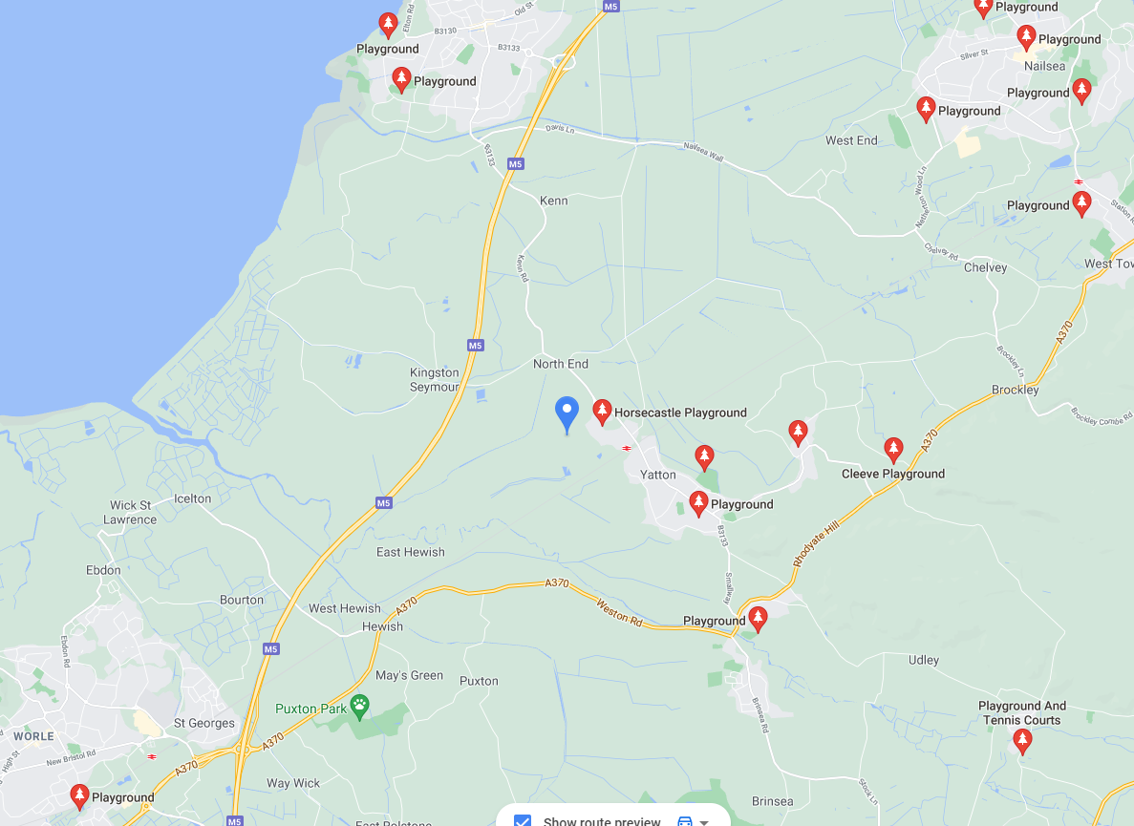
Horsecastle playground is within 500m from the site.
There are no public parks within 5km of the site although this information is sourced from google maps which may not have registered such parks within its database.
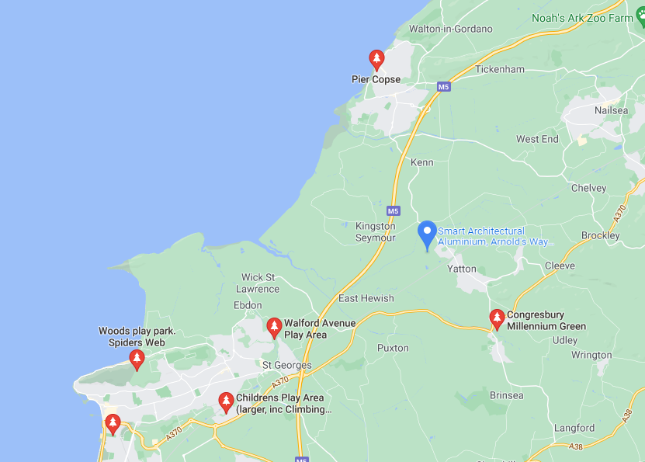

9. Infrastructure

9.1 Highways
The site is located off the road “Arnolds Way” with the ‘M5’ and ‘A370’ as the main highways within proximity of the site.
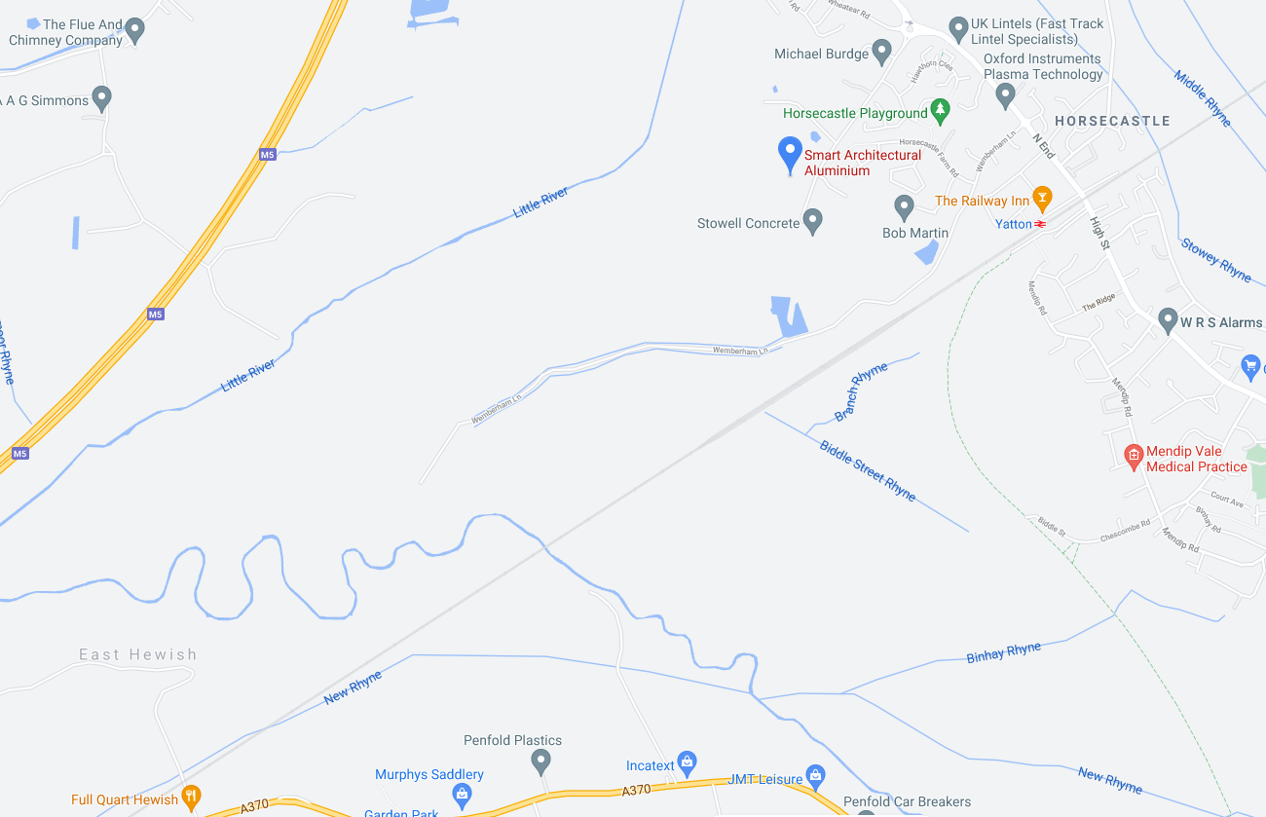

9.2 Footpaths

There is a footpath opposite the site that leads to the train station.
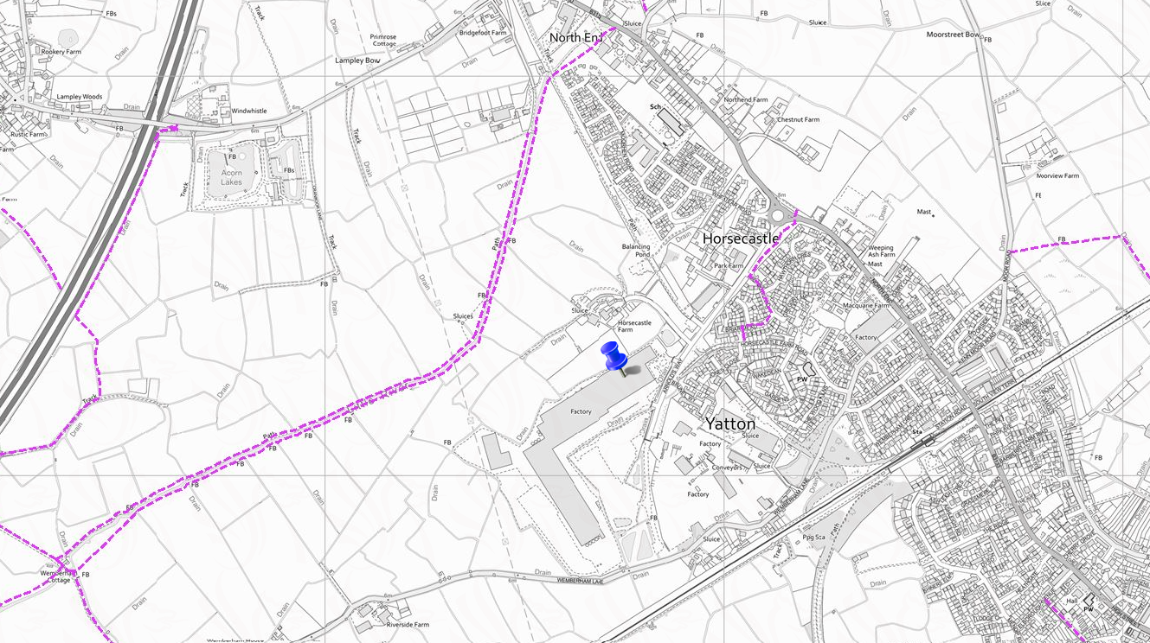

9.3 Cycleways

The site may be accessed using National Cycle Routes 410 and 26 via conventional roads.
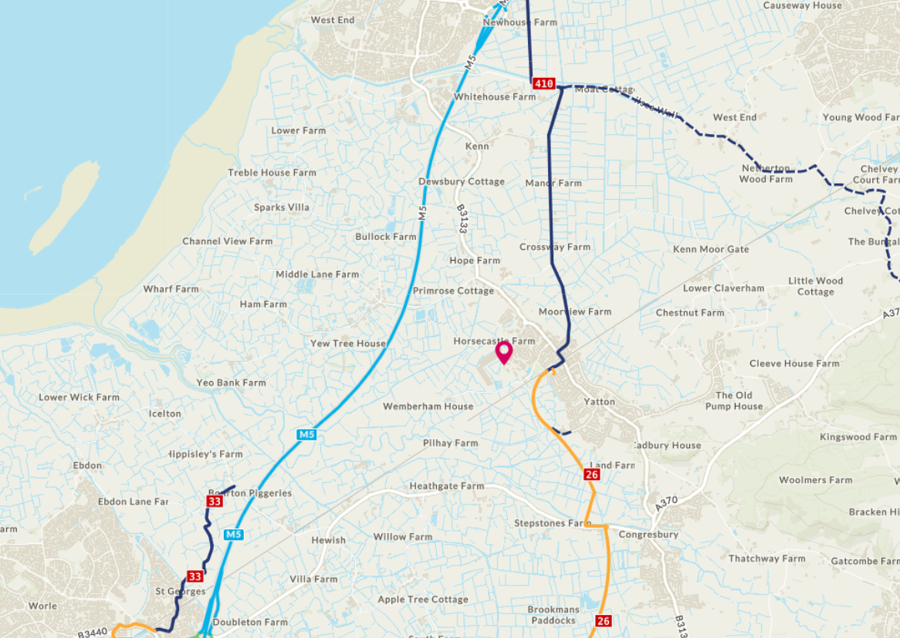

9.4 Utilities
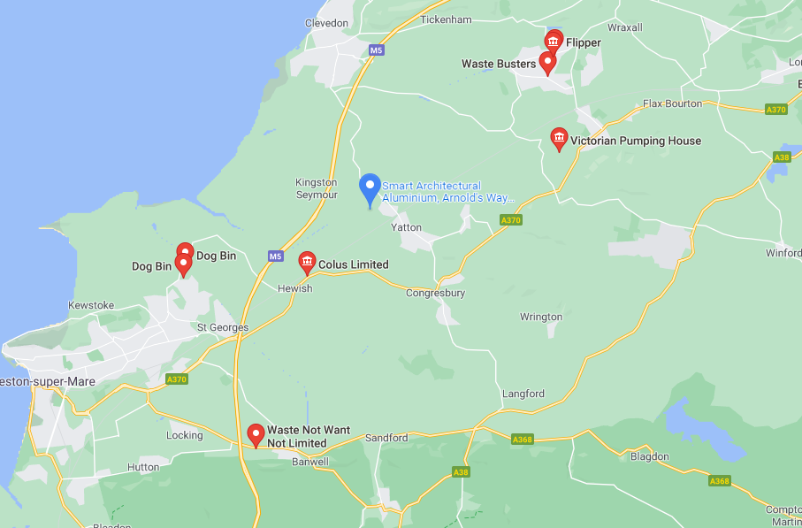
Hinkley gas pipe runs next to the site which has prevented construction of renewable energy sources being built.
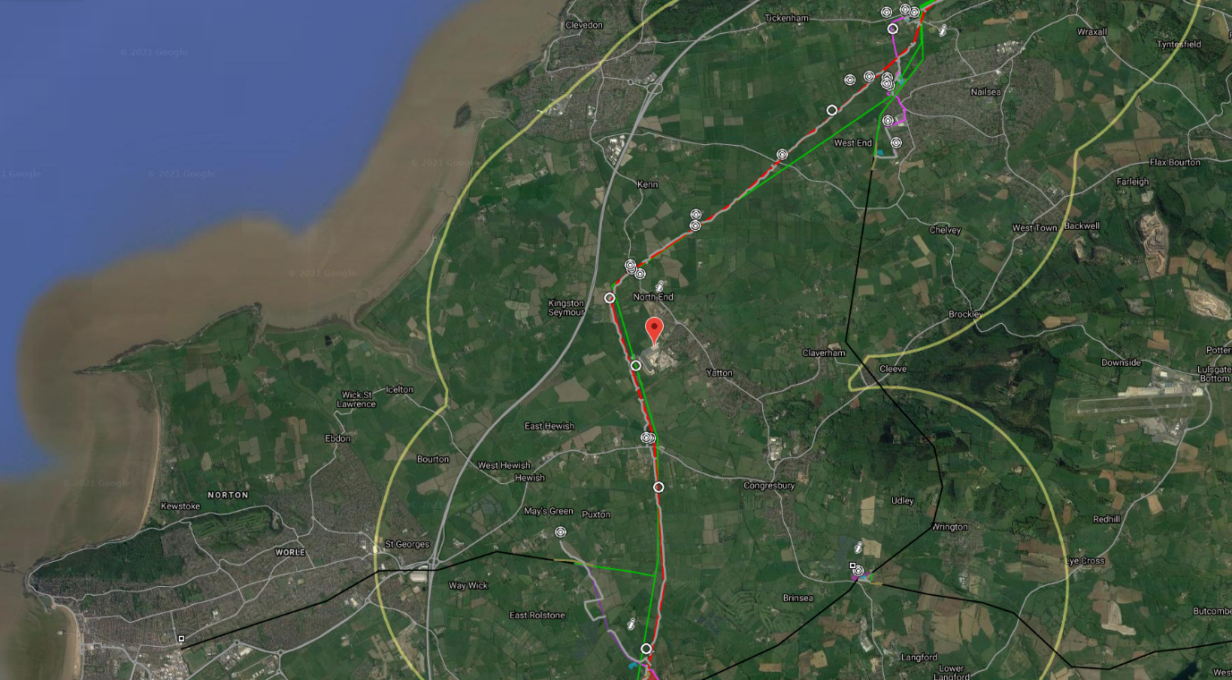
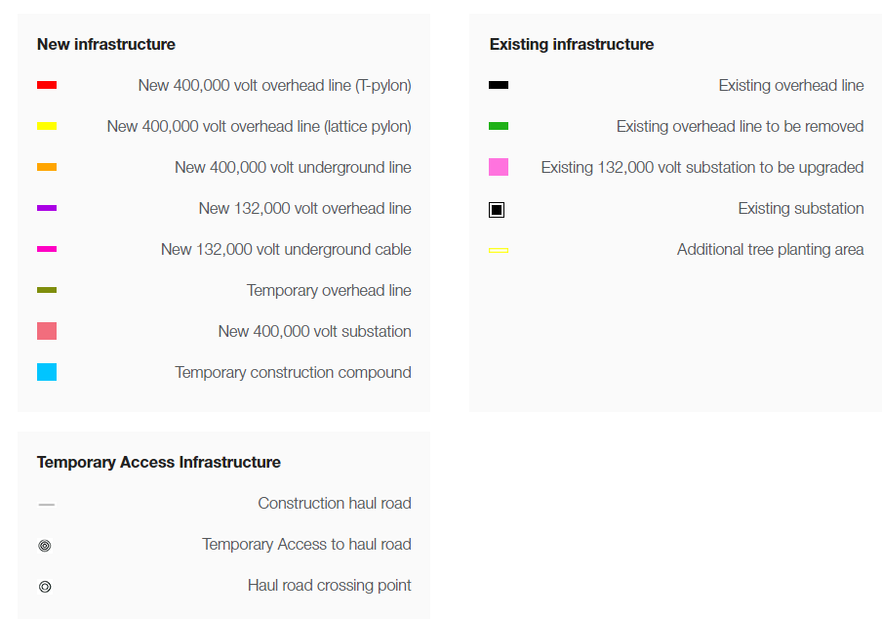

Appendix

Former Catchment Sensitive Farming Priority Areas 2011-2015 