
Non-Technical Summary

Household, commercial and industrial waste transfer station

Unit 19 Bakers Park,
Cater Road,
Bishopsworth,
Bristol,
BS13 7TT

Document Title | Non-Technical Summary
Revision | 4.0
Date | 30-09-24
Document Reference | ETM Bakers Park NTS 30-09-24
Prepared For | ETM Recycling Ltd
Authored By | MTS Environmental Ltd

Quality Control
Revision No. | Date Revised | Description of changes | Authored By | Sign Off | Approved By | Sign Off
1.0 | 14/03/23 | Original draft for permit variation application | Kasia Haywood |  | Luke Bridges
2.0 | 24/05/23 | Small updates for final issue for permit variation | Kasia Haywood |  | Luke Bridges
3.0 | 18/06/24 | Amendments based on EA discussions | Leonie Horwood |  | Luke Bridges
4.0 | 30-09-24 | Amendments based on EA request | Shawn Almeida |  | Luke Bridges

DISCLAIMER: This document was prepared by MTS Environmental Ltd solely on behalf of the Client (ETM Recycling Ltd). MTS accepts no responsibility or liability for any use that is made of this document other than the purpose for which it was originally commissioned and prepared.
This document may contain information of a specialised and/or highly technical nature and the Client is advised to seek clarification on any elements which may be unclear to it. Information, advice, recommendations and opinions in this document should only be relied upon in the context of the whole document and any documents referenced explicitly herein and should then only be used within the context of the appointment.
Information reported herein may be based on the interpretation of public domain data collected by MTS and/or information provided by the Client. These data have been accepted in good faith as being accurate and valid.

Introduction
1.1.1 This document forms the application for a variation of an existing environmental permit of an A11: household, commercial and industrial waste transfer station under the Environmental Permitting Regulations 2016. The applicant and operator of the waste facility is ETM Recycling Ltd and their site is located at Unit 19, Bakers Park, Cater Road, Bishopsworth, Bristol, BS13 7TT. The site has been operating under the permit number JP3793FP, issued by the Environment Agency in August 2004.
The purpose of this variation is to:
- Add additional waste types accepted on site
- Change the limits of activities and treatment operations permitted on site:
  - EPR Schedule 1, Part 2, Chapter 5, Section 5.4 Disposal, recovery or a mix of disposal and recovery of non-hazardous waste (a) Disposal of non-hazardous waste with a capacity exceeding 50 tonnes per day (or 100 tonnes per day if the only waste treatment is anaerobic digestion) involving one or more of the following activities and excluding activities covered by Council directive 91/271/EEC concerning urban wastewater treatment – • (ii) physico-chemical treatment; • (iii) pre-treatment of waste for incineration or co-incineration;
1.1.2 This non-technical summary outlines the details of the variation and the proposed new additional waste types to be processed by ETM Recycling Ltd on site.
1.1.3 In addition to this non-technical summary, the following documents have been produced and reviewed to support this permit variation application:
- The relevant Environment Agency application forms (Parts A, C2, C3 and F1)
- Supporting drawings (Site Layout Plan and Site Location Plan)
- Site Condition Report – a document detailing the current condition of the area of land to be included in the permit boundary
- Environmental Risk Assessment
- Dust Management Plan
- Environmental Management System
- Noise Management Plan
- Fire Prevention Plan

Site Location
2.1.1 The site is located at Unit 19, Bakers Park, Cater Road, Bishopsworth, Bristol, BS13 7TT (Figure 1). The national grid reference for the site is ST 57464 68764. The site is predominantly surrounded by other industrial units, with the nearest residential building sitting ∼105m away from the centre of the site.

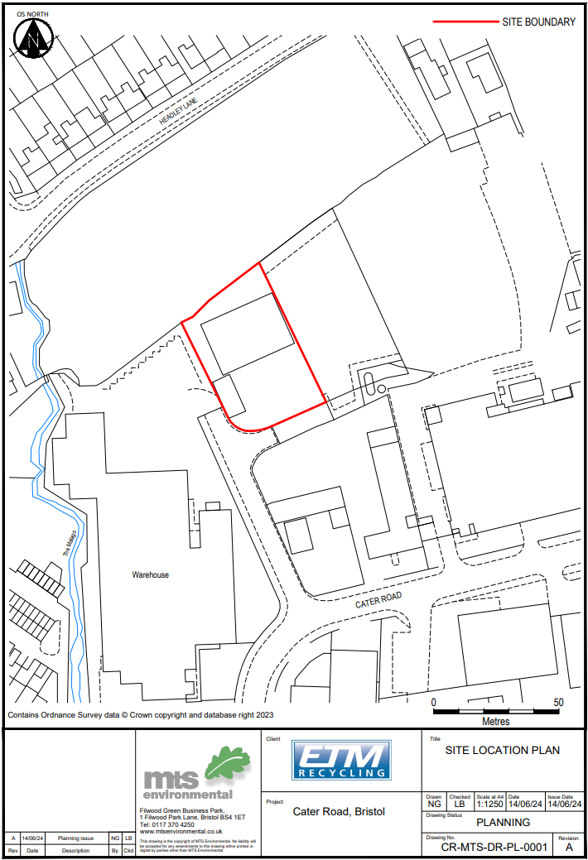
Figure 1 – Site Location Plan

Figure 2 – Site Layout Plan
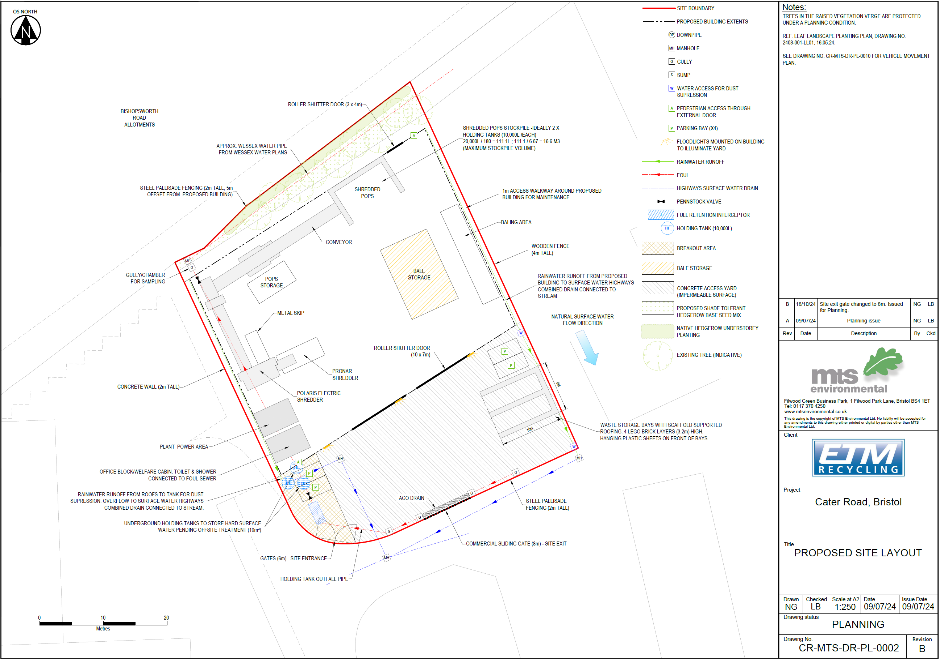

Application

Permit Variation Application
3.1.1 ETM Recycling Ltd currently hold a bespoke permit that allows the operation of a household, commercial and industrial waste transfer station. The new proposed waste streams to be accepted and new operations/treatment processes on site require a substantial variation to the environmental permit. The new activity is covered by activity code 1.16.2.3 - Section 5.4 (a)(iii) and (b)(ii) – non-hazardous waste installation – pre-treatment for incineration or co-incineration.

Permitted Activities
3.2.2 The site will be used for the treatment and storage of Persistent Organic Pollutants (POPs) waste and bulky wastes. Activities will include the physical sorting or separation of wastes, and shredding, with baling in future.
3.2.3 The main activities will involve the management of POPs waste and treatment through shredding to prepare it for disposal through incineration at a suitably permitted site for energy from waste. This operation will be undertaken in accordance with the Gov.uk guidance given by the Environment Agency regarding POPs waste.
3.2.4 The facility has been designed and will also be operated to ensure compliance with all relevant requirements of the Environment Agency and the Environmental Permitting Regulations 2016. The site will be managed in compliance with the non-hazardous and inert waste: appropriate measures for permitted facilities given by the Environment Agency.
3.2.5 The proposed activities covered by the Environmental Permitting (England and Wales) Regulations 2016 to be included in the new permit variation are provided in Table 1 below.
3.2.6 There are no changes to existing activities on site or the limits relating to them. This variation application proposes to add activity R5 – recycling/reclamation of other inorganic materials to permit the shredding of POPs waste on site, the limits of the activity are as stated in Table 1.
Table 1 – List of waste activities on site at Bakers Park
Description of Activities | Limits of Activities
D15: Storage pending any of the operations numbered D1 to D14 (excluding temporary storage, pending collection, on the site where it is produced.  D9: Physico-chemical treatment not specified elsewhere which results in final compounds or mixtures which are discarded by means of any of the operations numbered D1 to D12.  R3: Recycling/reclamation of organic substances which are not used as solvents (including composting and other biological transformation processes)  R4: Recycling/reclamation of metals and metal compounds.  R5: Recycling/reclamation of other inorganic materials  R13: Storage of waste pending any of the operations numbered R1 to R12 (excluding temporary storage, pending collection, on the site where the waste is produced) | Treatment consisting only of manual/mechanical sorting, separation, screening, blending, baling, shredding, crushing or compaction of non-hazardous or inert waste into different components for disposal or recovery. Shredding in excess of 75 tonnes per day.  All wastes shall be treated on an impermeable surface with sealed drainage.  Maximum storage in the building to be limited to 2000 tonne.  Maximum storage outside on impermeable surface to be 500 tonnes either in containers or in open bays.  Storage of wastes stored shall not exceed 5,000 tonnes in total at any one time.  Section 5.4 (a)(iii) and (b)(ii) – non-hazardous waste installation – pre-treatment for incineration or co-incineration. Shredding in excess of 75 tonnes per day.  There shall be no treatment of WEEE, batteries, cooling equipment or display equipment.  Wastes shall be stored for no longer than 1 year prior to disposal or 3 years prior to disposal.

Additional Waste Streams
    - One of the purposes of this permit variation application is that ETM Recycling Ltd seek to add European Waste Codes (EWC) to the permit to allow for the new proposed operations. All the codes listed in Table 2 seek to be included on the new permit (the proposed new codes are highlighted in red, all codes in black are already included on the existing permit).
    - New Waste Codes required for permit highlighted in red (description). Combustible waste highlighted in Green (EWC). Wastes which may be shredded are highlighted in italics.
Table 2 – Proposed list of waste codes on site at Bakers Park
Waste Code | Description
02 01 03 | Plat-tissue waste
02 01 04 | Waste plastics (except packaging)
03 01 01 | Waste bark and cork
03 01 05 | Sawdust, shavings, cuttings, wood, particle board and veneer other then those mentioned in 03 01 04
10 11 12 | Clean glass other than those mentioned in 10 11 11
10 12 08 | Waste ceramics, bricks, tiles and construction products (after thermal processing)
12 01 01 | Ferrous metal filings and turnings
12 01 03 | Non-ferrous metal filings and turnings
12 01 05 | Plastics shavings and turnings
15 01 01 | Paper and cardboard packaging
15 01 02 | Plastic packaging
15 01 03 | Wooden packaging
15 01 04 | Metallic packaging
15 01 05 | Composite packaging
15 01 06 | Mixed packaging
15 01 07 | Glass packaging
15 01 09 | Textile packaging
16 01 03 | End-of-life tyres
16 02 14 | Discarded equipment other than those mentioned in 16 02 09 to 16 02 13
16 02 16 | Components removed from discarded equipment other than those mentioned in 16 02 15
17 01 01 | Concrete
17 01 02 | Bricks
17 01 03 | Tiles and ceramics
17 01 07 | Mixtures of concrete, bricks, tiles and ceramics other than those mentioned in 17 01 06
17 02 01 | Wood
17 02 02 | Glass
17 02 03 | Plastic
17 04 01 | Copper, bronze, brass
17 04 02 | Aluminium
17 04 03 | Lead
17 04 05 | Iron and steel
17 04 07 | Mixed metals
17 04 11 | Cables other than those mentioned in 17 04 10
17 05 04 | Soil and stones other than those mentioned in 17 05 03
17 08 02 | Gypsum only other than that mentioned in 17 08 01
17 09 04 | mixed construction and demolition wastes other than those mentioned in 17 09 01, 17 09 02 and 17 09 03
19 12 01 | Paper and cardboard
19 12 02 | Ferrous metal
19 12 03 | Non-ferrous metal
19 12 04 | Plastic and rubber
19 12 05 | Glass
19 12 07 | Wood other than that mentioned in 19 12 06
19 12 08 | Textiles
19 12 10 | Combustible waste (refuse derived fuel)
19 12 12 | other wastes (including mixtures of materials) from mechanical treatment of wastes other than those mentioned in 19 12 11
19 13 02 | Solid waste from soil remediation other than those mentioned in 19 13 01
20 01 01 | Paper and cardboard
20 01 02 | Glass
20 01 08 | Biodegradable kitchen and canteen waste
20 01 10 | Clothes
20 01 11 | Textiles
20 01 36 | Discarded electrical and electronic equipment other than those mentioned in 20 01 21, 20 01 23, and 20 01 35
20 01 38 | Wood other than that mentioned in 20 01 37
20 01 39 | Plastics
20 01 40 | Metals
20 02 01 | Biodegradable waste
20 02 02 | Soil and stones
20 03 01 | Mixed municipal waste
20 03 07 | Bulky waste

    - 20 03 07 will be use to describe POPs wastes
    - 19 12 12 wastes will be wastes from mechanical treatment that are rejected from non-haz disposal options due to elevated LOI and incineration is the only disposal option.

Expected Annual Waste Throughput Tonnages
3.4.1 The annual tonnage throughput limits are to remain at 75,000 tonnes as per the current permit.

Permit Boundary Area
3.5.1 The facility currently operates on one unit of land off Caters Road and the site boundary will continue to remain the same as there will not be an increase in throughput due to this variation so the current site will be sufficient to accommodate this variation.

Site Management

4.1 General
4.1.1 A Technically Competent Manager is on site at least 20% of operational hours every week and a site supervisor, who will be responsible for daily operations will continue to be on site during working hours.
4.1.2 The Environmental Risk Assessment submitted as part of this application will be used to identify any risks and opportunities at the site, arising from this permit variation. Additional control measures will be implemented to prevent or reduce any added risks.
4.1.3 Operational procedures will be implemented that consider the location of waste processing and storage areas.
4.1.4 All employees will receive environmental training that incorporates the site activities and waste streams accepted onsite.
4.1.5 As identified in the Environmental Risk Assessment carried out as part of the permit variation application, specific management plans, covering emissions have been created and these will be implemented as part of the Environmental Management System (EMS). These management plans account for the waste types, and quantities of waste to be treated and stored on site.

4.2 POPs Waste
4.2.1 EA guidance on managing POPs waste (available on the gov.uk website) will be adhered to.
4.2.2 All shredding of POPs waste is conducted within the building and the shredded POPs waste is stored in the building. Fugitive emissions from processing of POPs waste are controlled with abatement measures such as bag filters on the shredding plant and others described in the Dust Management Plan.
4.2.3 Incoming POPs waste is coded as 20 03 07 and it is stated in the description that it contains POPs.
4.2.4 Outgoing POPs waste is shredded to the specification required for destination incinerator or cement kiln and classified as 19 12 10 and clearly described as containing POPs from domestic seating.

Environmental Setting

5.1 Potential Receptors
5.1.1 The site is predominantly surrounded by other industrial units and uses of land, with allotments situated to the north of the site. The nearest residential property in located on Headley Lane 105 m to the north of the site. There are other surrounding properties that continue both east and west along this road. Another area of residential properties is located on Whitchurch Road to the west of the site, the nearest property is located 165 m west of the centre of the site.
5.1.2 There are a number of schools within 1 km of the site including Merchants Academy, Gay Elms Primary School, St Peters Primary School, Bedminster Down School, Headley Park Primary School, Fair Furlong Primary School and Cheddar Grove Primary School. There are no hospitals located within 1 km of the site. There are two care homes located within 1km of the site: MHA Hartcliffe and Bishopsmead Lodge Care Home.
5.1.3 The site is located 85m from the River Malago.
5.1.4 All receptors within 1 km of the site are located on the Sensitive Receptor Plan.

5.2 Groundwater
5.2.1 The site is not within a source protection zone, it is located in Flood Zone 1 meaning it has a low probability of flooding. It has been assessed by Gov.uk as being at a very low risk of flooding from surface water, rivers and the sea. The underlying bedrock geology is of Rugby Limestone Member – limestone and mudstone, interbedded.
5.2.2 The soilscape of the site and surrounding area is shallow lime-rich soils over chalk or limestone.
5.2.3 The site is located above a Secondary A bedrock aquifer.

Monitoring

6.1 Air
6.1.1 Visual inspections will be carried out daily during operational hours, especially when carrying out activities that are dust producing. All processing operations are undertaken within the recycling building. Best practicable means will be applied to minimise dust emissions and to ensure compliance with the site-specific Dust Management Plan.

6.2 Groundwater
6.2.1 No monitoring of groundwater is proposed as fugitive releases to groundwater will be prevented by conducting all operations, including the unloading of waste, sorting, treatment and storage of waste streams in areas sealed with an impermeable concrete surfacing. Surface water flows through a positive drainage system which discharges to foul water following treatment in an interceptor. Any spills inside the building drains following the fall into an interceptor then a sealed collection tank. This prevents a pathway for migration of pollutants to groundwater.

6.3 Emissions
6.3.1 There will be no point source emissions to water or land associated with the proposed changes.
6.3.2 The potential sources of fugitive emissions to air have been identified and a Dust Management Plan has been prepared to prevent any potential dust emissions from reaching any nearby receptors.
6.3.3 Contaminated fugitive emissions to groundwater are highly unlikely as the site has a sealed surface water drainage system and impermeable surface in operational areas which drains to foul sewer. Only clean roof water runoff will drain into permeable made ground at the rear of the site via a soakaway. Fuel is stored in a fully bunded pallet off ground store in the storage/office container, away from waste operational areas.
6.3.4 Any potentially polluting spillages at the site will be subject to the procedures detailed in the site EMS.

Application Site Condition Report
7.1.1 An application Site Condition Report has been prepared for the land proposed as part of this bespoke environmental permit variation application.

Compliance with Best Available Techniques
8.1.1 ETM Recycling Ltd will work under the Best Available Techniques (BATs) Requirements taken from the EA’s Sector Guidance of non-hazardous and inert waste: appropriate measures for permitted facilities. BATs will be applied to the additional proposed activities at the ETM Recycling Ltd site to ensure all potential health and safety and environmental risks posed by these activities are considered and appropriately managed.

