
`

Environmental Management System

Household, commercial and industrial waste transfer station

Unit 19 Bakers Park,
Cater Road,
Bishopsworth,
Bristol,
BS13 7TT

Document Title | Environmental Management System
Revision | 4.0
Date | 30/09/24
Document Reference | ETM Caters Road EMS 30/09/24
Prepared For | ETM Recycling Ltd
Authored By | MTS Environmental Ltd

Quality Control
Revision No. | Date Revised | Description of changes | Authored By | Sign Off | Approved By | Sign Off
1.0 | 13/03/23 | Original draft for permit transfer and variation | Kasia  Haywood |  | Luke Bridges
2.0 | 24/05/23 | Small updates for final issue for permit variation | Kasia Haywood |  | Luke Bridges
3.0 | 31/03/24 | Amendments based on EA discussions | Leonie Horwood |  | Luke Bridges
4.0 | 30/09/24 | General updates | Shawn Almeida |  | Luke Bridges

DISCLAIMER: This document was prepared by MTS Environmental Ltd solely on behalf of the Client (ETM Recycling Ltd). MTS accepts no responsibility or liability for any use that is made of this document other than the purpose for which it was originally commissioned and prepared.
This document may contain information of a specialised and/or highly technical nature and the Client is advised to seek clarification on any elements which may be unclear to it. Information, advice, recommendations and opinions in this document should only be relied upon in the context of the whole document and any documents referenced explicitly herein and should then only be used within the context of the appointment.
Information reported herein may be based on the interpretation of public domain data collected by MTS and/or information provided by the Client. These data have been accepted in good faith as being accurate and valid.
Table of Contents
1. Introduction 3
1.1 General 3
1.2 Permits 3
1.3 Environmental Permit 4
1.4 Part B Mobile Plant Permit 4
2. Site Location 4
2.1 General 4
3. Management 6
3.1 General Management 6
3.2 Contingency planning 7
3.3 Sufficient Competent Persons 7
3.4 Staff Training 9
3.5 Avoidance, Recovery and Disposal of Wastes Produced by the Activities 9
4. operations 10
4.1 Permitted Activities 10
4.2 Permitted Wastes 12
4.4.3 Additionally, all loaded vehicles will be sheeted to avoid the escape of any waste. 15
4.4.4 The site will operate in accordance with a site-specific Dust Management Plan outlining mitigation measure in place on site. 15
4.5 Potentially Polluting Leaks and Spillages of Waste 15
4.6 Surface Water Management 16
4.7 Fires on Site 16
4.8 Recording and Reporting Procedures 17
4.9 Waste Acceptance and Control Procedures 17
4.10 Waste Refusal 18
4.11 Waste Quantity Measurement Systems 19
4.12 Site Inspections 19
4.13 Site Security 20
4.14 Site Closure Plan 20
5. POLLUTION CONTROL, MONITORING AND REPORTING 21
5.1 Pollution Risk Management 21
6. Emissions and Monitoring 21
6.1 Introduction - Emissions to Air, Land and Water 21
6.2 Monitoring Control and Reporting of Dust Emissions 21
6.3 Monitoring and Control of Noise 23
6.4 Monitoring and Control of Litter 23
6.5 Monitoring and Control of Pests (including scavengers, gulls) 23
6.6 Monitoring and Control of Mud and Debris 24
6.7 Monitoring and Control of Odour 25
6.7.1 The waste accepted on site is not putrescible in nature so odour should not cause any complications or breach of the permit on site. 25
6.7.2 On the detection of odour, the operator shall take action to review the waste management processes at the site and modify or cease handling the waste, if necessary, in order to minimise the production of odour. 25
6.7.3 The incident, actions and results shall be recorded in the site diary. 25
7. SITE RECORDS 25
7.1 Security and Availability of Records 25
7.2 Records of Waste Movements (Waste Returns) 25
7.3 Records of off-site Environmental effects 25
7.4 Records of on-site Environmental effects 25
7.5 Site Diaries 26

Appendices
Appendix A – Site Permit
Appendix B – Site Location, Layout and Drainage Plans
Appendix C – Sensitive Receptor Plan
Appendix D – Training Records
Appendix E – Environmental Risk Assessment
Appendix F – H&S Procedure
Appendix G – Forms

Introduction
  - General
    - This document comprising an Environmental Management System (EMS) has been written for ‘The Operator’ who will undertake the waste operations in accordance with a bespoke environmental permit (permit reference: JP3793FP) based on a household, commercial and industrial waste transfer station.
    - This document has been prepared for the Operator: ETM Recycling Ltd, Unit 19 Bakers Park, Cater Road, Bishopsworth, Bristol, BS13 7TT, and is site specific to the operations conducted at Caters Road site. The permit is referenced in Appendix A.
    - Condition 1.1.1 of the permit requires the Operator to manage and operate the activity:
- in accordance with a written management system that identifies and minimises the risk of pollution, including those arising from operations, maintenance, accidents, incidents, non-conformances, closure and those drawn to the attention as a result of complaints.
- and using enough competent persons and resources.
    - The site is operated in accordance with the non-hazardous and inert waste: appropriate measures for permitted facilities guidance. Additionally, the Environment Agency (EA) has published Environmental Permitting Guidance to help Operators understand the conditions or rules of the Permit. It describes the standards and measures that must be used to control the most common risks of pollution from the activity.
    - This EMS is written in accordance with the most relevant EA guidance on management systems found on the gov.uk website.
  - Permits
The Operator will work in accordance with its management systems and permit conditions where required and instructed.
  - Environmental Permit
    - The environmental permit JP3793FP authorises the Operator to operate, receive and process waste in accordance with the criteria outlined in the permit.
    - The Permit authorises the storage, treatment and recycling of waste. The following relevant D and R codes as specified in the Waste Framework Directive, are included in the permit:
- R13 - Storage of waste pending any of the operations numbered R1 to R12 (excluding temporary storage, pending collection, on the site where it is produced.
- R3 – Recycling/reclamation or organic substances which are not used as solvents (including composting and other biological transformation processes.
- R4 – Recycling/reclamation of metals and metal compounds.
- R5 - Recycling/reclamation of other inorganic materials.
- D9 - Physico-chemical treatment not specified elsewhere which results in final compounds or mixtures which are discarded by means of any of the operations numbered D1 to D12.
- D15 - Storage pending any of the operations numbered D1 to D14 (excluding temporary storage, pending collection, on the site where it is produced.
  - Part B Mobile Plant Permit
    - The operator may employ third party companies or use their own Part B permits to carry out processing activities on site using mobile plant. Any sub-contractors will be made aware of this EMS and will work in accordance with it and its own Part B mobile plant permit requirements.
  - Purpose of Variation
    - A variation application has been submitted in September 2024 to vary the permitted activity to an installation activity.
    - The new activity proposed on site is under 1.16.2.3 - Section 5.4 (a)(iii) and (b)(ii) – non-hazardous waste installation – pretreatment for incineration or co-incineration.
    - This will enable the shredding and treatment of POPs and related wastes at the Cater Road facility prior to disposal at an energy from waste facility. The full details of these activities are detailed in non-technical summary (ref – ETM Caters Road NTS 30-09-24).
- Site Location
  - General
    - The site is located at Unit 19, Bakers Park, Cater Road, Bishopsworth, Bristol, BS13 7TT as shown on the Site Location Plan in Appendix B. The approximate national grid reference for the site is ST 57464 68764.
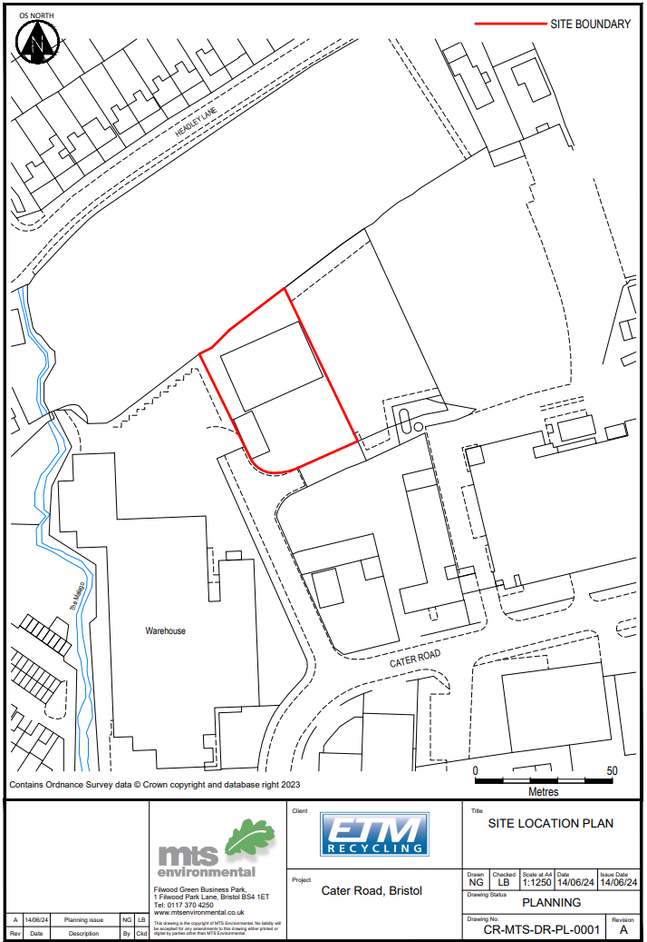
Figure 1 – Site Location Plan (also included in Appendix B)
Figure 2 – Site Layout Plan (also included in Appendix B)
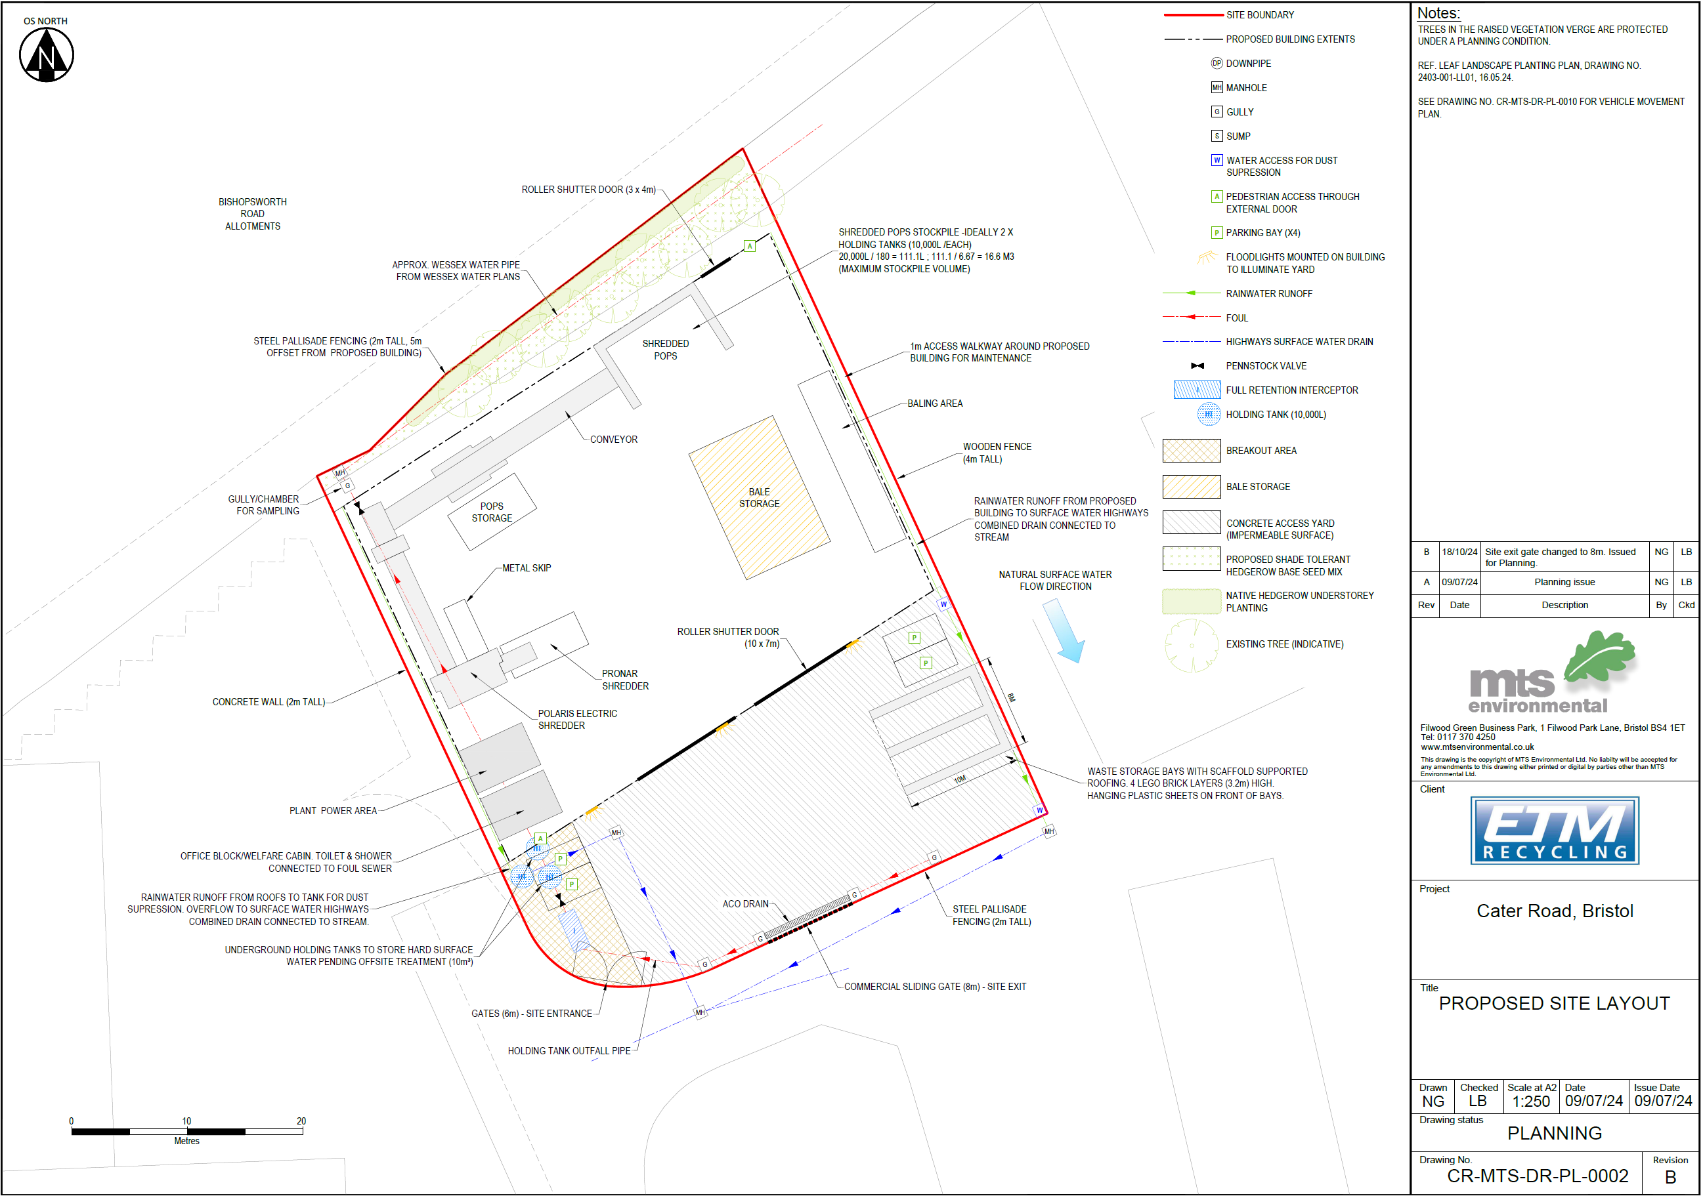
- Management
  - General Management
    - The Operator shall manage and operate the activities in accordance with this permit specific EMS and the bespoke permit, using sufficient competent persons and resources. ETM also have a corporate EMS structured on ISO 14001 requirements.
    - Operating techniques refer to the technical standards and appropriate measures cited within EA guidance, found on the gov.uk website, and the Specification for Highway Works. Annual reviews of the guidance will be undertaken to ensure this EMS is maintained in line with current legislation and guidance.
    - Records demonstrating compliance with the permit shall be maintained in accordance with Section 6 of this document.
    - Any person having duties that are or may be affected by the matters set out in this EMS shall have convenient access to a copy of this document and the permit. These documents will be available electronically via electronic systems and is issued as hard copy in the depot.
  - Contingency planning
    - The Operator will ensure that there are contingency plans in place to manage storage and treatment operations in the event of:
- Machinery / plant breakdown
- Accidents that may result in pollution to the environment
- Delivery problems
- Adverse weather conditions
- Staff shortages
    - The Operator will ensure that there are:
- Repair/servicing contracts are in place for all plant and machinery
- Repair /replacement can be achieved rapidly
- There is enough storage provision in the event of interruptions to the operation
- There are sufficient available staff to cover absence
    - In the event of an accident the Operator will follow the procedures in the Accident and Medical Incident Process.
    - In the event of an emergency, operations will be suspended where necessary to allow action to be taken safely. If necessary, all staff and others on site will be evacuated.
    - The Site Manager will be contacted in the event of any operational failure. The Operator will decide if operations are to be suspended before corrective action is taken. Any failures will be recorded in the site diary.
  - Sufficient Competent Persons
    - The Operator shall comply with the requirements of an approved competence scheme. The Technically Competent Manager/s (TCM) holds the Level 4 Certificate in Waste and Resource Management WAMITAB qualification. Copies of the certificates are included in Appendix C.
    - The site will be supervised by the TCM for at least 20% every week during the hours of operation and production. The TCM will make his presence known to the Nominated Competent Person/s (NCP) when attending the site.
    - In the event that the TCM cannot attend site, the NCP will be utilised to supervise those activities. This is relevant where it would be physically impossible to supervise all activities from the base of the TCM.
    - The TCM will ensure that all NCPs are provided with copies of and be familiar with the following:
- The relevant permit rules
- The EMS
    - During operational hours, the site will be supervised by the NCP/s who will be suitably trained and conversant with the requirements of the EMS and the permit to ensure that:
- All storage and treatment are carried out in accordance with the documents cited above
- They have sufficient authority to give or withdraw approval for treatment to go ahead at a particular time using specific risk assessments (e.g. with reference to weather conditions)
- They can be at site within 24hrs when treatment is occurring and 4 hours at any other time
- The person/s operating the equipment or delivering the waste to the site have been briefed on where and how the waste must be stored prior to treatment
- They raise any issues with the TCM to prevent permit breaches
- They are the first responder to any incidents including dust, noise or odour issues if the TCM is unavailable
- They report any incidents or non-conformances to the TCM
    - An NCP can be a direct employee of the company, a contractor or consultant or the TCM. The Operator will ensure that the roles and responsibilities of the NCP are clearly stated.
    - The Operator will ensure that the NCP is sufficiently trained to understand the following aspects:
- Waste management legislation and its requirements
- Environmental risk assessment
- Environmental protection measures
- The Operator’s management procedures
    - The Operator will maintain training records to demonstrate competence. These will be made available for inspection by the regulator.
    - The Operator will ensure that the management structure is regularly reviewed and kept updated to reflect any changes in management and staffing within the organisation, and/or as regards external contractors and consultants. Roles and responsibilities will be defined, and a written record will be maintained for inspection.
  - Staff Training
    - All new and existing staff will follow a specific training regime based on their role and responsibilities on site. This will improve the operation on site and reduce the likelihood of accidents and incidents which may harm the environment or site staff.
    - All staff will complete an orientation at the site and will maintain an up-to-date training record.
    - All staff are required to be aware of the controls outlined in this document and other relevant Management Plans.
    - All staff will receive appropriate health and safety and fire safety training relevant to their role.
    - Relevant staff will be trained in waste acceptance, identification of waste types and management of storage areas to ensure that operations comply with the requirements set out in the permit for the site.
    - Plant operators will have the necessary qualifications and will be trained to regularly check plant and machinery and identify any defects to prevent incidents that could have a negative impact on the environment or safety.
    - Contractors working on the site on a temporary basis will receive general site training.
  - Avoidance, Recovery and Disposal of Wastes Produced by the Activities
    - The Operator shall take appropriate measures to ensure that:
(a) The waste hierarchy referred to in Article 4 of the Waste Framework Directive is applied to the generation of waste by the activities; and
(b) Any waste generated by the activities is treated in accordance with the waste hierarchy referred to in Article 4 of the Waste Framework Directive; and
(c) Where disposal is necessary, this is undertaken in a manner which minimises its impact on the environment.
    - The Operator will ensure that each waste stream arising from the regulated facility will be characterised and quantified.
    - The Operator will use government guidance to decide how each waste stream is to be recovered or disposed of and be capable of justifying decisions that deviate from best practice.
    - Records will be maintained in order to explain why any waste may be subject to disposal. These will explain:
- Why recovery is technically and economically impossible; and
- Describe the measures planned to avoid or reduce any impact on the environment.
    - The Operator shall review and record at least every four years whether changes to those measures should be made and take any further appropriate measures identified by a review.
- operations
  - Permitted Activities
    - The permit boundary is outlined in red on the Site Layout Plan in Appendix B. Any references to ‘the site’ made in this or other site documents refer to this area and associated infrastructure.
    - The activities on site are 1.16.6 – Household, commercial and industrial waste transfer station.
    - The site allows the processing of Persistent Organic Pollutants (POPs) waste and bulky waste. Treatment activities will include sorting, separating, shredding and baling for the recovery of wastes. The waste will then be removed off site for recycling and reuse or disposal at appropriately permitted facilities. The bulky waste will mainly consist of PVC window frames and is shredded to separate out the metals which are recovered and plastics which are recycled. The shredded POPs waste may be baled and is sent for incineration for energy from waste.
    - The operating hours of the site are as follows. Outside of these hours, onsite maintenance work, emergency deliveries and general office use will be the only activities on site.
07:00 – 18:00 Monday to Friday
07:00 – 13:00 Saturday
Closed on Sundays and Bank/Public Holidays
    - The annual tonnage on site will not exceed 75,000 tonnes.
    - The Operator shall not undertake any waste management treatment activity unless it specifically complies with Table 1.
Table 1 - Waste Operating Techniques
Description of Activities | Limits of Activities
D15: Storage pending any of the operations numbered D1 to D14 (excluding temporary storage, pending collection, on the site where it is produced.  D9: Physico-chemical treatment not specified elsewhere which results in final compounds or mixtures which are discarded by means of any of the operations numbered D1 to D12.  R3: Recycling/reclamation of organic substances which are not used as solvents (including composting and other biological transformation processes)  R4: Recycling/reclamation of metals and metal compounds.  R5: Recycling/reclamation of other inorganic materials  R13: Storage of waste pending any of the operations numbered R1 to R12 (excluding temporary storage, pending collection, on the site where the waste is produced) | Treatment consisting only of manual/mechanical sorting, separation, screening, blending, baling, shredding, crushing or compaction of non-hazardous or inert waste into different components for disposal (no more than 50 tonnes per day) or recovery.  All wastes shall be treated on an impermeable surface with sealed drainage.  The maximum quantity of waste subjected to a treatment operation shall not exceed 75 tonnes per day.  Maximum storage in the building to be limited to 850 tonnes.  Maximum storage outside on impermeable surface to be 500 tonnes either in containers or in open bays.  There shall be no treatment of WEEE, batteries, cooling equipment or display equipment.  Wastes shall be stored for no longer than 1 year prior to disposal or 3 years prior to disposal.

Permitted Wastes
    - No wastes other than those with the (European Waste Code) EWC codes listed in Table 2 below shall be accepted onto site.
Table 2 Permitted Waste Types and Quantities for the Storage of Waste
Waste Code | Description
02 01 03 | Plant-tissue waste
02 01 04 | Waste plastics (except packaging)
03 01 01 | Waste bark and cork
03 01 05 | Sawdust, shavings, cuttings, wood, particle board and veneer other then those mentioned in 03 01 04
10 11 12 | Clean glass other than those mentioned in 10 11 11
10 12 08 | Waste ceramics, bricks, tiles and construction products (after thermal processing)
12 01 01 | Ferrous metal filings and turnings
12 01 03 | Non-ferrous metal filings and turnings
12 01 05 | Plastics shavings and turnings
15 01 01 | Paper and cardboard packaging
15 01 02 | Plastic packaging
15 01 03 | Wooden packaging
15 01 04 | Metallic packaging
15 01 05 | Composite packaging
15 01 06 | Mixed packaging
15 01 07 | Glass packaging
15 01 09 | Textile packaging
16 01 03 | End-of-life tyres
16 02 14 | Discarded equipment other than those mentioned in 16 02 09 to 16 02 13
16 02 16 | Components removed from discarded equipment other than those mentioned in 16 02 15
17 01 01 | Concrete
17 01 02 | Bricks
17 01 03 | Tiles and ceramics
17 01 07 | Mixtures of concrete, bricks, tiles and ceramics other than those mentioned in 17 01 06
17 02 01 | Wood
17 02 02 | Glass
17 02 03 | Plastic
17 04 01 | Copper, bronze, brass
17 04 02 | Aluminium
17 04 03 | Lead
17 04 05 | Iron and steel
17 04 07 | Mixed metals
17 04 11 | Cables other than those mentioned in 17 04 10
17 05 04 | Soil and stones other than those mentioned in 17 05 03
17 08 02 | Gypsum only other than that mentioned in 17 08 01
17 09 04 | Mixed construction and demolition wastes other than those mentioned in 17 09 01, 17 09 02 and 17 09 03
19 12 01 | Paper and cardboard
19 12 02 | Ferrous metal
19 12 03 | Non-ferrous metal
19 12 04 | Plastic and rubber
19 12 05 | Glass
19 12 07 | Wood other than that mentioned in 19 12 06
19 12 08 | Textiles
19 12 10 | Combustible waste (refuse derived fuel)
19 12 12 | other wastes (including mixtures of materials) from mechanical treatment of wastes other than those mentioned in 19 12 11
19 13 02 | Solid waste from soil remediation other than those mentioned in 19 13 01
20 01 01 | Paper and cardboard
20 01 02 | Glass
20 01 08 | Biodegradable kitchen and canteen waste
20 01 10 | Clothes
20 01 11 | Textiles
20 01 36 | Discarded electrical and electronic equipment other than those mentioned in 20 01 21, 20 01 23, and 20 01 35
20 01 38 | Wood other than that mentioned in 20 01 37
20 01 39 | Plastics
20 01 40 | Metals
20 02 01 | Biodegradable waste
20 02 02 | Soil and stones
20 03 01 | Mixed municipal waste
20 03 07 | Bulky waste

  - Site layout and general principles of operation

    - Details of the site layout are shown on the site layout plan in Appendix B. The site is separated into safe working areas with dedicated boundaries for specific activities.
    - Only waste that is suitable for direct use will be stored securely at the place where it will be used for treatment. The Operator will take all precautions to prevent the waste from escaping and ensure that members of the public are unable to gain access to the waste.
    - All waste will be stored and managed in accordance with the appropriate measures specified. These include:
- Wastes stored on an impermeable surface with sealed drainage.
- Designated and segregated stockpiles.
- Locating temporary stockpiles in areas of low permeability if possible.
- Grading temporary stockpiles to promote rainwater run off rather than infiltration through the stockpile.
- Managing all run off or leachate which may be produced by the waste.
- Being aware of slumping.
- Considering location of sensitive receptors such as residential properties/workplaces in relation to stockpiles that might be affected by loss of amenity or dust and odour.
    - Waste will only be stored at the site of treatment for a maximum of 1 year prior to disposal and 3 years prior to recovery.

    - The Operator will follow Best Practice for the storage of materials as listed below:
- On impermeable surface
- Not on land likely to become waterlogged, frozen or snow covered
- No odorous waste within 250m of residential or workplaces
- Not on land likely to flood
- Not on steeply sloping ground where there is risk of run off
- Not over land drains or land drained in the last 12 months

    - The following plant will be used within the waste processing area (inside the covered building):
- Wheeled Loading Shovel/Loader
- Mobile Shredder (UNTHA XR3000C)
- Water Tankers
- Baler
    - All POPs waste will be stored inside the covered building and not mixed with other wastes to prevent damage and contamination. If there is a mixed load containing POPs waste then the wholeload will be classed and managed as POPs waste.

  - Control of Mud and Debris

    - To control the release of mud and debris onto the public highway the following methods will be employed:
- Road sweeping.
- Containment, storage and treatment of waste in designated areas within stockpiles and/or containers.
- Water based dust suppression and wheel wash.
    - If any mud/debris is found on the public highway resulting from lorry movements into and out of the site, the affected public areas shall be cleaned. Measures will be taken to clear any such sources from the highway as soon as is practicable.
    - Additionally, all loaded vehicles will be sheeted to avoid the escape of any waste.
    - The site will operate in accordance with a site-specific Dust Management Plan outlining mitigation measure in place on site.

  - Potentially Polluting Leaks and Spillages of Waste
    - Adherence to the monitoring regime set out in Table 4, in conjunction with the site engineering for pollution prevention and the acceptance of permitted inert wastes only, will ensure that the risk of potentially polluting leaks and spillages of waste from the site is minimised.
    - Any minor spillages of liquid waste or oil shall be cleaned up immediately, by first containing the spill using sand or soil. In the unlikely event of a major spillage, immediate action shall be taken to prevent contamination entering surface drains, watercourses and un-surfaced ground. Temporary bunds using sand or similar will be placed around the area affected until the spill is cleared up.
    - Once the spillage has been contained any materials that may be subject to contamination shall be cleared immediately and placed in sealed, labelled containers and removed by a suitably permitted exterior contractor for remediation or disposal. The Environment Agency shall be informed immediately, and the details of the event recorded in the site diary in accordance with the ETM Management System.
    - If a spillage has contaminated the surface water drainage system, spill kits will be used which consist of absorbent mats that soak up any contaminating hydrocarbons. The Operator will arrange for the drainage system to be cleaned and emptied and the contents disposed of to a suitably permitted site. If a spillage occurs inside the building, the concrete is laid to fall into a gully which drains into an interceptor to a sealed collection tank which can then be emptied.
    - Fuel and oil stored on site will be contained in compliance with oil storage regulations. The fuel tanks will be contained within a bund capable of containing 110% of the maximum volume of the tank. This bund will enclose all the pipework and infrastructure associated with the tank. The tank will be locked to prevent unauthorised access to prevent leaks and theft.
    - All site surfaces will be inspected during daily checks for any litter or spillages. Any litter will be swept as necessary and contained for disposal to a suitably permitted site.
    - All staff will be informed and trained on the emergency response to spills.
  - Surface Water Management
    - The site benefits from an impermeable surface and sealed drainage system which all surface water from the operational site surface area drains into, following the natural fall of the site. Only clean roof water runoff drains into the permeable made-ground at the rear of the site via a soakaway.
    - Interceptor maintenance procedures will involve regular inspections and cleaning every six months.
    - Any potentially polluting contaminants found in the surface water will be treated through the full retention interceptor before draining to highways surface water line.
  - Fires on Site
    - No wastes shall be burnt on site. The use of welding/cutting tools (i.e., with naked flame) must be sanctioned first by the Depot Supervisor/competent person and a hot works permit issued.
    - Special care will be taken with respect to potentially explosive/volatile material during handling, e.g., aerosol cans, oxidising agents, corrosive substances. These shall be removed from the waste load prior to further handling. These wastes are not permitted under the permit and, the quantities and occurrence of these waste types entering the site is predicted to be small as long as the waste acceptance procedures are strictly adhered to.
    - All site operatives shall be required to recognise signs of smouldering waste at the point of reception. Such wastes shall remain in the container and removed to a safe area. The Depot Supervisor shall be informed. In the event of smouldering waste being tipped, the operative shall make an immediate assessment of the situation and inform the Depot Supervisor. The fire shall be extinguished as soon as practicable.
    - Combustible wastes shall be kept in segregated stockpiles, in a covered building, with fire prevention measures laid out in the Fire Prevention Plan.
    - Appropriate fire extinguishers shall be made available and easily accessible.
    - Fuel is stored securely on site as outlined in 4.5.5.
    - Regular fire drills will be conducted on site to ensure that staff follow the proper procedures.
  - Recording and Reporting Procedures
    - Where site personnel have dealt with a fire successfully, it should be reported to the Fire Service as well as the Environment Agency. Records will be kept of all significant events (including fire, accidents, waste refusal) in the Site Diary. Information should include the nature and extent of the incident, and the actions and remediation measures taken. The Site Diary must be in a form where it can be audited.
  - Waste Acceptance and Control Procedures
    - Waste shall only be accepted if:
- It is of a type listed in Table 2 above.
- It conforms to the description in the documentation supplied by the producer and holder
    - The Operator will ensure that all wastes accepted at the site for storage are fully characterised and acceptable by implementing the following procedures:
- Visual inspection of incoming materials in accordance with the appropriate documentation.
- Waste Transfer Note (WTN).
- chemical analyses (if available from producer).
    - The Operator will ensure that all Duty of Care transfer notes include the following information and are written legibly:
- Delivery date and time
- Origin of the waste.
- Waste description including type, quantity and EWC code
- Container type
- Carriers’ details
- Identity of the waste producer
    - The Operator will refer to the supporting information and WTN to identify and understand the beneficial and harmful properties of the waste to identify any potential problems that may arise from storage, transport and re-use. Any incoming POPs waste is coded as 20 03 07 and is stated that it contains POPs in the description. Outgoing POPs waste is shredded to the specification required for destination incinerator or cement kiln and classified as 19 12 10 and clearly described as containing POPs from domestic seating.
    - The Operator will confirm the physical state; liquid, sludge or solid by reference to the definitions found within EA Guidance for waste acceptance at landfills
    - Upon arrival on site, all vehicle drivers must report to the site office for weighing and inspection.
    - All waste received at the site shall be visually inspected to confirm that the description and composition conform to the written description and the European Waste Code on the relevant Duty of Care Transfer Note and to the description as detailed in the permit, and any other accompanying documentation.
    - Visual inspection of incoming waste will be undertaken on site.
    - Once confirmed the load will be discharged to the appropriate storage area / container. The waste shall be discharged and visually checked for a second time to ensure that there are no non-permitted wastes within the load.
    - All wastes received shall be kept separate from and shall not be covered by or mixed with other wastes until they have been confirmed and recorded for acceptance at the site.
    - Records will be maintained in accordance with Section 6 of this EMS.
  - Waste Refusal
    - In the event that a vehicle load, upon inspection, is non-compliant with the environmental permit the following steps will be implemented:
- Refusal of the container/load will result in refused entry or placed in quarantine area
- Enter the event in the site diary, including the relevant information contained on a WTN
- Contact waste producer to advise
    - Any items of non-permitted waste which are detected after acceptance at the site shall be placed immediately in the designated quarantine storage area, comprising a skip or similar container and segregated from the other wastes. The details shall be entered into the site diary.
    - Quarantined waste shall be removed from site within 7 days. A record shall be kept of all rejected wastes in the Site Diary.
    - Waste will be refused if maximum storage capacity has been reached on site, no further waste will be accepted until other waste has been removed off site to an appropriately permitted or exempt site.
  - Waste Quantity Measurement Systems
    - Incoming waste shall be recorded in cubic metres and measured based on the capacity of the containers used for transport.
    - A summary of waste outputs and inputs onto site will be submitted to the EA using the standard Generic Operator Returns electronic spreadsheet every quarter.
  - Site Inspections
    - Site inspections shall be undertaken by the TCM or NCP in his/her absence during operating hours and abnormal observations recorded in site diary. Table 4 represents the issues that may need to be covered and gives the suggested time intervals.
    - The suggested inspection criteria are included in Table 3.
Table 3 - Site Inspection Checklist
Issue | Frequency | Action
General site and road  cleanliness  (presence of mud/debris) | Daily | Sweep road, impermeable surfacing if mud/ debris  present. Record Inspections /actions in diary.
Inspect tanks, containers,  drums, drip trays and secondary  containment for leaks. | Daily | Any leaks to be stopped and cleaned up, containers  to be replaced/ repaired immediately. Record  inspections/ defects, damage and repairs in diary.
Visual inspection of boundary  fences for breaks / damage | Daily | Any defects shall be made secure by temporary repair  before the start of operations/end of working day  and shall be repaired within 24 hours of the damage  being detected. Record Inspections/ defects,  damage and repairs in site diary.
Check mobile bowser | Daily | Any defects shall be repaired before the start of  operations / end of the day within 24 hours of the  damage being detected. Record Inspections/ defects,  damage and repairs in Diary.
Visual monitoring for aerial  emissions - monitor dust at random  times throughout the  day. | Daily | Check site boundaries for visual dust emissions at  least twice daily.  Record inspections / results / weather conditions /  cause and actions in site diary.
General site cleanliness  (presence of litter and dust  deposits inside /outside site  boundary) | Daily | Site walkover and inspection. Collection from inside  and outside site (including boundary hedging) twice  daily. Investigate the cause. Record Inspections/  defects, damage and repairs in site diary.
Site Signage | Daily | Check that signs are in good condition and arrange to  repair /replace if damaged. Record Inspections  /defects, damage and repairs in site diary.
Pest infestation check. Check  containers and stockpiles to  monitor for vermin,  scavengers and flies | Daily | Implement Pest Management Plan if presence of  vermin, scavengers and /or flies are noted. Record  daily inspections and results in site diary.
Ensure waste is stored in  appropriate segregated containers  and areas in accordance with Good  Practice Guidance | Daily | Check quantities are in accordance with EMS and  Permit. Segregate as and when necessary. Record  actions in site diary.
Check condition of fixed  drainage facilities. | Weekly | Remove silt upon build up.  Check and record levels within containers/lagoons.  Take action to prevent spillage/ remove via vacuum  tanker, etc. Record actions in site diary.
Inspection of plant | Weekly | Maintenance/repair/regular servicing.  Record actions in diary and plant maintenance log  sheets.
Surfacing/Building | Monthly | Any defects affecting the integrity shall be repaired  within one week.
    - Any necessary repairs will be made within 5 working days of discovery, unless agreed otherwise with the EA.
    - Any major defects which have the potential to cause a breach in permit if not repaired will be repaired by the end of the same working day. If this is not possible then contact with the EA will be made to agree alternative options.
  - Site Security
    - The site is surrounded by palisade fencing and secure access gates.
    - 24-hour CCTV is in operation on site at the main site access gates.
    - In the event of a bomb scare, the site will be immediately evacuated, operations suspended, and the police contacted. The police will then take control of the site until the threat is removed. The EA will be informed of the event.
  - Site Closure Plan
    - In the event that the Operator wishes to cease the permitted waste operations on the site, the Operator will contact the EA to inform them of the closure.
    - Any waste remaining on site will be inspected by the TCM, who will produce plans for its quick and safe removal off site.
    - All waste, plant and machinery will be removed from site.
    - A site investigation will be conducted to determine the quality of the ground condition on site following all operations.
    - The Operator will submit a surrender of the permit application to the EA for duly making.
- POLLUTION CONTROL, MONITORING AND REPORTING

5.1 Pollution Risk Management
    - The Operator will ensure that a site-specific risk assessment is used throughout all treatment activities. See Appendix E for Environmental Risk Assessment.
    - Fuel will be stored in accordance with Environmental Laws and all staff will receive a Toolbox Talk on security procedures to minimise the chances of fuel being a source of pollution.
- Emissions and Monitoring

Introduction - Emissions to Air, Land and Water
    - Emissions from waste to land during operations can lead to pollution of surface and groundwater, and the air. Waste storage and treatment operations can lead to the production of emissions of dust, aerosols, odour, and noise.
    - The EA requires that the Operator take appropriate measures to control potential emissions to or from the waste operation. The following sections therefore set out the measures that will be taken to prevent or minimise the risk to potentially sensitive receptors.
    - All sensitive receptors to the site and their respective locations are shown on the sensitive receptor plan in Appendix C. This EMS has been produced in consideration of these receptors and their protection.

Monitoring Control and Reporting of Dust Emissions
    - The key sources for the generation of dust onsite are as listed below:
- Dust raising from haul roads and operational surfaces through vehicle movements.
- Dust raising from the mechanical loading /unloading of wastes.
- Dust raising from the treatment operations.
- Dust raising from stockpiles.
    - The Operator shall take all appropriate measures to reduce and prevent dust emissions generated by the site. Table4 below sets out the measures that shall be undertaken to control and monitor the release of dust and particulates.
Table 4 - Measures to Control and Monitor Emissions of Dust
Appropriate Measures for Reducing Emissions of Dust
- Undertake operations within suitable weather windows wherever possible.
- All processing and treatment activities undertaken inside the recycling building.
- All incoming loads to be tipped in such a way as to minimise dust generation.
- All loading /unloading activities to be undertaken carefully to prevent waste materials being dropped from a height.
- Manage loading operations from stockpiles to mixing plant as above.
- Keep stockpiles with the potential to give dust as small as possible.
- Locate potentially dusty material in sheltered areas if possible and consider covering with a suitable material or cover.
- Dampen down material.
- No storage of waste outside designated containers or stockpile areas.
- Limit vehicle speeds during treatment to reduce dust raising.
- Maintain records of all actions.
Monitoring of aerial emissions
- Daily visual monitoring of aerial emissions at site boundaries shall be carried out by staff supervising all waste handling operations. | - TCM /NCP to monitor operations throughout day at the site boundary that is downwind of operations.  - Abnormal observations and weather conditions including wind direction will be recorded on the Site Diary.  - Complaints to be recorded in the Site Diary.
    - The Operator will take account of the weather conditions and ensure that all waste operations are undertaken in accordance with this information.
    - The TCM will nominate a person, or persons to be responsible in the absence of the TCM to undertake and record abnormal events. Additionally, all operational staff will be made aware of the importance of preventing dust emissions from leaving the boundary of the site.
    - In the event of a complaint the Operator will immediately investigate the source of the dust and whether it is originating from the site. Action will be taken to prevent any further emissions leaving the site. A Corrective Action Report will be completed describing the incident and should include details as specified above. A record will be made in the site diary.
    - A site-specific Dust Management Plan has been produced, outlining the mitigation measures in place at the site.
  - Monitoring and Control of Noise
    - Noise and vibration will be maintained at levels associated with normal civil engineering activities. Where the site-specific Environmental Risk Assessment identifies sensitive receptors near the operation the Operator will take all measures to minimise noise impacts to those receptors.
    - The Operator will ensure that all plant is maintained in accordance with the manufacturer’s guidelines. Maintenance records will be maintained.
    - The activities on site are unlikely to greatly increase the noise level in the surrounding area due to the nature of business of the neighbours.
  - Monitoring and Control of Litter
    - The risk of litter becoming a nuisance is very low because wastes will have been segregated and should not contain litter. However, the potential for litter nuisance will be further minimised with the implementation of the following provisions:
- Sheeting of all incoming loads.
- All incoming loads to remain sheeted until ready to be tipped.
- Daily inspection of the site boundaries at least once per day, corrective action to be recorded in the site diary.
- Litter picking when required.
    - On the detection of litter, the Operator shall take action to review the waste management processes at the site and modify or cease handling the waste, if necessary, in order to minimise the production of litter.
    - The incident, actions and results shall be recorded in the site diary.
  - Monitoring and Control of Pests (including scavengers, gulls)
    - The Operator will take appropriate measures to prevent and reduce nuisance from scavengers, vermin, and flies. These are listed below in Table 5.
    - An inspection of stored wastes for pest infestations shall be carried out at least at weekly intervals and more often, if necessary, by the site supervisor and shall be recorded in the site diary.
    - On detection or notification of pest infestations, immediate action shall be taken to secure the attendance of a professional pest control contractor, to eliminate the pest infestation. The incident and remedial action shall be recorded in the site diary.
Table 5 - Measures to reduce nuisance from scavengers, vermin, and flies
Appropriate Measures for Reducing Nuisance from Scavengers, Vermin and Flies
- Reduce the potential for scavenging, attracting vermin and fly breeding in stockpiles by identifying waste likely to attract flies.
- Locate loading/ unloading areas, stockpiles as far from human receptors as is possible.
- Keep machinery clean.
- Store any putrescible waste within the covered recycling building.
- Conclude operations as quickly as possible.
Monitoring of aerial emissions
- Daily visual monitoring of stockpiles by staff supervising waste handling operations. | - TCM /NCP to monitor waste types for infestations  - Observations and weather conditions including wind direction will be recorded on the site diary
  - Monitoring and Control of Mud and Debris
    - Vehicles will be inspected, both the vehicles and bodies, upon entry and exit of the site for exterior mud and debris. Any excess mud and debris will be removed, and vehicles will be washed down to ensure that no mud is carried out onto access roads.
    - Any mud or debris detected on the site roads will be reported to the site manager.
    - Any mud or debris detected on the local public highways due to operations on site will be cleared immediately by the Operator, manually using a brush or using a road sweeper if necessary.
  - Monitoring and Control of Odour
    - The waste accepted on site is not putrescible in nature so odour should not cause any complications or breach of the permit on site.
    - On the detection of odour, the operator shall take action to review the waste management processes at the site and modify or cease handling the waste, if necessary, in order to minimise the production of odour.
    - The incident, actions and results shall be recorded in the site diary.
    - Any putrescible waste will be contained within the covered building and sent to a suitably permitted site for disposal.

- SITE RECORDS
  - Security and Availability of Records
    - All Duty of Care Transfer Notes will be kept for a minimum of 2 years.
    - Records of wastes rejected by the site and/or dispatched from the site shall be kept in the site office for a minimum of 6 years. These will be available for inspection by an authorised person.
  - Records of Waste Movements (Waste Returns)
    - Records of all waste movements shall be kept in accordance with the relevant condition in the permit. Additionally, a summary record of the waste types accepted and removed from the site shall be made on the Environment Agency returns form every quarter. This information will be submitted to the Agency within 1 month following the end of the quarter.
  - Records of off-site Environmental effects
    - Records of any off-site environmental effects including pollution incidents that caused or were alleged to have caused harm or health effects will be retained.
  - Records of on-site Environmental effects
    - Records that relate to the condition of the land and groundwater will be retained in the Site Condition Report. This is a live document and will be maintained throughout the life of the site. Records will include details on:
- Design, construction, inspection, monitoring & maintenance.
- Failure of pollution prevention control measures.
- Spills and incidents.
- Records of investigations and remedial actions.
- Records of remedial action in response to non-conformances as noted by an EA Officer.
  - Site Diaries
    - A site diary will be kept secure within the site office and made available for inspection by the Environment Agency as and when required. The diary will contain the following information and be maintained in a form that can be audited:
- Start and finish of any construction works.
- Maintenance.
- Plant and machinery breakdowns.
- Emergencies.
- Problems with waste received and action taken.
- Site inspections and consequent actions carried out by the Operator.
- TCM attendance - the date and the time on site and the time left site.
- Dispatch of any records to the Environment Agency.
- Severe weather conditions.
- Any environmental problems and remedial actions taken.
- Any complaints related to operational activities.
- Records of site monitoring – odour /dust/litter/ pests /surface water.
- Records of inspection of the interceptor.
    - All records shall be completed within 24 hours of the event.

Appendix A – Site Permit

Appendix B – Site Layout, Location and Drainage Plans

Appendix C – Sensitive Receptor Plan

Appendix D – Training Records

Appendix E – Environmental Risk Assessment

Appendix F – H&S Procedure

Appendix G – Forms

Non-hazardous and inert waste: appropriate measures for permitted facilities, Nov 2020 Environment Agency, gov.uk
https://www.gov.uk/guidance/develop-a-management-system-environmental-permits
Waste Framework Directive, 2008/98/EC
Guidance for waste acceptance at landfills, Environment Agency

