INTRODUCTION

The Medisort site is located on a corner plot of 0.86 acres on Fort Road which is in the NE corner of the Lineside Ind Est.We have Industrial premises on 3 sides of us the 4th side is allotments. There has been an operating clinical waste facility here since 2004 which was Initially, a transfer’s station, then moving on to processing clinical waste with one autoclave. Medisort took over the site in May 2010, Medisort later installed a second autoclave.

The site consists of the yard area and two covered buildings, which houses both autoclaves and associated equipment. All loading and unloading of waste to done to the rear of the building via two large roller shutter doors.

Non-Hazardous waste (Offensive waste 180104) is stored in 55-yard skips in the yard prior to collection. These skips are removed daily Mon-Sat.

The site has not received an Odour related compliant in the last 4 years.

Site Location:

Medisort Ltd

Fort Road

Wick

Littlehampton

BN17 7QU

/// rungs. Choice. indoor

OS Map Ref: TQ021026

Prevailing wind direction: West

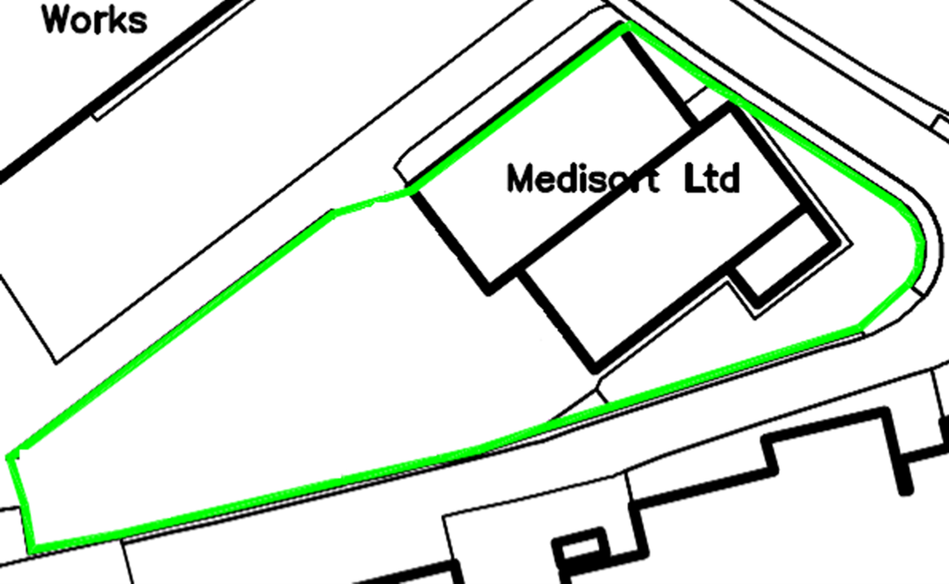
Prevailing wind:West
North

Waste Activities carried out on site.

Thermal Treatment in autoclaves (AR1).

Storage (AR3, AR8).

Repackaging (AR2, AR7).

Permitted waste types and quantities.
Table S2.2 Permitted waste types and quantities for thermal treatment in autoclaves (AR1)
Maximum quantity | The maximum annual throughput for the clinical waste activity is 12,000 tonnes.
Waste code | Description
16 | WASTES NOT OTHERWISE SPECIFIED IN THE LIST
16 02 | Wastes from electrical and electronic equipment
18 01 03* and 16  02 14 | discarded equipment other than those mentioned in 16 02 99 to 16 02 03 with infectious contamination
18 01 03* and 16  02 16 | components removed from discarded equipment other than those mentioned in 16 02 05 with infectious contamination
18 | WASTES FROM HUMAN OR ANIMAL HEALTH CARE AND/OR RELATED RESEARCH (EXCEPT KITCHEN AND RESTAURANT WASTES NOT ARISING FROM IMMEDIATE HEALTH CARE)
18 01 | wastes from natal care, diagnosis, treatment or prevention of disease in humans
18 01 03* | infectious waste, not contaminated with chemicals or medicines, including single- use medical instruments (Note 1)
18 02 | wastes from research, diagnosis, treatment or prevention of disease involving animals
18 02 02* | infectious waste, not contaminated with chemicals or medicines (Note 1)
20 | MUNICIPAL WASTES (HOUSEHOLD WASTE AND SIMILAR COMMERCIAL, INDUSTRIAL AND INSTITUTIONAL WASTES) INCLUDING SEPARATELY COLLECTED FRACTIONS
20 01 | separately collected fractions (except 15 01)
20 01 99 | infectious waste, not contaminated with chemicals or medicines – municipal, separately collected fractions, not from healthcare or research-related sources (Note 1)
Note 1: Excluding: sharps (unless rendered unusable and unrecognisable); anatomical waste; waste known or likely to contain ACDP Hazard Group 4 biological agents; any waste from a containment level 3 laboratory; all microbiological cultures from any source; and any potentially infected waste from pathology departments and other clinical or research laboratories (unless autoclaved before leaving the site of production).
Table S2.3 Permitted waste types and quantities for storage (AR3 & AR8) and repackaging (AR2 & AR7)
Maximum quantity |  | The total annual tonnage of waste from this table accepted at the site for storage and transfer only shall not exceed 8,000 tonnes.
Waste code |  | Description
09 |  | WASTES FROM THE PHOTOGRAPHIC INDUSTRY
09 01 |  | wastes from the photographic industry
09 01 01* |  | water-based developer and activator solutions
09 01 04* |  | fixer solutions
09 01 07 |  | photographic film and paper containing silver or silver compounds
15 |  | WASTE PACKAGING, ABSORBENTS, WIPING CLOTHS, FILTER MATERIALS AND PROTECTIVE CLOTHING NOT OTHERWISE SPECIFIED
15 01 |  | packaging (including separately collected municipal packaging waste)
15 01 04 |  | lead foils from dental care
16 |  | WASTES NOT OTHERWISE SPECIFIED IN THE LIST
16 02 |  | wastes from electrical and electronic equipment
16 02 09* |  | transformers and capacitors containing PCBs
16 02 10* |  | discarded equipment containing or contaminated by PCBs other than those mentioned in 16 02 09
16 02 13* |  | discarded equipment containing hazardous components other than those mentioned in 16 02 09 to 16 02 12
16 02 14 |  | discarded equipment other than those mentioned in 16 02 09 to 16 02 13
16 02 15* |  | hazardous components removed from discarded equipment
16 02 16 |  | components removed from discarded equipment other than those mentioned in 16 02 15
18 |  | WASTES FROM HUMAN OR ANIMAL HEALTH CARE AND/OR RELATED RESEARCH (EXCEPT KITCHEN AND RESTAURANT WASTES NOT ARISING FROM IMMEDIATE HEALTH CARE)
18 01 |  | wastes from natal care, diagnosis, treatment or prevention of disease in humans
18 01 01 |  | sharps not contaminated with chemicals or medicines
18 01 01 and 18 01  09 |  | non-infectious sharps from vaccines delivered in mass vaccination centres, in the community and or in care homes
18 01 02 |  | non-infectious anatomical waste, not chemically preserved
18 01 02 and 18 01  06* |  | non-infectious anatomical waste, chemically preserved, hazardous chemicals
18 01 02 and 18 01  07 |  | non-infectious, anatomical waste, chemically preserved, non-hazardous chemicals
18 01 03* |  | infectious waste, not contaminated with chemicals or medicines (may contain sharps)  infectious anatomical waste, not chemically preserved  infectious gypsum wastes(for example, plaster casts and moulds)
18 01 03* and 18 01  06* or 18 01 07 |  | infectious waste, contaminated with chemicals infectious anatomical waste, chemically preserved
Table S2.3 Permitted waste types and quantities for storage (AR3 & AR8) and repackaging (AR2 & AR7)
Maximum quantity |  | The total annual tonnage of waste from this table accepted at the site for storage and transfer only shall not exceed 8,000 tonnes.
Waste code |  | Description
18 01 03* and 18 01  09 |  | infectious waste, medically contaminated (not cytotoxic or cytostatic) – (may contain sharps)  sharps from vaccinations delivered in hospitals or GP surgeries
18 01 04 |  | non-infectious offensive waste- human healthcare  non-infectious gypsum wastes (for example, plaster casts and moulds)
18 01 06* |  | chemicals consisting of or containing hazardous substances
18 01 07 |  | chemicals other than those mentioned in 18 01 06
18 01 08* |  | cytotoxic and cytostatic medicines
18 01 09 |  | other waste medicines, excluding cytotoxic and cytostatic medicines – human healthcare
18 01 10* |  | amalgam waste from dental care
18 02 |  | wastes from research, diagnosis, treatment or prevention of disease involving animals
18 02 01 |  | non-infectious sharps, not contaminated with chemicals or medicines
18 02 02* |  | infectious waste, not contaminated with chemicals or medicines (may contain sharps)  infectious anatomical waste, not chemically preserved  infectious gypsum waste (for example, plaster casts and moulds)
18 02 02* and 18 02  05* and 18 02 06 |  | infectious waste, contaminated with chemicals infectious anatomical waste, chemically preserved
18 02 02* and 18 02  07* or 20 01 31* |  | infectious waste, contaminated with cytotoxic and cytostatic medicines (may contain sharps)
18 02 02* and 18 02  08 |  | infectious waste, medicinally contaminated (not cytotoxic or cytostatic) (may contain sharps)
18 02 03 |  | non-infectious anatomical waste, not chemically preserved non-infectious offensive waste  non-infectious gypsum wastes (for example, plaster casts and moulds)
18 02 03 and 18 02  05* |  | non-infectious anatomical waste, chemically preserved, hazardous chemicals
18 02 03 and 18 02  06 |  | non-infectious anatomical waste, chemically preserved, non-hazardous chemicals
18 02 05* |  | chemicals consisting of or containing hazardous substances
18 02 06 |  | chemicals other than those mentioned in 18 02 05
18 02 07* |  | cytotoxic and cytostatic medicines
18 02 08 |  | other waste medicines, excluding cytotoxic and cytostatic
20 |  | MUNICIPAL WASTES (HOUSEHOLD WASTE AND SIMILAR COMMERCIAL, INDUSTRIAL AND INSTITUTIONAL WASTES) INCLUDING SEPARATELY COLLECTED FRACTIONS
20 01 |  | separately collected fractions (except 15 01)
20 01 01 |  | paper and cardboard
Table S2.3 Permitted waste types and quantities for storage (AR3 & AR8) and repackaging (AR2 & AR7)
Maximum quantity |  | The total annual tonnage of waste from this table accepted at the site for storage and transfer only shall not exceed 8,000 tonnes.
Waste code |  | Description
20 01 02 |  | glass
20 01 31* |  | cytotoxic and cytostatic medicines – municipal, separately collected fractions not from healthcare or research-related sources
20 01 32 |  | other waste medicines, excluding cytotoxic and cytostatic medicines – municipal, separately collected fractions not from healthcare or research-related sources
20 01 99 |  | non-infectious offensive waste – municipal, separately collected fractions not from healthcare or research-related sources  non-infectious sharps, not contaminated with chemicals or medicines – not from healthcare or research-related sources  infectious waste, not contaminated with chemicals or medicines – municipal, separately collected fractions, not from healthcare or research-related sources (may contain sharps)

Site Plan

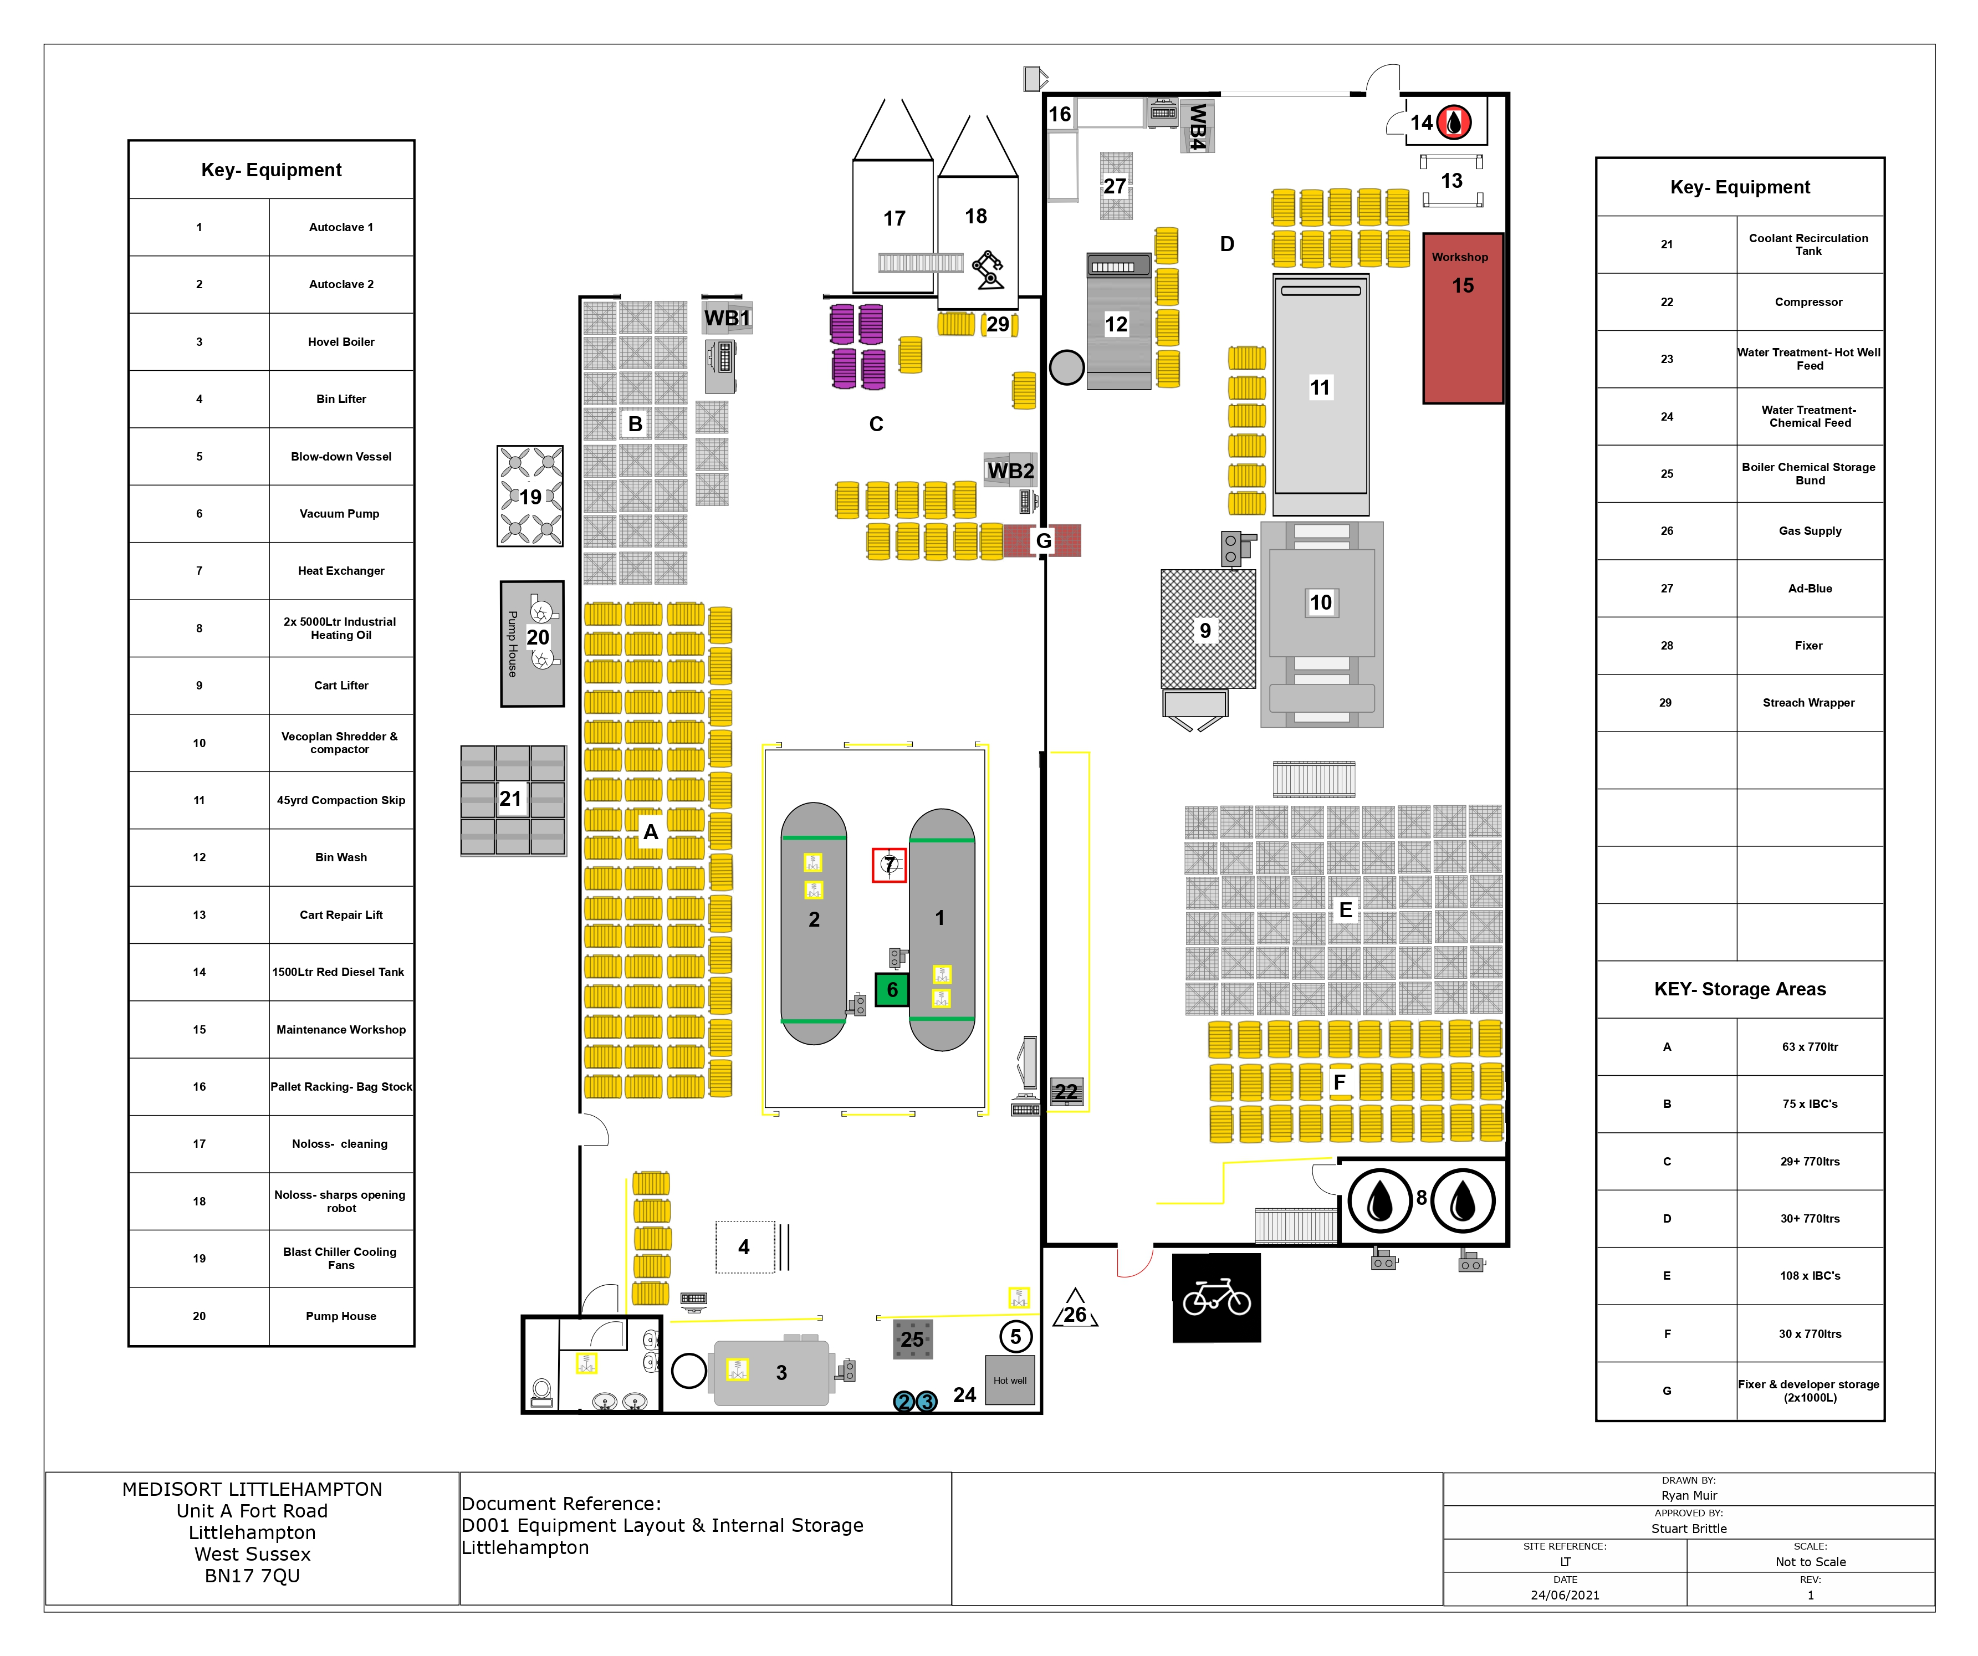

Medisort will carry out odour monitoring (Sniff Testing) daily to ensure compliance with our permit and in line with Environment Agency Guidance below.

You may need to carry out an assessment either to work out whether you are complying with your permit, or as a part of an investigation into a complaint system. You can use routine assessments to build up a picture of the impact the odour has on the surrounding environment over time. You can develop ‘worst case’ scenarios by doing assessments during adverse weather conditions or during particularly odorous cycles of an operation. Ideally, you should use the same methodology to follow up complaints.

Please note:
- Staff normally exposed to the odours may not be able to detect or reasonably judge the intensity of odours off-site. You might be better off using office staff or people who have not recently been working on the site to do this.
- Don’t use anyone who has a cold, sinusitis or a sore throat, because these can affect the sense of smell.
- To improve (or to check) data quality, you can get two people to do the test independently at the same time.
- Those doing the assessment should avoid strong food or drinks, including coffee, for at least half an hour beforehand. They should also avoid strongly scented toiletries and deodorisers in the vehicle used during the assessment.

Where you test will depend on:

- whether you are responding to a complaint.
- whether you are checking your state of compliance at sensitive receptors.
- whether you are trying to establish the source of an odour.
- wind direction.

The assessment may involve someone walking along a route that you have selected either because of these factors, or in response to the conditions they found when they got there. Another option is to choose fixed points so that you can evaluate the changing situation over several weeks or months. Or the test points may vary from test to test according to local conditions, which would help you identify worst case conditions. You should also keep a note of any external activities (such as agricultural practices) that could be the source of the odour, contribute to the odour, or be a confounding factor. Remember that an odour may become diluted or even change over a distance. You should also take the factors given in the H4 Guidance (Section 7.2 on monitoring ambient air) into account.

DAILY ODOUR CHECKS
The daily odour check will be conducted in line with this procedure and the result recorded on the daily/weekly maintenance checklist H003.30. If an intensity of 3 or greater is detected, then form E007.11.2 Odour Report Form (Sniff Test) will be completed and filed in the plant run sheets file in the plant manager’s office.

ODOUR ASSESSMENT SCORE TABLE
Intensity (Detectability) |  | Location Sensitivity
0 | Not used | 0 | Not detectable
1 | No detectable odour | 1 | Remote (no housing, commercial/industrial premises or public area within 500m)
2 | Faint odour (barely detectable, need to stand still and inhale facing into the wind) | 2 | Low sensitivity (no housing, etc. within 100m of area affected by odour)
3 | Moderate odour (odour easily detected while walking & breathing normally) | 3 | Moderate sensitivity (housing, etc. within 100m of area affected by odour)
4 | Strong odour | 4 | High sensitivity (housing, etc. within area affected by odour)
5 | Very strong odour (possibly causing nausea depending on the type of odour | 5 | Extra sensitive (complaints arising from residents within area affected by odour)
6 | Extremely strong odour (difficult to remain in the area without being nauseous) | 6 | Extra highly sensitive (advise housing and businesses with 100m to close windows and doors close operations until odour is under control.

CONTROL OF ODOUR ON SITE:

There is no Significant odour produced from the Autoclave process there is no extraction or abatement system fitted.
Odours if any that are emitted from the process are eliminated or reduced via the PLC (Programmable Logic Controller) system and the way the system has been set up to ensure that no un-controlled venting of the vessel inner chamber. The only elements that are released are

- Steam from the Boiler safety valves if there is a process problem.
- Steam from the autoclave feed line if there is a boiler or pressure reducing valve problem.
- Steam from boiler blow-down.
- Steam from the hot well.

Steam odour Issues
Boiler feed water is treated to prevent damage to it and associated pipework. Medisort will select water treatment chemicals that cause the least detectable odour from the steam vents. The current chemicals that are used:
- Pure Salt this product Is both odourless during storage and whilst in use.
- Water treatment chemical S301 which is both odourless during storage and whilst in use.

From the Autoclave Process
- Emission from point A1 Vacuum Pump Vent. Normal operations not visible
Abnormal operations
- Steam from a blown autoclave door seal. Checks are carried out on the door seal before each load is loaded.
- Steam from the sewer discharge point S1 this discharge is controlled by two thermocouples to ensure correct discharge temperature is maintained.

Waste operations
Waste operations could be the major contributor to odour for site operations if not controlled.

Waste for Treatment: Table S2.2 Permitted waste types and quantities for thermal treatment in autoclaves (AR1).
All waste is stored in closed bins inside the building as per permit requirements. until the point of transfer into the treatment carts for autoclaving. If a bin is found to be odorous the lid will be closed, and the tipping operation will not commence until the autoclave cycle is ready to be loaded to minimise the odour release from that bin.

Waste for transfer/storage: Table S2.3 Permitted waste types and quantities for storage (AR3 & AR8) and repackaging (AR2 & AR7).
Hazardous waste that is to be transferred off site will be stored in locked wheeled bins or other UN approved, PG II containers and then loaded in accordance with the current Carriage of Dangerous Goods Regulations. Loading of theses bins only takes place in the permitted area.

There are two waste steams which requiring transferring of site that could lead to odour issue if not managed. appropriately:

18 01 02 Anatomical Waste:
- We only accept anatomical waste if we have guaranteed next day onward disposal.
- Only accept this waste if it’s appropriately packaged in a one way burn bin and is sealed correctly.

18 01 04/18 02 03 Offensive Waste:
- Can become an odour issue in the warmer weather, the 180104/180203 is transfer off site on a daily and sent off to a EfW plant.
- The 180104/180203 is stored in 55-yard skips in the yard.

The other EWCs codes on our permit pose little or no odour issues.

Our waste tracking system, MediTrack, is used to prevent odour in a way that means we can deal with waste on a first come first treatment or transfer basis by indicating to all site staff information on all aspects of the waste on site including:
- Arrival date and time.
- Disposal date and time.
- From where waste originated.
- Waste type by EWC code.
- Weight of consignment.
- Number of bins for consignment.
- Bin numbers that waste is contained in.

The system also displays current waste levels on site for
- Processing or
- Transfer by EWC code and weight for each category

All wheeled bins are washed in our dedicated bin washer.
Site housekeeping will be of a standard to ensure that the floors are cleaned weekly, and that flock residue is removed from around the shredder and compactor daily.

Any particularly odorous wastes presented by a third-party contractor will only be accepted to site once the waste has been Inspected by the Site Manager, Shift supervisor or COTC holder for the site.

The daily sniff test procedure will be carried out daily by shift supervisor or COTC holder for the site and recorded on H003.30

Medisort has laid a route out to be followed when undertaking the daily sniff test. D010 Odour Monitoring Points.

Complaints from outside parties will be dealt with using the E007.11.3 Site Complaint Form and will be reported to the EA by Medisort.

Source of odour | Receptor | Likelihood | Odour level as per OAST | Control measures | Actions if odour starts causing a problem | Who is responsible for taking action
Waste awaiting transfer/ storage. | General Public  Work Force | Unlikely if controlled | 0-2 | Ensure waste that is due for transfer is dispatched on a first in first out basis. | Transfer waste immediately | Site Manager, Shift supervisor or COTC Holder for site
Waste accepted for onsite treatment. | General Public  Work Force | Unlikely if controlled | 0-2 | Ensure that waste accepted for onsite treatment is autoclave on a first in first autoclaved basis. | If problem waste found at waste reception staff would seek advice from Site manager, COTC Holder for site. | Site Manager, Shift supervisor or COTC Holder for site
Blown door seal @ Pre-Vacuum | Work Force |  | 0-2 | Maintenance: staff trained to check door seals when loading the autoclave along with daily checks recorded on H003.30 | Sterilisation cycle aborted. door seal replaced. | Site Manager, Shift supervisor or COTC Holder for site
Boiler Blow-down | General Public | Daily discharge  4 to 6 times per day | 0-2 | Discharge would only be virgin steam The process takes approximately three seconds and vents via a roof mounted vent stack with a height of 8 meters approximately above the ground. | Check boiler chemical feed rate. | Site Manager, Shift supervisor or COTC Holder for site
Shredding operations | Work Force | Daily | 0-2 | Shredder is enclosed  Shredder debris removed when required daily checks recorded on H003.30 | Shut down shredder operation investigate odour. | Site Manager, Shift supervisor or COTC Holder for site
Blocked Drains | General Public  Work Force | Possible | 0-2 | Daily Checks of drainage system and records of findings recorded on  H003.30 | Stop operations and unblock drains. | Site Manager or COTC Holder for site
Bin Washing | Work Force | Daily | 0-2 | Daily washing of all bins 770/360ltr bins via the dedicated bin washer. | Re- wash bins until odour is gone | Site Manager or COTC Holder for site
Waste Spillage | General Public  Work Force | Possible | 0-2 | Waste handling Procedures E007 section 7.5 to 7.5.8 | H011 Accident Management Plan | Site Manger or suitably trained staff.
Fire on Site | General Public  Work Force | Unlikely | 0-5 | Fire risk assessment  Operation procedures | H011 Accident Management Plan | Site Manger or suitably trained staff.
Sewer Discharge | General Public  Work Force | Unlikely | 0-2 |  | Checks on waste feed stock  Check boiler chemical feed rate. | Site Manger or suitably trained staff.
Offensive Waste  Storage  18 01 04/180203 | General Public  Work Force | Possible | 0-2  0-3 if the Weather is persistently warm. | Daily dispatch to third party disposal. Mon-Sat. | Contact. 3rd party disposal. to see if scheduled collections can be adjusted. To allow for earlier removal. | Site Manager or COTC Holder for site
Flock Waste  19 01 03 | General Public  Work Force | Possible | 0-2 | Daily dispatch to third party disposal. Mon-Sat. | Contact. 3rd party disposal. to see if scheduled collections can be adjusted. To allow for earlier removal. | Site Manager or COTC Holder for site
Odorous waste arriving at site | General Public  Work Force | Possible | 0-2 | If processable, waste would be treated as soon as practicable. | Immediate Processing | Site Manager or COTC Holder for site
18 01 02 Anatomical Waste | General Public  Work Force | Possible | 0-2 | We only accept anatomical waste if we have guaranteed next day disposal. | Remove from site immediately to 3rd party disposal. (Incineration) | Site Manager or COTC Holder for site

Associated documents:
E007.11.2 Odour Report Form.
E007.11.3 Site Complaint Form.
D010 Odour Monitoring Points.
H003.30 Daily & Weekly Maintenance checklist.
E007 section 7.5 to 7.5.8.
H011 Accident Management Plan.

