The Medisort Limited is committed to conducting its activities in an environmentally responsible manner and recognises the need to continually improve its operations where practical to do so, in order to reduce the effects on the environment. The Company also recognises its role in environmental stewardship.

In order to achieve these overall objectives the following policy has been adopted.

- To identify and use materials/processes that reduces the risk of pollution.
- To promote natural resource conservation by the efficient use of energy and the minimal use of raw materials.
- To minimise discharges, emissions and waste and their environmental effects, including maximisation of recycling.
- To set annual environmental objectives and targets against which to measure improvements in environmental performance.
- To ensure compliance with environmental legislation and regulations.
- To document procedures and continuously monitor progress in environmental performance through regular measurement, review and audit, utilising a management system compliant with ISO 14001:2004 which is compatible with our quality system.
- To encourage our suppliers and subcontractors to adopt an environmental management system.
- To ensure that all employees are made aware of environmental issues through a programme of training relevant to their roles.
- To conduct our activities so as to maximise our influence on environmental good practice.
- To provide information on our environmental performance to interested parties.

This policy shall be available to the public.

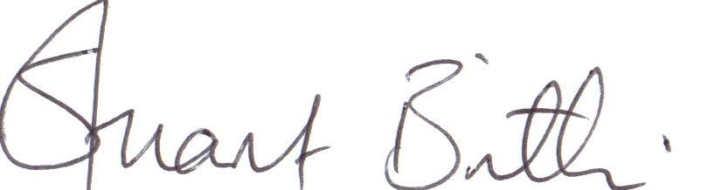

Stuart Brittle
Managing Director
April 2024

