CONTENTS

1. INTRODUCTION

2. SITE LOCATION

3. WASTE ACCEPTANCE

4. THE PROCESS

5. ENVIRONMENTAL PROTECTION and CONTROL MEASURES

6. AMENITIES

7. MAINTENANCE

8. INTEGRATED MANAGEMENT SYSTEMS

9. SITES of SPECIAL SCIENTIFIC INTEREST

10. SUSTAINABILITY

## 1 INTRODUCTION

* 1. **Medisort Limited.**

This application seeks a variation to an existing Environmental Permit: **QP3536TW**

**While preparing this NTS and other associated paperwork, Medisort Ltd has considered all the requirements within EA guidance: Healthcare waste and appropriate measures for permitted facilities.**

Medisort Limited has been the permit holder for this site since May 2010. Medisort Ltd currently operates 2 Steam sterilisation units (Autoclaves); the site is also an active transfer station, mainly concentrating on healthcare-style wastes. Medisort Ltd is dedicated to reducing and reusing elements within the healthcare waste sector. We recently participated in a comprehensive research programme alongside The University of Brighton on reusing elements within single-use incontinence pads and other absorbent hygiene products (AHPs).

We also offer and encourage healthcare providers who use single-use metal instruments to use our steam sterilisation services. Once sterilisation is done, the SUIs can be included in metal recycling schemes.

This Variation application will allow us to extend our quest to reduce and reuse elements from the healthcare waste sector, in this case, sharps containers.

The NO-LOSS system has been developed with Sharpak; the NO-LOSS system is designed to work with the SHARPAK ZERO range of containers.

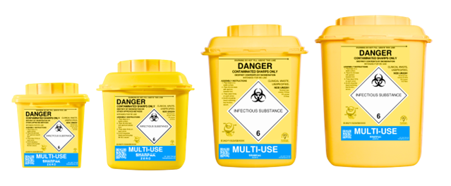

The current SHARPAK range.

The Sharpak NO LOSS Wash System installed at the premises of Medisort; Littlehampton is

a bespoke system comprising of 2 key areas**.**

The first area is designed for the automated and safe removal of the sharps container contents. Operators place the locked reusable sharps containers onto a conveyor, which travels through an opening into a locked area that houses the robotic arm. This area is kept under negative pressure while in operation.

The robotic arm removes the container from the conveyor and, using sensors, determines which opening jig to place the container into. Four different-sized reusable sharps containers are used, each with a specific opening jig.

The opening jig removes the lid from the container before the arm recollects the opened container and moves around to the waste chute.

Once emptied of sharps waste, the robotic arm transports the reusable sharps container to a tray loader, which inverts it onto a wash tray using a predetermined pattern based on the container size.

The wash trays then pass along a conveyor to the second area where the wash unit is housed. The conveyor transports the contaminated reusable sharps container into an Electrolux professional Warewashing Hygiene Multi Rinse Rack wash system consisting of 3 washer phases.

* The first wash phase is set at 750C + 100C and incorporates the use of a glass wash detergent (ECOLab Assert Lemon) to remove soiled debris and organic matter.
* The second wash phase is set at 800C +50C to rinse the container before passing to the final washer phase.
* The third wash phase to set at 950C + 50C to complete the decontamination steps.

The reusable sharps container exits the wash system and is manually removed for storage.

The NO-LOSS system aims to reuse each container up to 100 times; once this 100 times cycle is reached, the container is then grounded back down to plastic pellets to be reused in making new NO-LOSS containers; this alone reduces the need for raw materials along with a carbon reduction.

**Carbon savings:**

* 89% less carbon is used during the lifecycle of the container.
* 90% carbon saving in manufacturing.
* 99% carbon saving in plastic.
* 100% carbon saving in incineration.

Medisort has gone through a process of converting its existing customer base to the Sharpak NO – LOSS containers.

We are currently in talks with many of the NHS Trusts we work with about converting to the Sharpak NO–LOSS containers.

There is no change in how the Sharpak NO – LOSS containers are collected and transported, unlike any other sharps container, except for the fact that using the Sharpak NO – LOSS containers gives the option to support the waste hierarchy framework. In particular, the elements of Prevention, Preparing for reuse and recycling.

Using the Sharpak NO – LOSS containers supports the NHS target of net zero for direct carbon emissions by 2040 and net zero for indirect carbon emissions by 2045 and ensure the NHS is using its resources effectively, in the case of using Sharpak NO – LOSS containers; it also has no impact on the way the Healthcare staff produce or use their sharps boxes at the point use.

<https://sharpaks.com/zero/>

<https://youtu.be/u_fNueMMP6s>

1. **SITE LOCANTION**

**Medisort Ltd**

**Fort Road**

**Wick**

**Littlehampton**

**BN17 7QU**

**/// rungs. Choice. indoor**

**OS Map Ref: TQ021026**

**Prevailing wind direction: West**

**No Loss Installation. (within or permired area)**

**/// mole.lines.crisis**

**2.3** Access to the site is via Fort Road; waste deliveries come through the Lineside Ind Est, which has direct access to the A259.

2.4 The NO LOSS equipment is located in two joined 40-foot ISO containers on impermeable surface in our yard within our permitted area; the unit is covered by a waterproof lean too, with access from inside the main building via a roller shutter.

**See Document:**

**D007 Littlehampton Site green line (with the location of** **NO-LOSS )**

**D025 Site Access & Egress**

## 3 WASTE ACCEPTANCE

**3.1** All waste deliveries will be deposited in the waste reception area in the existing building and will be tracked using MediTrack **E007.5.9 i4 MediTrack Waste Booking & Tracking Procedure**

**3.2** Pre-acceptance procedures are in place to ensure that only waste that may be accepted under the Environmental Permit is directed to the site. Suitably trained operatives will check all vehicles delivering waste to the site to ensure that only permitted wastes are accepted. The site has dedicated weighbridges where visual checks will be made before wastes are directed to the appropriate storage area. **D013 Waste transfer flow**

**3.5** Pre-acceptance waste audits are logged on Medisort's MOPS - Medisort Order Processing System

, along with pre-acceptance waste audit evidence from third parties. **E007.4.1.1 i12 Pre-Acceptance Waste Audit form**

**3.6** Only wastes permitted by the Environmental Permit will be accepted. Any loads containing non-permitted waste will be rejected from the site or dealt with as the Environment Agency advises. Any waste found to be non-conforming, such as missed consigned waste, incorrectly used EWCs or incorrect packaging, will be placed in the quarantine area.

The COTC holder will complete the **E005.4.1** **Non-conformance Action Form**. The customer/producer must immediately be advised of the problem and agree on remedial action. The maximum storage time for quarantined loads must take account of the potential for odour generation and insect infestation. The maximum storage volume for quarantined waste is one bin. In all cases, two working days is the maximum storage time for hazardous waste that has failed to meet the acceptance criteria.

**3.7** Waste Permit:

|  |  |
| --- | --- |
| **Table S2.2 Permitted waste types and quantities for thermal treatment in autoclaves (AR1)** | |
| **Maximum quantity** | **The maximum annual throughput for the clinical waste activity is 12,000 tonnes.** |
| **Waste code** | **Description** |
| **16** | **WASTES NOT OTHERWISE SPECIFIED IN THE LIST** |
| **16 02** | **Wastes from electrical and electronic equipment** |
| 18 01 03* and 16  02 14 | discarded equipment other than those mentioned in 16 02 99 to 16 02 03 with infectious contamination |
| 18 01 03* and 16  02 16 | components removed from discarded equipment other than those mentioned in 16 02 05 with infectious contamination |
| **18** | **WASTES FROM HUMAN OR ANIMAL HEALTH CARE AND/OR RELATED RESEARCH (EXCEPT KITCHEN AND RESTAURANT WASTES NOT ARISING FROM IMMEDIATE HEALTH CARE)** |
| **18 01** | **wastes from natal care, diagnosis, treatment or prevention of disease in humans** |
| 18 01 03* | infectious waste, not contaminated with chemicals or medicines, including single- use medical instruments (Note 1) |
| **18 02** | **wastes from research, diagnosis, treatment or prevention of disease involving animals** |
| 18 02 02* | infectious waste, not contaminated with chemicals or medicines (Note 1) |
| **20** | **MUNICIPAL WASTES (HOUSEHOLD WASTE AND SIMILAR COMMERCIAL, INDUSTRIAL AND INSTITUTIONAL WASTES) INCLUDING SEPARATELY COLLECTED FRACTIONS** |
| **20 01** | **separately collected fractions (except 15 01)** |
| 20 01 99 | infectious waste, not contaminated with chemicals or medicines – municipal, separately collected fractions, not from healthcare or research-related sources (Note 1) |
| Note 1: Excluding: sharps (unless rendered unusable and unrecognisable); anatomical waste; waste known or likely to contain ACDP Hazard Group 4 biological agents; any waste from a containment level 3 laboratory; all microbiological cultures from any source; and any potentially infected waste from pathology departments and other clinical or research laboratories (unless autoclaved before leaving the site of production). | |

|  |  |
| --- | --- |
| **Table S2.3 Permitted waste types and quantities for storage (AR3 & AR8) and repackaging (AR2 & AR7)** | |
| **Maximum quantity** | **The total annual tonnage of waste from this table accepted at the site for storage and transfer only shall not exceed 8,000 tonnes.** |
| **Waste code** | **Description** |
| **09** | **WASTES FROM THE PHOTOGRAPHIC INDUSTRY** |
| **09 01** | **wastes from the photographic industry** |
| 09 01 01* | water-based developer and activator solutions |
| 09 01 04* | fixer solutions |
| 09 01 07 | photographic film and paper containing silver or silver compounds |
| **15** | **WASTE PACKAGING, ABSORBENTS, WIPING CLOTHS, FILTER MATERIALS AND PROTECTIVE CLOTHING NOT OTHERWISE SPECIFIED** |
| **15 01** | **packaging (including separately collected municipal packaging waste)** |
| 15 01 04 | lead foils from dental care |
| **16** | **WASTES NOT OTHERWISE SPECIFIED IN THE LIST** |
| **16 02** | **wastes from electrical and electronic equipment** |
| 16 02 09* | transformers and capacitors containing PCBs |
| 16 02 10* | discarded equipment containing or contaminated by PCBs other than those mentioned in 16 02 09 |
| 16 02 13* | discarded equipment containing hazardous components other than those mentioned in 16 02 09 to 16 02 12 |
| 16 02 14 | discarded equipment other than those mentioned in 16 02 09 to 16 02 13 |
| 16 02 15* | hazardous components removed from discarded equipment |
| 16 02 16 | components removed from discarded equipment other than those mentioned in 16 02 15 |
| **18** | **WASTES FROM HUMAN OR ANIMAL HEALTH CARE AND/OR RELATED RESEARCH (EXCEPT KITCHEN AND RESTAURANT WASTES NOT ARISING FROM IMMEDIATE HEALTH CARE)** |
| **18 01** | **wastes from natal care, diagnosis, treatment or prevention of disease in humans** |
| 18 01 01 | sharps not contaminated with chemicals or medicines |
| 18 01 01 and 18 01  09 | non-infectious sharps from vaccines delivered in mass vaccination centres, in the community and or in care homes |
| 18 01 02 | non-infectious anatomical waste, not chemically preserved |
| 18 01 02 and 18 01  06* | non-infectious anatomical waste, chemically preserved, hazardous chemicals |
| 18 01 02 and 18 01  07 | non-infectious, anatomical waste, chemically preserved, non-hazardous chemicals |
| 18 01 03* | infectious waste, not contaminated with chemicals or medicines (may contain sharps)  infectious anatomical waste, not chemically preserved  infectious gypsum wastes(for example, plaster casts and moulds) |
| 18 01 03* and 18 01  06* or 18 01 07 | infectious waste, contaminated with chemicals infectious anatomical waste, chemically preserved |

|  |  |  |  |
| --- | --- | --- | --- |
| **Table S2.3 Permitted waste types and quantities for storage (AR3 & AR8) and repackaging (AR2 & AR7)** | | | |
| **Maximum quantity** | | **The total annual tonnage of waste from this table accepted at the site for storage and transfer only shall not exceed 8,000 tonnes.** | |
| **Waste code** | | **Description** | |
| 18 01 03* and 18 01  09 | | infectious waste, medically contaminated (not cytotoxic or cytostatic) – (may contain sharps)  sharps from vaccinations delivered in hospitals or GP surgeries | |
| 18 01 04 | | non-infectious offensive waste- human healthcare  non-infectious gypsum wastes (for example, plaster casts and moulds) | |
| 18 01 06* | | chemicals consisting of or containing hazardous substances | |
| 18 01 07 | | chemicals other than those mentioned in 18 01 06 | |
| 18 01 08* | | cytotoxic and cytostatic medicines | |
| 18 01 09 | | other waste medicines, excluding cytotoxic and cytostatic medicines – human healthcare | |
| 18 01 10* | | amalgam waste from dental care | |
| **18 02** | | **wastes from research, diagnosis, treatment or prevention of disease involving animals** | |
| 18 02 01 | | non-infectious sharps, not contaminated with chemicals or medicines | |
| 18 02 02* | | infectious waste, not contaminated with chemicals or medicines (may contain sharps)  infectious anatomical waste, not chemically preserved  infectious gypsum waste (for example, plaster casts and moulds) | |
| 18 02 02* and 18 02  05* and 18 02 06 | | infectious waste, contaminated with chemicals infectious anatomical waste, chemically preserved | |
| 18 02 02* and 18 02  07* or 20 01 31* | | infectious waste, contaminated with cytotoxic and cytostatic medicines (may contain sharps) | |
| 18 02 02* and 18 02  08 | | infectious waste, medicinally contaminated (not cytotoxic or cytostatic) (may contain sharps) | |
| 18 02 03 | | non-infectious anatomical waste, not chemically preserved non-infectious offensive waste  non-infectious gypsum wastes (for example, plaster casts and moulds) | |
| 18 02 03 and 18 02  05* | | non-infectious anatomical waste, chemically preserved, hazardous chemicals | |
| 18 02 03 and 18 02  06 | | non-infectious anatomical waste, chemically preserved, non-hazardous chemicals | |
| 18 02 05* | | chemicals consisting of or containing hazardous substances | |
| 18 02 06 | | chemicals other than those mentioned in 18 02 05 | |
| 18 02 07* | | cytotoxic and cytostatic medicines | |
| 18 02 08 | | other waste medicines, excluding cytotoxic and cytostatic | |
| **20** | | **MUNICIPAL WASTES (HOUSEHOLD WASTE AND SIMILAR COMMERCIAL, INDUSTRIAL AND INSTITUTIONAL WASTES) INCLUDING SEPARATELY COLLECTED FRACTIONS** | |
| **20 01** | | **separately collected fractions (except 15 01)** | |
| 20 01 01 | | paper and cardboard | |
| **Table S2.3 Permitted waste types and quantities for storage (AR3 & AR8) and repackaging (AR2 & AR7)** | | | |
| **Maximum quantity** | | **The total annual tonnage of waste from this table accepted at the site for storage and transfer only shall not exceed 8,000 tonnes.** | |
| **Waste code** | | **Description** | |
| 20 01 02 | | glass | |
| 20 01 31* | | cytotoxic and cytostatic medicines – municipal, separately collected fractions not from healthcare or research-related sources | |
| 20 01 32 | | other waste medicines, excluding cytotoxic and cytostatic medicines – municipal, separately collected fractions not from healthcare or research-related sources | |
| 20 01 99 | | non-infectious offensive waste – municipal, separately collected fractions not from healthcare or research-related sources  non-infectious sharps, not contaminated with chemicals or medicines – not from healthcare or research-related sources  infectious waste, not contaminated with chemicals or medicines – municipal, separately collected fractions, not from healthcare or research-related sources (may contain sharps) | |

**3.8** THE NO-LOSS system will only process NO LOSS Sharpak sharps containers consigned as:

**WASTES FROM HUMAN OR ANIMAL HEALTH CARE AND/OR RELATED RESEARCH (EXCEPT KITCHEN AND RESTAURANT WASTES NOT ARISING FROM IMMEDIATE HEALTH CARE)**

**18 01 (Human Healthcare)** **Description**

* 18 01 01 Non - infectious sharps not contaminated with chemicals or medicines.
* 18 01 01 and 18 01 09 Non - infectious sharps contaminated with medicines.
* 18 01 03* Infectious sharps, not contaminated with chemicals or medicines.
* 18 01 03* and 18 01 09 Infectious sharps contaminated with medicines.

**WASTES FROM HUMAN OR ANIMAL HEALTH CARE AND/OR RELATED RESEARCH (EXCEPT KITCHEN AND RESTAURANT WASTES NOT ARISING FROM IMMEDIATE HEALTH CARE)**

**18 02 (Animal Healthcare)**  **Description**

* 18 02 01 Non - infectious sharps not contaminated with chemicals or medicines.
* 18 02 02* Infectious sharps, not contaminated with chemicals or medicines.
* 18 02 02* and 18 02 08 Infectious sharps contaminated with medicines.

**Non-Sharps: (Pharmaceutical Waste consigned in SHARPAK style containers)**

**18 01 (Human Healthcare) Description**

* 18 01 09 Other waste medicines, excluding cytotoxic and cytostatic medicines.

**18 02 (Animal Healthcare)** **Description**

* 18 02 08 Other waste medicines, excluding cytotoxic and cytostatic medicines.

**MUNICIPAL WASTES (HOUSEHOLD WASTE AND SIMILAR COMMERCIAL, INDUSTRIAL AND INSTITUTIONAL WASTES) INCLUDING SEPARATELY COLLECTED FRACTIONS**

**20 01 Description**

* 20 01 32other waste medicines, excluding cytotoxic and cytostatic medicines – municipal, separately collected fractions not from healthcare or research-related sources

**3.9 Processing of Sharps and Non-Sharps.**

* All sharps will be processed in a batch with compatible EWC codes.
* Non-Sharps (Pharmaceuticals) will not be mixed with sharps during the process and will be batch processed with their compatible EWCs.

## 4 THE PROCESS

The Sharpak NO LOSS Wash System installed at the premises of Medisort; Littlehampton is a

bespoke system comprising two key areas.

The first area is designed for the automated and safe removal of the sharps container contents.

The second area is where the washing process takes place.

**4.1 Flow and Equipment Diagram.**

**4.****2 Sharps box Emptying process:**

* Operators place full containers onto a conveyor **(1)** and make their way down to the "

Sharps Box Opening Area"

**Conveyor(1)**

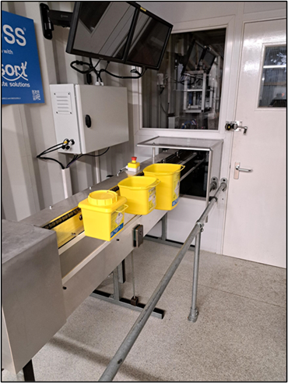

* 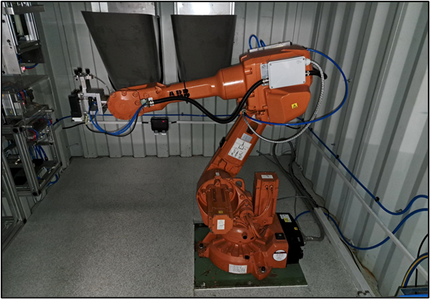Once in the "Sharps Box Opening Area" " the robotic arm**(2)** removes the container from the conveyor and, using sensors, determines which opening jig to place the container into currently, four different-sized reusable sharps containers are used, each having specific opening jig**(3)**. The opening jig then removes the lid from the container before the arm recollects the opened container and drops its contents down the chute at the back of the "Sharps Box Opening Area" The chutes lead to a larger UN-approved container for storage whilst on site and for onward transport to a suitable disposal site.

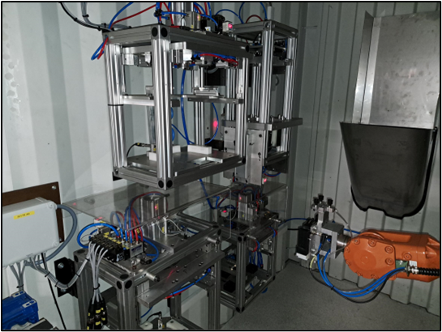**Robotic Arm (2) Opening Jig (3)**

• The "Sharps Box Opening Area" is always locked and kept under negative pressure whilst in operation.

**4.2 Sharps box washing process:**

* Once emptied of sharps waste, the robotic arm moves the reusable sharps container to a washing tray**(4);** part of this operation is the robotic inverting the reusable sharps container onto a wash tray using a predetermined pattern based on the container size.

**Washing Tray (4)**

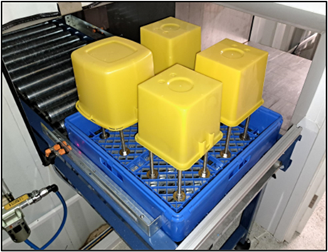

* The wash tray sits on the second conveyor, transporting the reusable sharps container to the washing unit.
* The washer unit is a Commercial food-grade conveyor base unit supplied by Electrolux from the Clean and Green award-winning range. The unit is designed for low energy and water usage.
* The washer unit has three wash phases:
  + The first wash phase is set at 75OC +/- 100C and incorporates a glass wash detergent (ECOLab Assert Lemon) to remove soiled debris and organic matter.
  + The second wash phase is set at 800C +/-50C to rinse the container before passing to the final washer phase.
  + To complete the decontamination steps, the third wash phase is set at 950C +/- 50C.
* The reusable sharps container exits the wash system and is manually removed for storage.
* The reusable sharps containers are then returned to the Sharpak manufacturing facility for quality checking.

Water usage:

* Each wash tray uses 0.9ltr, which is wastewater.
* The water is used in the wash cycle in this order: Final Rise – Wash Cycle – Prewash, then discharge at a rate of 0.9ltrs per wash tray.
* There are three internal tanks:

Prewash 35ltrs

Wash 70lts

Final 12ltrs

These tanks will be emptied and refilled daily, in line with the manufacturer's recommendations; **all wastewater** from the NO LOSS will be containerised and disposed of at an appropriate off-site treatment or disposal facility.

The detergent (Ecolab Assert Lemon) is added using a peristaltic pump delivered based on water flow into the machine, so it's consonantly added (topped up).

The detergent is not the effective sanitiser; it is there to act as a sufactant and, therefore, does not get "used up" so it's constantly effective.

## 5 ENVIRONMENTAL PROTECTION and CONTROL MEASURES

**Control of Emissions to Water,Land and Air.**

The NO-LOSS system is housed in two purpose-built ISO-style containers; the left-hand container houses the feed conveyor and the robot system, and the second container houses the second conveyer leading to the sanitising/washing unit; these containers are housed in a weatherproof enclosure. The opening and emptying process happens under negative pressure, and the air is extracted via a HEPA filter.

**5.1** The ISO-style containers are within our permitted area, which has an impermeable surface.

**5.2** Any wash water from the sanitising/washing unit will be containerised for off-site treatment/ disposal.

**5.4** Emission to air from waste received on-site is controlled by only accepting waste in sealed or closed packaging; this could range from a clinical waste bag, sharps box and wheeled bins or IBCs and palletised waste.

The waste waiting for transfer would be kept in secure packaging appropriate for that particular waste stream, and waste waiting on treatment will be stored in 360/770-wheeled bins as per our current permit.

**5.5** Emission to air from the "Sharps Box Opening Area",, which operates under negative pressure, is extracted to the atmosphere within the existing building via a HEPA filter.

Steam extractor to help with the drying process from the washing process is extracted to the atmosphere within the existing building and is not filtered.

**5.6** Odour management: the NO-LOSS system requires no additional odour management controls.

**5.7** If anything unforeseen was to happen, Medisort has a very comprehensive Accident Management Plan **H011 Accident** **Management Plan.**

**5.**8 Chemicals used in the washing process.

* Ecolab Assert Lemon (Manual Warewashing Detergent)
* Salt (used for water softening only)

**See Documents**

**H011 Accident Management Plan**

**SDS Ecolab Assert Lemon**

**COSH Assment Ecolab Assert Lemon**

**E007.11.1 Odour Management Plan LH**

## 6 AMENITIES

**6.1** Medisort's comprehensive management techniques are designed to minimise any risk of nuisance from noise, dust, odour, Litter, or vermin.

An approved pest control company will undertake pest control; pest control is integrated into Medisort's site maintenance and management checklists and procedures. **H003.30 i8 Maintenance Daily Weekly Checklist HH,**

* Litter and dust control is integrated into Medisort's site maintenance and management checklists and procedures. The NO-LOSS system will have no impact on Medisort's current Litter and Dust procedures.
* Noise: the site will use a Noise Management Procedure. The NO-LOSS system will not impact Medisort's current noise management procedures. **E007.12. Noise Management Procedure**
* Odour the site will use an Odour Management Plan. The NO-LOSS system will not impact Medisort's current odour management procedures. **E007.11.1 Odour Management Plan LH**

**6.2** All waste acceptance and treatment operations will take place inside a building. The building will be enclosed, with access gained through roller shutter doors. Waste will be treated or transferred on a first-in, first-out basis, hence minimising storage times and preventing any build-up of waste at the facility.

**6.3** Regular monitoring, inspections, and maintenance will be carried out to ensure the effective operation of the treatment and transfer process. Any Maintenance requirements to the NO-LOSS system will be integrated into Medisort's current maintenance checks: **H003.30 i8 Maintenance Daily Weekly Checklist, H003.32 i4 Maintenance Monthly Checklist, H003.33 i2 Maintenance Quarterly Checklist**

**6.4** All vehicles will access the site via Fort Road **E007.12.1 Noise management procedure LH**

**See Documents**

**E007.12.1 Noise management procedure LH**

**E007.11.1 Odour Management Plan LH**

**H003.30 i8 Maintenance Daily Weekly Checklist**

**H003.32 i4 Maintenance Monthly Checklist**

**H003.33 i2 Maintenance Quarterly Checklist**

## 7 MAINTENANCE

**7.1** Implementing a detailed maintenance plan minimises The risk of unplanned breakdowns. This will ensure that all equipment items are maintained in good working condition throughout their useful life and repaired or replaced if they are not operating to the required standard. This maintenance regime will minimise the risk of environmental and human health harm.

**7.2** In the event of extended maintenance or breakdown of THE NO-LOSS system, Medisort will utilise its incineration partners.

**See Documents**

**H003.30 i8 Maintenance Daily Weekly Checklist HH**

**H003.32 i4 Maintenance Monthly Checklist HH**

**H003.33 i2 Maintenance Quarterly Checklist HH**

## 8 INTEGRATED MANAGEMENT SYSTEMS

**8.1** Medisort has appropriate management to operate the site in compliance with its Integrated Management System. This will be audited for inclusion under our IMS certification. Medisort will have complete control over site operations, maintenance, staff competence and training, prevention of accidents, organisation, document management and records.

**See Documents**

**ISO 9001 Cert.**

**ISO 14001 Cert.**

**E002 ENVIRONMENTAL MANAGEMENT SYSTEM**

## 9 SITES of SPECIAL SCIENTIFIC INTEREST

**9.1** Medisort acknowledges that there are areas of SSSI in the area. The operation of the. NO-LOSS system will have an impact on any of these areas SSSI.

**See Documents:**

**E004.3.1 Habitats Assessment LH**

**E008.5.1 SSSI Site Locations Near LH**

**10** **SUSTAINABILITY**

Medisort is involved in several projects to move forward on how healthcare waste and its components can be reused or reduced.

* The NO-LOSS system will add to Medisort's ability to either reuse or reduce healthcare waste components and move towards a greener and Net Zero Carbon future. <https://sharpaks.com/zero/>
* The nappy recycling project looks at ways and techniques of extracting the fibres and the superabsorbent polymers from the nappy waste, which can then be used in either producing fibres and a recovered super absorbent polymer or producing cat litter from the combination of the recovered fibres and absorbent polymer. <https://www.brighton.ac.uk/business-services/knowledge-transfer-partnerships/medisort.aspx>
* With the NO-LOSS system, we also reduce vehicle loads to and from our Incineration partners.
* We are supplying customers with clinical waste bags (tiger bags) with increased recycled content.
* Autoclaving of blood and gas analysis machines (End-of-life equipment) to allow them to be effectively recycled.
* Autoclaving of single-use metal instruments to allow for metal recovery.
* Installation of solar panels on the roof at the Littlehampton site.

**See Documents:**

**E016 Sustainability Policy**

**E001 i3 Environmental Policy**