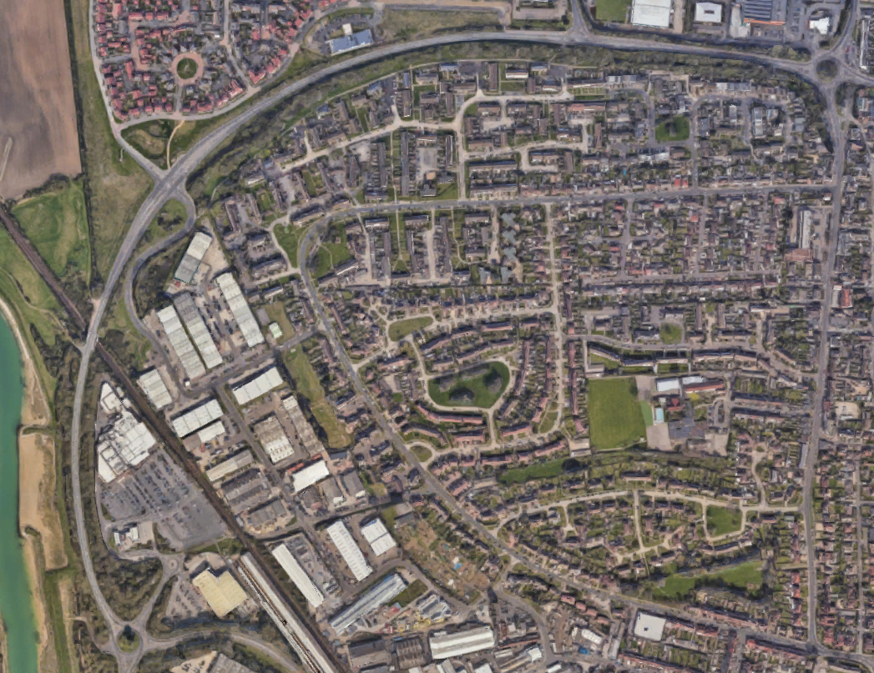
Standard Rule
Medisort
A259
A259
Eldon Way

To ensure compliance for our Vehicle Operators Licence, heavy goods vehicles MUST enter and exit via Eldon Way. Strictly no access via Clun Road
Roadworks
On the rare occasions when roadworks are undertaken in Eldon Way Medisort will contact the local council on highwayslicencing@westsussex.gov.uk to gain temporary access via Clun Road.

