

Berry Hill BC (13018) IED permit application
EPR/MP3193FE / WML319 (23668)
Additional Submission Information

October 2023

Environmental permitting (England and Wales) Regulations 2016

Contents
Introduction 4
Attachments List 5
Wessex Commitment Statements 6
Schedule 5 no.2 Q3 and 5 6
Schedule 5 no.2 Q9 6
Schedule 5 no.2 Q3 7
Process flow diagrams and Site Plans 8
Wessex Water Enterprises / Wessex Water Services Boundary Plan 8
Multi Operator Permit Boundary Plan 9
Asset Plan 9
Process Flow Diagrams 10
WWSL Berry Hill BC Process Flow Diagram 10
WWEL Berry Hill BC Biogas Process Flow Diagram 10
Emission / Sampling plan 11
WWEL Emission Plan 11
Schedule 5 no. 2 Q3 12
Drainage Plan 13
Form C6 completion 13
Process Description 13
PVRVs 14
Schedule 5 no.2 Q6 14
Schedule 5 no.1 Q20 14
Schedule 5 no. 2 Q6 all remaining parts 14
AERA 20
LDAR 20
Schedule 5 no.2 Q7 20
Digester Monitoring 21
Waste Pre-acceptance and Acceptance and Rejection Procedure 21
Waste storage, Handling, Throughput and EWC acceptance 21
Schedule 5 no.2 Q10 i) 21
Schedule 5 no.1 Q14 22
Schedule 5 no.1 Q4 25
Schedule 5 no.1 Q15 25
Containment 25
OMP 25
Multi-operator and demarcation 25
Schedule 5 no.2 Q32 25
Maintenance / Corrosion 26
Schedule 5 no.2 Q4 26
Raw Material Data Safety Sheets 27
Schedule 5 no.1 Q18 27
Appendix 1 – Inspection and maintenance 28
Appendix 2 – Design Standards 30

Introduction

The initial application for Berry Hill BC (Bioresources Centre) was made in November 2021. Wessex Water Services (WWSL) have subsequently received two schedule 5’s for another site and the additional information requested has been used to inform this additional gap submission to support the original Berry Hill application. This document is to be read in conjunction with the original application paperwork. Any replacement diagrams and reports included with this submission are to be taken as the latest reference document and the original versions disregarded. We very much appreciate the opportunity to submit this information now.
This submission is laid out in key areas following sectioning in Poole’s schedule 5 notices. References to attachments are made within each area along with an item number and are listed in the attachment list below.
As part of this gaps document, we’ve included an updated process description and diagram; the drainage plan, the emissions & sampling plans. There is also a revised Leak Detection and Repair plan, Odour Management Plan and secondary containment report.
The permitting snapshot is the original submission from November 2021 but with the use of two additional tanks (SLTH02 and SLTH05) and a standby generator. These new assets are marked on the process description and process flow diagram.
There have been no changes to the permit boundary and the current proposed secondary containment solution is within this original boundary.
We have used the structure and content from the second Poole schedule 5 notice (April 2023) to inform the revisions. Finally, a form C6 is attached as requested in the early part of 2022 for Tranche 2 sites and onwards. We have completed as much as possible, and it is to be read in conjunction with our commitment to complete the BAT 3 inventory analysis and risk assessments.
The air emission attachments have been updated in line with the most recent RFI received for Poole on 17 August 2023. The Air Emissions Risk Assessment has been updated with the additional pollutants Carbon Monoxide (CO), Particulates (PM10) and Total Volatile Organic Compounds (TVOCs) and will replace the previous AERA submitted on 13 January 2023.
The multi-operator aspect of this permit variation remains the same as the situation in November 2021, with the WWSL permit EPR/MP3193FE/ WML319 covering sludge treatment assets and most of the gas assets and the WWEL permit EPR HB3406LE only covering the CHP. As requested for Poole, we’ve included a WWSL / WWEL demarcation plan. The multi-operator aspect of this permit variation remains the same as the situation in November 2021, with the WWSL permit EPR/BB3934AG covering sludge treatment assets and most of the gas assets and the WWEL permit EPR/ HB3602TR only covering the CHP. As requested for Poole, we’ve included a WWSL / WWEL demarcation plan.

Attachments List

Attachment no. | Name / Area | File Name
1 | Boundary Plan | Berry Hill BC Plans Pack
1 | Asset Plan | Berry Hill BC Plans Pack
2 | Berry Hill Process Flow Diagrams | Berry Hill Process Flow Diagrams
1 | Emissions Plan | Berry Hill BC Plans Pack
1 | Sampling Plan | Berry Hill BC Plans Pack
3 | Drainage plan | Berry Hill BC Drainage Plan
4 | C6 form – vary a bespoke water discharge activity | Berry Hill BC C6 Form
5 | C6 form – additional responses | Berry Hill BC C6 Form – additional responses
6 | Berry Hill Process Description | Berry Hill Process Description
7 | AERA report | Berry Hill AERA.pdf
8 | Air Emission modelling | Berry Hill EA Files.zip
9 | LDAR plan | BIOP016 Berry Hill Fugitive emissions Leak Detection (LDAR plan) v 2 October 2023
10 | BIOF016 LDAR Berry Hill BC Appendix 3 | BIOF016 LDAR Berry Hill BC Appendix 3
11 | Process Monitoring | Berry Hill Digestion Process Monitoring Description
12 | Waste Pre-Acceptance, Acceptance and Rejection Procedure | TRTWP549 Waste Pre-Acceptance, Acceptance and Rejection Procedure
13 | WRC pre-acceptance record form | BIOF037 WRC pre-acceptance record form
14 | Residues Plan | Residues Plan - Berry Hill Bioresource Centre (TRTWP552)
15 | Best Tanker Practice for Berry Hill (TRTWG730) | Best Tanker Practice for Berry Hill (TRTWG730)
16 | Avoiding driving off whilst connected (TBT058) | Avoiding driving off whilst connected (TBT058)
17 | Containment report | Berry Hill BC CIRIA 736 IED Report October 2023
18 | Odour Management Plan | Berry Hill BC TRTWP525 OMP version 3 Final
19 | Polymer Zetag 8165 | ZETAG 8165.pdf
20 | Polymer Zetag 8187 | ZETAG 8187.pdf
21 | Mabanaft Diesel - TDS | Mabanaft Ltd – Diesel TDS1.pdf
22 | Mabanaft Diesel - SDS | Mabanaft Ltd – Diesel SDS1.pdf
23 | Gearbox Oil Fuchs Gear Oil 460 | Safety Data Sheet Renolin CLP Gear Oil 460 Fuchs Lubricants (UK) Plc (1).pdf
24 | Antifoam  Solenis Burst PF 13 | Safety Data Sheet Burst PF 13 T Solenis (1)
25 | CHP Oil – Fuchs Titan Ganymet Ultra | Fuchs Lubricants Company_TITAN GANYMET ULTRA LA.pdf

Wessex Commitment Statements

Schedule 5 no.2 Q3 and 5
Regarding assets with the potential to produce biogas, biomethane and diffuse emissions, and in line with BAT 14d, provide the following information regarding the ALL open topped, floating roofed and stated enclosed assets
A written confirmation that you will fully enclose open tanks
A written description that demonstrates the tank enclosure/cover will be designed and installed in line with guidance, Biological waste treatment: appropriate measures for permitted facilities.
Wessex Water commit to fully enclosing all secondary digesters at Berry Hill BC. All capital schemes will be designed and in line with BATc 14d and Section 7 of the Biological waste treatment: appropriate measures for permitted facilities.
Site improvements
Our strategy for remedial works, including the larger and more complicated items such as tank covering and secondary containment are closely tied in with process safety, resilience, landbank pressure and net zero. This will involve shutting down sites in a planned and ordered way to complete the work in an appropriate and safe manner. This strategy was detailed in our Chief Executive response (23/06/2023) to your IED compliance letter and we also outlined this approach in a meeting with the Wessex Area Director and local EA on 08/08/2023 in Bridgwater.

The following items are assets at Berry Hill BC have been identified as requiring remedial works:
Howard Tanks, SLTH02 SAS & raw sludge holding tank, are to be covered as in the above statement in line with BAT14d or the tank (s) will be replaced.

Schedule 5 no.2 Q9
Provide the following information regarding releases of effluent/digestate in storm conditions:
Provide written procedures which describes the site’s contingency arrangements to prevent digestate and effluent being discharged to the WwTW while the WwTW are in storm conditions.
The current situation is that liquors are returned to the inlet of Holdenhurst WRC upstream of the storm overflow. We are developing a contingency procedure to prevent this discharge in storm conditions and provide a commitment to divert this overflow to down stream of the storm overflow.

Provide a description of the buffer storage proposals to control or hold emissions in the event of storm overflow conditions at the WwTW.
There are no current proposals for additional buffer storage.

Should any contingency arrangements use storage tanks to act as a buffer, provide evidence that demonstrates the waste waters or digestates can be held in this storage during the period of storm overflows.
No storage contingency arrangements are in use other than the available pumping station capacity.

Schedule 5 no.2 Q3
Provide a written confirmation that you will undertake (using a UKAS accredited laboratory) a chemical analysis of the waste water which tests for ALL pollutants which you expect to find in the discharge (not just the limited data set as specified in response to question 13 of the previous schedule 5 notice) and that you will use an appropriate ‘minimum reporting value’ (MRV) (usually 10% of the environmental quality standards (EQS)). You will be able to gain an understanding of the expected pollutants by examining the likely pollutants in the input wastes, trade effluents and other sludge inputs which are combined for treatment at the installation.
Provide written confirmation that the sampling and chemical analysis will be undertaken in line with guidance Surface water pollution risk assessment for your environmental permit - GOV.UK (www.gov.uk) and Monitoring discharges to water: guidance on selecting a monitoring approach - GOV.UK (www.gov.uk).
Provide a written statement with a commitment that those undertaking the sampling and analysis will be accredited to MCERTS or provide evidence of an equivalent standards.
Wessex Water are committed to providing information about the characteristics of the waste water streams being discharged at Berry Hill BC and will do so in line with BAT 3, 6 and 7. In addition, we will undertake sampling and analysis in line with Surface water pollution risk assessment for your environmental permit - GOV.UK (www.gov.uk) and Monitoring discharges to water: guidance on selecting a monitoring approach - GOV.UK (www.gov.uk)

Wessex Water will achieve this by using UKAS accredited laboratory/laboratories to carry out chemical analysis of waste water streams which will test for the pollutants as outlined in Surface water pollution risk assessment for your environmental permit - GOV.UK (www.gov.uk). We will ensure these laboratories will be UKAS accredited laboratories to ISO17025 and use an appropriate ‘minimum reporting value’ (usually 10% of the environmental quality standard (EQS).

The intention is that the analysis will be carried out between our Wessex Water UKAS accredited laboratory and an external UKAS accredited laboratory. We do still have a little uncertainty over whether suitable analytical methodologies are available at the external laboratories.

Wessex Water will ensure staff undertaking the sampling and analysis will be accredited to MCERTS or equivalent standards, for which suitable evidence will be provided.

Process flow diagrams and Site Plans
A pdf copy of all plans is included in the attachment pack, Berry Hill BC Plans Pack (Item no 1). Individual WWSL and WWEL permit boundary plan are also included in the Plans Pack.

Wessex Water Enterprises / Wessex Water Services Boundary Plan
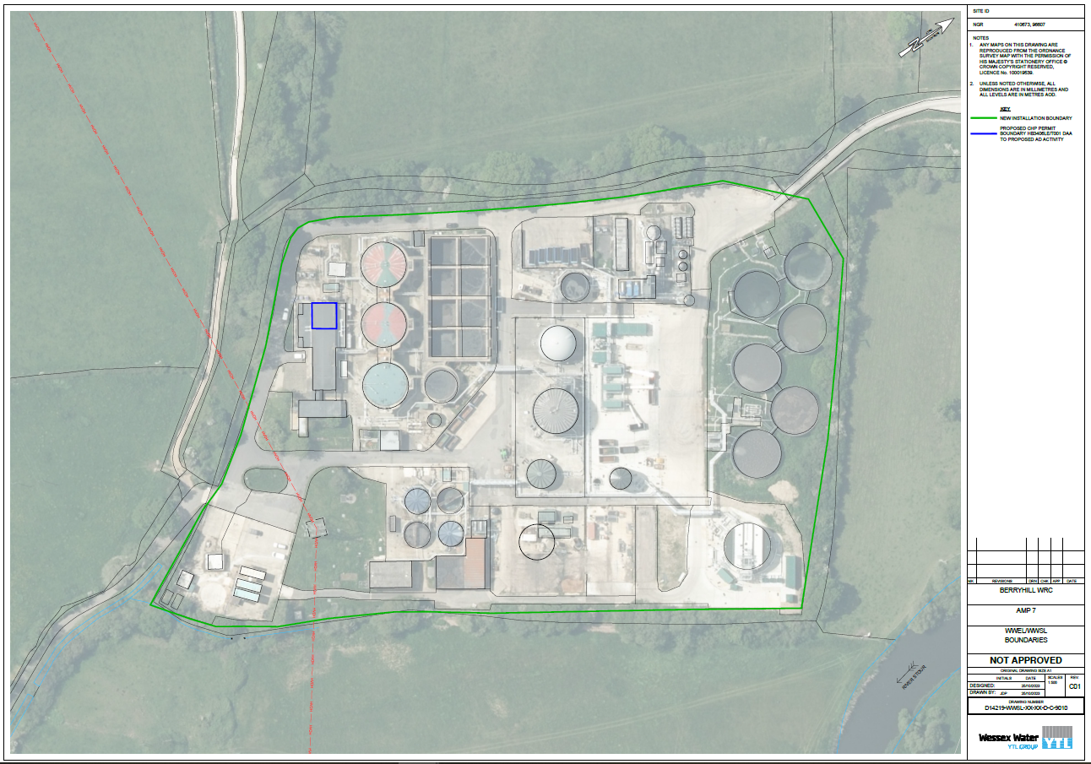

Multi Operator Permit Boundary Plan
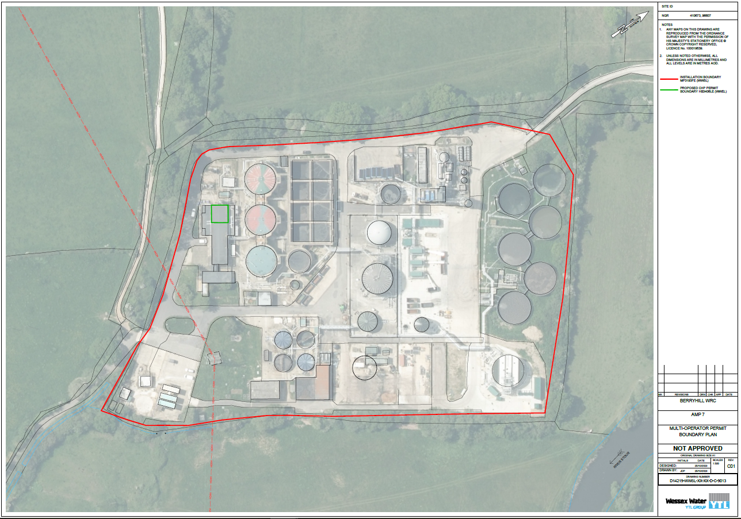

Asset Plan
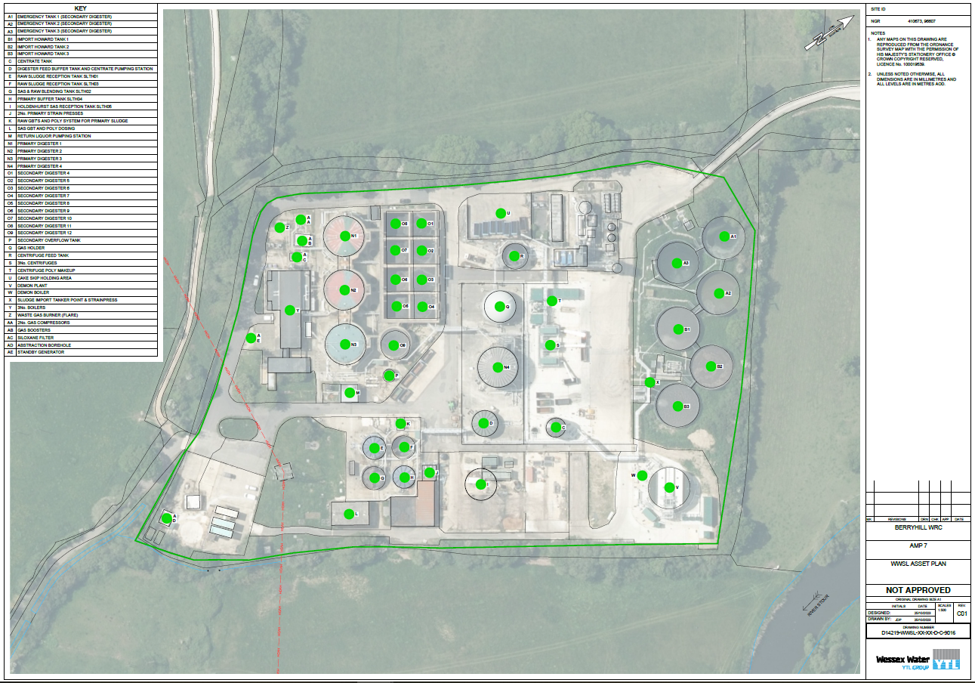

Process Flow Diagrams
A pdf copy of both diagrams is included in the attachment pack, Berry Hill BC Process Flow Diagrams, item no. 2.

WWSL Berry Hill BC Process Flow Diagram
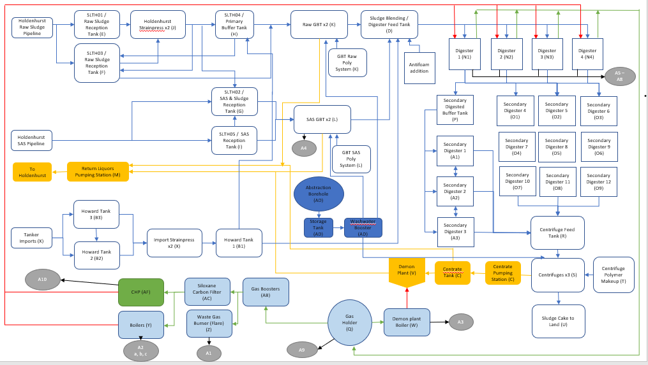

WWEL Berry Hill BC Biogas Process Flow Diagram
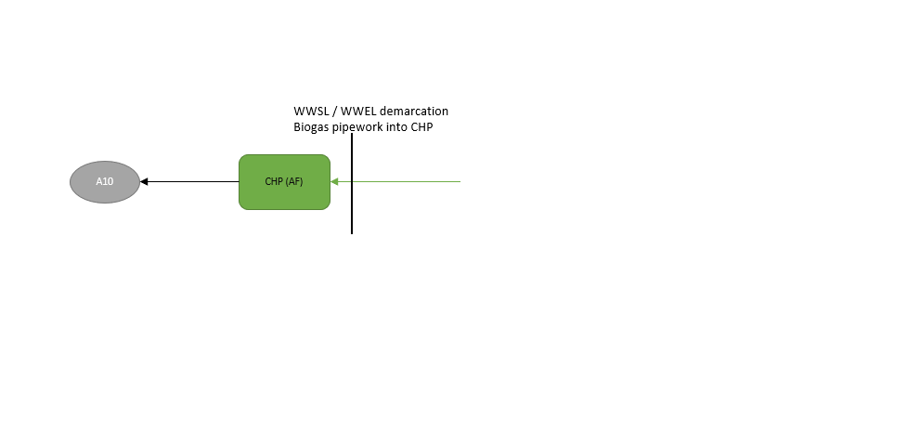

Emission / Sampling plan
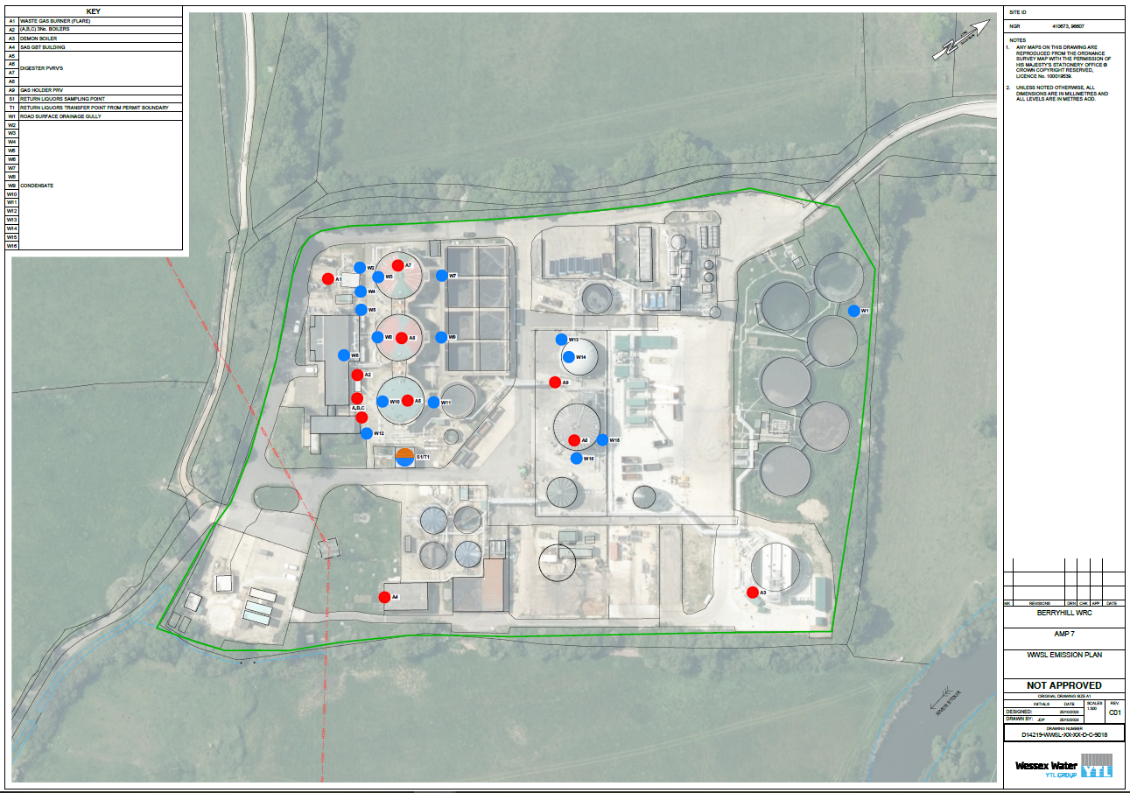

WWEL Emission Plan
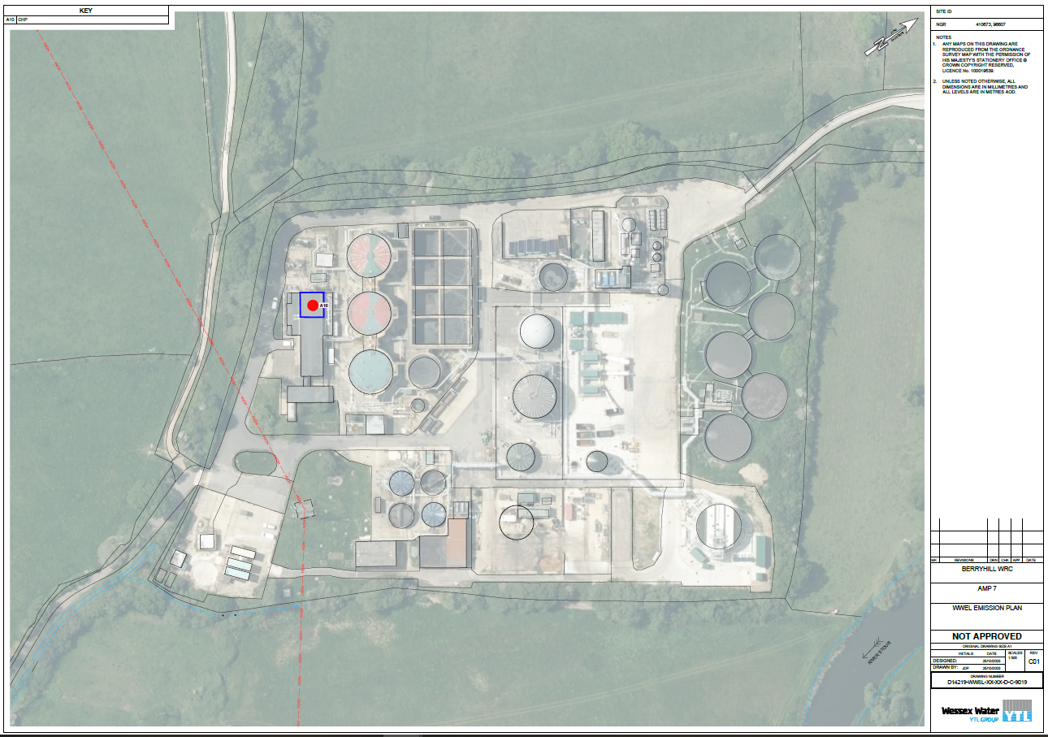

Schedule 5 no. 2 Q3
Submit a revised emissions point plan that shows the location of the sampling points for the identified waste water effluent streams.

See attached sample point plan number 9 in the Berry Hill BC Plans Pack (Item no. 1)

Provide the grid references for the chosen sampling points.
The plan referenced above shows the sampling point for the wastewater emissions to water; we have allocated one sampling point.

This is for the combined wastewater streams from the Demon liquor treatment plant and the pre-digestion sludge thickening activities, plus condensate.

Name | Waste type | Sample location | Sampling point NGR
Combined Sample Point -Demon Effluent  And Thickening Liquors | Demon Liquor Treatment Plant Effluent (treated centrate), and thickening liquors from the GBT’s (pre digestion). This sample point at The Return Liquor PS (M) will also include surface water, drainage and very small volumes of biogas condensate. | S1 | SZ 1066296576

Drainage Plan

Drainage plan – a PDF copy is included in the attachment pack, Berry Hill BC Drainage plan. Item no 3.
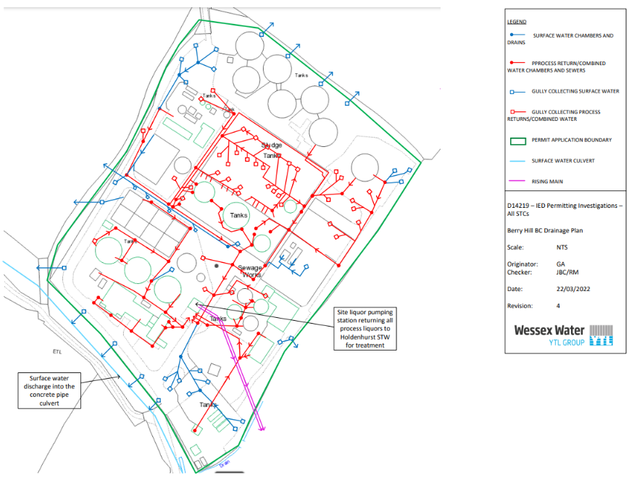

Form C6 completion
Application for an environmental permit Part C6 – Variation to a bespoke water discharge activity or groundwater activity (point source discharge) or point source emission to water from an installation. We have included the form C6, plus an additional responses document (item no.’s 4 and 5).

Process Description
A PDF copy of the Process Description (Berry Hill Process Description) is included in the attachment pack (item no. 6).

PVRVs

Schedule 5 no.2 Q6
Provide a written a statement explaining that pressure vacuum release valves (PVRVs) are installed on all tanks (including the enclosed secondary digesters) and all assets containing volatile materials where there is a risk of over or under pressurisation in line with section 8.11 of the Biological waste treatment: appropriate measures for permitted facilities guidance, BATc 14d and 38 ensuring you address the following aspects:

Schedule 5 no.1 Q20
Provide details of all plant handling volatile materials and confirm whether they have PRVs installed.

Asset Name | PVRV/ PRV  Fitted | Manufacturer
Digester 1 | 2X PVRV | Elmac Technologies
Digester 2 | 2X PVRV | Elmac Technologies
Digester 3 | 2X PVRV | Elmac Technologies
Digester 4 | 2X PVRV | Elmac Technologies
Gas Bag | 1X PRV | Motherwell
Siloxane plant | NO | N/A
Boilers | NO | N/A
CHP | NO | N/A
Waste Gas Burner (Flare) | NO | N/A

Schedule 5 no. 2 Q6 all remaining parts
ii) Explain how PRVs are designed by appropriately qualified engineers and can cope with the anticipated maximum gas production volumes.

Berry Hill digestion improvement scheme D9540 Asset maintenance period 6 scope was inclusive but not limited to design changes and introduction of new assets within the biogas handling asset base.

Mass flow calculations were conducted with principal contractor North Midland Construction (NMCN).
The modelling undertaken provides anticipated gas production volumes for the design intent of the project. This has gone through various checks and reviews under Construction, Design and Management (CDM) regulations 2015.

Subsequently derived from the mass flow calculations design Specification.
NMCN digesters 1,2,3,4 mechanical equipment specification & NMCN Sets out the PVRV requirements.

The design specification states that each PVRV digesters 1,2,3 shall achieve a relief flowrate 600Nm/hr @ 24mbarg and each PVRV digester 4 shall achieve a flow rate of 250Nm/hr @ 36mbarg. In addition, the specification states required vacuum protection which is common across all PVRV’s @ 800Nm/hr @ -3mbarg.

Given the above gas production on an hourly basis for any given digester PVRV will be 113.4m3.

Note – Each digester has 2 PVRV’s installed which are identical in exception to digester 4 which is set at a higher relief pressure due to configuration of the biogas system.

During design, the below standards were also taken into consideration.

• Section 3 specification – General Information
• Section 6 specification – Standard Mechanical
• WIMES 8.09 Valves
• 2014/34 EU

Installation
- WIMES 4.01 – Paints & Coatings for Corrosion Protection
- API2521
- API2000
- 2014/34 EU

NMCN equipment specification digesters 1,2,3 & 4 are attached.

iii) Describe how you monitor gas production rates and organic loading to prevent excess pressure in tanks and vessels.
Operation of Berry Hill BC is governed by the mass flow calculation, HAZID (Hazard Identification System) and HAZOP (Hazard and Operability Study) processes. Controls are in place to monitor the process and ensure stability, with action limits identified where appropriate.

All work on site is detailed in operating procedures and task sheets which is currently being migrated to the Work Management System. These procedures contain information to inform appropriate action in the event of a problem with the digestion process.

All instrumentation displays instantaneous values, and all meters are visible on SCADA (Supervisory Control And Data Acquisition), with programmed status alerts for readings outside the accepted range and telemetry alarms, configured appropriately. Data is collated in archive trends to allow increased monitoring and identification of process issues.

The SCADA system can be viewed from the control room, or remotely on site by all levels of Operational staff who have the required authorisation.

Below are the activities and triggers thar have been identified to reduce the risk.

Gas production rates
All four digesters have independent biogas flow meters which monitor instantaneous flow rates, calculated hourly flow rates and total flow per 24 hr. All have derived telemetry alarms and SCADA alerts based on high and low readings.

Biogas pressure is measured on each digester and on the common gas holder. Biogas pressure data is also manually recorded daily. Pressure is also cross referenced to biogas production. In addition, the biogas holder has ultrasonic level measurement of gas levels.
Gas holder air blowers inflate the outer membrane of the gas holder to maintain biogas pressure to the gas booster pumps. Each air blower has a variable speed drive, and this varies the blowers’ speed from a control feedback loop from the gas holder pressure instrument.

As the production of biogas increases above the rate of CHP consumption, the volume in the gas holder will increase to a level such that the pressure in the system will not exceed the 24 mbarg PVRV release point. When the gas holder reaches 80%, the waste gas burner (flare) will be called to operate. This will decrease the pressure within the system.

In the event of the flare being called to operate as the level within the gas holder is equal to / + 80% a SCADA alert & telemetry alarm for operational staff to investigate the cause of increased biogas level within the gas holder.

In the event of flare failing or gas holder equal to / + 90% the digesters will be automatically taken out of service and no further feedstock introduced, a SCADA alert / telemetry alarm will be triggered for operational staff to investigate.

Organic Loading
Each digester has a flow meter to measure sludge feed volume, the maximum volume is derived by the mass flow and additionally the site HACCP (Hazard Analysis and Critical Control plan). Each flowmeter is calibrated annually.

Site operational staff monitor %ds routinely as a key performance indicator (KPI); monitoring asset performance and conducting onsite sampling to measure %ds. They also complete traffic light performance sheets which analyse feed in / feed out against the set requirements.

The maximum feed rate for each digester is 151m3 per 24hrs = 6.29m3 per hr. The maximum feed setpoint is locked within the control system to manage the organic loading rate and prevent a non-conformance of the site HACCP plan.

Once the 24hr target feed total has been achieved the digester will not introduce any further feedstock until the period resets. Weekly samples are submitted to Wessex Water’s internal laboratory for analysis; in the event of a parameter exceedance, an exception report is generated from Wessex Water’s lab sample system which is circulated to both the site scientist and site manager to prompt further investigation.

iv) Describe how you monitor pressure with appropriate technology such as pressure sensors fitted to your digestion tanks and gas storage vessels
Explained in answer to points ii) and iii)

v) Explain how PVRVs are correctly installed to withstand variance in pressure so that they do not routinely start to vent when gas production fluctuates.
PVRVs are installed, maintained, and calibrated by a competent approved specialist contractor. The installation was conducted in accordance with the manufacturer’s literature and the pressure relief directive 2006/42/EC / PSSR.

All new installations or assets subject to maintenance will be evaluated for tightness and function and receive an inspection before becoming a live asset. Following installation, a conformance and function certificate will be provided. PVRVs are inspected annually by a competent person and calibrated to ensure the maximum set pressure remains correct and vacuum protection is maintained.

The gas system has been designed to prevent pressure fluctuations that could cause a PVRV to release an emission to air in normal operation.
vi) Provide the maximum pressure for each digester above which there will be no further feed introduced.
Normal operating pressure of the biogas system is 13mbarg. Digesters 1,2,3 PVRVs are calibrated to a lift pressure of 24mbarg and digester 4 PVRV is calibrated for 36mbarg. A SCADA alert & telemetry alarm will be triggered for the operational team to investigate.

Points in iii) are also applicable.

As the production of biogas increases above the rate of CHP consumption, the volume in the gas holder will increase to a level such that the pressure in the system will not exceed the 24 mbar PVRV release point. When the gas holder reaches 80%, the waste gas burner (flare) will be called to operate. This will decrease the pressure within the system.

In the event of the waste gas burner (flare) being called to operate as the level within the gas holder is equal to / + 80% a Scada alert & telemetry alarm for operational staff to investigate the cause of increased biogas level within the gas holder.

In the event of flare failing or gas holder equal to / + 90% the digesters will be automatically taken out of service and no further feedstock introduced, a Scada alert / telemetry alarm will be triggered for operational staff to investigate.

vii) Confirm that PVRVs are designed in accordance with BS EN ISO 28300:2008, or other recognised standards.
PVRVs have been designed in accordance with API2521, API2000, 2014/34 EU

viii) Describe how you detect leaks from your PVRVs under normal operating conditions.
All operational staff are trained and understand the site LDAR (Leak Detection and Repair) plan and conduct their activities in accordance with the requirements.

Physical observational checks are conducted daily ensuring that PVRVs are seated correctly and are not leaking in normal operating conditions. Medium and high-rate releases in normal operation would be detected by lower-than-expected flow measurements on the biogas flow meters, where alarms are set up for high and low flow readings.
ix) Explain how you restrict using PVRVs, so they activate in emergency situations only.
Operation of Berry Hill BC is governed by the mass flow calculation, HAZID (Hazard Identification System) and HAZOP (Hazard and Operability Study) processes.

The combined heat and power engine (CHP) is sized to consume the gas production as per mass flow calculations. The CHP is 1,050kw and required to operate between 80%-92% load to consume the biogas volumes produced within the anaerobic digestion process.

In the event of gas production exceeding the capabilities of the CHP; whether because of increased gas yield or due to asset performance, the flare stack will operate to regulate gas pressure to ensure there is not a release from a PVRV. In the event of gas production exceeding capabilities of the CHP feed rate, the digestion process organic loading would be reduced by operational staff; either by adjusting the digester feed volume or %DS thickness.

Planned maintenance activities that have the potential to cause an environmental impact from the PVRVs are controlled by a process risk assessment (PRA). PRAs are submitted 7 days in advance of any planned activity for review and approval by the site scientist and site manager and if needed other departments such as engineering, or compliance are consulted. The competent person will assess whether the risk present from the planned activity is of a tolerable level and where required will implement additional controls, including informing the EA of any potential issues as per Schedule 5 notification.

High PVRV pressures could be generated by asset failures. Asset failures generate telemetry alarms with set levels 1 – 7, in the event of a telemetry alarm being triggered this will first go to the regional operations centre (ROC) and be scheduled to operational staff. Telemetry alarm levels response times are determined on a risk-based approach.

x) Describe how you will log and record release events from PVRVs.
Operation of PVRVs will occur in conjunction with associated pressure alarms within the gas system. This will be recorded in the archive data on the SCADA system and provide details such as time of alarm and the duration of the alarm (event), this information would be recorded within the PVRV event log and action undertaken will be in accordance with LDAR plan.

PVRV releases will be recorded on the company health and safety management system as a ‘Process Safety incident.’ This will then trigger a root cause investigation.

AERA
In response to Poole RFI received on 17 August 2023; we have revised the air emission work for Berry Hill incorporating the requirement for inclusion of Carbon Monoxide (CO), Particulates (PM10) and Total Volatile Organic Compounds (TVOCs) into the modelling as well as revising the AERA report. We confirm we use low sulphur diesel throughout.
Both the AERA report (item no 7) and the Air Emission modelling (item no 8) are included in the attachment pack.

LDAR

Schedule 5 no.2 Q7
Taking into consideration the proposal submitted in response to the previous two questions, provide a revised version of your leak detection and repair (LDAR) programme and ensure the following points have been addressed:

We have attached the LDAR plan (item no. 9) and have answered the questions within the text. For each sub-question below, the relevant section or appendix has been referenced.
i) Include a method for locating unknown fugitive emission sources.
See Section 9 of attached LDAR plan (BIOP016)

ii) Estimates of the type and volume of release from each leak location.
See Section 7 and Appendix 1 Table 2 of attached LDAR plan (BIOP016)

iii) Prioritised locations (from highest risk to lowest risk) based on potential quantity of release, environmental impact and your DSEAR.
See Appendix 1 Table 2 of attached LDAR plan (BIOP016)

iv) Identification of monitoring methods and frequency of monitoring to quantify significant emissions where possible.
See Section 8 of attached LDAR plan (BIOP016)

v) Specify the equipment used for leak detection.
See Section 8 of attached LDAR plan (BIOP016)

vi) Deadline for the implementation of leak detection activities.
Annual surveys are already completed, and the further requirements of the LDAR will be rolled out before permit issue.

vii) A description of the mitigation measures you will implement in the event of diffuse emissions.
See Section 10 of attached LDAR plan (BIOP016)

viii) A map of the site and inventory that identifies locations (point and area sources) for potential emissions.
See Appendix 2 of attached LDAR plan (BIOP016)

ix) Identification of components deemed as high, medium or low risk.
See Appendix 3 of attached LDAR plan (BIOP016) & Appendix 3 (BIOF016) (Item no.’s 9 and 10)

xi) Inclusion of a written statement obtained from Wessex Water Enterprises Limited (WWEL) confirming that they will operate the CHP engine in line with the LDAR programme or provide an additional standalone LDAR programme for WWEL that addresses the CHP and associated assets they control (the provision of a standalone Schedule 5 Notice for WWEL to provide an LDAR programme can be undertaken on request).
Section 1 of the LDAR plan (BIOP016) details this.

Digester Monitoring

Berry Hill BC Digestion Process Monitoring Description is included in the attachment pack (Item no.11).

Waste Pre-acceptance and Acceptance and Rejection Procedure
TRTWP549 Waste Pre-Acceptance, Acceptance and Rejection Procedure is included in the attachment pack (Item no. 12), along with BIOF037 WRC pre-acceptance record form (Item no.13).

Waste storage, Handling, Throughput and EWC acceptance
This section contains:
Residues plan plus tanker and best practice, throughput waste treatment capacity and EWC codes accepted by Berry Hill.

Schedule 5 no.2 Q10 i)
Ensure you include EWCs that are suitable for Sludge AD.
The table below lists the EWC codes that represents wastes imported into the sludge AD facility only now and in the future. These are the only EWC codes Berry Hill BC will accept. We have taken reference from Waste codes for sewage sludge materials: Regulatory Position Statement 231 and biological waste treatment: appropriate measures for permitted facilities for wastes that are appropriate for anaerobic digestion. The codes listed below, in addition to 19 08 05 and 20 03 04, are restricted in terms of their description to “sewage sludge only”.

Form C3 Question 1 (SI Table 4) – List of Waste Codes
Waste Code | Waste description
19 02 06 | sludges from physico/chemical treatment other than those mentioned in 19 02 05
19 08 05 | sludges from treatment of urban waste water
19 06 06 | digestate from anaerobic treatment of animal and vegetable waste
19 12 12 | wastes from mechanical treatment of wastes other than those mentioned in 19 12 11 (sewage sludge only)
20 03 04 | Septic tank sludge

Schedule 5 no.1 Q14
Explain and provide calculations to show how you have provided adequate storage and treatment capacity for sludge.

For purposes of this response, we take the term tonnes to be equivalent to wet tonnes which is equivalent to m3. In our application we stated that there is 219,000 tonnes/year capacity in the digesters, this equates to 600 tonnes/day.
The raw sewage sludge entering the digesters has been thickened via the GBTs and so the answer to points iii), v) and vi) and will be higher as sludge entering the permit boundary will be thinner.
i) The sludge storage maximum capacity in m3
26,683 m3
ii) How you will ensure that the sludge storage maximum capacity on site is not exceeded.
Tank levels are monitored with high level alarms. Both import Howard tanks have inhibits and tanker volumes will not be discharged if volumes in import tanks are too high. Lights to indicate the level in the tank are visible to all staff, including drivers. They will change to red when the tank level is in inhibit and at 95%.

Operational staff have the capability to inhibit the desludging of the UWWT stream at Holdenhurst WRC to reduce the volume of sludge being passed into the permitted area, however the performance of the wastewater treatment process is also key and consequently indigenous sludge takes precedence over tankered imports.

iii) The annual throughput of indigenous sludge in tonnes.
190,352 population equivalent (p.e.) (based on 2025 p.e. estimation) generating 45g solids per day equals 8.57 tonnes DS/d, add to that sludge produced by chemical dosing for P removal equating to 2.08 tonnes DS/d and sludges generated through secondary treatment in the WRC process equating to 4.45tonnes DS/d. And using a typical dry solid % of 1.5 % this gives the figure of 1006.7m3/d indigenous sludge, ((8.57+2.08+4.45)/1.5%)

The annual throughput of indigenous sludge 367,433m3/year (1006.7*365).
iv) The calculation for how the above storage capacity and retention time provide adequate storage and treatment for the annual throughput of sludge.
The indigenous raw sludge from Holdenhurst and imported sludge, blended, is typically ~2.2%DS (dry solids). Accounting for the more dilute SAS from Holdenhurst making up one third of pre-thickened sludge, this results in a typically lower pre-thickened sludge at 1.8%DS. Once thickened, sludge is typically ~6% DS. The below tables show the average retention time throughput the various stages in the process.
Our commitment to sludge compliance is managed in accordance with a Hazard Analysis Critical Control Point plan (HACCP). This ensures the sludge treated at Berry Hill is in conformity with the applicable Biosolids Assurance Scheme (BAS) and is compliant with the conventional treated standard.
A critical control point within the HACCP includes a maximum daily flow of 600m3/d (thickened sludge) which equates to an annual throughput of 219,500m3/year thickened sludge, this also equates to 2000m3/day pre-thickened sludge with an annual throughput of 730,000m3/year.
The processing of indigenous sludge takes priority over imported sludge and the daily operations of site will manage this accordingly. Periodically, we review the import sludge cap and currently it is 405 m3/d. Below are three tables to illustrate the Process retention times within the tanks at Berry Hill BC.
Process retention times | Import sludge cap 405m3/d
2 x import Howard tanks  2200m3 | 5.5 days
1 Howard for strained sludge  1100m3 | 2.7 days

Process retention times | Indigenous sludge  Holdenhurst flows of approx. 700m3/d raw and 300 m3/d SAS
Holdenhurst Reception Tank (SLTH01)  245m3 | <1 day
Holdenhurst sludge import tank (SLTH03)  450m3 | <1 day
Primary buffer tank (SLTH04)  300m3 | <1 day
SAS import tank (SLTH02 + SLTH05 )  1018m3 | 3.4 days

Process retention times | HACCP Maximum limit (600m3/day thickened digestion feed 6% DS) | Average Oct22-Oct23  (474m3/day thickened digestion feed 6% DS)
Digester feed buffer tank  300m3 | <1 day | <1 day
4 x primary anaerobic digestion tanks  9456m3 | 15.8 days | 19.9 days
Secondary storage tanks (8 rectangular + radial)  7,785m3 | 7 days | 7 days
Centrifuge feed tank  529m3 | <1 day | 1.1 days

v) The total volume of imported sludge to be received at site each year.
LEPs have been granted for the previous three years for this permit reference (EPR/MP3193FE), to allow us to bring extra imported sludge in due to the capital scheme at Poole BC. The LEPs allowed a maximum imported sludge per annum of up to 250,000m3/year or 684m3/day, though actual annual totals are generally lower; for example, total sludge movements in 2022 equated to 183,782 m3.
vi) The combined throughput of both imported sludge volumes and the annual throughput of indigenous sludge per annum.
Based on the calculations in answers iii, iv and v, the total combined throughput is 617,433 tonnes/year unthickened.
However, due to the variability of the %DS, the maximum total figure of unthickened sludge entering the IED permit boundary could be higher, plus the capacity of the digestion plant as detailed in point iv) means form C3 states that the maximum annual throughput is 730,000 tonnes/year.
vii) The cake skip maximum storage volumes and number of skips.
Each cake skip holds approximately 15 tonnes. There is no long-term storage for full cake skips. Movements out are continuous throughout the week.

The maximum number of skips which are held on site is up to fifteen. Therefore, the maximum possible cake storage on site is 225 tonnes.
viii) How you will ensure that the cake skip storage maximum capacity is not exceeded on site.
Skip numbers are controlled by the Biosolids Controllers who oversee the movement of full cake skips from site and the return of the empty skips.

The only locations for skips are by the centrifuges [S] and skip holding area [U].

ix) How non-conforming digested sludge cake will be stored on site to ensure it is segregated from conforming digested sludge cake.
All non-conforming digested sludge cake is held within labelled skips, to ensure segregation from conforming digested sludge cake. Each type of skip is labelled differently as an identification tool. These skips will be held in a different location to other conforming skips as well.

x) How long non-conforming digested sludge cake will be stored on site.
Non-conforming digested sludge cake is kept on site for a minimum length of time until it can be removed for retreatment, this will typically be 1 or 2 days. On occasions a non-conforming cake skip will be held for a longer period of up to 4 days whilst awaiting sample results.
xi) How non-confirming digested sludge cake will be removed off site or treated onsite.
The non-confirming skips are removed from site using our skip removal contractors under the direction of the Biosolids Controllers. The contractor holds a Waste Carrier Licence as detailed in the permit application. We do not carry out retreatment at Berry Hill BC.

Schedule 5 no.1 Q4
Provide a copy of your residue management plan.
TRTWP552 Berry Hill BC Residues Plan is included in the attachment pack (item no.14)

Schedule 5 no.1 Q15
Explain how you will ensure that the transfer of waste into and from sealed tankers will be managed. This should include:
i) An explanation of procedures to ensure tanker drive off is not undertaken.
ii) An explanation of how you will contain any leaks, (including worst-case leaks), spills and drips from the transfer of tankered waste at dedicated points.
iii) An explanation of how you will comply with ‘wash out’ certification for tankers.
i) We have two procedures, Best Tankering Practice for Berry Hill (TRTWG730) and, Avoiding driving off whilst connected (TBT058) (Item no’s 15 and 16). Both are attached as separate documents. In addition to procedure all sludge discharge points are fitted with snap off connectors so in the event of drive off tank and pipework is not damaged and tank integrity is not compromised.
ii) Tankers are fitted with endcaps and isolation valves for large spillage and emergency stop switches. Small spills and drips are collected via drip trays and buckets.
iii) Wessex Water have a fleet of sludge tankers who only transport UWWT (LoW EWC code 19 08 05) sludge between smaller wastewater sludge works and the imports sites such as Berry Hill. This waste is not hazardous and not of an animal by-products origin.

Containment
Containment report item no 17 is attached entitled: Berry Hill Bioresources Centre CIRIA 736 IED Report Secondary Containment Assessment issue 1.

OMP
There is one OMP for Berry Hill BC:
TRTWP525 – Berry Hill BC OMP covering WWSL assets is included in the attachment plan (Item no 18)

Multi-operator and demarcation

Schedule 5 no.2 Q32
To differentiate the assets and associated pipework between Wessex Water Service Limited (WWSL) and Wessex Water Enterprises Limited and to derive clear lines of responsibility for both operators, provide a detailed written description and site plan of all the permitted assets belonging to WWEL. This should include:
A description of the plant, pipework and any associated areas for WWEL
WWEL have responsibility for the CHP only with the demarcation point being the last flange on the pipework leading to the CHP unit. All other assets and pipework are the responsibility of WWSL.

A site plan clearly demonstrating the extent of plant/pipework under WWEL’s control.
The site plan entitled: Berry Hill BC Plans, map no.6 in the attachment pack (Item no. 1) shows the demarcation between WWSL and WWEL. This has been physically marked on site.

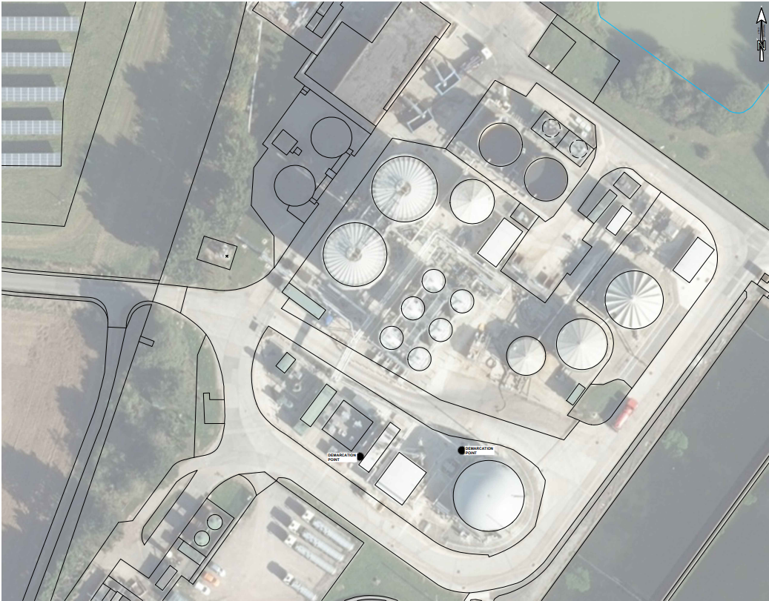

Separated emission point plans for any air emissions associated with each operators’ assets (i.e. the CHP, boilers, flare, etc). These plans should follow on from each other maintaining the sequential naming convention for air emission points.
See attached plan 9 and 10 Berry Hill WWEL Emission Points, in Berry Hill BC Plans Pack, Item no. 1.

Maintenance / Corrosion

Schedule 5 no.2 Q4
Provide a written description of how you ensure that equipment and pipework (including biogas and sludge/effluent carrying assets) are not subject to corrosion addressing the following aspects:

Inspection and maintenance
See Appendix 1

Design standards
See Appendix 2

Raw Material Data Safety Sheets

Schedule 5 no.1 Q18
Provide the material safety data sheets (MSDS) for raw materials used on site
We have revised the list of raw materials used by this installation and have include the list below as required by Form C3 Q3c Table 5.
These are included in Attachment Pack as Item no.’s 19 to 25
 | Raw Material Name | Quantities  Annual Throughput /year | Total held in site | Description of use of raw material
WWSL | Polymer Zetag 8165 | 37.1 m3 | 0.71 m3 | Thickening SAS (surplus activated sludge) and raw primary sludge.  Dewatering digested sludge
 | Polymer Zetag 8187 | 37.1 m3 | 0.71 m3
 | Diesel tank (Mabanaft – low sulphur diesel) | 10 m3 | 12.2 m3 | Diesel fuel used in CHP and boilers
 | Demon diesel tank (Mabanaft – low sulphur diesel) | 36 m3 | 10.9 m3 | Maintaining temperature in the DEMON reactor. Will be used more often in winter
 | Gearbox Oil  Fuchs Gear Oil 460 | 0.04 m3 | 0.02 m3 | Gearboxes across site
 | Carbon | 4.41 m3 | 2.21 m3 | Siloxane removal from biogas. Only the quantity held in the carbon filter is held on site.
 | Antifoam  Solenis Burst PF 13 | 12 m3 | 2.5 m3 | Used for foam suppression in the digesters and centrifuges
WWEL | CHP Oil – Fuchs Ganymet Ultra | 8 m3 | 2 m3 | Engine lubricating oil for onsite CHP gas engine / onsite diesel generator.

Appendix 1 – Inspection and maintenance

Our Bioresources assets receive regular planned maintenance from our frontline operational teams including EMI (Electrical, Mechanical & Instrumentation). The maintenance activities range from intrusive tasks such as component replacement through to operational checks and visual inspections. Asset maintenance tasks and frequency are driven by an understanding of the consequence (or criticality) of the asset’s failure in service and the optimal application of resource to mitigate against consequences of failure.
Some assets do have specific maintenance tasks to check for signs of corrosion, while others require inspection of pipework for leaks (which would also cover corrosion). The tables below show some of the maintenance activities on our assets at Berry Hill BC.
Examples of Corrosion related maintenance tasks at Berry Hill BC
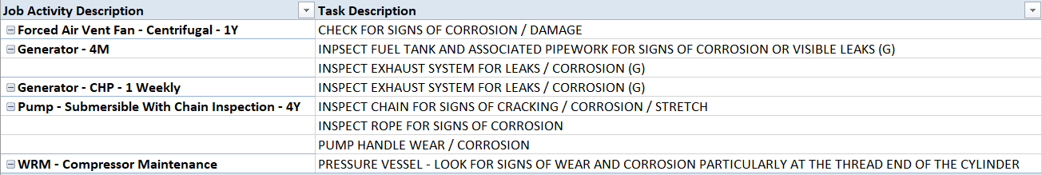

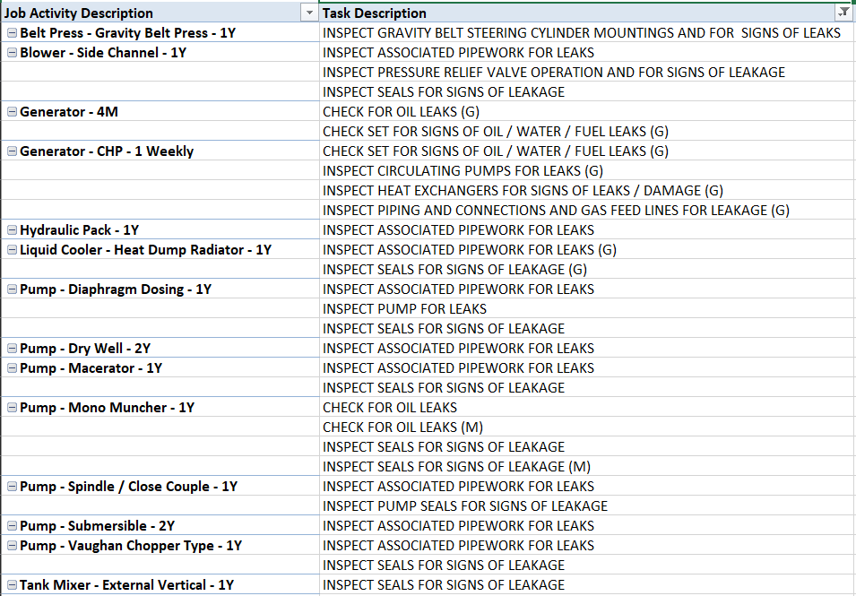
In addition to the tasks shown above, our EMI technicians are required to assess and record the condition of the installed asset on completion of every planned maintenance job on to WAM (Work and Asset Management). The table below is taken from our Condition Grade Assessment Guide (AMG007). It shows that for condition grades 3-5, corrosion is a factor in the grading and is therefore considered in the overall assessment of asset condition.

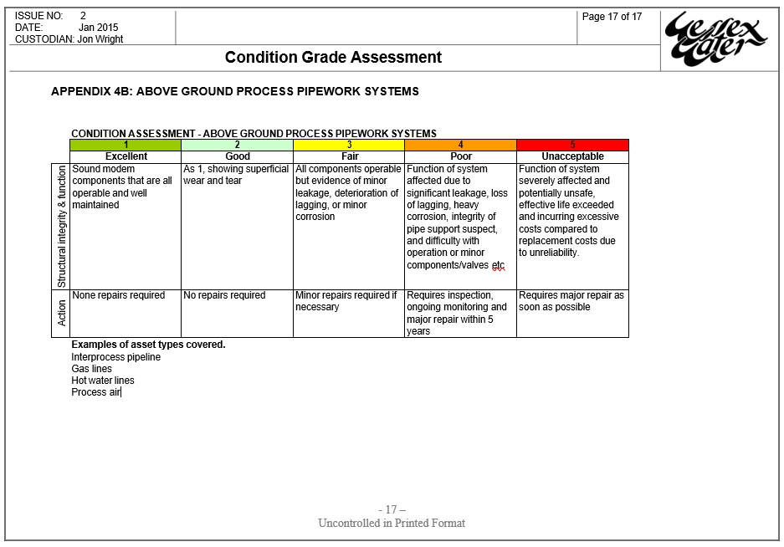

We are currently reviewing both the maintenance strategy and our planned maintenance schedules to ensure we can clearly demonstrate compliance with all of our EPR permit requirements.

Appendix 2 – Design Standards

Provide a written description of how you ensure that equipment and pipework (including biogas and sludge/effluent carrying assets) are not subject to corrosion addressing the following aspects:
During the design and construction phase, WWSL and its delivery partners ensures that corrosion prevention is appropriately managed in the following ways:
Appointment of Design Resource
As part of WWS’ quality management system, and in line with CDM 2015 regulations, designers will be allocated to projects based on the competency required to complete the task. This is formally documented at a scheme kick-off meeting. It is mandatory for all design calculations, specifications, drawings, and other outputs, to be checked and approved on WWS projects. Where specifying pipework or other assets that may be subject to corrosion, checks will be undertaken by a senior or principal mechanical engineer. The approver will normally be by the discipline lead, workstream lead or the named Principal Designer.
On every scheme, a technical manager (TM) is appointed to provide technical advice and governance as the project progresses. Any deviation from technical standards, including those with relevance to corrosion, must be approved by the TM. Deviations will also require acceptance from the Operator where it has the potential to impact inspection and maintenance of the relevant asset. Relaxation of standards relevant to corrosion would not be acceptable under any circumstance.
Design Reviews
WWS and its partners deliver projects in line with a mandatory project delivery process. This includes mandatory technical review meetings at key project milestones with project stakeholders, including the TM and the Operator. The reviews include:
Outline and Detailed Design Reviews
These meetings are used to confirm that the:
- project need is being addressed.
- design complies with WWS technical standards and specifications.
- design and enabling actions undertaken meet relevant regulatory requirements such as planning, ecological considerations, IED requirements.
- appropriate calculation, design, and drawing checks have been completed.
- design is adequate, practical, safe, and economic to construct, commission, and to operate and maintain with reasonable effort.
The deliverables reviewed typically include a detailed engineering model and associated engineering outline and construction drawings.
A key focus of these reviews is to give the operator a clear understanding of the spatial access, lifting and maintenance provisions included in the design. The use of digital approaches such as engineering 3D models allows operators to quickly understand the design intent and an opportunity to challenge aspects that they feel could be improved.
Hazard and Operability Analysis (HAZOP), Control Philosophy, and URS Review
The HAZOP is a systematic, in depth, review of the design solution, which ensures that appropriate safeguards are in place to avoid the proposed system failing and leading to a safety or pollution event. HAZOP guide words include composition, leakage and spillage, and operation and maintenance e.g. appropriate isolation.
The deliverables reviewed must include all pipeline and instrumentation diagrams, control philosophy, and user requirements specification.
Procurement:
The framework agreements with delivery partners, and their sub-contractors and designers, includes a clause stating that they must comply with WWSL and industry approved technical standards when delivering works on behalf of WWS. Deviation from these standards would be considered a defect requiring rectification unless a deviation is formally agreed with the Technical Manager and Operations prior to installation works.
Delivery partners must hold ISO 9001, 14001, 45001 accreditations and must demonstrate technical competence to be appointed. They are required to deliver projects to the WWSL delivery process.
Technical Standards
All designers must comply with WWSL and industry approved technical standards, including the Water Industry Mechanical and Electrical specification (WIMES) standards. WWSL standards are regularly reviewed and updated to ensure they reflect latest best practice and innovation. Examples of relevant specifications and what they broadly cover is referenced below.
WIMES
WIMES 8.03 MECHANICAL INSTALLATION – Issue 5 June 2021  Corrosion prevention | Section 4.6 - Corrosion prevention and/or Corrosion protection of Equipment after installation.  Table 5 – Corrosivity Category Definitions and Associated Corrosion Prevention / Protection Measures
WIMES 8.03 MECHANICAL INSTALLATION – Issue 5 June 2021  Valve Installation | Section 6 – Valve Installation  Install in accordance with the Purchaser’s planned maintenance requirements, so all valve components that will require regular inspection, cleaning or maintenance are readily and safely accessible and where appropriate, easily replaceable.  Designed to ensure safe isolation. The standard of isolation should be determined in an ALM in accordance with HSG 253 or the purchaser’s ALM standard.
WIMES 8.08 Pipework (Non-Buried Applications) – Issue 1, June 2021  Section 6.2 Materials Selection | Defines requirements for the design, fabrication, installation, inspection, and testing of non-buried pipework in the water industry.  Pipework material selection to ensure that the specified design life is achieved, considering all possible material degradation mechanisms associated with the specified external operating environment and process fluid.  Includes provisions to avoid galvanic corrosion.
WIMES 8.08 Pipework (Non-Buried Applications) – Issue 1, June 2021  Section 6.3 Corrosion Prevention | Internal and external surfaces of ductile iron and carbon steel shall be protected in accordance with WIMES 4.01.  The type of internal lining and /or external coating shall be as specified / stated in the SCHEDULE.
WIMES 8.08  Appendix C – Pipework specification tables  Appendix D – Pipework selection tables. | Allows selection of suitable pipework for the required application.
WIMES 4.01 - Paints and Polymeric coatings for corrosion protection - Issue 5 August 2018 | Defines the requirements for paints and polymeric coatings used for the protection of plant and equipment.
WIMES 8.09 – Valves – Issue 2 March 2021 | Defines the requirements for the performance, design, construction and testing of valves for use in the water industry.  Includes – external operating environment of the valve, special hazards associated with the operating environment, and references for further information relating to the operating environment to which the valve is being incorporated.

WWS Design Standards
DS224 SITE PLANNING – LAYOUT, PLANT, ROADS, LANDSCAPING - Issue 5b, February 2020 | Sufficient space provided around all structures and plant, equipment, and instrumentation to facilitate all required access during … operation, inspection & repair.
DS 460 - SLUDGE THICKENING & DEWATERING - MECHANICAL - Issue 5, November 2018 | Larger sites are subject to IED … which specify that pipework should preferably be installed above ground, or otherwise contained within a suitable inspection channel.
DS 250 – ABOVE GROUND VERTICAL CYLINDRICAL TANKS. Issue 2 March 2020 | Sets out material selection for sludge storage tanks.

