CONTENTS
- BACKGROUND INFORMATION
1.1. Site operator/licence holder
1.2 Site history and planning status
1.3 Waste management operations
Figure 1 Permit Boundary
Table 1 Permit activities
1.4 Hours of operation
1.5 Waste types and quantities
1.6 Staffing and management
1.7 Health and Safety

2.0 SITE INFRASTRUCTURE
2.1 Access and parking 7
2.2 Notice boards and signs 7
2.3 Site security 7
2.4 Site office 8
2.5 Weighbridge 8
2.6 Fuel storage/ chemical storage/ effluent storage 9
2.7 Drainage 9
2.8 Waste transfer and storage 10
2.9 Vehicles, plant and equipment 10

3.0 SITE OPERATIONS
3.1 Waste acceptance procedures
3.2 Checking in and inspection of loads
3.3 Waste sampling procedures
3.4 Waste Processing
3.5 Waste collection
3.6 Site Closure

4.0 ENVIRONMENTAL CONTROL, MONITORING AND REPORTING
4.1 Breakdowns and spillage’s
4.2 Site inspection and maintenance
4.3 Control of mud and debris
4.4 Control and monitoring of dust
4.5 Odour control
4.6 Litter control
4.7 Control of pests, birds and other scavengers
4.8 Control of Fire
4.9 Control and monitoring of noise and vibration
4.10 Local receptors
4.11 Environment Agency reporting mechanism
4.12 Actual or potential non-compliance reporting mechanism
4.13 Complaints procedure

5.0 Contingency Planning
5.1 Breakdowns
52 Enforced shutdowns
5.3 Drought
5.3 Climate Change
5.4 Cyber security

6.0 Site Closure

Document Control
Issue date | Version | Changes | Prepared by | Next review
May 2025 | 1.0 | Original | C. Cowdrey | May 2026

This document has been prepared by Claire Cowdrey BSc (hons) MCIWM of CMC Environmental Limited on instruction from M.B Wilkes. It will be updated annually or sooner if there are any changes in legislation or significant site changes for which an amendment of this document is required. This document is available electronically and a hard copy is available on site.
All staff and contractors are made familiar with the contents of the EMS on induction and where pertinent are required to know and understand the sections specific to their role within the company.
This document is issued for M.B Wilkes for the specific purposes connected with the above-mentioned project only. It should not be relied upon by any other party or used for any other purpose.
CMC Environmental accept no responsibility for the consequences of this document being relied upon by any other party, or being used for any other purpose, or containing any error or omission which is due to an error or omission in data supplied to us by other parties. This document contains confidential information and proprietary intellectual property. It should not be shown to other parties without consent from CMC Environmental or from the party which commissioned it.

- BACKGROUND INFORMATION

1.1. Site Operator.
1.1.1 M.B Wilkes operate an inert and excavation waste transfer station with treatment under permit reference EPR/BB3408FG. The site has been established on this since the 1950’s where it has changed and grown with the demand for the products and services required and offered.
1.1.2 M.B Wilkes were first issued a standard rules permit to operate in 2015 and have continued to operate in accordance with the conditions of this permit for the past 10 years. Before that the site operated under a Waste Management Licence originally granted by Dorset County Council. The Site now operate under a bespoke permit due to changes in standard rules permitting although the operations remain the same as per the original standard rules permit.
1.1.3 M.B Wilkes (hereafter referred to as the Site) operate an inert and excavation waste transfer station with treatment from their site at Henbury Quarry, Old Market Road, Wimborne. BH21 3QZ. The site accepts and processes inert wastes mainly from the construction and demolition industry.
1.1.4 The Site also has a sales area where they supply gravel, sand, recycled aggregates, garden stones and topsoil along with decorative gravel and chippings to other companies, Local Authorities and members of the public.
1.2 Site History and Planning Status.
1.2.1 When the existing 350 acre site was purchased it was for the timber, but in 1958 the company saw the value in the famous Ginger Sand that could be quarried. As the years went by more opportunities were sought including offering a more comprehensive service and being able to accept inert wastes which could be recycled and recovered to reduce the dependence on primary aggregates and soils.
1.3 Waste Management Operations
1.3.1 The site operates under a bespoke environmental permit EPR/BB3408FG which has been granted to M.B Wilkes Limited. The permit allows treatment consisting of sorting, separation, washing, screening, crushing and blending of waste into different components for recovery or disposal. As detailed in table 1 below.
1.3.2 All waste management operations take place within the permitted boundary as shown on figure 1 below.
1.3.3 Wastes accepted at site shall not exceed 250,000t per year.
1.4 Applicable Guidance
1.4.1 The activities will be undertaken in accordance with appropriate measures specified in the following sections of the non-hazardous and inert waste appropriate measures guidance:
section 2 – General management
section 3 – Pre-acceptance, acceptance and tracking
section 4 – Storage (sections 4.1 to 4.7 and sections 4.13 and 4.1.1)
section 5 – Waste Treatment (section 5 introduction and sections 5.1 and 5.2)
section 6 – Emission control (section 6 introduction and sections 6.3.1 to 6.3.8 and 6.3.16 to 6.3.18, sections 6.5)
section 9 – Waste minimisation, recovery and disposal
Figure 1. Permit Boundary M.B Wilkes from original permit.

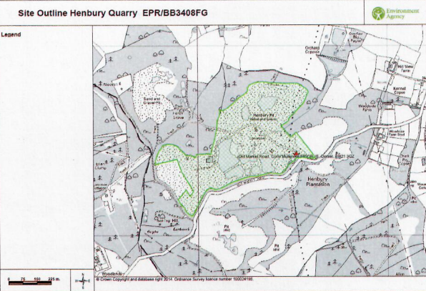
NGR: SY9651997428

Table 1 – Permitted Activities
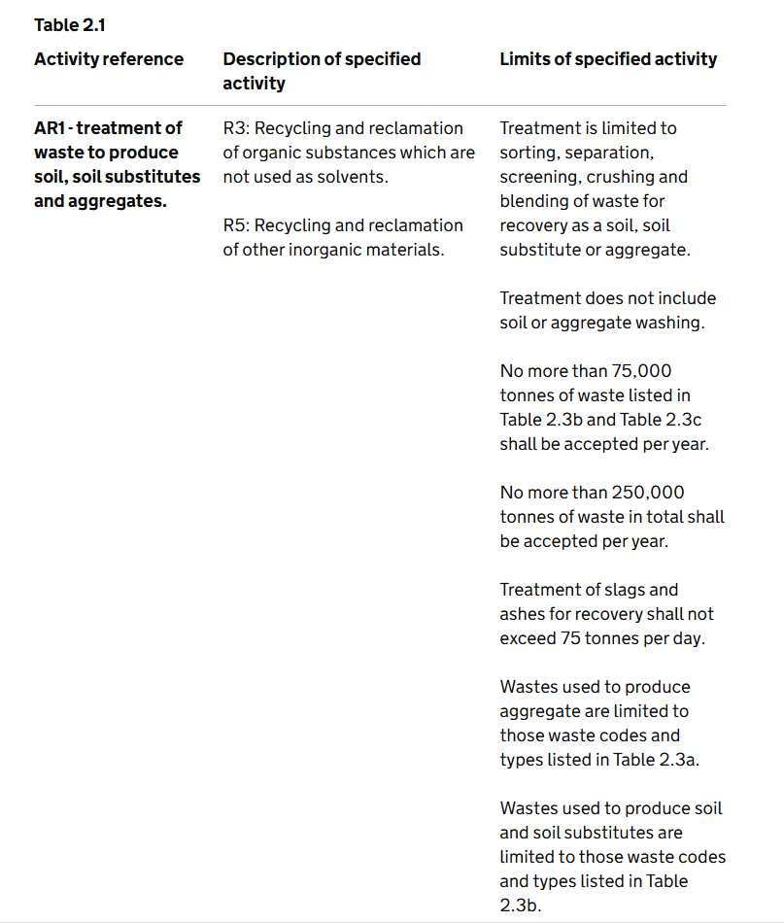
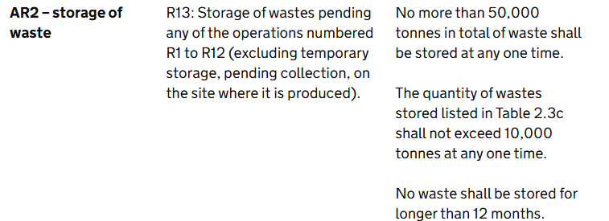

1.4 Hours of Operation
The site is open to trade and members of the public within the hours listed below:
Hours of operation are:
Monday – Friday 07:00 – 16:30
Saturday 07:00 – 11:30
Sundays Closed
Public and bank holidays Closed

1.5 Waste Types and Quantities
1.5.1 Wastes to be accepted at site are limited to those listed in table 2 of the environmental permit EPR/BB3408FG and in appendix I of this management system.

