

NON-TECHNICAL SUMMARY TO ACCOMPANY PERMIT APPLICATION.

Site Address

M.B Wilkes

Henbury Quarry

Old Market Road

Wimborne

BH21 3QZ

NGR

SY 96297 97517

Operator Details

M.B Wilkes Limited

Document Reference

WILKES.2025.NTS

Permit Reference

EPR/BB3408FG

Prepared by

Claire Cowdrey BSc (hons) MCIWM)

CMC Environmental Limited

Issue Date

November 2025

Introduction
This document is the non-technical summary to accompany the application for a bespoke environmental permit for M.B Wilkes Limited located at Henbury Quarry, Old Market Road, Wimborne. BH21 3QZ. Grid reference: SY9651997428.
As detailed in the main text of this document the application is to move from a standard rules permit EPR/BB3408FG to a bespoke permit to continue with the activities previously permitted under the standard rules permit SR2009 No6 – Inert and Excavation Waste Transfer Station with Treatment.

Application
This application is being made to allow the site to continue operations as per their previous standard rules permit (SR2009 No6). The new standard rules permit which they have been moved to (SR2022 No1) does not permit the physico-chemical treatment of waste namely the washing of soils and aggregates and therefore a bespoke permit application is being made to add this activity back into their environmental permit to allow them to continue as they have done for the past 30 years. Nothing else is changing with regards to the permitted operations and therefore the risk has not increased due to this being a continuation of a previously permitted activity.
This application is being made to allow the site to continue with the activities listed in table 2.1 of their current SR2022 No1 permit which is:
- Sorting
- Separation
- Screening
- Crushing
- Blending of waste for recovery as a soil, soil substitute or aggregate

- With the addition of soil and aggregate washing.
The processes, procedures, activities, operations, operational hours, site boundary and managerial systems remain as per the previous operations.
Waste codes and activities have been transposed from SR2022 No1 to align site activities with the new standard rules permit with the addition of the washing of waste.

Waste Inputs and Processing.
The majority of waste brought to site is from demolition and construction projects that M.B Wilkes provide the inert disposal and grab away vehicles for. Smaller amounts of inert wastes are accepted from members of the public such as builders and landscapers.
The drivers of all M.B Wilke’s vehicles including the grab way vehicles and bulkers have strict instructions to follow as set out in the Waste Acceptance Procedure as detailed in the Environmental Management System.
The commercial department will record the quantity, description of waste and previous use of the land the waste is coming from. The driver on site must be vigilant for any visual or olfactory evidence of contamination. The driver must confirm the former land use appears to be as described and that the transfer note is accurate. Laboratory testing of any load over 1000m3 must have been carried out in advance and results of which supplied to M.B Wilkes before collection and removal of the waste. If the driver is unsure of any of the above, the load will be rejected in situ and management will be informed for a decision on how to proceed.

Once the waste arrives on site it undergoes sorting, separation and processing by mechanical means as well as physico-chemical treatment by washing. The waste is then stockpiled for onward use. See appendix III – flow chart of inert waste recovery.

Permitted activities as described in table 2.1 of the current standard rules permit will still apply with the addition of the soil and aggregate washing.

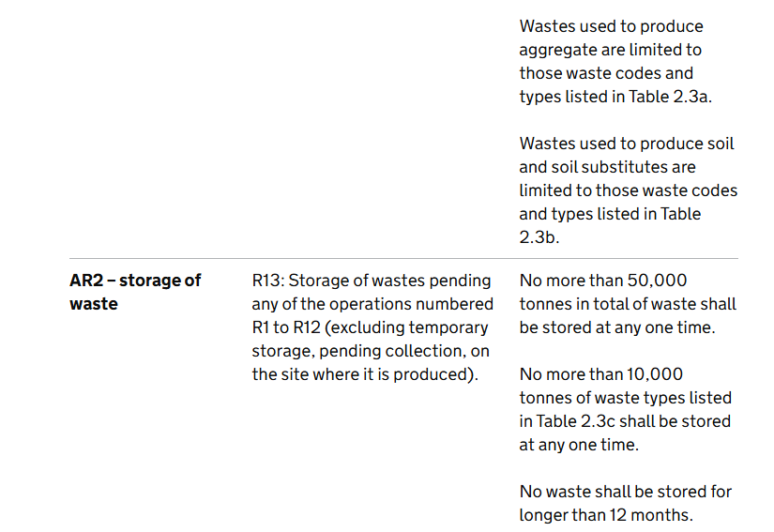
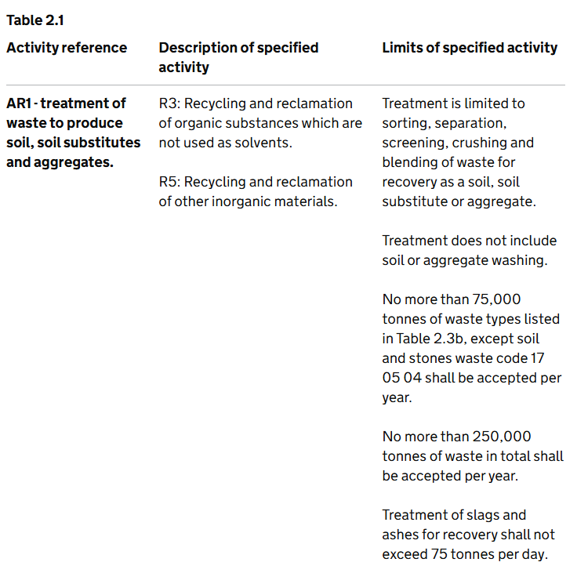

4.0 Process Description

The inert waste recovery acceptance and inspection criteria is detailed as below taken from M.B Wilkes Waste Recovery Plan:
Inert Waste Acceptance & Inspection Criteria

All loads of material that arrive at M B Wilkes for disposal will be inspected on the customer site by the driver, and at the point of arrival at the weighbridge by the weighbridge clerk. This check will be undertaken to ensure that the load is Inert Waste & in a suitable condition to accept at site. As well as a visual inspection the weighbridge will ensure all relevant details are recorded as part of the weighbridge process, these include:
- Delivery date.
- Time.
- Waste description.
- Waste origin.
- EWC code.
- Vehicle registration.
- Customer name.
- Haulier name.
- Vehicles gross weight. Following tipping, the vehicle will re-weigh to establish the tare & net weights.
- Disposal cost.
- Receipt of completed “Tipping Load Inspection Form” by member of site staff.

The above list cannot be fully completed, allowing for the generation of a weighbridge ticket until the load has been successfully tipped, accepted and the vehicle has been back on the weighbridge.

Duty of Care / Waste Carriers Licence
The weighbridge clerk will ensure that all businesses that transport Inert Waste material for hire or reward have a current valid Waste Carriers Registration & that MB Wilkes holds a copy of the WCR or card as proof registration. A file is held within the Weighbridge that contains copies of all WCR’s provided by customers. Anyone not holding a valid registration will need to obtain this before being permitted to tip on our site.

Load inspection
Given that the Weighbridge Clerk believes that the waste material to be tipped is Inert & is compliant with the waste types permitted at site for disposal. The customer will be directed to the correct tipping area. During or following discharge of waste from vehicle, the load contents will again be inspected by a member of staff to ensure it is suitable & compliant for disposal at site. If the material is deemed unsuitable for the operation, the results of this will be communicated back to the weighbridge. The customer will be recharged accordingly, and the material would be moved to an appropriate operation, or if the material is unsuitable for the site the load will be isolated and rejected.

Load rejection
In the event of a load being rejected, its rejection will be communicated back to the weighbridge & the Site Forman or another member of the site management will undertake a further inspection of the load, in the customer’s presence. If this load inspection confirms that the load is to be rejected, the customer will be advised of the reason for the rejection & the material will be re-loaded onto their vehicle & must be taken away from site for disposal at a suitably licenced facility. The load rejection details will be noted in the Commercial Director site diary, and the weighbridge ticket will be cancelled. If an Issue is detected after the customer has left site. The same procedure us followed, however in addition the Commercial Director will contact the customer and request they remove the material following the Waste Duty of Care Code of Practice.

5.0 Material Acceptance on Site.

This Site accepts wastes mainly from construction and demolition sites or earth removal works through the hire of grab vehicles, and is accepted through the Waste Acceptance Procedure. The majority of wastes are mixtures of concrete, bricks and ceramics, mixed construction wastes, waste aggregates, and soils. Other wastes as listed in appendix I may also be accepted subject to waste acceptance procedures and Site Management approval.

The material is then processed in a number of ways and is shown in the inert waste recovery flow chart in appendix III.

Inert waste will be processed by screener, trommel, crusher, wash plant and silt press to produce a number of products of varying sizes which are tested to comply with Quality Protocol Standards and made available for sale from the site.

6.0 Wash Plant.

When there is the required quantity of stockpiled waste to be processed through the wash plant this will be activated, and the washing process commences. The wash water is drawn from pond 1 (as per the Waste Management Plan Nov.2025). the waste is ‘washed’ and the resultant wash water is treated with flocculants to aggregate and remove the fine suspended clay sand particles before being released back into the ponds for re-use. The removed suspended particles are stockpiled on site. EWC codes 17 05 04 - Soil and stones other than those mentioned in 17 05 03 and 17 09 04 - mixed construction and demolition waste are the waste inputs to the wash plant.

All working plant on site is maintained to a high standard including the wash plant. There are written procedures for this and each week there are specific maintenance days on site. It is in the site’s interest to maintain plant in good working order to process waste. A spill kit is kept next to crucial parts of plant which may, in the event of a breakdown or accident, cause a pollution.

There is a discharge permit in place for pond 2 which leads, via an outlet pipe, to a downstream ditch. This pipe is bunged and controlled by the site operators. It is rarely opened as the site operators need to conserve as much of the surface water in the ponds as possible for the drier months.

7.0 Site location and receptors
Receptor | Location and distance from the site (where applicable)
Residential | 650m east from the wash plant.
Source Protection Zones | SPZ1 and SPZ 2
Environmentally Protected Sites | None found within screening distance
Geology | Bedrock geology  Poole Formation - Sand, silt and clay. Sedimentary bedrock formed between 56 and 41.2 million years ago during the Palaeogene period.
Flood Risk | Surface water and rivers and seas = very low
Priority Habitats | Ancient woodland 200m
 | Deciduous woodland 50m
Priority Species | None

The EA published generic risk assessment for SR2022 No.1 has been saved to the site’s environmental files and a printed copy is available in the site office for reference. With the addition of the wash plant back into the current permit an additional risk assessment has been made to cover this piece of equipment and process.

8.0 Drainage

There are no formal drainage arrangements on site as this is a former quarry. There are no point sources emissions to air, water or land from the activities which take place. Clean and uncontaminated rainwater, through natural seepage, goes to groundwater.

9.0 Conclusion
In conclusion the site activities which have remained the same for the past 30 years will continue to remain the same. The addition of the physico-chemical treatment of waste namely the washing of soils and aggregates is to allow this process to continue by including it back into the permitted activities which M.B Wilkes’ original permit (EPR/BB3408FG) allowed. This operation along with all the other operations, procedures and activities has been inspected and audited by the local Environment Agency Officers over the past 3 decades and has not been the subject of any non-compliances with the permit. The 40 staff who work for M.B Wilkes are all highly trained in all aspects of waste management and environmental protection and that training remains ongoing.

Appendix I – Waste Codes Currently Accepted at Site.
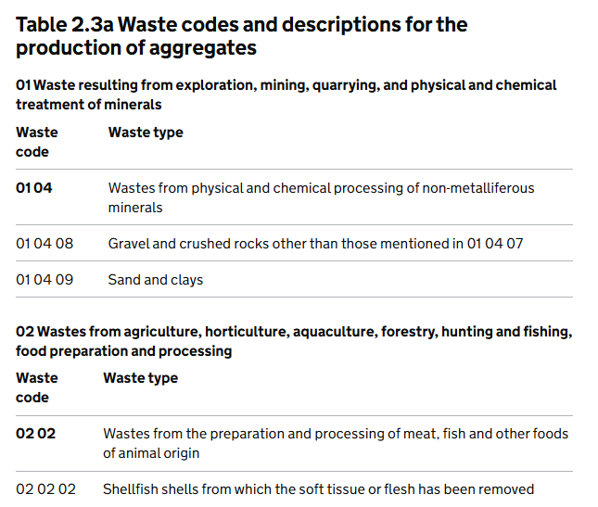

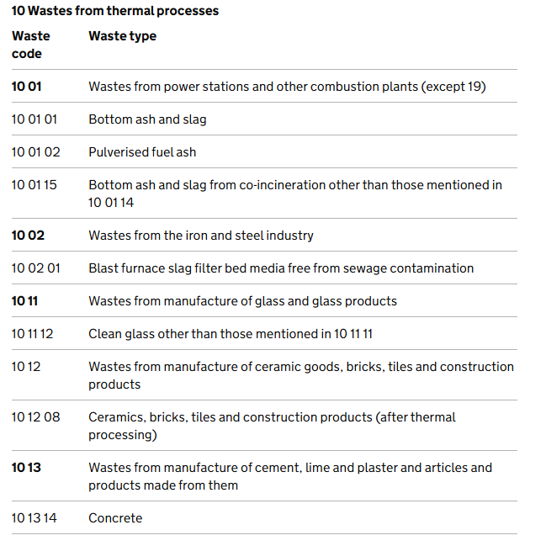
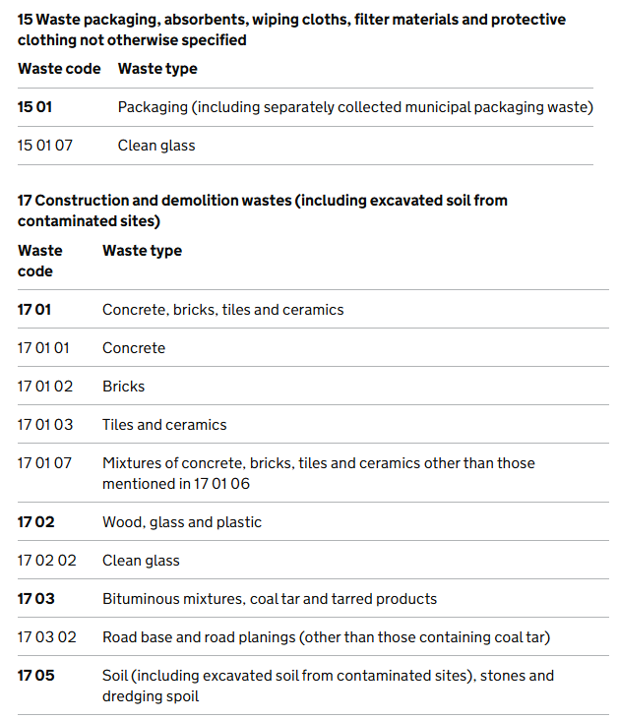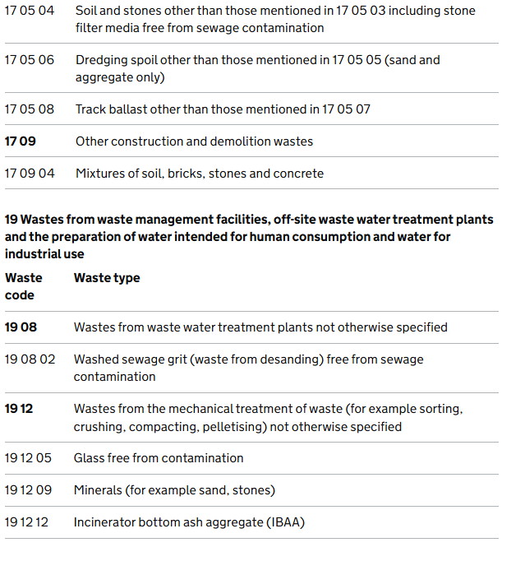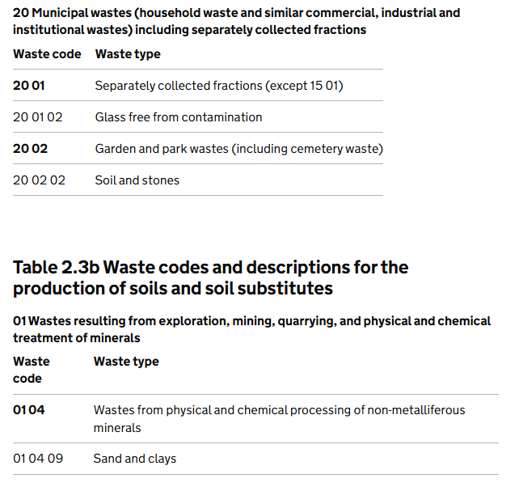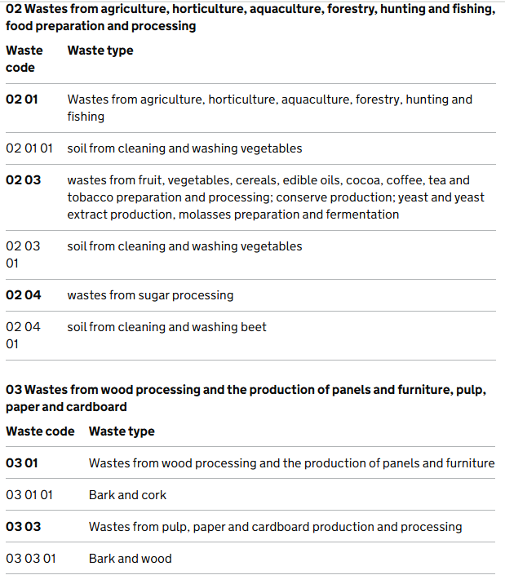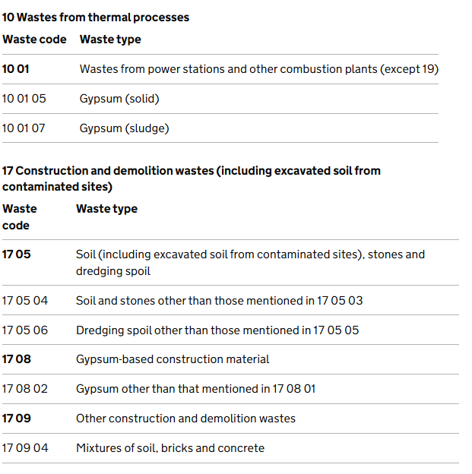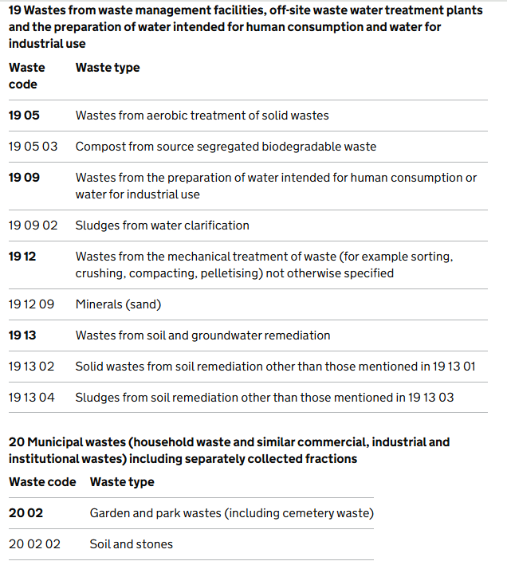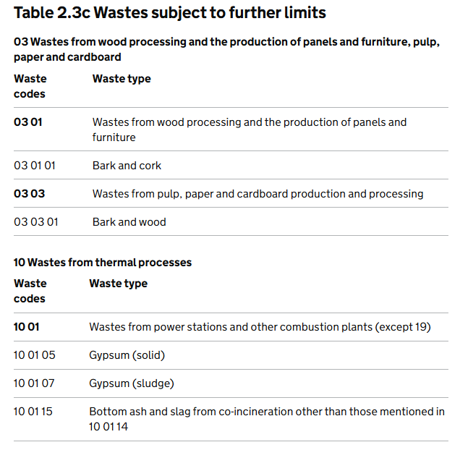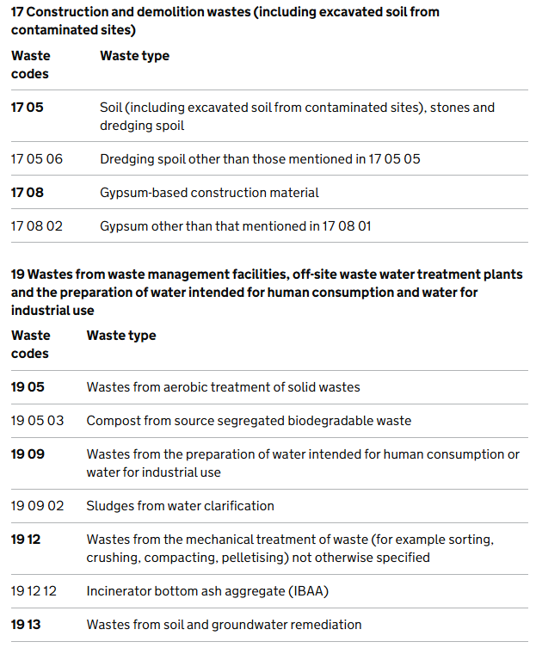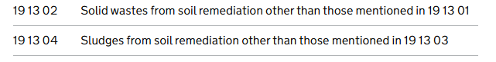

Appendix II - Permit boundary EPR/BB3408FG
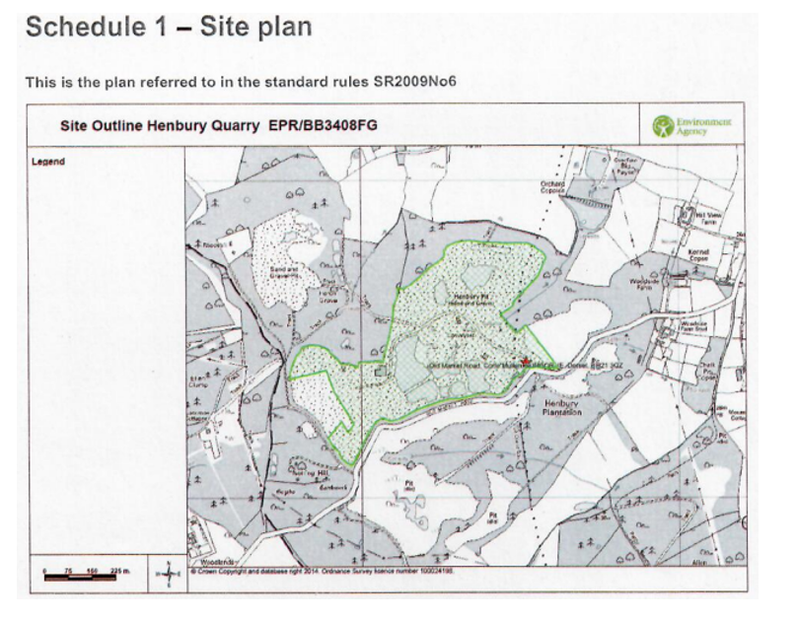

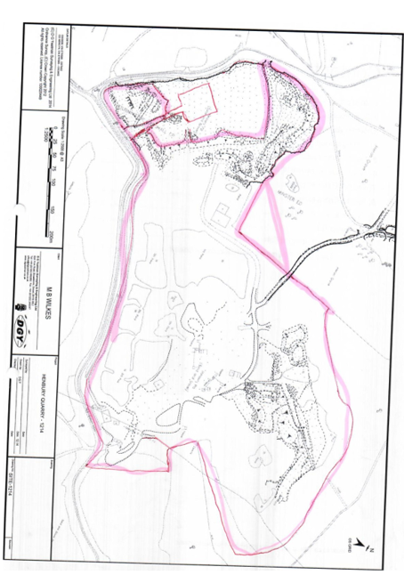

Appendix III – Inert waste Recovery Flow Chart.

