**Canford Renewable Energy Ltd**

Proposed Hydrogen Generating Facility

Whites Pit, Poole, Dorset

Standalone Permit Application Section 4.2 Part A(1)(a)(i)

Producing Inorganic Chemicals.

**Permit Application Support Document**

For Part B6

LCL/CRE/H2 Whites Pit/202205/B6Support

Prepared by:

Lindfield Consultants Ltd

Lindfield, Queens Road, Swanage

Dorset BH19 2EU

lindfieldconltd@btinternet.com

**Application for an environmental permit Part B6 – New bespoke water discharge activity or groundwater activity (point source discharge) or point source emission to water from an installation**

This Document is in support of the Part B6 Application for the Proposed Hydrogen Generating Plant at Whites Pit and includes all the documents references that are required by the completed Form B6. The answers to the various questions are set out in order below in this Word Document referencing to the question for ease of reference rather than in individual or a separate documents.

The Effluent is Mineralised Water and is discharged to the public sewer which connects to Poole Sewage Treatment Works which then discharges its effluent to Holes Bay, part of Poole Harbour.

**Question 3**

**3b** Document LCL/CRE/H2Whites Pit/202205/B63b

The manufacturer advises that the A90 unit needs 270 litres of water per hour at full load of which 90 litres is electrolysed to H2 and O2 and the remainder 180 litres per hour is mineralised reject water.

Water consumption per A90 Unit per day at full load will be 270 x 24 =6480 litres or 6.48m3 and the reject or waste water will be 180 x 24 =4320 litres or 4.32 m3 per day. So if there are two units per container that will be 8.64m3 for the two. The amount of water required will, for the two A90 units be 12.96m3.

**3f** Document LCL/CRE/H2Whites Pit/202205/B63f

Water consumption per A90 Unit per day at full load will be 270 x 24 =6480 litres or 6.48m3 and the reject or waste water will be 180 x 24 =4320 litres or 4.32 m3 per day. So if there are two units per container that will be 8.64m3 for the two. The amount of water required will, for the two A90 units be 12.96m3.

The two Electrolyser Containers will discharge a maximum of 17.28 m3 per day.

The average rate of discharge would be 0.2 l/sec but as it is pumped that might increase at times to 1 l/s

**Question 6**

**6a** Document LCL/CRE/H2Whites Pit/202205/B66a  
The Effluent is mineralised water and therefore no treatment is required to allow it to be ultimately discharged to Holes Bay see answer to Qu 8b

**6c** Document LCL/CRE/H2Whites Pit/202205/B66c

No treatment is required as the quality of the effluent is such that it can be discharged to Holes Bay. See answer to Qu 8b.

**Question 7**

**7e** Document LCL/CRE/H2Whites Pit/202205/B67e

Since the effluent is de-ionised or mineralised tap water it will not contain specific substances in 7b, 7c or 7d. For question 7c the Applicant has no knowledge of what may be being discharged into the foul sewer upstream of their point of discharge to the foul sewer which is a pumping trunk main.

**Question 8**

**8b** Document LCL/CRE/H2Whites Pit/202205/B68b  
  
Please note that the Form doesn’t allow one to insert a Document reference

The water that is discharged from the plant is from the Reverse Osmosis Unit where 3 litres of tap water are processed to make 1 litre of demineralised water which means that the remaining two litres will have 1.5 times the minerals compared to the original tap water

The EA website below sets out how to carry out screening tests for estuaries and coastal waters of which Poole Harbour is one**.**

[https://www.gov.uk/guidance/surface-water-pollution-risk-assessment-for-your-environmental-permit#screening-tests-estuaries-and-coastal-waters](https://urldefense.proofpoint.com/v2/url?u=https-3A__www.gov.uk_guidance_surface-2Dwater-2Dpollution-2Drisk-2Dassessment-2Dfor-2Dyour-2Denvironmental-2Dpermit-23screening-2Dtests-2Destuaries-2Dand-2Dcoastal-2Dwaters&d=DwMFAg&c=euGZstcaTDllvimEN8b7jXrwqOf-v5A_CdpgnVfiiMM&r=yeoIfWZE3mR_eK8mjaY3yNtLsF4emExtZSXXKFzlsoI&m=bAxjfTEtXOYUiZdQ7f6Q0ecNg486OQ4wX1M8Ciwk9Cg&s=nn0XF_gH9ZFQONghDbKlc85FHQhrj3lTlzRsryXS-tg&e=)

The document includes the Environmental Quality Standards (EQS) for estuaries and coastal waters which are contained in the following spreadsheets.

* [Estuaries and coastal waters specific pollutants and operational environmental quality standards](https://assets.publishing.service.gov.uk/government/uploads/system/uploads/attachment_data/file/1000956/Estuaries_and_coastal_waters_specific_pollutants_and_operational_environmental_quality_standards.ods) (ODS, 8.3 KB)
* [Estuaries and coastal waters priority hazardous substances, priority substances and other pollutants environmental quality standards](https://assets.publishing.service.gov.uk/government/uploads/system/uploads/attachment_data/file/1057292/Estuaries_and_coastal_waters_priority_hazardous_substances__priority_substances_and_other_pollutants_environmental_quality_standards__2_.ods) (ODS, 7.82 KB)

The first spreadsheet has been downloaded and the EQS compared with the Water quality parameters supplied by Bournemouth Water for the Whites Pit area, which can be found at

<https://www.bournemouthwater.co.uk/siteassets/water-quality-report-2022/zbw1-alderney-south.pdf>

In the table below the values of the various water quality parameters that are provided by Bournemouth Water for Whites Pit have been added to the EA Spreadsheet and compared to the EQS. As indicated above the mineralised water will have 1.5 times the concertation of parameters that would be expected in the tap water prior to the Reverse Osmosis so these too have been compared with the average annual EQS. As can be seen in the table below, none of the parameters in the Mineralised Water exceed the average annual EQS.

Comparing the second spreadsheet with the Bournemouth water quality parameters, Benzene, Cadmium, Lead and Nickel are in the second but not the first spreadsheet but again the concentrations recorded in the water are less than the Annual Average EQS.

Test 1 from the Guidance states this:

**Test 1**

*Check whether the level of pollutant in the discharge is more than the EQS limits. You need to test for both annual average limits and maximum allowable concentration if the chemical and element has both types of EQS.*

*If the chemical and element is more than EQS limits, carry out test 2. If it’s below EQS limits you do not need to anything more as your pollutant is not a risk to the environment*.

So in accordance with the highlighting the Mineralised Water is not regarded as a Pollutant, is not a risk to the Environment and no further screening is required.





**8f** DocumentLCL/CRE/H2Whites Pit/202205/B68f

The assessment is given in the answer to question 8b above.

**Question 9**

**9a** DocumentLCL/CRE/H2Whites Pit/202205/B69a

There is no inlet sampling point as the water taken in is tap water.

**9b** DocumentLCL/CRE/H2Whites Pit/202205/B69b  
The effluent sample point is the pumping chamber at NGR 402859,96773.

**9h** DocumentLCL/CRE/H2Whites Pit/202205/B69h

See plan overleaf

**Appendix 4**

4.2 Document LCL/CRE/H2Whites Pit/202205/B6A44.3

NGR 402893,96758 is the point where the discharge pipe to the sewer leaves the installation. It is not where that pipe joins the private sewer that connects to the Public Sewer nor is it where the Mineralised Water will eventually discharge to the Estuary having been through Poole STW**.** That discharge point is given in the table 4.1 below.

4.6 DocumentLCL/CRE/H2Whites Pit/202205/B6A44.6

It is not clear to which discharge point this refers. Enquiries have been made to Modelling_Requests@environment-agency.gov.uk' <[Marine_Modelling_Requests@environment-agency.gov.uk](mailto:Marine_Modelling_Requests@environment-agency.gov.uk)> to ascertain whether the Permit SW/401354/009 – WESSEX WATER SERVICES LIMITED discharge is to a location with restricted dilution or dispersion.

The NGR of where it is understood that the discharge takes place is given in the table below and this NGR is shown in the Local Map extract below. It is assumed that this discharge is in hydraulic connectivity with Holes Bay (Poole Harbour) so that it is within tidal influence and the receiving water will be saline. Bearing in mind the DWF from Poole STW at about 2000m3/hr average with peak presumably greatly in excess of this is the potential 17.28m3/day Mineralised Water from the Hydrogen Generating plant at 0.036% is very unlikely to be significant.

Outfall is to a culvert that flows to Holes Bay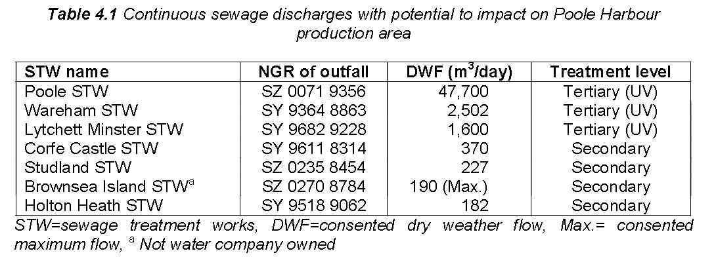

And this is that location

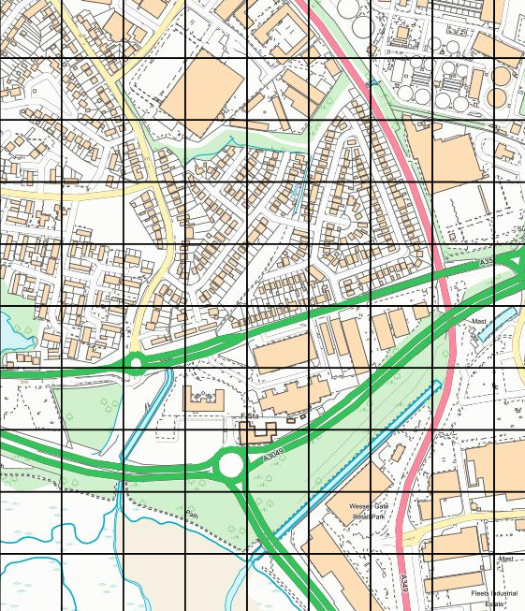

Holes Bay