NDC Polipak Limited
Fire Prevention Plan
July 2023
Version 1.0

GARRATTS LANE,
CRADLEY HEATH, B64 5RE

Document Control Sheet

Version Reference | Date | Reason for Change | Issued by
1.0 | 12/07/23 | Initial Draft | PD
Approved by |  | Phil Burt

CONTENTS
1 Introduction 4
1.1 Roles and Responsibilities 4
1.2 Purpose 4
1.3 Scope 4
1.4 Liaison with Fire Rescue Service (FRS) 4
1.5 General considerations 4
2 Causes of Fire 5
3 Fire Prevention Plan 6
3.1 Site Plan and Receptors 6
3.2 Material Receipt and Storage 6
3.3 Signage 8
3.4 Training, Awareness and Visitors 8
3.5 Security 8
3.6 Planned Preventative Maintenance 9
3.7 Self Combustion 9
3.8 Hot Works 10
3.9 Mechanical Treatment 10
3.10 Hot Exhausts 10
3.11 Additional Actions 10
4 Fire Detection and Management 12
4.1 Fire Detection 12
4.2 Fire Fighting Strategy 13
4.3 Managing Fire Water 14
4.4 Future Actions 16
5 Annex A: Site Layout 17
6 Annex B: Site Drainage 19
7 Annex C: Fire Fighting Access, Equipment & Water Supply Plan 20
8 Annex D: Key Receptors 21
9 Annex E: Waste Acceptance Procedures 22
10 Annex F: Fire Risk Checks Form for Fire Prevention 23
11 Annex G: Emergency Contacts 24
12 Annex H: EMS Documents 25

- Introduction
  - Roles and Responsibilities
The designated WAMITAB qualified person(s) has responsibility for ensuring these procedures are adhered to. The WAMITAB qualified person(s) is specifically responsible for:
- Ensuring the adequate training of staff and contractors working on site regarding the content of these procedures;
- Ensuring the adequate provision of resources such as personal protective equipment (PPE);
- Ensuring the provision and maintenance of hand-held fire extinguishers and other fire fighting equipment at the site is adequate.
  - Purpose
The primary purpose of this Fire Prevention Plan (FPP) is to guide staff and contractors in the prevention of fire for NDC Polipak Limited. This FPP also confirms the actions to be taken in the event of fire in order to minimise any impact on the environment and to control the fire where appropriate.
This FPP will be issued to the Fire Brigade in the event of a fire to aid with fire fighting.
  - Scope
This FPP has been prepared in accordance with Environment Agency guidance.
In addition, all fire prevention measures will meet the stringent insurance requirements for the business.
Annex A shows a site layout plan.
  - Liaison with Fire Rescue Service (FRS)
The FRS will be provided a copy of this FPP in advance of commencing operations.
  - General considerations

The NDC Polipak Limited site is located at Garratts Lane, Cradley Heath, Birmingham B65 5RE. The site is Approximately 6 Km E of Birmingham City Centre between the M5 & A4036. The site is approximately 1.58 Hectares in size and consists of an enclosed industrial unit. The unit is used for the storage and treatment of LDPE plastic waste material. At the time of writing this FPP, the site currently consists of concrete impermeable surface in the yard and manufacturing area under cover and a sealed drainage system. The site’s main activity is the storage, heat treatment and extrusion of waste plastic materials to produce plastic products for industrial use.
The surrounding land use is a mix of light industrial, residential & commercial business.
NDC Polipak Limited operate under an existing Environmental Management System [EMS] which identifies the potential sources of pollution from site activities and controls site operations to eradicate emissions or where that is not possible to minimise their effect on human and environmental health.
This Fire Prevention Plan [FPP] forms part of the EMS.
The site has sealed drainage and as the process operation is under cover there is no run off to foul or surface water from the process. Plastic waste is stored in external firebays and the site benefits from kerbing to prevent run off to the adjoining canal. See Annex B Site Drainage.
- Causes of Fire
The following have been identified as potential causes of fire and their relevance to this site, when operational, is given in Table 1
Table 1 Causes of Fire and Applicability to the NDC Polipak site.
Cause of Fire | Applicability to the NDC Polipak Limited Site
- Arson or vandalism | No – see section 3.5 Security
- Self-combustion | No – see 3.7 Self Combustion
- Naked lights | No – none on site
- Plant or equipment failure | No – see 3.6 Planned Preventative Maintenance
- Electrical faults | No – none on site
- Discarded smoking materials | Yes – on site smoking is only permitted in the designated area
- Hot works | Yes – see 3.8 Hot works
- Hot exhausts | No – see 3.10 Hot exhausts
- Industrial heater | No – none on site
- Open burning (adjacent to site) | No – no likely sources of burning adjacent to site
- Damaged or exposed electrical cables | No – no live cables on the site or to be introduced
- Reactions between incompatible materials | Not relevant given the waste types
- Neighbouring site activities | No - potential sources of risk from neighbouring land use
- Sparks from loading buckets | No – No loading buckets.
- Hot loads deposited at the site | No – not a risk given the types of materials and sources of materials.
Mitigation measures in relation to these activities, where under control of NDC Polipak Limited, are set out in this FPP.
- Fire Prevention Plan
NDC Polipak Limited recognises that the risk of fire cannot be eliminated. However, the site will be operated in accordance with a robust management system. Operational Procedures are listed in the site’s EMS Manual Section 1.6 ‘Operational Control’.
In addition to Operational Procedures, the following reasonable actions will be taken to minimise the risk of fire, in accordance with Environment Agency guidelines.
  - Site Plan and Receptors
A Site Plan is given in Annex A showing the key features of the site relevant to the Fire Prevention Plan including site access, security, drainage and buildings. Annex C is a Fire Fighting Equipment plan including the location of extinguishers.
A map showing key receptors within 1 km of the site is in Annex D.
  - Material Receipt and Storage
Waste material will be collected using the company’s vehicles or delivered to site, which will be removed from the customer’s site and returned to NDC Polipak Limited site for processing. Waste acceptance procedures will be followed as set out in Annex E.
Only the waste types and EWC codes named on the environmental permit will be accepted at the site. Wastes entering the site will be inspected and registered at the site. Non-compliant waste materials not allowed on the permit will be turned away from the site. A record will be made in the site diary.
All waste is checked on arrival at site for type and condition.
Unpermitted waste or waste that provides an unnecessarily high fire risk will not be accepted at the site. Non-conforming waste not authorised will be rejected or quarantined until it can be removed from the premises.
    - Quarantine area
The site plan shows the quarantine area. The area is located close to the water hydrant for quenching burning or smouldering material.
The Fire Quarantine Area is a dedicated emergency or quarantine area with a clear area of 6m around it. The internal unit is used for storage and waste processing with minimal waste preparation i.e. heat treatment and extrusion.
The facility has access to water and extinguishers for fighting smaller fires. Larger fires would be dealt with by the FRS.
- There is a large area in front of the building should any material need to be moved outside.
- The quarantine area will be 82 CUMECS and can easily contain 50% of the largest piles LDPE waste firebays 9-17 each of which is 163 CUMECS

    - Waste storage times
Wastes will be kept on site for less than 3 months prior to processing. Consideration is given to the likely dry nature of the material and the implications this has for self-combustion. See 3.2.3 (stock rotation and management).
NDC Polipak Limited has key customers for each material. In addition, contingency customers are in place in case of a need to move material off site when the regular customer is not able to receive it. In this way, the stock will not build up to levels over the permitted limits.
    - Stock rotation and management
Given the limited storage time on site stock rotation is deemed unnecessary, however;
The company will, if necessary, undertake monthly stock checks which will involve moving the waste within each pile. The purpose of the stock check is:
- To turn wastes in order to ensure the waste is not at risk of self-combustion and any potential hotspots are dissipated;
- To ensure the waste volumes do not exceed those specified in the permit.
- To ensure waste is not kept on site for longer than allowed by the permit
Records will be maintained in the site office of the physical monthly stock checks.
The site manager in charge of stock checking will be vigilant for signs of combustion or hotspots. If any are found, these will immediately be quenched with water and reported to the management team. Stock rotation will be by mechanical means as necessary.
Waste will follow the first in/first out principle as detailed in Annex F points 10/11/12 and waste will be rotated in date order to ensure that waste is removed in date order.
    - Waste storage
All waste accepted at the site will be checked upon delivery. If it is accepted it will be directed to one of the concrete firebays within the yard for storage pending waste treatment in the recycling area. A 1m freeboard between the height of the waste and firebay is observed at all times.

Firebays 1-8, all 9x3x3m=81 cubic M = LDPE

Firebays 9-17, all 12x3.4x4m = 163 cubic M = LDPE
There are 2 12 yard skip one for general waste and one for scrap metal. These will be kept 6m from all other combustible waste.

  - Signage
Signage will be positioned throughout the facility showing Fire Exits and the position of extinguishers and other relevant fire fighting equipment.
All waste storage areas will be clearly marked to ensure waste throughput timescales are adhered to.
NDC Polipak Limited will reinforce fire prevention messages using signs with key messages for staff.
  - Training, Awareness and Visitors
All staff and contractors working on-site will be aware and understand the contents of this FPP and the site Fire Response Plan. Through site inductions and on-going staff awareness and training, NDC Polipak Limited will ensure that all relevant staff and contractors will:
- Understand what they must do during a fire.
- Know where the fire prevention plan is kept
- Participate in regular exercises to test how well this FPP plan works and to confirm staff understand what to do.
For visitors to the site:
- They will be escorted at all times and signed in.
- They will understand the Smoking policy for the site. Smoking only in designated areas.
- When signing in, information on the fire exits and muster point will be provided.
Training records are maintained as required by the site EMS.
Staff will be required to undergo regular fire training as part of the WAMITAB competency requirements. In addition, regular drills (annually) will be undertaken where desktop scenarios are played out and staff will be required to become familiar with this FPP as part of their ongoing competence. The site manager will be responsible for implementing this plan and detailing annual tests and drills.
  - Security
The following security features will reduce fire risks from vandalism and deliberate arson through preventing access to the site by unauthorised people:
- Doors are closed outside of main production hours to block access further. Site is operational 24/7.
- Regular checks of the Perimeter fencing and gates to the premises. The site is secured by a fence on all 4 boundaries.
- 1 entrances/ exit points to the site to/ from the public highway is in place, which is secured.
- CCTV/motion detectors which can be viewed remotely by the management team covering the whole of the permitted area and yard areas.
- A CCTV system with 24hr motion detection and heat detection is employed for night time security. This sends alerts to security of NDC Polipak Limited and would notify the site manager if a fire were to break out during out of hours.
- There are staff on-site overnight and the security camera system in the yard and entrance provides 24hr coverage and sends alerts to the operator once motion is detected. The site operates 24/7.

  - Planned Preventative Maintenance
The site has a Planned Preventative Maintenance Programme to ensure all machinery and components continue to remain effective. There is no mobile plant on site except from a small scissor lift and FLTs.
There is a programme of routine planned maintenance is for each item of plant and machinery to manufacturers specifications, as well as the processing equipment in order to prevent breakdown and faults which may pose a fire risk.
Limited Electrical equipment including CCTV, lights & plant will be used at the site.
A PAT certificate will be provided to demonstrate that this equipment has been checked by a qualified electrician. A PPM schedule and maintenance contract will be in place to ensure that electrical equipment & plant is fit for purpose and to minimise the risk of ignition sources.
All faults needing corrective action will be reported to the Site Manager to be implemented.
For contingency, NDC Polipak Limited recognises that if needed to ensure a continued material throughput, machinery will be hired from specialists if a significant plant breakdown occurs. This is to ensure continued effective operations and prevent excessive storage of materials which are likely to give rise to the exceeding of permitted waste quantities.
Appendix K shows the maintenance schedule.

  - Self Combustion
Given the stock rotation throughput times and material type, there is a limited potential for self-combustion. EA Guidance states that the risk increases when wastes are stored over 3 months and that combustible materials must not be stored for more than 6 months. Waste is not stored in the unit overnight.
Daily checks are made on the site as part of the Fire Risk Daily Checks Form (Annex F) and this includes checking for signs of self-combustion and housekeeping issues which may impact on fire risk.
The risk of combustion is low, as the materials which will be managed on site are not anticipated to be contaminated with oil, however they will be dry. As a result, a regime of turning the waste materials monthly during a stock take will be in place only if required. For details see 3.2.3 Stock Rotation and Management.
The company has considered the risk of self-combustion and consider that given the storage times, management procedures in place and materials stored, the waste is unlikely to generate hot spots. However, during operation, if the site records show that hotspots do occur on site regularly, the Site Management will consider further measures such as temperature probes.
  - Hot Works
Hot works will be undertaken at the site under a permit system. This is away from all waste by 6m.
FLT gas is kept in the bottle cage externally.

No other combustible gases, chemicals, aerosols or fuels are kept on site.

  - Mechanical Treatment
Mechanical treatment means the use of mobile plant. The plant used on site will be as follows:
- FLT x 6
- Scissor lift

  - Hot Exhausts
During operations, site operatives will be vigilant for signs of ignition from operational hot exhausts.
At the end of the working day, vehicles will be parked away from combustible materials as indicated on the site plan. A Daily Site fire watch & Check at the end of the shift will be undertaken by the site manager or his nominee to check that there is no risk of ignition from exhausts. The fire watch will be conducted at the beginning of the shift (9am) – lunchtime (1pm) and end of the shift (5pm). See Fire Risk Daily Checks Form Annex F.

  - Additional Actions
Further actions to mitigate fire risk on site include:
- Overnight parking of vehicles away from processing and storage areas.
- The access route into the site is always kept clear and will therefore provide access for emergency vehicles.
- Site walkovers taken each day will identify any accumulations of combustible dust, litter or material which may pose a fire risk in the areas used by vehicles.
- Debris blowing off site will be checked and removed at shift start and finish.
- Good housekeeping will be maintained at all times to ensure dust and wastes are prevented from accumulating on site.
- Operational vehicles will be fitted with fire extinguishers
- Any fuel/oil spills from plant or vehicles will be cleaned up immediately with absorbent material and disposed of correctly
Sources of ignition including non-energy efficient (heat emitting) light bulbs, lit cigarettes, naked flames and storage heaters will not be allowed on site apart from designated areas
- All other sources of ignition will be kept at least 6m from flammable & combustible waste
- Cleaning – The site will be cleaned daily at the end of the operational shift in order to prevent build-up of dust, fluff and combustible waste. This will be focused on areas where dust may build up e.g. computer screens flat surfaces, mobile plant etc. Surfaces will be dusted, wiped and/or jet washed if appropriate.
- Regular inspections of vehicles and the main roads are made to ensure that no annoyance to other road users and neighbours is apparent.
- Activity location benefits from good sound attenuation provided by the internal industrial location & secure setting.
Ensure operations are only conducted within working hours and where practical noise is minimised by using the minimal movements of vehicles and materials onto and from site.
- Fire Detection and Management
  - Fire Detection & Suppression
NDC Polipak Limited will
- Provide portable extinguishers both CO2 and Foam types x 2 of each stored in the recycling area. Fire blankets are also stored 3mx3m to cover small waste piles if required. All staff will be trained in their use. Site fire marshals will be responsible for directing their deployment.
- carry out regular inspections, including at the start and end of every working day
All staff are aware of this FPP and the risk of fire on site and are trained to remain vigilant.
Security staff are trained in actions in case of fire detection.
The camera systems detailed below will be installed prior to permit issue. One overlooking the fire bays and looking into the recycling area. This camera will detect fire and send alerts to staff/security out of hours. Staff can respond to alerts within a reasonable time frame.

https://www.axis.com/en-gb/products/axis-q29-series

NDC Polipak Limited do not deem it necessary to fit automatic fire suppression system in the covered buildings as no waste is stored inside the building.
Fire Suppression:
The Site Fire Fighting Equipment Plan (Annex C & A2) shows the following items for fire suppression:
- 1 x BS750 water hydrant at the site entrance approx’ 90m from the site. Within the office stores, hand held fire extinguishers are also provided along with fire blankets.

    - Water Supplies
Table 2 shows the available water on site which can be delivered from the hydrant above. See Annex C for water supply site plan.

Table 2: Volume of Water Available
Hydrant x1 90m from site boundary | 1850
Total Delivery (l/m) | 1850

Water supplies for fire fighting can come from the hydrant on site, in addition to one or more FRS water supply trucks if the FRS deems it necessary.
The largest stockpile likely to require water for fire fighting is considered to be the LDPE waste firebay awaiting processing. The largest pile - a maximum of 163m^{3.}

  - Fire Fighting Strategy
In the event of a fire being suspected or detected, the following steps will be taken:
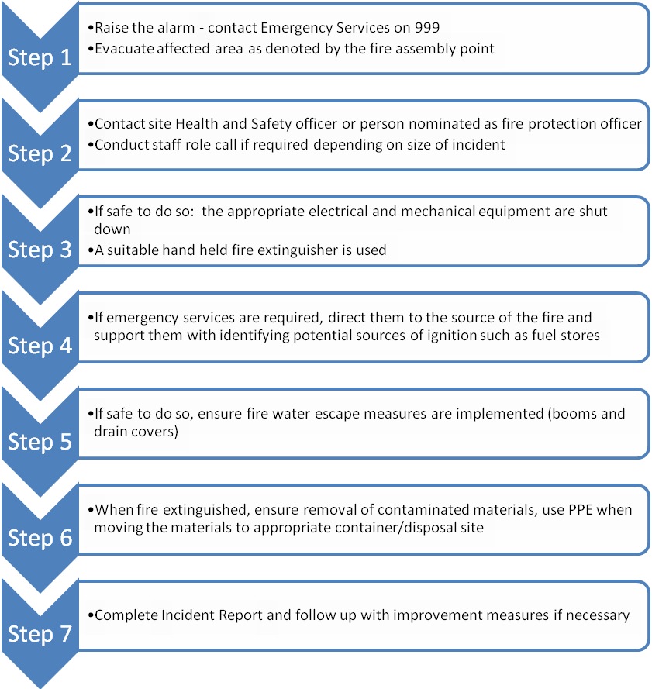
The Site Manager, will liaise with the Emergency Services on their arrival. The Site Manager will clearly identify him/herself to the Emergency Services on their arrival on site and update the FRS on the situation ensuring they are made aware of the location any compressed gases or flammable liquids on site.
Prior to arrival of the FRS on-site there are several measures that NDC Polipak Limited can take to help fight fire, assuming there is no risk to life.
- Hand held fire extinguishers & fire blankets can be deployed in order to contain fires where possible see 4.1
- Fire blankets/sheets can be used to smother smaller isolated sources of fire. See 4.1
- There are no waste piles stored internally in the recycling area. See appendix A.
- In the event of a fire or observed self-combustion, burning waste, if safe to do so, will be moved to the Fire Quarantine Area or alternative designated site. No more incoming waste will be allowed to enter the premises and will be diverted or stopped until it is safe to resume delivery.
- Neighbours and local businesses downwind will be notified of any potential fire incident by the emergency services by telephone as soon as possible from the local contact list. This will be completed by telephone and will be completed as soon as it is safe to do so. Local receptors will be notified in order of proximity to the site and prevailing wind direction. Local receptors will be kept updated as to the progress of fire-fighting as new information comes to light and fully debriefed at the end of the event.
- Once the fire has been dealt with, post fire de-contamination arrangements will be agreed with the local EA officer.
- The site is an impermeable surface and will be scraped clean
- Manufacturing site floor, Drains and runs will be gulped out and cleaned by tankers with whom NDC Polipak Limited have a contract.
- Waste will be removed from site if necessary.
- If necessary, soil and groundwater monitoring will be undertaken as agreed with the EA
- Once the local EA officer has agreed that the site is ready to become operational again then operations will recommence.

  - Managing Fire Water
Table 3 shows the potential volume of fire water which may need to be managed on site should the largest waste pile (non-hazardous waste) require quenching.

Table 3: Volume of Water Required
Total Requirement for 3 hours for 18 CUMEC (l) | 193,644L
*Based on EA guidance: 2000l of water is required for a 300CUMEC pile for 3 hrs

Table 4 shows the volume of fire water which can be contained within the site. The process operation benefits from being inside a covered area and sealed drainage system inside the unit which will contain firewater. There is a small ramp at the recycling area entrance. There is no discharge to surface water. A boom will be deployed across the entrances and a kerb around the perimeter to retain water to a height of 5cm as per Annex C.

Table 4: Volume of Firewater Contained within Site
Average Site Length (m) | 160
Average Site Width (m) | 70
Water Depth (m)* | 0.05
Site Volume (m³) | 560
Site Volume (l) | 560,000
*minimum height of curb or boom

These tables show that the site would be able to contain the volume of water needed in a worst-case scenario. Therefore, the key receptors in Annex D which could be affected by firewater will be protected. The site entrance will be protected by boom of 5cm to prevent egress of firewater out of the entrance. (Need to use portable boom)

  - Future Actions
This plan is based on current planned operations. NDC Polipak Limited understand that it is important that this Fire Prevention Plan is maintained up to date and relevant to the business. Therefore, it will be updated accordingly, in collaboration with the Environment Agency as required, should business operations change in the future.

- Annex A: Site Layout

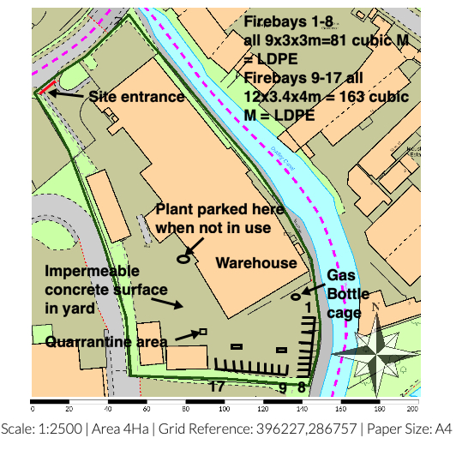
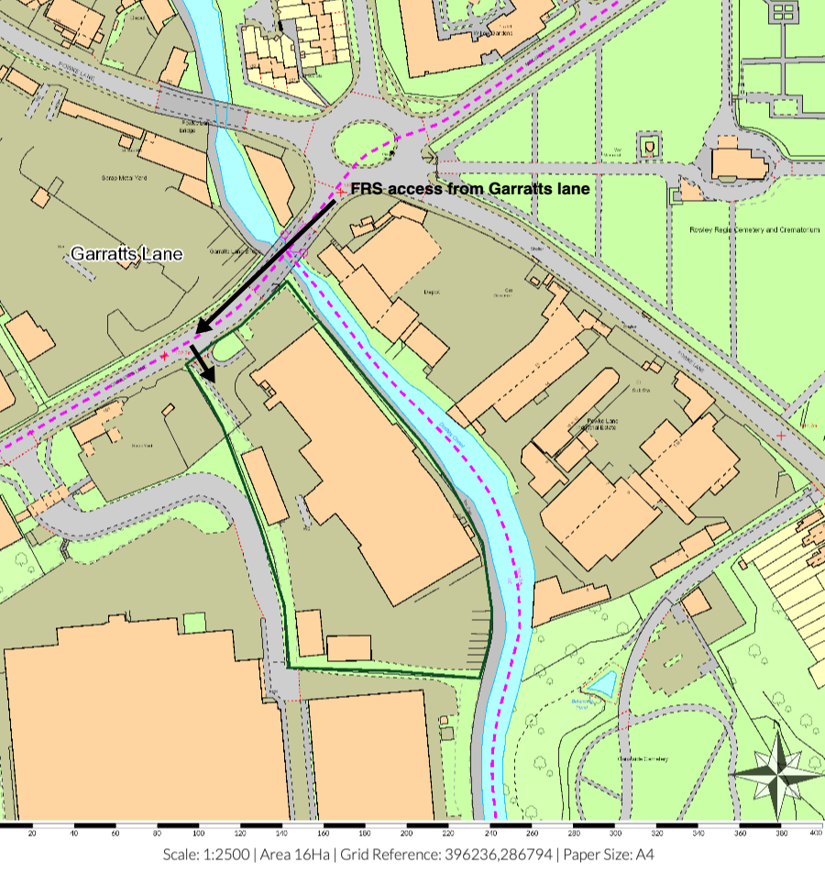
A2- Site Access
- Annex B: Site Drainage

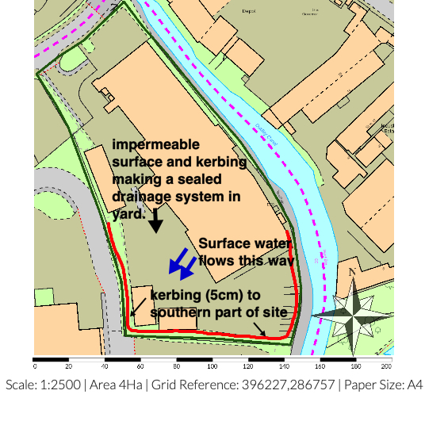
- Annex C: Fire Fighting Access, Equipment & Water Supply Plan
Car parking area

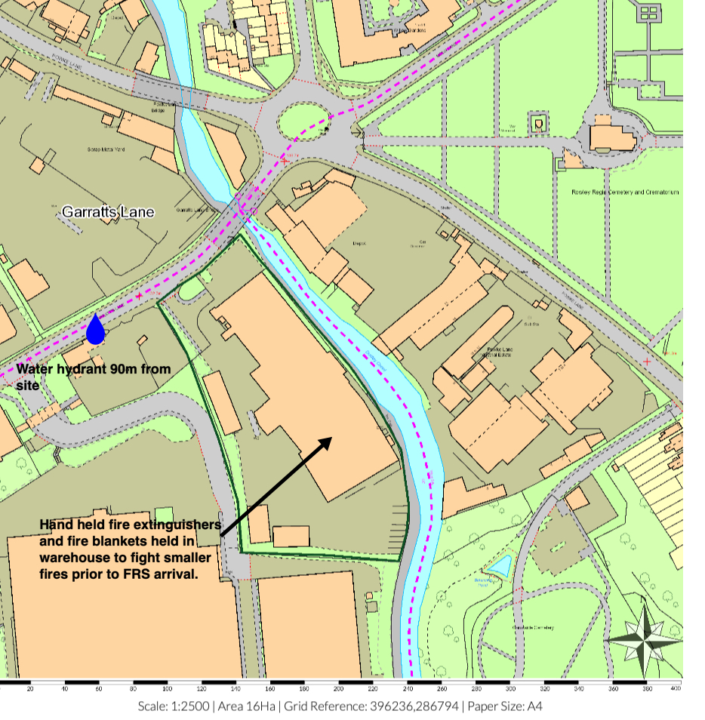C1

- Annex D: Key Receptors
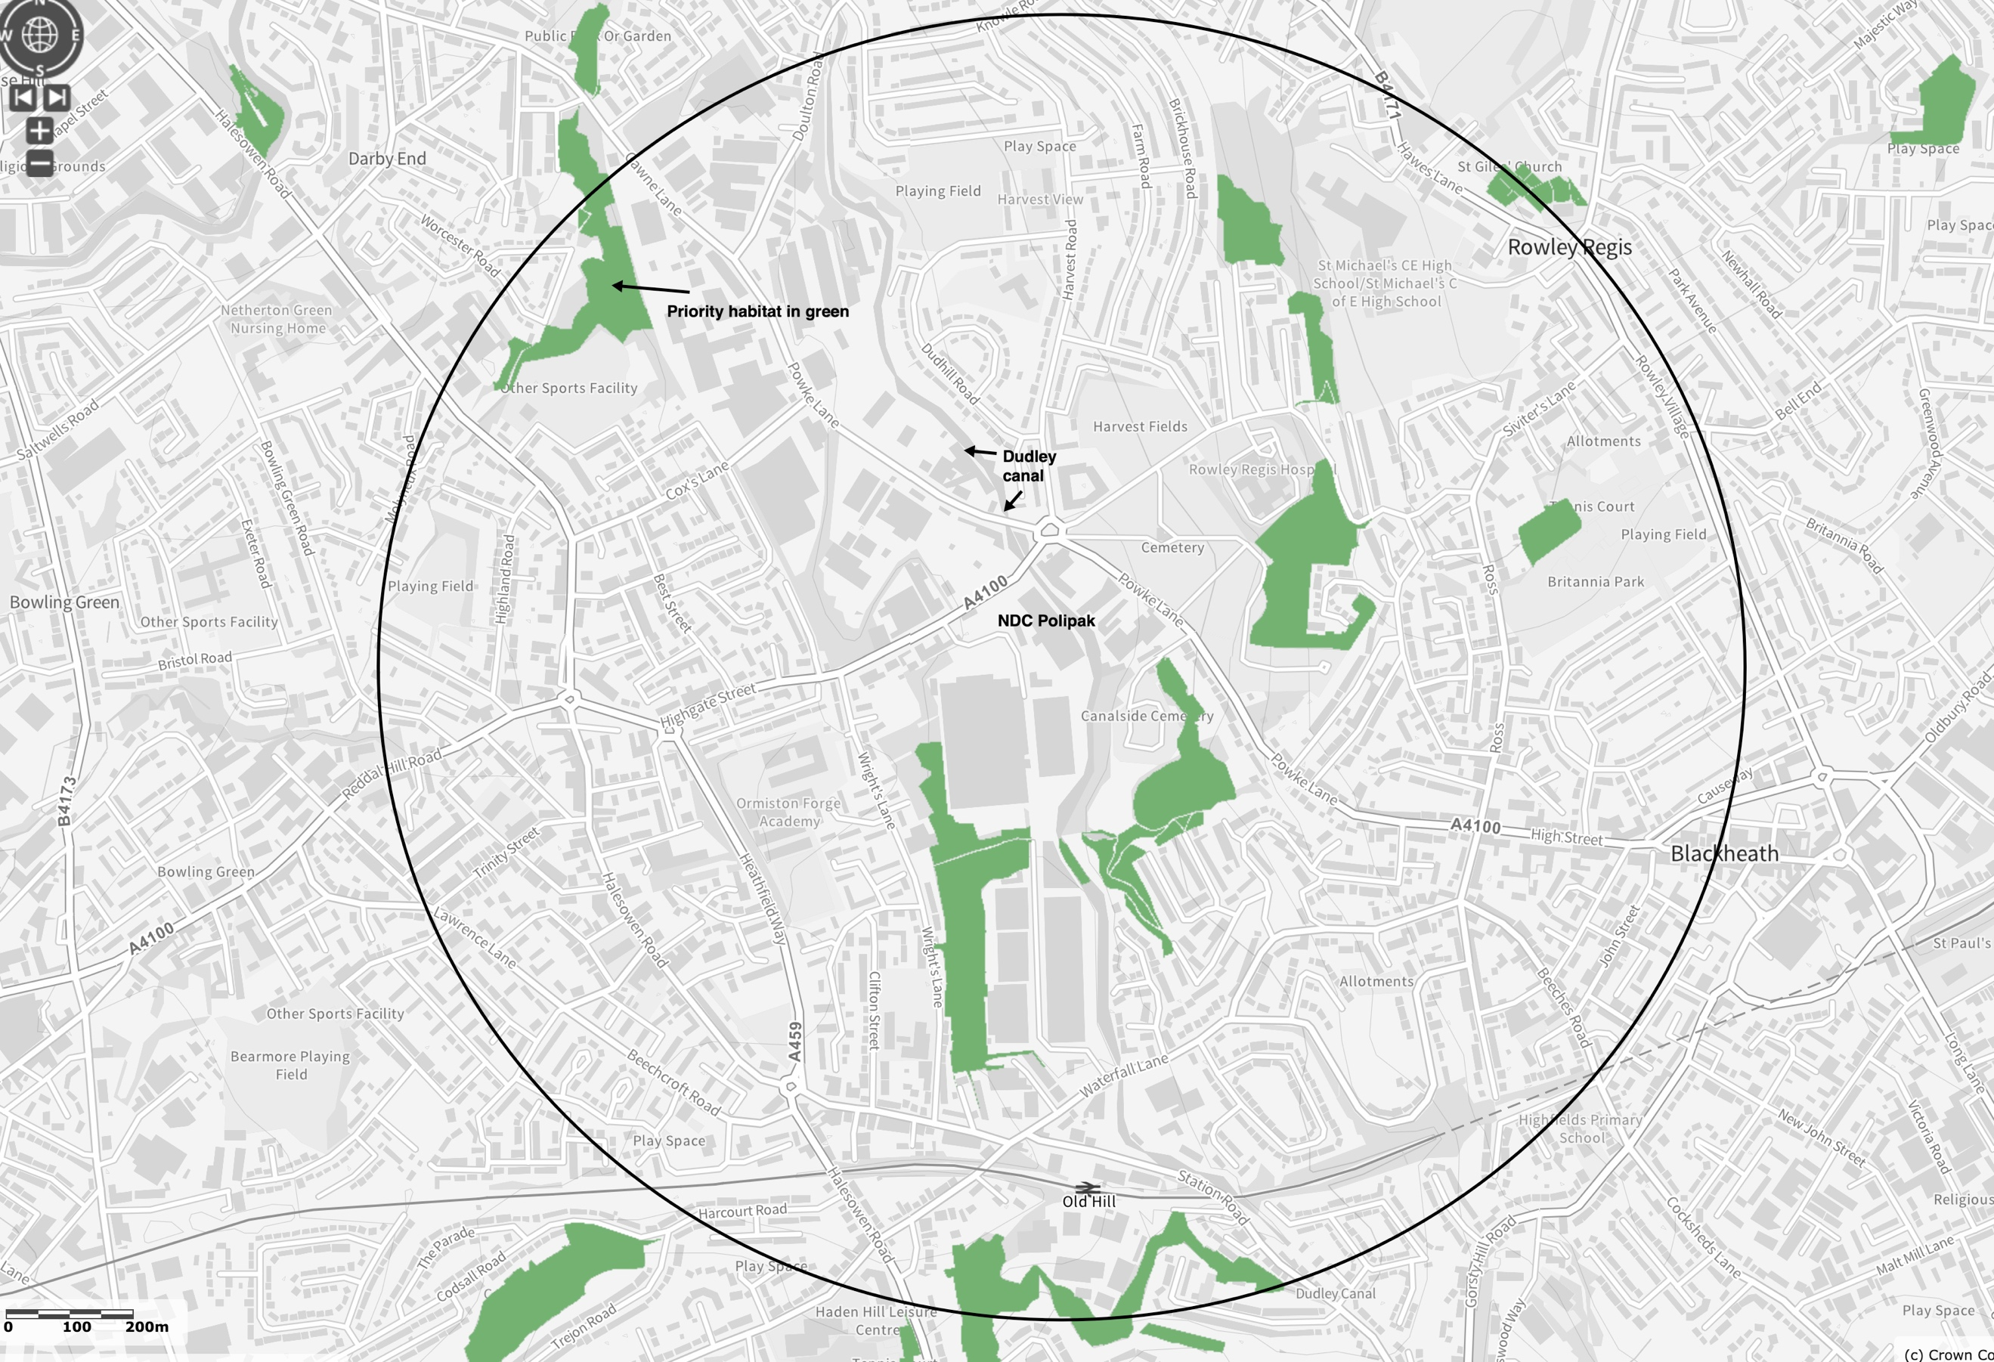 | Key Receptors  The receptors shown are within 1km of the site (black circle). Sensitive human receptors include areas containing residential properties & light industry all round the site, especially to the SE & SW.  The site is in on an industrial estate which is bordered on all sides by commerce or light industry. There are few residential premises in the immediate vicinity. There are no designated local wildlife site or SSSI’s within 1Km. There is woodland designated habitat to the S and E. There is major key infrastructure nearby including the Dudley Canal adjacent to the site. The site is enclosed and waste is stored externally in firebays with a sealed drainage system.  The nearest Fire Response Service is Halesowen Rd, Cradley Heath B64 7JU. Approx’ 1.5Km South.  Wind Direction  According to the UK Met Office, the prevailing wind direction in the area is South-Westerly. This means the prevailing winds blow over the site to the north east, which is away from the bulk of the residential areas.

- Annex E: Waste Acceptance Procedures
In order to identify non-compliant wastes including any hot loads, the following Waste Acceptance Procedure is implemented by NDC Polipak Limited.
Waste Acceptance
The procedure that shall be adopted at site is detailed below
1. Waste arrives on site.
2. Documentation is checked at the office at the weighbridge office to the site. See annex A2.
3. All vehicles will have their contents examined and photographed during unloading and this shall be crosschecked with the documentation presented.
4. Staff will check that the type of waste is acceptable in terms of the waste permit.
5. If the waste is unacceptable the waste shall be isolated and arrangements put in place for the contractor to remove the waste from site or for the waste to be segregated in the quarantine area until such times that it can be removed.
6. If the person who is checking in the load is suspicious of its contents the driver shall be directed to the waste inspection area near the reception office, where the load shall be sampled and inspected to ensure that it corresponds to the accompanying documentation. In any event compliance testing will be carried out at regular intervals.
7. Assuming the on-site verification at the office is satisfactory, the load is checked in and directed to the yard as appropriate. Here, the waste will be checked again to verify that the description is correct before tipping is allowed.
N
- Annex F: Fire Risk Checks Form for Fire Prevention
The following regular check has been completed:

Checks to be made
- Security – all security fencing and security equipment is intact (daily)
- Signs of Self Combustion – no smoke visible /potential hot spots identified (daily)
- Storage areas – housekeeping is suitable (daily)
- Storage areas – pile sizes within permitted limits (daily)
- Exhausts – exhausts are cool and located away from combustible materials(daily)
- Fire fighting water – all hose reels and hydrants are accessible(daily)
- Fire extinguishers – all fire extinguishers are in the correct place and intact(daily)
- Fire Quarantine area – clear from waste and signage intact(daily)
- Mobile plant parked remotely, secured and key out when site closed(daily)
- Waste turned when? – recorded on waste inventory in site office(monthly)
- Waste in (t) – recorded on waste inventory weekly in site office. Waste removed in date order
- Waste out (t) – recorded on waste inventory weekly in site office. Waste removed in date order.

Date | Morning check (initials) | Evening Check (Initials) | Issues to Report to Site Manager

- Annex G: Emergency Contacts

Name & Address |  | Telephone Number
Environment Agency | General Enquiries:  Incident Hotline Reporting: | 03708 506 506  0800 80 70 60
Electricity Supplier & mains switch location
Gas supplier & shut off valve location
Water supplier & shut off valve location
Local Authority Emergency Services
Insurance Company and policy number
Nearest Hospital
Emergency Spillage Response company

- Annex H: EMS Documents
Drainage & Bund Checks
- A current site drainage plan will be drawn up and displayed in the office areas for information. The standard colour coding of blue for surface water drainage that discharge to the environment and red for sealed or foul drainage systems will be employed.
- The integrity of impermeable surfaces, gulleys and storage areas will be visually inspected by the operator on a monthly basis. To achieve this, it will be necessary to sweep/ wash clean the impermeable surface that form licensed area and clear any debris that has collected in the front of the building. Where any defects are found, remedial steps will be taken promptly to maintain the integrity of the structure. If, however the integrity of the structure is breached a temporary repair will be made by the end of the working day and a full repair will be made within 10 days.
Area | When Checked | Date | Comments
Storage bays | weekly | xxx | Clean
Hardstanding | 6 monthly | xxx
Gas bottle store | monthly | xxx

Site Vehicle and Machinery Maintenance.

- All site vehicles will be fitted with working exhaust silencing equipment.
- Staff will not continue to operate any piece of machinery or equipment that appears to be visibly or audibly failing.
- All vehicles and machinery operated within the site will undergo regular planned preventive maintenance/ servicing and inspections, at the frequency deemed appropriate by manufacturer or required by legislation. As a minimum, this will be a statutory annual inspection of lifting (LOLER) and work (PUWER) equipment. Maintenance/ Servicing and inspection records will be kept on site for reference.
- Where the necessary maintenance and repair skill do not exist within the company, a contract for these services will be in place, so that the repair of site vehicles and machinery will be undertaken promptly.
- If mobile plant maintenance/ repair will involve the removal/ loss of potentially polluting fluids from the vehicle, if possible, the vehicle should be moved to impermeable concrete area and worked on there, where any spills will land on an impermeable surface. All fluid leaks or drained oils will be collected in a container and removed.
- Where mobile plant must be repaired in the location that it breaks down, if this is on hard standing, drip trays and absorbent mats will be put in place under the vehicle before work begins, to capture any spills of potentially polluting substances and prevent contamination to the earth below.
Plant and Vehicles will be inspected and recorded below;

Equipment | When checked | Date | Comments | signed
Delivery vehicles | weekly
FLT | Daily

Dealing with Spills
Scope: To detail how spills during normal and abnormal operations are dealt with to minimize impact on the environment
Responsibility: Site owner
Background: Spillage of oils and chemicals can have an impact on the soil and groundwater beneath the site.
The site carries quantities of absorbent granules and absorbent booms to mop up small quantities of hydrocarbon and other liquids if spilt. If used these are stored in a hazardous waste container until removed from the site by specialist contractor within a reasonable period of time.

- During normal operations, all staff have been made aware of the requirement to minimise fuel and liquid spills on site
- Relevant staff have had appropriate training on how to deal with a fuel spill in the event of an incident occurring
- Absorbent is used to clean up the spill at source. If it is a larger spill and it is safe to do so then the source of the spill is curtailed if possible.
- The location of spill kits and absorbent material is identified on the site plan
- Where possible all spills are directed to the sealed drainage system for containment
- A store of general absorbent material will be kept on site in an easily accessible central location known to all site staff. The absorbent material will be hydrocarbon (fuel, oil etc.) absorbent, as this is the most likely material to be spilt on site.
- Where leakage from any storage container on site is found, actions to remedy the leak will be taken. Any such leakage and remedial action will be recorded in the site diary.
In addition:
- The source of the leak or spill will be investigated, located and stopped.
- If any significant leaks or spills of substances occur, which have the potential to harm the environment or pose a risk to human health; the materials detailed under the section 'site provisions' will be utilized and disposed of appropriately.
- Any pooling leak or spill of a potentially polluting liquid will be soaked up with appropriate absorbent material, such as saw dust, sand or granules. The absorbent material will be cleared from the ground when it has soaked up all free polluting liquid.
- In the event of a significant and/ or on-going leak or spill of a potentially polluting liquid, clay damit mats or suction covers will be applied to drain grills to seal them to prevent (further) liquid from entering the drainage system.
- If any leaks or spills of substances occur, which have the potential to harm the environment or pose a risk to human health escape the site boundary, the management will inform the Environment Agency immediately. Any remedial action specified by the Environment Agency will be undertaken, a record of which will be made in the site diary.

Waste Acceptance, Storage and Inspection
To deal with the acceptance, storage & inspection of waste on-site.
Introduction
The company will introduce a system of storage on-site to minimise the potential for cross contamination and potential run off from wastes whilst stored on site.

Waste Types
Only the waste types and EWC codes named on the environmental permit will be accepted at the site. Wastes entering the site will be inspected and registered at the site. Non-compliant waste materials not allowed on the permit will be turned away from the site. A record will be made in the site diary.

Working Hours

Normal working hours will be 0800-0800 Monday – Sunday

Responsibility

The yard supervisor is responsible for identifying and highlighting non-conforming waste. The WAMITAB qualified person(s) is responsible for inspecting, documenting and safe removal of any non-conforming waste.

Waste Storage
Areas will be nominated on-site for waste storage. These will be labelled and identified on the site plan. The site plan will be updated on a regular basis provide a record of what type of waste and quantity is stored where.

Waste Acceptance
The procedure that shall be adopted at site is detailed below
1. Waste arrives on site.
2. Documentation is checked at the office.
3. All vehicles will have their contents examined and photographed during unloading and this shall be crosschecked with the documentation presented.
4. Staff will check that the type of waste is acceptable in terms of the waste licence.
5. If the waste is unacceptable the waste shall be isolated and arrangements put in place for the contractor to remove the waste from site.
6. If the person who is checking in the load is suspicious of its contents the driver shall be directed to the waste inspection area close to the reception office, where the load shall be sampled and inspected to ensure that it corresponds to the accompanying documentation. In any event compliance testing will be carried out at regular intervals if required
7. Assuming the on-site verification at the office is satisfactory, the load is checked in and directed to the yard as appropriate. Here, the waste will be checked again to verify that the description is correct.

Waste Area Inspection
As part of the EMS waste areas are inspected routinely, deviations from normal operation conditions, result are logged and acted upon in the site log.

Records
NDC Polipak Limited shall keep records of all waste loads rejected including;
- Date
- Name of Carrier
- Source of Waste
- Vehicle Registration
- Description of Waste
- EWC code
- Quantity of Waste
- Name of person carrying out inspection
- Destination of Load prior to rejection

Fire Prevention Plans, Version 3 January 2021
http://www.metoffice.gov.uk/climate/uk/regional-climates/

