003 - Site Boundary and Location Plan Feb 22
Ditchford Bank Farm Poultry
EPR/JP3604MJ

IAN PICK ASSOCIATES LTD
Specialist Agricultural & Rural Planning Consultants

Station Farm Offices Wansford Road
Nafferton Driffield
East Yorkshire

YO25 8NJ

T : 01377 253363
E : mail@ianpick.co.uk
W : www.ianpickassociates.co.uk

CLIENT
G O Few and Sons Ditchford Bank Farm
Hanbury Bromsgrove Worcestershire

B60 4HS
JOB TITLE

Proposed Poultry Unit

DWG. TITLE

Location Plan

SCALE
1=2500
DRN

IP

DWG. NUMBER

IP/GOF/01

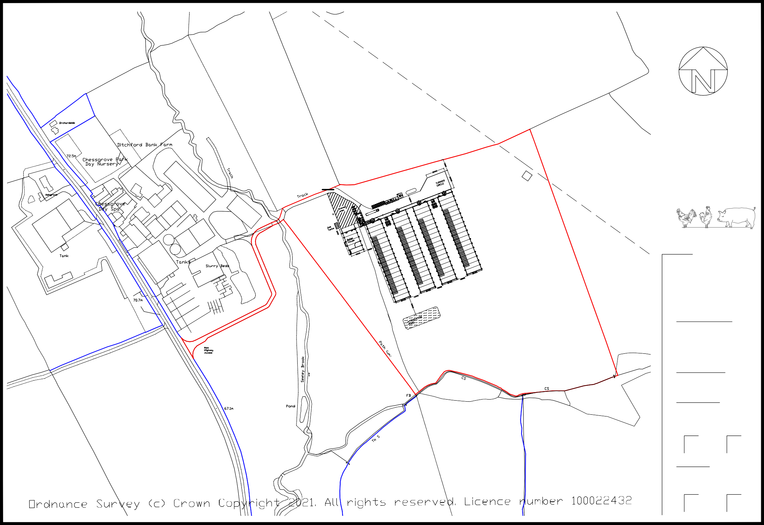
DATE
Mar 21
REV
-

