IAN PICK ASSOCIATES LTD

Specialist Agricultural & Rural Planning Consultants

Station Farm Offices Wansford Road

Nafferton Driffield

East Yorkshire

# YO25 8NJ

**T** : 01377 253363

**E** : [mail@ianpick.co.uk](mailto:mail@ianpick.co.uk)

**W** : [www.ianpickassociates.co.uk](http://www.ianpickassociates.co.uk/)

*CLIENT*

G O Few and Sons Ditchford Bank Farm

Hanbury Bromsgrove Worcestershire

# B60 4HS

*JOB TITLE*

Proposed Poultry Unit

*DWG. TITLE*

Location Plan

*SCALE*

1=2500

*DRN*

# IP

*DWG. NUMBER*

***IP/GOF/01***

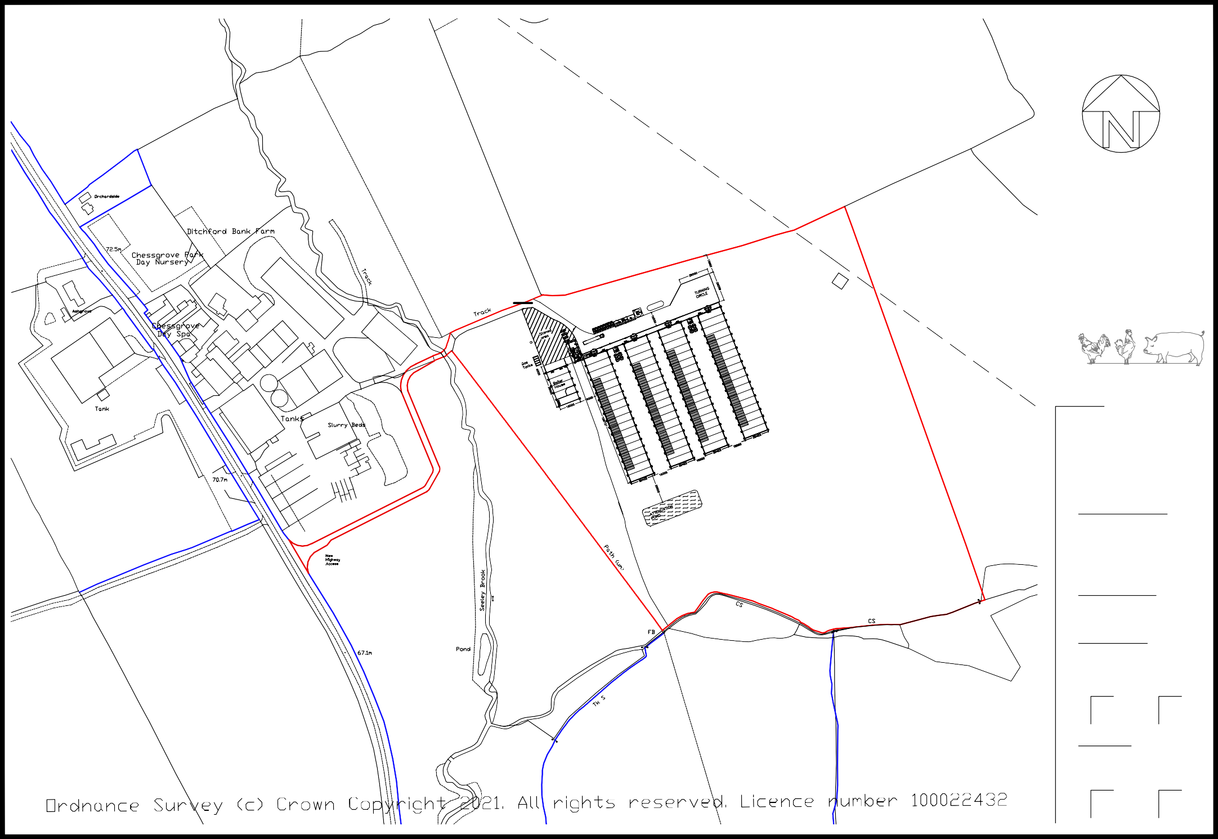*DATE*

Mar 21

*REV*

-