YARM Flood Alleviation Scheme

Frequently asked questions and answers

Date: 28 March 2023

Contents of FAQs

A. What’s happening in Yarm Page 4

1. What is the Yarm Flood Alleviation Scheme?

2. What would a flood map of Yarm look like without gates?

3. What does a flood map of Yarm look like with gates?

4. What does a 1 in 10-year flood event mean?

5. Is Yarm protected during the construction period?

6. Will there be temporary gates while the new gates are fitted?

B. Operating the flood gates Page 7

7. Why do you shut the private gates first?

8. Why can’t the current flood gates be blocked up?

9. Why can’t the current flood gates be made smaller?

10. Why aren’t the flood gates automated?

C. Public access gates Page 7

11. What is happening with the public access gate types and widths?

12. Why will some gates become sliding gates?

13. Why does the cladding need to be removed on the new gates?

14. How long will it take to install each new flood gate?

D. Operational access improvements Page 9

15. Why are these improvements required?

E. Surveys and site investigations Page 9

16. What surveys have been done on the project?

F. Environmental enhancements proposals Page 10

17. Are there any other measures that you are taking, as well as replacing the flood gates?

18. What is coir roll or matting?

G. Timescales for delivering Yarm Flood Alleviation Scheme Page 13

19. What are the timescales for delivering the scheme?

H. Contact us Page 13

20. How can I get in touch with the Environment Agency?

21. Can the Environment Agency advise me on getting flooding insurance for my property?

A. What’s happening in Yarm

1. What is the Yarm Flood Alleviation Scheme?

Yarm has a long history of flooding, dating back as early as 1771, when Yarm High Street flooded to a depth of 6 metres.

In 1993, the original Yarm flood alleviation scheme was completed. This scheme involved the construction of flood walls and flood gates to protect Yarm from the River Tees. Unfortunately, in 1995, these new flood defences were overtopped, and Yarm suffered flooding from the River Tees. Additional works which built on the previous scheme were then undertaken in 2002. These works involved raising the flood walls by 0.5m (to their current height) and the installation of numerous new flood gates.

In total, the Environment Agency maintains 1.3km of flood wall and 32 flood gates in Yarm, with the defences providing critical flood risk reduction to over 500 homes and businesses.
A project to replace the flood gates in Yarm started in 2017, with 30 flood gates being installed by April 2018.

Unfortunately, the flood gates that were installed in 2017 are deteriorating faster than expected and are challenging for our staff to operate. Whilst the existing flood gates can and will continue to be operated in the short term to protect Yarm, our assessments have concluded that new and improved flood gates are required, providing Yarm with a greater level of flood resilience.

The Environment Agency is looking to replace the Yarm flood gates because:

The existing gates are deteriorating faster than expected. They continue to protect Yarm however the gates do need to be replaced.

We have a new flood gate specification – using this specification to design new gates means that we will have gates that are safer and easier to operate.

Wide single leaf swinging flood gates can be dangerous to operate in windy conditions or on uneven ground, putting our staff at risk of injury. Consequently, we have made some gates smaller and changed some to sliding gates to make them safer to operate.

Another benefit of the new gates is that we will be able to shut the gates more quickly. This means that we will be able to shut them later reducing the impact on residents. There will still be some instances where we need to close the gates early.

2. What would a flood map of Yarm look like without gates?
The flood map of Yarm if the gates were not replaced, below, highlights that major flooding occurs within the 5-to-10-year return period.

The flood map shows the effects of a flood event if no gates where in place and closed. This highlights that the first properties are affected in a 1 in 5-year event, and that between a 1 and 10-to-25-year event would have an effect such as shown in the photo.

3. What does a flood map of Yarm look like with gates?
The flood map with the gates, below, shows that it takes a 75-year return period to flood the same area of Yarm.

This flood map highlights that with the gates in place and closed, most properties at a 1 in 50-year event, and that it would take a 1 in 75-year event to cause similar damage to a 1 in 10-year event with no gates.

4. What does a 1 in 10-year flood event mean?

Floods are often defined according to their likelihood of occurring in any given year. The most used definition in planning is the '1 in 100-year flood'. This refers to a flood level or peak that has a one in a hundred, or 1%, chance of being equalled or exceeded in any year. Similarly, a '1 in 200-year flood' has a one in two hundred, or 0.5%, chance of being equalled or exceeded in any one year.

Therefore a 1 in 10-year flood event has a 10% chance of occurring in any given year.

5. Is Yarm protected during the construction period?

Yes, the Environment Agency and Contractor will make sure all works are carried out with the same standard of flood protection in place.

A temporary flood barrier will be installed in a specific location during a flood event. All works will be subject to a permit system, where no works will be able to be carried out if a flood event is likely.

6. Will there be temporary gates while the new gates are fitted?

Yes, we have temporary works gate design to maintain the flood protection for Yarm during the construction / installation of the new gates.

B. Operating the flood gates

7. Why do you shut the private gates first?

The private access gates take longer to close and only affect the individual residential properties, these form most of the work, take longer and are therefore closed earlier on a lower trigger (Phase 1).

The public access gates affect access to the riverside and the car parks and are therefore closed at the latest (safest) possible time to limit access restrictions and impacts on the public and day to day business around Yarm. (Phase 2).

8. Why can’t the current flood gates be blocked up?

The Environment Agency has explored blocking up gates with landowners, but some need to be maintained for access reasons.

9. Why can’t the current flood gates be made smaller?

The Environment Agency has explored reducing the size of as many gates as possible, but some need to be maintained for access reasons.

10. Why aren’t the flood gates automated?

It’s not possible to power all the gates, and as such Operatives will still need to attend site to make sure all others are closed.

C. Public access gates
11. What is happening with the public access gate types and widths?
Public access gate types and widths:

Wide single leaf swinging flood gates can be dangerous to operate in windy conditions or on uneven ground, putting our staff at risk of injury. Consequently, we have made some gates smaller and changed some to sliding gates to make them safer to operate.

Flood Gate 17, off Bridge Street, is being changed to a sliding gate, with a small reduction on the width from 2.9m to 2.7m.

Flood Gate 28, which provides access to Yarm Wharf car park, has been identified as a sliding gate, due to the size and operational forces required to close the gate in windy conditions. Small alterations to the gate position is required to house the sliding gate.

Flood Gate 30, on Silver Street, near Yarm Wharf, is to be reduced from 1.8m to 1.5m to lower the wind loading on the gate during operations.

Flood Gate 31, along Castle Dyke Wynd, agreement has been made to halve the current width to 1.8m.

Gate cladding type:

Agreement has been made with the Local Planning Authority that all new gates will be painted black on both the wet and dry side, with the removal of the current cladding to reduce additional weight.

Cladding Removal:

The existing flood gates in Yarm have a wood effect cladding on them. As part of the Yarm Flood Alleviation Scheme, we are proposing to exclude cladding on the new flood gates. By excluding the cladding, the overall weight of the new gates will be reduced, making them safer to operate and improving our ability to visibly inspect the gates and monitor condition.

All newly installed gates will be painted black on both the wet and dry side. The Local Planning Authority has confirmed that this is acceptable given the Environment Agency’s permitted development rights.

12. Why will some gates become sliding gates?

Wide single leaf swinging flood gates can be dangerous to operate in windy conditions or on uneven ground, putting our staff at risk of injury. So we have made some gates smaller and changed some to sliding gates to make them safer to operate.

13. Why does the cladding need to be removed on the new gates?

The cladding does not affect the structure of the gate or improve the flood protection. However, it does add to the overall weight which increases the operational forces required to open and close. Removing the cladding reduces the weight for the site team to move.

14. How long will it take to install each new flood gate?

Estimated construction and installation time per gate is between 15 and 30 days, depending on the size, location, and complexity.

D. Operational access improvements
15. Why are these improvements required?
Currently the operatives are accessing the gates from various uneven ground, and along grasses embankments. The Environment Agency has a duty of care to look after the work force and this includes supplying them with a safe place of work and a safe access.
We are developing proposals for some access improvements along the west side of Yarm, to ensure safer access for our staff.
Along the west side of Yarm, access to and between flood gates for our staff can be difficult, as there are several different steps and very small working areas/platforms on the river side of the gates. We are developing initial proposals for some access improvements along the west side of Yarm to make access for our staff safer.

Site investigations information is currently being used to develop concept designs for the access improvements along the west side of Yarm to make accessing, maintaining, and operating the flood gates safer for our staff.
A Pre-Planning application has been submitted to Stockton Borough Council and early-stage designs are being produced to share with the Local Planning Authority, landowners and key stakeholders for comment and discussion.

Once we have these proposals, we will share these with the relevant landowners and stakeholders for discussion and comment.

E. Surveys and site investigations
16. What surveys have been done on the project?

We have carried out a Topographical Survey, Drone Survey, and a Bathymetric Survey.

The Topographic Survey produces a layout with all current contours, shapes, and elevation of the working area, along with highlighting street furniture to aid the consultants to design the new gates to suite the exiting surroundings.

The Drone Survey was used to inspect and record the river side of the wall and areas of the embankment not visible from the walkways.

The Bathymetric Survey was used to record the embankment profile and condition above and below the surface of the water and highlight any erosion that can’t be identified from the surface.

What is a Topographical Survey?

A topographical survey is a map that shows the features and elevation of the land, both natural and man-mad, this allows the consultants to design the gates to suite the existing ground.

What is a Bathymetric Survey?
Bathymetric survey is a type of hydrographic survey that maps the depths and shapes of underwater terrain.
What are site investigations?
- A site investigation simply is the process of the collection of information, the appraisal of data, assessment, and reporting without which the hazards in the ground beneath the site cannot be known.
- This can include:
  - Exiting services within the ground
  - Condition of existing structures
- Understanding the ground conditions.

F. Environmental enhancements proposals
17. Are there any other measures that you are taking, as well as replacing the flood gates?

Yes. The Tees around Yarm has historically been modified for recreational and flood protection purposes, as well as for urbanisation. Because of this, through the Water Framework Direction (WFD) several mitigation measures have been identified to help maximise the waterbodies ecological potential.

We have therefore proposed to implement the following mitigation measures to create habitat, food sources, enhance existing structures, restore natural processes, and rehabilitate the banks. We propose to achieve this through implementing the following on sections of the river:

- Use of willow spiling in areas so that the willow roots grow into and strengthen the riverbanks.
- Use of natural materials in areas to protect the toe of the riverbank from erosion.
- Use of seeded coir matting in areas of high wear to reduce erosion of the bank.
- Installation of coir roll and reeds to create new habitat along the edge of the Tees.

18. What is coir roll or matting?

Coir is a matting made from natural materials such as coconut husk fibres, which will assist seeds and roots to mature without being washed away within the river.

The proposed Environment Agency funded measures are designed to provide ecological improvement to a heavily modified waterbody. The proposals are natural, will create habitat, improve ecology, and will rehabilitate around 50m of riverbank, increasing the resilience of sections of bank along True Lovers Walk.

You can find more information about the proposed Environmental Enhancements on our webpage: https://consult.environment-agency.gov.uk/north-east/yarm-floodgates

Location 1

Erosion is occurring along the toe of the bank, with concerns raised about potential erosion into the adjacent footpath. To rehabilitate the bank, it is proposed to tether some large woody debris (tree trunks) along the toe of the bank anchored in place with a combination of rebar pins through the trunk itself and some living willow stakes. Behind the tethered trunk a section of willow spiling could then be installed and back filled with soil and seeded. The tethered trunk will aid in protecting the newly installed spiling allowing it to grow and form roots into the bank helping to strengthen the bank.

The second photo shows an Example willow spiling completed by the Tees Rivers Trust
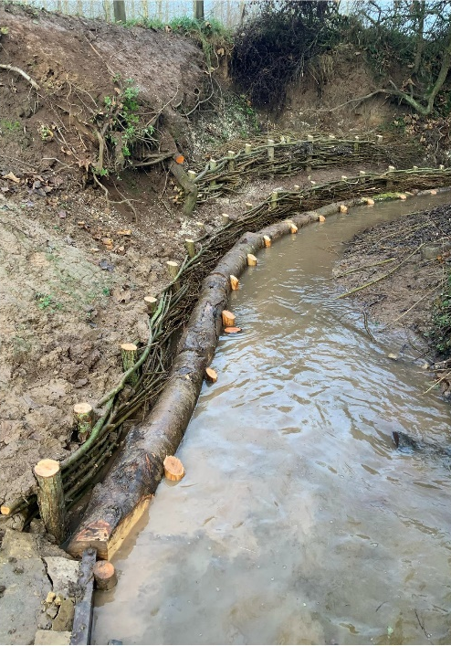

Location 2

At location 2, there is an area of bank being used repeatedly as an access point by dogs, showing signs of erosion. The proposal here is to reinforce the bank surface using either a natural geotextile (coir type material) or bank reinforcement mesh to create a more purpose-built area for this activity. The lower edge of the bank could be armoured further either with a coir roll or using a timber edge (tree trunk or similar). The reinforced area of bank can then be seeded with a mixture of native and locally sourced plant species, creating valuable habitat.
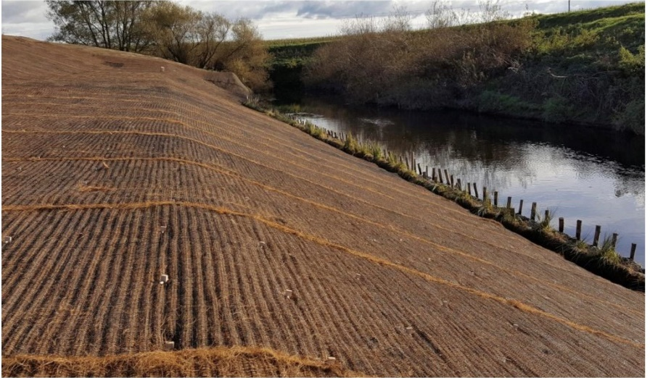
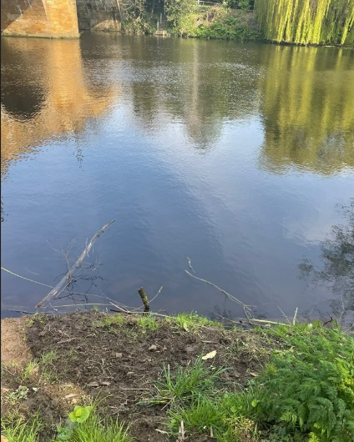
Location 3

Location 3 is upstream of the road bridge. This area has had previous works installed which have now failed (see pictures right of the stakes). Replacement of the coir roll would be recommended coupled with some willow spiling to further reinforce the toe of the bank. The willow spiling will grow into the bank, strengthening the bank. The total length of this section is 15m.

Location 4

Location 4 has previously had pre planted coir roll installed and these have grown to a certain degree. It is recommended that some additional coir rolls be installed in this area (arrowed areas), possibly with a more diverse range of reeds. Increasing the reed area will provide a range of benefits, including additional shelter for birds and mammals, structure, food sources, and provision of localised shade and generally an increase in habitat complexity and biodiversity. The proposal should improve the resilience of around 10m of riverbank.

G. Timescales for delivering Yarm Flood Alleviation Scheme

19. What are the timescales for delivering the scheme?
Timescales
We continue to work on the detailed design of the new flood gates and once finalised, the detailed programme of works will be produced and shared with the landowners and stakeholders. Currently we plan to install the public access gates first. We will speak with all landowners and stakeholders as soon as the detailed programme has been developed, to inform them of the anticipated construction window for each flood gate.

H. Contact us

20. How can I get in touch with the Environment Agency?

We want to give the local community as many opportunities as possible to give us their thoughts and opinions throughout the project.

If you would like more information or have a specific question, please get in touch with us by email. You can also request to receive our electronic Yarm newsletter or by post.

Email

EA-YarmFAS@environment-agency.gov.uk

Citizen Space

You can also visit our Yarm web page to keep up to date with the latest developments, view newsletters and find out the dates for drop-in events in Yarm: https://consult.environment-agency.gov.uk/north-east/yarm-floodgates

QR code below (for Citizen Space)

Would you like to find out more about us or your environment?
Then call us on
03708 506 506 (Monday to Friday, 8am to 6pm)
Email: enquiries@environment-agency.gov.uk
Or visit our website
www.gov.uk/environment-agency

Incident hotline
0800 807060 (24 hours)

Floodline
0345 988 1188 (24 hours)
Find out about call charges (https://www.gov.uk/call-charges)

Environment first
Are you viewing this onscreen? Please consider the environment and only print if necessary. If you are reading a paper copy, please don’t forget to reuse and recycle.

21. Can the Environment Agency advise me on getting flooding insurance for my property?

Our local teams can provide you with up-to-date details of flood risk in your area for insurance purposes; this is known as an Insurance Related Request (IRR).
An IRR is only available where the likelihood of flooding from both rivers and the sea or surface water has been assessed as more than 1 in 1,000 (0.1%) chance in any given year.
The standard IRR provides information about:

- whether an area falls within or outside the area at risk of flooding from rivers, the sea and surface water
- whether there are any defences in the area and the standard of protection that they provide
- how likely flooding is, considering any risk management measure such as flood defence barriers in the area
- whether there are any plans for flood risk management measures in the area

To request an IRR for the North East area, you can email northeast-newcastle@environment-agency.gov.uk. Please include the full address of the property in question and confirm that you are requesting an IRR. IRRs are free of charge and we will usually provide a written response within 20 working days.

