Ponteland Flood Alleviation Scheme: a summary of consultation responses
FINAL 18 November 2019

Contents
Ponteland Flood Alleviation Scheme: a summary of consultation responses 1
Contents 2
1. Introduction 3
2. How we ran the consultation 3
3. Social Media posts 4
4. Summary of Online Consultation Responses 5
5. Additional Responses 7
6. Next Steps 8
Appendix A - Responses 9
Appendix B - Email response 10

- Introduction
The purpose of this consultation was to gather feedback from the public on our preferred solution to reduce flood risk as part of the Ponteland Flood Alleviation Scheme.
This was a second consultation that followed on from a first round of consultation in January 2019, which proposed a range of options for consideration. Information on the January event is published below.
Ponteland Flood Alleviation Scheme Consultation Responses.pdf,
https://consult.environment-agency.gov.uk/north-east/ponteland-flood-alleviation-scheme-consultation/results/pontelandfloodalleviationschemeconsultationresponses.pdf
Ponteland Flood Alleviation Scheme Consultation Response Feedback Report FINAL
https://consult.environment-agency.gov.uk/north-east/ponteland-flood-alleviation-scheme-consultation/results/pontelandfloodalleviationschemeconsultationresponsefeedbackreportfinal.pdf

- How we ran the consultation
We ran a formal consultation for five and a half weeks from 16/9/2019 to 21/10/2019.
The online consultation was hosted on our Citizen Space consultation platform, with an information document and an online survey.
We also held a public a community drop-in event from 2:00 pm to 7:00 pm on Wednesday 18 September 2019 at Ponteland Memorial Hall, Ponteland. The event was attended by over 20 local residents of Ponteland.
Hard copies of the questionnaire were also distributed at the community drop-in event and responses were accepted by email.
We promoted both the online consultation and the public community drop-in event using a number of methods including:
- Placing an advert in the local, widely read magazine, Ponteland News
- Through the Environment Agency North East Twitter channel
- Emailing the promotional flyer for the drop-in event to stakeholders and partners, including Ponteland Town Council, Northumberland County Council and Northumbrian Water.
- Inviting key partners to be present at the drop-in event

We received 0 online and 2 hand written responses to the consultation, received at the drop-in event. In addition we also received an additional comment via email.

- Social Media

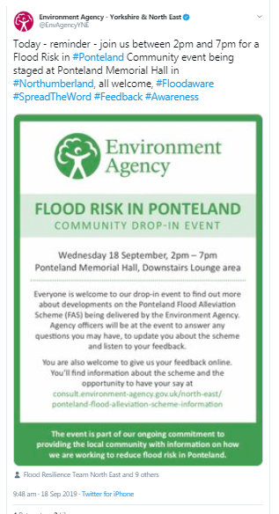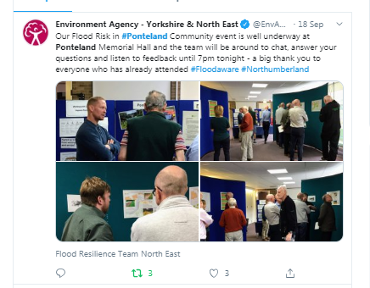

- Summary of Consultation Responses
We received 2 responses to the online consultation.

Flood Risk

Q1 - Do you have experience of flooding in Ponteland?

Q2 - If yes, was this flooding from the river over topping or from surface water (drains being unable to cope)?

We received 2 qualitative responses to this question.

Comments received in response to Q2

River flood garden, it is part of floodplain

Both: Recent (early Sept) minor flooding on High Street

Q3 - Were you previously aware of the flood risk in Ponteland before this consultation?

All respondents to the questionnaire indicated they were previously aware of the flood risk in Ponteland.

Q4 - Are you currently signed up for a flood warning in Ponteland?

You can sign up to receive flood alerts and warnings in Ponteland online at https://www.gov.uk/sign-up-for-flood-warnings or by calling Floodline on 0345 988 1188.

We would like to thank residents for sharing information on local flooding with the EA team in this and the previous consultation. This scheme will help maintain the current protection from flooding from rivers (fluvial flood risk). We will continue to work with our partners, Northumbrian County Council and Northumbrian Water, to understand surface water flood risk.

We are pleased to see residents are signing up for flood warnings and sharing this information with their neighbours. Also see the response to the email queries in Appendix B
How we are using your comments - Flood Risk

Scheme Preferred Option

Q5 - We have now identified a preferred option for maintaining flood risk protection in Ponteland to replace the end of life assets. Are you in support of the preferred option?

All respondents to the questionnaire indicated they were in support of a scheme to reduce flood risk in Ponteland.
1 of the 2 respondents provided a comment in response to this question.

Comments received in response to Q5

The E.A. seems keen to minimise disturbance and there is a proven need to improve aged assets.

Q6 - Please tell us any other comments or ideas you have about the scheme below

1 of the 2 respondents provided a response to this question.

Comments received in response to Q6

Keep tree removal to a minimum. Plant as many trees as possible in the area of the works.

Responses were in favour of the scheme and no significant issues were raised through the consultation process, so the next step is to progress with detailed design.
As part of this we will continue to look at options for appropriate tree planting locations and will ensure that work is carried out to keep disruption to a minimum.
How we are using your comments - Scheme Preferred Option

5. Additional Responses
In addition to the consultation responses, we also received a submission via email (see Appendix B) to which we responded. The consultation response from this enquiry was not returned.

6. Next Steps
The responses from this and the previous consultation will used as a basis to approve the design.
Once the design has been finalised in early 2020, it will be submitted for approval for funding to allow construction. We will communicate updates on design and a brief, non-technical summary of the fluvial (river) and surface water modelling investigations that are feeding into the development of the Ponteland Flood Alleviation Scheme via the citizen space website.

https://consult.environment-agency.gov.uk/north-east/ponteland-flood-alleviation-scheme-information/

Would you like to find out more about us or your environment?

Then call us on

03708 506 506 (Monday to Friday, 8am to 6pm)

Email

enquiries@environment-agency.gov.uk

Or visit our website

www.gov.uk/environment-agency

Incident hotline

0800 807060 (24 hours)

Floodline

0345 988 1188 (24 hours)
Find out about call charges (www.gov.uk/call-charges)

Environment first:
Are you viewing this on screen? Please consider the environment and only print if absolutely necessary. If you are reading a paper copy, please don’t forget to reuse and recycle.

Appendix A - Responses received

Respondent Number | 1 | 2
Q1. Do you have experience of flooding in Ponteland | Yes | Yes
Q2. If yes, was this flooding from the river overtopping or from surface water (drains being unable to cope) | River flood garden – it is part of floodplain | Both. Recent (early Sept) minor flooding on Main Street
Q. 3 Were you previously aware of the flood risk in Ponteland before this consultation? | Yes | Yes
Q4. Are you currently signed up for a flood warning in Ponteland? | Yes | No
Q5a. We have now identified a preferred option for maintaining flood risk protection in Ponteland to replace the end of life assets. Are you in support of the preferred option? | Yes | Yes
Q5b. Please let us know any specific reasons for your response above | / | The E.A seems keen to minimise disturbance and there is a proven need to improve aged assets.
Q6. Please tell us any other comments or ideas you have about the scheme below | / | Keep tree removal to a minimum. Plant as many trees as possible in the area of the works.

Respondent Number | 1 | 2
How did you find out about the consultation? | / | Ponteland Town Council
On a scale of 1 – 5, how useful did you find the consultation document? | 5 (very useful) | 4
Did you attend our public event? | Yes | Yes
On a scale of 1 – 5, how useful did you find the public event? | 5 | 5
How well do you feel your views were listened to by our staff at the community event? | 5 (I felt listened to) | 4
What is your interest in Ponteland and the scheme? | Resident (Homeowner) | Resident (Homeowner)
Can we publish your response? | Yes | Yes
Submitted date | 2019-11-07  15:42:36 | 2019-11-07  15:49:11

Appendix B - Email representation

From: REDACTED
Sent: 02 October 2019 04:33
To: Enquiries, Unit <enquiries@environment-agency.gov.uk>
Subject: Ref 191004/JC01 Ponteland Flood Alleviation Scheme

I’m responding to the current consultation due to close this month. I can’t find the online version of the Feedback Form.

Will you publish on the Ponteland microsite the results of your further investigation and possible further work into the surface water management in Ponteland please?
The microsite is a useful information source, as is the new beta site showing the EA’s maintained areas in Ponteland.

Are you updating the current fluvial and surface water flood risk map?

I continue to have concerns about other agencies’ planned and actual maintenance of Ponteland’s surface water system. In particular, for the County Council which seems only to carry out maintenance when there is a complaint of minor flooding problem, and the below ground highway drainage from Clickimin to the town centre.

Thank you.
REDACTED
_________________________________________________________
EA Response

Dear REDACTED

Many thanks for your email dated 2 October 2019. I’ve attached the Feedback Form as a Word document and a PDF. As we have highlighted through the consultation, we are progressing with a business case for the proposed Flood Alleviation Scheme in Ponteland which will need to be approved prior to any works commencing, we would be interested in any views you may have and will consider these as part of the consultation process. You are welcome to fill in the form and post it back to: Kirsty Harwood, Ponteland FAS project team, Tyneside House, Newcastle Business Park, Skinnerburn Road, Newcastle upon Tyne, NE4 7AR or email the completed form to me.

We are delighted that you find the microsite on Citizen Space useful. We will be publishing a brief non-technical summary of the fluvial (river) and surface water modelling investigations that are feeding into the development of the Ponteland Flood Alleviation Scheme on the Citizen Space, after the consultation has closed and when the results are complete. It’s important for local residents to note that our investigations have only been undertaken in a very discrete location, with known fluvial flood risks. Wider and further work in relation to surface water management in Ponteland, or the surrounding area, is the responsibility of Northumberland County Council.

With regards to your query about the current fluvial and surface water flood risk map, we will update the fluvial flood maps and mapping products that are part of our flood warning service, following completion of the Ponteland flood alleviation scheme. It is the responsibility of the Lead Local Flood Authority, in this case Northumberland County Council, to update the national surface water mapping, and as a key partner, we will share any surface water outputs with the council for its consideration, once the scheme is complete.

Thank you for your feedback about your concerns about planned and actual maintenance of Ponteland’s surface water system and below ground drainage. As we have said, we do work closely with Northumberland County Council; however this area of work sits with the local authority and as such, may we suggest that you contact them direct to express your concerns.

Thank you once again for your interest in the Ponteland FAS and we look forward to receiving your feedback form.

