Environment Agency Houghton Regis Flood Alleviation Scheme:
Frequently asked questions
- What is the Houghton Regis flood alleviation scheme?
Heavy rainfall can cause areas in Luton to flood. To reduce the flood risk from the rivers in Luton, we are planning to build a flood storage area (FSA) on the Houghton Brook near Houghton Regis. The FSA will reduce the flood risk to over 500 properties downstream in Luton.
- What is a flood storage area (FSA)?
Our FSA is designed to fill with and hold water at times of heavy rainfall, when river levels are high. The FSA will allow water to drain away slowly into the Houghton Brook as river levels reduce. The FSA will consist of an earth embankment to hold back water and a structure to control the flow rate out of the FSA. By controlling the flow, water is stored upstream to prevent flooding downstream in Luton.
We have also allowed for capacity in the FSA for some surface water runoff from the surrounding area. This is water that collects during heavy rainfall on impermeable surfaces such as roads and pavements.

- Where is the site for the FSA?
The FSA will be located to the south of Chalton on land between Houghton Regis and Luton. The land is adjacent to the M1 motorway on the site of the major new development Houghton Regis North. A location map of the site is at the bottom of this document.

- What stage is the project at now?
We are in discussions with Central Bedfordshire Council (CBC) and intend to submit our planning application for the scheme in late 2018. If we are successful in our planning application, we anticipate starting construction in Spring/Summer 2019.
- How long will construction take?
The construction works for the FSA are expected to last 6 months. We will endeavour to limit disruption to the local community in the construction phase. Where possible, we will use the new Woodside Link road to minimise traffic impacts to local residents.

- How often will the flood storage area operate?
We expect the FSA to hold water on average once a year, sometimes more. On these more frequent occasions the FSA will hold back small quantities of water which may only flood a small area. During the less frequent heavy rainfall events, the amount of water stored in the FSA will be greater along with the submerged flooded area.
- How big will the waterbody be when it is full?
The FSA is designed to hold in excess of 100,000 m3 of water during a high risk flood event, flooding an area of 75,000 m2 behind the embankment. That’s the equivalent of 40 Olympic swimming pools of water covering 10 full sized football pitches in area.
- How long will the water take to drain away from the flood storage area?
At maximum capacity, the water will take approximately 24 hours to drain away from the flood storage area naturally.
- Where is the access route during the construction period?
The construction site will be accessed from the Woodside Link Road during the construction phase. This will mean that the construction vehicles will not be using Houghton Regis as a through-way.
- Where is the access route into the flood storage area?
The FSA will be accessed via the existing access used by Highways England on Kestrel Way. Pedestrian access will be retained in the area via the public footpath and cycleway along the River Lee beneath the A505 (Woodside Link) and can be accessed via the Woodside Link directly.
- Who would look after the storage area?
The embankment and flow control structure will be maintained by the Environment Agency.
- Who will be responsible for looking after the watercourse?
Currently the land owner is the Houghton Regis North Development Consortium (HRN1). Once the FSA is complete the responsibility for the watercourse will stay with the landowner. For information about the proposed new development by HRN1 please get in touch with HNR1 at: contact@hrn1.co.uk

We maintain a small number of structures and stretches along both the Houghton and Lewsey Brook. A range of maintenance checks are carried out during the course of the year. For more information about this and general riparian responsibilities please visit: https://www.gov.uk/government/publications/riverside-ownership-rights-and-responsibilities

- What impacts will the proposed scheme have upstream?
There will be no impact on river levels upstream of the FSA.
- How much will flood risk be reduced downstream?
Our scheme will reduce the flood risk to properties in Luton, which are presently at a high risk of flooding along the River Lee. The scheme will also reduce flooding downstream of the FSA to route 6 of the National cycleway (parallel to the River Lee).
- How will you fund the scheme?
This scheme has received government funding of £4million, together with a contribution of £230k from Luton Borough Council.
We hope to purchase the land for the embankment area, together with access rights, for a nominal sum from the developers (HRN1) and the landowners.
- Are public routes/cycleways to be maintained in the same position? Through the build? On completion?
We will need to divert the cycleway around the FSA to accommodate the embankment. Access to the cycleway will be maintained through the construction phase wherever possible.
- Cycle path under the Woodside link (underpass)
We are aware that occasionally the cycle path floods within the underpass. This path is owned and maintained by Central Bedfordshire Council. We expect this cycle path to sporadically flood during less frequent, heavy rainfall events, at which point it will become part of the flood pond. If you have any cycle path issues to report please contact Central Bedfordshire Council on 0300 300 8301.

- How will we take current wildlife into account whilst constructing our scheme?
As part of the environmental work for the scheme, we are undertaking ecological surveys of the site. We are preparing suitable protection and mitigation measures within the design and throughout our construction programme. This includes general ecological surveys, water vole and bird surveys as well as taking into account information that was collected as part for the wider HRN1 development.
All the surveys will be carried out by qualified professional ecologists. The results forming the report that will be submitted as part of our planning application. Throughout the works an Environmental Action Plan will be in place and an Environmental Clerk of Works appointed to ensure that work on site does not harm the environment, local wildlife or residents.
The results of surveys and our understanding of the ecological context of the scheme have also been taken into account when designing the landscaping plans for the site. In particular as part of the modified brook and creation of new wetland and woodland areas within the site.
- Will there be any environmental improvements within our scheme?
Currently the Houghton Brook through the FSA has a man-made straight channel. Our scheme will create a new winding, more natural channel. Our scheme will also include environmental improvements which will increase habitat diversity.

If you have any observations of local wildlife using the site please report it to Bedfordshire and Luton Biodiversity Recording and Monitoring Centre here: http://www.bedscape.org.uk/BRMC/newsite/index.php?c=about_home

- Will our scheme impact the flood risk in Chalton village?
No, our scheme will not impact flood risk in Chalton village.

- Will our scheme have an impact on groundwater levels in the area?
There will be no impact on groundwater levels.

- How will the access to the attenuation ponds be managed?
Access points already exist for the attenuation ponds.

- Will we be creating more scrapes to hold the water?
We will be create some scrapes downstream of the embankment. These will be for environmental improvements and will not store water.

- Where will we get the material to create the embankment?
The material for the embankment will be imported from an offsite source.
Embankment dimensions: 650m long, average height is 2.5 meters

- Who will maintain the scrapes and other environmental features created as part of the FSA in the next 20 years?
The land developer and the council will discuss and agree this as part of the planning application. We are committed to looking after landscaping for a couple of years on completion of the FSA, after which it will be passed onto the developer to manage the land.

- The footprint of the scheme has been given to the EA by the developer. Is this an offset of Section 106 funding?
We are in discussions with the developer to secure the land for the footprint of the scheme for a nominal transfer of payment.

- How does the scheme integrate with the drainage of the surrounding area?
The design accommodates additional surface water from the HRN1 development, subject to planning approval.

- Has consideration been given to the flow control structure creating a blockage in the river corridor? For example, will water voles be able to get past the structure?
We are installing a mammal ledge within the flow control structure and hope that the environmental improvements encourage Water Voles to make a return to the Houghton Brook.
Contact us
If you would like any more information on the Houghton Regis flood alleviation scheme please email:
PSO-HNL@environment-agency.gov.uk
Or write to:
Houghton Regis Team PSO, Environment Agency, Alchemy, Welwyn Garden City, Bessemer Road, Welwyn Garden City, AL7 1HE
Or phone: 0203 025 9210
Other Environment Agency messages

- We work with local partners to take into account local needs and opportunities when deciding where to invest.
- We work closely with local authorities and other partners who have a responsibility for managing flood risk and planning for climate change.
- From 2015 to 2021 the Environment Agency is working to reduce the risk of flooding from rivers, the sea, groundwater and surface water for at least 300,000 homes.
- Between 2015 and 2020 we are spending over £1 billion on maintaining flood risk management assets. This is compared to the £812 million spent in the previous five years.
  - This includes spending on developing technology and direct maintenance work such as dredging, inspecting assets, and carrying out repairs.
- For information about riparian responsibilities please visit: https://www.gov.uk/government/publications/riverside-ownership-rights-and-responsibilities

Be aware
- You will need to get our consent for works or structures on or near main rivers. Contact us on 03708 506 506 at an early stage in your project planning.
Be prepared
- Call Floodline on 0345 988 1188 (24/7 service) to find out if your property is at risk of flooding. If it is at risk, sign up for our free Flood Warning Service and start preparing for when a flood happens.
Incident hotline
- Call our free 24/7 Incident Hotline on 0800 80 70 60 to report: River flooding, blockages and fly-tipping in rivers, pollution that threatens a water or land, Illegal fishing or fish in distress or dead, damage or danger to the natural environment.
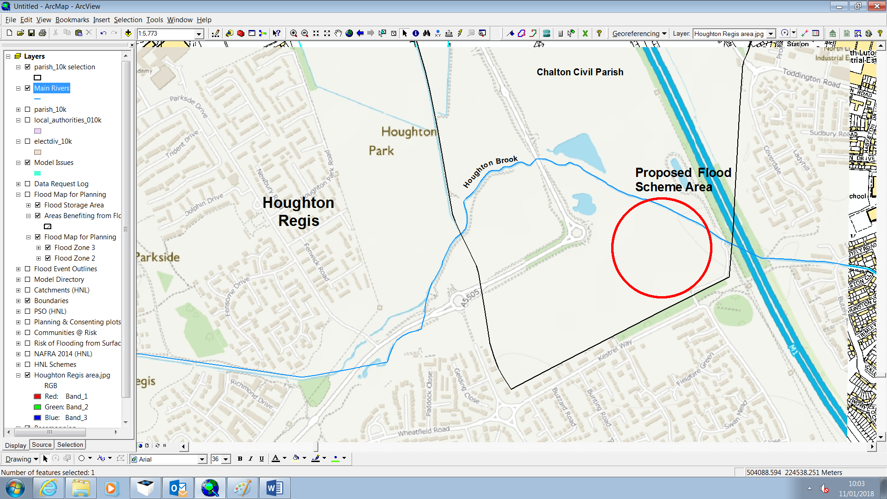Map to illustrate approximate location of the Houghton Regis flood alleviation scheme

