Water stressed areas – final classification 2021
Date: 1 July 2021
Version: 1.0

We are the Environment Agency. We protect and improve the environment.
We help people and wildlife adapt to climate change and reduce its impacts, including flooding, drought, sea level rise and coastal erosion.
We improve the quality of our water, land and air by tackling pollution. We work with businesses to help them comply with environmental regulations. A healthy and diverse environment enhances people's lives and contributes to economic growth.
We can’t do this alone. We work as part of the Defra group (Department for Environment, Food & Rural Affairs), with the rest of government, local councils, businesses, civil society groups and local communities to create a better place for people and wildlife.

Published by:
Environment Agency
Horizon House, Deanery Road,
Bristol BS1 5AH
www.gov.uk/environment-agency
© Environment Agency 2021
All rights reserved. This document may be reproduced with prior permission of the Environment Agency.
Further copies of this report are available from our publications catalogue: www.gov.uk/government/publications or our National Customer Contact Centre: 03708 506 506
Email: enquiries@environment-agency.gov.uk

Contents

Water stressed areas – final classification 2021 1
Foreword 4
Introduction 5
Final classification 5
Approach to our assessment 8

Foreword
This report sets out the results of the updated determination of areas of water stress that took place in 2021. These results update the one previously published in 2013.
The Secretary of State accepted our advice on the water company areas that should be determined to be in areas of serious water stress and has determined those areas as areas of serious water stress on 1 July 2021. This followed our public consultation in February and March 2021. The determination is solely to inform whether water companies should be able to consider the option of charging by metered volume for all customers. This is known as compulsory metering. It must be considered alongside other options to manage water supplies in their water resources management plans.
A lot has changed since the classification was revised in 2013. The National Framework for Water Resources and water companies’ water resources management plans (WRMP19) were published in 2020. Using the latest data from these plans has improved our understanding of water resources needs. This includes the impact of climate change, pressure on the environment and how to meet the challenges they create.
Water stress applies both to the natural environment and to public water supplies. Both will be affected by climate change. Public water supplies are under pressure from reductions in abstraction to make them more environmentally sustainable. There is also a need to make public water supplies more resilient to droughts and meet additional demands associated with development and population growth.
The determination shows where we believe there are or, are likely to be, environmental impacts caused by public water supplies or the need for major water resources developments. It indicates where these could be reduced by improving water efficiency through metering. It does not indicate that there will not be enough water for supplies or reflect water company performance.
Serious water stress is defined in the Water Industry (Prescribed Conditions) Regulations 1999 as where ‘the current household demand for water is a high proportion of the current effective rainfall which is available to meet that demand; or, the future household demand for water is likely to be a high proportion of the effective rainfall which is likely to be available to meet that demand’.
The water stress method takes a long-term view of the availability and the demand for public water supply, rather than a snapshot of shorter or peak periods. It accounts for future population growth, climate change, environmental needs and increased resilience. It reflects and supports the commitments that water companies have made to reduce leakage and water consumption.

Introduction
As our water supplies come under increasing pressure, we need water companies to better manage the volume of water they distribute. To help with this, water companies in areas which are under serious water stress are able to charge all customers for the volume of water used. This is measured by a water meter on each property. Metering must be shown to be cost-effective and that there is customer support through the water resources management plan (WRMP) process.
Local authorities can use the water stress determination to inform whether they can require the tighter standard of 110 litres per head per day in new developments. Otherwise the use of the water stress determination is only to allow water companies to consider compulsory metering in their water resources management plans. It must not be used for other purposes such as development planning or water resources planning.
We consulted publicly on our approach between 11 February and 11 March 2021. We have published our summary of the responses to the consultation and our analysis on citizen space.
Our understanding of the current and future pressures on water resources has improved significantly since 2013. This includes the impacts of population growth, climate change and environmental requirements. It includes the expectation that public water supplies are resilient to extreme droughts with a frequency of 1:500 years. This means before there are restrictions such as stand pipes.
Water companies in areas determined as an area of serious water stress must evaluate compulsory metering alongside other options through their WRMPs. The water stress determination applies to individual water companies’ areas or parts of water companies’ areas. It cannot be applied to regions greater than water companies’ areas or the whole country.
We used the latest available evidence to review how we identify the areas of England that have different levels of water stress. This included information in WRMP19 and produced for the National Framework for Water Resources published in 2020. We used interim water resources position statements produced by regional groups to look at the impacts of resilience to 1:500 year droughts.
We explain the method in the section on ‘our approach’ in this document. A technical report ‘Appendix 3: Water stress assessment methodology’ contains more detailed information on the method and its development. This is also available on the GOV.UK and Citizen Space webpages.

Final classification
To satisfy the specific purpose of the Water Industry (Prescribed Condition) Regulations 1999 (as amended), the Environment Agency has looked across the current and future water usage and climate change scenarios, to provide an water stress situation for each water company area.
Even those areas that have been determined as not seriously water stressed, still experience pressure on water resources. The results assess where water resources are being or are likely to be exploited to a degree which may result in pressure on the environment or water supplies both now and in future. They do not indicate how individual water companies are performing in the management of their water resources, or a level of risk to public water supply.
The following company areas have been determined by the Secretary of State to be classed as seriously water stressed for metering purposes using the updated analysis. The numbers in brackets refer to the numbers on the map in figure 1:
Additional company areas as a result of the 2021 determination:
- Cambridge Water (4)
- Portsmouth Water (7)
- South Staffordshire Water (10)
- Severn Trent Water – excluding Chester zone (12)
- Veolia Water (15)
- Wessex Water (17)
- South West Water – Bournemouth (19)
- South West Water – Isles of Scilly (20)
The companies determined to be in areas of serious water stress in 2013 remain so:
- Affinity Water (1)
- Anglian Water – East Anglia (2)
- Essex and Suffolk Water (5)
- SES Water (8)
- South East Water (9)
- Southern Water (11)
- Thames Water (14)
The following company areas are determined to be not seriously water stressed for metering:
- Bristol Water (3)
- Northumbrian Water (6)
- South West Water – Devon and Cornwall (13)
- United Utilities (16)
- Yorkshire Water (18)
- Dŵr Cymru Welsh Water – Herefordshire (21)
- Anglian Water – Hartlepool (22)
- Severn Trent – Chester zone (23)

Figure 1 shows a map of the results. It shows areas coloured red are those that are seriously water stressed and those in yellow are not seriously water stressed.
Figure 1: map showing results of water stress classification
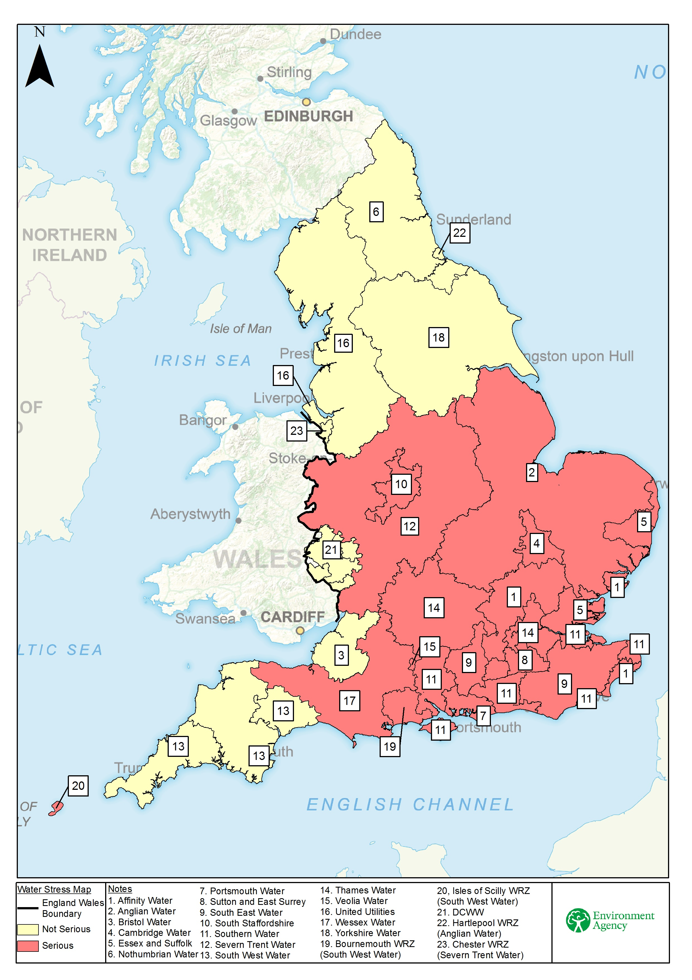

Approach to our assessment
This section explains the steps we took to classify areas of water stress. We split the analysis into the areas covered by water companies. This was so we could look at situations where the water company has distinctly different geographical areas, for example Anglian Water and South West Water.
The assessment of water stress involved adjusting the future planned supply demand balances in the water company WRMP19. The adjustments included:
- making the WRMP19 data more consistent between water companies
- changes to reflect the impact of a higher level resilience to drought
- a reduced impact upon the environment from existing abstractions
Where these adjustments lead to a future supply demand deficit there is a case for serious water stress.
The assessment of water stress on public water supplies involved analysing the published data in the WRMP19 supply demand balance in each water company area. The analysis included:
- making the calculation of the supply demand balance more consistent between water companies (such as removing supply side drought measures)
- allowing for the impact of moving to a 1:500 (0.2%) risk of needing standpipes during droughts
- ensuring the achievement of a 50% reduction in leakage by 2050
- allowing for the reductions in personal consumption set out in WRMP19
- removing the impact of new supply side sources after 2024 to 2025
- allowing for the impact of changes to increase sustainability including climate change
The sustainability changes were derived from the future environment flow requirements which were assessed for the National Framework. This investigated the effects of climate change and the potential impact that this could have on existing abstractions. We used the enhanced scenario which sees greater environmental protection for:
- Protected Areas
- Sites of Special Scientific Interest (SSSI) rivers and wetlands
- principal salmon rivers and chalk streams and rivers
In these cases it applied the most sensitive flow constraint appropriate, increasing the proportion of natural flow that is protected for the environment.
The National Framework analysis gives an indication of the potential changes in abstraction needed by region. We allocated the potential abstraction reduction to water company area based on the location of the public water supply abstractions. The approach we have taken to assess the environmental needs is set out in a separate report as Appendix 2 to the consultation which you can find on the GOV.UK and Citizen Space webpages.
We assumed that the environmental sustainability changes reduce the environmental stress to an acceptable level. Where the adjusted supply demand balance became negative there is a case for serious water stress.
Our assessment followed the following steps:
- checked and collated WRMP19 data to ensure data is reported and used consistently
- extended the water resource planning data projections to 2050 where required
- applied a consistent reduction in leakage across all companies to match the commitment by the water industry to achieve a 50% reduction by 2050
- removed the impact of climate change from WRMP19 data after 2019 to 2020 to avoid double counting with sustainability changes which include the impact of climate change
- used information from the initial water resources position statements from regional groups to allow for increased resilience of supplies to a 1:500 (0.2%) drought event
- included the impacts of supply side investment until 2025 but not beyond. The exception to this is Portsmouth Water’s Havant Thicket Reservoir because of its current stage of development
- allowed for population and housing growth as set out in WRMP19
- adjusted the supply-demand balance to account for future sustainability reductions using the enhanced scenario produced for the National Framework
- allowed for different sizes of water company areas by normalising the data using target headroom as set out in WRMP19
- recalculated the supply-demand balance in annual steps until 2050 to determine the level of water stress
- used 2039 to 2040 as the year for the determination of water stress because it is when the planned resilience level of 1:500 will be achieved
- allowed for water company areas that are completely separate to be treated individually, such as Bournemouth and South West Water
We have continued to use the terms ‘serious’ and ‘not serious’ as in the classification in 2013 as the determination is solely to indicate the consideration of compulsory metering.
Following the consultation response we tested the sensitivity of the results to the risk that planned reductions in leakage and per capita consumption (PCC) would not be achieved. This included tests with no reduction in leakage and PCC of 132 litres per person per day. This is instead of the 50% reduction in leakage and PCC of 118 litres per person per day used in our initial analysis. These tests did not change the final classification.
Target headroom represents the minimum buffer that companies should plan to maintain between supply and demand for water to cater for current and future uncertainties. We used the predicted supply demand balance as a percentage of target headroom in 2039 to 2040 for of the assessment. This allows for the different sizes and characteristics of each water company area. Where the supply demand balance deficit is more than half the target headroom the area is considered to be in serious water stress. A technical report, ‘Appendix 3: Water stress assessment methodology’ contains more detailed information on the method and its development. This is available on GOV.UK and Citizen Space webpages.

Isles of Scilly
South West Water has taken on managing the water supplies and planning for the Isles of Scilly. It was not legally possible for the company to produce a WRMP until the formal transfer had taken place on 1 April 2020. We treated the Isles of Scilly as a special case and evaluated the level of water stress based on our knowledge and the information provided by South West Water. Our evaluation included:
- a review of the company’s business plan which identifies the pressure on water resources and how demands are currently met including dependence on desalination
- evidence provided by South West Water on the risk of saline intrusion from groundwater abstraction at existing boreholes
- lack of available water for abstraction due to the natural geology and potential licence constraints to protect the environment
- the sensitive nature of the environment to abstraction
- the large number of environmental designations in place
- the vulnerability of groundwater quality and resources to dry weather
On this basis our recommendation was that there was sufficient evidence that the Secretary of State should determine the Isles of Scilly should be determined to be in an area of serious water stress.

Wales
The assessment of water stress only covers England. The Herefordshire zone in England is operated by Dŵr Cymru Welsh Water. Water resources zones operated by water companies wholly or mainly in Wales come under different regulations from those operated by companies wholly or mainly in England. Welsh Ministers would decide on metering in the Herefordshire zone in consultation with the Secretary of State in England. We included the Herefordshire zone in our assessment so we cover the whole of England but the results show it is not an area of serious water stress.
If you have any questions linked to Wales, please contact Natural Resources Wales at WREPP@cyfoethnaturiolcymru.gov.uk

Would you like to find out more about us or your environment?
Then call us on
03708 506 506 (Monday to Friday, 8am to 6pm)
Email: enquiries@environment-agency.gov.uk
Or visit our website: www.gov.uk/environment-agency
incident hotline
0800 807060 (24 hours)
floodline
0345 988 1188 (24 hours)
Find out about call charges (https://www.gov.uk/call-charges)
Environment first
Are you viewing this onscreen? Please consider the environment and only print if absolutely necessary. If you are reading a paper copy, please don’t forget to reuse and recycle.

