Programmes of measures for Upper Costa Beck
Welcome to the consultation on updating the programme of measures for Upper Costa Beck. Everyone’s views are welcomed.
You can respond online on this website. If you would prefer to respond using a response form, you can download one under 'related documents' below.
All responses will be considered. We will publish a summary of your responses on GOV.UK following analysis of responses.
The closing date of this consultation is the 9th of March 2026

Why we are consulting on a programme of measures for Upper Costa Beck
The Secretary of State’s decision to approve an update to the 2022 Humber River Basin Management Plan (RBMP) was subject to a claim for Judicial Review. The claim focussed on the programme of measures as it applies to the Upper Costa Beck.
A Consent Order to settle the claim was agreed between the relevant parties. The Consent Order requires the Environment Agency to prepare an updated programme of measures and proposed Humber River Basin Management Plan as they apply to Upper Costa Beck and submit them to the Secretary of State for approval.
This consultation is one of the required steps in that process.
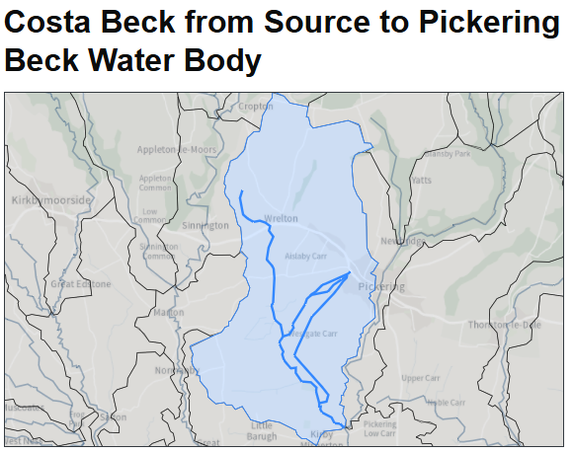
Water body ID: GB104027068480

Summary of recent activity in the Upper Costa Beck
(‘Costa Beck from Source to Pickering Beck’ water body (GB104027068480))
Since the publication of an updated programme of measures for Costa Beck in September 2024, technical, regulatory and partnership activity has been carried out across the Costa Beck catchment to take forward those measures and improve the evidence base. This work has informed this updated water body programme of measures for Costa Beck.
Routine water quality monitoring has continued across Costa Beck, as well as environmental permit compliance monitoring of the several discharge consents in the catchment. Water quality monitoring has contributed to updated 2025 Water Framework Directive (WFD) classifications for Costa Beck and these latest results have informed the content of the programme of measures.
Regulatory visits to commercial fisheries in the Costa Beck catchment have been carried out to provide advice, assess compliance with discharge permits, and ensure operators understand their responsibilities. As part of the previous programme of measures a refreshed enforcement strategy for commercial fisheries in the catchment was also developed, clarifying regulatory expectations, outlining enforcement options and sanctions proportionate to non-compliances and ensuring future actions align with the Regulators’ Code and achieve improved environmental outcomes.
Geomorphology investigations in the water body catchment were carried out by Environment Agency specialists. Investigations comprised of preliminary desk studies in April 2024 and two subsequent field visits in April and June 2025. The purpose of the investigation was to improve understanding of the geomorphology of the water body, including the pressures affecting its form and functioning, and by extension its ecology, and identify opportunities to tackle these pressures and support delivery of the water body’s objectives. This work was detailed in a Geomorphology Report produced in August 2025. This report has been used to refine and add detail to the required mitigation measures, ensuring that interventions are precisely targeted to address the most significant sources of impact to the ecology in Costa Beck.
Significant agricultural pollution prevention improvements representing around £160,000 of investment have been delivered across three key farms in the catchment, including new slurry systems, improved manure management and yard roofing. Further improvements and site-specific sediment reduction advice is ongoing, with additional visits planned. These will focus on promoting the importance of nutrient management plans on farms and investigating sediment runoff pathways (e.g. surface runoff and subsurface drainage) to determine the most effective measures. This will be particularly focussed on the Middleton Drain, Black Syke, and Twelve Foot Cut tributaries. This additional work was highlighted following the Geomorphology Report produced in August 2025.
Early engagement with catchment partners has been undertaken to gather feedback on the updated programme of measures. This has helped shape realistic, locally supported measures, identify opportunities for collaborative delivery and has ensured the updated programme of measures is aligned with wider catchment initiatives.
- Updated programme of measures for the Upper Costa Beck
Please review the proposed updated programme of measures for the Upper Costa Beck and respond to the consultation question, below.

Consultation questions
Question 1
We published an updated programme of measures for the Upper Costa Beck programme of measures on our consultation website.
Do you agree with the updated programme of measures for the Upper Costa Beck?
☐Yes
☐ No
☐ Not sure
If you answered 'no' or 'not sure', please explain your reasoning for what you would change and provide any supporting evidence.”:

About you
Please read the sections below before providing information about you.
How we will use your information
The Environment Agency will make all responses publicly available during and after the consultation, unless you have specifically requested that we keep your response confidential.
We will not publish names of individuals who respond.
Throughout the consultation we will make all comments (excluding personal information) publicly available on our Citizen Space website. This includes comments received online, by email, post and by fax, unless you have specifically requested that we keep your response confidential. We will not publish names of individuals or personal data. But we will publish the name of the organisation for those responses made on behalf of organisations.
We will not respond individually to responses. After the consultation has closed, we will publish a summary of the responses on our website and contact you to let you know when this is available.
In accordance with the Freedom of Information Act 2000, we may be required to publish your response to this consultation but will not include any personal information. If you have requested your response to be kept confidential, we may still be required to provide a summary of it.
Consultation principles
This consultation is being conducted in line with the Cabinet Office’s “Consultation Principles” which can be found at Consultation Principles on GOV.UK.
If you have any questions or complaints about the consultation process, please email: mailto:consultation.enquiries@environment-agency.gov.uk
Privacy Notice
The Environment Agency would like to keep you informed about the outcomes of the consultation. If you would like to receive an email acknowledging your response and telling you when we’ve published the summary of responses, please provide your email address with your response.
By giving us your email address, you consent for us to email you about the consultation. We will keep your details until we have notified you of the response document publication.
We will not share your details with any other third party without your clear and full consent, unless required to do so by law.
You can withdraw your consent to receive these emails at any time by contacting us at: rbmpequiries@environment-agency.gov.uk
The Environment Agency is the data controller for the personal data you provide. For more information on how we deal with your personal data please see our personal information charter on GOV.UK.
You can email our Data Protection team: dataprotection@environment-agency.gov.uk.
Question 2
Are you responding as an individual or on behalf of an organisation or group?
When we come to analyse the results of this consultation, it would help us to know if you are responding as an individual or on behalf of an organisation or group.
Please select from the following options:
☐ Responding as an individual
☐ Responding on behalf of an organisation or group
☐ Other
If you're responding on behalf of an organisation or group, please tell us who you are responding on behalf of and include its type e.g. business, environmental group:

If you selected other, please specify:

Question 3
Please tell us if you would like to (tick all that apply):
☐ Receive an email acknowledging your response
☐ Receive an email to let you know that the summary of responses has been published
If you have ticked any of the boxes above, please provide us with your email address:

☐ Put a cross in this box if you are requesting non-disclosure of your response.
Please provide an explanation to support your request:

Question 4
Please tell us how you found out about the consultation:
☐ From the Environment Agency
☐ From another organisation
☐ Through an organisation you’re a member of
☐ Press article
☐ Social media e.g. Facebook, Twitter
☐ Through a meeting you attended
☐ Other (please specify)
Other:

When you send your response form to rbmpenquiries@enivronment-agency.gov.uk you have submitted your response. By doing so you give us permission to analyse and consider your response in our results.

