APPENDIX 5
Photographs of key views
Figure 1: View of St Nicholas Church and Skirbeck Conservation Area from Fishtoft Road
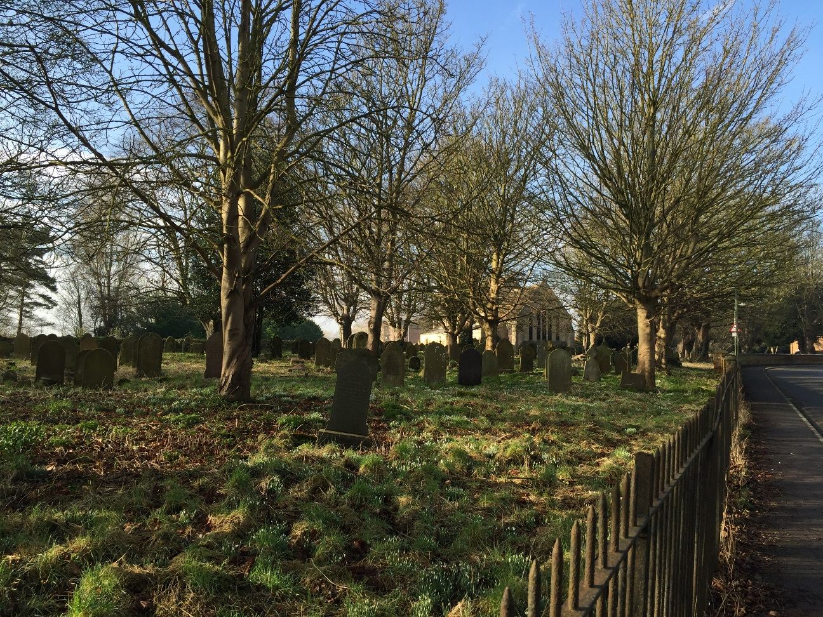
Source: EA 2017

Figure 2: View of St Nicholas Church across pond
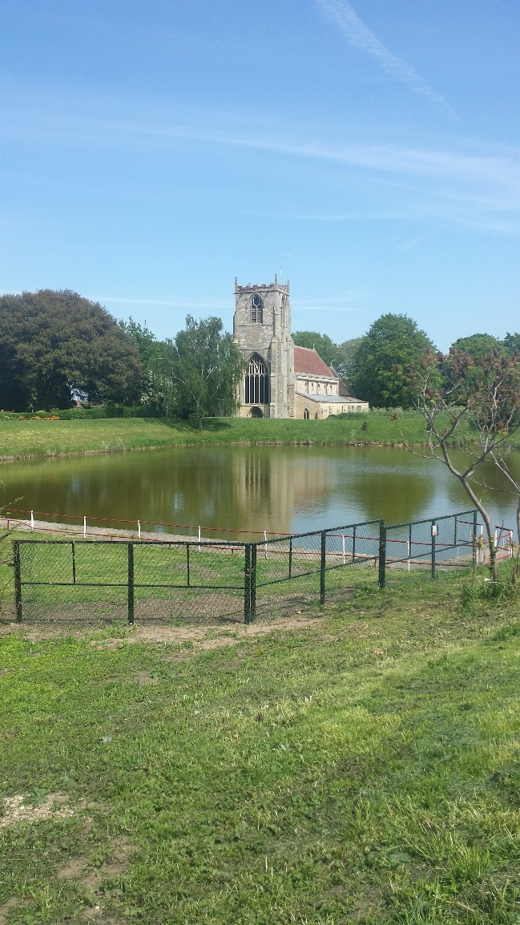
Source: MM 2015

Figure 3: St Nicholas Church from right bank showing back drop of trees and semi natural embankment
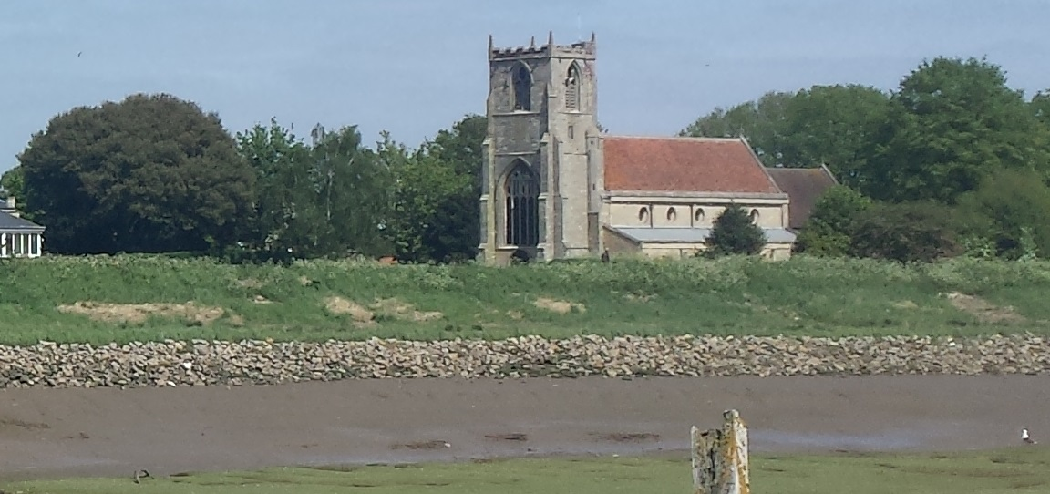
Source: MM 2015

Figure 4: Views of church from right bank with Port of Boston on the left of the picture
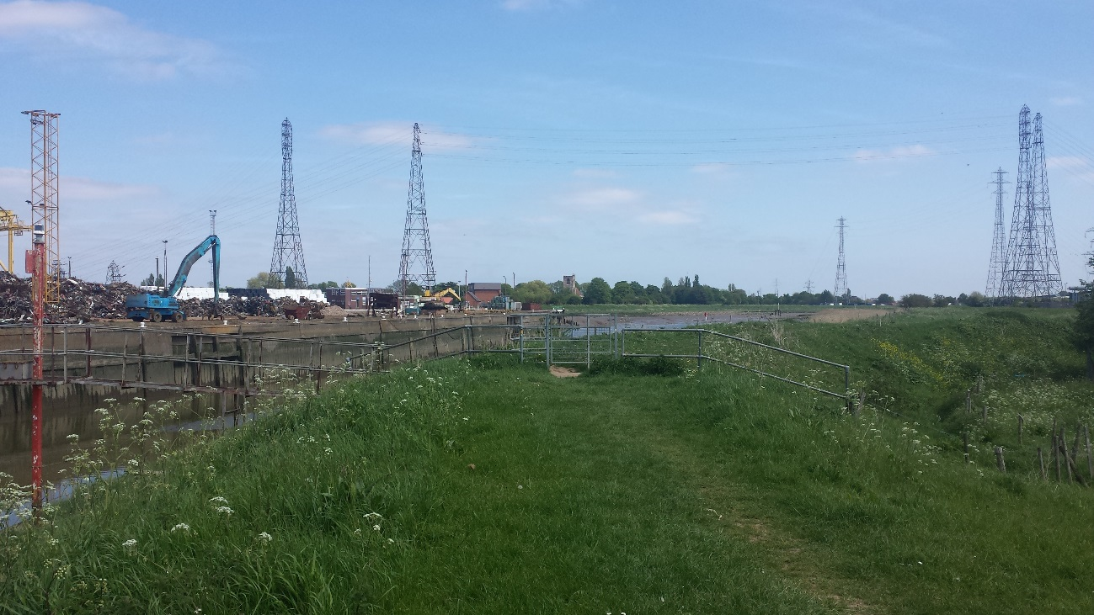
Source: MM 2015

Figure 5: Maud Foster Sluice from right bank with Port of Boston to the left and modern housing within Skirbeck Conservation Area to the right
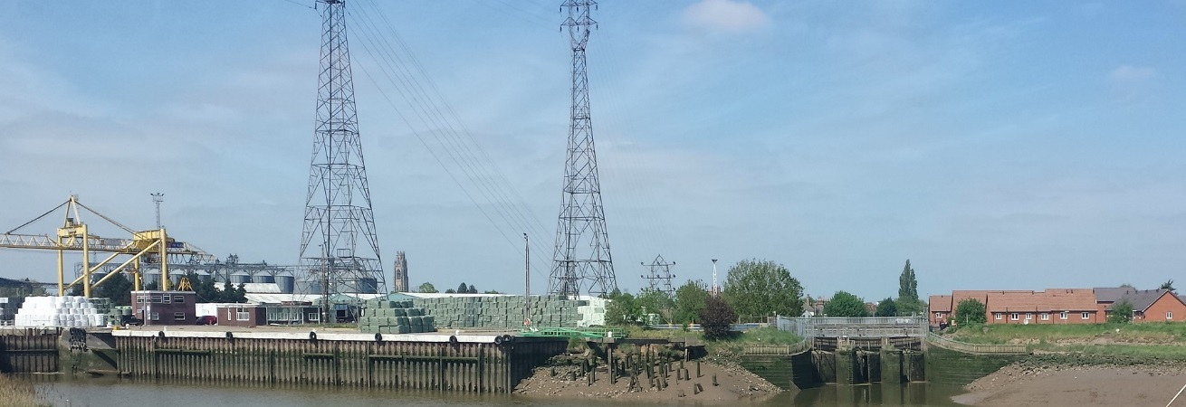
Source: MM 2015

Figure 6: View from St Nicholas Church and conservation area looking upstream towards barrier site.
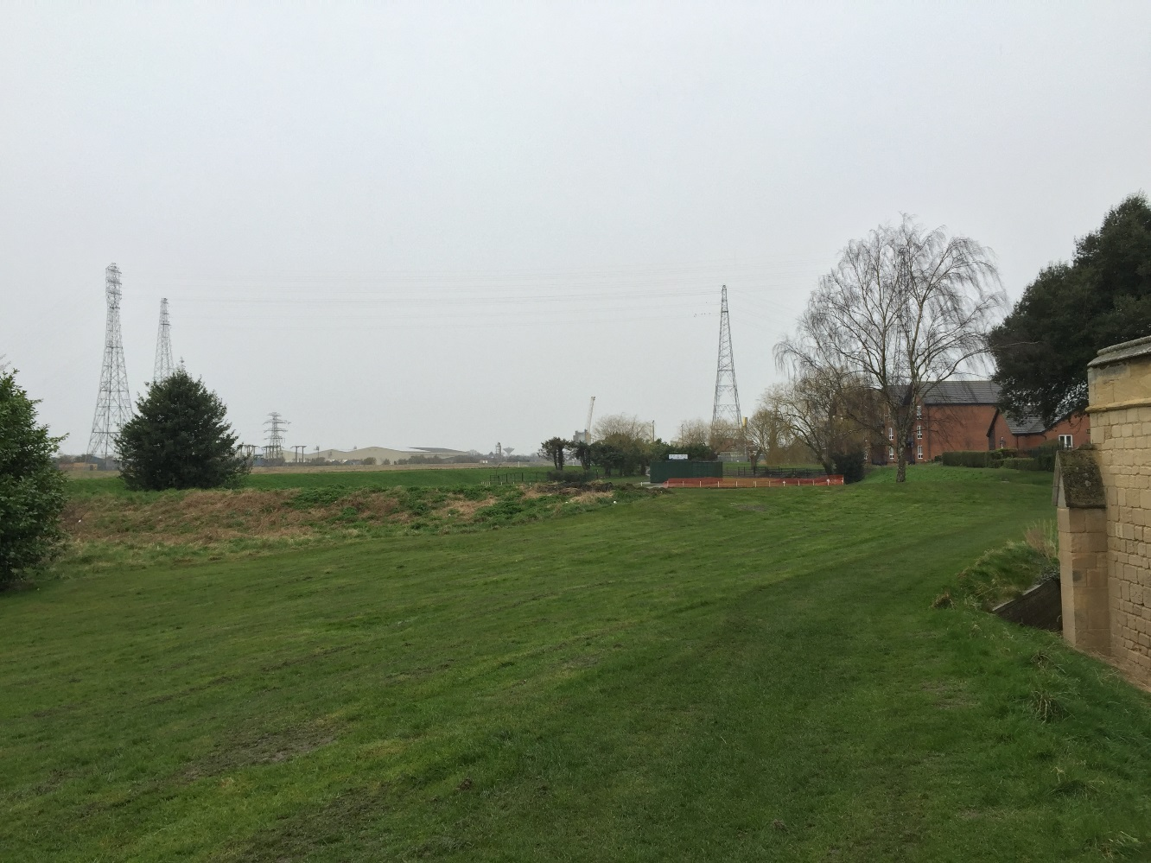
Source: EA 2017
Figure 7: View upstream from the bank adjacent to Black Sluice towards the Stump with Boston Conservation Area on the left hand side
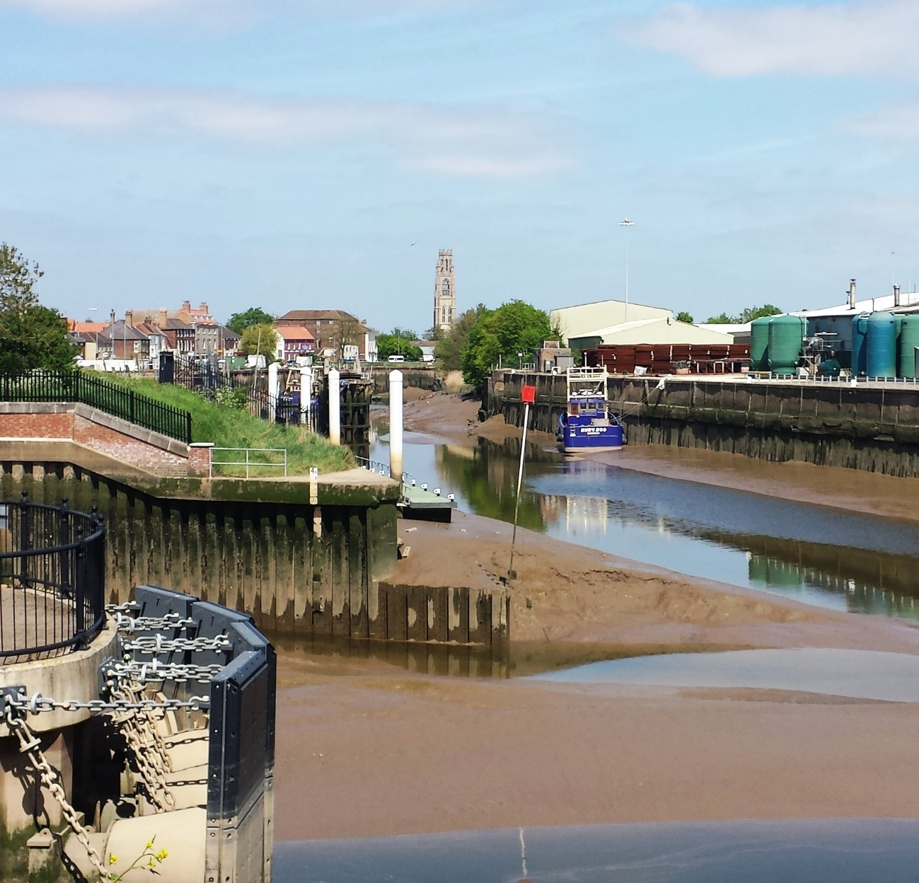
Source: MM 2015

