Construction Update August 2023

Jackson Civil Engineering are working on behalf of the Environment Agency to build a replacement flood defence at Matlock and reinstate flood protection from the River Derwent. Our project is being delivered in partnership with Derbyshire County Council and Derbyshire Dales District Council.
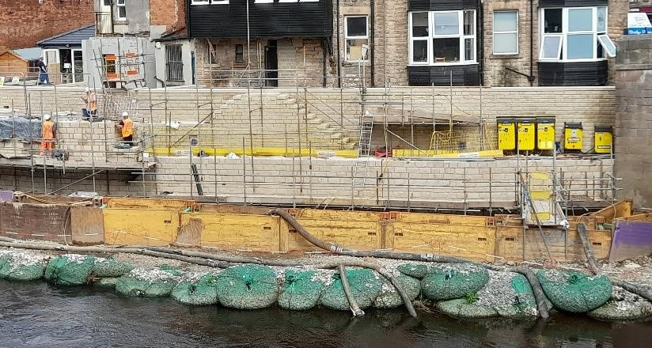
Construction of the flood wall is now complete, with the entire wall and tie in sections fully cladded with locally sourced Birchover Quarry Gritstone. Once the rest of the in-river works are complete, hand railings and gates will be fitted to provide safe working access for Environment Agency operatives to maintain the walls and drainage systems. To support the heritage look and colour palette of the area, these fittings have been special ordered in traditional styles.
The river side wall is now also structurally complete, with the stone cladding well under way. Cladding is expected to be completed by mid-August, allowing us to begin deconstructing the working platform. Once the platform has been completely removed, we will be able to install the erosion protection along the base of the river wall, ensuring long lasting security of the wall.

Matlock Flood Wall

Contact

the Environment Agency helpline on
03708 506 506

Or

email
EMDenquiries@environment
-
agency.gov.uk

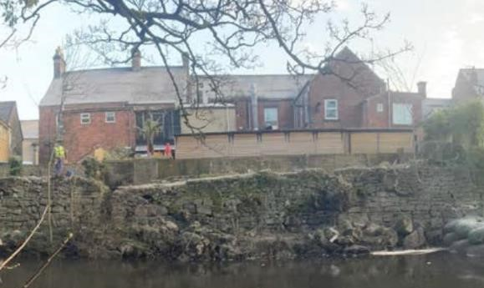
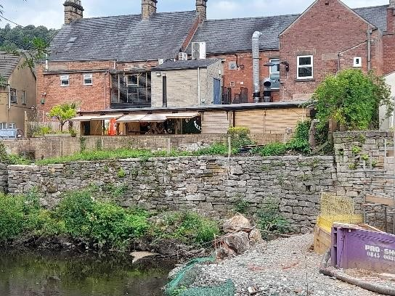
Works have also been completed to the section of wall upstream from the flood wall, directly behind the Mad Hatter. This section had been assessed as in poor condition, with several mature trees rooted within the dry wall and pushing the stones out of alignment, with the potential to destabilise the wall. Utilising the expertise of the
local stonemasons, and in consultation with heritage partners and archaeologists, the wall was disassembled by hand. All tree and roots have been removed, and the wall carefully reassembled to its original condition, strengthening the section.

crane will be derigged and leave site. Cleaning and any repairs needed to the surface of the A6 will be carried out, and then the barriers across the A6 will be removed. On the day of reopening, barriers will be switched to the head of Matlock Bridge, which will close from 8pm, allowing the A6 to reopen around 10 minutes later. The bridge will remain closed for around 6 weeks while we return it to the previous single lane configuration. There will be a few overnight single lane closures on crown square to allow for the scraping and resurfacing works, as well as overnight closures of the A6 and Snitterton Road for line painting.

Contact Us
If you have any questions or concerns about this project, please contact our Public Liaison Officer: Kathryn Battelle via email kbattelle@jackson-civils.co.uk or call 07970 159492.

If you would like to be added to our mailing list to receive future updates about this scheme, please contact us through the email address.
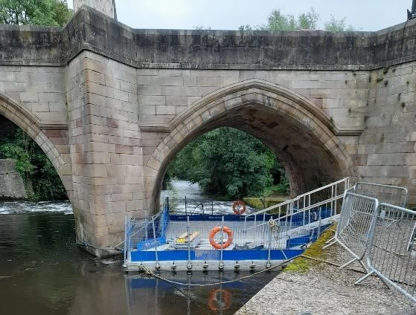

Matlock Flood Wall

A floating pontoon has been installed within the right
-
hand arch

of
Matlock Bridge. This is to enable works to remove graffiti, and
complete repointing of the stonework
underneath

the
arches and
around the cutwaters. Once completed on the right arch, the
pontoon will be moved to the centre
arch, and finally the left ar
ch
to complete these works a
cross the entire bridge.

With the works drawing to a close, plans to demobilise the site and
release the A6 have been confirmed. As soon as the
working
platform has been removed and all in river works are complete, the

Contact

the Environment Agency helpline on
03708 506 506

Or

email
EMDenquiries@environment
-
agency.gov.uk

Improving the image of Construction

The Considerate Constructors Scheme was setup to
improve the image of the
construction industry. The
scheme aims to encourage best practice beyond
statutory requirements and show the industry to be
a considerate one. Our site has signed up to the
scheme.

Site Reference:
132104

To find out more about this project, please visit the project information page at:
https://consult.environment-agency.gov.uk/east-midlands/matlock/ or use this QR Code
Follow us on twitter @JacksonCivils and @EnvAgencyMids

