**The effect of eutrophication on fish assemblages and the role of fish in reinforcing the turbid, algal dominated state with particular reference to the Norfolk Broads and the current situation in Hoveton Broad**

Ruth Hall

**Background**

The fish assemblages found in the Broads are influenced by the connectivity of the system, saline influence, natural colonization, past stocking, interactions between species and the habitat quality; particularly water quality, the presence of vegetation and the availability of food.

Habitat quality is particularly affected by eutrophication; the process by which unnaturally high concentrations of nutrients leads to increases in phytoplankton, reductions in water clarity and a reduction in macrophytes. The increased productivity of a lake, particularly in the form of short-term algal blooms, leads to an increase in dead organic matter accumulating on sediments. As bacteria mineralise this material they consume oxygen, depleting its concentration in the water, which can lead to fish kills. This results in turbid, algal-dominated lakes (e.g. Moss, 2010).

**The response of fish and fish assemblages to eutrophication**

The way in which fish assemblages change in response to increasing nutrient levels is well established, with salmonid and coregonid dominated assemblages being replaced by pike and perch dominated assemblages, which are in turn replaced by cyprinid dominated assemblages. More specifically as nutrient enrichment increases it is roach, bream and carp that eventually dominate (e.g. Jeppessen *et al.,* 2000; Moss, 2010). These changes in fish assemblage are a response to the changes in habitat as a result of nutrient enrichment, but the changes in assemblage and in food web interactions that are a consequence of this, further alters the lake ecosystem.

It is the switch between a pike and perch dominated assemblage which is associated with macrophytes to a roach and bream dominated assemblage associated with the turbid, algal dominated state that is particularly pertinent to Hoveton Broad. The loss of habitat complexity due to the loss of macrophytes and reduction in water clarity disfavor piscivores, which are dependent on light for finding and capturing their prey. The loss of refuges also increases cannibalism in pike resulting in fewer small pike, which are more efficient at controlling young planktivorous fish numbers than a few large pike (Grimm and Backx, 1990).

This reduction in pike and perch has a knock-on effect on other small fish as they are released from the predation pressure. Consequently there is an increase in fish able to withstand these more algal dominated, lower water clarity, lower oxygen conditions; the cyprinids. This increase in number of young cyprinids increases competition amongst them and competition between cyprinids and percids and this results in a decrease in the average size of these species with eutrophication. This reduces the number of perch reaching the size at which they would become piscivorous, thus reducing predation pressure further.

Amongst the fish that exploit the pelagic zone, roach become dominant with eutrophication, not only due to a lack of predation pressure, but because they are able to exploit smaller zooplankton prey, have a higher predation efficiency on cladocerans and have a higher potential growth rate (Persson, 1983).

Of the species that can exploit the benthic habitat ruffe can initially increase in abundance with an increase in nutrients, as they out-compete young benthivorous perch, as unlike perch their foraging ability is independent of light. However, as nutrient availability increases further ruffe struggle to compete with Bream. This is because of the efficiency of bream when foraging for benthic invertebrates and their ability to switch between the pelagic and benthic feeding mode. The inability of ruffe to compete with bream has been illustrated by their increase in numbers after bream have been removed as part of biomanipulation experiments. In these situations ruffe numbers have later declined after a number of years, if water quality has improved sufficiently to enable perch to take advantage of the pelagic niche and then reach the benthivorous stage where they can compete with ruffe (Jeppessen *et al*., 2010).

Surveys in the Broads have led to the same conclusions. Where habitat complexity provided by macrophytes remains the piscivores (pike and perch) dominate by biomass. Tench eels and rudd are also found in greater abundance in these habitats than in those where macrophytes are absent and the water is turbid. Conversely, under turbid, algal dominated conditions roach and bream are more abundant and there are fewer pike, perch, tench, rudd and eel. Figure 1 (Kelly, 2008)

Relative biomass of fish



Relative number of fish

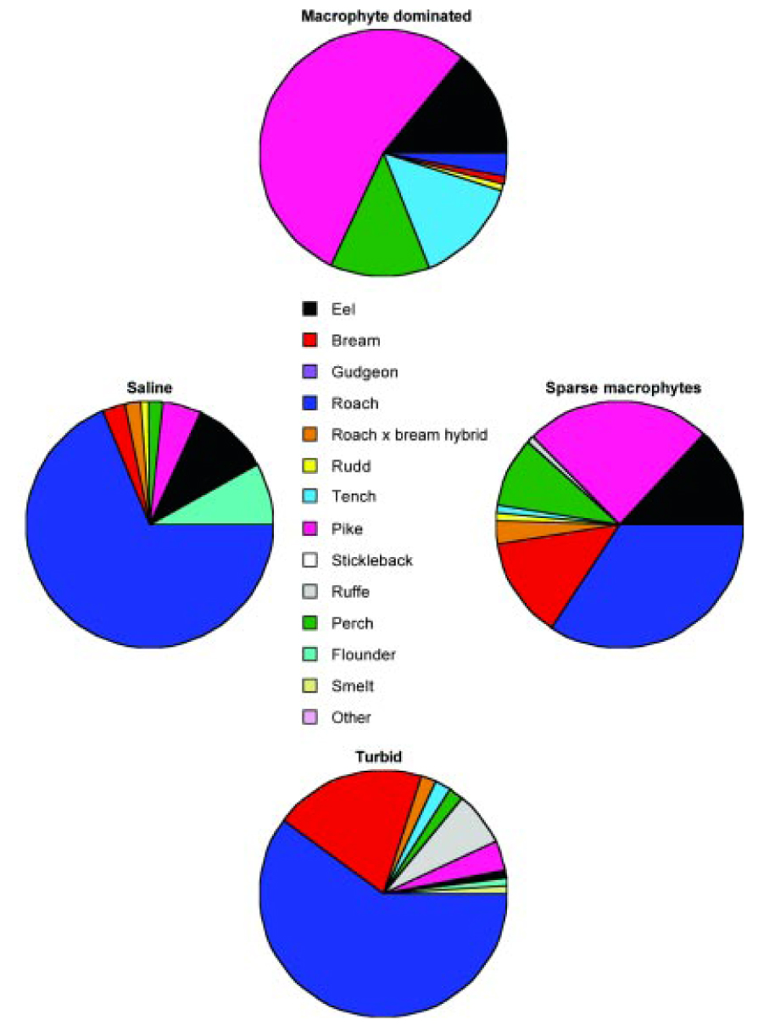

Figure 1 Relative biomass and number of fish in the Broads in macrophyte dominated and turbid conditions. Presented in Kelly (2008). Data from selected Environment Agency (National Rivers Authority) fisheries surveys and surveys conducted for the Broads Authority.

**Reasons for the current assemblage at Hoveton and likely assemblage under unimpacted conditions**

Recent surveys of Hoveton Broad show that although there are seasonal changes in the fish assemblages, roach and bream dominate the assemblage in spring and summer, the macrophyte growth season. Roach dominate by number and bream by biomass (Hindes, 2017). Multiple studies have illustrated that such assemblages are a consequence eutrophication, which we know has occurred at Hoveton, resulting in a loss of macrophytes and consequently habitat complexity. Under unimpacted conditions with extensive macrophyte beds a fish assemblage dominated by pike and perch, but also with tench, rudd and eel forming a larger part of the assemblage than is currently the case could be expected at Hoveton Broad.

**The likely role of the fish assemblage in the current condition of Hoveton Broad**

The dominance of roach and bream under eutrophic conditions is not just a symptom of eutrophication, these species play a critical role in the food web, which reinforces the turbid, algal dominated state. Large numbers of small roach significantly alter the zooplankton community in lakes, which reduces their ability to control the phytoplankton. The effect roach has on lake functioning has also been shown many times via biomanipulation, both in the Broads and elsewhere, when removal of roach has led to increases in large zooplankters, reduced phytoplankton abundance and therefore increased water clarity, which has enabled macrophyte growth and a shift back to a fish assemblage described above as typical in macrophyte dominated systems (Bernes *et al*., 2015, Phillips *et al*., 2015).

Perrow (1999) reported that in open water with no refuges, >0.2 ind. m-2 of zooplanktivorous fish, such as roach, may exert a negative effect on zooplankton, although where there were submerged plants, the density may have to be much higher (> 1 ind.m-2) to exert the same effect. Hindes (2017) reported finding more than 5 roach individuals per m-2 in Hoveton Broad in spring, although this later decreased it remained above 0.2 m-2 throughout the rest of the year. As Hoveton has extremely sparse macrophytes this level of roach abundance has the capacity to detrimentally affect the lake.

Bream also play an important role, as benthic feeders they resuspend the sediment increasing turbidity and uprooting macrophytes. They also promote nutrient release and cycling from the sediment. This reinforces the algal dominated state. Work in experimental ponds found that suspended sediment concentrations increased linearly with bream biomass, with an increase of 46g sediment m-1 day-1 per 100kg bream ha -1 and a reduction of 0.38 m-1 in secchi disc depth (Breukelaar *et a*l., 1994). Research by Zambrano *et al* (2006) on Norfolk lakes, including the broads, showed that assemblages dominated by benthivorous fish formed a distinct community which was associated with turbid lakes with no vegetation, adding further weight to the evidence of their detrimental impact on macrophytes. These findings have led to the conclusion that biomanipulation in the Broads may be better targeted towards benthivorous rather than zooplanktivorous fish. This has been reinforced by observations that where large bream have effectively been eliminated there appears to have been a more favourable response in water quality, recovery of submerged macrophytes and the fish community (Kelly, 2008).

Although the exact boundaries of any relationship between fish biomass and macrophyte cover remain difficult to define, a general rule of thumb appears to be that a broad is unlikely to support good populations of plants with more than around 100 kg ha-1 of benthivorous fish (Kelly, 2008). At Hoveton in spring, a mean bream biomass of over 250 kg ha-1 was recorded, this declined to nearer 150 kg ha-1  in summer and declined further in autumn, but it rose to over 100 kg ha-1 again in winter (Hindes, 2017). The presence of such a high biomass of bream, particularly at the start of the growing season, has the capacity to detrimentally affect Hoveton Broad.

**Potential for Biomanipulation**

Biomanipulation including the removal of roach and bream has consistently produced clear water conditions in the Broads. The Broads review (Phillips et.al., 2015) states that a large reduction in chlorophyll *a* and corresponding increase in Secchi depth (often to the lake bed) providing ‘gin-clear’ conditions appears to be guaranteed in biomanipulated lakes and exclosures in the Broads. An increase in macrophyte cover will almost invariably follow, although the extent of cover and the timescale over which this occurs is likely to be variable depending on other factors (e.g. propagule bank, source of colonists, climatic conditions, herbivory by waterbirds; Bakker *et al.,* 2013).

**Conclusion**

The present fish assemblage found in Hoveton Broad is what you would expect in a system subject to eutrophication. The literature and the lack of any macrophyte recovery in the broad would suggest that with the current fish assemblage at current levels a clear water macrophyte dominated state will not be achievable. Consequently if the lake is to be restored to a plant dominated state with its associated fish assemblage, the current fish assemblage will need to change significantly. If this does not occur, Hoveton Broad will remain in a turbid, algal dominated state.

**References**

Bakker, ES, Sarneel, JM, Gulati, RD, Liu, Z, van Donk, E. (2013) Restoring macrophyte diversity in shallow temperate lakes: biotic versus abiotic constraints.*Hydrobiologia* 710:23-37.

Bernes, C., Carpenter, S., Gardmark, A.,Larsson, P., Persson, L., Skov, C., Speed, J., and Van Donk, E. (2015) What is the influence of a reduction of planktivorous and benthivorous fish on water quality in temperate eutrophic lakes? A systematic review *Environmental Evidence* 4:7

Breukelaar, A.,Lammens, E., Klein Breteler, J., and Tatrai, I. (1994) Effects of benthivorous bream and carp on sediment resuspension and concentrations of nutrients and chlorophyll a. *Freshwater Biology* 32 113-121.

Grimm M.P. & Backx J. (1990) The restoration of shallow eutrophic lakes and the role of northern pike, aquatic vegetation and nutrient concentration. *Hydrobiologia*, 200:201, 557–566.

Hindes, A. (2017) Hoveton Great Broad Restoration project: Seasonal comparative fish surveys summary report. Report to Natural England.

Jeppesen, E., Jensen, J., Søndergaard, M., Lauridsen T., and Landkildehus, F. (2000) Trophic structure, species richness and biodiversity in Danish lakes: changes along a phosphorus gradient*. Freshwater Biology* 45, 201–218

Kelly, A. (2008) Lake restoration strategy for the Broads. Broads Authority.

Moss, B. (2010) Ecology of freshwaters a view for the twenty-first century. 4th edition Wiley-Blackwell

Perrow, M.R., Jowitt, A.J.D., Leigh, S.A.C. Hindes, A.M. & Rhodes, J.D. (1999). The stability of fish communities in shallow lakes undergoing restoration: expectations and experiences from the Norfolk Broads (UK). *Hydrobiologia*, 408/409, 85-100.

Persson L. (1983) Effects of intra- and interspecific competition on dynamics and size structure of a perch *Perca fluviatilis* and a roach *Rutilus rutilus* population. *Oikos*, 41, 126–132.

Phillips, G., Bennion, H., Perrow, M.R., Sayer, C.D., Spears, B.M., Willby, N. (2015) A review of lake restoration practices and their performance in the Broads National Park, 1980-2013. Report for Broads Authority, Norwich and Natural England.

Zambrano, L., Perrow, M., Sayer, C., Tomlinson, M., Davidson, T. (2006) Relationships between fish feeding guild and trophic structure in English lowland shallow lakes subject to anthropogenic influence: implications for lake restoration *Aquatic Ecology* 40:391–405